**Usability Text Analysis**

**Low-fidelity Prototype**

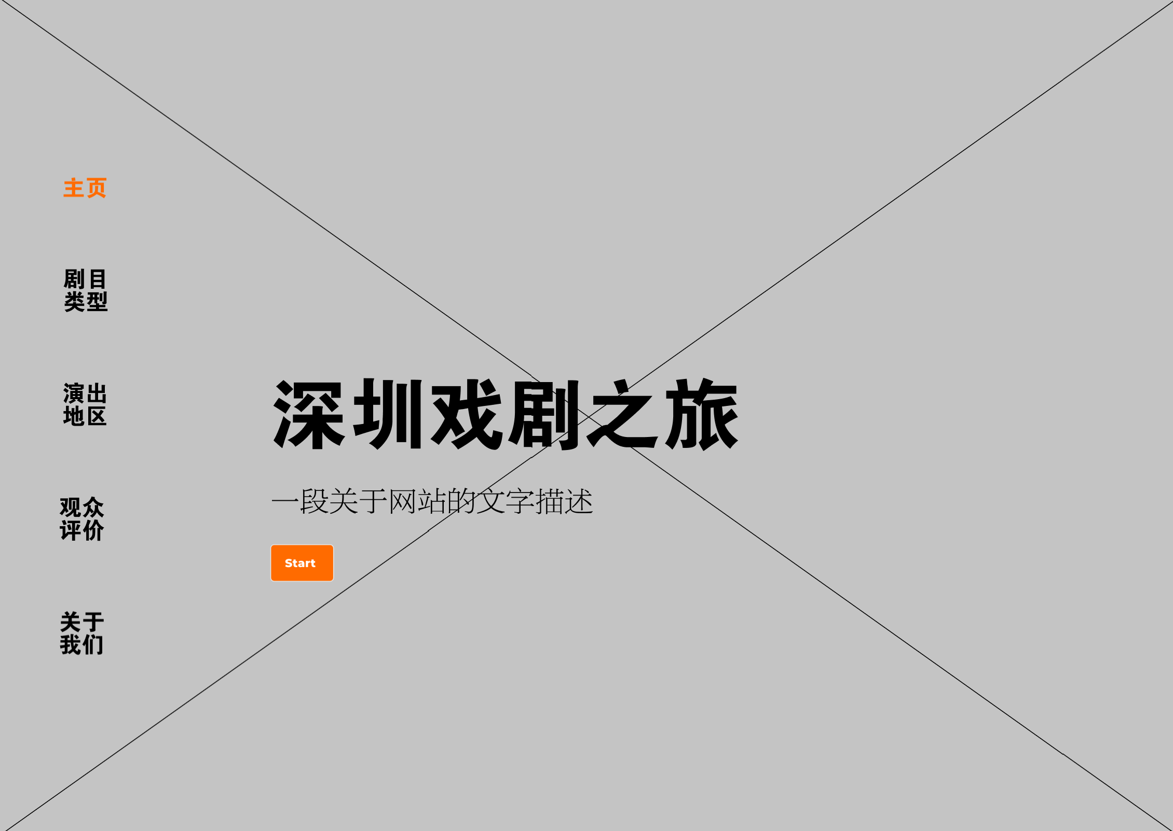

Figure 1. Homepage

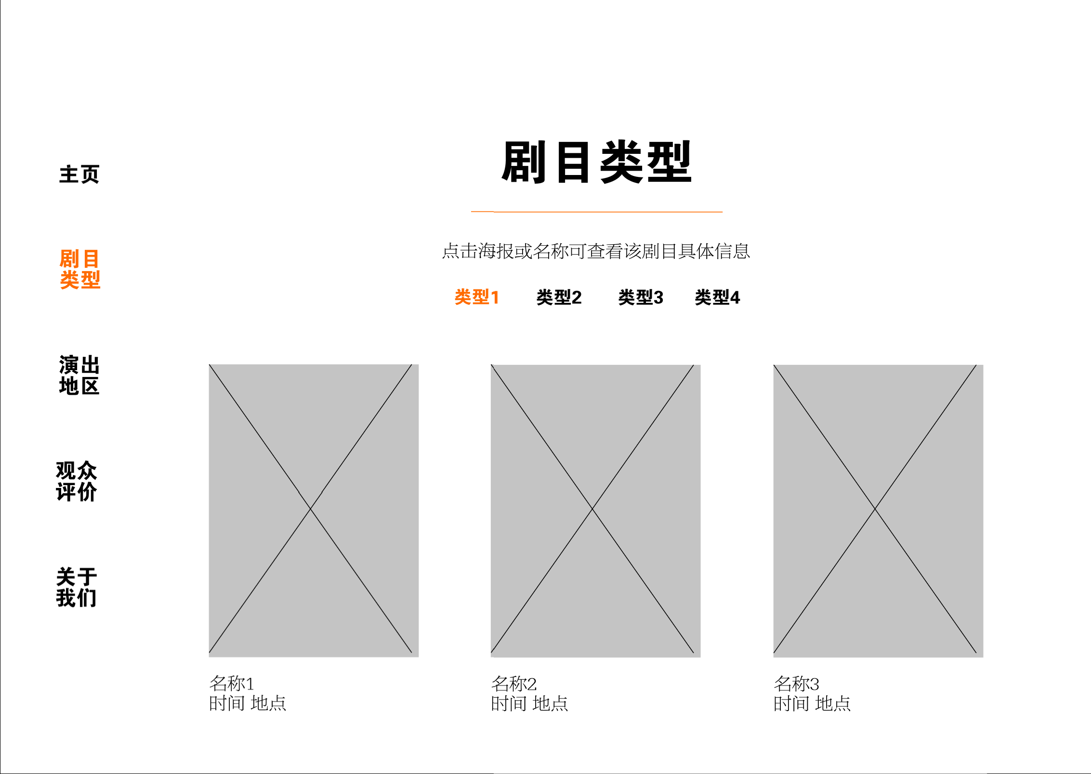

Figure 2. “Theatre Type” Page

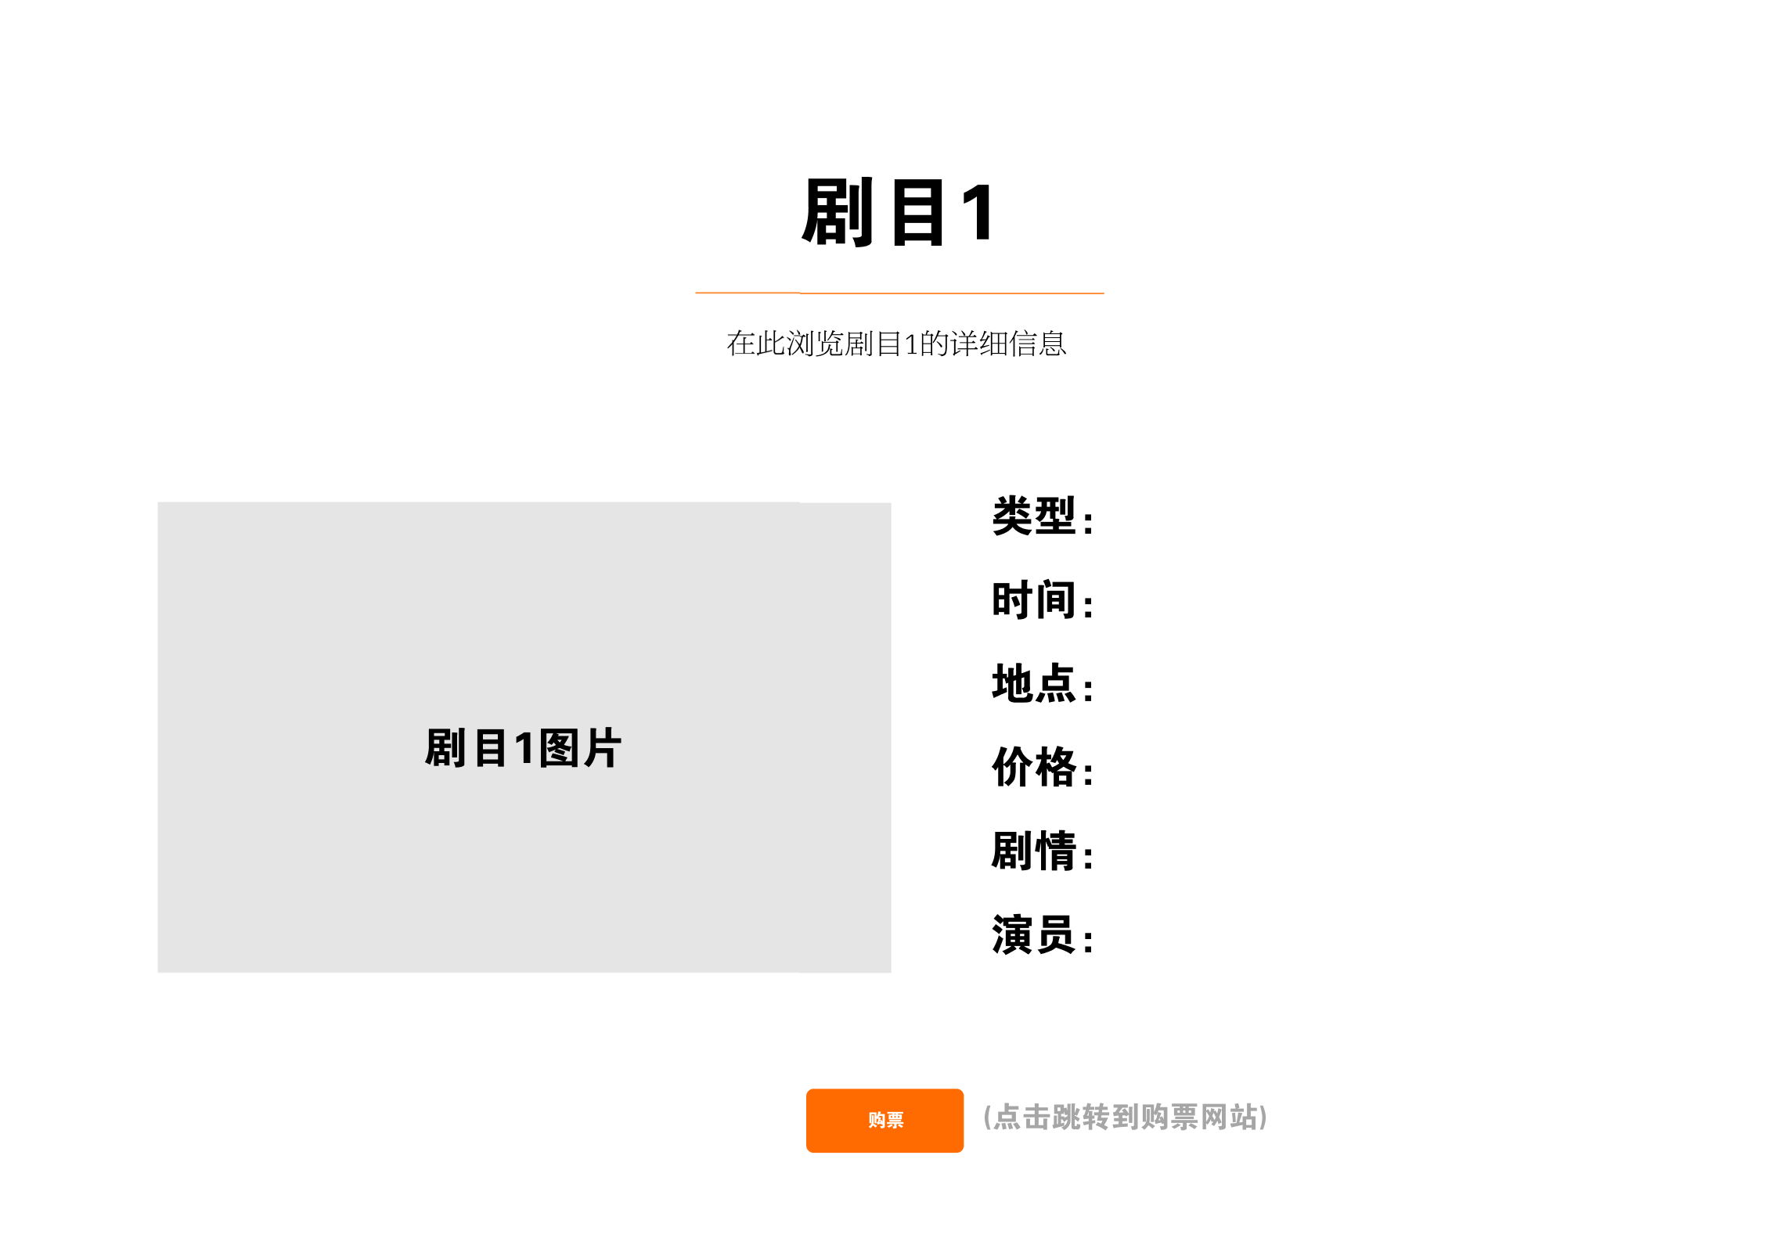

Figure 3. “Theatre Details” Page

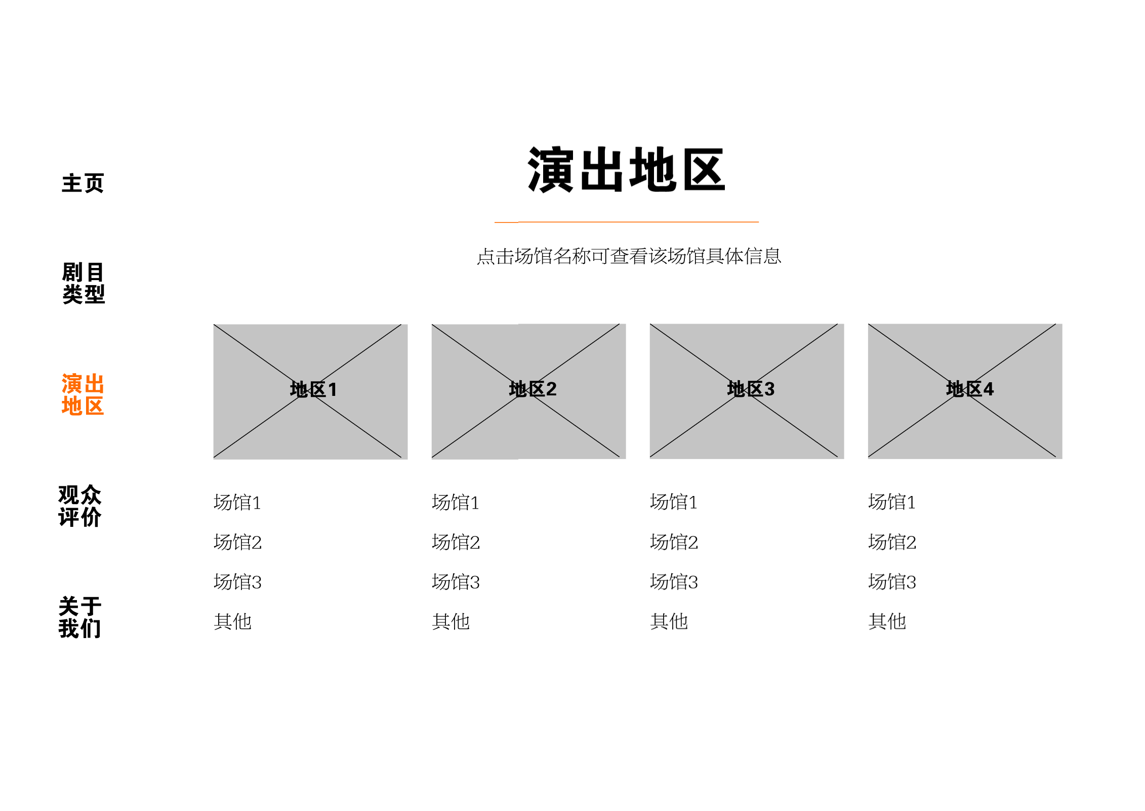

Figure 4. “Activities Location” Page

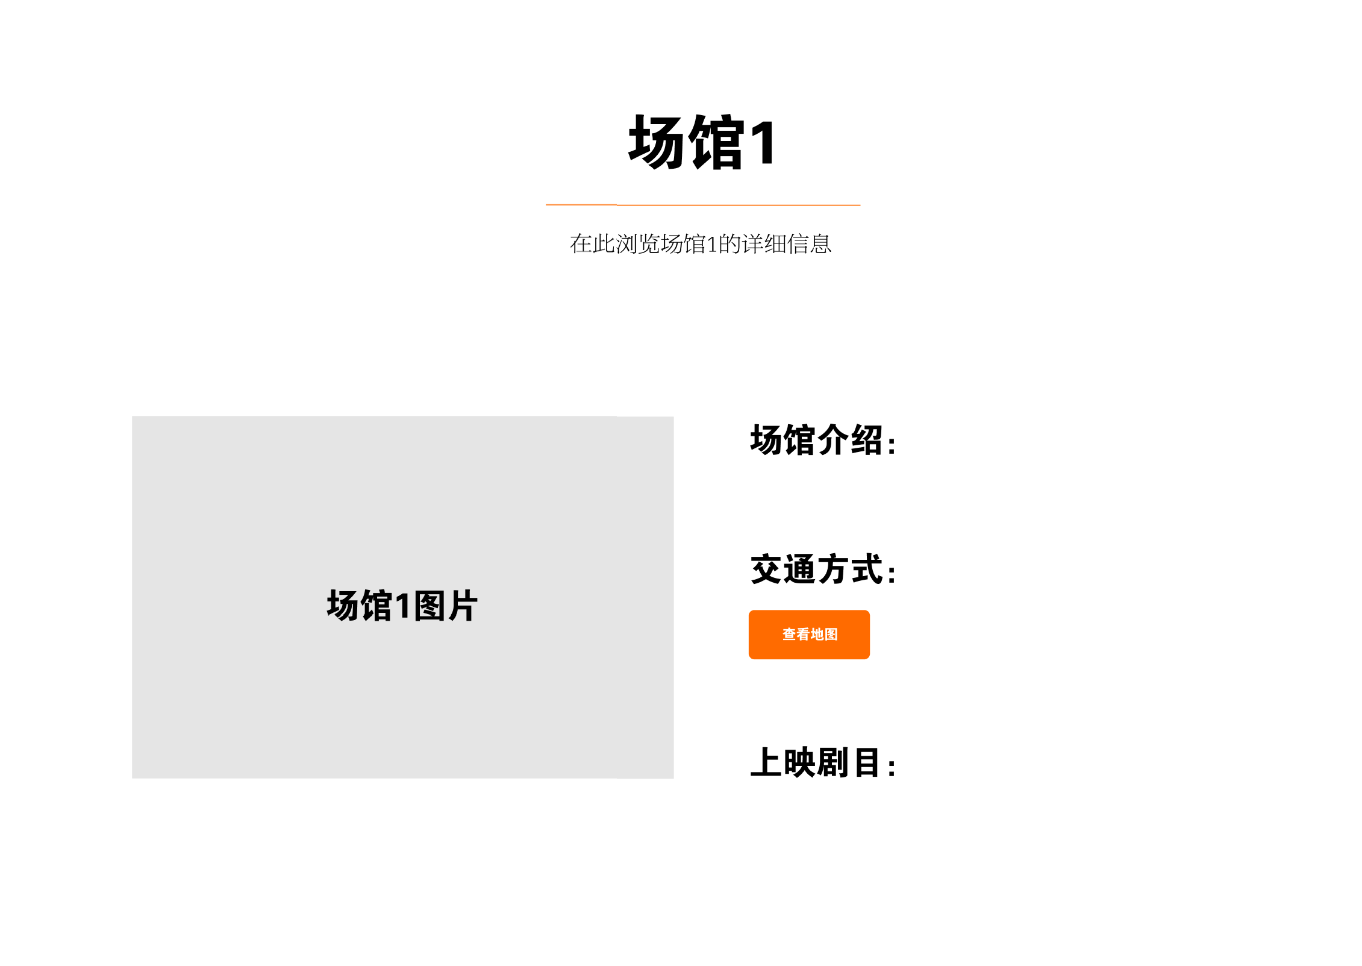

Figure 5. “Venue Details” Page

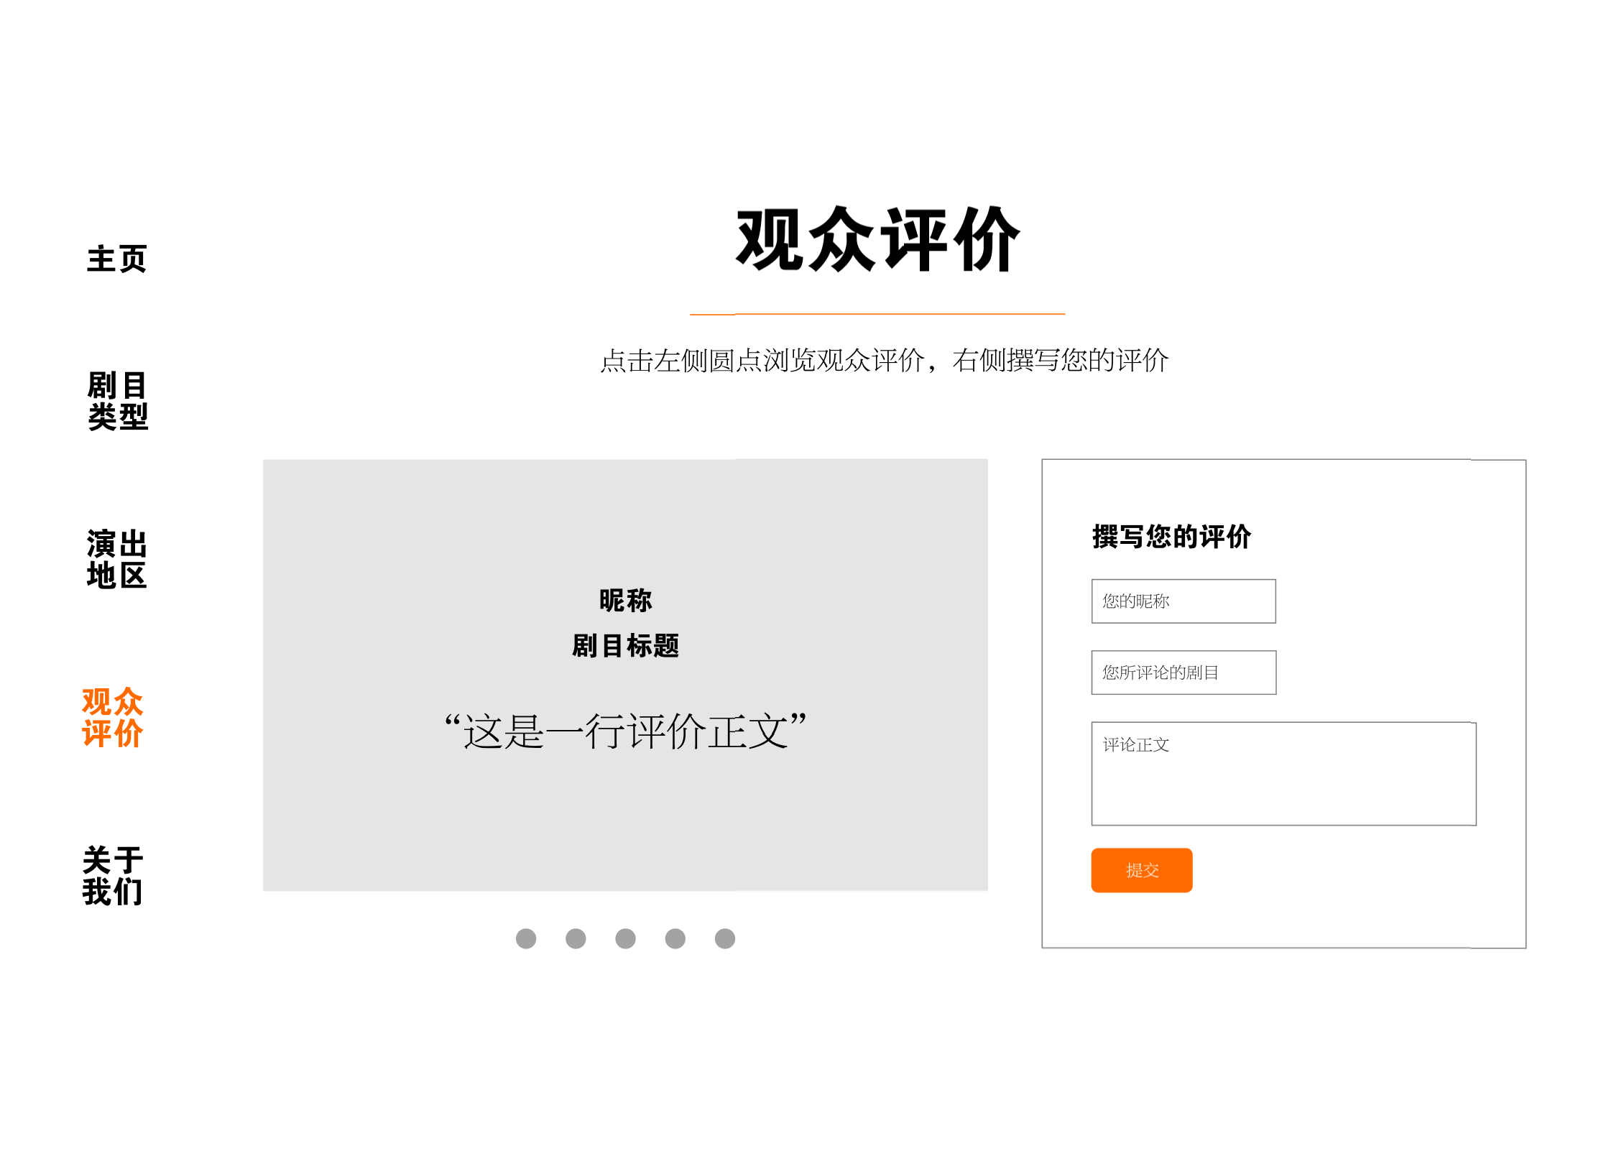

Figure 6. “Audience Comments” Page

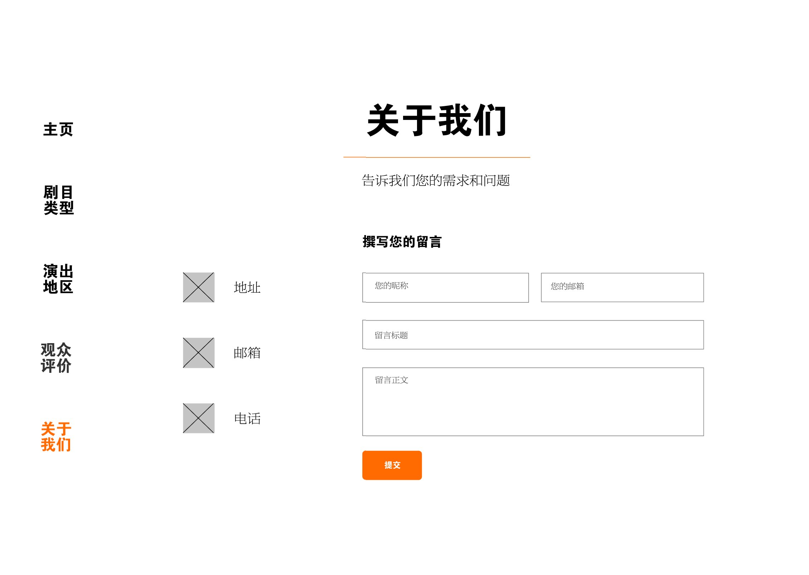

Figure 7. “About Us” Page



Figure 8. Footer

1. **Adjust the “START” button on the homepage（主页）**

Based on the participants' performance on the task and their post-text interviews, the developer found that the meaning of the "START" button on the homepage caused some confusion among the participants. Although they tended not to be confused for long about the button's meaning (as it is common on other websites' homepages), one participant suggested that there were terms that better informed the user of the button's function than "Start", such as "Start browsing", etc.

In addition, one participant suggested that the three methods to accessing the "Theatre Type" page from the homepage - clicking the "START" button, scrolling down, and clicking on the navigation bar on the left - may be relatively unnecessary. Developer could consider linking the "START" button to another section that is equally important for users.

1. **Add a "General Browse"（综合浏览）page**

In the post-text interview, one participant said that she sometimes did not pick plays with a strong sense of purpose. When browsing the web, she did not have a clear idea, such as "I want to see musical next" or "I want to see a show in Nanshan District next”. More often than not, she just wanted to have a general overview of what are being performed recently.

For this reason, it is necessary to add a "General Browse" section. At the same time, even though the users may not have a clear purpose at the beginning of the browsing, the needs to "search by theatre type", "search by price", etc. may arise from time to time. Therefore, a sub-function to search by different kinds of criterion are still required in the "General Browse" page.

1. **Merge the "Theatre Type" page with the "General Browse" page**

For the reasons mentioned above, the “Theatre Type” page can be merged with the newly added “General Browse” page to prevent duplication of core functions. Within the "General Browse" page, users can choose to filter all activities by Theatre Type and focus on what they are interested in, which will improve their efficiency.

1. **Add the "Upcoming Events"（近期活动） page**

In the post-text interview, a participant indicated that visualizing what theater events would be held in the near future is a very important function for them. Although everyone has a preference for a particular type of play, "preference" does not mean that they only see that type of performance. Most theater lovers are interested in learning about all the theater-related activities that take place within a certain period of time. Often, after getting a general idea of what is going on, users concentrate on reading about the parts that interest them the most, such as the type of theatre they are most interested in, the most convenient location, and so on.

Therefore, even though the "General Browse" page shows when each event is taking place, it is not straightforward enough to meet the user's need for "visualizing what theater events are taking place in the near future". Therefore, the developer feels that it is necessary to add a "Upcoming Events" page and have the "START" button on the home page link directly to this page to make it easier and faster for these users to accomplish their goals.

1. **Link the “Theatre Details” pages to the “Venue Details” pages**

As participants completed the usability text task, the developer found that each participant entered the "Theatre Details" page from the "Theatre Type" page, and then also entered the "Venue Details" page from the "Activities Location" page.

Therefore, the developer thinks that it is necessary to link the "Location" information on the "Theatre Details" pages to the "Venue Details" pages; “Theatre Details” pages should be linked to the “Ongoing Activities” information on the “Venue Details” pages, which helps simplify the process of obtaining relevant information and improves the user experience.

1. **Add common public transportation stations information to the "Venue Details" pages**

In the post-text interview, the participant who cares about the location of the events reflected that she would like to see the public transportation stations near the venue in addition to the function to view a map directly on the "Transportation" section of the "Venue Details" pages. Therefore, the developer decides to add this message to the page in order to meet the needs of users who use public transportation more often.

1. **Add the feature of viewing audience rating by Theatre name in "Audience Comments"（观众评价） page**

Participant who was more interested in past audience reflections of the activities, both during the actual process to accomplish the task and in the post-text interview, felt that presenting audience comments in the form of carousel did not seem to be sufficiently economical, since the carousel does not have much space for text content to display. In addition, the current format to present the comments only allows users to read them in order, one by one, which is not efficient for obtaining useful information. Many viewers would firstly choose the plays they were interested in in mind and then intentionally read the reviews of those plays on this page.

Therefore, the developer decides to change the presenting method of audience comments on the "Audience Comments" page and add the feature to view comments by theatre name.

1. **Change the title of "About Us"（关于我们） to "Contact Us"（联系我们）**

Besides, one participant mentioned in the post-text interview that, considering that the core content of the "About Us" page is mainly about how to contact the web developer, it might be more appropriate to change the title of the page to "Contact Us" to more directly summarize the functionality of the page to the users.

1. **Add related links in the footer**

Finally, based on the observation and analysis of other similar websites, the developer thinks that it is sensible to add other theater-related websites as related links on the footer to further facilitate users’ data collection and content acquisition, and to improve the sense of use of this website.