**Team I: Go Problem Solver Testing Document**

**1.** Using problem creation mode attempt to recreate the free-play style problem displayed below upon the problem solver's board or, if preferred, create your own more specialised life and death problem. We recommend using the bounds displayed and the Objective: *White to kill 5,2*.

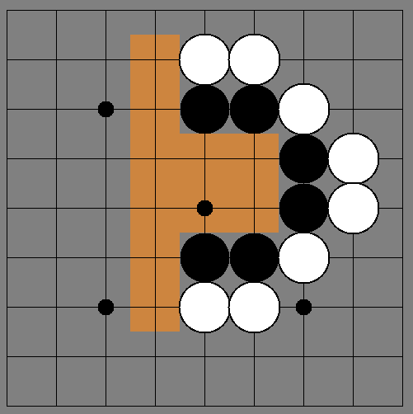

**2.** Please answer the following questions about your experience creating the problem.

**Did you create the problem above or a new one? (If new: please describe it.)**

**How difficult/easy was it to create the problem?**

**What features did you like whilst creating a problem?**

**What features did you dislike or think were missing?**

**Any other comments?**

**3.** Using competitive play mode attempt to play the problem in the mode of your choice: human vs. human, AI vs. human or AI vs. AI. We recommend using AlphaBeta for the AI.

**Which mode did you choose and why?**

**How difficult/easy was it to play through the problem?**

**What features did you like whilst playing through the problem?**

**What features did you dislike or think were missing?**

**Any other comments?**

**4.** After your usage of the problem solver, consider the general interface and answer the questions below.

**Do you find the user interface graphically appealing? Please gives reasons for or against.**

**Do you find the layout of the user interface easy to use? Please give reasons for or against.**

**Any other comments on the general program?**