**Team I: Go Problem Solver Testing Document**

**1.** Using problem creation mode attempt to recreate the free-play style problem displayed below upon the problem solver's board or, if preferred, create your own more specialised life and death problem. We recommend using the bounds displayed and the Objective: *White to kill 5,2*.

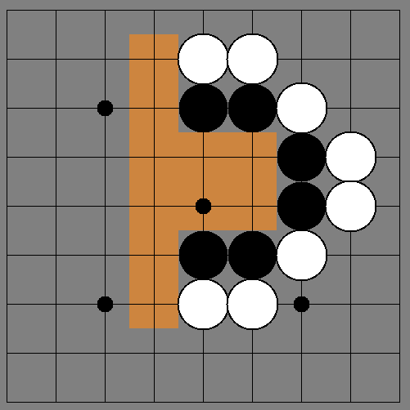

**2.** Please answer the following questions about your experience creating the problem.

**Did you create the problem above or a new one? (If new: please describe it.)**

Problem above

**How difficult/easy was it to create the problem?**

Medium because SOMEONE didn't give instructions

**What features did you like whilst creating a problem?**

I liked the bound thing and the ability to put down the different coloured stones(?)

**What features did you dislike or think were missing?**

Might need a button shortcut for changing from white to black

**Any other comments?**

I liked the interface, it was very friendly and pretty.

**3.** Using competitive play mode attempt to play the problem in the mode of your choice: human vs. human, AI vs. human or AI vs. AI. We recommend using AlphaBeta for the AI.

**Which mode did you choose and why?**

AI vs. Human cause I tried Ai vs Ai and it broke

**How difficult/easy was it to play through the problem?**

I had no idea what i was doing but it was fun because I cheated and won.

**What features did you like whilst playing through the problem?**

I could cheat, and it told me what the AI move was, so if it couldn't make a move I was told rather than just sitting there having no idea what was going on (in short good player feedback)

**What features did you dislike or think were missing?**

I had no idea if i had won or lost, you could add as a future addition a move suggest-er like in chess.

**Any other comments?**

**Fun.** Very nice project, would be better for someone who knew how to play but personally I feel some more feedback regarding score or 'win/lose' would be good.

**4.** After your usage of the problem solver, consider the general interface and answer the questions below.

**Do you find the user interface graphically appealing? Please gives reasons for or against.**

Yes, you can clearly see the board and the objective bounds colour stands out clearly against the non-bounds colour.

**Do you find the layout of the user interface easy to use? Please give reasons for or against.**

Yes once I had found all of the buttons. Finding all of the features was difficult.

**How well do you think the AI played? Please give reasons for or against.**

The AI beat me I think, I don't really know. But i've never played before so I'm not sure how that helps.

**Any other comments on the general program?**

Very nice program that I can see would be very useful to players of Go!