10. Considerando las definiciones de los ejercicios anteriores demostrá por inducción sobre xs las siguientes propiedades:

a) sum.(sumar1.xs) = sum.xs + #xs

Definiciones:

sum [] = 0 | (1)
sum (x:xs) = x + (sum xs) | (2)
sumar1 [] = [] | (3)
sumar1 (x:xs) = (1 + x) : sumar1 xs | (4)
#[] = 0 | (5)
#(x:xs) = 1 + # xs | (6)

Caso base:

Reemplazo a xs por [ ]

sum (sumar1 xs) = sum xs + #xs
sum (sumar1 []) = sum [] + #[]
≡ { Por (1), (3) y (5) }
sum ([]) = 0 + 0
≡ { Por (1) }
0 = 0
≡ { Reflexividad del = }
True

Caso Inductivo:

Demostramos la propiedad con una lista no vacia (x:xs).

sum (sumar1 xs) = sum xs + #xs
sum (sumar1 (x:xs)) = sum (x:xs) + #(x:xs)
≡ { Por (2), (4) y (6) }
sum ((1 + x) : sumar1 xs) = x + (sum xs) + 1 + #xs
≡ { Por (2) }
(1 + x) + (sum (sumar1 xs)) = 1 + x + (sum xs) + #xs
≡ { Por HI }
1 + x + (sum xs) + #xs = 1 + x + (sum xs) + #xs
≡ { Reflexividad del = }
True

b) sum.(duplica.xs) = 2 * sum.xs

Definiciones:

sum [] = 0 | (1)
sum (x:xs) = x + (sum xs) | (2)
duplica [] = [] | (3)
duplica (x:xs) = (2 * x) : duplica xs | (4)

Caso base:
Reemplazo xs por [ ]
sum (duplica xs) = 2 * sum xs
sum (duplica []) = 2 * sum []
≡ { Por (1) y (3) }
sum ([]) = 2 * 0
≡ { Por (1) }
0 = 0
≡ { Reflexividad del = }
True

Caso inductivo:
Demostramos la propiedad con una lista no vacia (x:xs).

sum (duplica xs) = 2 * sum xs
sum (duplica (x:xs)) = 2 * sum (x:xs)
≡ { Por (2) y (4) }
sum ((2*x) : duplica xs) = 2 * (x + (sum xs))
≡ { Por (2) }
(2*x) + sum (duplica xs) = 2*x + 2 * (sum xs)
≡ { Por HI }
(2*x) + sum (duplica xs) = (2*x) + sum (duplica xs)
≡ { Reflexividad del = }
True

c) #(duplica.xs) = #xs
Definiciones:

#[] = 0 | (1)
#(x:xs) = 1 + # xs | (2)
duplica [] = [] | (3)
duplica (x:xs) = (2 * x) : duplica xs | (4)

Caso base:
Reemplazamos xs con [ ]
#(duplica xs) = #xs
#(duplica []) = #[]
≡ { Por (1) y (3) }
#([]) = 0
≡ { Por (1) }
0 = 0
≡ { Reflexividad del = }
True

Caso inductivo:
Demostramos la propiedad con una lista no vacia (x:xs).

#(duplica xs) = #xs
#(duplica (x:xs)) = #(x:xs)
≡ { Por (2) y (4) }
#((2*x): duplica xs) = 1 + #xs
≡ { Por (2) }
1 + #(duplica xs) = 1 + #xs
≡ { Por HI }
1 + #xs = 1 + #xs
≡ { Reflexividad del = }
True

11. Demostrá por inducción las siguientes propiedades.
a) xs ++ [ ] = xs

[] ++ ls = ls (1)
(x:xs) ++ ls = x : (xs ++ ls) (2)

Caso base: Reemplazamos a xs con []:
xs ++ [] = xs

[] ++ [] = []
={Por (1), xs:= []; ls := []}
[] = []
={Reflexividad del =}
True

Caso Inductivo: Demostramos la propiedad con una lista no vacia (x:xs).

xs ++ [] = xs

x:xs ++ [] = x:xs
={por (2), x:=x; xs:=xs; ls:=[]}
x: (xs ++ []) = x:xs
={Por (HI)}
x:xs = x:xs
={Reflexividad del =}
True

b) #xs ⩾ 0

# [] = 0 (1)
# (x:xs) = 1 + # xs (2)

Reemplazamos a xs por []:

#xs ⩾ 0

#[] ⩾ 0
={Por (1)}
0 ⩾ 0
= {Reflexividad del ⩾}
True

Caso inductivo: Reemplazamos a xs por una lista no vacia (x:xs)

#xs ⩾ 0

#(x:xs) ⩾ 0
={Por (2), x:=x; xs:=xs}
1 + #xs ⩾ 0
={Por HI, #xs = 0 ∨ #xs > 0}
1 + 0 ⩾ 0
= {Aritmetica}
1 ⩾ 0
= {Se cumple que 1 es mayor a 0}
True
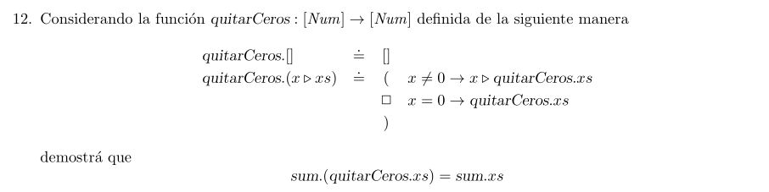
(3)
(4)
(5)

sum [] = 0 | (1)
sum (x:xs) = x + (sum xs) | (2)

Caso base:
sum (quitarCeros xs) = sum xs

sum (quitarCeros []) = sum []
={Por (3) y (1)}
sum [] = 0
={Por (1)}
0 = 0
={Reflexividad del = }
True
Caso inductivo:
Caso 1: x /= 0

sum (quitarCeros xs) = sum xs

sum (quitarCeros x:xs) = sum x:xs
={Por (4) y (2)}
sum (x: quitarCeros xs) = x + sum xs
={Por (2), x:=x; xs:= quitarCeros xs}
x + sum (quitarCeros xs) = x + sum xs
={Por HI}
x + sum xs = x + sum xs
={Reflexividad del =}
True

Caso 2: x == 0

sum (quitarCeros xs) = sum xs

sum (quitarCeros x:xs) = sum x:xs
={Por (5) y (2)}
sum (quitarCeros xs) = x + sum xs
={Por HI y x == 0}
sum xs = 0 + sum xs
={Aritmética}
sum xs = sum xs
={Reflexividad del =}
True

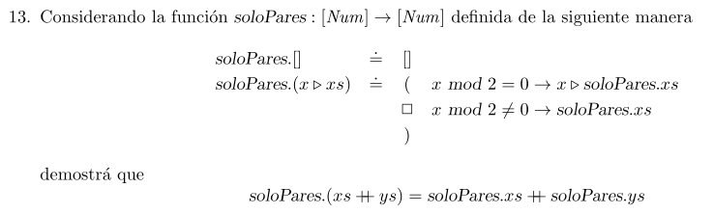
(1)
(2)
(3)
[] ++ ys = ys (4)
(x:xs) ++ ys = x : (xs ++ ys) (5)

Caso base:
soloPares (xs ++ ys) = soloPares xs ++ soloPares ys

soloPares ([] ++ []) = soloPares [] ++ soloPares []
={Por (4), ys:=[]}
soloPares [] = soloPares [] ++ soloPares []
={Por (1)}
[] = [] ++ []
={Por (4), ys:=[]}
[] = []
={Reflexividad del = }
True

Caso inductivo:
Caso 1: x `mod` 2 == 0

soloPares (xs ++ ys) = soloPares xs ++ soloPares ys

soloPares (x:xs ++ ys) = soloPares x:xs ++ soloPares ys
={Por (5)}
soloPares (x: (xs ++ ys)) = soloPares x:xs ++ soloPares ys
={Por (2)}
x: (soloPares (xs ++ ys)) = x: (soloPares xs) ++ soloPares ys
={Por (5)}
x: (soloPares (xs ++ ys)) = x: ((soloPares xs) ++ soloPares ys)
={Por HI}
x:(soloPares xs ++ soloPares ys) = x:((soloPares xs) ++ soloPares ys)
={Reflexividad del =}
True

Caso 2: x `mod` 2 /= 0

soloPares (xs ++ ys) = soloPares xs ++ soloPares ys

soloPares (x:(xs ++ ys)) = soloPares x:xs ++ soloPares ys
={Por (5)}
soloPares (x: (xs ++ ys)) = soloPares x:xs ++ soloPares ys
={Por (3), x:=x, xs:= (xs ++ ys)}
soloPares (xs ++ ys) = soloPares x:xs ++ soloPares ys
={Por (3)}
soloPares (xs ++ ys) = soloPares xs ++ soloPares ys
={Por HI}
soloPares xs ++ soloPares ys = soloPares xs ++ soloPares ys
={Reflexividad del =}
True

14. Considerando la función sum : [Num] → Num que toma una lista de números y devuelve la suma de ellos, definí sum y demostrá que:

sum(xs ++ ys) = sum xs + sum ys

sum [] = 0 | (1) | [] ++ ys = ys | (3)
sum (x:xs) = x + (sum xs) | (2) | (x:xs) ++ ys = x : (xs ++ ys) | (4)

Caso base:
sum(xs ++ ys) = sum xs + sum ys

sum([] ++ ys) = sum [] + sum ys
={Por (1) y (3)}
sum ys = 0 + sum ys
={Aritmética}
sum ys = sum ys
={Reflexividad del =}
True

Caso inductivo:
sum(xs ++ ys) = sum xs + sum ys

sum(x:xs ++ ys) = sum x:xs + sum ys
={Por (4) y (2)}
sum(x: (xs ++ ys)) = x + sum xs + sum ys
={Por (2), x:=x, xs:=(xs ++ ys)}
x + sum (xs ++ ys) = x + sum xs + sum ys
={Por HI}
x + sum xs + sum ys = x + sum xs + sum ys
={Reflexividad del =}
True

15. Considerando la función repetir : Nat → Num → [Num], que construye una lista de un mismo número repetido cierta cantidad de veces, definida recursivamente como:

repetir 0 x = [] | (1)
repetir n x = x : repetir (n-1) x | (2)

Demostrá que
#(repetir n x) = n

#[] = 0 | (3)
#(x:xs) = 1 + # xs | (4)

Caso base:
#(repetir n x) = n

#(repetir 0 x) = 0
={Por (1)}
#[] = 0
={Por (3)}
0 = 0

Caso inductivo:
#(repetir n x) = n

#(repetir (n+1) x) = n+1
={Por (2)}
#(x:(repetir (n+1)-1 x)) = n+1
={Aritmética}
#(x:(repetir n x)) = n+1
={Por (4), x:=x; xs:=(repetir n x)}
1 + (repetir n x) = n+1
={Por HI}
1 + n = n+1
={Aritmética}
n+1 = n+1
={Reflexividad del =}
True
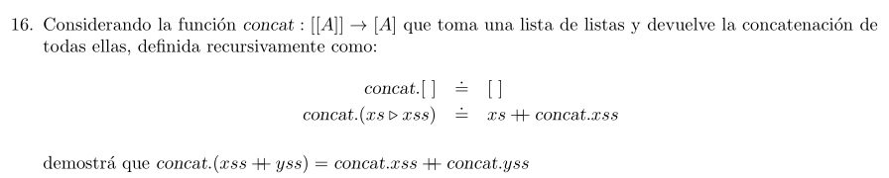
(1)
(2)
concat (xss ++ yss) = concat xss ++ concat yss

[] ++ ys = ys | (3)
(x:xs) ++ ys = x : (xs ++ ys) | (4)

Caso base:
concat (xss ++ yss) = concat xss ++ concat yss

concat ([] ++ yss) = concat [] ++ concat yss
={Por (3)}
concat yss = concat [] ++ concat yss
={Por (1)}
concat yss = [] ++ concat yss
={Por (3), ys:= (concat yss)}
concat yss = concat yss
={Reflexividad del =}
True

Caso inductivo:

concat (xss ++ yss) = concat xss ++ concat yss

concat (xs:xss ++ yss) = concat xs:xss ++ concat yss
={Por (3)}
concat (xs: (xss ++ yss)) = concat xs:xss ++ concat yss
={Por (2), xs:=xs; xss:=(xss ++ yss)}
xs ++ concat (xss ++ yss) = concat xs:xss ++ concat yss
={Por (2)}
xs ++ concat (xss ++ yss) = xs ++ concat xss ++ concat yss
={Por HI}
xs ++ concat xss ++ concat yss = xs ++ concat xss ++ concat yss
={Por reflexividad del =}
True

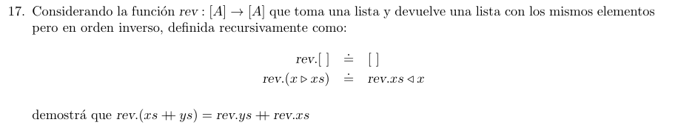
(1)
(2)
rev (xs ++ ys) = rev ys ++ rev xs

[] ++ ys = ys | (3)
(x:xs) ++ ys = x : (xs ++ ys) | (4)

Caso base:
rev (xs ++ ys) = rev ys ++ rev xs

rev ([] ++ ys) = rev ys ++ rev []
={Por (3) y (1)}
rev ys = rev ys ++ []
={Por 11a, xs:=(rev ys)}
rev ys = rev ys
={Reflexivilidad del =}
True

Caso inductivo:
rev (xs ++ ys) = rev ys ++ rev xs

rev (x:xs ++ ys) = rev ys ++ rev x:xs
={Por (4)}
rev (x: (xs ++ ys)) = rev ys ++ rev x:xs
={Por (2), x:=x; xs:=(xs ++ ys)}
rev (xs ++ ys) ++ [x] = rev ys ++ rev x:xs
={Por (2)}
rev (xs ++ ys) ++ [x] = rev ys ++ rev xs ++ [x]
={Por HI}
rev ys ++ rev xs ++ [x] = rev ys ++ rev xs ++ [x]
={Reflexividad del =}
True

18. Demostrá por inducción las siguientes propiedades. Ayuda: Recordá la definición de cada uno de los operadores impliacados en cada operacion.

a) xs ++ (ys ++ zs) = (xs ++ ys) ++ zs

[] ++ ys = ys | (1)
(x:xs) ++ ys = x : (xs ++ ys) | (2)

Caso base:
xs ++ (ys ++ zs) = (xs ++ ys) ++ zs

[] ++ (ys ++ zs) = ([] ++ ys) ++ zs
={Por (1)}
ys ++ zs = ys ++ zs
={Reflexividad del =}
True
Caso inductivo:
xs ++ (ys ++ zs) = (xs ++ ys) ++ zs

x:xs ++ (ys ++ zs) = (x:xs ++ ys) ++ zs
={Por (2)}
x: (xs ++ (ys ++ zs)) = (x: (xs ++ ys)) ++ zs
={Por HI}
x: (xs ++ ys) ++ zs = x: (xs ++ ys) ++ zs
={Reflexividad del =}
True

b) (xs ++ ys) ↑ #xs = xs

[] ++ ys = ys | (1)
(x:xs) ++ ys = x : (xs ++ ys) | (2)
#[] = 0 | (3)
#(x:xs) = 1 + # xs | (4)
(x:xs) ↑ 0 = [] | (5)
[] ↑ n = [] | (6)
(x:xs) ↑ n = x: xs ↑ (n-1) | (7)

Caso base:
(xs ++ ys) ↑ #xs = xs

([] ++ ys) ↑ #[] = []
={Por (1) y (3)}
ys ↑ 0 = []
={Por (5)}
[] = []
={Reflexividad del =}
True

Caso inductivo:
(xs ++ ys) ↑ #xs = xs

(x:xs ++ ys) ↑ #(x:xs) = x:xs
={Por (2) y (4)}
(x: xs ++ ys) ↑ 1 + #xs = x:xs
={Por (7), x:=x, xs:=(xs++ys), n:=(1+#xs)}
x: (xs++ys) ↑ (1+#xs)-1 = x:xs
={Aritmética}
x: (xs ++ ys) ↑ #xs = x:xs
={Por HI}
x:xs = x:xs
={Reflexividad del =}
True

c) (xs ++ ys) ↓ #xs = ys

[] ++ ys = ys | (1)
(x:xs) ++ ys = x : (xs ++ ys) | (2)
#[] = 0 | (3)
#(x:xs) = 1 + # xs | (4)
xs ↓ 0 = xs | (5)
[] ↓ n = [] | (6)
(x:xs)↓ n = xs ↓ (n-1) | (7)
Caso base:
(xs ++ ys) ↓ #xs = ys

([] ++ ys) ↓ #[] = ys
={Por (1) y (3)}
ys ↓ 0 = ys
={Por (5)}
ys = ys
={Reflexividad del =}
True
Caso inductivo:
(xs ++ ys) ↓ #xs = ys

(x:xs ++ ys) ↓ #(x:xs) = ys
={Por (2) y (4)}
(x: xs ++ ys) ↓ 1 + #xs = ys
={Por (7), x:=x; xs:=xs++ys; n:=1+#xs}
xs++ys ↓ (1+#xs)-1 = ys
={Aritmética}
xs++ys ↓ #xs = ys
={Por HI}
ys = ys
={Reflexividad del =}
True

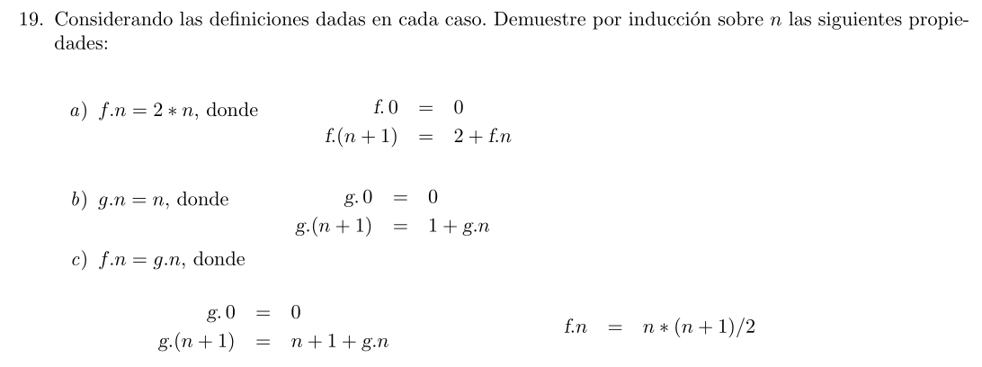

a) f n = 2 * n

f 0 = 0 | (1)
f n = 2 + f (n-1) | (2)

Caso base:
f n = 2 * n

f 0 = 2 * 0
={Por (1) y aritmética}
0 = 0
={Reflexividad del =}
True

Caso inductivo:
f n = 2 * n

f n+1 = 2 * (n+1)
={Por (2)}
2 + f n+1-1 = 2* (n+1)
={Aritmética}
2 + f n = 2 * (n+1)
={Por HI y Aritmética}
2 + 2 * n = 2*n + 2*1
={Aritmética}
2 + 2 * n = 2 + 2 * n
={Reflexividad del =}
True
b) g n = n

g 0 = 0 | (1)
g n = 1 + g (n-1) | (2)

Caso base:
g n = n

g 0 = 0
={Por (1)}
0 = 0
={Reflexividad del =}
True
Caso inductivo:
g n = n

g n+1 = n+1
={Por (2)}
1 + g (n+1-1) = n+1
={Aritmética}
1 + g n = n + 1
={Por HI}
1 + n = n + 1
={Aritmética}
n + 1 = n + 1
={Reflexividad del =}
True
c) f n = g n

g 0 = 0 | (1)
g = (n-1) + 1 + g (n-1) | (2)
f n = n * (n + 1)/2 | (3)

Caso base:
f n = g n

f 0 = g 0
={Por (1) y (3)}
0 * (0+1)/2 = 0
={Aritmética}
0 = 0
={Reflexividad del =}
True
Caso inductivo:
f n = g n

f n+1 = g n+1
(n+1)*(n+1+1)/2 = (n+1-1) + 1 + g (n+1-1)
={Aritmética}
(n+1)*(n+2)/2 = n + 1 + g n
={Aritmética y HI}
(n*n + 2*n + 1*n + 1*2)/2 = n + 1 + f n
={Aritmética y (3)}
(n*n + 3*n + 2)/2 = n + 1 + n*(n+1)/2
={Aritmética}
(n*n + 3*n + 2)/2 = n + 1 + (n*n + 1*n)/2
={Aritmética}
(n*n + 3*n + 2)/2 = ((n+1)*2 + n*n + n)/2
={Aritmética}
(n*n + 3*n + 2)/2 = (2*n + 2*1 + n*n + n)/2
={Aritmética}
(n*n + 3*n + 2)/2 = (n*n + 3*n + 2)/2
={Reflexividad del =}
True

