# Version #1:

## Q1 [Easy] - Find the right relationship

**Tags**: Relationship

#### A retailer can sell to multiple customers and customers can buy from multiple stores. So the relationship between the “Retailer” and the “Customers” table will be_________________

Answer: Many to Many

## Q2 [Medium] - Which JOIN is most suitable?

**Tags**: JOIN

For the tables visualized below, which kind of join will lead to the resultant table?

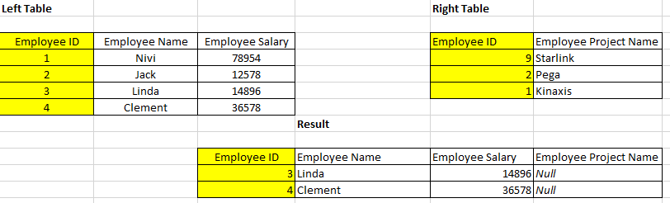

Answer: Left Join

## Q3 [Hard] - Based on Instruction #1 to #5

**Tags**: Data Transformation, Data Modeling, Slicer, Filter, Data Visualization, DAX

Refer to #Instruction Guide business case study to solve the rest of the questions.

Blu wants to analyze the transactions that have gross that are not negative. Further analysis is needed on a Deputy Manager level.

For a Deputy Managers named **Allan Guinot** and **Annelie Zubar,** what is the total sales in Millions?

Answer: Allan Guinot: 2.56M

Annelie Zubar: 2.42M

Total : 4.98M

## Q4 [Hard] - Based on Instruction #1 to #5

**Tags**: Data Transformation, Data Modeling, Slicer, Filter, Data Visualization, DAX

Blu management is interested to know the highest total sales contribution(in percentage) based on the top 5 territories made by DMs Allan Guinot and Annelie Zubar jointly. What is the right answer? _________

Answer: 1.84M(37.67)

## Q5 [Medium] - Based on Instruction #6 to #7

**Tags**: Data Visualization, DAX, Data Formatting

To analyze the effect of probable loss of gross margins due to un-optimized inventory levels, Blue wants to know if there’s an immense need to maintain higher levels of Inventory. Maintaining higher levels of inventory can pose a serious risk to business due to piling up of unused stocks.

In the process, Management wants to know that out of total gross margin availed, what percentage is due to the transactions that occurred due to Scenario 1(where when due to lesser inventory, all the ordered goods were not delivered to the customer)For which month and territory Gross Percentage is unexpectedly low?  
Answer: Month:February(2), Territory:GA,Gross Percentage:28.34

## Q6 [Easy] - After making the final dashboard

For the overall period during which stores have been opened, find out at which time (year, quarter, month) highest rent was generated and how much?

Answer: Year: 2013 , Month :January, Quarter: 1, Rent:711754

## Q7 [Easy] - After making the final dashboard

The global business head is always on the lookout to expand the business to various new industries in existing regions where penetration is low.

For territories WV, NC, OH and PA, what is the total number of units sold and out of it, much is the units sold for the Home category with gross margin > 10?

Answer: Units Sold: 320K

Units Sold for Home Category: 70K