Banker’s Algorithm: 2
Page Replacement Algorithm 4
Memory Allocation 9
• First Fit 9
• Best Fit 10
• Worst Fit 11
Disk Scheduling 12
• FCFS 12
• SCAN 13
• C-SCAN 14
• LOOK 15
• C-LOOK 16
• SSTF 17
Process Scheduling 18
• FCFS 18
• SJF 20
• HRRN 21
• SRTN 22
• RR 23

Banker’s Algorithm:

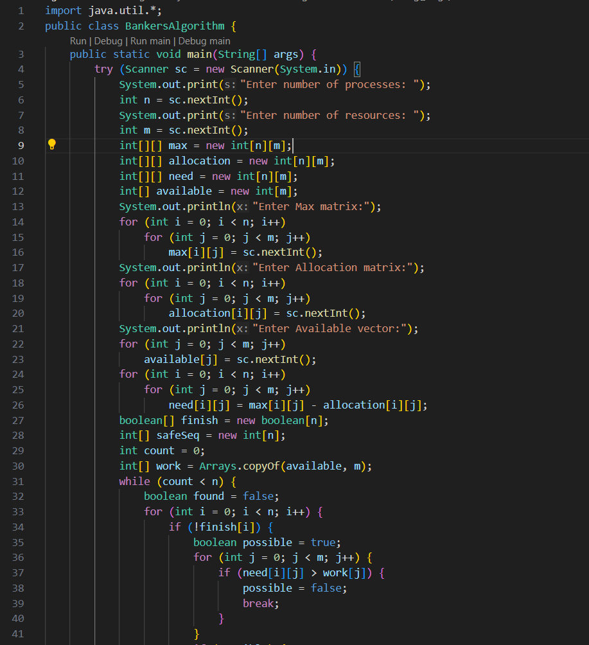
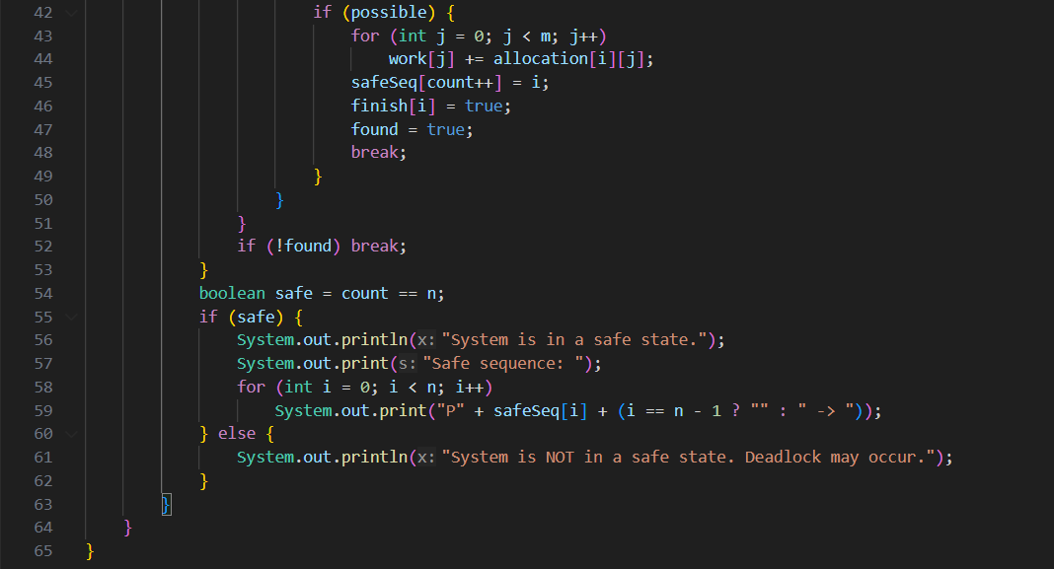
OUTPUT:
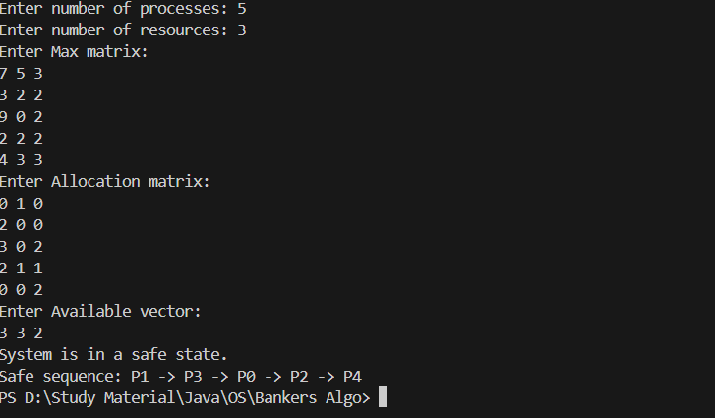

Page Replacement Algorithm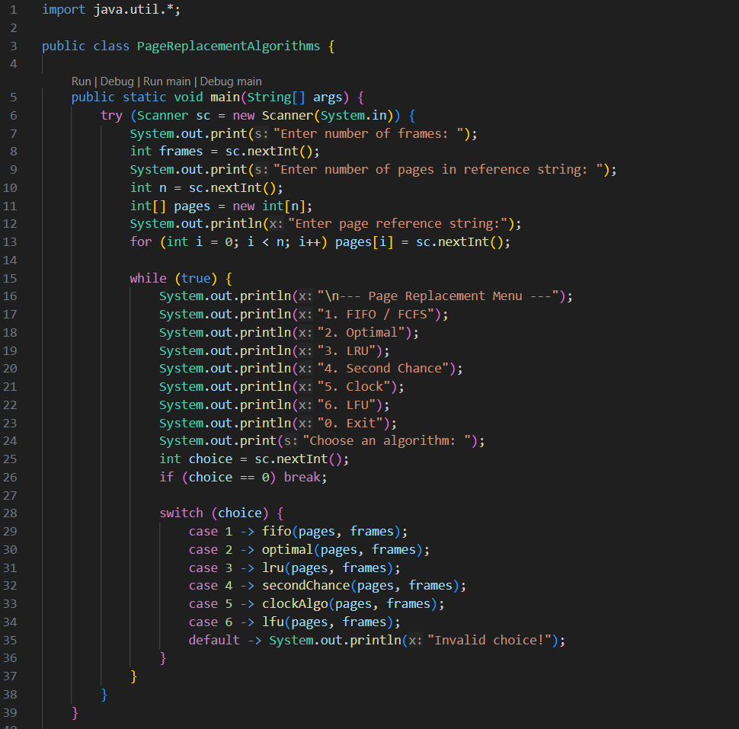
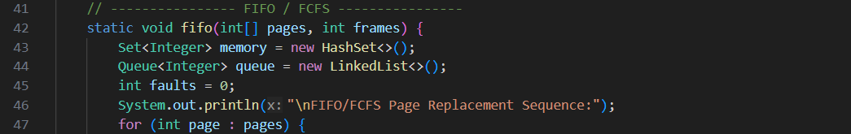

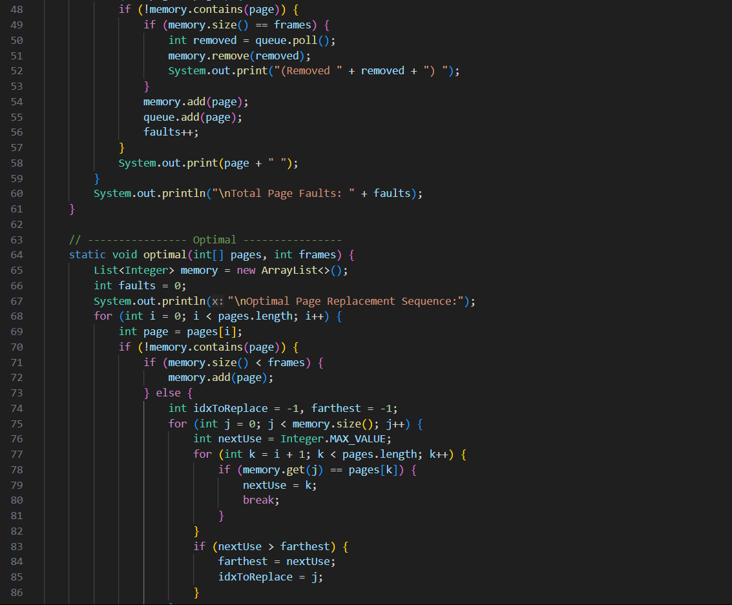
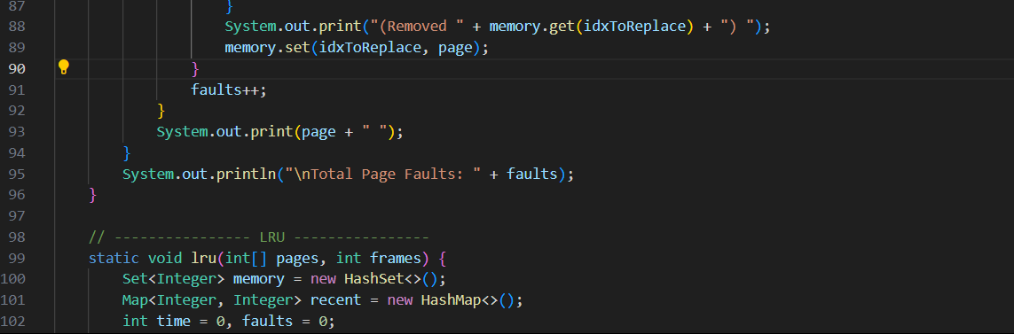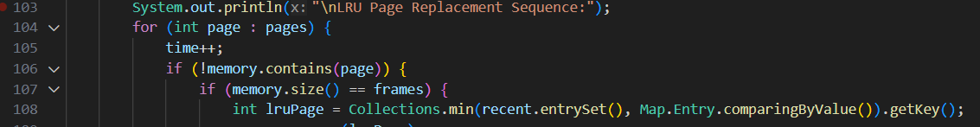
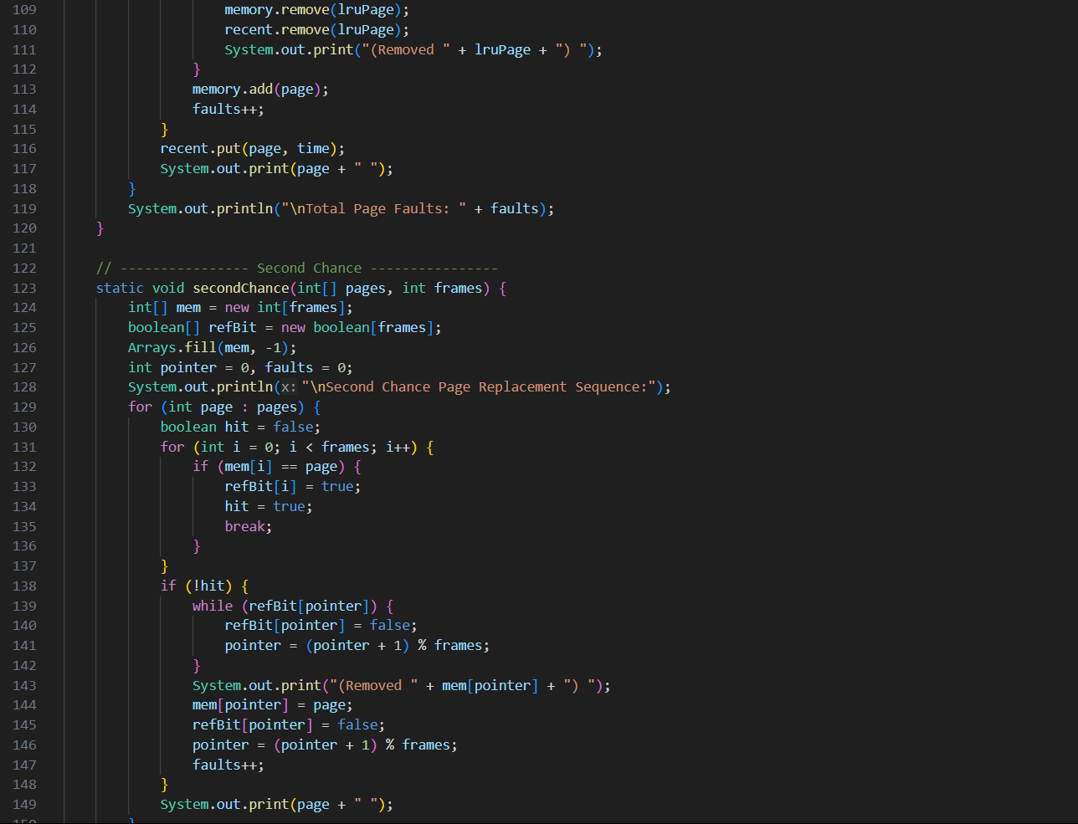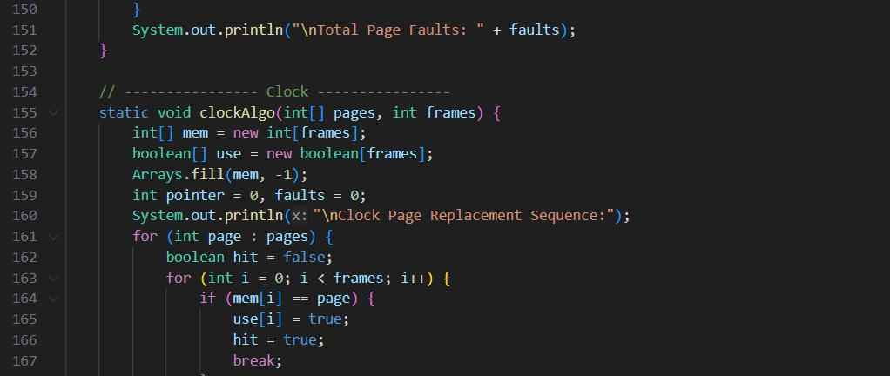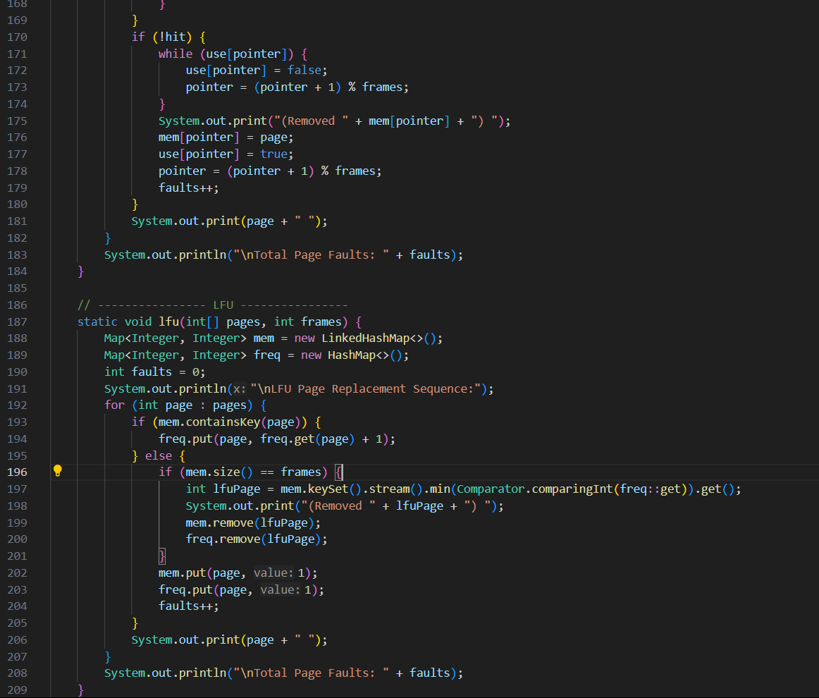

OUTPUT:
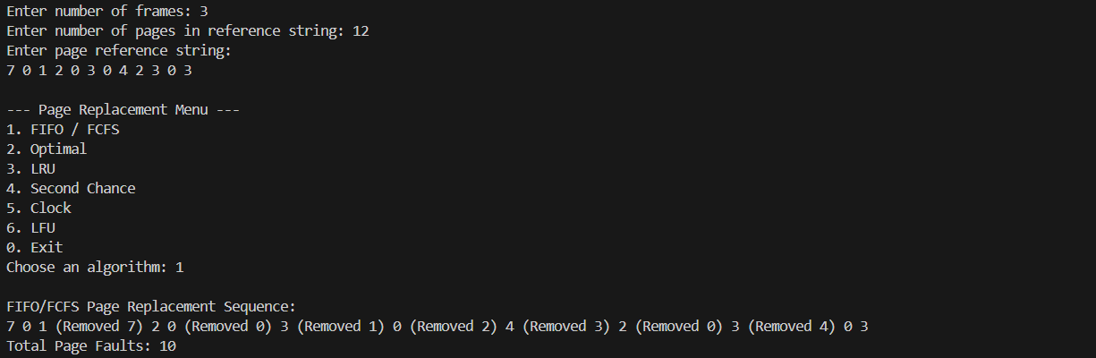

Memory Allocation

First Fit
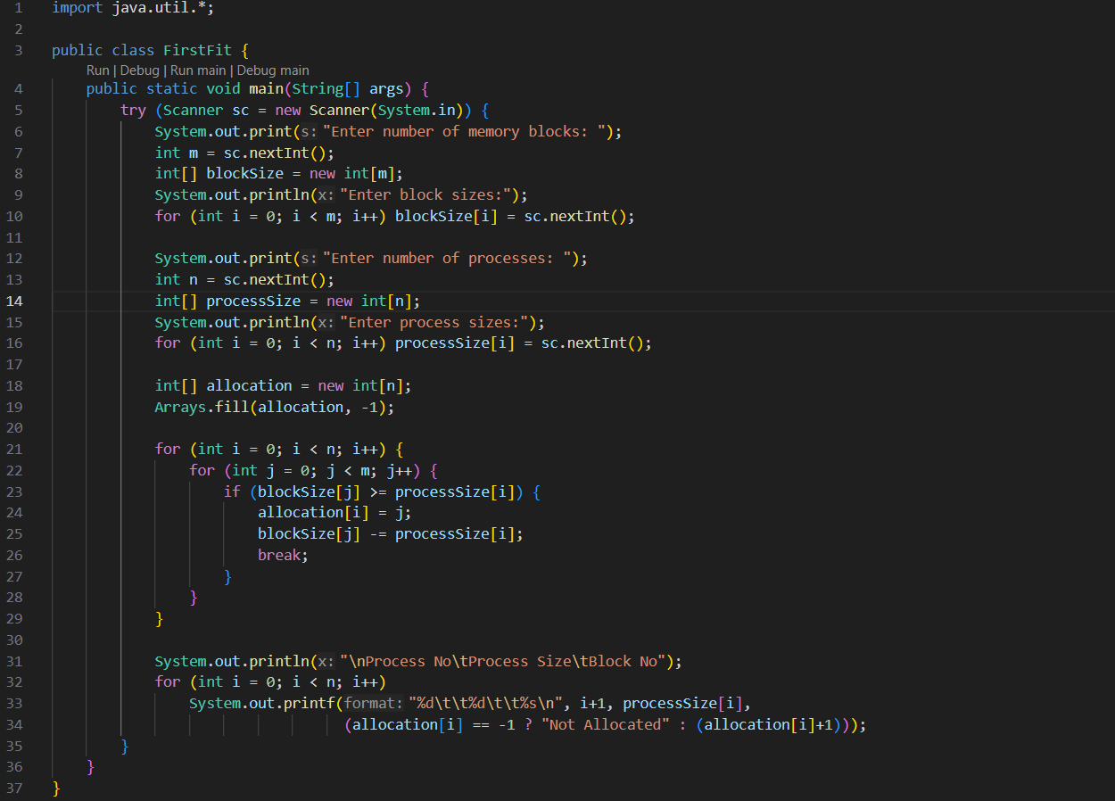
OUTPUT
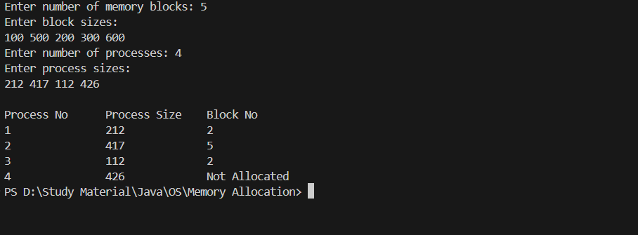

Best Fit
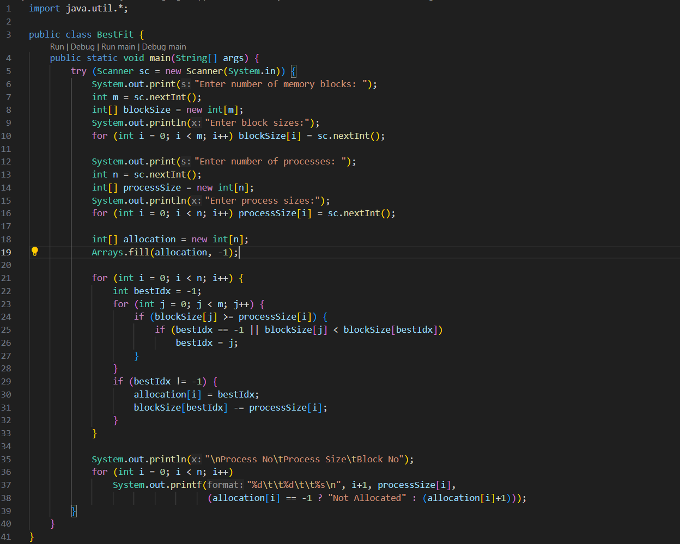
OUTPUT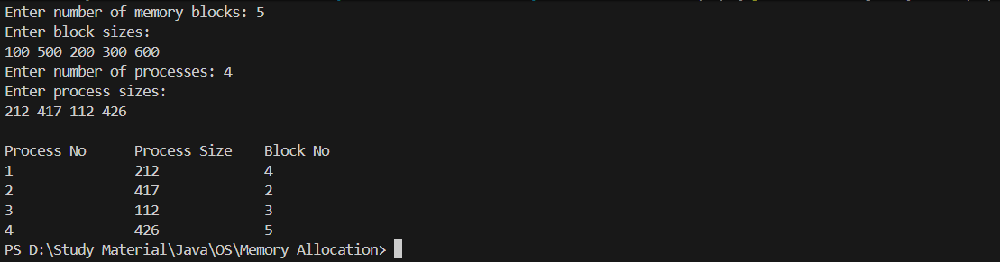

Worst Fit
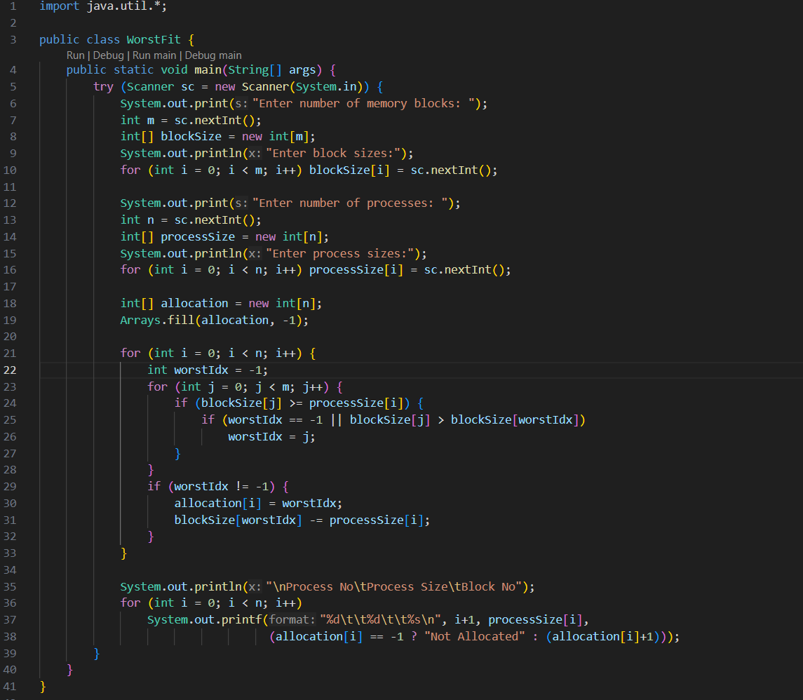
OUTPUT
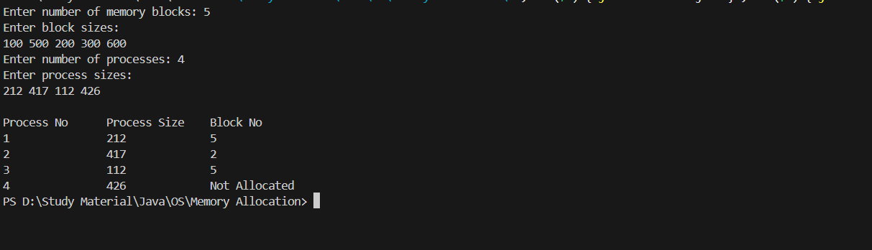
Disk Scheduling

FCFS
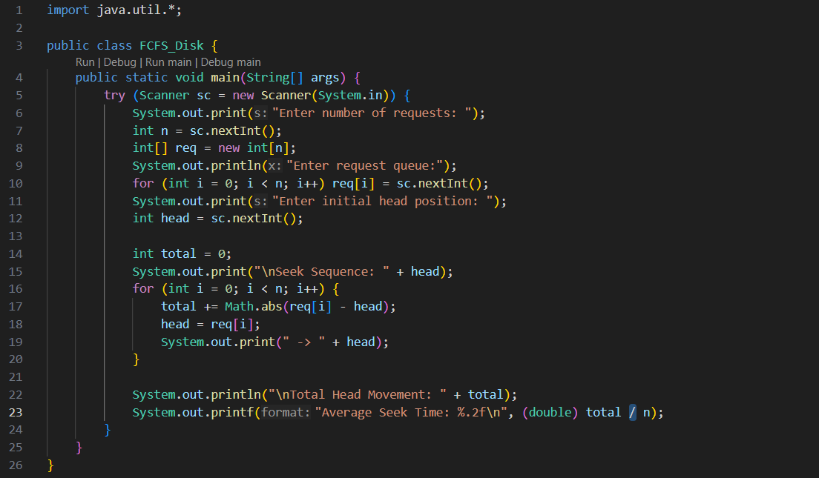
OUTPUT
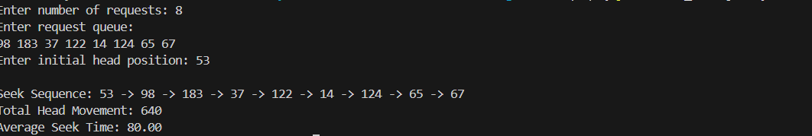

SCAN
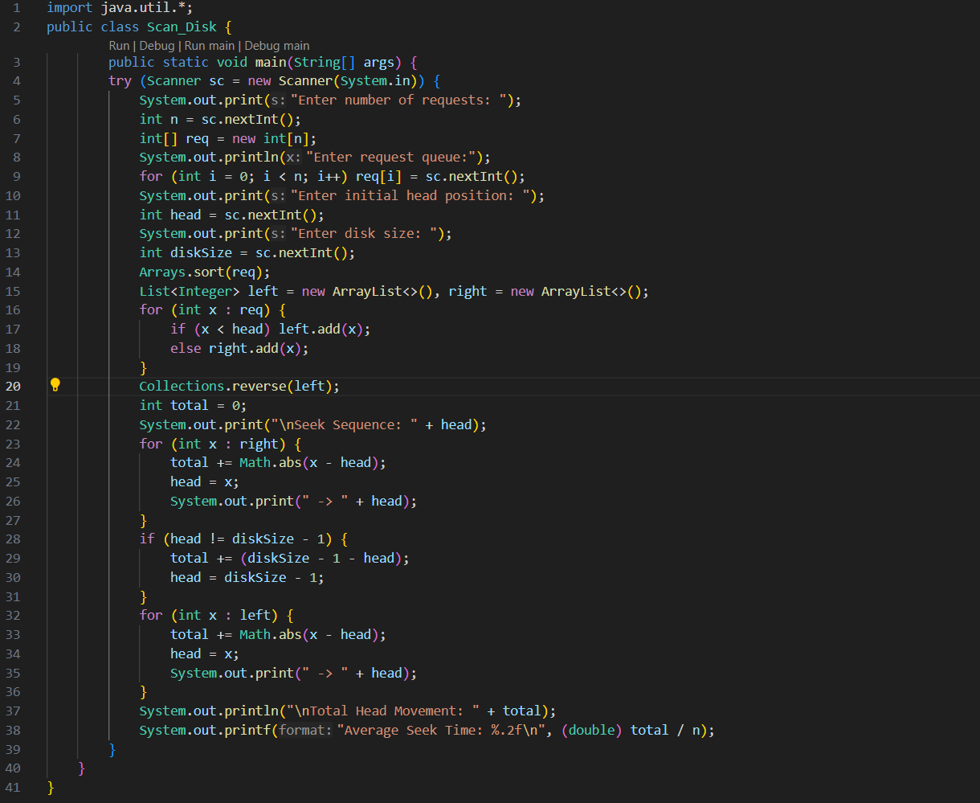
OUTPUT
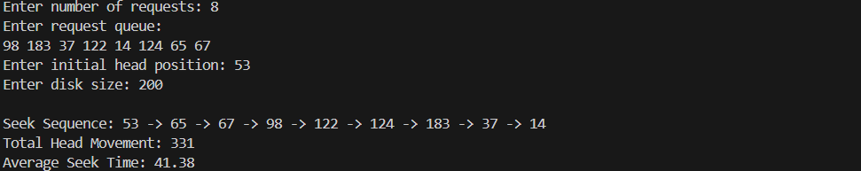

C-SCAN
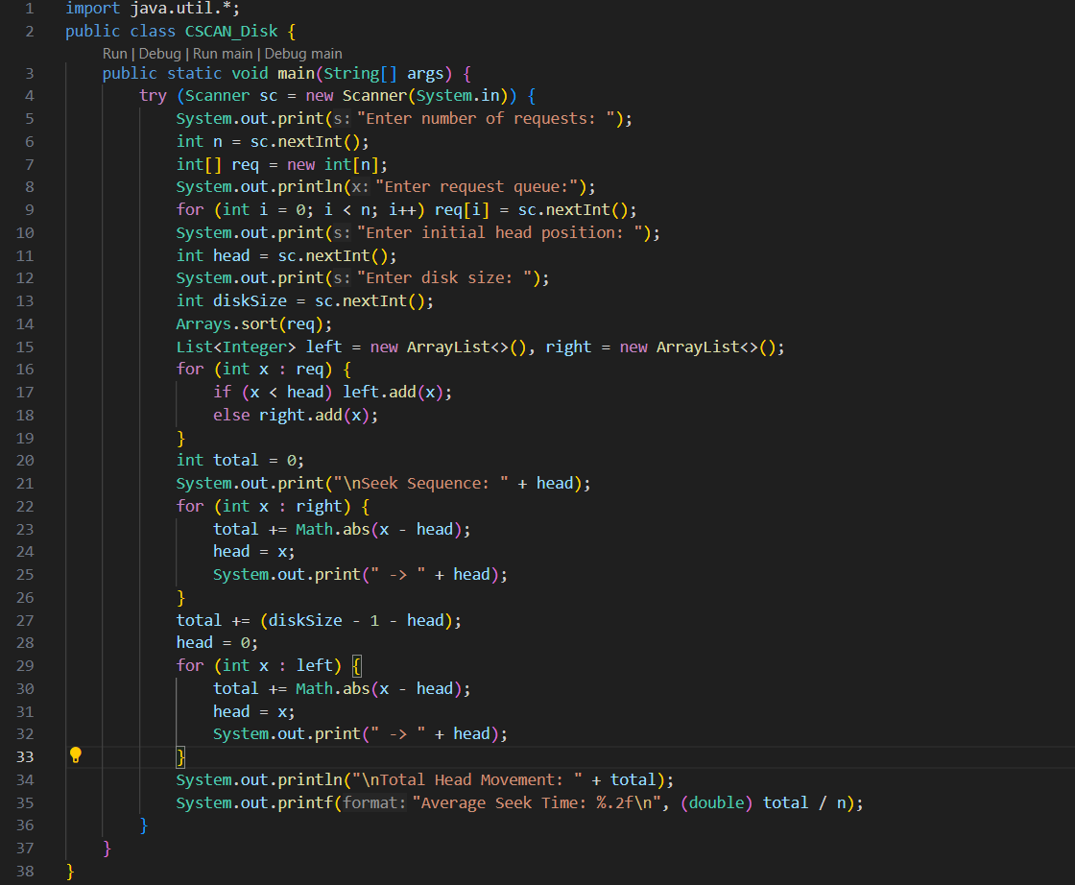
OUTPUT
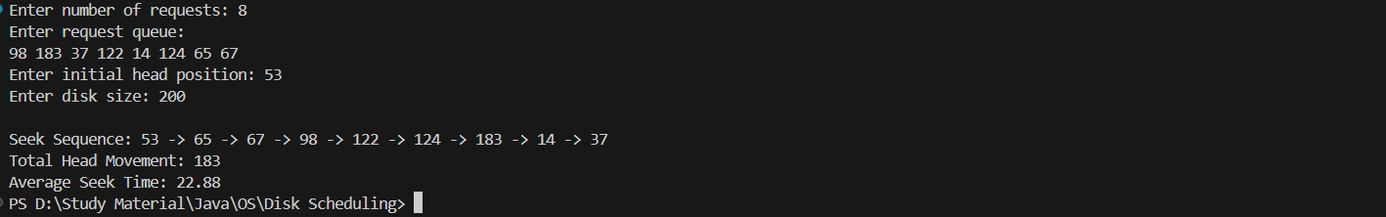

LOOK
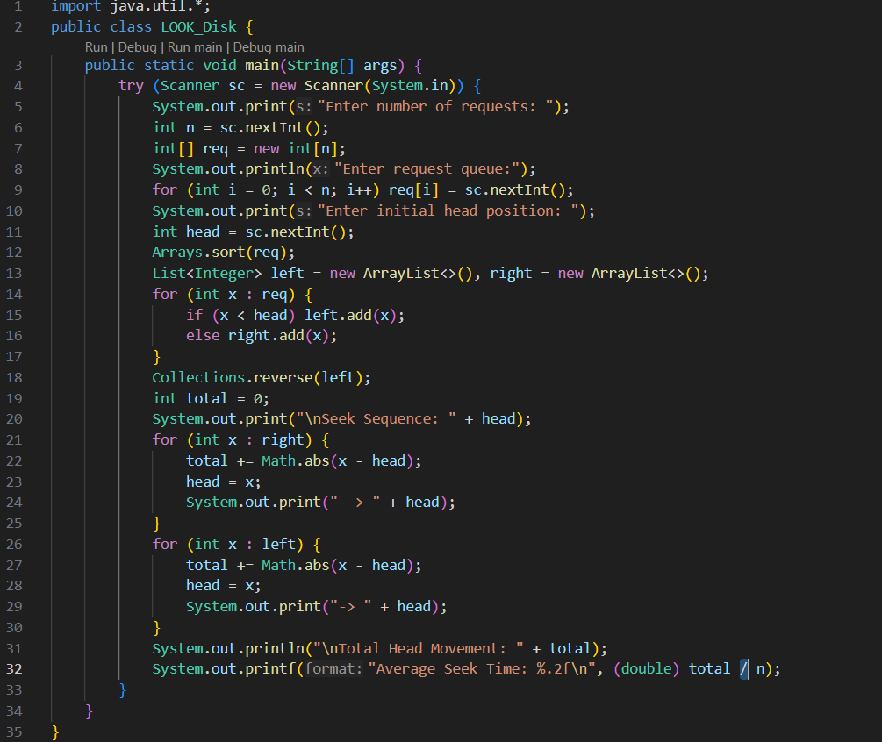
OUTPUT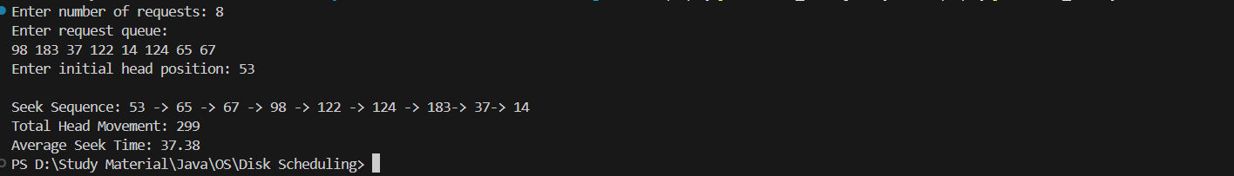

C-LOOK
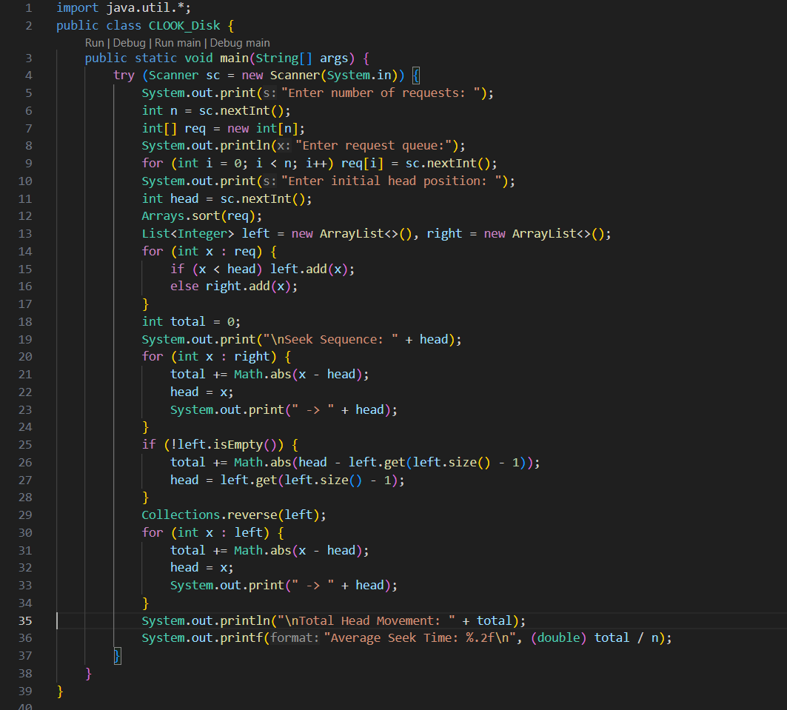
OUTPUT
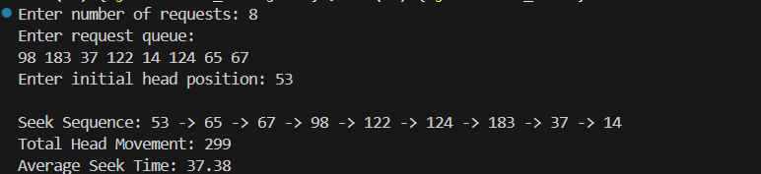

SSTF
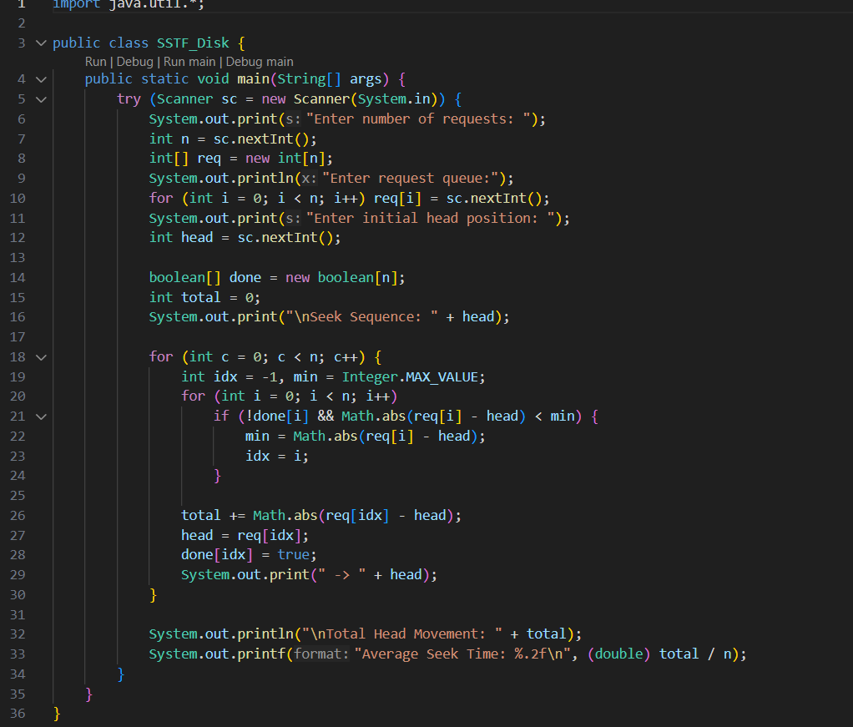
OUTPUT
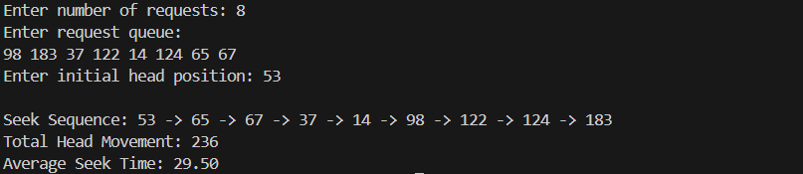

Process Scheduling

FCFS
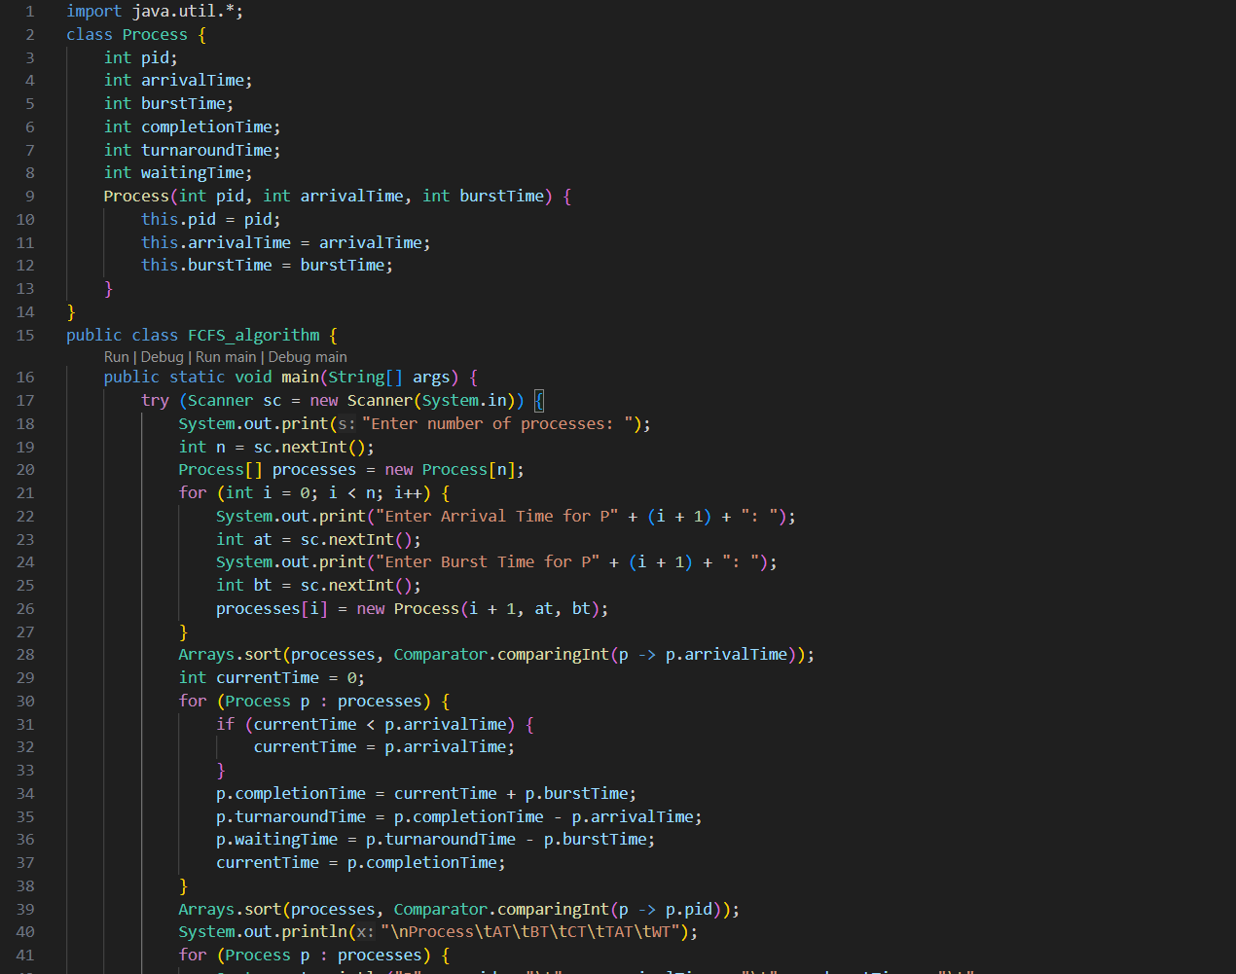
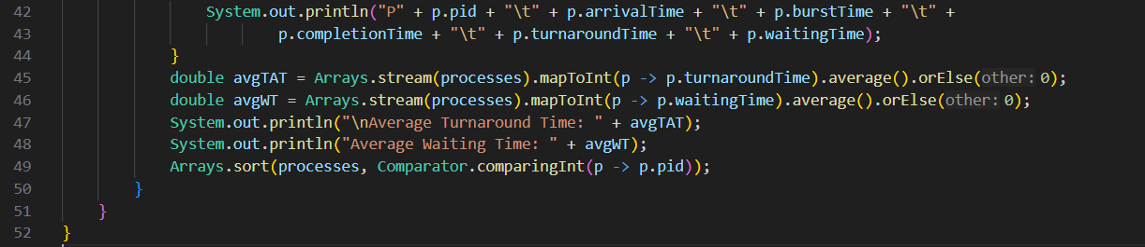

OUTPUT
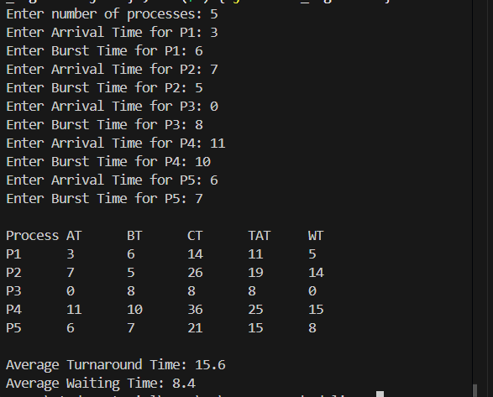

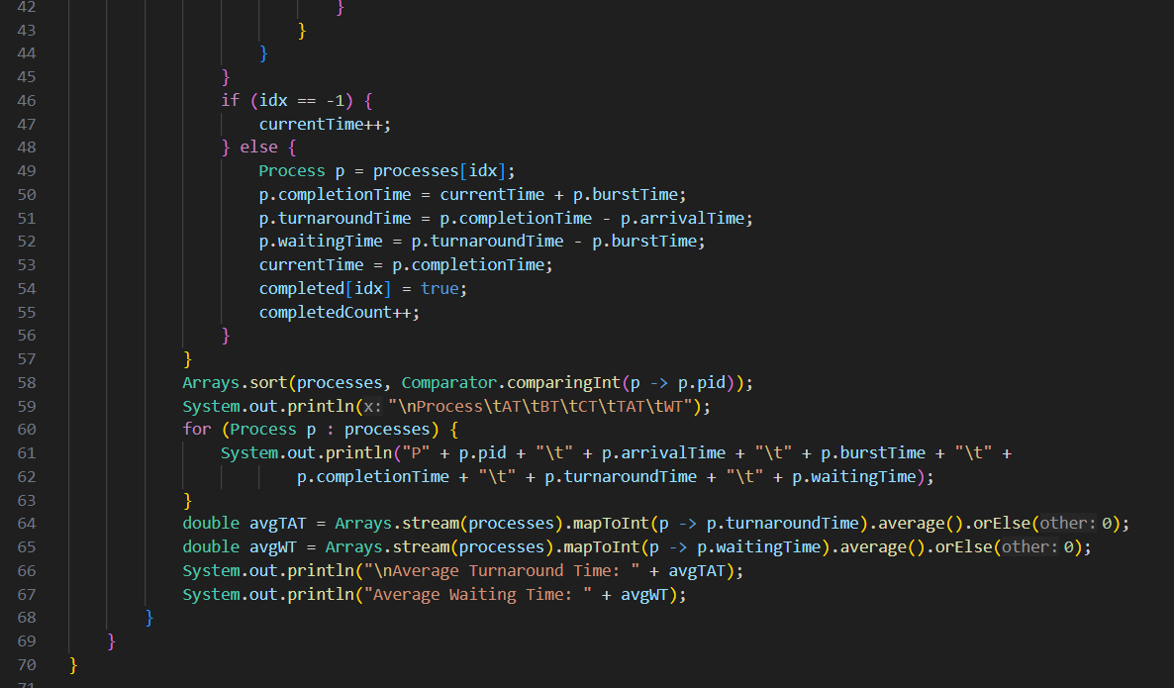
SJF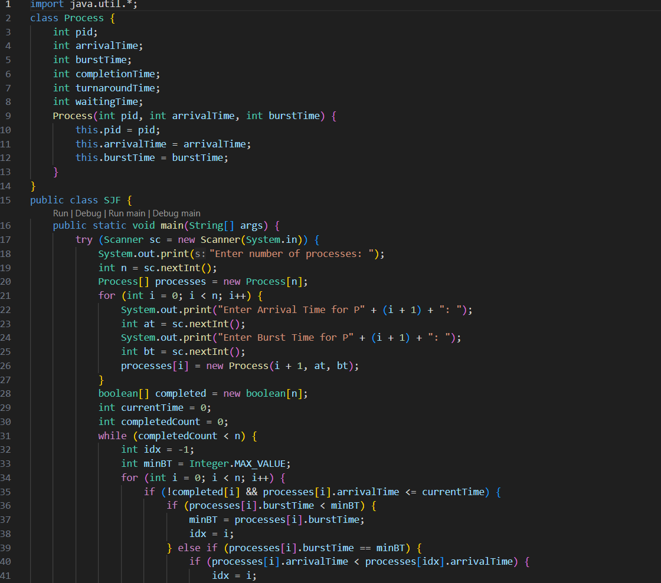

OUTPUT
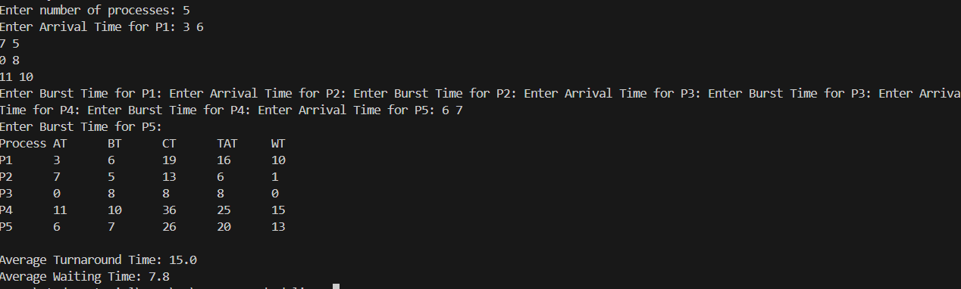

HRRN
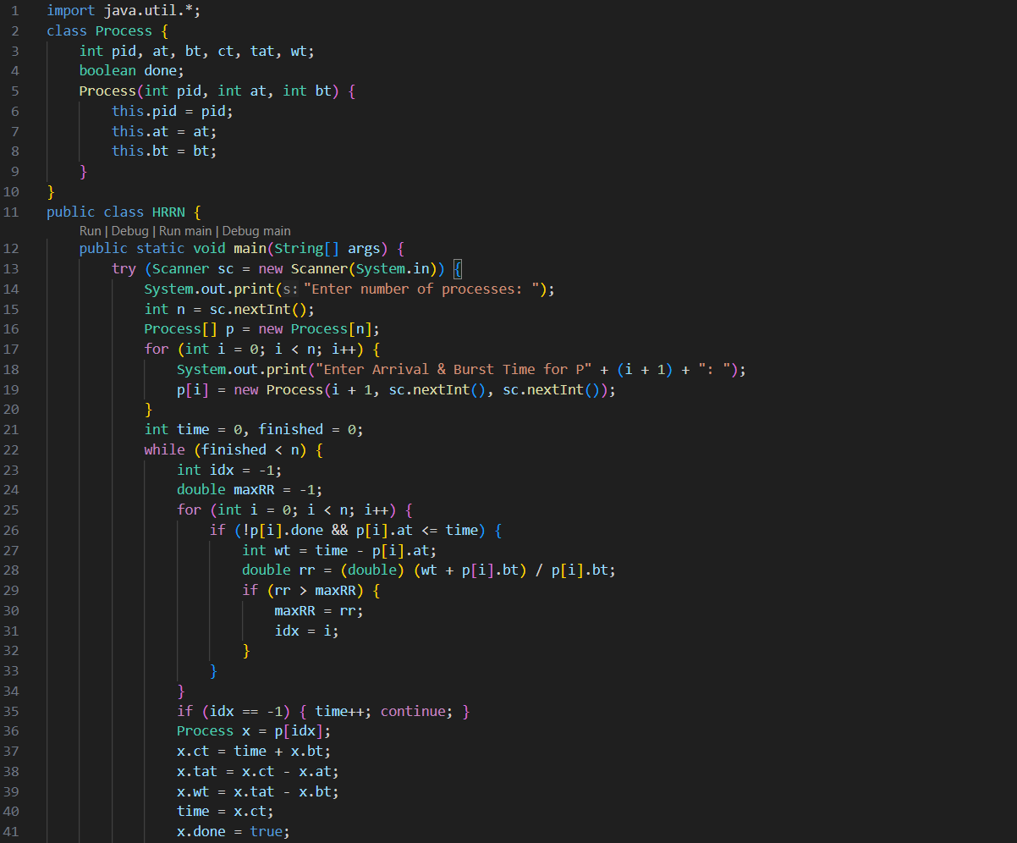
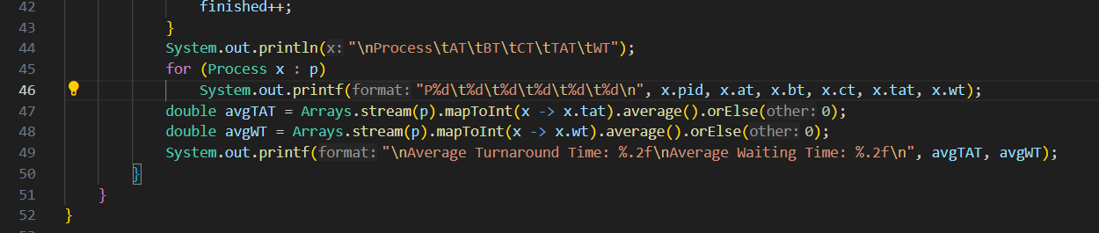
OUTPUT
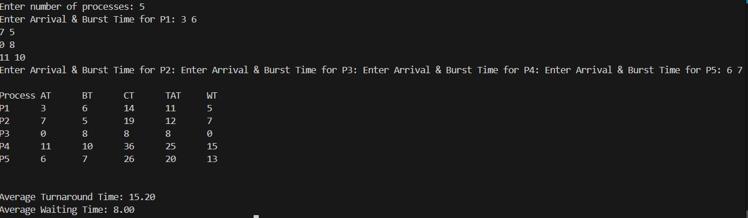

SRTN
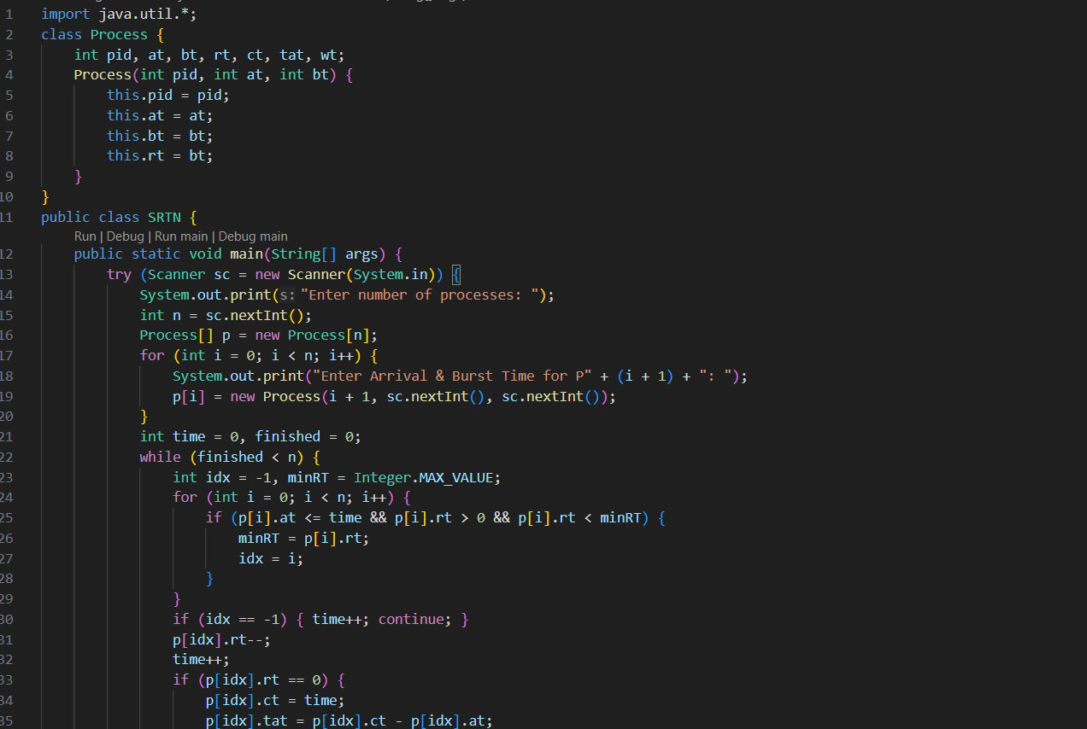
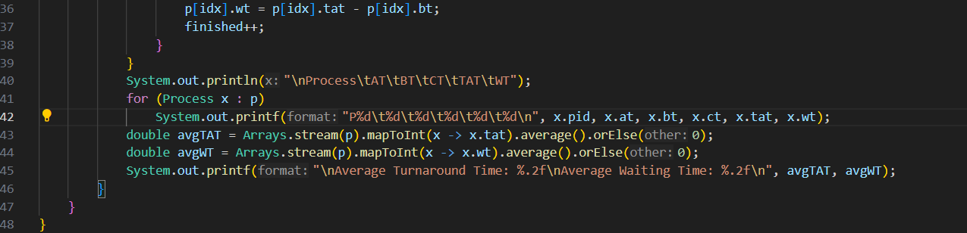
OUTPUT
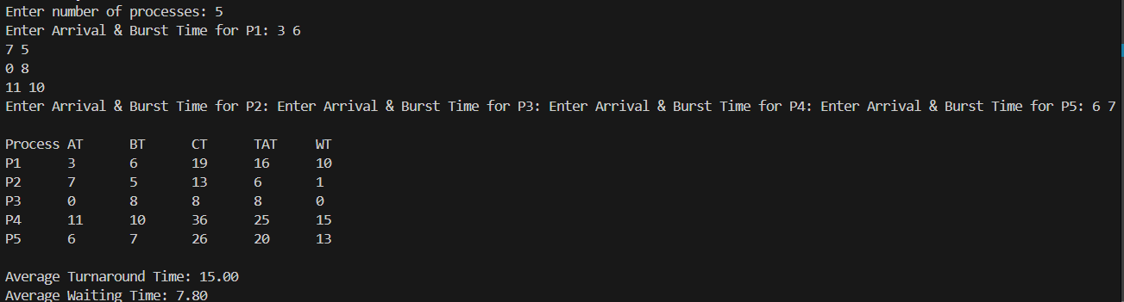

RR
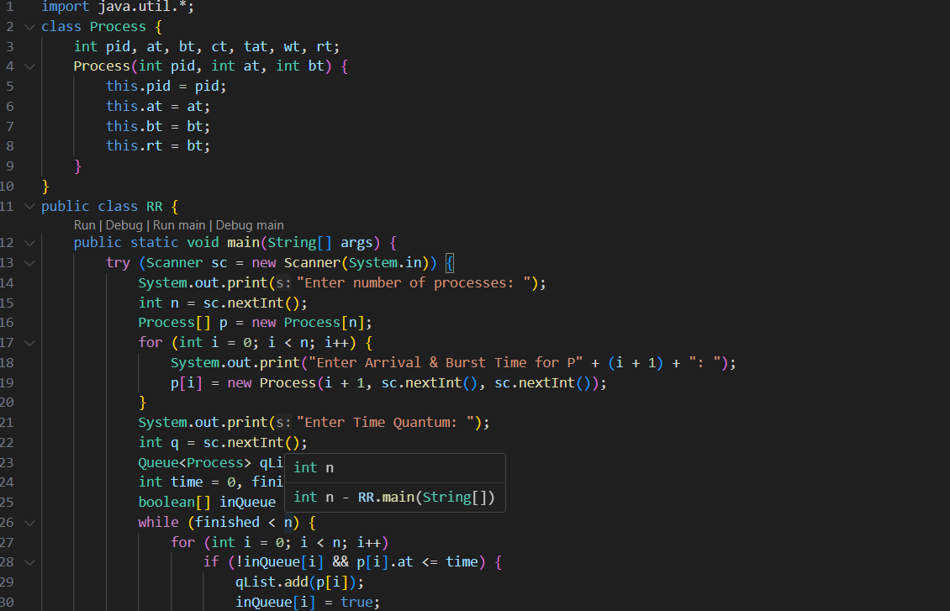
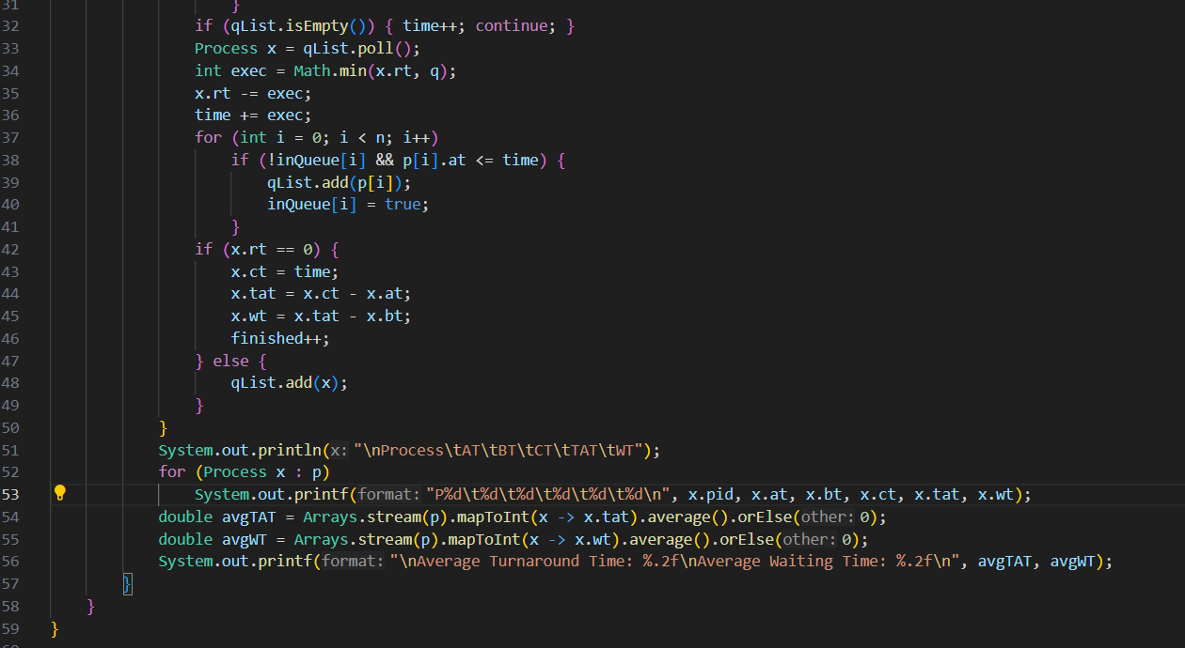
OUTPUT
