**Wiki page for Lab Asmt 1**

1. GitHub

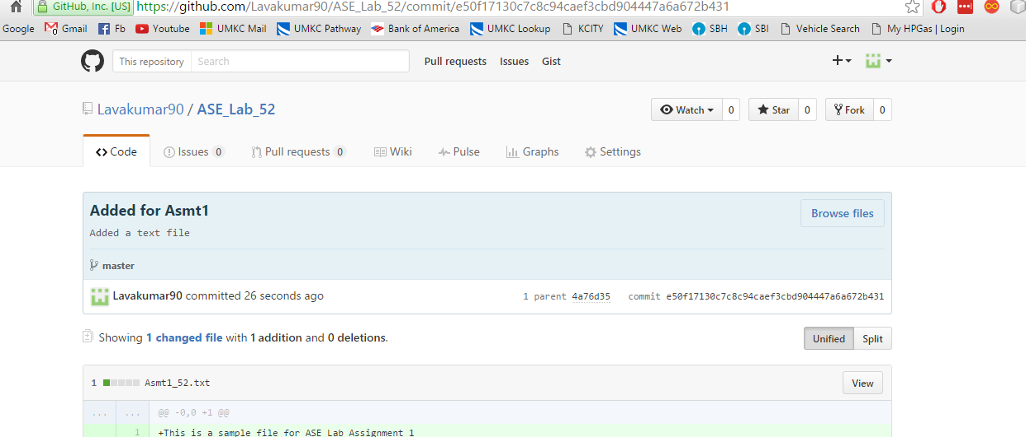

1. GenHub
   1. Iteration1 with 3 stories

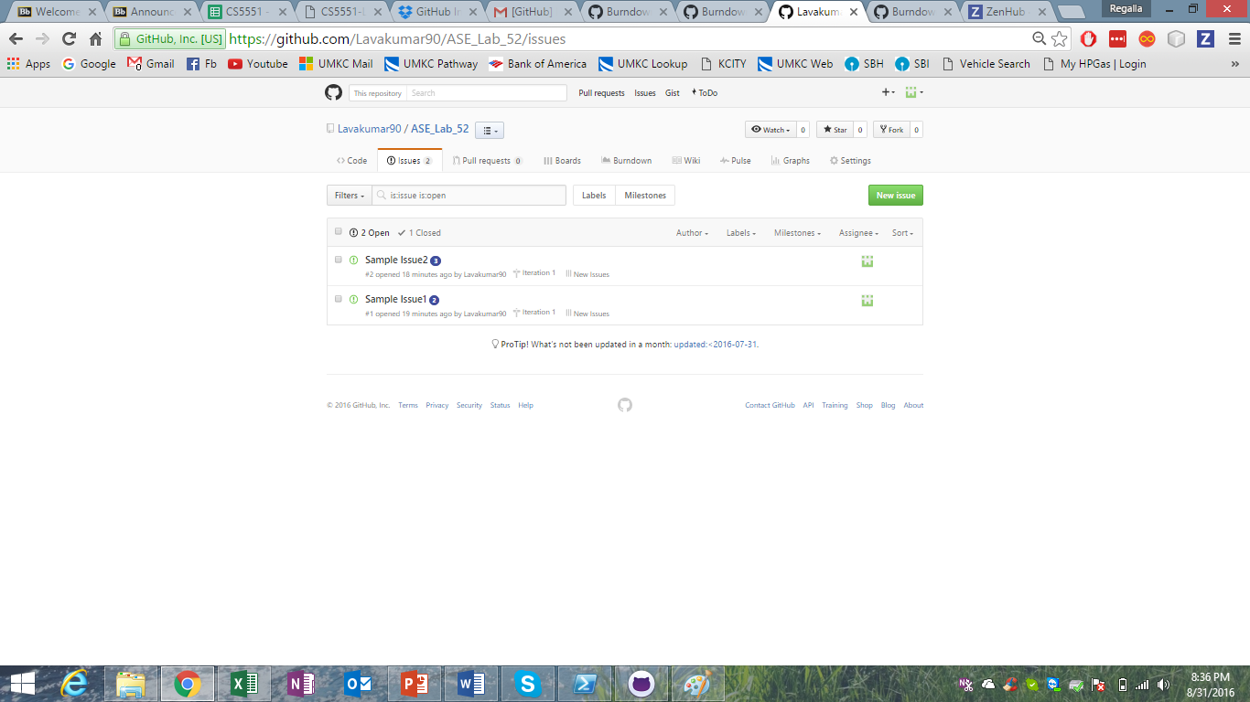

* 1. Burndown chart

