**CS5542 – Big Data Analytics and Apps**

**Lab 10 – Assignment Submission**

Name: Lava Kumar S

Class ID : 38

1. Write a TensorFlow program for the following Task.  
**a.** Retrain Inception Model final layer for Image Dataset that is not covered in class. Report accuracy etc.  
**b.** Visualizations (Tensor Board): training, loss, weights etc. and validation   
**c.** Report Confusion Matrix for training and validation/testing.In the Wiki Page, include a brief description of your dataset and your approach/results for this task.

**Data Set**  
Pictures of objects belonging to 101 categories. About 40 to 800 images per category. Most categories have about 50 images.   
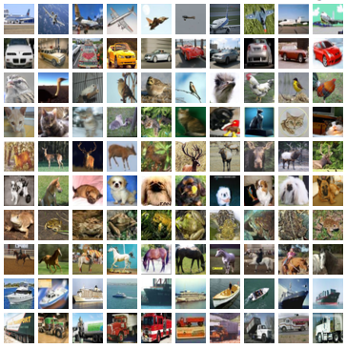

**Data Set Accuracy**  
We have taken 3 classes from caltech and we used those to retrain the inception model and the outputs are displayed below.  
  
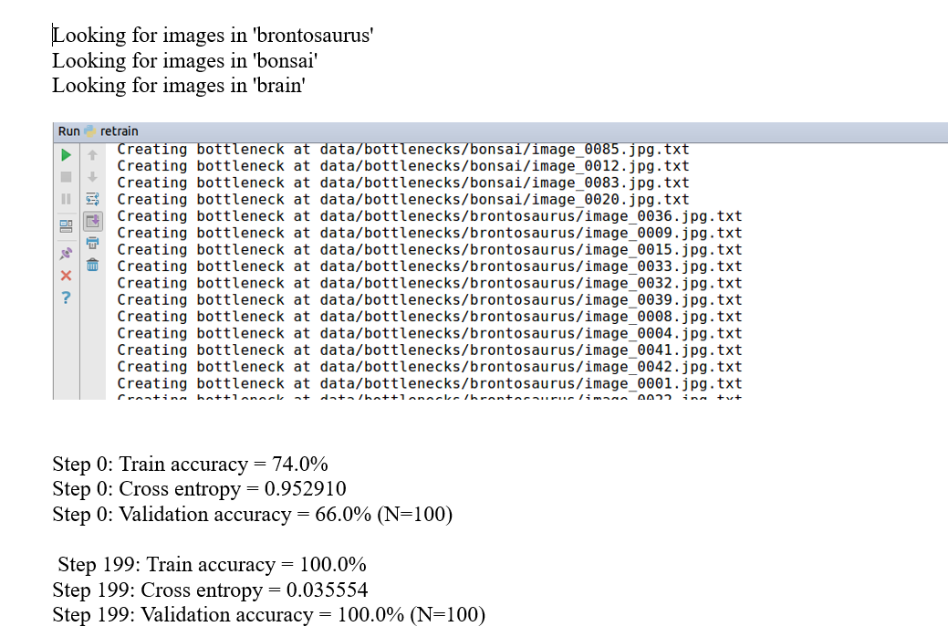

**Visualizations**  
  
All the visualizations for the the inception model are displayed below.

**Graph**  
  
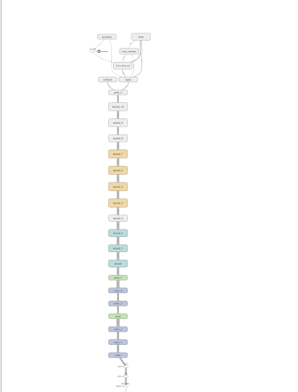

**Accuracy,Entropy & Activations**  
  
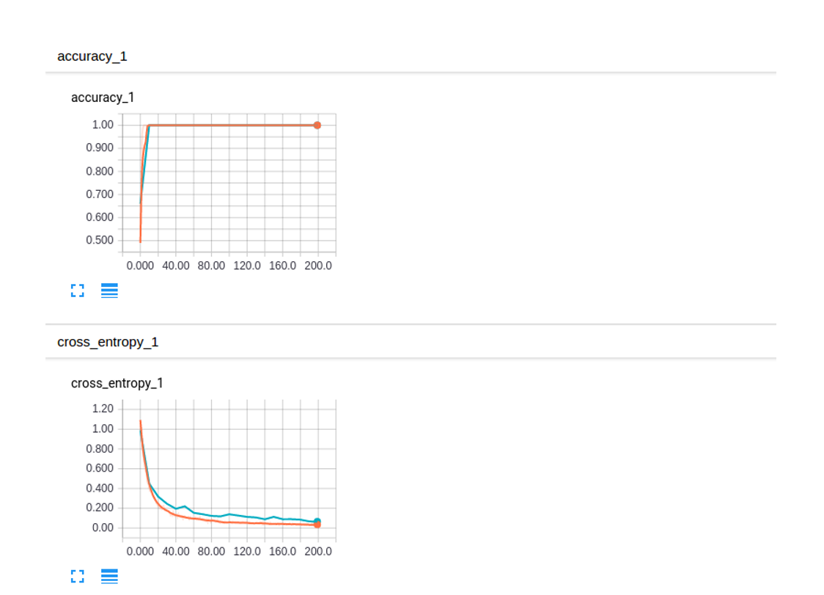  
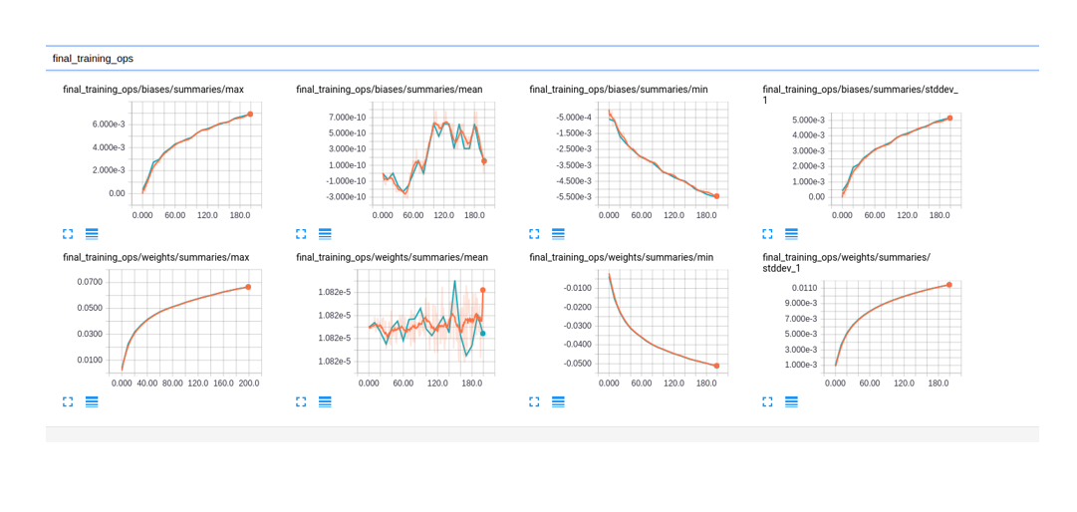  
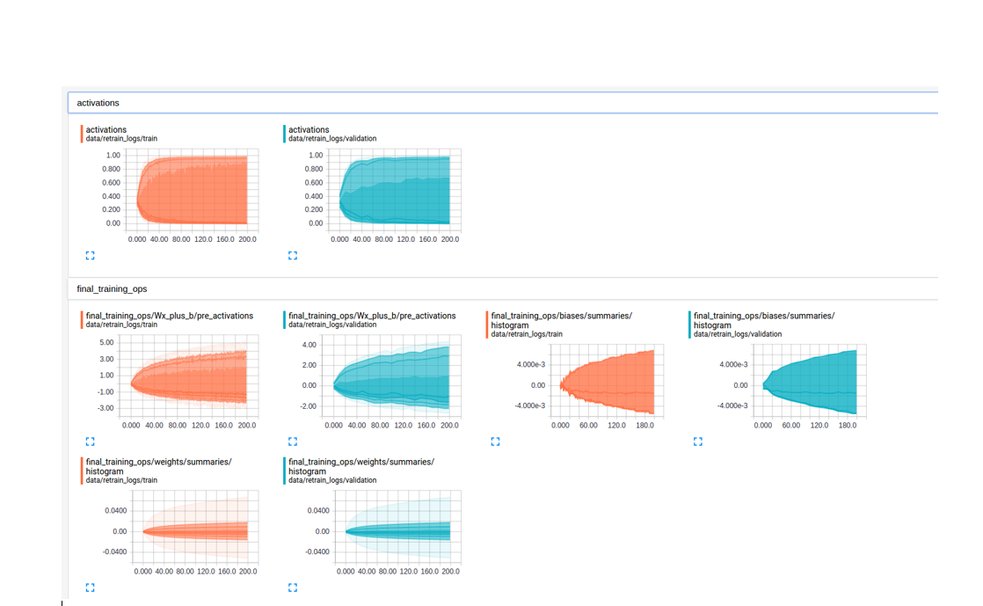  
  
**Task 2**  
Develop a Web-based Application for Visual Question Answering that is relevant to your own project including the following features.**a** Web application for Visual Question answering  
**b.**Connect the web application to TensorFlow AP.

**Web Page**  
  
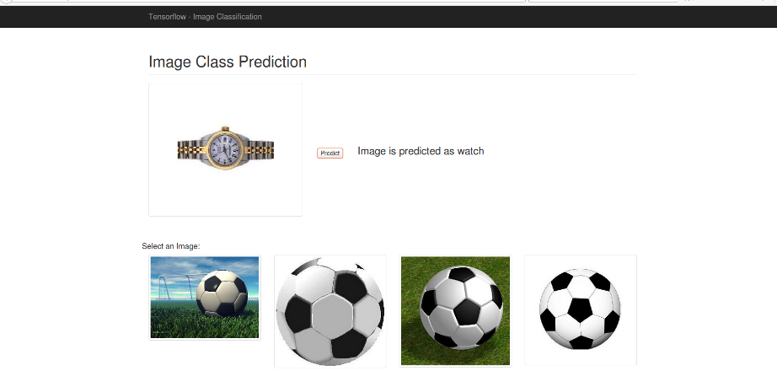  
  
**Prediction 1**  
  
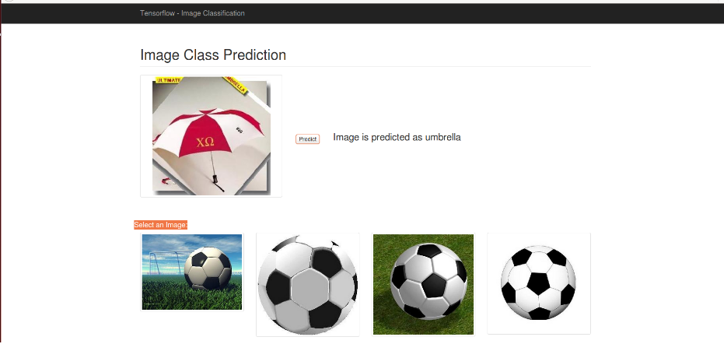  
  
**Prediction 2**

