**CS5542 – Big Data Analytics and Apps**

**Lab 6 – Assignment Submission**

Name: Lava Kumar S

Class ID : 38

**Task 1**  
Create your own dataset for Image Classification/Object Detection Problem. Handle fuzzy classification/object detection task using at least two classification algorithms (e.g., Decision Tree, Random Forest, Naïve Bayes). Report the accuracy and confusion matrix obtained.

**What s Fuzzy Logic?**

Fuzzy logic is a mathematical methodology (and a philosophical ideology) that is similar in construct to boolean algebra and similar in appearance to probability, but more general than both in fundamental ideas. This generality is the freedom for truth variables to hold any value between 0 and 1 (inclusive), and fuzzy logic proponents claim this generality allows greater flexibility, freedom, accuracy and compactness when representing real world situations. All the usual properties of boolean algebra can be extended to fuzzy logic, and probability's degree of belief in a boolean variable becomes a fuzzy variable's degree of truth.

Fuzzy logic has had a great deal of success where it has been applied in the real world, and is often touted as a means of making machines smarter. However, for the most part, fuzzy logic has actually been used in control systems as a way of providing more human-like behaviour. For example, many household appliances (notably white goods such as washing machines and refrigerators) now contain fuzzy control systems that allow the machine to adjust to the specific circumstances currently presented to it, with some even learning patterns of usage. While this does improve the machines and their behaviour, it isn't really an advance in the areas of general intelligence on arbitrary domains and machine learning. Only (relatively) recently is the area of fuzzy machine learning being developed, with the most popular approach being fuzzy neural networks (often abbreviated to simply neuro-fuzzy) to allow machine intelligences to learn from arbitrary empirical data and experiences.

**Data Set From Video**

A dataset with three images is taken from the given video nd the features are extracted from it.The below screenshot shows the dataset images.The images that are selected from the images are taken he features are extracted from it  
  
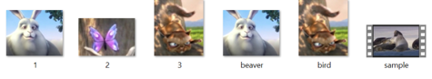

**Object Feature Extraction**

The three images from the videos are sent to object feature detection from Openimaj and the features are detected from it.

**Openimaj**

OpenIMAJ is an award-winning set of libraries and tools for multimedia content analysis and content generation. OpenIMAJ is very broad and contains everything from state-of-the-art computer vision (e.g. SIFT descriptors, salient region detection, face detection, etc.) and advanced data clustering, through to software that performs analysis on the content, layout and structure of webpages.  
  
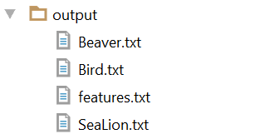

**Object Detection**

Next the video is taken as an input and the features from the video are checked with the features of the features extracted from the screenshots and the data are stored in the features text file.  
when the program is run the below screesnshot is shown.  
  
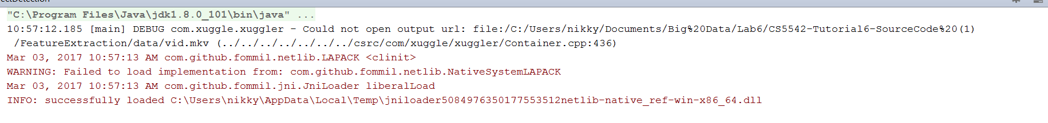  
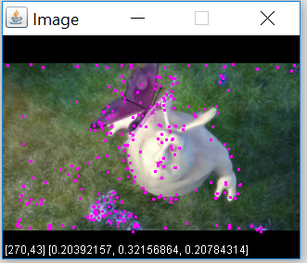 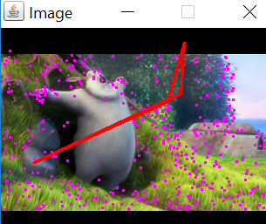  
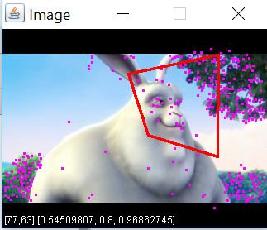

**Object Detection Output**

The output specifies a box around the image.  
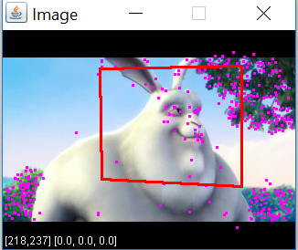 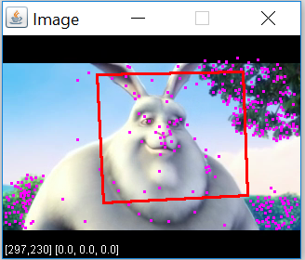  
The box is diaplayed around the image.Hence the desired output is obtained.

**Decision Tree generations**

These features and the test featuretext data is sent to the decision tree and Random tree to create a confusion matrix and accuracy is checked and based on the accuracy the weights can be adjusted to get the required output.  
  
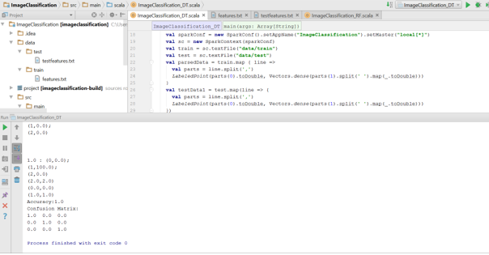

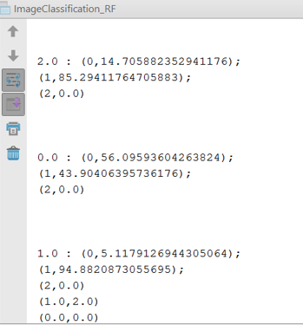  
  
  
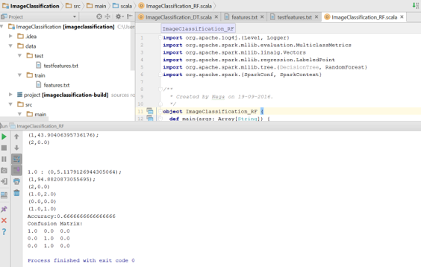  
  
The box is displayed around the image. Hence the desired output is obtained.

**Image Prediction**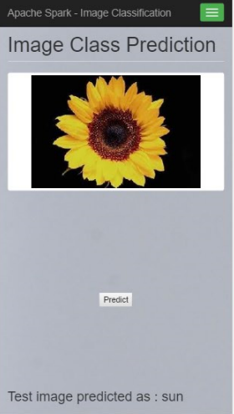 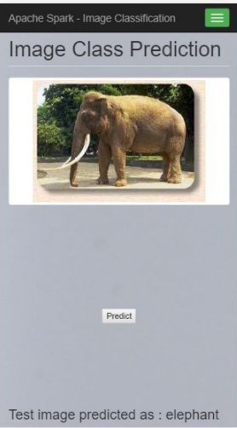  
Hence once the predict button is pressed the output is displayed.

**Android Application with Clarifai And Spark**  
An Android app is developed where the user can select an image and the corresponding objects with the score are displayed below. A spark server is run at the back end.  
  
