**CS5542 – Big Data Analytics and Apps**

**Lab 9 – Assignment Submission**

Name: Lava Kumar S

Class ID : 38

Write a TensorFlow program for the following Task.  
**a.**Implement a CNN model for image classification for the datasets that you consider relevant to your project.  
**b.**Report accuracy and time to build the CNN model.  
**c.**Visualizations (Tensor Board): training, loss, weights etc.

**DataSet**  
Used a sub-set of CIFAR-10(10000 images) The CIFAR-10 dataset consists of 60000 32x32 colour images in 10 classes, with 6000 images per class. There are 50000 training images and 10000 test images. The dataset is divided into five training batches and one test batch, each with 10000 images. The test batch contains exactly 1000 randomly-selected images from each class. The training batches contain the remaining images in random order, but some training batches may contain more images from one class than another. Between them, the training batches contain exactly 5000 images from each class.  
  
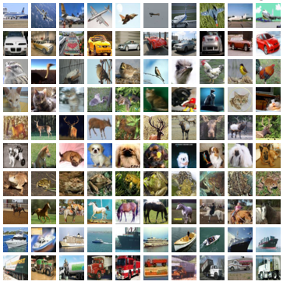  
**Program For CNN**

*data_path = "/home/Lava/Desktop/source/MNIST_SOFTMAX/data_new/CIFAR-10/data_batch_1"*

*fo = open(data_path, 'rb')*

*fo.seek(0)*

*dict_ = (pickle.load(fo,encoding='bytes'))*

*l=np.array(dict_[b'labels'])*

*d=np.array(dict_[b'data'])*

*fo.close()*

*trX,tstX,trY,tstY = train_test_split(d,l , test_size=0.33, random_state=42)*

*target=np.zeros((6700,10))*

*for i in range(0,len(target)-1):*

*x=trY[i]*

*target[i-1][x]=1*

**Accuracy & Execution**

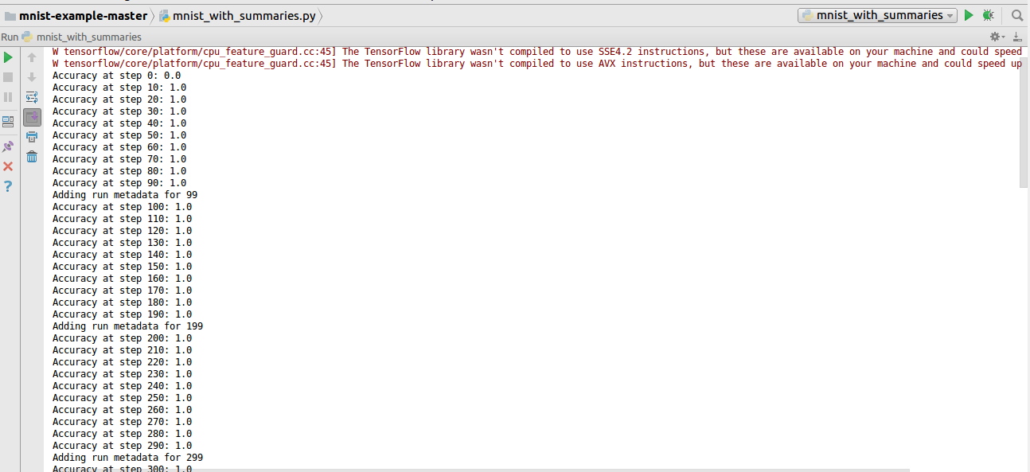

**Graph**  
  
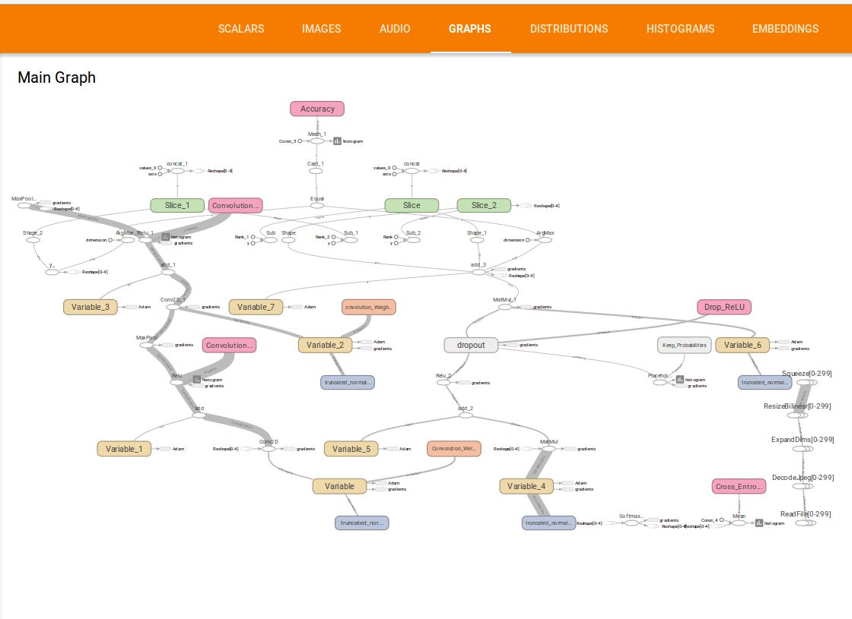  
**Other Tensor Board Graphs**  
  
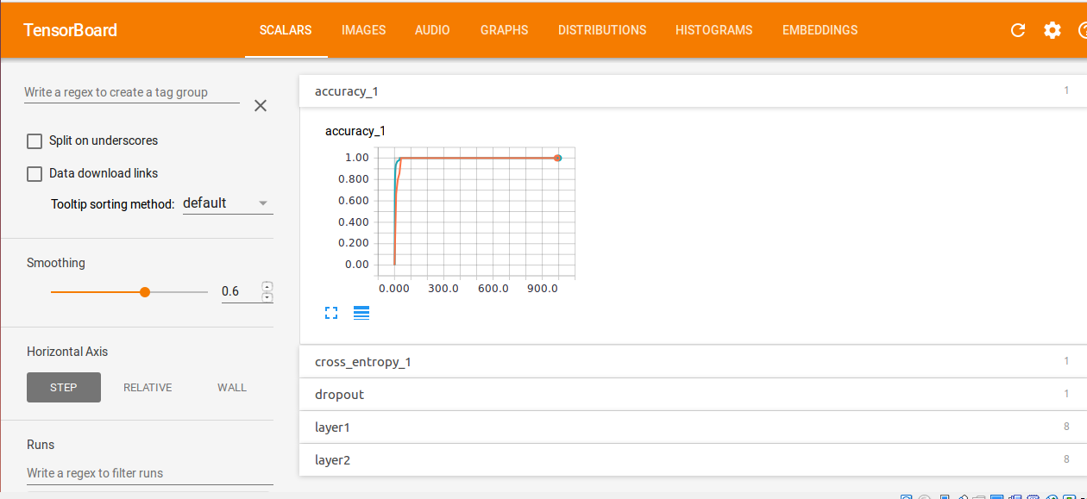  
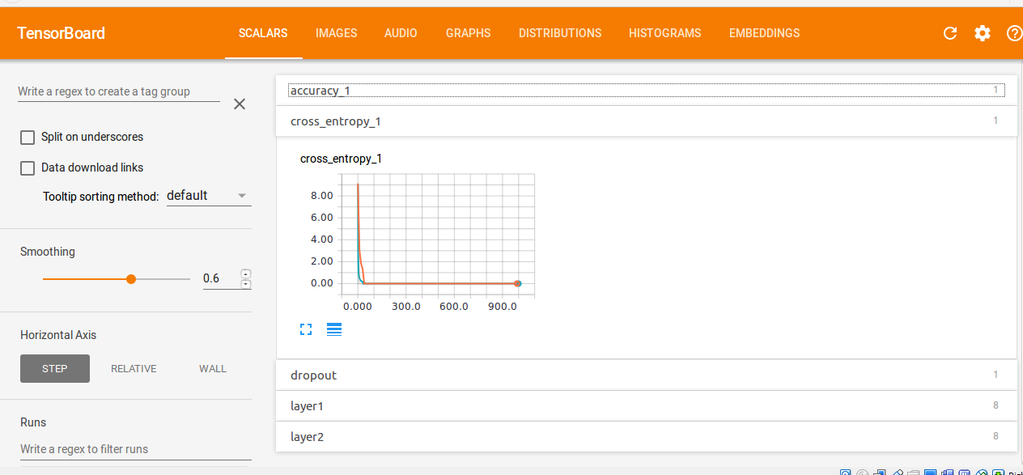

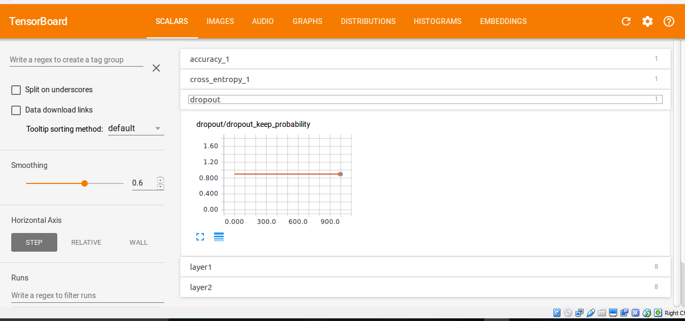  
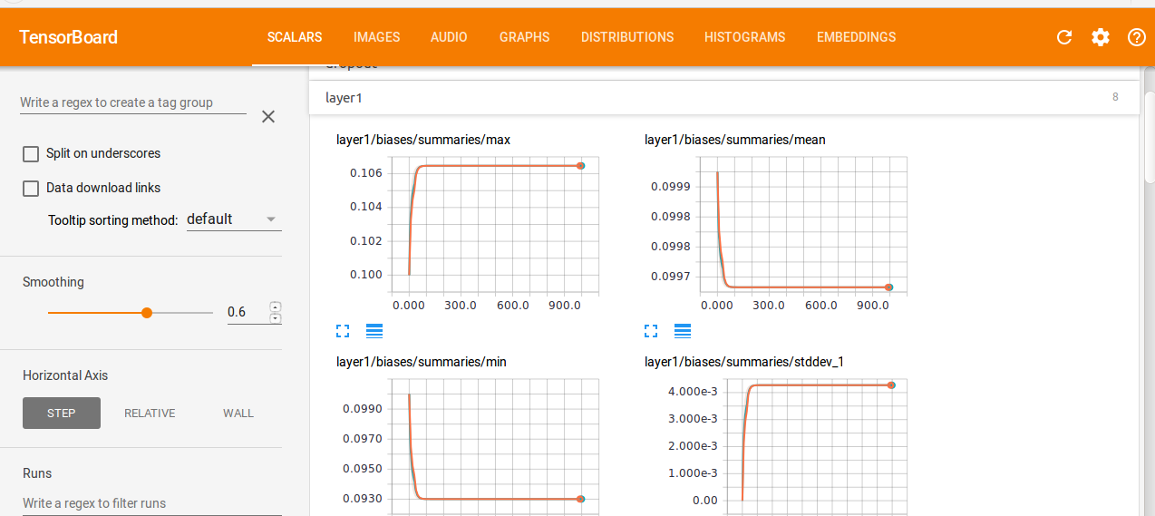

**Task 2**  
Develop a Web-based Application for Visual Question Answering that is relevant to your own project including the following features  
**a.**Google Conversation API  
**b.**Question answering for images  
**c**.Connect it to Clarifai API or Spark AP.

API.AI makes it possible for your service to receive and respond to user queries in natural language. So whether you aim to answer questions or help users to be more productive, API.AI can help you build engaging experiences.  
  
**Data Retrival**  
  
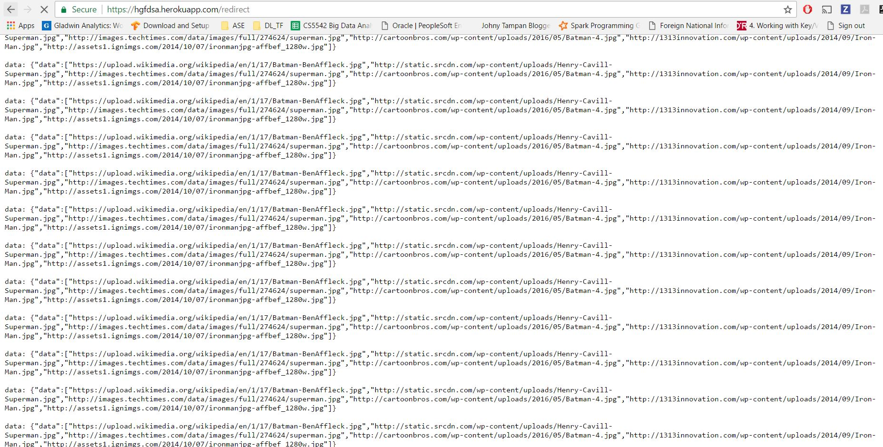

**Google Conversation**  
  
  
