**ZenHub Report**

**Issues:**

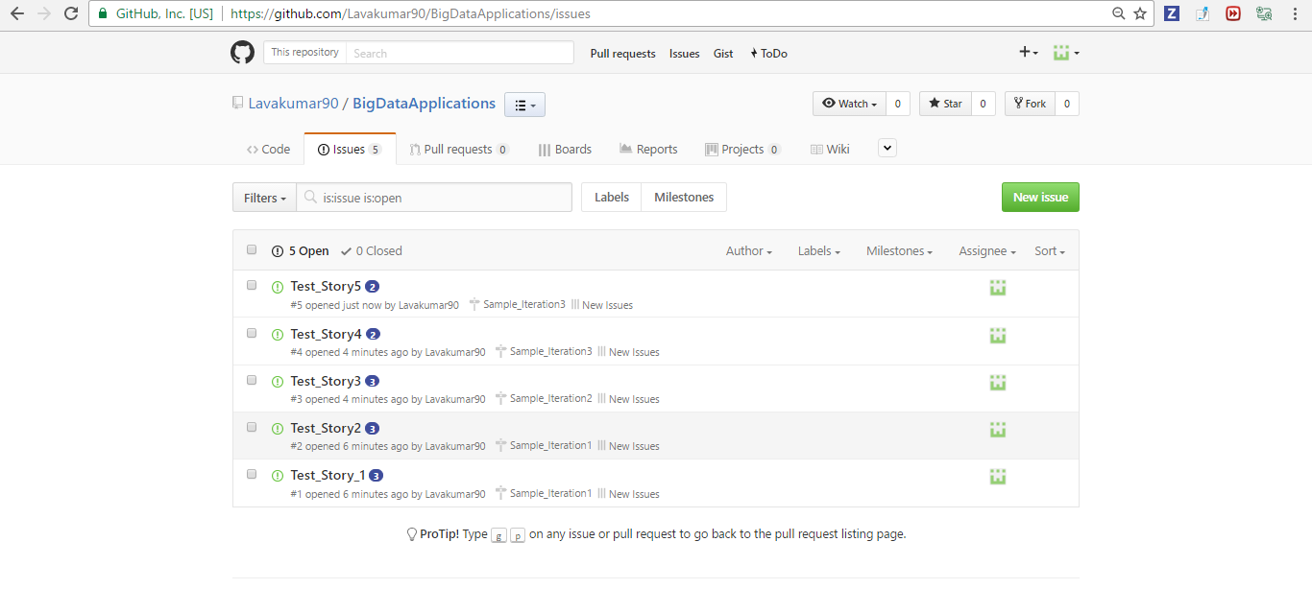

**Board:**

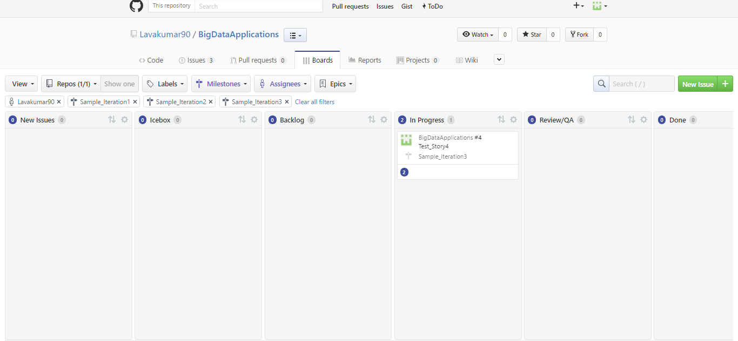

**Report:**

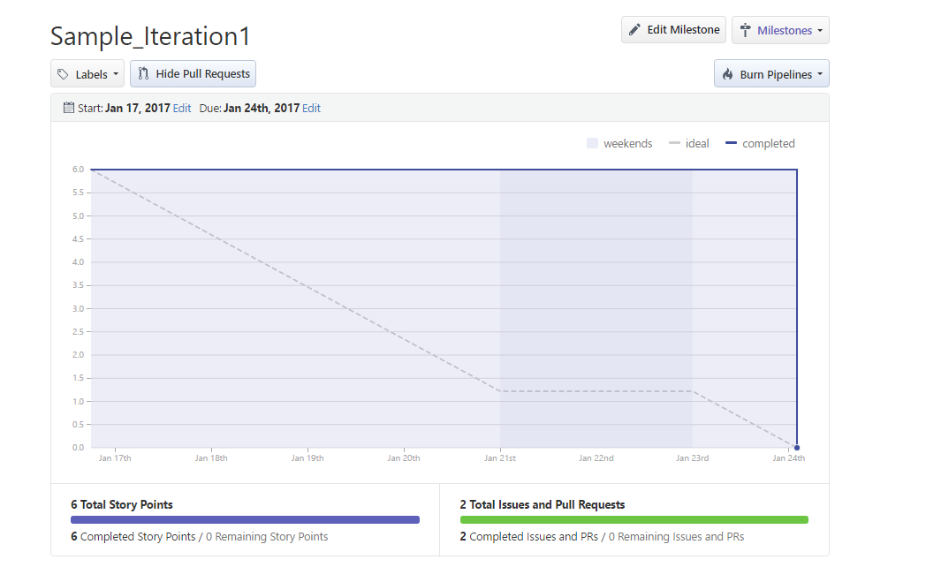

**Please find the complete details in the below Zenhub path:**

<https://github.com/Lavakumar90/BigDataApplications>