**CS5560 Knowledge Discovery Management**

**LAB ASSIGNMENT #1**

**Lab Submission through the following link before June 13, 2017 (T) 11:59PM.**

<https://goo.gl/forms/eGLZpAZwQYimFlI03>

1. **Create a Scala project**

In IntelliJ using Scala and SBT. Add any library to SBT and use in it in your project.

**Step 1:**

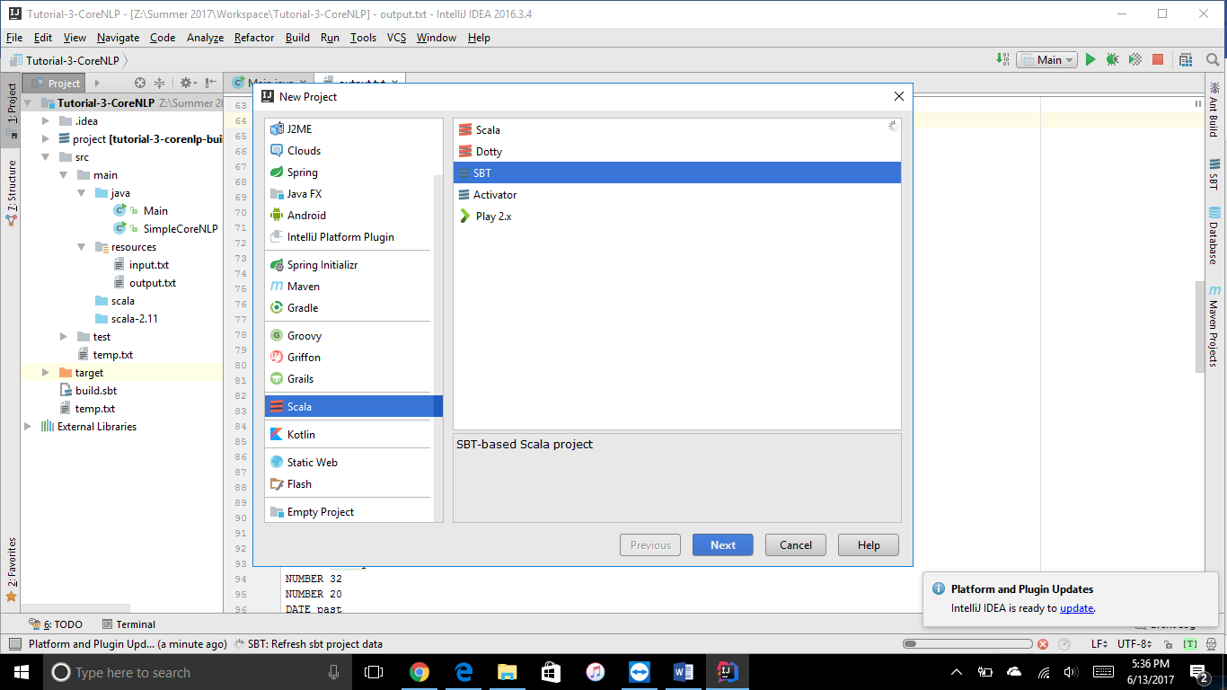

Step 2: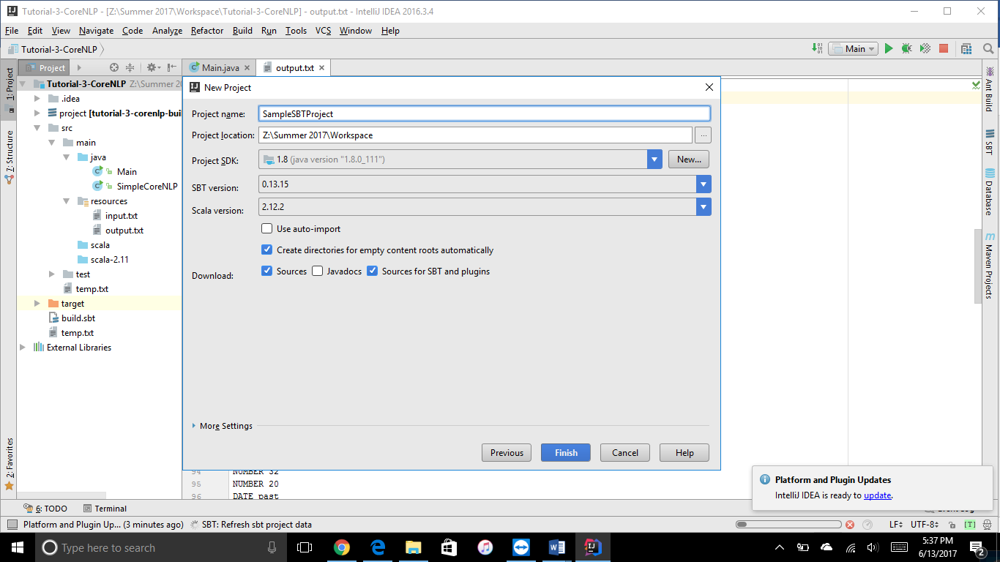

Step 3:

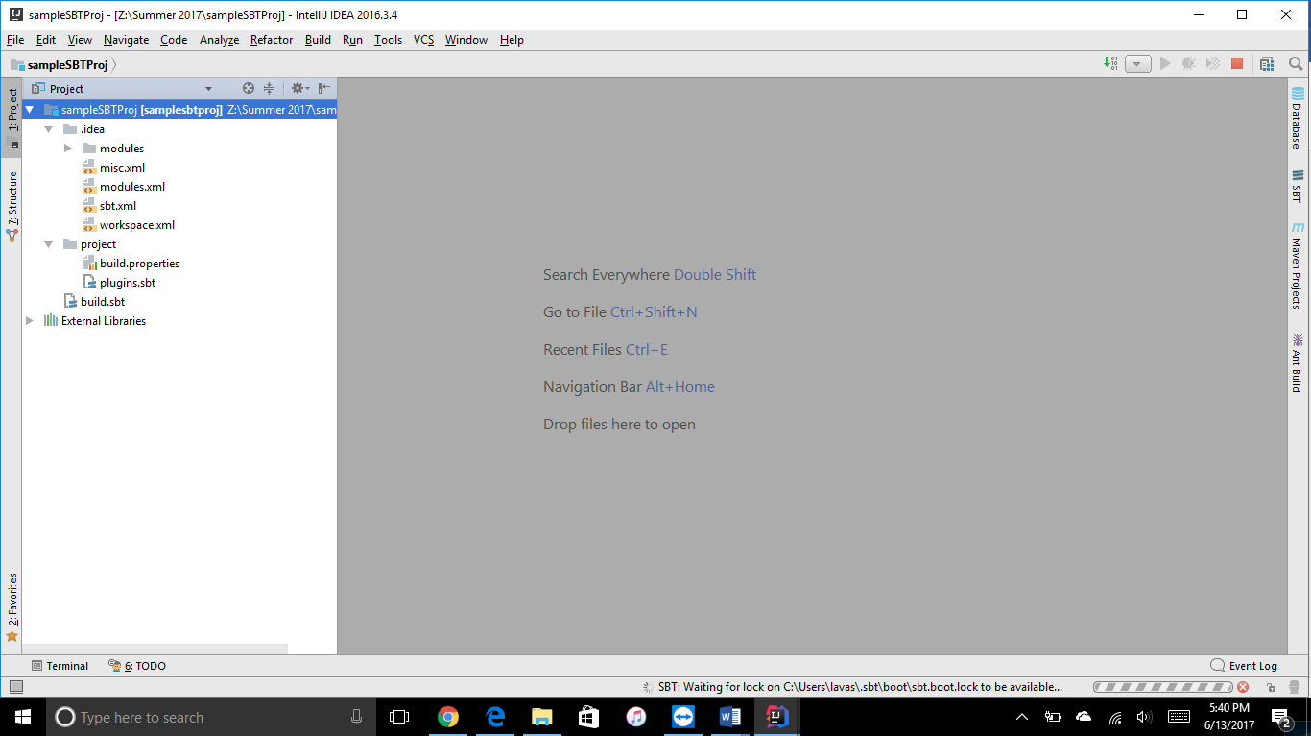

Step 4:

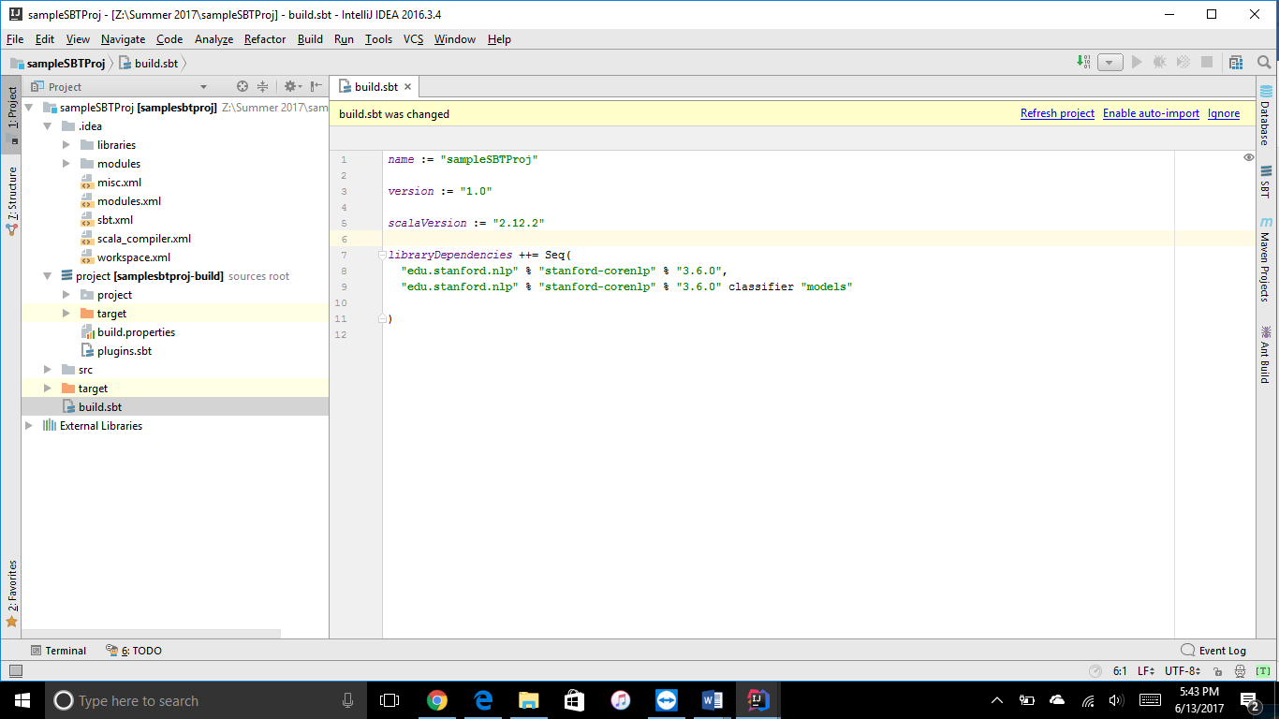

Step 5:

The sample project is updated in Github Lab-1A.

<https://github.com/Lavakumar90/CS5560_Lava_Lab_Repository>

1. **Create a Python project**

In PyCharm using Python. Add any library to Python Interpreter and use it in your project

Step 1:

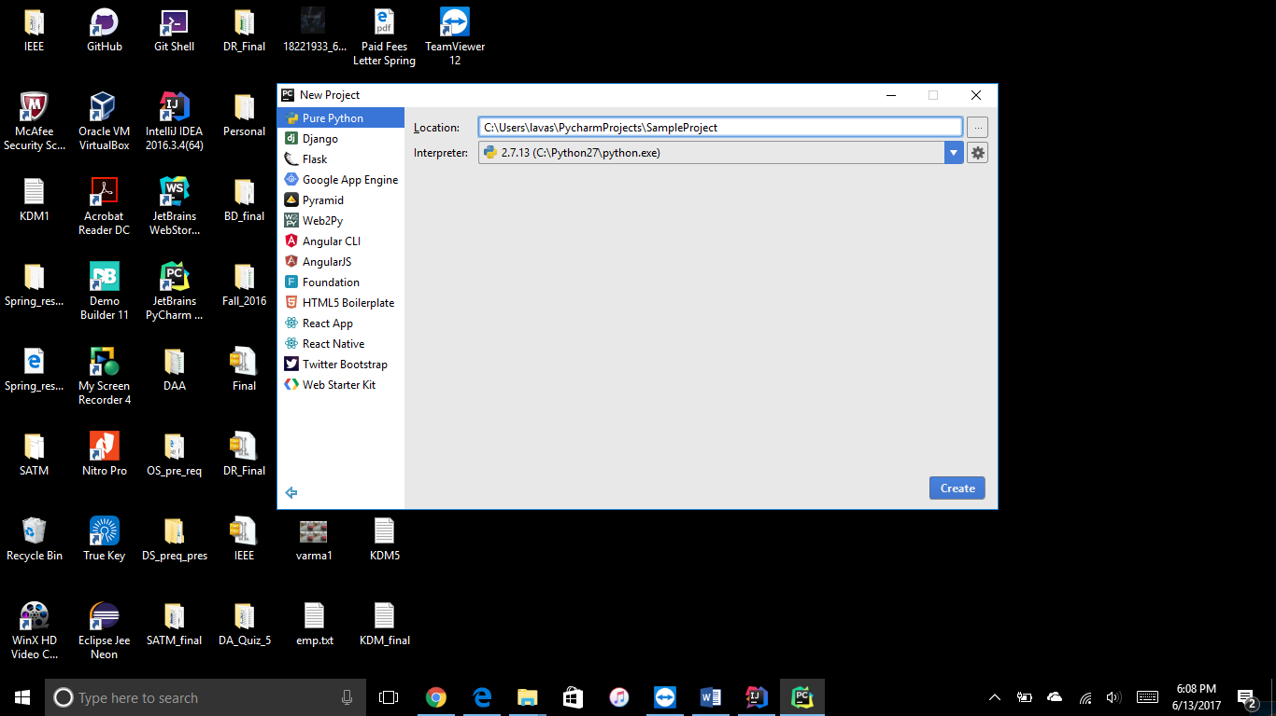

Step 2:

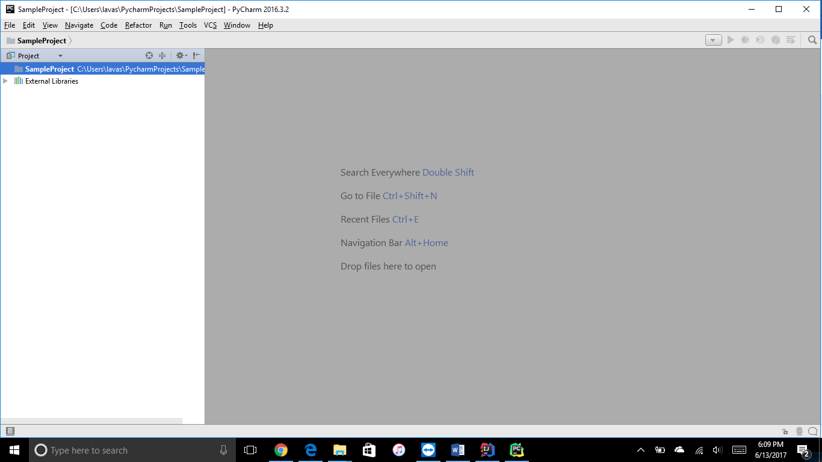

Step 3:

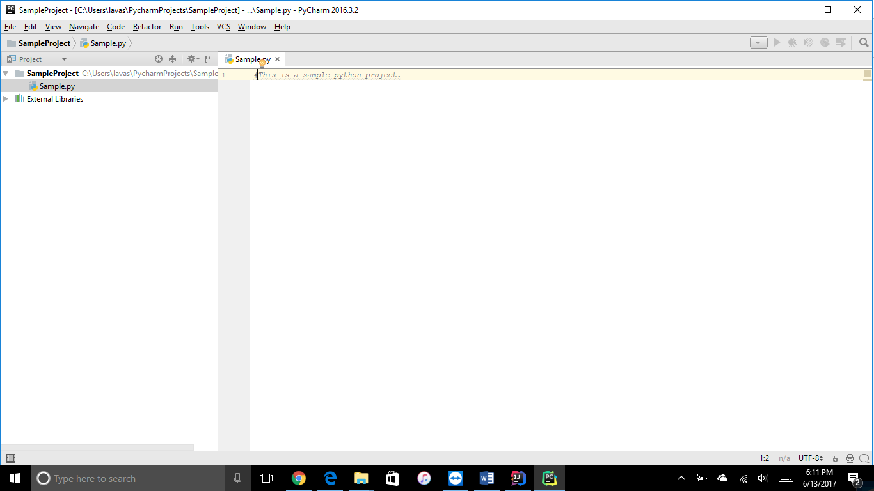

Step 4:

The sample project is updated in Github Lab-1A.

<https://github.com/Lavakumar90/CS5560_Lava_Lab_Repository>

1. **Create GitHub Account**.
   1. Create CS5560<your name>LabSubmission repository in remote Github. Clone it to local machine.
   2. In the repository push your projects (scala and python) into Lab Submission1 folder
   3. Write a brief report on your submission using Wiki Page

<https://github.com/Lavakumar90/CS5560_Lava_Lab_Repository>

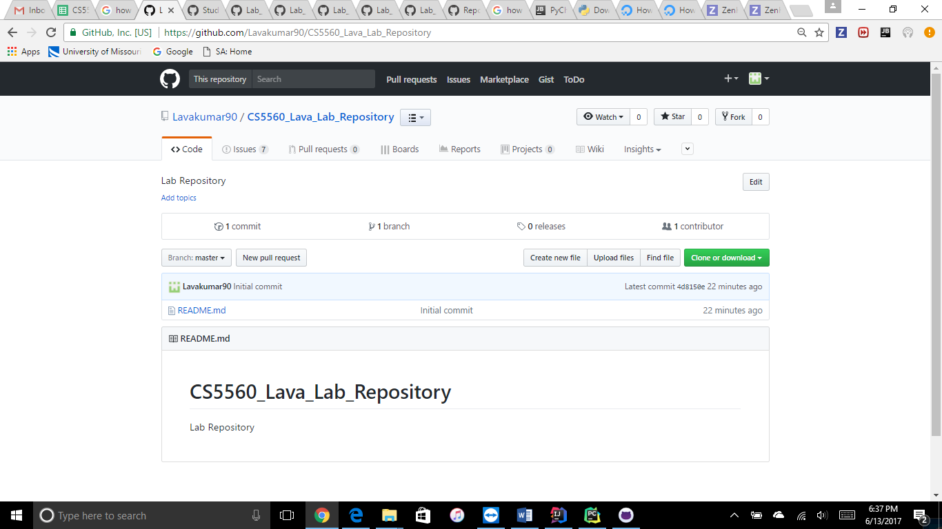

1. **Create ZenHub Tool Account**.
   1. Create a board, 3 iterations, at least 5 tasks and show the analytics graph.
   2. Add some useful information about your project from analytics graph to Wiki Page.

<https://github.com/Lavakumar90/CS5560_Lava_Lab_Repository/issues>

<https://github.com/Lavakumar90/CS5560_Lava_Lab_Repository/issues#boards?repos=94266605>

<https://github.com/Lavakumar90/CS5560_Lava_Lab_Repository/issues#reports?report=burndown&milestoneId=2581602>

