**CS5560 Knowledge Discovery Management**

**LAB ASSIGNMENT #1**

1. **Generate the following NLP tasks for the following sentence manually**

***Input***:

* 1. The dog saw John in the park
  2. The little bear saw the fine fat trout in the rocky brook.

**NLP Tasks:**

1. *Part-of-speech (POS) tagger*

*The – DT*

*Dog- NN*

*Saw- VBD*

*John- NNP*

*In- IN*

*The- DT*

*Park- NN*

1. *Named entity recognizer (NER)*

*John- PERSON*

1. *Co-reference resolution system*

*"The dog"- "John in the park" - "the park"*

1. *Part-of-speech (POS) tagger*

*The – DT*

*Little- JJ*

*bear- NN*

*saw- VBD*

*the- DT*

*fine- JJ*

*fat- JJ*

*trout- NNS*

*in- IN*

*the- DT*

*rocky- JJ*

*brook- NN*

1. *Named entity recognizer (NER)*

*O*

1. *Co-reference resolution system*

*"The little bear"- "the fine fat trout in the rocky brook"- "the rocky brook"*

1. **Create a NLP project for the following tasks using CoreNLP**

***Input***: Choose Dataset from the sheets.

*Please find the text document in the GitHub link*.

**Git hub link:** <https://github.com/Lavakumar90/CS5560_Lava_Lab_Repository/tree/master/Lab_Asmt_1B>

***NLP Tasks:***

1. *Part-of-speech (POS) tagger*
2. *Named entity recognizer (NER)*

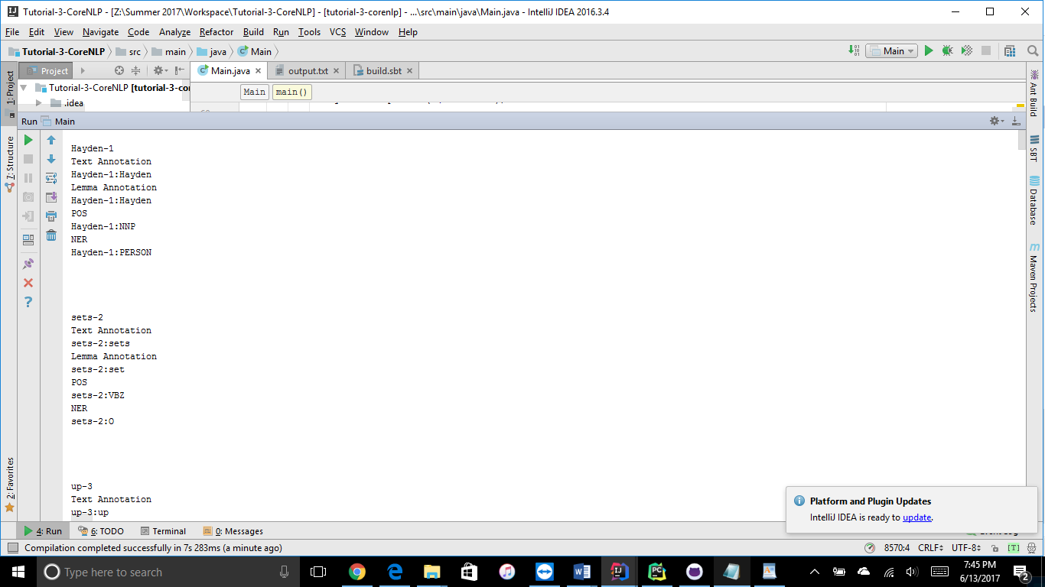

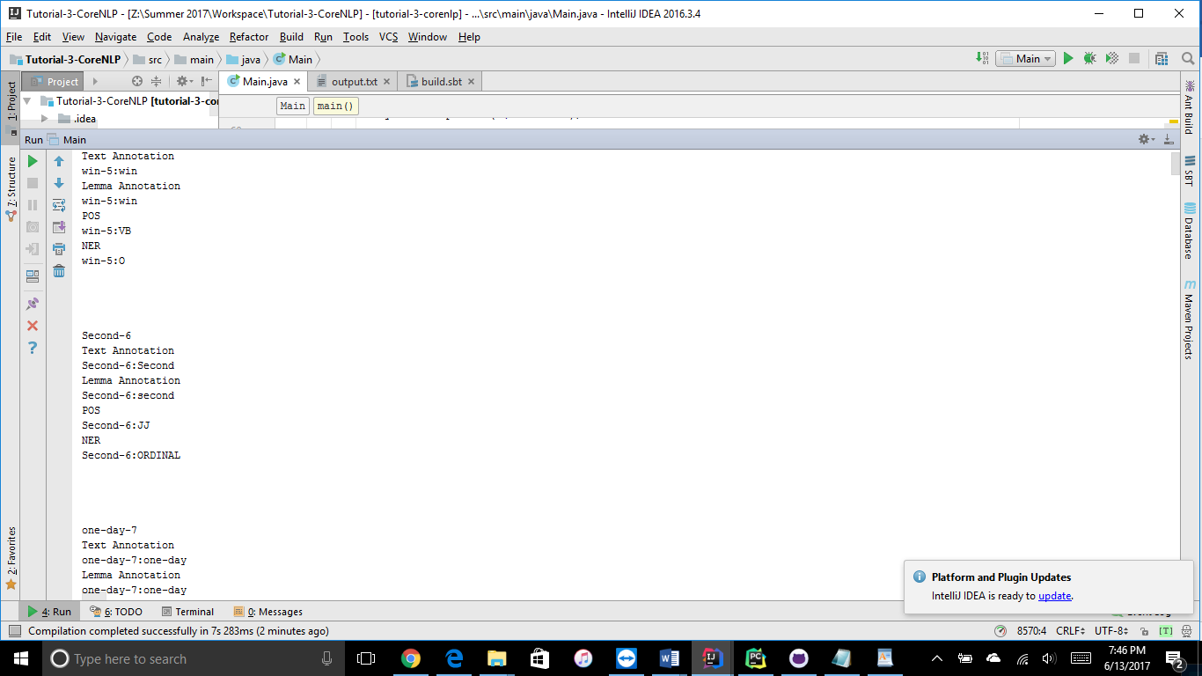

1. *Co-reference resolution system*

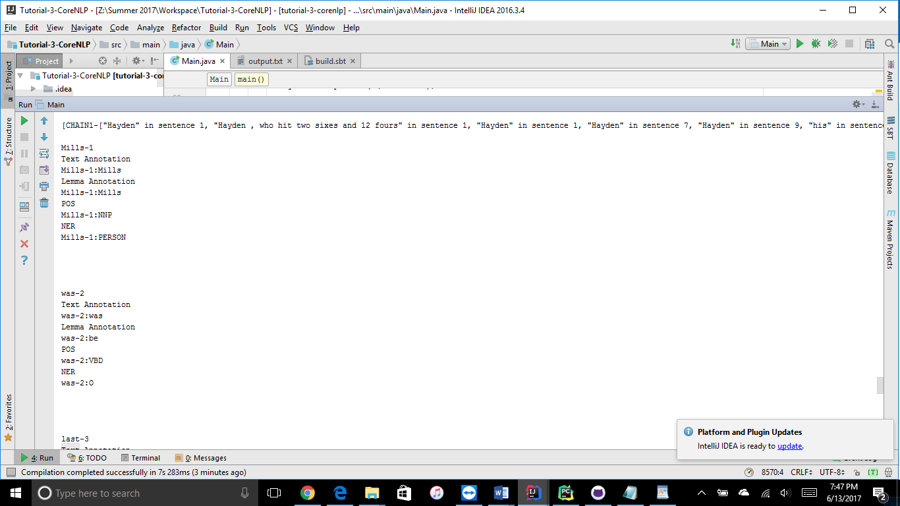

1. *Sentiment Analysis*

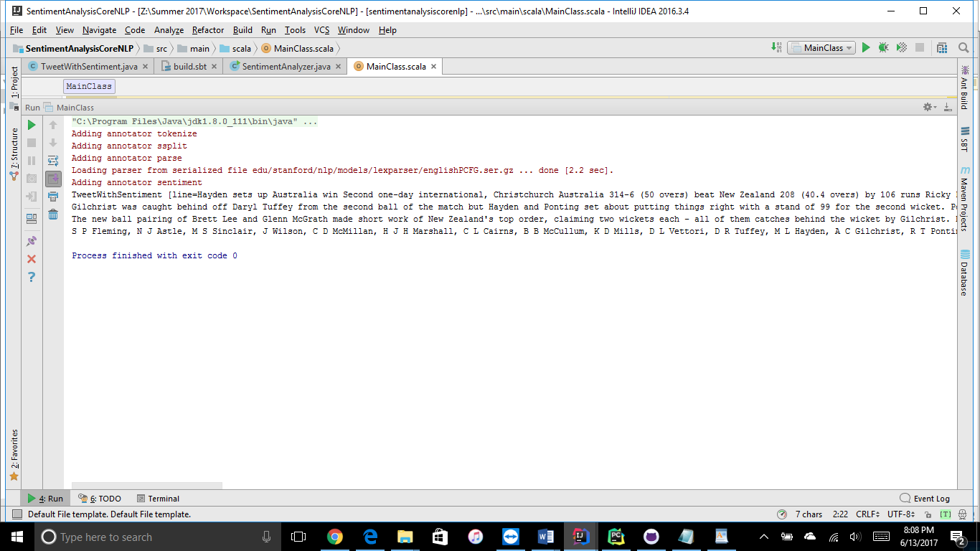

1. **Create a simple question answering system as an extension of the dataset and tasks done in (2). *(Take home assignment)***

**Git hub link:** <https://github.com/Lavakumar90/CS5560_Lava_Lab_Repository/tree/master/Lab_Asmt_1B>

**Input Text document:**

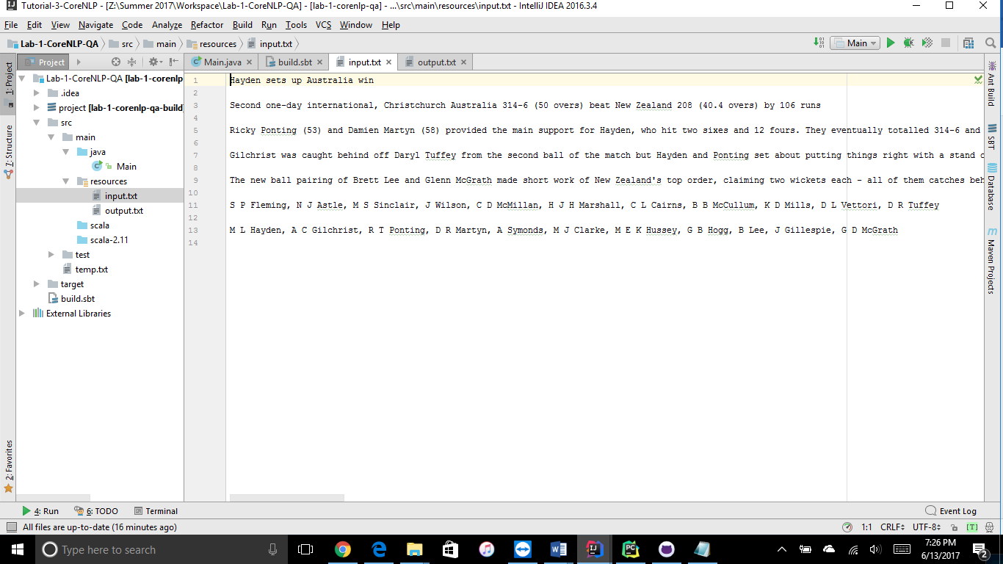

**Source Code:**

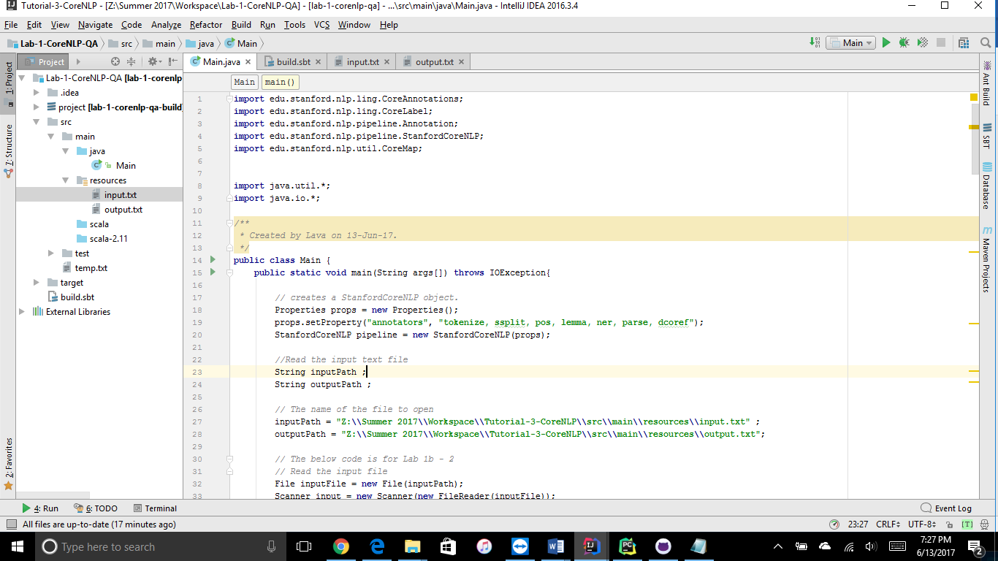

**Processing of NLP:**

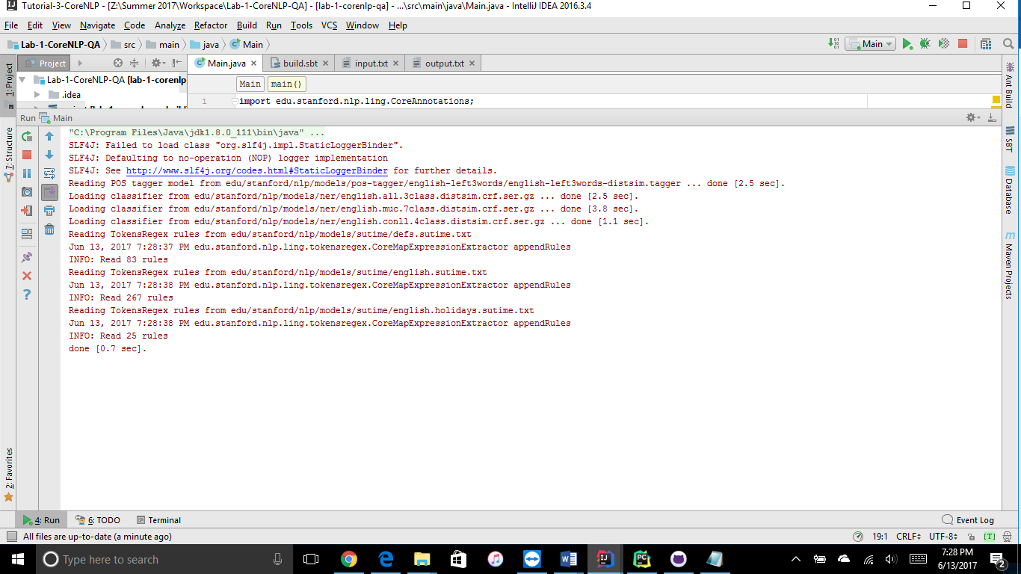

**NLP output for the input file:**

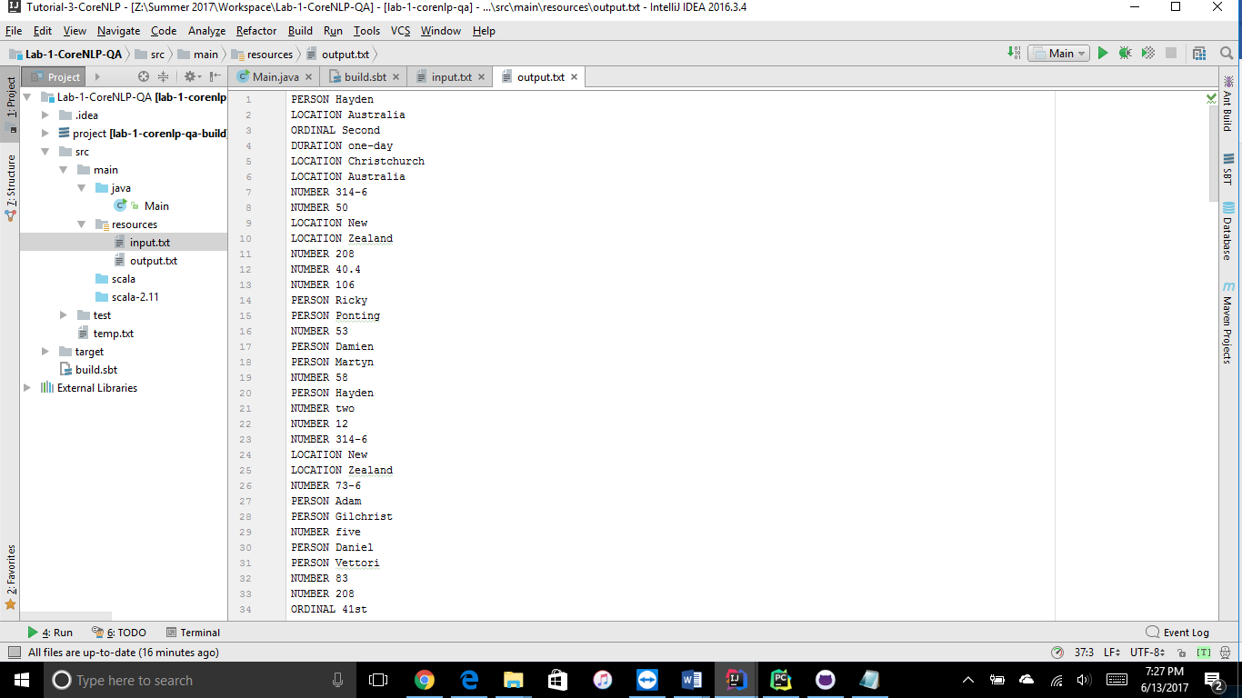

**Question 1:**

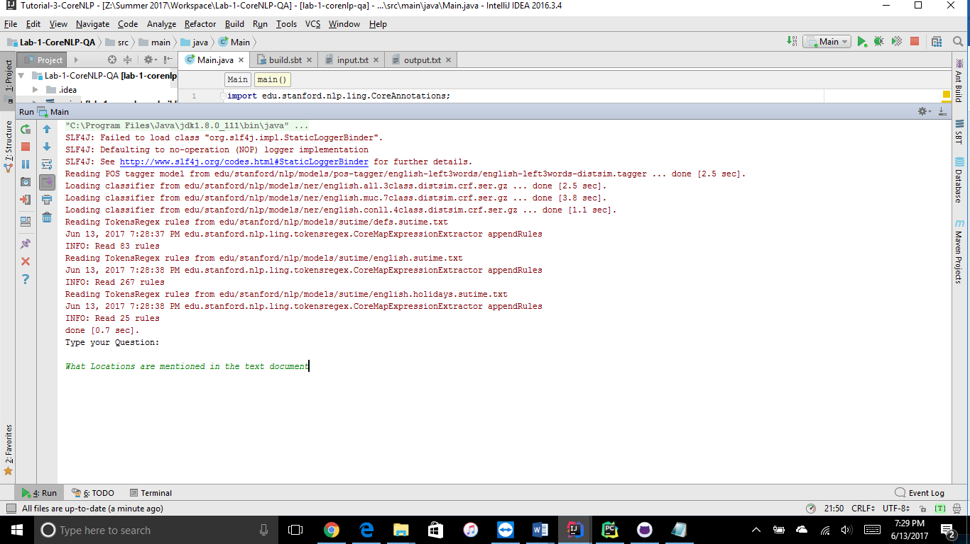

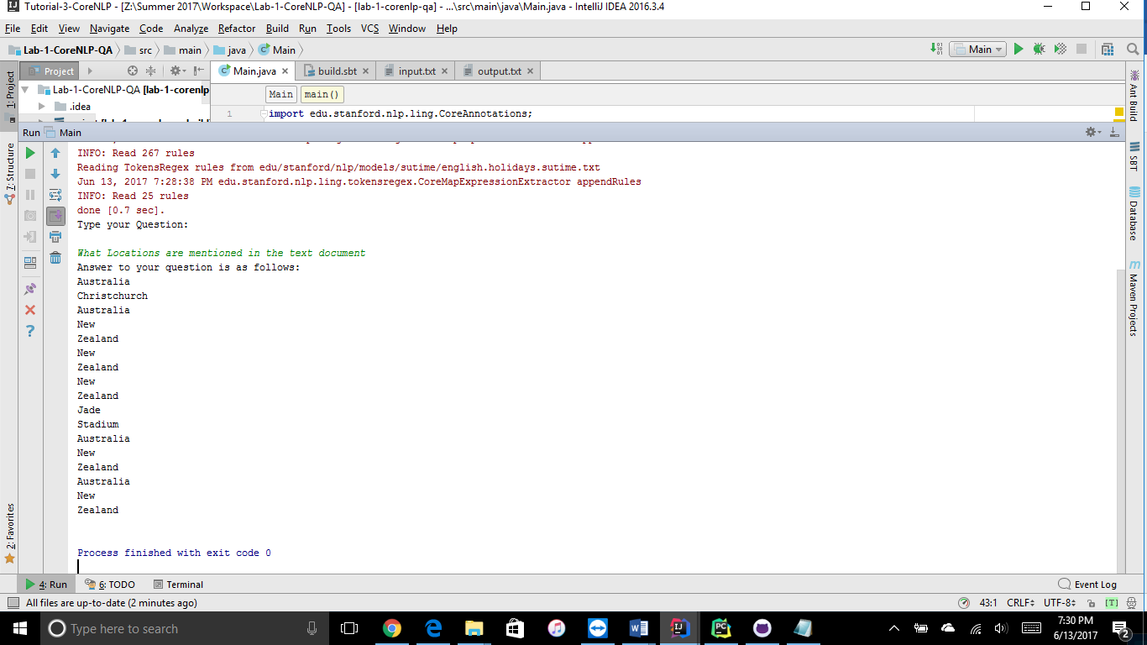

**Question 2:**

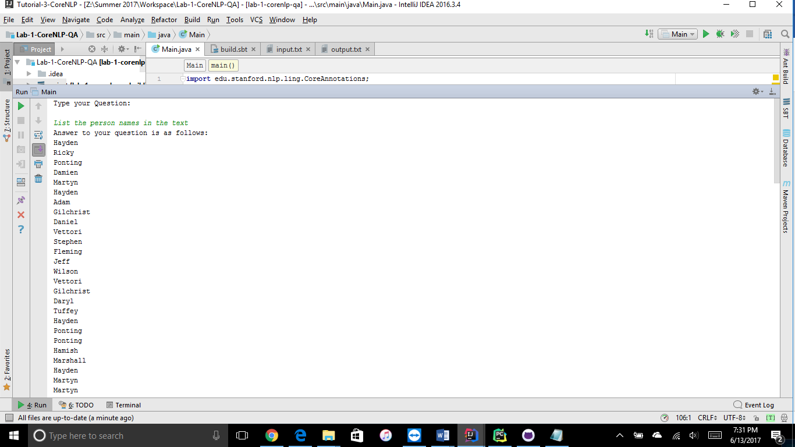

**Question 3:**

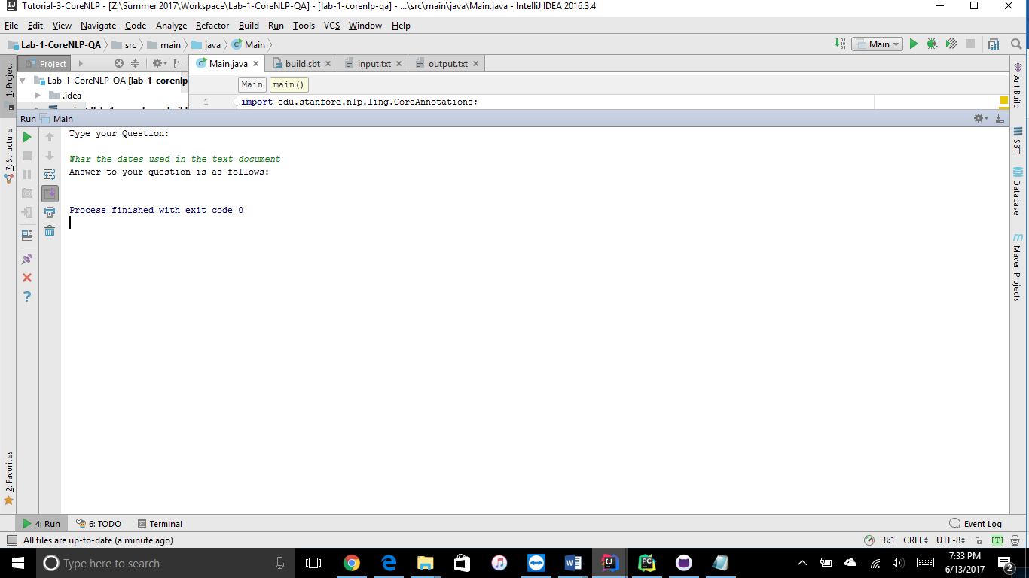

**Question 5:**

