**CS5560 Knowledge Discovery Management**

**LAB ASSIGNMENT #6**

**Name: Lava Kumar Surparaju**

**Class ID: 27**

**Lab 6 Assignment:**

1. ***In Class Question***

***Complete the family Ontology as explained in tutorial in the following manner.***

1. ***Create Equivalent Classes for all possible classes***

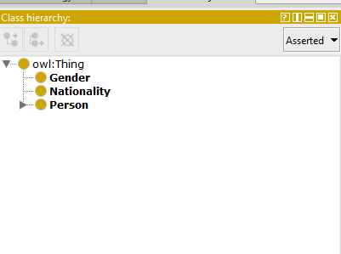

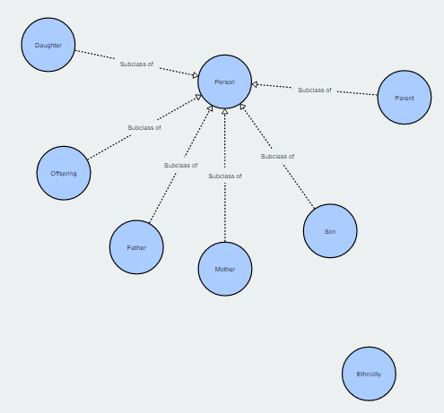

1. ***Add additional details to the object properties which don’t have domain or range specified***

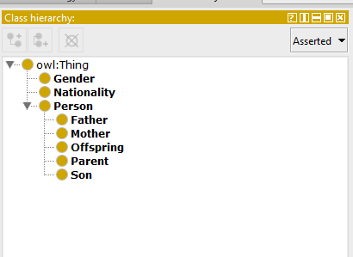

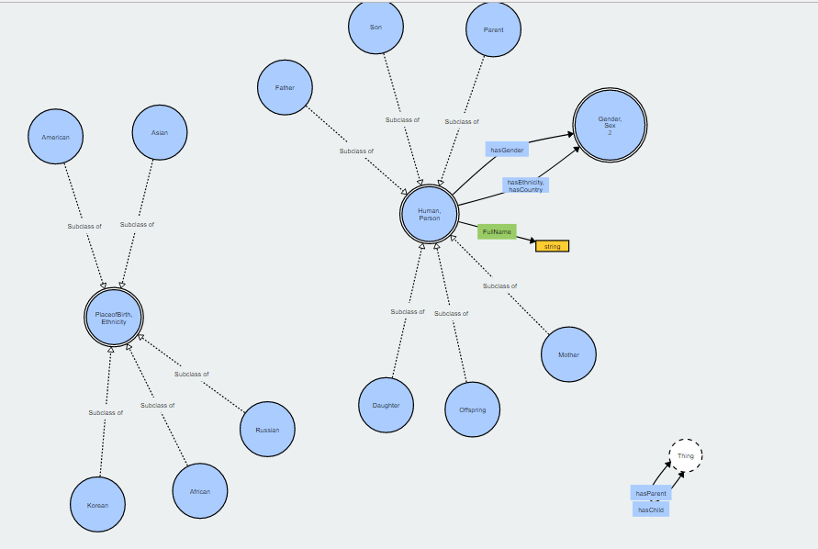

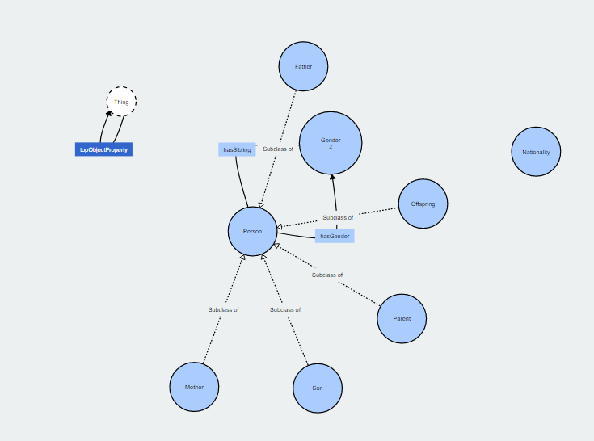

1. ***Under the Ethnicity Class, create at least 3 subclasses and 2 object properties***

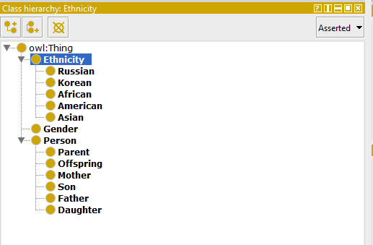

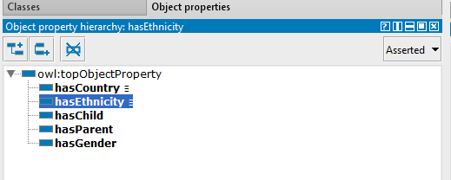

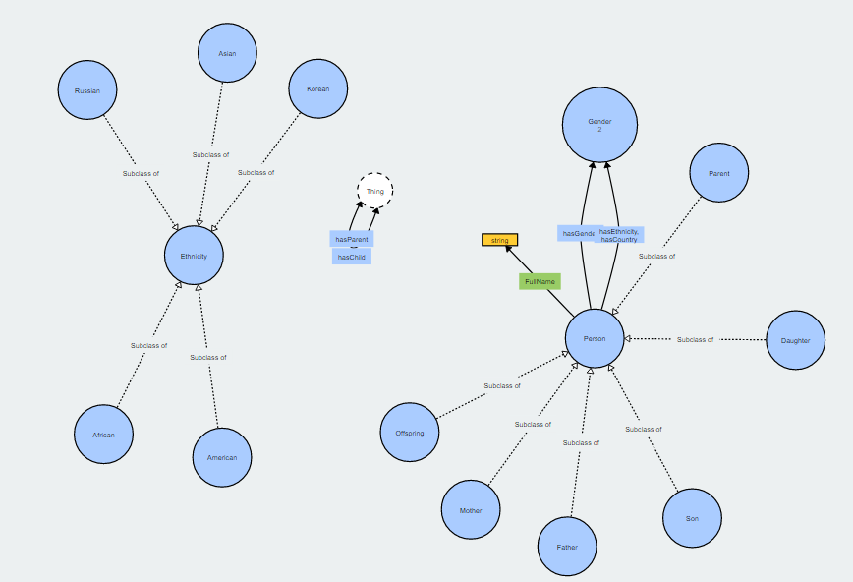

1. ***Add 5 individuals to the Ontology***

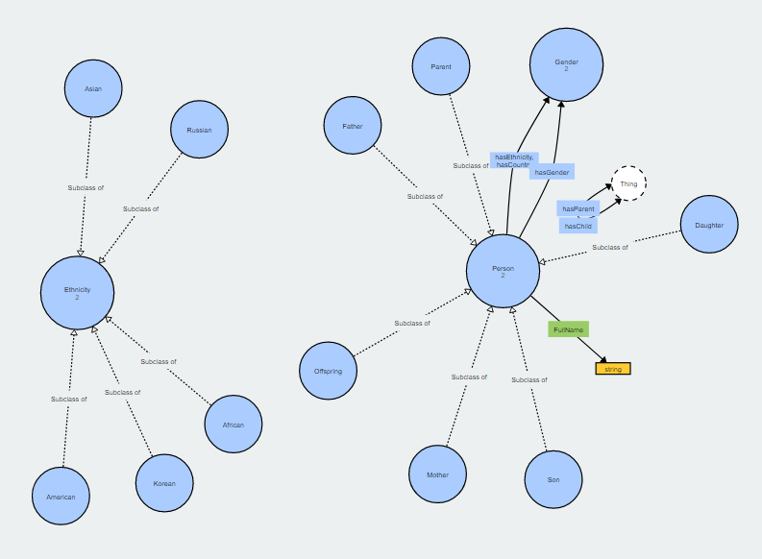

1. ***Perform SPARQL queries based on your new object properties***
2. retrieves distinct objects related to different classes.

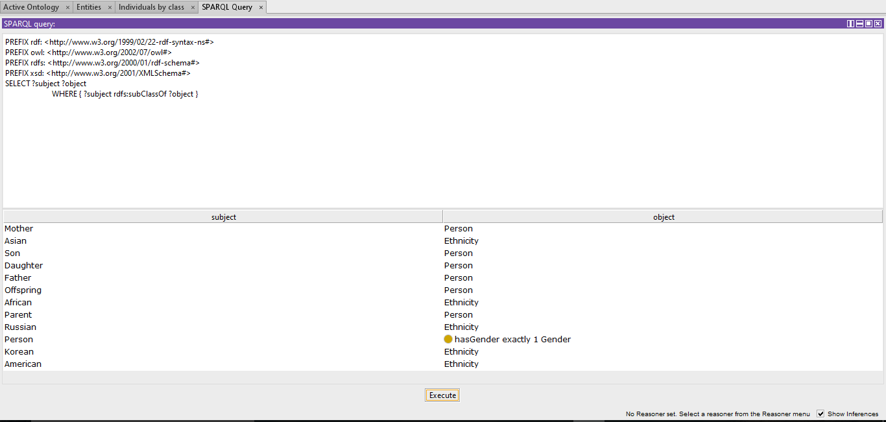

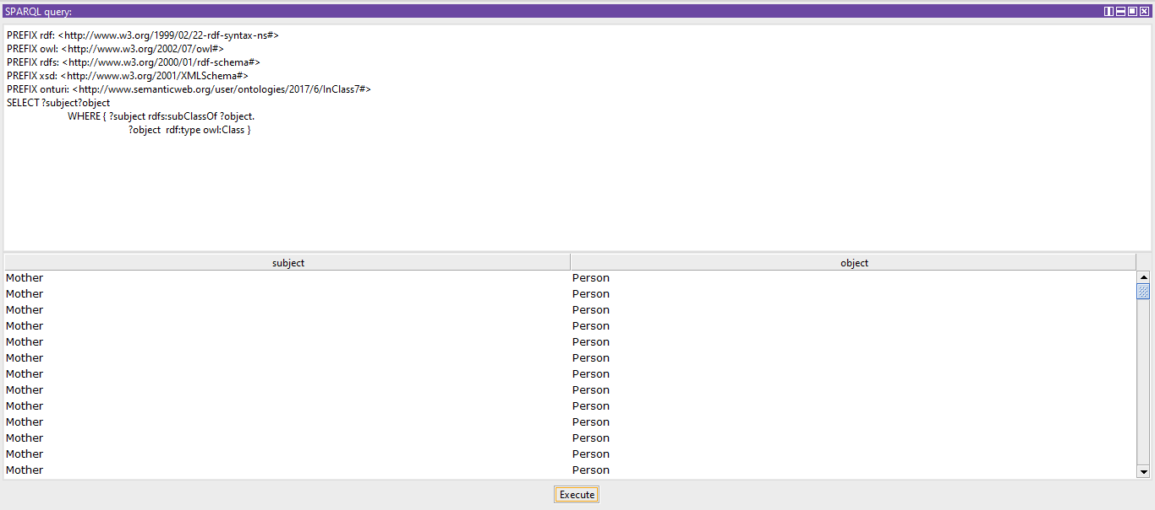

1. ***Take home Question***
2. ***Design your own ontology (classes, hierarchy, object and data properties) based one of categories from*** 
   1. ***Your own data***
   2. ***Yahoo! Answer data (The*** [training data](https://umkc.box.com/s/pph3fjv865wostjfc4zbnnzxl16m9r41) ***contains 2,698 questions, already labeled with one of the following 7 categories. The*** [test data](https://umkc.box.com/s/83yzy207p1u90mvhwft1bjpno18d70qf) ***contains 1,874 questions that are unlabeled).***
3. ***Create a sample triplet set from your data based on the object and data properties in your ontology and populate it***

