**CS5560 Knowledge Discovery Management**

**LAB ASSIGNMENT #7**

**Name: Lava Kumar Surparaju**

**Class ID: 27**

**Lab 7 Assignment:**

1. In Class Questions

Generate a knowledge graph (ontology learning) as explained in tutorial in the following manner.

1. Create a class hierarchy (classes) for a given domain (e.g., Food, Family) containing at least 5 classes

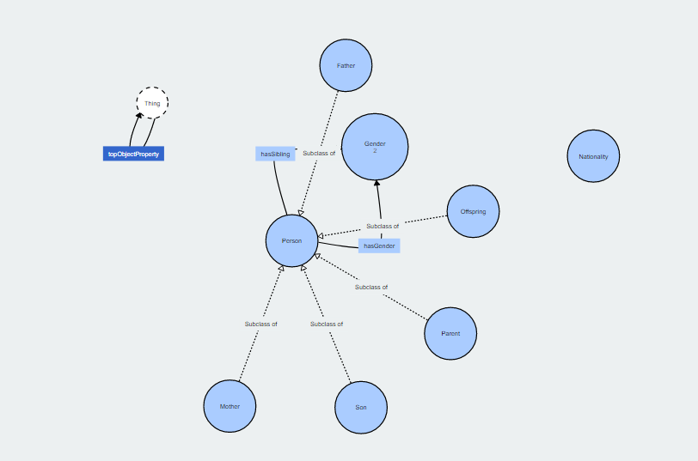

1. Create properties by specifying domains (subjects) and ranges (objects) (at least 5 properties)

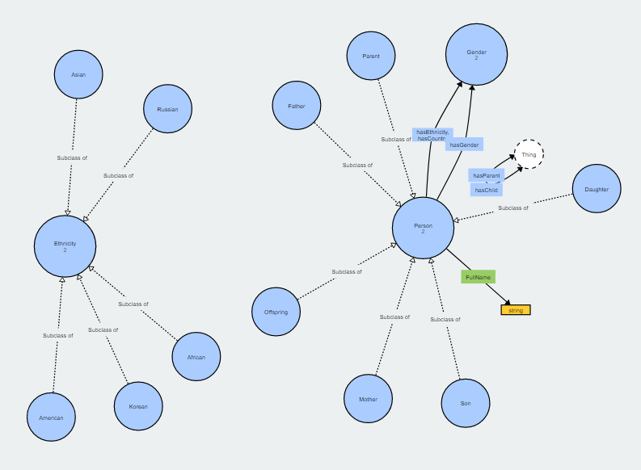

1. Prepare a paragraph (in the same domain with your ontology) containing at least 5 sentences (containing at least 10 instances)

Automated food and drink recognition methods connect to cloud-based lookup databases to match and identify a scanned food or drink item, and report the results back to the user. However, these methods remain of limited value if we cannot further reason with the identified food and drink items, ingredients and quantities/portion sizes in a proposed meal in various contexts.This will help with personalized food menu planning (particularly useful for people with special dietary requirements dictated by their health condition and/or other factors such as meal cost/affordability), and advise users about any essential ingredients lacking in their diet (under-nutrition) or about their intake of substances with cumulative toxicity in daily food, so that they can always stay within the recommended limits. Users can also be warned regarding allergens or any other food intolerances in food they are about to ingest, based on their known medical history of such conditions (e.g., peanut allergy).

1. Generate a knowledge graph including new Individuals and new Triplets by the execution of the knowledge graph generation program.

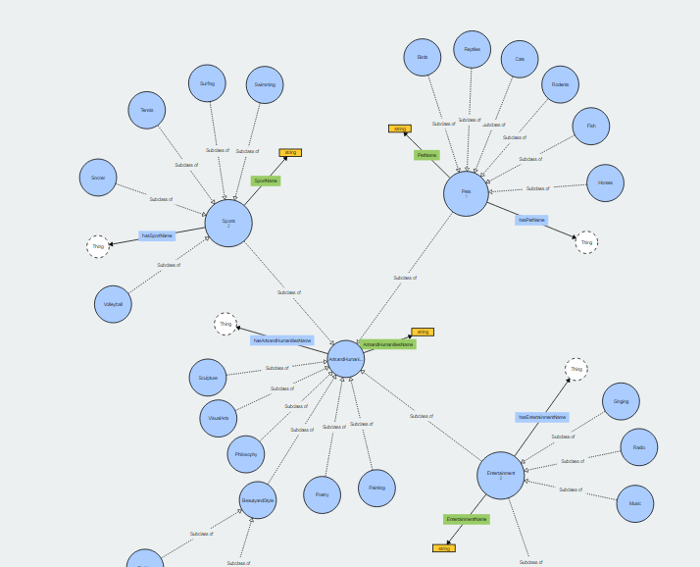

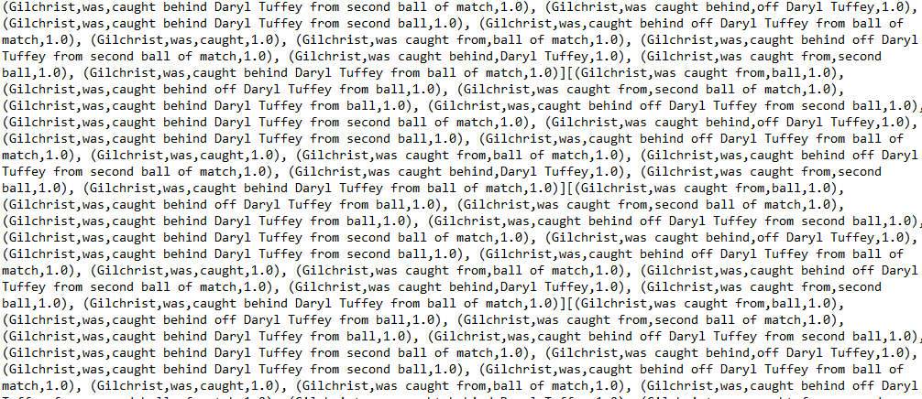

1. Design at least 5 questions and execute the DL queries with your new knowledge graph.

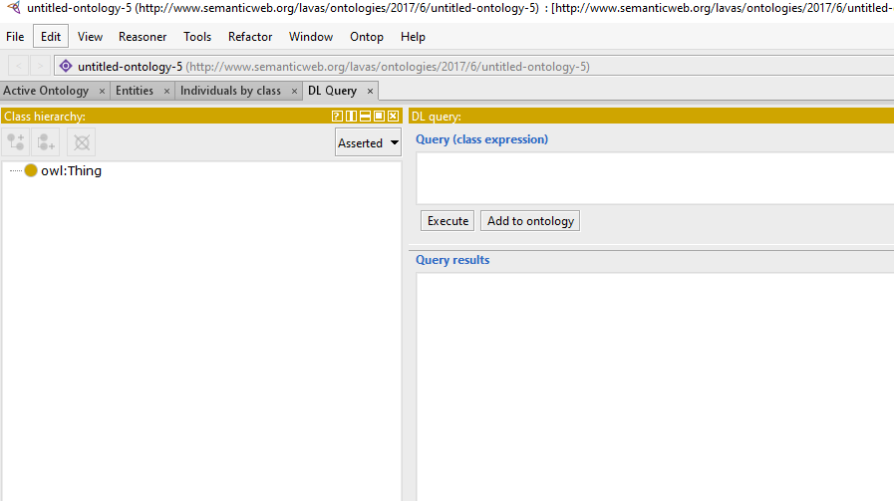

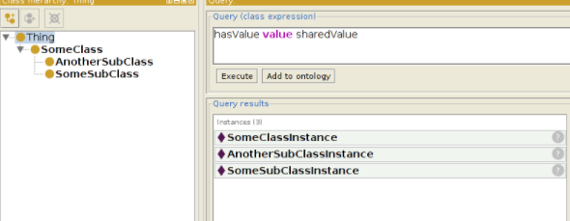

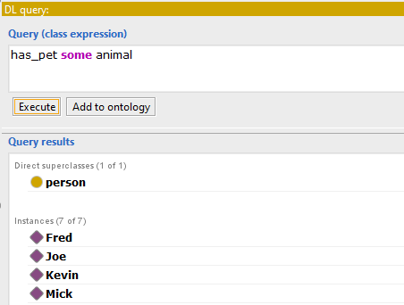

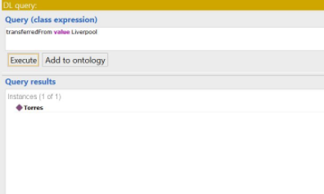

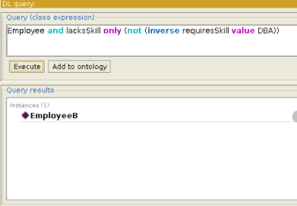

1. Take Home Question
2. Design your own ontology (classes, hierarchy, object and data properties) based on two datasets from the following datasets
   1. Your own data
   2. Stanford data https://rajpurkar.github.io/SQuAD-explorer/
   3. Yahoo! Answer data (The [training data](https://umkc.box.com/s/pph3fjv865wostjfc4zbnnzxl16m9r41) contains 2,698 questions, already labeled with one of the following 7 categories. The [test data](https://umkc.box.com/s/83yzy207p1u90mvhwft1bjpno18d70qf) contains 1,874 questions that are unlabeled).

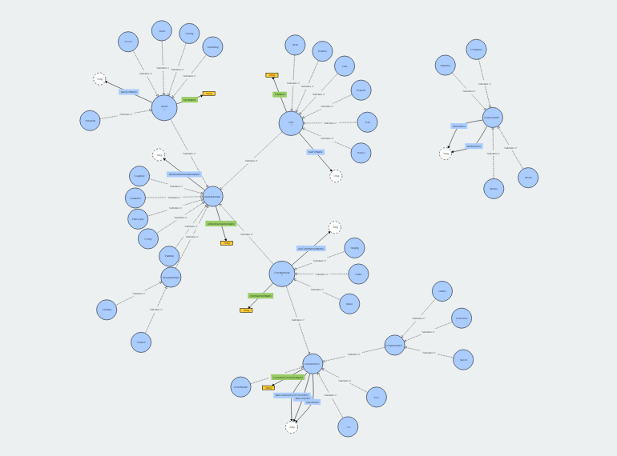

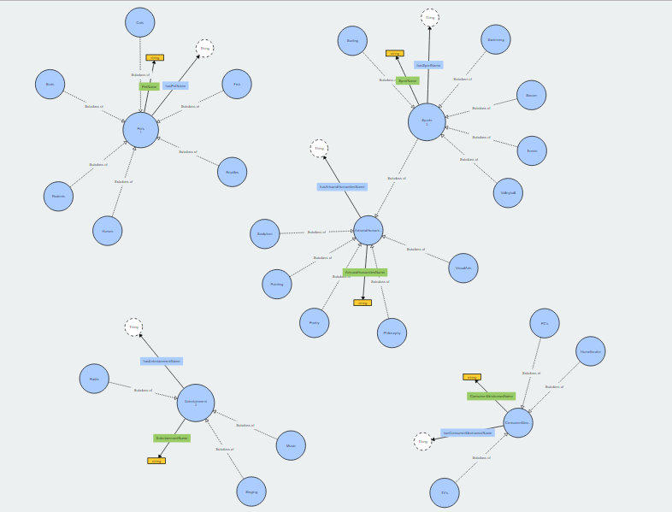

1. Automatically create a set of individuals and triplets from your dataset based on classes and properties in your ontology



1. Formulate at least some informative queries, implement them using DL queries, and execute them by mapping questions to DL queries. Report the results

