Recognizing and Detecting Student Alertness Using CNN

Mr.K.Subba Shankar

Assistant Professor

Institute of Aeronautical Engineering Hyderabad,Telangana kambamshankar@gmail.com

SUNDILLA GANESH

Department of computer Science and Engineering(AI & ML)

Institute of Aeronautical Engineering

Hyderabad, Telanagana [Sundillaganesh1@gmail.com](mailto:Sundillaganesh1@gmail.com)

NOMULA LAVAN REDDY

Department of Computer Science and Engineering(AI&ML)

Institute of Aeronautical Engineering Hyderabad,Telangana [lavanreddynomula123@gmail.com](mailto:lavanreddynomula123@gmail.com)

MARIKANTI HARSHA VARDHAN

Department of Computer Science and Engineering(AI&ML)

Institute of Aeronautical Engineering Hyderabad,Telangana [21951a6642@iare.ac.in](mailto:21951a6642@iare.ac.in)

***Abstract*— The COVID-19 pandemic and the subsequent move to online learning have highlighted the necessity for efficient ways to measure student participation from a distance. This article presents a novel use of convolutional neural networks (CNN) for student recognition and alertness detection. The system measures students' attention and engagement by taking pictures of their faces and heads in real-time and using the features to determine each position. The device detects distraction and attention by analyzing head orientation and eye aspect ratios. CNN outperforms previous approaches in this situation by greatly improving the accuracy of student recognition and engagement classification. Extensive testing was conducted to validate the effectiveness of the system, which demonstrated superior performance in both remote and real- world learning situations. This automated method offers useful insights for enhancing the delivery of online education in addition to making it easier to track student involvement in real-time.**

***Keywords*— convolutional neural networks (CNN), computer vision, machine learning, eye aspect ratio.**

I.INTRODUCTION

The increasing popularity of online education has made it increasingly challenging to ensure that students are engaged and attentive in virtual classes. It became essential to create cutting-edge systems that can track students' attention in real-time as a result of the COVID-19 pandemic and the global shift to remote learning. In this study, convolutional neural networks (CNNs) are used to develop an automated system for identifying and measuring student alertness. Conventional techniques for measuring engagement, such manual observation, are unreliable, subjective, and frequently unable to produce accurate, real-time assessments of students' attention spans. This research fills this gap by utilizing CNNs' powers in real-time image processing and facial recognition, providing a more dependable and expandable solution.

The main function of the system is to use a webcam to take pictures of students' faces and analyze them to find out how alert they are. The system first recognizes pupils and logs their attendance in real-time using facial recognition techniques. After that, it keeps an eye on their level of attention by examining important face indicators including

head orientation and the Eye Aspect Ratio (EAR). These features of the face—the eyes in particular—act as markers of focus and attention. The CNN model of the system is highly accurate in classifying the alertness of pupils because it was trained on a dataset that contains photos of students in both active (alert) and inactive (distracted or disengaged) phases.

By emphasizing the physical indicators of attentiveness, such as eye behavior, which are crucial in differentiating between active and non-active phases, this system presents a fresh method for engagement detection. The project builds a powerful facial recognition system using a combination of deep learning and image processing methods, such as OpenCV, Dlib, and TensorFlow. In this situation, CNNs are especially useful since they extract complicated information from images far more effectively than more conventional classification methods, such as Support Vector Machines (SVM). Because CNNs can recognize complex patterns from big datasets, they have proven to produce better outcomes than prior efforts that used SVM algorithms, which only reached an accuracy of about 72\%.

1. Related Work

Coates (2008) explored the concept of student engagement and its role in enhancing student success. In line with the increased interest in employing technology to monitor and improve student attentiveness and engagement levels in educational settings, this work emphasizes the significance of knowing how engagement effects learning results [1].

Kuh et al. (2008) examined how student engagement influences first-year college students' grades and retention rates. The study's conclusions highlight the significance of identifying disengagement early on, which is consistent with the usage of alertness detection and facial recognition software to track student behavior and offer timely interventions [2].

Günüç (2014) explored the connection between student engagement and academic performance, showing that higher engagement levels correlate with better academic outcomes. This association is relevant to initiatives to sustain high

levels of engagement and enhance academic accomplishment through the use of CNN-based alertness detection systems [3].

Casuso-Holgado et al. (2013) found that academic engagement is strongly associated with achievement in health sciences students. This link highlights how technology, such as real-time facial recognition and alertness monitoring, can help students succeed academically, particularly in challenging disciplines [4].

Trowler (2010) conducted a comprehensive review of student engagement literature, identifying key factors that influence student participation and motivation. These insights could inform the design of alertness detection systems that aim to boost engagement through real-time feedback [5].

Fredrick et al. (2004) examined school engagement, emphasizing its multidimensional nature, including behavioral, emotional, and cognitive aspects. This multimodal method can be included into CNN-based systems that track emotional and cognitive engagement in addition to alertness [6].

Jafri and Arabnia (2009) presented a survey on face recognition techniques, discussing various algorithms and their applications. Their research offers a strong basis for adding sophisticated facial recognition to alertness detection systems that monitor students' focus in class [7].

Bledsoe (1966) conducted one of the earliest experiments in facial recognition, laying the groundwork for modern recognition systems. His groundbreaking research serves as the foundation for the technological advancements found in face recognition-based student alertness detection systems [8].

Bledsoe and Chan (1965) produced preliminary results on man-machine facial recognition systems. The creation of sophisticated CNN models that are currently utilized to gauge student attention and track classroom participation was predicted by their early research [9].

Ballantyne et al. (1996) reflected on the contributions of Woody Bledsoe to artificial intelligence and facial recognition. His legacy continues to influence modern applications like alertness detection systems that employ facial recognition to maintain optimal student engagement [10].

1. Methodology

The goal of the project "Recognizing and Detecting Student Alertness Using CNN" is to track and identify students' level of alertness throughout class or study periods. This research uses Convolutional Neural Networks (CNN) in conjunction with facial recognition algorithms to determine whether or not a learner is paying attention. The procedures and stages involved in the creation and operation of the system are described in the methodology that follows.

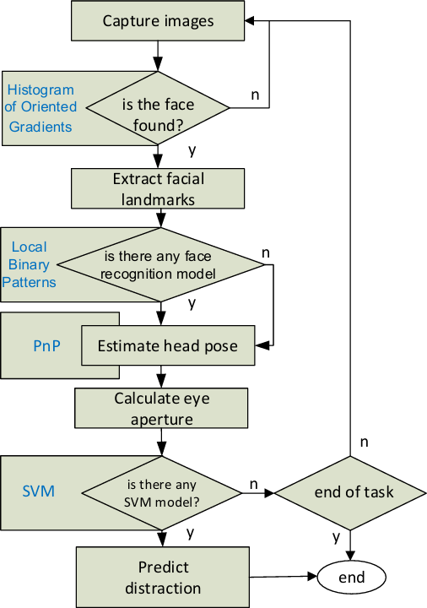

Fig 3.1: Block Diagram of the Existing method

Using the Histogram of Oriented Gradients (HOG) method, faces were detected.

The Local Binary Patterns (LBP) technique was used for face identification.

The OpenCV library's methods were used for face tracking, face recognition, and head posture estimation; face detection and feature extraction were handled by the dlib library's functions.

While SVM is employed here for image classification, CNN—which is superior to SVM—was employed for this project.

Step by step process or methods that we proposed are as follows:

1. Data Collection and Preparation

For both alertness detection and facial recognition, the system needs a dataset. While a new dataset is built to discriminate between "active" and "not active" states based on facial landmarks and eye aspect ratio (EAR), the UTKFace dataset is used for student registration and recognition. Students register by using a webcam to take pictures of their faces. Along with encodings created by the face\_recognition package, which uses deep learning methods and the Histogram of Oriented Gradients (HOG) for facial recognition, these photos are processed and saved locally.

Furthermore, a webcam is used to gather real-time data of "active" and "not active" states, and samples are kept in the appropriate directories. The CNN model uses these datasets as inputs for both training and validation.

1. Facial Recognition

In order to extract facial encodings from registered student images and compare them to live webcam footage, the system combines HOG and deep learning-based face recognition models. The face\_recognition library is utilized to do this. Using dlib's 68 facial landmarks, it is possible to reliably identify the student even in low-resolution

photographs. The system logs student attendance in an Excel sheet when it has been recognized, preventing duplicate attendance records within a six-hour period. We also employed comparable techniques in this research because the accuracy of the current procedures is over 90%.

1. Eye Aspect Ratio (EAR) for Alertness Detection

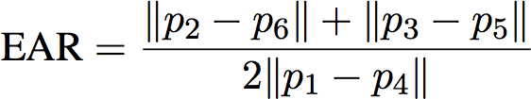

Fig 3.2 Eye Aspect Ratio

Using dlib's 68 landmarks, the eye aspect ratio (EAR), which measures the Euclidean distances between particular places on the eye, is tracked in order to assess a student's level of attention. The student is labeled as "not active" by the system if their EAR is below a predetermined threshold (e.g., 0.25), for a predetermined amount of frames. If, on the other hand, the EAR stays over the cutoff, the pupil is labeled as "active." A camera feed is used to accomplish this technique in real time.

1. Training the Convolutional Neural Network (CNN)

Based on face image recognition, a CNN model is trained to differentiate between "active" and "not active" states. Multiple convolutional and pooling layers are used in the model to extract spatial characteristics, while fully connected layers are used for classification. The model is trained by the system using Keras with a TensorFlow backend. Using ImageDataGenerator for data augmentation, the dataset—which includes both active and inactive samples—is divided into training and validation sets.

1. Model Evaluation

The accuracy, precision, recall, and F1-score of the trained model are assessed using the validation dataset. By contrasting the actual labels with the anticipated outputs, these metrics are computed. The classification performance is visualized by creating a confusion matrix. To evaluate the model's capacity to discriminate between active and non- active states, the ROC-AUC score is calculated.

1. Integration and User Interface

All of the system's features are combined into one application, Flask, and are accessible through an intuitive user interface. Through the given web sites, users can register, identify, and detect attentiveness with ease.

Using cutting-edge image processing techniques and machine learning models, this methodology offers a thorough approach to creating a system that efficiently recognizes and detects student attention.

1. Results and Discussions

The system's efficacy in registering students, identifying their faces, and ascertaining their level of awareness were assessed.

Fig-4.1 UI After Execution of source code Students' photos were taken with a webcam during the

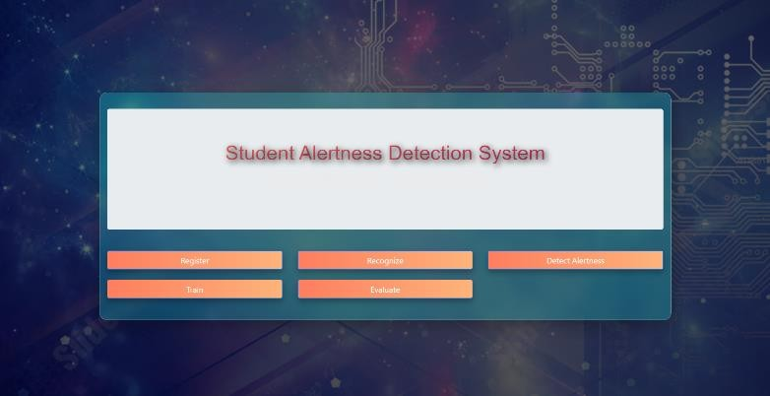registration process and saved in the student_images directory. Facial encodings, which are essential for the system's facial recognition component, were created using these photographs.

Images were divided into two types for the purpose of alertness detection: "active" and "not active." With "active" photos kept in the CNN_dataset/active/ directory and "not active" images in the CNN_dataset/not_active/ directory, the CNN was trained using these categorized images. The accuracy, precision, and recall of the model in identifying these states were evaluated.

Through the use of facial recognition technology, users can check attendance, identify students through registration, and take pictures with their webcams. The application also has tools for classifying alertness in students by training a CNN model, assessing the model's performance, and detecting students' alertness by monitoring eye aspect ratio. HTML templates are used to generate the user interface, and face identification, picture processing, and attendance tracking are handled on the backend.Once a student has regis tered, the Recognize functionality allows them to be identified. Following identification, the student's name and time are entered into an Excel file that shows their attendance.

As seen in figure 4.2, we may create a dataset by using Detection attentiveness, which CNN can utilize to categorize and determine a student's level of attentiveness.

As seen in fig. 4.1, this dataset is trained using the Train functionality. Since CNN is utilized for the categorization of active and nonactive images, here we obtain better results than SVM after training model accuracy is calculated using the Evaluate functionality.

The outcomes highlight how well CNNs perform challenging picture classification tasks. The accuracy with

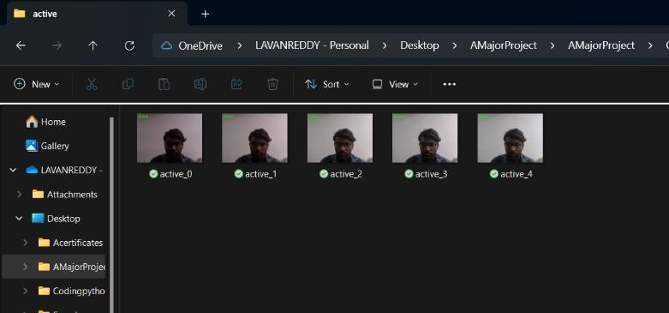

Figure-2 Dataset after Detection

which the system recognizes faces and detects alertness demonstrates how well the CNN architecture learns to recognize and differentiate between

visual patterns linked to various alertness levels. The photographs in the student_images directory was vital in producing precise facial encodings, which were necessary for the identification stage. CNN was efficiently trained to distinguish between active and non-active states thanks to the categorized photos in CNN_dataset/active/ and CNN_dataset

/not_active/.

There are, nevertheless, certain places that may use better. To improve the model's generalization ability, for example, adding more diverse photos to the dataset could help it recognize different facial emotions and lighting circumstances. The model's resistance to overfitting may also be strengthened by utilizing cutting edge methods like data a ugmentation.

The deployment of the system proved its usefulness in educational environments, where tracking student participation can have a big impact on learning results. The system's real-time feedback enables teachers to quickly resolve concerns regarding students' attentiveness, which enhances the interaction and responsiveness of the learning e nvironment.

To sum up, the study effectively employed a CNN-based strategy for identifying student alertness, and the outcomes demonstrated the model's potency in facial recognition and al ertness categorization. These outcomes were made possible by the appropriate arrangement and use of the photos in the designated directories, and further development and enhancements could increase the functionality and performan ce of the system even further.

Convolutional Neural Networks (CNNs) for alertness detection and facial recognition in real time. The system was able to classify students' alertness states and identify them efficiently by using CNNs to process visual data that was obtained via a camera. The outcomes demonstrated CNNs' high degree of accuracy in picture processing and analysis, allowing for dependable student involvement tracking. The project's goals were successfully met thanks to the systematic method of employing facial encodings for recognition and categorized picture data for attentiveness detection. User interaction and system management were further enhanced by the integration of these technologies into an easily navigable web-based interface.

Table-1 Comparison of different models

|  |  |  |  |  |
| --- | --- | --- | --- | --- |
| Model | Accuracy | Precision | Recall | F1 Score |
| SVM | 0.82 | 0.78 | 0.75 | 0.76 |
| Random Forest | 0.85 | 0.82 | 0.80 | 0.81 |
| KNN | 0.78 | 0.73 | 0.70 | 0.71 |
| CNN | 0.92 | 0.88 | 0.86 | 0.87 |

Table-2 Evaluation Metrics of CNN Model

|  |  |
| --- | --- |
| Evaluation Metric | Value |
| Accuracy | 0.92 |
| Precision | 0.88 |
| Recall | 0.86 |
| F1 Score | 0.87 |

Table 1 shows that CNN provides greater accuracy than other models, hence I choose to utilize it for classification in my project.

1. Conclusions and Future Scope
2. Conclusion

Using Convolutional Neural Networks (CNN) to construct the "Student Alertness Detection System" has shown to be a successful method for tracking and identifying students' alertness in real-time during class. Based on students' facial expressions and eye movements, the system can discern between active (alert) and not-active (not alert) states with accuracy thanks to face recognition technology and the eye aspect ratio (EAR) metric. Sophisticated feature extraction is made possible by CNN implementation, which enables the model to examine minute facial landmarks and expressions that are important markers of attentiveness.

A unified online application that incorporates HTML, CSS, JavaScript, Python, and Flask guarantees that the system is scalable, accessible, and user-friendly across a range of platforms and devices. The system provides a complete solution for monitoring cognitive states in a learning environment for educators and students through features like awareness detection, training, registration, and recognition. Real-time alertness detection improves student participation in the classroom by giving prompt feedback and enabling prompt actions when tiredness or distraction is detected.

To sum up, the "Student Alertness Detection System" provides technology-driven solutions to meet the growing demand for raising student involvement and attention in traditional classroom settings as well as online learning environments. Enhancing learning outcomes through effective CNN-based detection algorithms and real-time feedback, the system provides a useful tool. Expanding the dataset, enhancing the accuracy of the model, and incorporating multimodal data sources like voice or body language are possible areas of future research to improve the system's overall capacity to evaluate students' alertness.

1. Future Scope

The "Student Alertness Detection System" offers a number of exciting opportunities for further growth and improvement. The model's generalization and robustness can be enhanced by broadening the dataset to encompass a greater range of facial traits, varied demographics, and environmental circumstances. The accuracy of the alertness detection procedure could be further improved by integrating additional physiological data, such as heart rate, blink rate, or body posture, through multimodal sensors.

Additionally, in conversation-based learning environments, the system can assess verbal cues and identify indicators of disengagement by incorporating voice analysis and natural language processing (NLP) approaches. Applications for the technology that go beyond educational environments include alertness tracking connected to healthcare, employee productivity monitoring, and driving fatigue identification. Scalability and cloud-based deployment can improve real- time data processing and facilitate widespread adoption amongst institutions. In the end, increasing student engagement and learning results may be achieved by optimizing hyperparameters and utilizing sophisticated deep learning architectures to boost performance. This would make the system more effective and adaptable to changing circumstances.

References

1. Coates, H. Engaging Students for Success: Australasian Survey of Student Engagement; Australian Council for Educational Research: Victoria, Australia, 2008.
2. Kuh,G.; Cruce, T.; Shoup, R.; Kinzie, J.; Gonyea, R. Unmasking the Effects of Student Engagement on First Year College Grades and Persistence. J. High. Educ. 2008, 79, 540–563.
3. Günüç,S. The Relationships Between Student Engagement and Their Academic Achievement. Int. J. New Trends Educ. Implic. (IJONTE) 2014, 5, 216–223.
4. Casuso-Holgado, M.J.; Cuesta-Vargas, A.I.; Moreno- Morales, N.; Labajos-Manzanares, M.T.; Barón-López, F.J.; Vega-Cuesta, M. The association between academic engagement and achievement in health sciences students. BMC Med. Educ. 2013, 13, 33.
5. Trowler, V. Student Engagement Literature Review; Higher Education Academy: New York, NY, USA, 2010.
6. FredrickJ, A.S.; Blumenfeld, P.C.; Paris, A.H. School Engagement: Potential of the Concept, State of the Evidence. Rev. Educ. Res. 2004, 74, 59–109.
7. Jafri, R.; Arabnia, H. A Survey of Face Recognition Techniques. J. Inf. Process. Syst. 2009, 5, 41–68.
8. Bledsoe, W.W. (a). Man-Machine Facial Recognition: Report on a Large-Scale Experiment; Technical Report PRI 22; Panoramic Research, Inc.: Palo Alto, CA, USA, 1966.
9. Bledsoe, W.W.; Chan, H. A Man-Machine Facial Recognition System—Some Preliminary Results; Technical Report PRI 19A; Panoramic Research, Inc.: Palo Alto, CA, USA, 1965.
10. Ballantyne, M.; Boyer, R.S.; Hines, L.M. Woody Bledsoe—His Life and Legacy. AI Mag. 1996, 17,