Ideation Phase
Define the Problem Statements
Attribute | Details
Date | 08 March 2026
Team ID
Project Name | VoltEdge: EV Data Analytics Dashboard using Tableau & PostgreSQL
Maximum Marks | 2 Marks

Team Members
- Sanskruti Roman – Team Lead
- Lavani Sardar – Member
- Sanskruti Sawant – Member
- Sayali Firake – Member

Project Overview
This project focuses on analyzing Electric Vehicle (EV) data using PostgreSQL for robust data storage and Tableau for creating interactive, high-fidelity visualizations. The system analyzes EV charging patterns, battery performance, and vehicle efficiency to bridge the information gap for city planners, fleet managers, and consumers. The final dashboards are integrated into a responsive web interface using Flask, providing a centralized portal for data-driven mobility insights.

Technical Architecture
The project follows a structured 5-step data pipeline to ensure data integrity and visualization accuracy:
- Data Collection: Gathering comprehensive EV datasets (Specs, Range, Pricing, and Infrastructure) from public EV repositories.
- Data Storage: Consolidating raw data into a structured PostgreSQL database environment.
- Data Processing: Utilizing SQL queries (DML/DDL) within pgAdmin for data cleaning, normalization, and transformation.
- Visualization: Designing a suite of 11 interactive Tableau dashboards to identify trends and outliers.
- Web Integration: Embedding the Tableau visualizations into a Flask web application using the Tableau JavaScript API for a seamless user experience.

Problem Statements
PS-1: Charging Pattern and Usage Analysis
- I am: Aarav, a city energy planner.
- I’m trying to: Understand the peak hours and geographic hotspots where EV users charge their vehicles.
- But: I do not have a clear, unified visualization of charging demand across different times and locations.
- Because: EV charging data is scattered across multiple providers and formats, making it difficult to interpret without advanced analytics.
- Which makes me feel: Concerned about potential grid instability and the risk of inefficiently placing new charging infrastructure.
PS-2: Battery Performance vs. Driving Range
- I am: Meera, a fleet manager of an EV taxi company.
- I’m trying to: Monitor the real-world battery performance and range efficiency across my entire fleet.
- But: I cannot easily identify which specific vehicles or battery types are underperforming compared to manufacturer benchmarks.
- Because: Raw operational data (Wh/km, Top Speed, Range) is complex and lacks visual context for quick comparison.
- Which makes me feel: Worried about rising maintenance costs, reduced operational lifespan, and unexpected vehicle downtime.
.
Sample Analytical Graphs
The following graphs from the VoltEdge portal provide the insights required by our primary stakeholders:
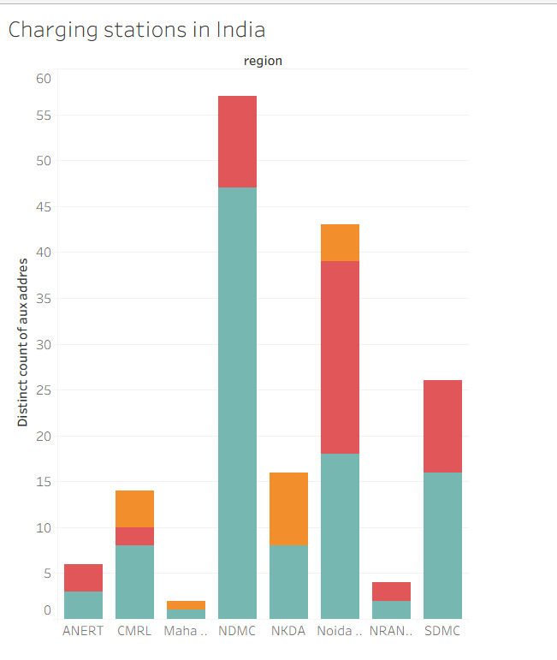
- Figure 1: Regional Infrastructure Analysis – This chart allows planners to see that regions like NDMC have the highest density of stations, while others need more investment.
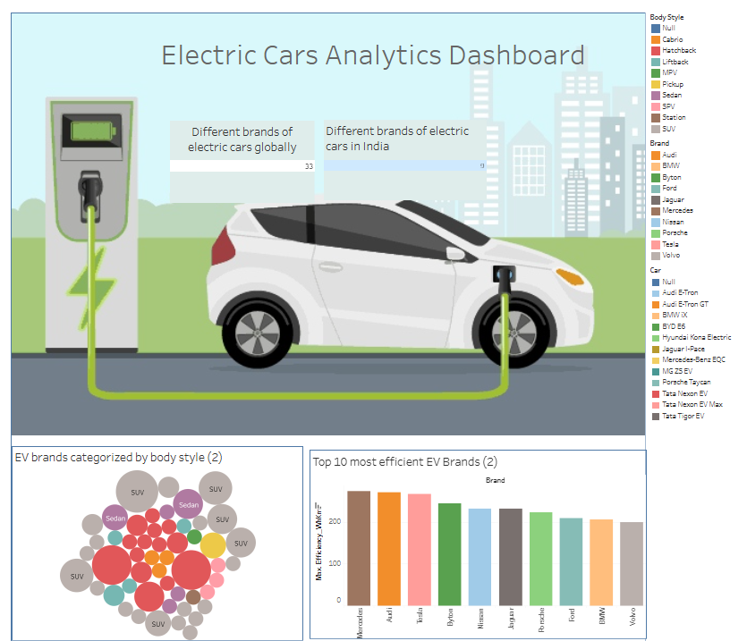
- Figure 2: Comprehensive EV Market Overview – This interactive dashboard provides a 360-degree view, from Body Style distribution (Bubble Chart) to Brand Efficiency (Bar Chart).
Conclusion
The VoltEdge dashboard successfully streamlines the analysis of complex EV data using the power of PostgreSQL and Tableau. By converting raw data into interactive visual stories, the platform empowers stakeholders to optimize energy consumption, manage fleet health, and support the global transition to sustainable transportation.

