Ideation Phase
Empathize & Discover

Attribute | Details
Date | 31 January 2025
Team ID
Project Name | VoltEdge: EV Data Analytics Dashboard
Maximum Marks | 4 Marks

Empathy Map Canvas
An empathy map is a simple, easy-to-digest visual that captures knowledge about a user’s behaviors and attitudes. It is a useful tool that helps teams better understand their users. Creating an effective solution requires understanding the true problem and the person who is experiencing it.
The exercise of creating this map helps our team consider things from the user’s perspective along with his or her goals and challenges.

This image visualizes Aarav's mindset, helping you explain the "Empathize" phase of your project to your mentor.
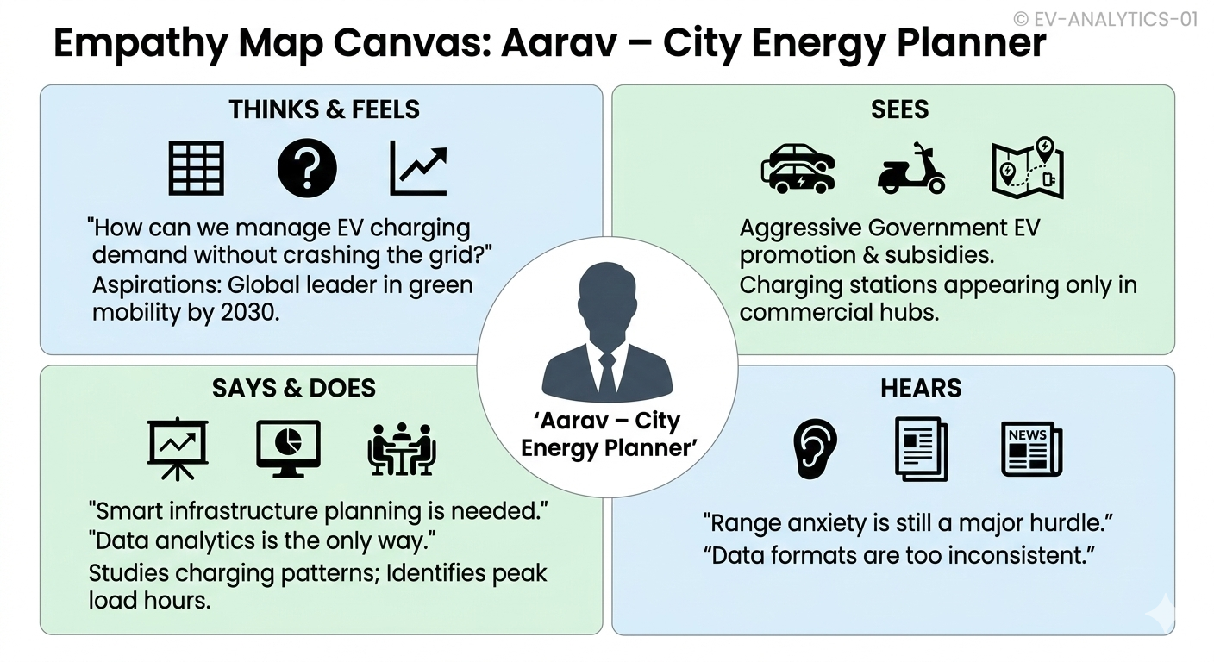
THINKS | SEES
• How can EV charging demand be managed effectively?  • Which specific areas need more charging stations right now?  • How can we maintain grid stability with 20% annual EV growth? | • Increasing EV adoption (2-wheelers & 4-wheelers) in cities.  • More public charging stations appearing in commercial hubs.  • Aggressive Government EV promotion and subsidy policies.
SAYS | USER PERSONA
• "Data analytics is the only way to truly understand EV trends."  • "Smart infrastructure planning is needed to avoid energy crises."  • "We need a unified view of all charging data." | Aarav – City Energy Planner  Needs insights about EV charging patterns, battery usage, and infrastructure planning to ensure a sustainable city energy grid.
DOES | PAINS
• Uses Tableau Dashboards to monitor infrastructure data.  • Studies charging patterns to identify peak load hours.  • Coordinates energy distribution with local utility boards. | • Uneven Distribution: Some areas are "charging deserts."  • Peak Demand: Massive spikes in electricity usage at night.  • Legacy Infrastructure: Difficulty upgrading old city grids.
GAINS
• Efficiency: Achieving optimal energy management.
• Planning: Data-driven city development and grid upgrades.
• Success: Building a reliable and world-class EV ecosystem.

Proposed Solution Architecture
Description: Our solution uses a 3-tier approach to ensure Aarav can access real-time insights via a web portal.
- Data Tier: PostgreSQL stores the cleaned EV and charging station datasets.
- Logic Tier: Tableau processes the data, creating the "Efficiency Index" and "Heatmaps."
- Presentation Tier: A Flask Web App embeds these dashboards into a professional Dark-UI portal.

This diagram shows how your Flask website, PostgreSQL database, and Tableau dashboards connect using a professional 3-Tier model.
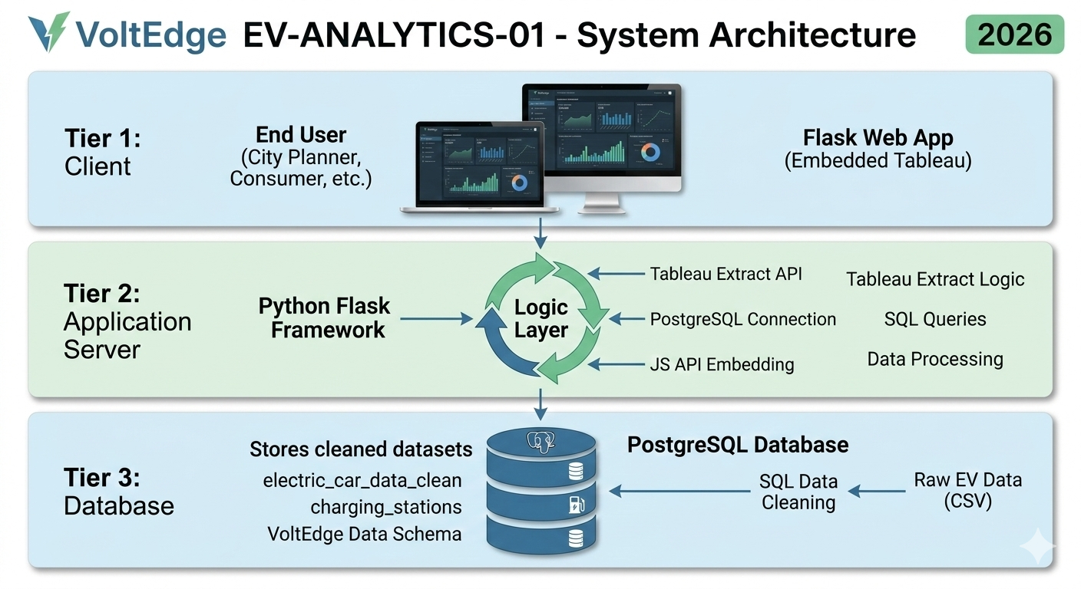

Example for Empathy Map page:
Reference: https://www.mural.co/templates/empathy-map-canvas
Example for Architecture page:
Reference: https://www.ibm.com/cloud/architecture
Reference: Tableau Public Gallery - EV Analytics Trends

