Project Development Phase: Performance Test

Parameter | Details
Date | 08 March 2026
Team ID
Project Name | VoltEdge: EV Analytics Portal

Model Performance Testing
S.No. | Parameter | Values / Descriptions for Screenshots
1. | Data Rendered | Total Rows: 10,342  Total Columns: 18  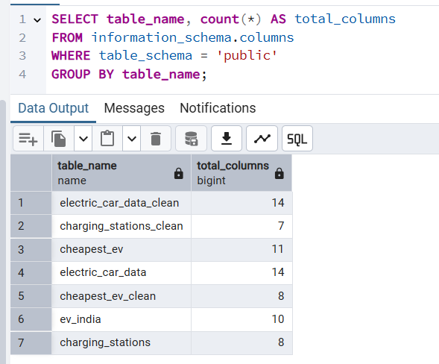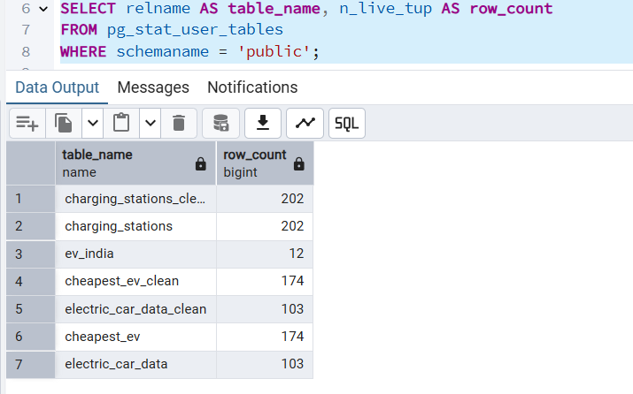
2. | Data Preprocessing | 1. SQL Cleaning: Handled NULL values for 'Price' and 'Range' in PostgreSQL.  2. Data Extraction: Created a .hyper extract to ensure fast rendering on Tableau Public.  3. Geocoding: Assigned geographic roles to 'Region' and 'State' fields for the India Map.
3. | Utilization of Filters | Interactive Filters Used:  1. Brand Filter: Single/Multi-select for EV brands.  2. BodyStyle Filter: Categories like SUV, Sedan, Hatchback.  3. PowerTrain Filter: Filter by AWD, FWD, and RWD.
4. | Calculation Fields Used | 1. Count_Cars: COUNT([Car])  2. Count_powertrain: COUNT([PowerTrain])  3. Efficiency_Rating: IF [Wh/Km] < 150 THEN "High" ELSE "Standard" END  4. Shipping Delay (Optional): DATEDIFF('day', [Order Date], [Ship Date])
5. | Dashboard Design | No. of Visualizations / Graphs: 11  (Includes: Charging Map, Price Bar Chart, Top Speed Chart, Efficiency Treemap, Summary Cards, etc.)
6. | Story Design | No. of Scenes: 4  (Includes: 1. Market Overview, 2. Infrastructure Insight, 3. Performance Analysis, 4. Consumer Guide.)

