# Section A: Theory Questions

# 1. What is a list in Python? Explain how it differs from a tuple.

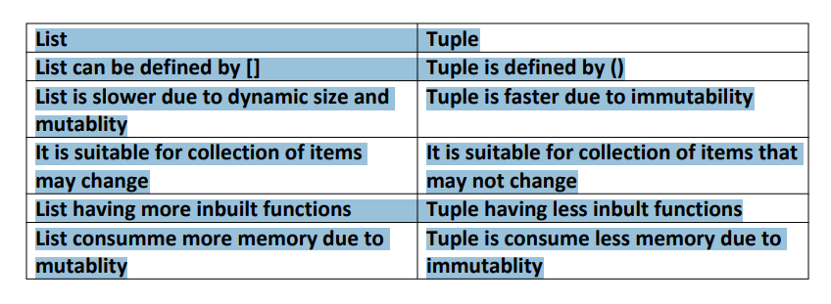

# 2. How does Python handle memory management in terms of garbage collection?

# 3. Describe the difference between == and is operators in Python.

1) == is equal to operator it only compares’ the values.

e.g

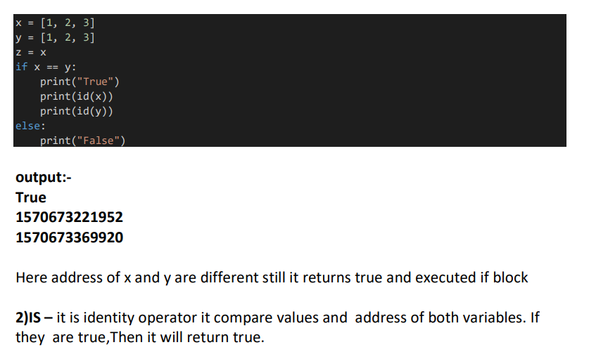

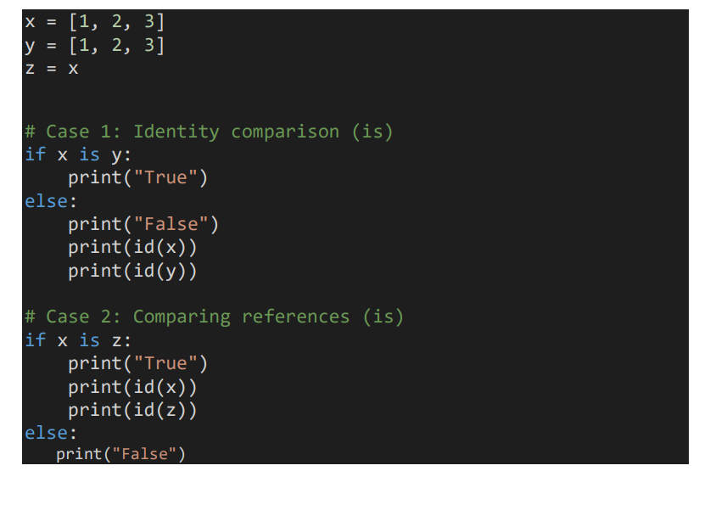

output:-

False

1570673221952

1570673369920

True

1188639039808

1188639039808

Here in case-1 x & y are having different address and same values hence it returns

false

In case-2 x & z are having same address and same value hence it returns true

# 4. Explain the concept of mutable and immutable objects in Python with examples.

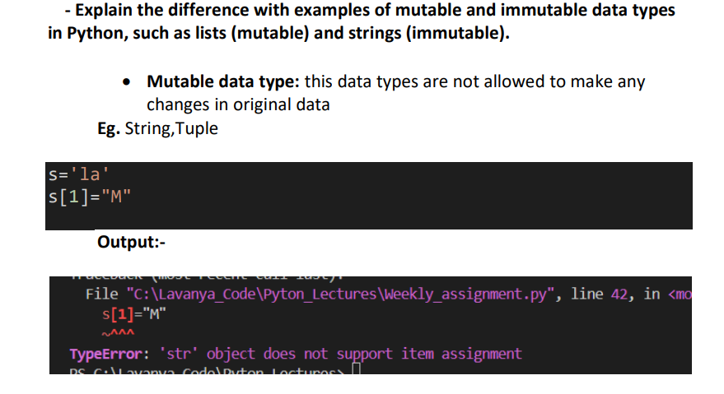

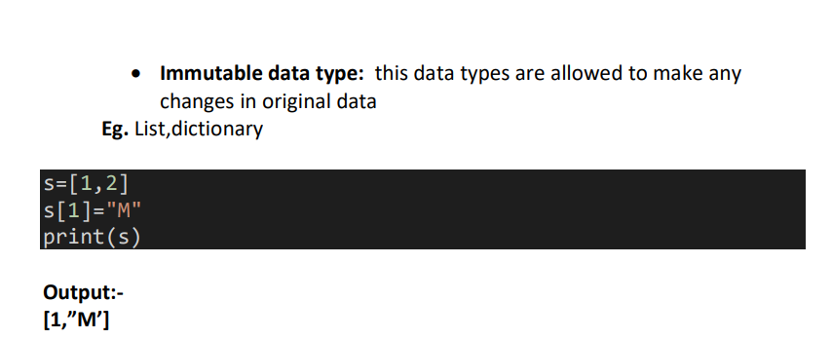

# 5. What is the purpose of a dictionary in Python? How is it different from a list?

Dictionary: it is mapping data type which stores data. in the form of key value

pairs

Keys in dictionary are unique ,dictionary is defined using {} and dict() method# 6. What are the basic loop structures in Python? How do for and while loops differ?

Elements from the list can be accessed using the index, while the elements of the dictionary can be accessed using keys.1

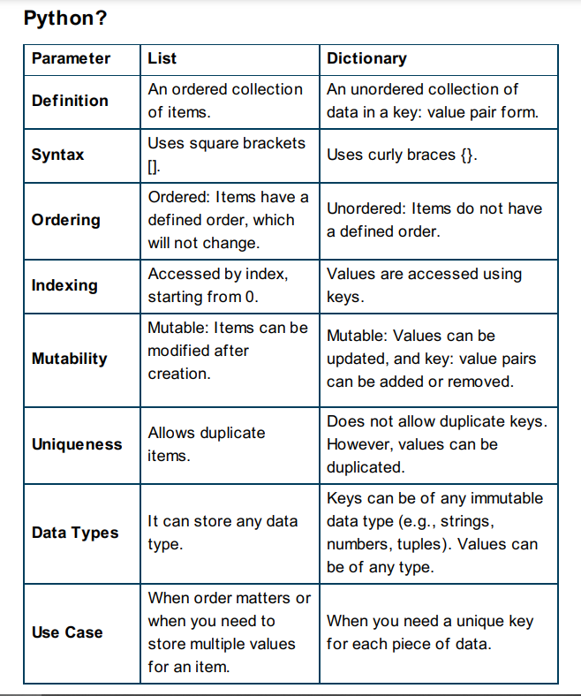

6. What are the basic loop structures in Python? How do for and while loops differ?

If you want to iterate a elements of any ie

# 7. What is the output of the following Python expression? Explain the result:

# print(len("Hello") + 10 - 3)

# output:12

# here len method returns the count of letters in string hence

# it returns 4 +10-3 =12

# 8. What do the terms "key" and "value" represent in a Python dictionary?

# value: in dictionary represents any type of data like int,string,float set,list

# key:in dictionary reperesnts the unque value(string, number, or tuple with immutable elements) which can be extracted the value

# 9. How do you access elements from a tuple? Can you change the elements of a tuple?

Tuple is MUTABLE

if you want to change tuple elements then

You have to convert it into a list type and change the element

And convert tuple back to tuple type

# 10. Describe what is meant by a set in Python. How does a set differ from a list?

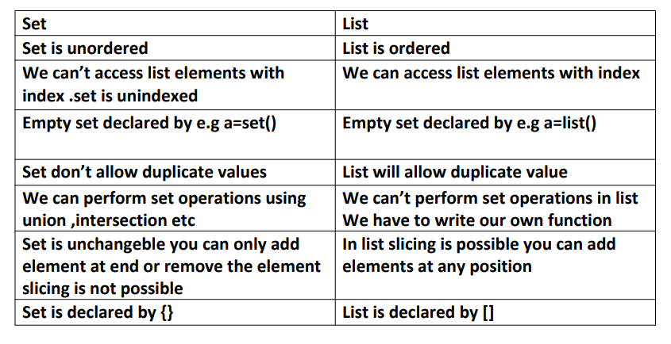

#  Section B: Code Output / Correction Questions

# 1. What will be the output of the following code?

# a = [1, 2, 3, 4]

# a[1] = 10

# print(a)

# ANS:[1,10,3,4]

# 2. The following code contains an error. Identify and correct it.

# nums = {1, 2, 3, 4, 5}

# nums.add([6, 7])

# print(nums)

# ANS: unhashable type:list

# 3. What will be the output of this code?

# num = 10

# while num > 0:

#     print(num)

#     num -= 2

# ANS:10

# 8

# 6

# 4

# 2

# 4. Correct the following code to make sure it adds the item to the dictionary:

student = {"name": "John", "age": 20}

student["marks"] = 80

# print(student)

# ANS: no any correction is needed

# 5. What will be the output of this code?

# tuple1 = (1, 2, 3, 4)

# tuple2 = (5, 6)

# print(tuple1 + tuple2)

# output:(1,2,3,4,5,6)

# 6. The following code contains an error. Find and correct it.

# data = [5, 10, 15, 20]

# if 10 in data:# :colon is very important

#        print("Found")

# 7. What will be the output of this code?

# a = [1, 2, 3]

# b = a

# a.append(4)

# print(b)

# ANS:[1,2,3,4]

# 8. The following code is incorrect. Correct the error in the while loop.

# num = 0

# while num < 5:

#        print("Python")

# ANS: infinite loop

# 9. What will be the output of the following code?

# x = 5

# if x < 10:

#        print("Smaller")

# else:

#        print("Larger")

# output:Smaller

# 10. The following code throws an error. Identify and correct it.

#    nums = {1, 2, 3}

#    nums.remove(4)

#    print(nums)

#  Section C: Program Writing

# Write Python programs for the following topics:

# 1. List: Write a Python program that takes a list of numbers from the user and calculates the sum of all even numbers in the list.

# l=list(map(int,input("Enter numbers").split(" ")))

# print(l)

# output:[10, 20, 30, 4, 50, 60]

# 2. Set: Write a Python program that takes two sets and returns their union, intersection, and difference.

s1={1,2,3,5,8,9,10,11,4}

s2={10,20,30,3,5,8}

print(s1.intersection(s2))

# output:{8, 10, 3, 5}

print(s1.union(s2))

# output:{1, 2, 3, 4, 5, 8, 9, 10, 11, 20, 30}

print(s1.difference(s2))

# output:{1, 2, 4, 9, 11}

# 3. Tuple: Write a Python program to find the index of the first occurrence of an element in a tuple.

# t=(345,1,2,3,4,90,2,1,34,1)

# print(t.index(1))

# output:1

# 4. Dictionary: Write a Python program that creates a dictionary with keys as names of students and values as their scores, and then prints the student with the highest score.

# d={'abhi':20,'boob':89,'cipra':90,'dipa':45}

# m=max(d.values())

# for i,v in d.items():

#     if v==m:

#         print(i,v)

#         break;

# output:cipra 90

# 5. Conditionals: Write a Python program that takes a number as input and checks whether it is positive, negative, or zero.

# a= int(input("enter number"))

# if a>0:

#     print(f"{a} is positive")

# elif a<0:

#     print(f'{a} is negative')

# else:

#     print(f"{a} is zero")

# output: 0 is Zero

# 6. Loops: Write a Python program that prints all numbers from 1 to 20, but for multiples of 3 print "Fizz" and for multiples of 5 print "Buzz". For numbers which are multiples of both 3 and 5, print "FizzBuzz".

# for i in range(1,20):

#     if(i%3==0):

#         print('Fizz')

#     elif(i%5==0):

#         print("Buzz")

#     elif(i%3==0 and i%5==0):

#         print("FizzBuzz")

#     else:

#         print(i)

# output:1

# 2

# Fizz

# 4

# Buzz

# Fizz

# 7

# 8

# Fizz

# Buzz

# 11

# Fizz

# 13

# 14

# Fizz

# 16

# 17

# Fizz

# 19

# 7. List: Write a Python program that reverses a list

# without using the reverse() method.

# l=[10,20,30,40,50,1,2,3]

# l2=[]

# for i in range(len(l)-1,-1,-1):

#     l2.append(l[i])

# print(l2)

# output:[3, 2, 1, 50, 40, 30, 20, 10]

# 8. Set: Write a Python program that removes duplicates from a list

# by converting it to a set and then back to a list.

# l=[1,2,3,1,2,3,4,5,67,10,20,67,89]

# l=set(l)

# l=list(l)

# print(type(l),l)

# output:<class 'list'> [1, 2, 3, 4, 5, 67, 10, 20, 89]

# 9. Tuple: Write a Python program to convert a tuple into a list

# and a list into a tuple.

# t=(10,20,30,40,506)

# l1=list(t)

# print(type(l1),l1)

# list1=[10,20,30,40]

# t1=tuple(list1)

# print(type(t1),t1)

# output:<class 'list'> [10, 20, 30, 40, 506]

# <class 'tuple'> (10, 20, 30, 40)

# 10. Numeric: Write a Python program that calculates the factorial of a number using a for loop.

# n=int(input("enter no "))

# fact=1

# for i in range(1,n+1):

#     fact*=i

# print(fact)

# output:enter no 5

# 120