# Section A: Theory

import numpy as np

**# 1. What is a NumPy array, and how is it different from a Python list?**

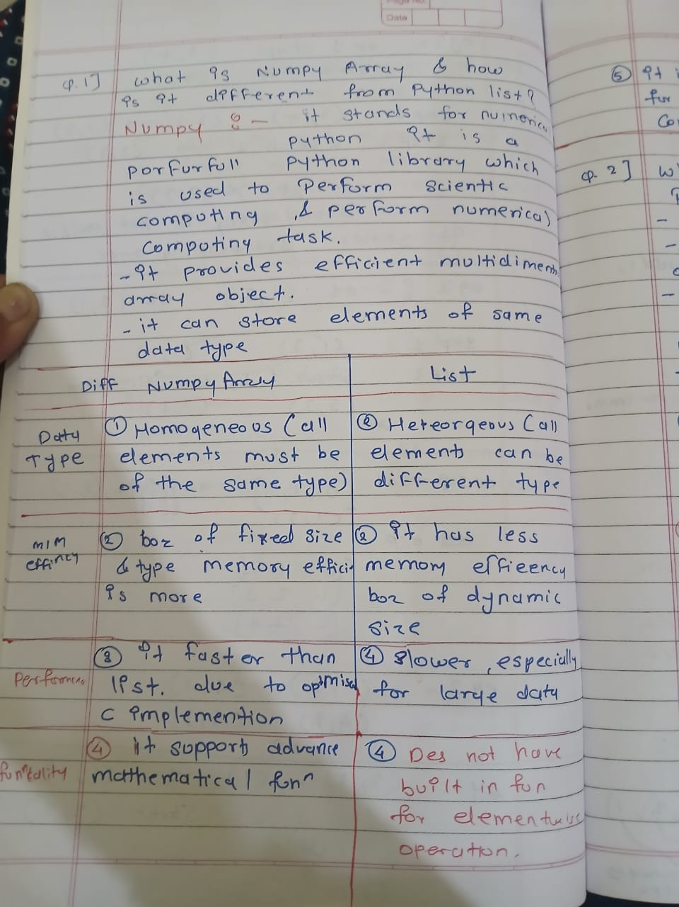

**# 3. What are ufuncs in NumPy? Provide an example.**

x=[1,2,34,4]

y=[10,10,20,10]

print(np.add(x,y))

print(type(np.add))

print(np.sqrt(x))

print(type(np.sqrt))

print(np.less(x,y))

def each_add_10(x,y):

    return x+y+10

arr=np.frompyfunc(each_add_10,2,1)

print(arr(x,y))

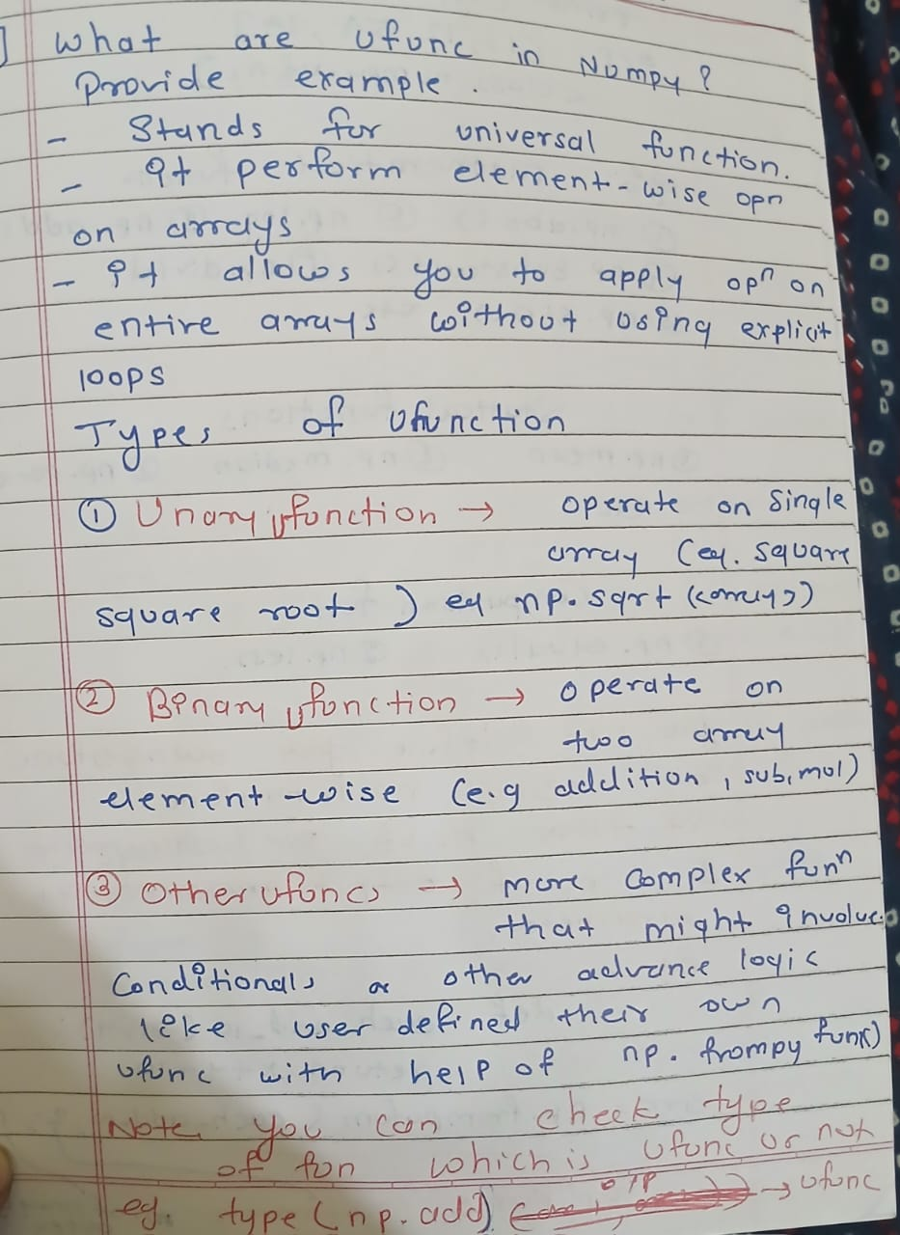

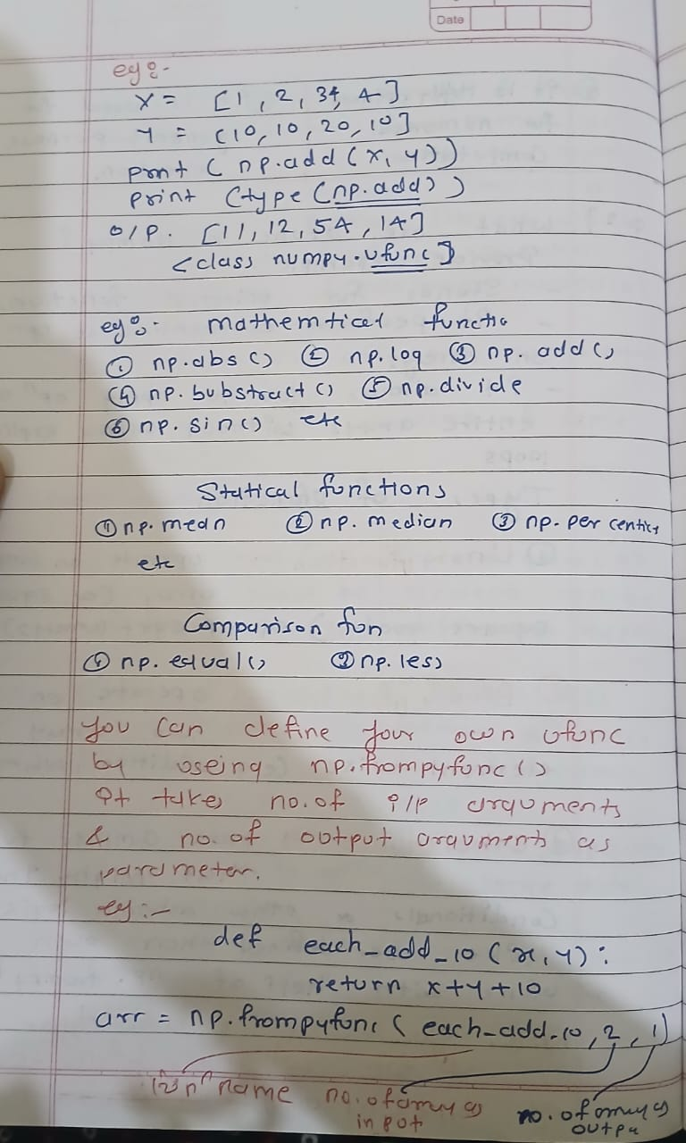

**# 2. Explain the concept of broadcasting in NumPy with an example**.

|  |  |
| --- | --- |
| C:\Users\Admin\Downloads\3-1.jpg | C:\Users\Admin\Downloads\3-2.jpg |

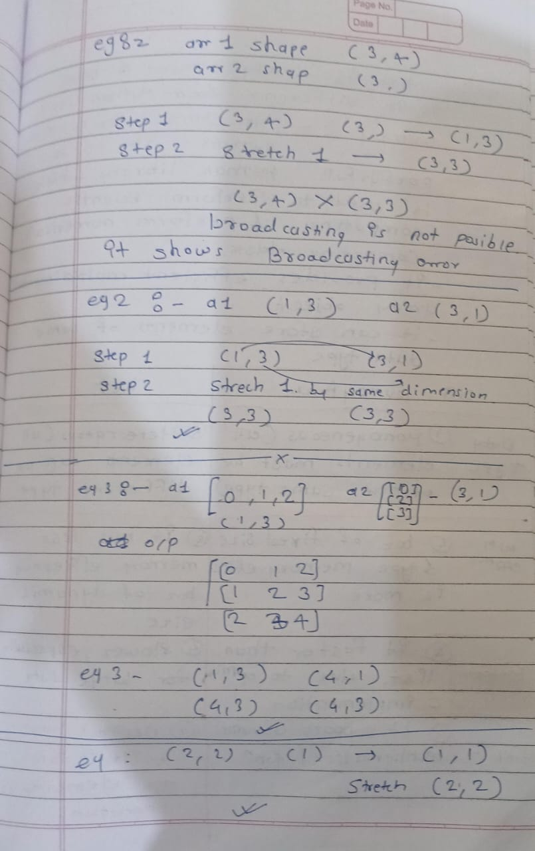

**# 4. What is the purpose of the numpy.random module? Name three functions it provides.**

|  |  |
| --- | --- |
| **C:\Users\Admin\Downloads\4-1.jpg** | **C:\Users\Admin\Downloads\4-2.jpg** |
| **C:\Users\Admin\Downloads\4-3.jpg**  **C:\Users\Admin\Downloads\4-5.jpg** | **C:\Users\Admin\Downloads\4-4.jpg** |

from numpy import random as rd

# rand

# print(rd.rand(2,2))

# [[0.08217302 0.5734172 ]

#  [0.61766962 0.03358355]]

#randint

# print(rd.randint(1,10)) ->5

# print(rd.randint(1,10,(2,2)))

# [[3 2]

#  [5 8]]

# print(rd.randint(1,10,size=5))

# [3 4 1 2 1]

# randn

# print(rd.randn(2,2))

# [[ 2.24035776  1.23595522]

#  [-0.39494653 -0.6499075 ]]

# choice

# print(rd.choice([1,2,3,4]))#2

print(rd.choice([1,1,4,5,6],size=6))#[6 1 6 5 1 1]

print(rd.choice([1,2,3,4],size=3,replace=False))#[2 1 4]

print(rd.choice([1,2,1,3,4],size=4,replace=False))#[2 4 1 1]

# print(rd.choice([1,2,3,4,1],size=6,replace=False))#Error

# Shuffle

arr=[10,20,30,40]

rd.shuffle(arr)

print(arr)

arr2=np.array([[10,20,30],[11,22,33],[1,2,3]])

rd.shuffle(arr2)

print(arr2)

# Permutation

print(rd.permutation([1,2,3,7,8,9,0]))

#uniform

print("Uniform",rd.uniform(1,100))

#normal

print(rd.normal(0,1,(2,2)))

#binomal

print(rd.binomial(10,0.5,3))

#seed

rd.seed(12)#it can be any number

print(rd.rand())

# 5. Explain how to compute the transpose of a matrix in NumPy.

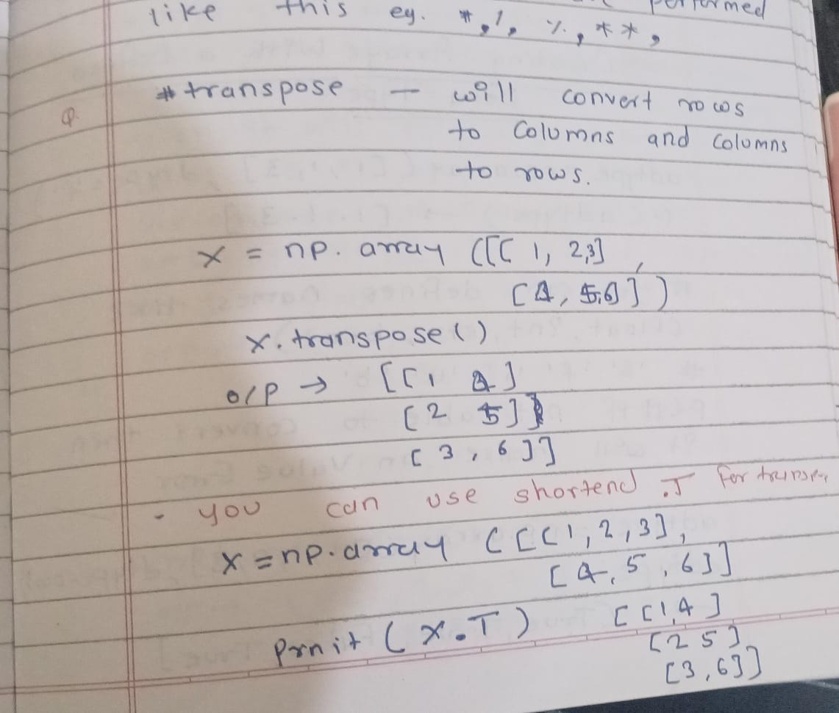

arr=np.array([[1,2,3],[4,5,6]])

print(arr)

trans=np.transpose(arr)

print(trans)

witht=trans.T

print(witht)

# output:

# [[1 2 3]

#  [4 5 6]]

# [[1 4]

#  [2 5]

# #  [3 6]]

# [[1 2 3]

#  [4 5 6]]

# 6. Define the inverse of a matrix. When does a matrix not have an inverse?

|  |  |
| --- | --- |
| 6-1.jpg | 6-2.jpg |

# 7. What are the primary features of a pandas Series?

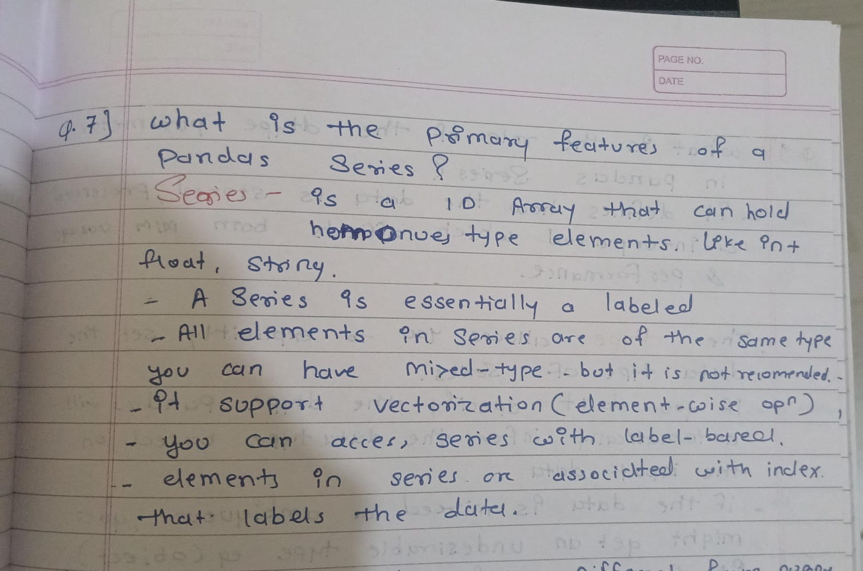

# 8. How does a pandas Series differ from a NumPy array?

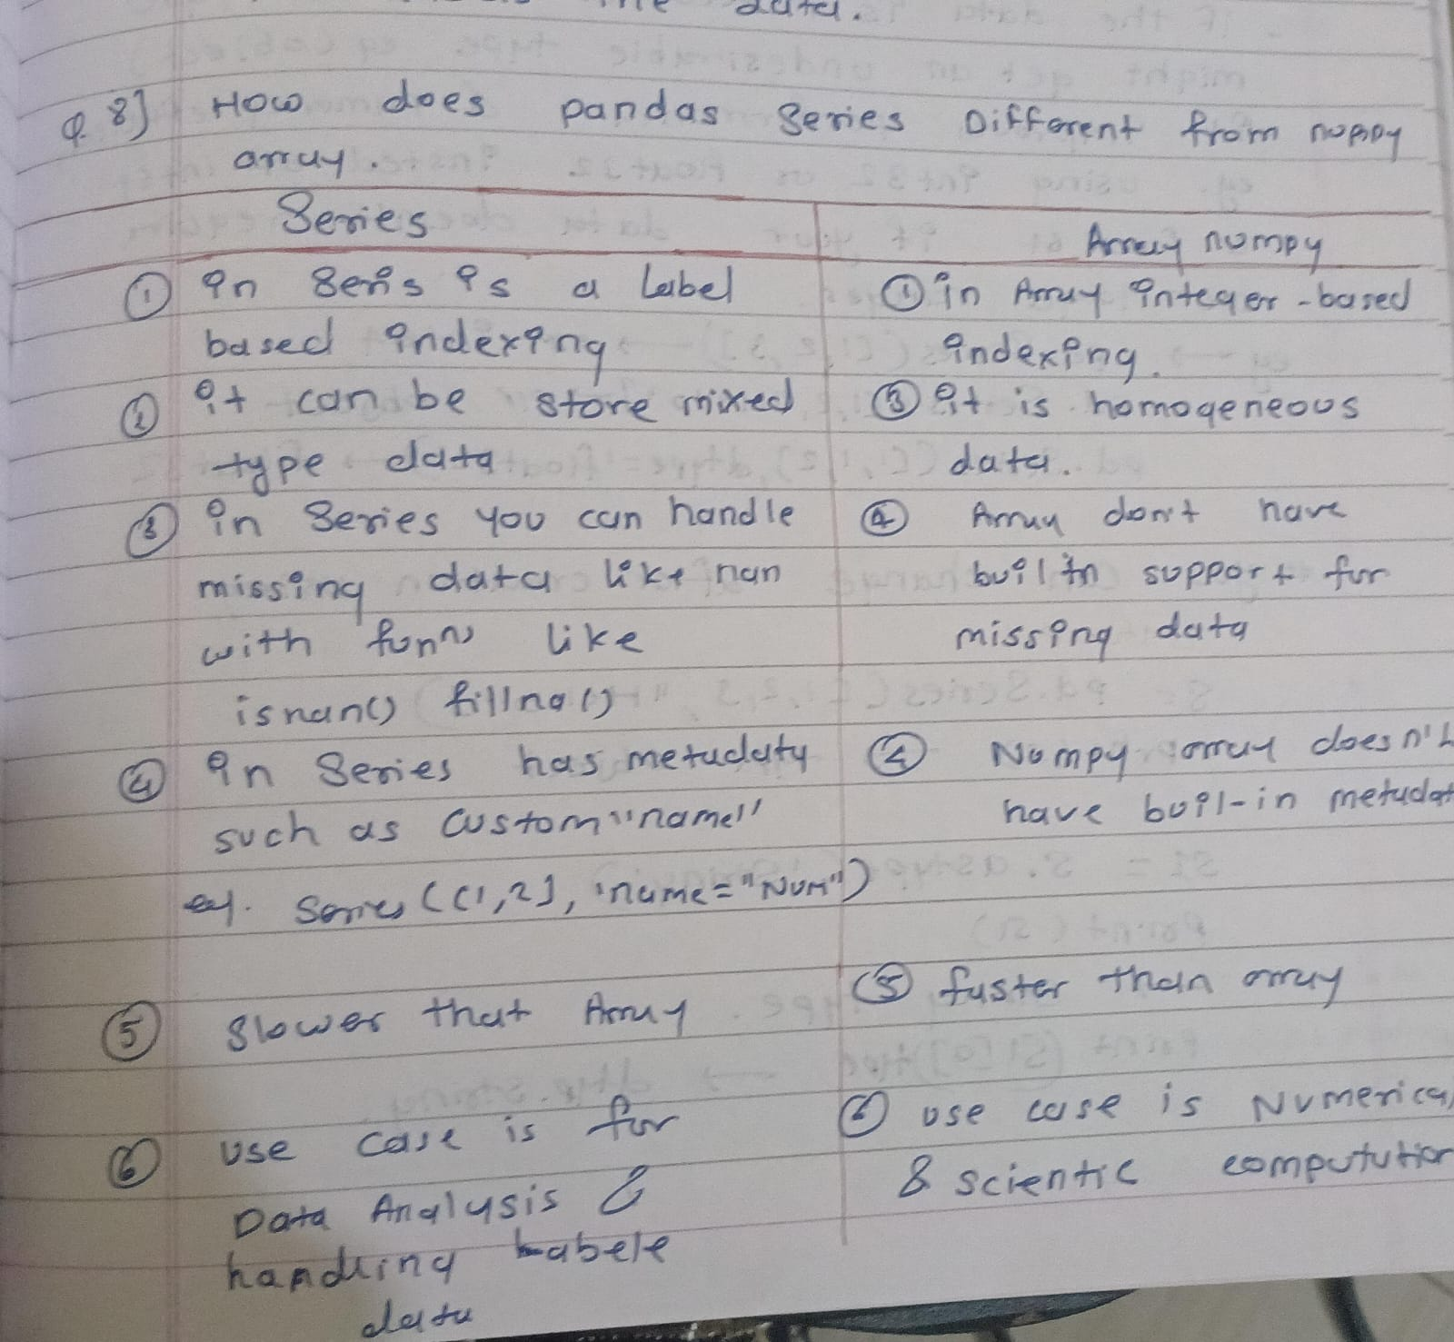

# 9. What is the role of the dtype parameter in a pandas Series?

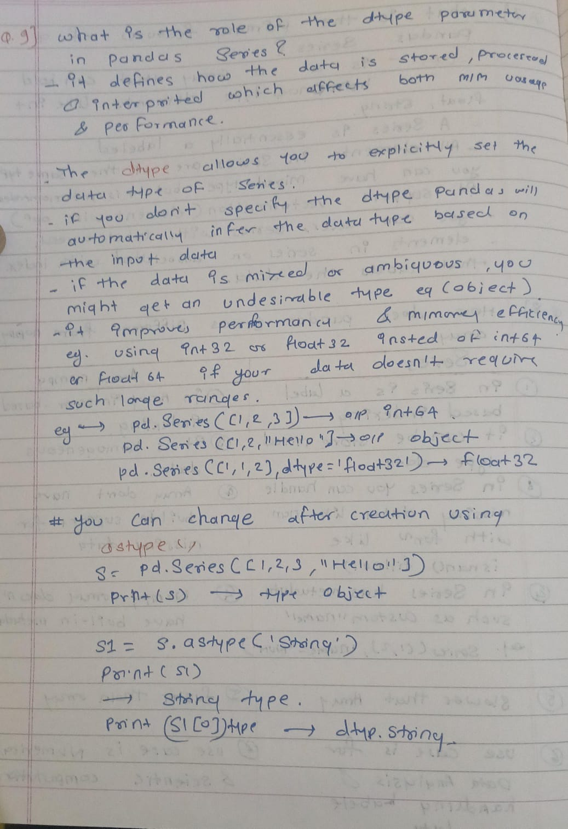

print("Q-9-----------")

s=pd.Series([1,2,3,"hello"])

print(s)

s1=s.astype('string')

print(s1)

print(type(s1[0]))

s2=pd.Series([1,1,2],dtype='float32')

print(s2)

# 10. Discuss the advantages of using pandas over NumPy for data analysis.

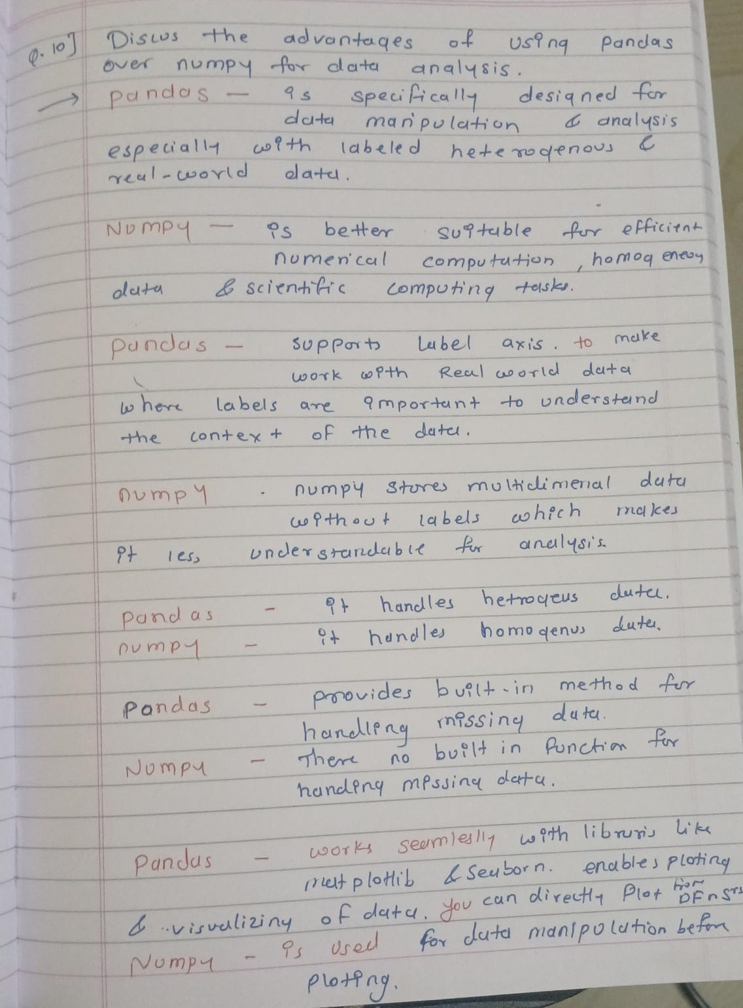

# Section B: Correct the Error

# 1. arr = np.array[1, 2, 3]

#ANS

# arr = np.array([1, 2, 3])

# 2. result = np.random.randint(10, 20, size=5, replace=False)

# ANS:

# result = np.random.randint(10, 20, size=5)  #replace is present choice function

# 3. np.add([1, 2, 3], [4, 5])

# ANS

# print(np.add([1, 2], [4, 5]) )

# 4. matrix = np.array([[1, 2], [3, 4]]) print(matrix.T()

matrix = np.array([[1, 2], [3, 4]])

# ANS: print(matrix.T)

# 5. inv_matrix = np.linalg.inv([[1, 2], [3, 4]])

# inv_matrix = np.linalg.inv([[1, 2], [3, 4]])

# ANS

# print(inv_matrix)

# [[-2.   1. ]

#  [ 1.5 -0.5]]

# 6. series = pd.Series[1, 2, 3]

# ANS

series = pd.Series([1, 2, 3])

print(series)

# 7. data = {'a': 1, 'b': 2, 'c': 3} pd.Series(data, index=data.keys)

ANS

data = {'a': 1, 'b': 2, 'c': 3}

print(pd.Series(data))

# 8. random_arr = np.random.random(2.5)

ANS

random_arr = np.random.rand(2,5)

print(random_arr)

print(np.random.random(2))#random takes only 1 positional argument

# 9. matrix = np.array([1, 2], [3, 4])

ANS

matrix = np.array([[1, 2], [3, 4]])

# 10. print(pd.Series([1, 2, 3, 4], dtype=int64))

ANS

print(pd.Series([1, 2, 3, 4], dtype='int64'))#you  have to give it in string form if you giving with bytes other wise int is ok