ASSIGNMENT 2

LAVANYA K

192121084

1.There are four very old cave painting . Find the oldest painting using else if ladder in c++

4200 years old 8500 years old

1000 years old 1300 years old

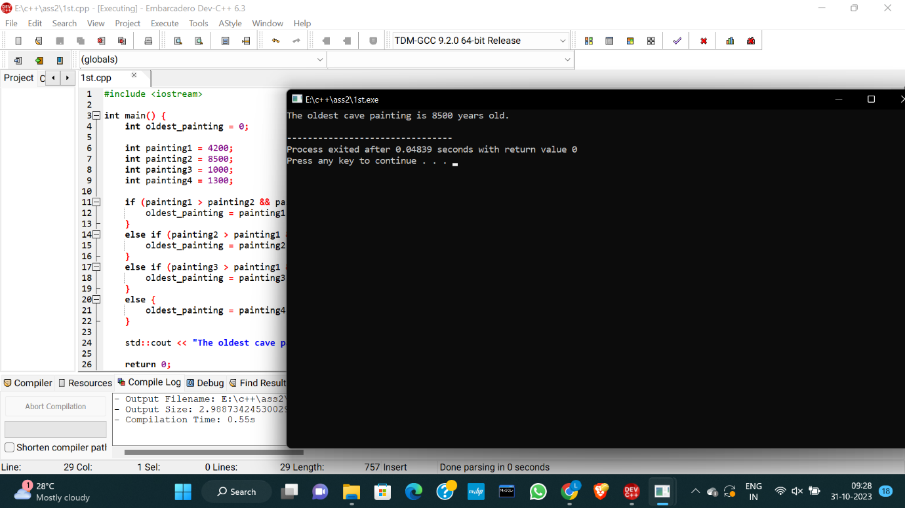

2. One bus can carry 48 children. How many children can three buses carry. Write a c++ program using parameterized constructor.

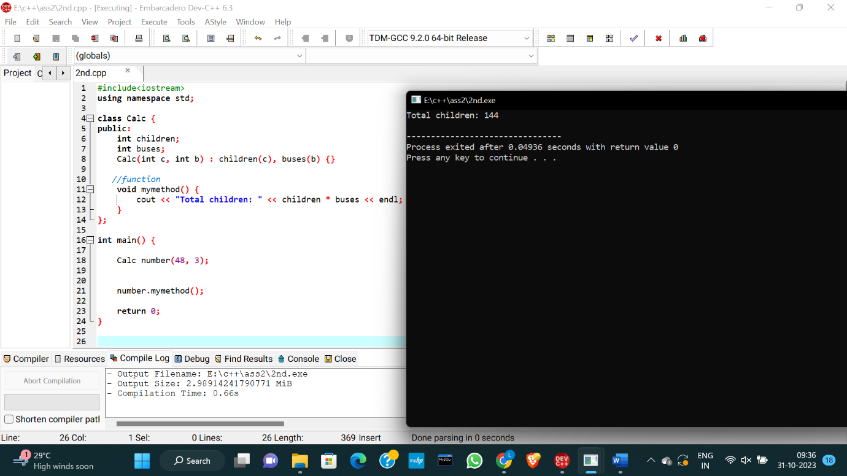

3. Kiran bought 1kg plastic for Rs.10, but sold 1kg plastic for Rs.12. How much money does she earn on selling 1kg plastic? Write c++ program using default constructor.

