ASSIGNMENT3

LAVANYA

192121084

1. 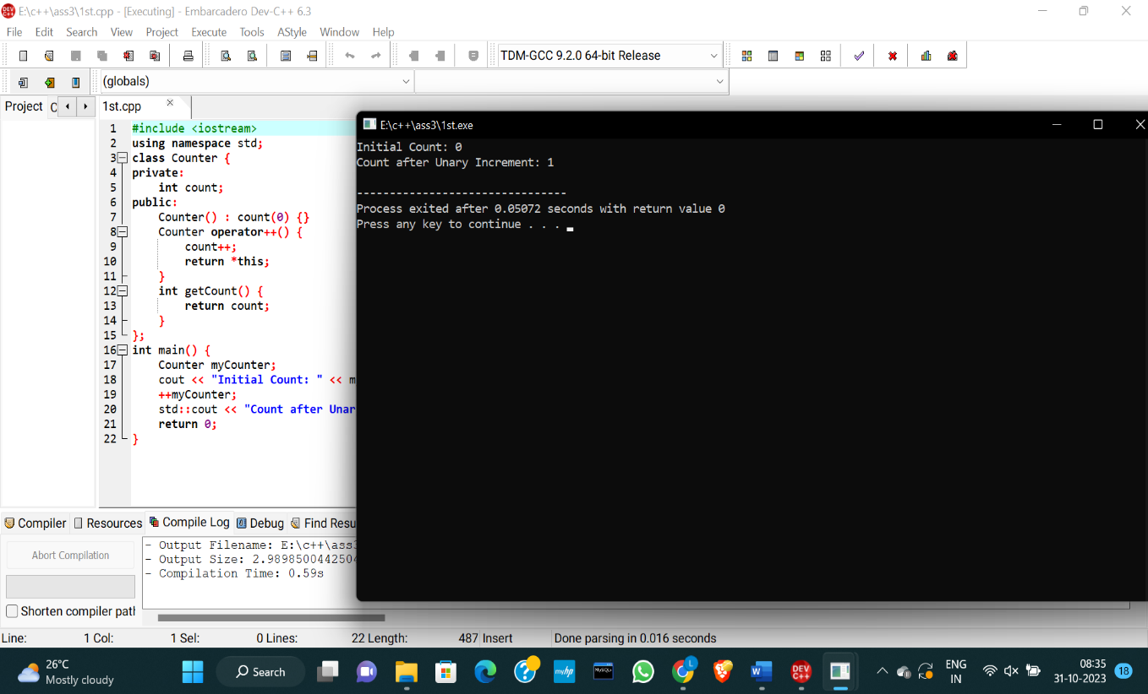Write a C++ program to demonstrate the overloading of a unary operator.

2. Write a C++ program to demonstrate the overloading of a binary operator.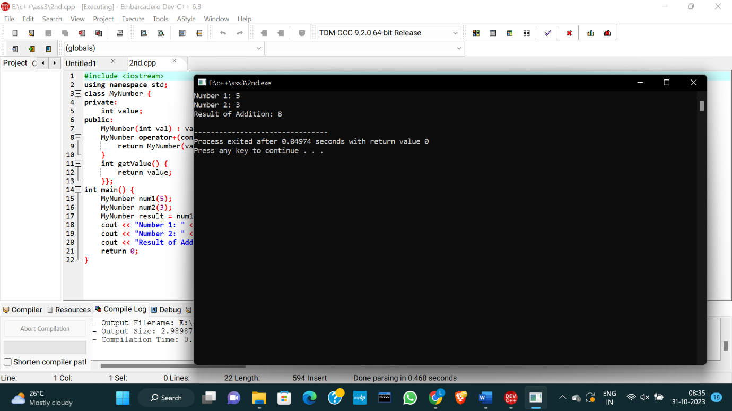

3. What is the output of the following code?

#include<iostream.h> #include<string.h>

void main()

{

cout<<strlen(“Hello, World.\n”)<<”\n”;

}

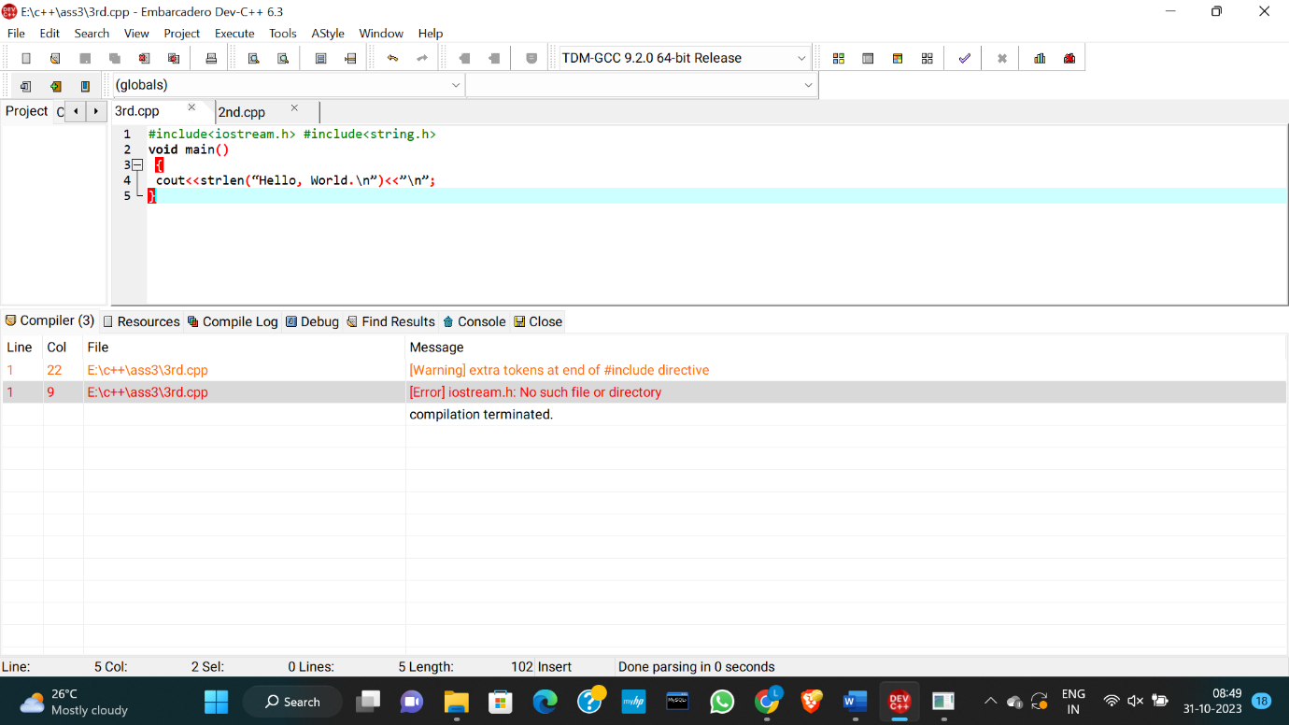

CORRECTED CODE:

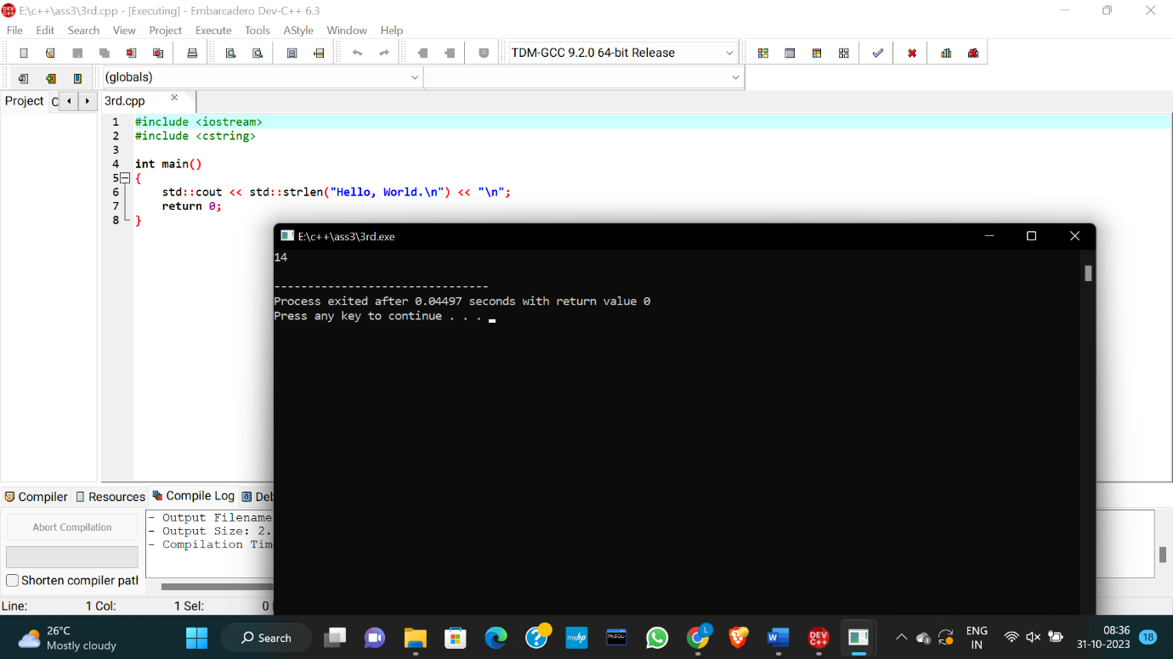

4. What is the output of the following code?

#include<iostream.h>

void main()

{

int a = 20;

int &n = a;

n=a++;

a=n++;

cout<<a <<”,”<<n<<endl;

}

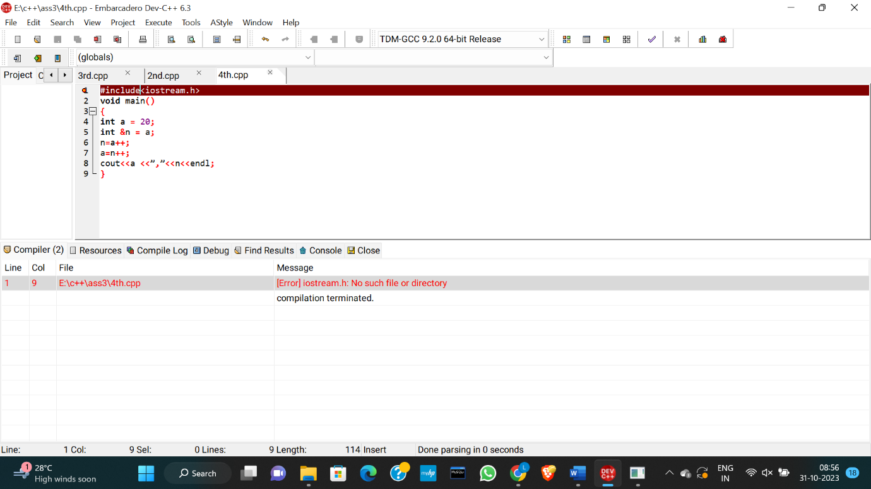

CORRECTED CODE:

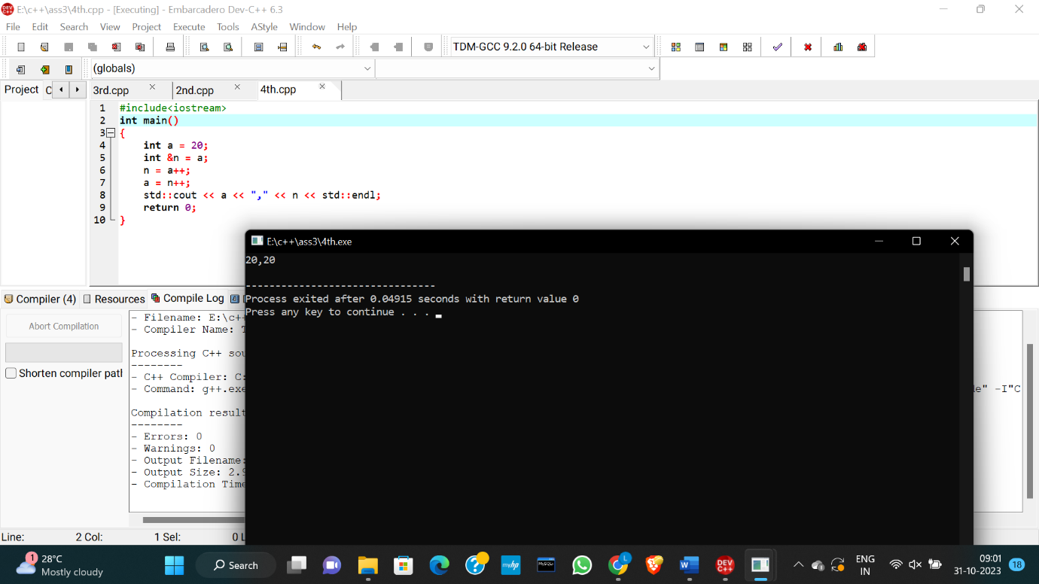

5. Write down a C++ program to implement function overloading.

