TRAIN DATA ANALYSIS AND INTERACTIVE TRAIN ENQUIRY SYSTEM

INTRODUCTION
The Train Data Analysis and Interactive Train Enquiry System is a data analysis project developed using Python and Pandas. The project focuses on analyzing railway schedule data, identifying travel patterns, examining station traffic, and developing an interactive system that allows users to search for direct trains between two stations.
The project was completed in multiple levels, beginning with basic data exploration and cleaning and progressing toward data transformation, statistical analysis, visualization, and finally an interactive train enquiry system.
The main objective of the project is to transform raw railway schedule data into meaningful information that can support train route analysis and provide useful route information to users.

OBJECTIVES
The major objectives of this project are:
- To understand and explore the structure of the railway dataset.
- To clean and prepare the data for analysis.
- To standardize train schedule information.
- To calculate journey durations for different trains.
- To classify routes based on journey duration.
- To analyze train frequency across railway stations.
- To identify high-traffic railway stations.
- To use pivot tables and cross-tabulations for deeper analysis.
- To create meaningful visualizations from the analyzed data.
- To develop an interactive route-based train enquiry system.
- To display available direct trains between a selected source and destination.
- To estimate the journey duration between two selected stations.

TOOLS & TECHNOLOGIES
The following tools and technologies were used in the project:
- Python – Main programming language used for data analysis.
- Pandas – Used for data cleaning, transformation, grouping, aggregation, and analysis.
- Matplotlib – Used for creating data visualizations.
- Jupyter Notebook / Python Environment – for developing and testing the analysis.
- User Input – Used to create the interactive train enquiry system.

DATASET DESCRIPTION
The dataset contains railway schedule information for multiple trains and stations.
Column | Description
SN | Station sequence number within a train
Train_No | Unique train number
Station_Code | Code representing the railway station
Station_Name | Name of the railway station
Route_Number | Route number associated with the train
Arrival_time | Scheduled arrival time
Departure_Time | Scheduled departure time
Distance | Distance covered up to the station
1A | Availability information for First AC
2A | Availability information for Second AC
3A | Availability information for Third AC
SL | Availability information for Sleeper class

LEVEL 1- DATA EXPLORATION
The first level focused on understanding the structure and contents of the dataset.
The dataset was loaded using Pandas and examined to understand the number of records, columns, data types, and general structure.
Basic exploratory operations such as viewing the first and last records, checking column names, and examining data types were performed.
This initial exploration helped in understanding how the train and station information was organized and provided a foundation for the subsequent data cleaning and analysis stages.
Key observations
- Each train can have multiple station records.
- Train_No identifies the train.
- SN represents the sequence of stations within a train.
- Arrival and departure times are important for calculating journey durations.
- Station-level analysis can be performed using Station_Name.
- Route information can be analyzed using Route_Number.

LEVEL 2 –DATA TRANSFORMATION AND ANALYSIS
2.1 Standardization of Schedule Fields
The arrival and departure time columns were converted into Pandas Timedelta format.
df["Arrival_time"] = pd.to_timedelta(df["Arrival_time"])
df["Departure_Time"] = pd.to_timedelta(df["Departure_Time"])
This conversion allowed the time values to be used effectively in duration calculations and other time-based analysis.

2.2 Journey Duration Calculation
Since each train has multiple station records, the total journey duration was calculated using the first departure time and the last arrival time for each train.
Train_Journey = df.groupby("Train_No").agg(Starting_Time=("Departure_Time", "first"),Ending_Time=("Arrival_time", "last")).reset_index()
The journey duration was then calculated by subtracting the starting time from the ending time.This provided a single journey duration for every train.
2.3 Route Classification
The trains were classified into three categories based on their journey duration:
- Short Route: Less than 3 hours
- Medium Route: 3 to 6 hours
- Long Route: More than 6 hours
This classification made it easier to compare trains based on the approximate length of their journeys.

2.4 Station-Wise Train Frequency
The number of unique trains operating through each station was calculated.
station_frequency = (df.groupby("Station_Name")["Train_No"].nunique()
.reset_index(name="Train_Count"))
Using nunique() ensured that a train was counted only once for each station.

LEVEL 3 – DATA CLEANING AND VALIDATION
The third level focused on ensuring that the dataset was reliable and suitable for analysis.
3.1 Missing Schedule Values
The arrival and departure columns were checked for missing values.
df[["Arrival_time", "Departure_Time"]].isnull().sum()
No missing schedule values were found. Therefore, no imputation or removal was required for these fields.

3.2 Duplicate Records
The dataset was checked for duplicate rows using:
df.duplicated().sum()
The result was 0, indicating that no exact duplicate records were present in the dataset.
Therefore, no duplicate rows were removed.

3.3 Verification of Station Order
The SN column was used to verify the sequence of stations within each train.
The station sequence was checked using:
df["Correct_Train_Order"] = df.groupby("Train_No")["SN"].transform(
lambda x: x.is_monotonic_increasing)
The verification showed that the station sequence was correctly ordered for all trains.
The temporary verification column was removed after validation.

3.4 Verified Dataset
After completing the cleaning and validation process, the verified dataset was saved as:
Verified_Train_Dataset.csv
This cleaned dataset was then used for further analysis and the final interactive system.

LEVEL 4 – STATISTICAL ANALYSIS AND VISUALIZATION
4.1 Average Journey Duration by Route Type
The average journey duration was calculated for each route category.
The results were:
Route Type | Average Journey Duration
Short | Approximately 1 hour 19 minutes
Medium | Approximately 4 hours 16 minutes
Long | Approximately 12 hours 32 minutes
The results show a clear difference between the three route categories. Short routes have considerably lower average journey durations, while long routes require substantially more travel time.

4.2 High-Traffic Stations
The station frequency analysis identified the stations with the highest number of unique trains.
The top five stations were:
Rank | Station | Unique Train Count
1 | CST-MUMBAI | 1,027
2 | KALYAN JN | 828
3 | THANE | 796
4 | SEALDAH | 745
5 | CHENNAI BEAC | 738
CST-MUMBAI recorded the highest number of unique trains in the dataset.
These stations can be considered important railway hubs based on the number of train services associated with them.

4.3 Visualizations
Two main visualizations were created:
Visualization 1 – Average Journey Duration by Route Type
This bar chart compares the average journey duration of Short, Medium, and Long routes.
The chart clearly demonstrates that journey duration increases as the route category changes from Short to Medium and then to Long.
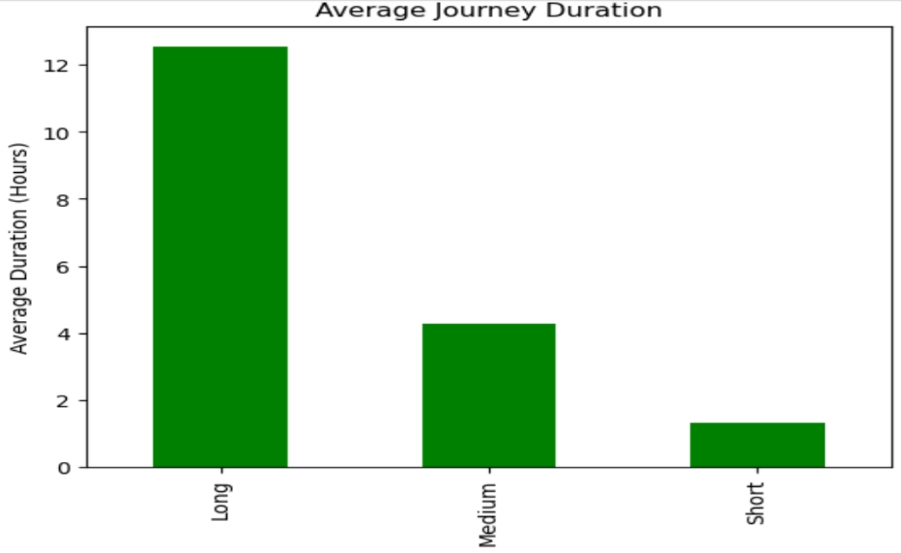
Visualization 2 – Top 5 High-Traffic Stations
A bar chart was created to compare train activity across the five highest-frequency stations.
CST-MUMBAI had the highest train frequency, followed by KALYAN JN, THANE, SEALDAH, and CHENNAI BEAC.

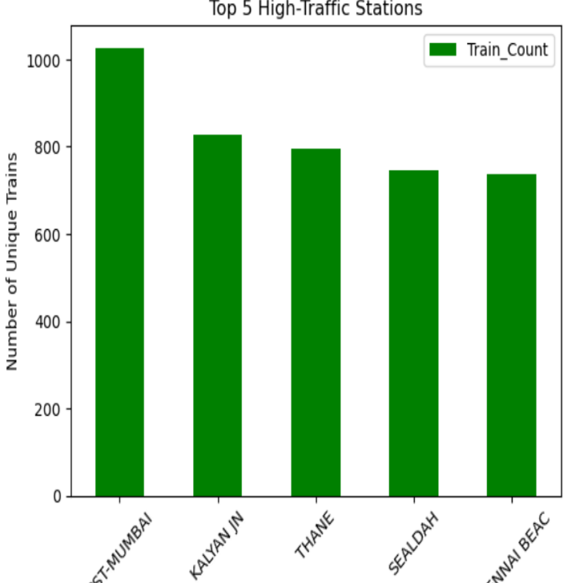

LEVEL 5 – ADVANCED DATA ANALYSIS
5.1 Station-Wise Pivot Table
A pivot table was created to examine the distribution of unique trains across stations.
station_pivot = pd.pivot_table( df, index="Station_Name",
values="Train_No",aggfunc=pd.Series.nunique)
This provided a summarized view of train activity at individual stations.

5.2 Station and Route Cross-Tabulation
A cross-tabulation was created to analyze the relationship between stations and route numbers.
station_route_crosstab = pd.crosstab(
df["Station_Name"],
df["Route_Number"],
values=df["Train_No"],
aggfunc=pd.Series.nunique ).fillna(0)
This analysis helped identify how train activity is distributed across different stations and route numbers.

5.3 Advanced Insights
The pivot table and cross-tabulation analysis showed that train activity is not evenly distributed across all railway stations.
A relatively small number of major stations account for a high number of train services, indicating their importance within the railway network.
The cross-tabulation also provides a more detailed understanding of how different route numbers contribute to train activity at individual stations.
Overall, combining station-level and route-level analysis provides a clearer understanding of railway connectivity and train distribution.

LEVEL 6 – FINAL CAPSTONE SYSTEM
6.1 Interactive Route-Based Train Enquiry System
The final stage of the project involved developing an interactive train enquiry system using Python.
The system allows a user to enter:
- Source station
- Destination station
The system then searches the dataset and identifies all available direct trains between the selected stations.
For each matching train, the system displays:
- Train number
- Source station
- Destination station
- Departure time
- Arrival time
- Estimated journey duration

6.2 Direct Train Identification
The system determines direct trains by checking whether the selected source and destination stations are both served by the same train.
The station sequence number (SN) is also checked to ensure that the source station occurs before the destination station in the train's route.
This prevents trains travelling in the opposite direction from being incorrectly included.

6.3 Journey Duration Estimation
The estimated journey duration is calculated using:
Destination Arrival Time − Source Departure Time
The system also handles cases where the calculated duration crosses midnight.
The resulting trains are sorted according to journey duration so that shorter journeys appear first.

6.4 Example
For the route:
Source: THIVIM
Destination: MADGOAN JN.
The system successfully returned multiple direct trains.
Examples include:
Train No. | Departure | Arrival | Estimated Duration
12618 | 18:38 | 19:30 | 52 minutes
22629 | 05:22 | 06:20 | 58 minutes
12051 | 13:04 | 14:05 | 1 hour 1 minute
107 | 11:08 | 12:10 | 1 hour 2 minutes
16345 | 21:40 | 22:45 | 1 hour 5 minutes
The result demonstrates that the system can successfully process a user's route query and return relevant train information.

OVERALL FINDINGS
The project provided several useful insights into the railway dataset.
- Train journey durations vary significantly depending on the route.
- Long-distance trains have considerably higher average journey durations than short and medium routes.
- Train activity is concentrated around certain major railway stations.
- CST-MUMBAI recorded the highest number of unique trains among the stations analyzed.
- The SN column provides a reliable way to determine the order of stations within a train.
- Pivot tables and cross-tabulations provide useful methods for understanding station and route distributions.
- The final interactive system demonstrates how data analysis techniques can be transformed into a practical user-oriented application.

CONCLUSION
The Train Data Analysis and Interactive Train Enquiry System successfully demonstrates the complete data analysis workflow, from raw data exploration and cleaning to transformation, statistical analysis, visualization, and application development.
The project strengthened practical skills in Python, Pandas, data cleaning, grouping, aggregation, time-based calculations, pivot tables, cross-tabulation, and data visualization.
The final capstone system builds on these analytical skills by allowing users to interact with the dataset and obtain route-specific train information. This demonstrates how a structured dataset can be transformed into a simple and useful information system.
Overall, the project provided practical experience in handling real-world-style transportation data and converting analytical results into meaningful, user-friendly outputs.

