**#8WeekSQLChallenge - Case Study 2 - PIZZA RUNNER**

**Results and answers for the case study**

(Note: The queries are available in the Github repository)

**Case study questions:**

**A. Pizza Metrics**

1. How many pizzas were ordered?

Answer: 14 Pizzas

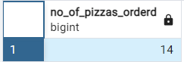

2. How many unique customer orders were made?

Answer: 10 unique orders

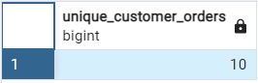

3. How many successful orders were delivered by each runner?

Answer:

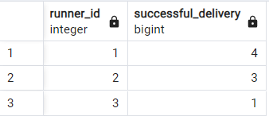

4. How many of each type of pizza was delivered?

Answer:

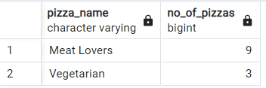

5. How many Vegetarian and Meatlovers were ordered by each customer?

Answer:

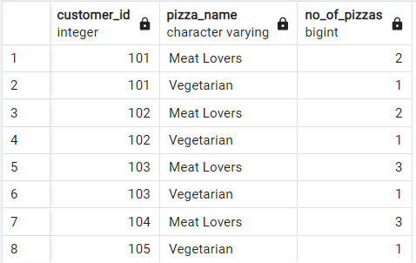

6. What was the maximum number of pizzas delivered in a single order?

Answer:

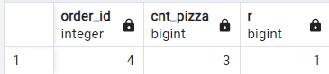

7. For each customer, how many delivered pizzas had at least 1 change and how many had no changes?

Answer:

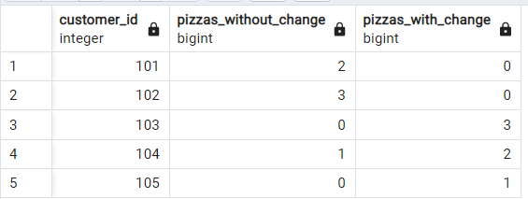

8. How many pizzas were delivered that had both exclusions and extras?

Answer: only one pizza. (2 orders were placed that had both exclusions and extras but one (order 9) was cancelled)

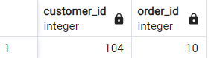

9. What was the total volume of pizzas ordered for each hour of the day?

Answer:

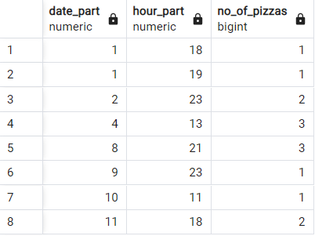

10. What was the volume of orders for each day of the week?

Answer:

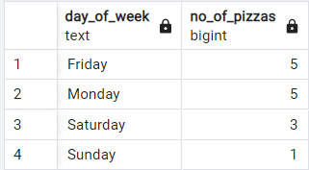

**B. Runner and Customer Experience**

1.How many runners signed up for each 1 week period? (i.e. week starts 2021-01-01)

Answer: (The first week is week 0)

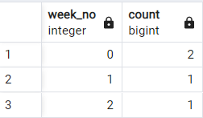

2.What was the average time in minutes it took for each runner to arrive at the Pizza Runner HQ to pickup the order?

Answer:

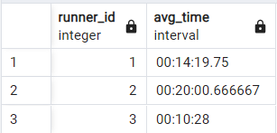

3.Is there any relationship between the number of pizzas and how long the order takes to prepare?

Answer:

Yes. It appears so. On an average, it looks like, it takes around 10 minutes to prepare 1 pizza. So, more the pizzas, more the time. But it also depends on the time of order. For eg. if it is placed in the midnight, it takes more time than the orders placed during evenings and afternoons. It could be because of less number of staffs perhaps for the shift or the runners might take more time to arrive at the location.

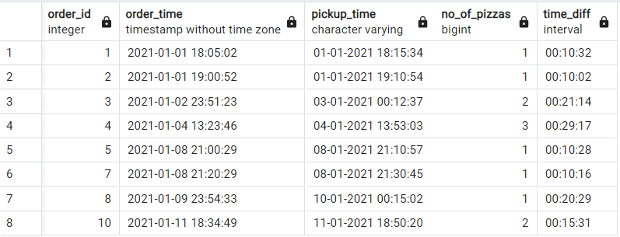

4.What was the average distance travelled for each customer?

Answer:

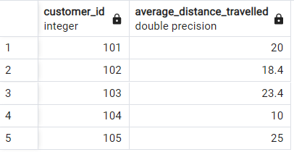

5.What was the difference between the longest and shortest delivery times for all orders?

Answer:

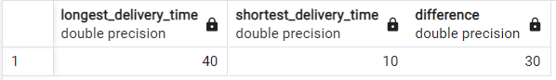

6.What was the average speed for each runner for each delivery and do you notice any trend for these values?

Runner 2 seems to be a better runner among all. Further R2 seems to deliver very fast at night, which could be owing to less traffic. Notice that the same distance of 23.4 Km has taken much longer in the noon time.

Runner 1 seems to be an average runner.

I assume that the time of order also plays an important role in delivery time and we cannot just determine the best runner based on only the avg speed.

Answer:

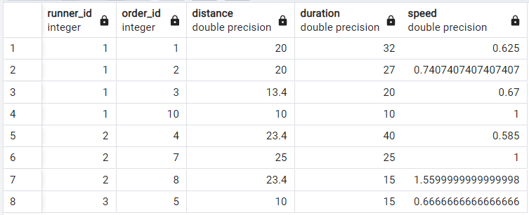

7.What is the successful delivery percentage for each runner?

Answer:

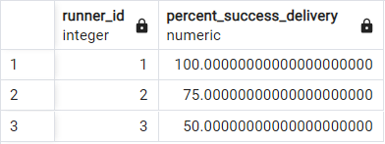

**C. Ingredient Optimisation**

1. What are the standard ingredients for each pizza?

-->Learning: To split a string to array, use unnest with string_to_array function.

--> To join those values from different row into a single field, use STRING_AGG function.

Answer:

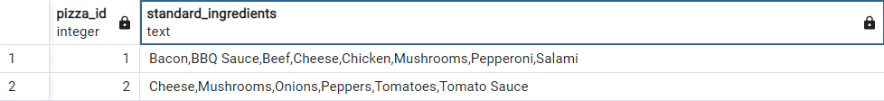

2. What was the most commonly added extra?

Answers:

The most preferred extra is bacon

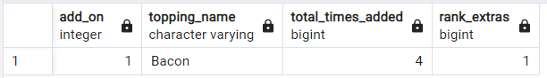

3. What was the most common exclusion?

Answers:

Cheese was the most common exclusion

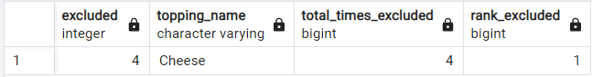

4. Generate an order item for each record in the customers_orders table in the format of one of the following:

Meat Lovers

Meat Lovers - Exclude Beef

Meat Lovers - Extra Bacon

Meat Lovers - Exclude Cheese, Bacon - Extra Mushroom, Peppers

Answer:

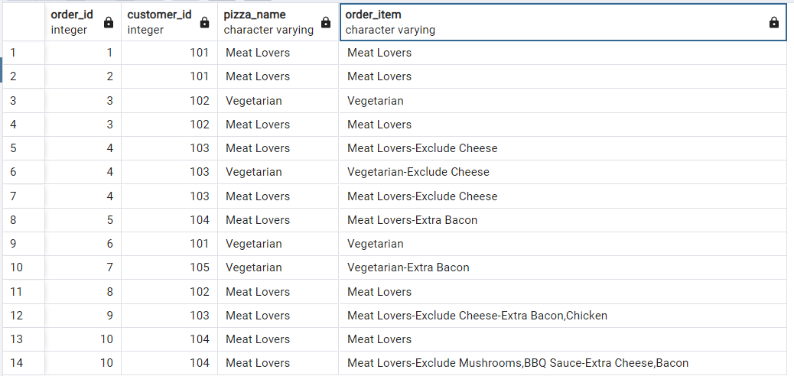

5. Generate an alphabetically ordered comma separated ingredient list for each pizza order from the customer_orders table and add a 2x in front of any relevant ingredients

For example: "Meat Lovers: 2xBacon, Beef, ... , Salami"

Answer:

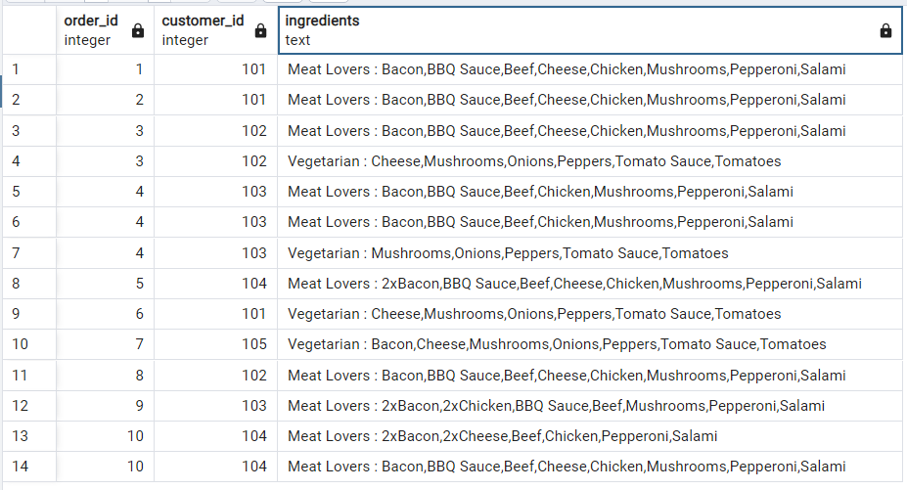

6. What is the total quantity of each ingredient used in all delivered pizzas sorted by most frequent first?

Answer:

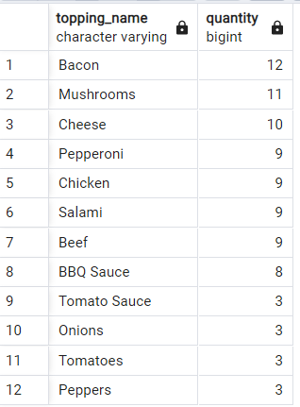

**D. Pricing and Ratings**

1. If a Meat Lovers pizza costs $12 and Vegetarian costs $10 and there were no charges for changes - how much money has Pizza Runner made so far if there are no delivery fees?

Answer:

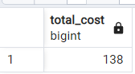

2. What if there was an additional $1 charge for any pizza extras?

Add cheese is $1 extra

Answer:

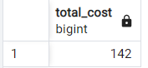

3. The Pizza Runner team now wants to add an additional ratings system that allows customers to rate their runner, how would you design an additional table for this new dataset - generate a schema for this new table and insert your own data for ratings for each successful customer order between 1 to 5.

Sample:

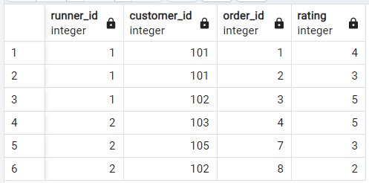

4. Using your newly generated table - can you join all of the information together to form a table which has the following information for successful deliveries?

* customer_id
* order_id
* runner_id
* rating
* order_time
* pickup_time
* Time between order and pickup
* Delivery duration
* Average speed
* Total number of pizzas

Answer:

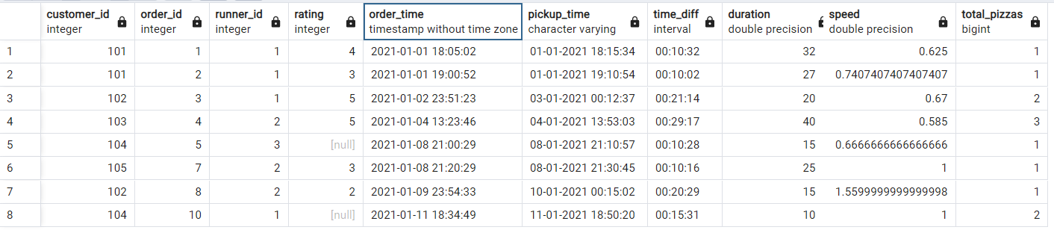

5. If a Meat Lovers pizza was $12 and Vegetarian $10 fixed prices with no cost for extras and each runner is paid $0.30 per kilometre travelled - how much money does Pizza Runner have left over after these deliveries?

Answer:

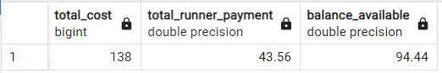

**E. Bonus Questions**

If Danny wants to expand his range of pizzas - how would this impact the existing data design? Write an INSERT statement to demonstrate what would happen if a new Supreme pizza with all the toppings was added to the Pizza Runner menu?

We should be adding an entry to pizza_names table as below

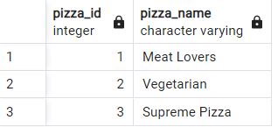

We should also add the new pizza variety and the toppings to pizza_recipes table as below,

The table pizza_recipes now looks like below:

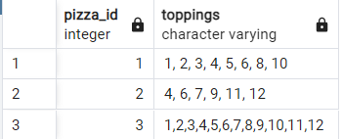

The change in data design happen only in pizza_names and pizza_recipes table.

Some insights overall:

A: Pizza Metrics

1. Runner 1 delivered the most number of successful orders (4) closely followed by runner 2 (3)

2. Meat lovers variety of the pizza is the most favourite

3.Most number of pizzas were delivered either late evenings/night or at noon

4.A large volume of pizzas were sold on Fridays and Mondays than on weekends

B. Runner and Customer experience

1.Runner 3 took the least average time (10.28 mins) to reach pizza runner HQ while Runner 2 took the longest (20 mins)

2. On an average, it takes around 10 minutes to prepare 1 pizza. So, more the pizzas per order, more the time. There is also an exception for order 8, where an order of only one pizza has taken 20 minutes. So, there could be other factors contributing, like the runner and time of order

3. The shortest delivery time was in 10 minutes, while the longest one was 40 minutes.

4. The time of order also plays a role in the delivery time of orders. This could be due to traffic congestions at peak hours, which could delay the delivery

5. Runner 1 has 100% successful deliveries

C. Ingredient Optimization:

1. The most loved 'Extra' ingredient is Bacon

2. The most excluded ingredient is Cheese.

3. Bacon, mushrooms and cheese were the mostly used ingredient while onions, peppers, tomatoes and tomato sauce were the least used in the pizzas delivered.

D. Pricings and Ratings

1. The total amount made by Pizza Runner is $138, if there is no extra amount charged for Extras. It would be $142 on charging $1 for an extra

2. Assuming that Pizza runner doesn't charge for extras, the amount made is $138. The runners are paid $0.3/Km. After paying the runners, Pizza Runner has $94.44

E. Bonus Question:

If Danny wants to add a new pizza to the menu, the data design would happen in two tables - pizza_names and pizza_recipes, as there would be a new row in these tables.