**OUTPUTS:**

**a)INITIAL WEB PAGE:**

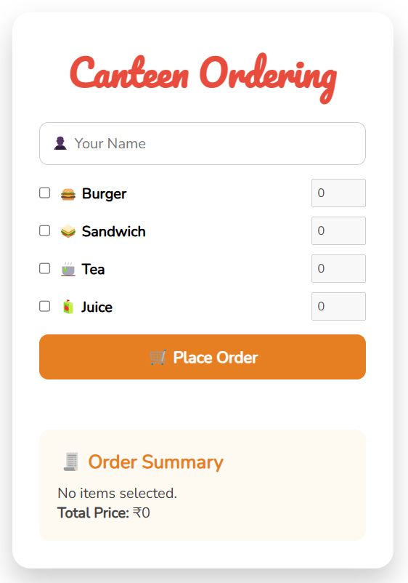

**b)ORDERS PLACED:**

On placing each order the corresponding images will be generated and the total amout will be calculated .

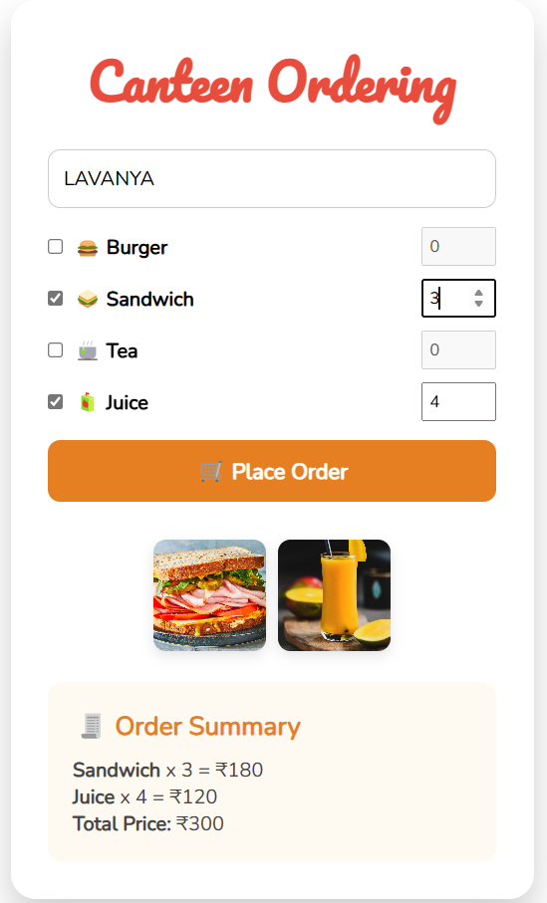 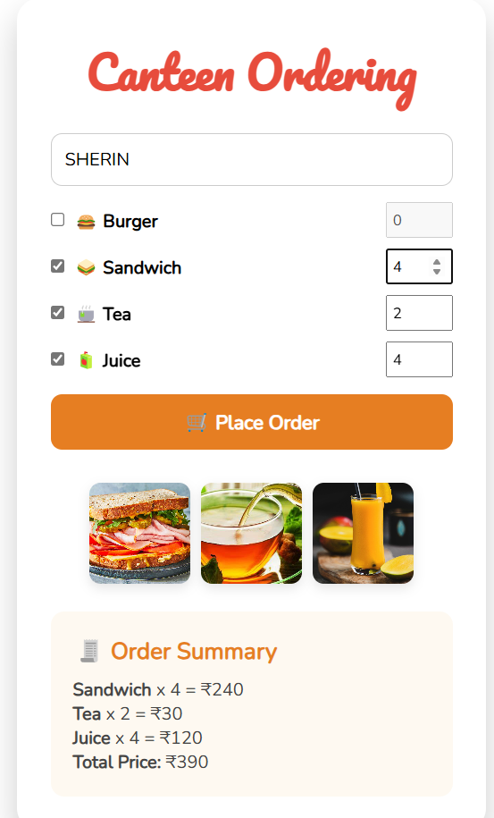

**c)ORDER CONFIRMED:**

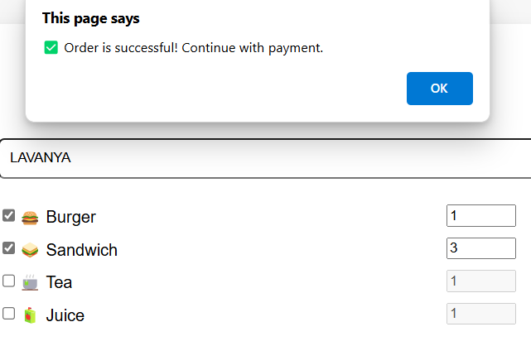

**d)PAYMENT MODE:**

After placing the order the payment page is opened and after paying payment successful message appears.

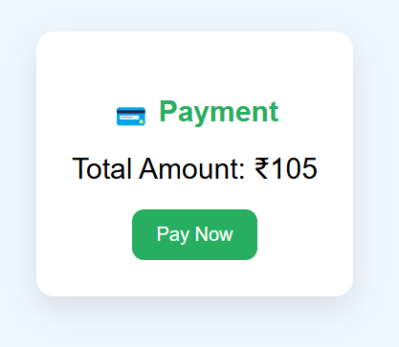 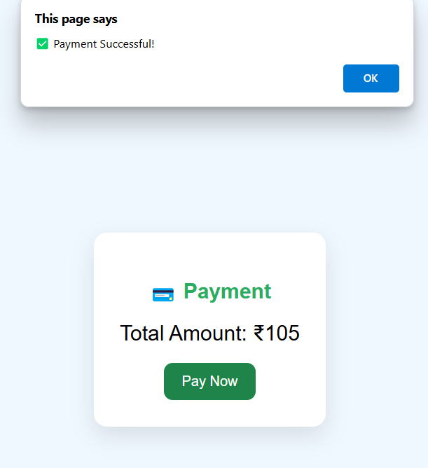

**e)THANKING PAGE:**

After placing the order it ends with thanking page.



**f)DATABASE TABLE VIEW:**

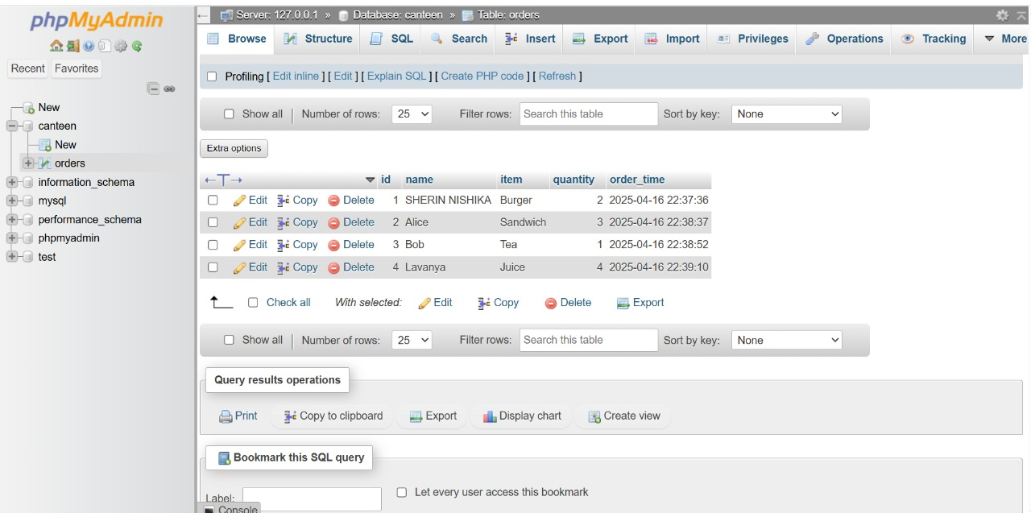

**g)ORDERS LIST:**

