Date: 28 May 2024

To

The Dean FoEA

IIT Kharagpur

Respected sir,

My name is Bhumika Rishitha Mathangi (Roll Number:23CS30031) . I am a first year undergraduate student of the department of computer science and engineering enrolled in its dual degree course.

I hope this letter finds you well. I wanted to reach out and ask for permission to attend the summer quarters and write the exams in which I got “p” grade so as to improve my total grade. I am sorry to ask you this late sir but I was waiting for second semester results to know about my performance and change the subject to which there is a scope of getting a higher grade. My current grade is 6.51.I happened to know the importance of cumulative grade and I really wish to improve sir. I would like to improve my grade by attending summer quarters for Advanced Calculus MA11003 and Electrical Technology EE11003.

Thank you for your understanding and support . I look forward to your guidance on how I can make up for.

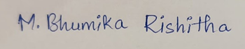 Signature of Faculty Advisor

(Partha Bhowmick)