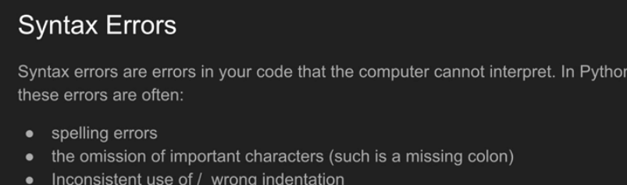

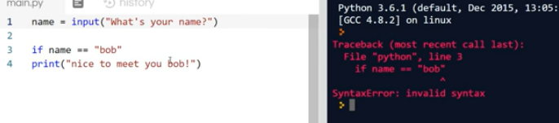

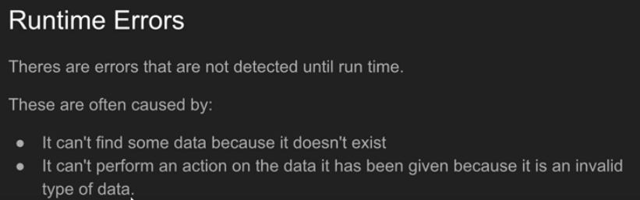

# 

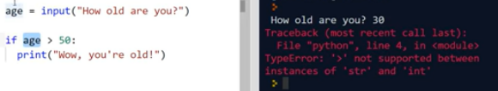

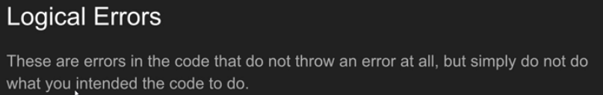

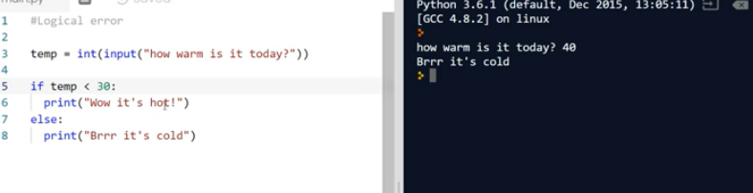

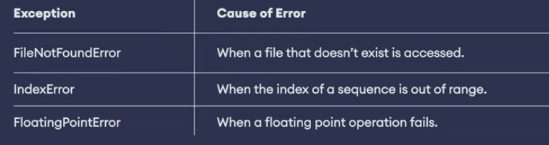

If exception occurs inside try, control of the program immediately jumps to the except block and the program continues. Else, it will completely skip the except block. Simple!

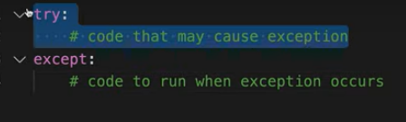

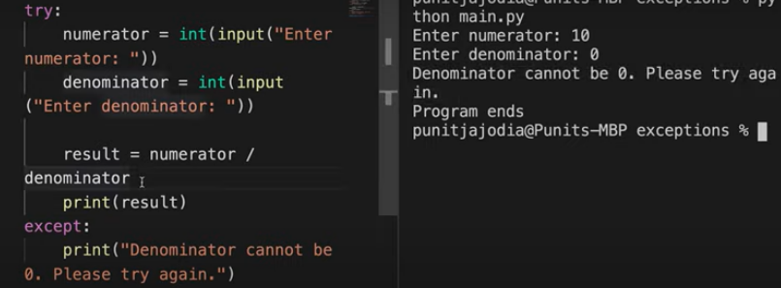

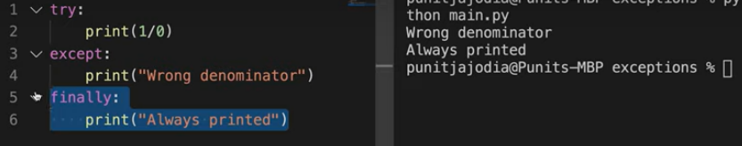

You can specify your error through different except blocks

