**PROJECT REPORT**

**TITLE: HOME AUTOMATION USING SENSORS AND ARDUINO**

**Team Members :**

**Name: Aprajitha V.S, Lavanya Gupta**

**Reg No. : 22BRS1165, 22BRS1142**

**INTRODUCTION:**

The integration of sensors like Arduino, LED, buzzer, servo motor, ultrasonic, relay, LDR, DHT11, temperature sensor, and smoke sensor in home automation systems addresses the growing need for convenience, energy efficiency, safety, and customization in residential settings.

Home automation systems leveraging sensors like Arduino, LED, buzzer, servo motor, ultrasonic, relay, LDR, DHT11, temperature sensor, and smoke sensor address the growing need for convenience, energy efficiency, and safety in residential settings. These systems automate tasks such as lighting control, climate regulation, security monitoring, and appliance management, enhancing comfort and security while reducing energy consumption. Challenges include interoperability, complexity, reliability, and cost, yet the scope and applications are broad, spanning from lighting and climate control to security, safety monitoring, and smart irrigation. Despite challenges, advancements in sensor technology continue to drive innovation, making home automation increasingly accessible and indispensable for modern living.

In summary, home automation systems with sensors offer a comprehensive solution for modern living, addressing various needs and challenges while providing enhanced comfort, efficiency, and security in residential environments.

-----------------------------------------------------------------------------------------------------------------

**LITREATURE REVIEW:**

Research Papers Summary:

The 10 research papers explore various aspects of home automation systems, including IoT-based applications, Arduino and Raspberry Pi implementations, wireless sensor networks, and energy-efficient solutions. They cover topics such as lighting control, temperature regulation, security features, and integration with mobile applications.

Challenges and Research Gaps:

Despite the advancements presented in these papers, several challenges and research gaps are evident. Firstly, there's a lack of comprehensive integration of sensors and actuators for holistic automation solutions. Many papers focus on specific aspects of home automation, overlooking the potential of advanced sensor technologies like gas sensors and occupancy detectors. Additionally, there's limited exploration of predictive analytics and machine learning techniques for proactive automation and personalized user experiences. Resilience against network disruptions and cybersecurity threats, as well as the scalability and affordability of home automation solutions, are also overlooked. Finally, there's a gap in considering user-centric design principles and privacy implications in the deployment of these systems.

In summary, while these papers contribute valuable insights to the field of home automation, addressing these challenges and research gaps is essential for advancing the development and adoption of intelligent and sustainable smart home solutions.

-----------------------------------------------------------------------------------------------------------------

**METHODOLOGY:**

The project employs a modular approach to home automation, integrating various sensors, actuators, and a microcontroller to achieve intelligent control and monitoring of home environments. The methodology involves the following components and steps:

1. Sensors:

- Arduino: Acts as the central processing unit, responsible for interfacing with sensors, processing data, and controlling actuators.

- LED: Used for visual feedback and status indication, such as indicating system status or sensor readings.

- Buzzer: Provides audible alerts and notifications, such as alarms for security breaches or critical system events.

- Servo Motor: Enables mechanical control of devices such as door locks, curtains, or window blinds.

- Ultrasonic Sensor: Detects the presence of objects or individuals within a specified range, useful for occupancy sensing or intrusion detection.

- Relay: Controls the switching of high-power devices such as lights, fans, or appliances based on sensor inputs or user commands.

- LDR (Light Dependent Resistor): Measures ambient light levels, facilitating automatic adjustment of lighting intensity or activation of lights based on darkness.

- DHT11 (Temperature and Humidity Sensor): Provides real-time temperature and humidity data for climate control and environmental monitoring.

- Smoke Sensor: Detects the presence of smoke particles, triggering alarms and alerts in case of fire hazards.

2. Microcontroller (Arduino):

- Acts as the brain of the system, interfacing with sensors, processing sensor data, and controlling actuators based on predefined logic and user inputs.

- Executes programmed algorithms to implement various automation tasks, such as adjusting lighting, regulating temperature, or activating security measures.

- Communicates with external devices or systems, such as smartphones or home networks, to enable remote monitoring and control of the home automation system.

- Sensors: Capture environmental data and detect events.

- Microcontroller (Arduino): Processes sensor data, executes control algorithms, and interfaces with actuators.

- Actuators: Respond to control signals from the microcontroller, performing actions such as switching lights, adjusting temperature, or activating alarms.

This methodology enables the creation of a versatile and customizable home automation system capable of enhancing convenience, energy efficiency, safety, and security in residential environments. The modular design facilitates scalability and expansion to accommodate additional sensors or functionalities as needed.

-----------------------------------------------------------------------------------------------------------------

**RESULT AND DISCUSSION**

Tables of components used:

|  |  |  |
| --- | --- | --- |
| SENSORS | MICROCONTROLLER | ACTUATORS |
| LED | Arduino | Relay |
| Buzzer |  | Servo Motor |
| Servo Motor |  |  |
| Ultrasonic Sensor |  |  |
| Relay |  |  |
| LDR |  |  |
| DHT11 |  |  |
| Smoke Sensor |  |  |

Block Diagram

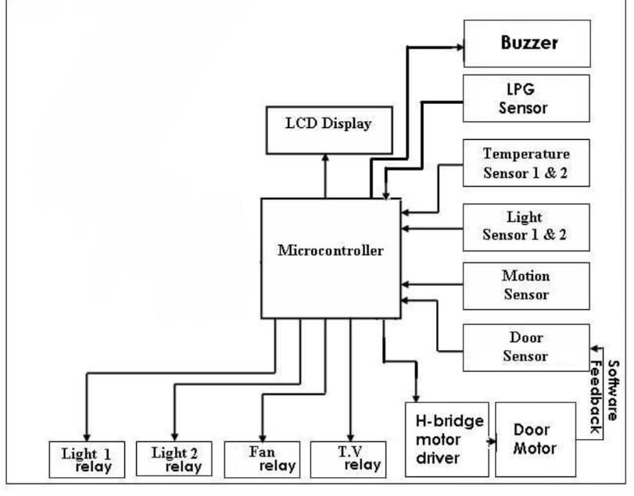

Connection Setup

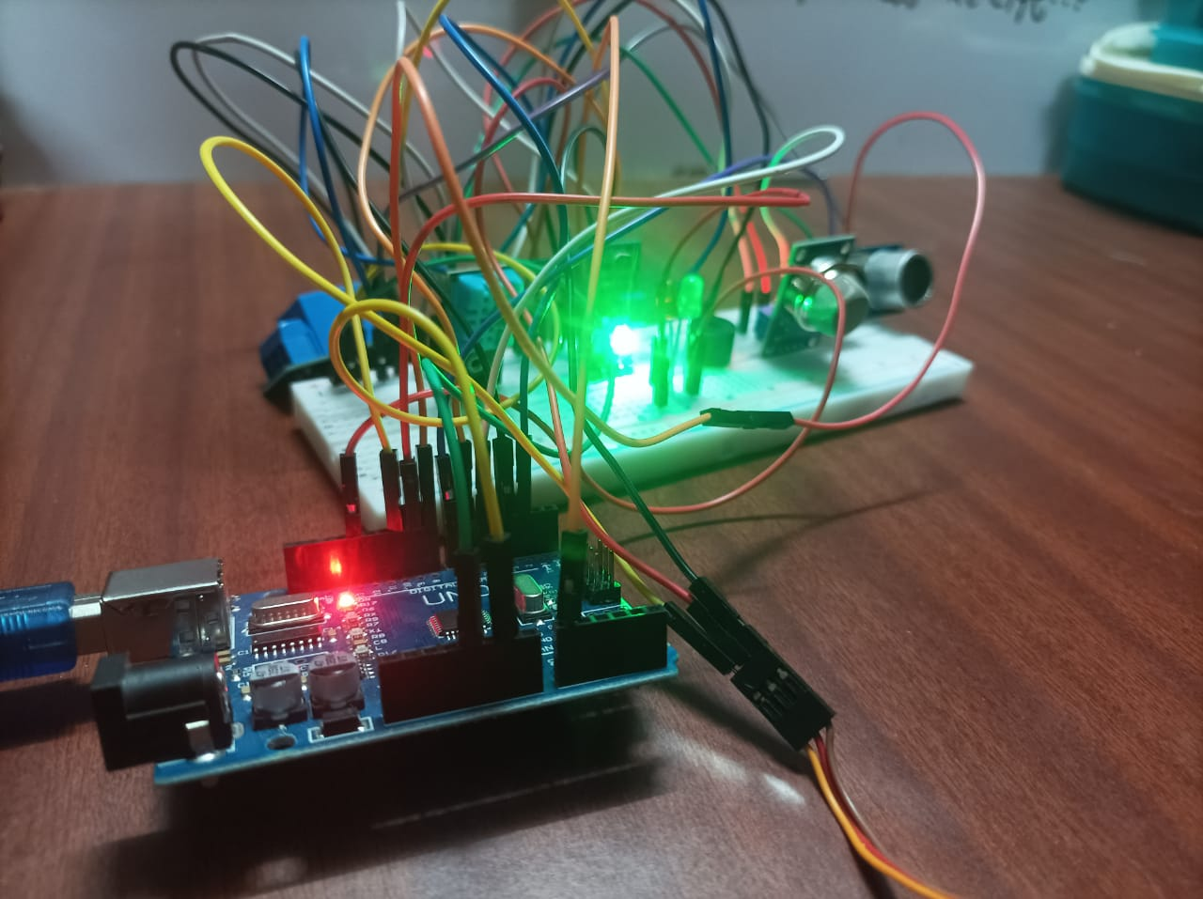

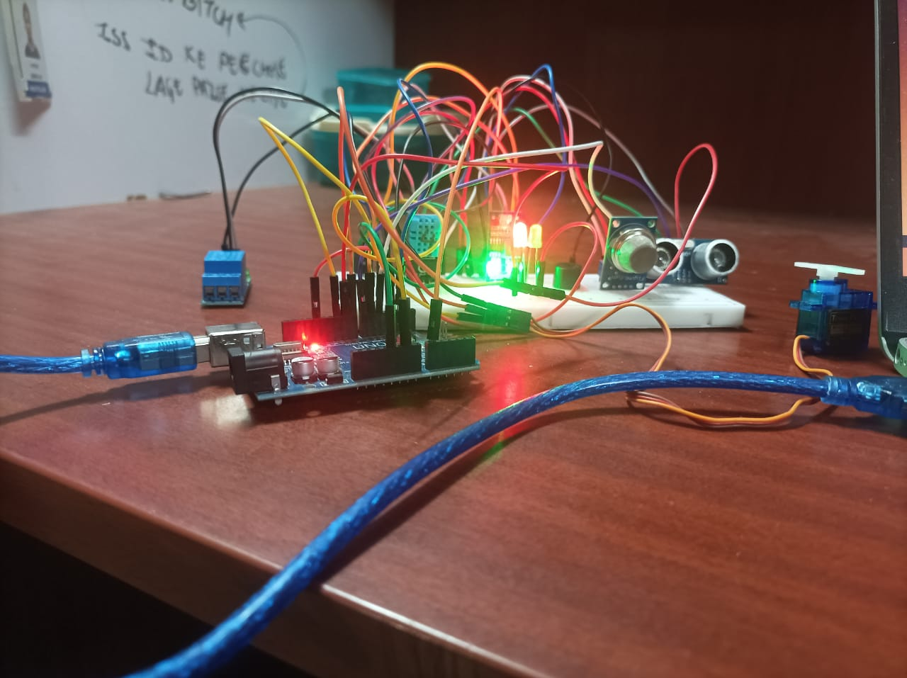

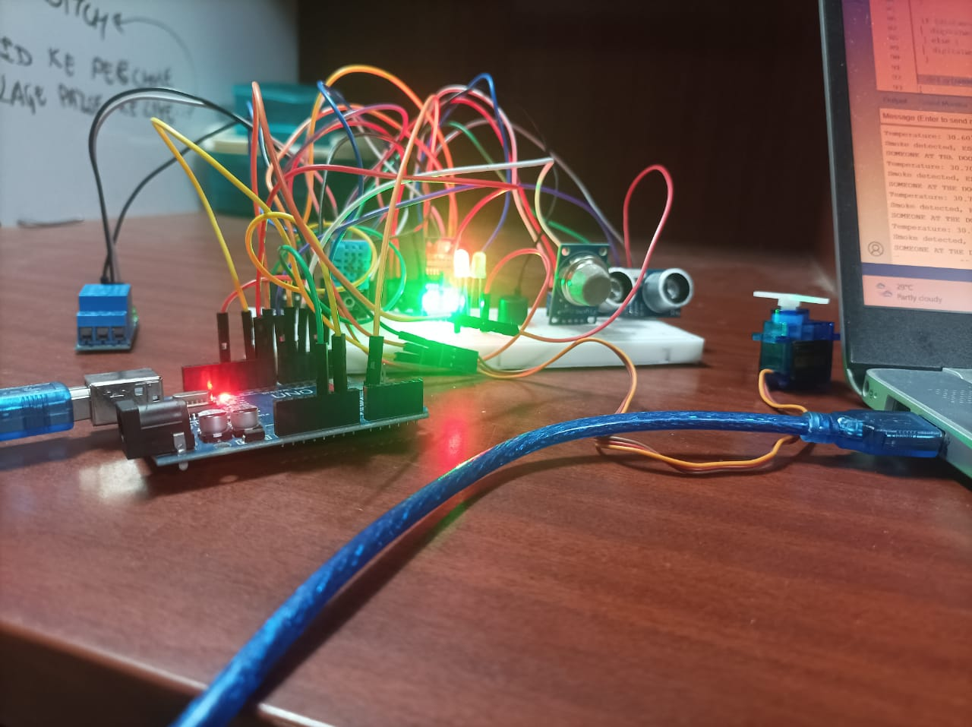

Code

#include <DHT.h>

#include <NewPing.h>

#include <Servo.h>

#define DHTPIN 2

#define DHTTYPE DHT11

#define LDRPIN A0

#define RELAYPIN 3

#define LEDPIN 4

#define SMOKEPIN 5

#define BUZZERPIN 6

#define TRIGGER_PIN 7

#define ECHO_PIN 8

#define MAX_DISTANCE 200

#define RED_LED_PIN 9

#define SERVO_PIN 10

DHT dht(DHTPIN, DHTTYPE);

NewPing sonar(TRIGGER_PIN, ECHO_PIN, MAX_DISTANCE);

Servo myservo;

void setup() {

Serial.begin(9600);

dht.begin();

pinMode(LDRPIN, INPUT);

pinMode(RELAYPIN, OUTPUT);

pinMode(LEDPIN, OUTPUT);

pinMode(SMOKEPIN, INPUT);

pinMode(BUZZERPIN, OUTPUT);

pinMode(RED_LED_PIN, OUTPUT);

pinMode(TRIGGER_PIN, OUTPUT);

pinMode(ECHO_PIN, INPUT);

myservo.attach(SERVO_PIN);

}

void loop() {

float h = dht.readHumidity();

float t = dht.readTemperature();

int ldrValue = analogRead(LDRPIN);

int smokeValue = digitalRead(SMOKEPIN);

unsigned int distance = sonar.ping_cm();

Serial.print("Temperature: ");

Serial.print(t);

Serial.print("°C, Humidity: ");

Serial.print(h);

Serial.print("%, LDR Value: ");

Serial.print(ldrValue);

Serial.print(", Smoke: ");

Serial.print(smokeValue);

Serial.print(", Distance: ");

Serial.print(distance);

Serial.println(" cm");

if (t > 25) {

myservo.writeMicroseconds(2000); // Full speed clockwise

} else {

myservo.writeMicroseconds(1000); // Full speed counterclockwise

}

if (ldrValue < 800) {

digitalWrite(LEDPIN, HIGH);

digitalWrite(RELAYPIN, HIGH);

} else {

digitalWrite(LEDPIN, LOW);

digitalWrite(RELAYPIN, LOW);

Serial.print("ENVIRONMENT IS BRIGHT, ");

Serial.println("Relay is off and the lights are switched off");

}

if (smokeValue == HIGH) {

digitalWrite(BUZZERPIN, HIGH);

Serial.println("Smoke detected, ESCAPE TO YOUR NEAREST EXIT");

} else {

digitalWrite(BUZZERPIN, LOW);

}

if (distance < 20) { // You can adjust this value according to your requirement for the range

digitalWrite(RED_LED_PIN, HIGH);

Serial.println("SOMEONE AT THE DOOR");

}

else {

digitalWrite(RED_LED_PIN, LOW);

}

delay(2000); // Delay between readings

}

Working of the model

This Arduino-based home automation system utilizes various sensors and actuators to automate tasks and monitor environmental conditions within a home. Here's a description of how the model works:

1. Initialization: The setup function initializes communication with sensors and actuators, setting their pin modes and configuring parameters such as the sensor type and maximum distance for the ultrasonic sensor.

2. Data Acquisition: In the loop function, sensor data is acquired from different sensors:

- DHT11 Sensor: Reads temperature and humidity data.

- LDR (Light Dependent Resistor): Measures ambient light intensity.

- Smoke Sensor: Detects the presence of smoke particles.

- Ultrasonic Sensor: Measures the distance of objects from the sensor.

3. Data Processing and Control:

- Temperature Control: If the temperature exceeds a threshold (25°C in this case), the servo motor is activated to adjust a physical component, such as opening or closing a window or curtain.

- Light Control: Based on the LDR reading, the LED and relay are controlled to adjust lighting. When the environment is bright (LDR value < 800), the LED and relay are turned off to save energy.

- Smoke Detection: If smoke is detected, the buzzer is activated to alert occupants of a potential fire hazard.

- Proximity Detection: The ultrasonic sensor detects objects within a specified range. If an object is detected within 20 cm, an LED indicator is activated to indicate someone's presence at the door.

4. Feedback: Sensor readings and system actions are serially printed to the Arduino Serial Monitor for real-time monitoring and debugging.

5. Delay: A delay of 2000 milliseconds (2 seconds) is introduced between sensor readings to prevent rapid iteration and conserve resources.

Overall, this model demonstrates a basic implementation of a home automation system using Arduino and various sensors to monitor environmental conditions and automate control actions based on predefined thresholds and events. It showcases functionalities such as temperature and light control, smoke detection, and proximity sensing, contributing to convenience, safety, and energy efficiency in a residential setting.

----------------------------------------------------------------------------------------------------------------

**CONCLUSIONS**

In conclusion, the working model of this Arduino-based home automation system effectively demonstrates the integration of various sensors and actuators to automate tasks and monitor environmental conditions within a home. By leveraging sensors such as the DHT11 for temperature and humidity, LDR for ambient light, smoke sensor for fire detection, and ultrasonic sensor for proximity sensing, the system enables intelligent control and real-time monitoring of key parameters.The model showcases functionalities such as temperature-controlled servo motor activation, light control based on ambient light levels, smoke detection with audible alerts, and proximity sensing for door security. These features contribute to enhanced comfort, safety, and energy efficiency in a residential environment.Additionally, the feedback provided through the Arduino Serial Monitor allows for real-time monitoring and debugging of the system, enhancing user interaction and system transparency.

Overall, the working model serves as a proof-of-concept for a scalable and customizable home automation system, demonstrating the potential for integrating sensor technologies to create smart and responsive living environments. With further refinement and expansion, such systems hold promise for improving quality of life, enhancing safety, and reducing energy consumption in modern homes.

---------------------------------------------------------------------------------------------------------------------------

**REFERENCES:**

[1]Kumar, P. S. (2015). Research paper on home automation using Arduino. International Journal of Advanced Research in Computer and Communication Engineering, 1(8), 801-805.

[2]Al Mamun, M. A., Abdullah, I., & Hossain, M. S. (2020). Smart home automation system using Arduino and Android application. Journal of Computer Science Engineering and Software Testing, 6(2), 8-12.

[3]Jayaraman, R., & Ganesh, G. (2021). Development of smart home applications based on Arduino and Android platforms: An experimental work. Sensors, 21(4), 29.

[4]Maqsood, J. (2016). Smart home automation based on different sensors and Arduino as the master controller. International Journal of Scientific and Research Publications, 6(10), 461-465.

[5]Chiktay, I. B., & Dalvi, M. S. (2021). Home automation using Arduino WiFi module ESP8266. [Paper presented at the International Conference on Intelligent Systems and Information Management].

[6]Hossain, M. B., Rahman, M. M., & Kabir, M. A. (2018). A review of home automation systems using Arduino. International Journal of Computer Applications, 181(14), 1-6.

[7]Alawneh, S., & Bader, A. (2017). Design and implementation of a smart home automation system using Arduino. International Journal of Computer Applications, 174(13), 39-43.

[8]Kumar, D. (2018). A smart home automation system with security and home appliances control. International Journal of Computer Applications, 185(10), 22-26.

[9]Jayakumar, S., & Ramalingam, V. (2017). Home automation system using Arduino and Bluetooth low energy. International Journal of Engineering and Computer Science, 7(7), 8227-8231.

[10]Pawar, S. S., & Deshpande, S. S. (2018). Implementation of home automation system using Arduino and Zigbee. International Journal of Engineering Research and Application, 8(5), 2-7.

-----------------------------------------------------------***------------------------------------------------------------