A Mini Project Report On

ONLINE BLOOD BANK MANAGEMENT
BACHELOR OF TECHNOLOGY
In

COMPUTER SCIENCE AND ENGINEERING


Under the Guidance of
Mrs.V. Radhika

BY
A. POOJITHA (15D21A0556)
CH. LAVANYA (15D21A0566)
S. CHANDANA (15D21A05A9)

Department of Computer Science and Engineering

SRIDEVI WOMEN’S ENGINEERING COLLEGE
(Approved by AICTE, Accredited by NBA and Affiliated to JNTU HYDERABAD)
V.N. PALLY, Gandipet, Hyderabad-75
2018-2019

Department of Computer Science and Engineering
SRIDEVI WOMEN’S ENGINEERING COLLEGE
(Approved by AICTE, Accredited by NBA and Affiliated to JNTU HYDERABAD)
V.N. PALLY, Gandipet, Hyderabad-75
2018-2019


CERTIFICATE
This is to certify that the Mini Project report entitled “Online Blood Bank Management” is being submitted by Ms A.POOJITHA (15D21A0556), Ms CH.LAVANYA (15D21A0566) and Ms S.CHANDANA (15D21A05A9) in partial fulfilment for the award of degree of Bachelor of Technology in Computer Science and Engineering is a record of bonafide work carried out by them.

Internal Guide Head of the Department
Mrs V. RADHIKA Dr.M. RAMASUBRAMANIAN (Assistant professor) (Professor and HOD)

External Examiner

DECLARATION
We hereby declare that the mini project entitled “Online Blood Bank Management” is the work done during the period from 22nd May 2018 to 11th July 2018 and is submitted in partial fulfilment of the requirements for the award of Degree of Bachelor of Technology in Computer Science and Engineering from Jawaharlal Nehru Technological University, Hyderabad.

- POOJITHA (15D21A0556)
CH. LAVANYA (15D21A0566)
S. CHANDANA (15D21A05A9)

ACKNOWLEDGEMENT
At every outset I express my gratitude to almighty lord for showering his grace and blessings upon me to complete this project.
Although our name appears on the cover of this book, many people had contributed in some form or the other form to this project Development. We could not do this project without the assistance or support of each of the following we thank you all.
I wish to place on my record my deep sense of gratitude to my project guide, Mrs.V. Radhika, Assistant professor, Department of CSE for her constant motivation and valuable help through the project work.
We also wish to express our sincere thanks to Dr. M. RAMASUBRAMANIAN, professor and HOD, Department of Computer Science and Engineering for his valuable suggestions and advice.
We are also extremely thankful to Mrs Dr. B.L. Malleswari, principal of Sridevi Women’s Engineering College, for providing the facilities to complete the dissertation.
Finally, we would like to thank all our faculty and friends for their help and constructive criticism during my project period. Finally, we are vey much indebted to my parents for their moral support and encouragement.

- POOJITHA (15D21A0556)
CH. LAVANYA (15D21A0566)
S. CHANDANA (15D21A05A9)

Index
CHAPTER | TOPIC | PAGE NO.
 | Certificate
 | Declaration
 | Acknowledgement
 | Abstract
1. | Introduction | 1
1.1 | Solutions of the problem | 2
1.2 | Modules | 3
1.3 | Software and hardware requirements | 3
2. | System analysis | 4
2.1 | Introduction | 4
2.2 | Analysis model | 4
2.3 | Study of the system | 7
2.4 | System requirements specifications | 8
2.5 | Proposed system | 10
2.6 | Process modules used with justification | 11
3. | Feasibility report | 11
3.1 | Technical feasibility | 12
3.2 | Operational feasibility | 12
3.3 | economic feasibility | 13
4. | Software requirements specifications | 13
4.1 | Functions requirements | 17
4.2 | Performance | 19
5. | Selected software | 19
5.1 | What is android | 21
5.2 | Features | 24
5.3 | Development | 29
6. | System design | 29
6.1 | Introduction | 29
6.2 | Normalization | 29
6.3 | Data flow diagrams | 31
6.4 | UML diagrams | 35
7. | Output screens | 38
8. | System testing &implementation | 50
8.1 | Introduction | 50
8.2 | Strategic approach of software testing | 50
8.3 | Unit testing | 50
9. | System security | 54
9.1 | Introduction | 54
9.2 | Security in software | 54
10 | Conclusion | 56
11. | Future enhancement | 57
12. | Bibliography | 58

INTRODUCTION
ABSTRACT
This project acts an important role in saving life of human beings and which is also its main aim. The project Android Blood Bank system is developed so that users can view the information about registered blood donors such as name, address, and other such personal information along with their details of blood group and other medical information of donor. The project also has a login page where in the user is required to register and only then can view the availability of blood and May also register to donate blood if he/she wishes to. The main aim of developing this application is to reduce the time to a great extent that is spent in searching for the right donor and the availability of blood required. Thus, this application provides the required information in no time and also helps in quicker decision making.

PROBLEM IN EXISTING SYSTEM
- In the previous days we have to search the blood manually through call, visiting the hospitals and blood banks for the suitable blood group.
- Manually Search the donors who having the suitable blood group.
- With the existing system it is difficult to search the blood donors who having the similar blood groups.
- This is some dangerous to the patient who need the blood.
  - SOLUTION OF THESE PROBLES
The development of this new system contains the following activities, which try to automate the entire process keeping in the view of database integration approach.
- Blood bank application having the information about the currently blood available blood banks and hospitals.
- It contains the information about the blood donors’ according to the blood group wise.
- This system can be used to view all the donor details and accordingly select the right donor
- Usage of this application will greatly reduce time in selecting the right donor.
- This application can be used by any common people.
- The application can prove very beneficial into the clinics, hospitals as the requirement is very high in such places.
- By using this application to find the location of donor through Google map.
- And it will provide the route between donor and acceptor whenever give the source and destination from details of donor list.
- In this application only admin can add the life saver details. User can see directly list of the life saver details.

MODULES
This project consists of two parts:
- Users (mobile application)
1. Donor
2. Acceptor
3. Life Saver
- Administrator and blood banks (web application)
- Donor: -In this module donor has to register the detail about him along with the blood group, area, contact no.
- Acceptor: -User should register for using this app. After registration user can get the entire donor list by using area and blood group specification.
- Admin: -By this app Admin can see the list of all the donor and acceptor. Admin can add the life saver details.

SYSTEM REQUIREMENTS
Software Requirements:
- Front End : Android, Java
- Back End : SQ-Lite
- Operating System : Windows-7
- Frame Work : Android
- IDE : Android Studio

Hardware Requirements:
- Processor : Intel Pentium-IV and above
- Hard disk : 80GB Min.
- RAM : 4GB

SYSTEM ANALYSIS

2.1 INTRODUCTION
After analysing the requirements of the task to be performed, the next step is to analyse the problem and understand its context. The first activity in the phase is studying the existing system and other is to understand the requirements and domain of the new system. Both the activities are equally important, but the first activity serves as a basis of giving the functional specifications and then successful design of the proposed system. Understanding the properties and requirements of a new system is more difficult and requires creative thinking and understanding of existing running system is also difficult, improper understanding of present system can lead diversion from solution.
2.2 ANALYSIS MODEL
SDLC METHDOLOGIES: -
This document plays a vital role in the software development life cycle (SDLC) as it describes the complete requirement of the system. It means for use by developers and will be the basic during testing phase. Any changes made to the requirements in the future will have to go through formal change approval process.
SPIRAL MODEL: -
It was defined by Barry Boehm in his 1988 article, “A spiral Model of Software Development and Enhancement. This model was not the first model to discuss iterative development, but it was the first model to explain why the iteration models.
As originally envisioned, the iterations were typically 6 months to 2 years long. Each phase starts with a design goal and ends with a client reviewing the progress thus far. Analysis and engineering efforts are applied at each phase of the project, with an eye toward the end goal of the project.

The steps for Spiral Model can be generalized as follows:
- The new system requirements are defined in as much details as possible. This usually involves interviewing a number of users representing all the external or internal users and other aspects of the existing system.
- A preliminary design is created for the new system.
- A first prototype of the new system is constructed from the preliminary design. This is usually a scaled-down system, and represents an approximation of the characteristics of the final product.
- A second prototype is evolved by a fourfold procedure:
- Evaluating the first prototype in terms of its strengths, weakness, and risks.
- Defining the requirements of the second prototype.
- Planning and designing the second prototype.
- Constructing and testing the second prototype.
- At the customer option, the entire project can be aborted if the risk is deemed too great. Risk factors might involve development cost overruns, operating-cost miscalculation, or any other factor that could, in the customer’s judgment, result in a less-than-satisfactory final product.
- The existing prototype is evaluated in the same manner as was the previous prototype, and if necessary, another prototype is developed from it according to the fourfold procedure outlined above.
- The preceding steps are iterated until the customer is satisfied that the refined prototype represents the final product desired.
- The final system is constructed, based on the refined prototype.
- The final system is thoroughly evaluated and tested. Routine maintenance is carried on a continuing basis to prevent large scale failures and to minimize down time.

The following diagram shows how a spiral model acts like:

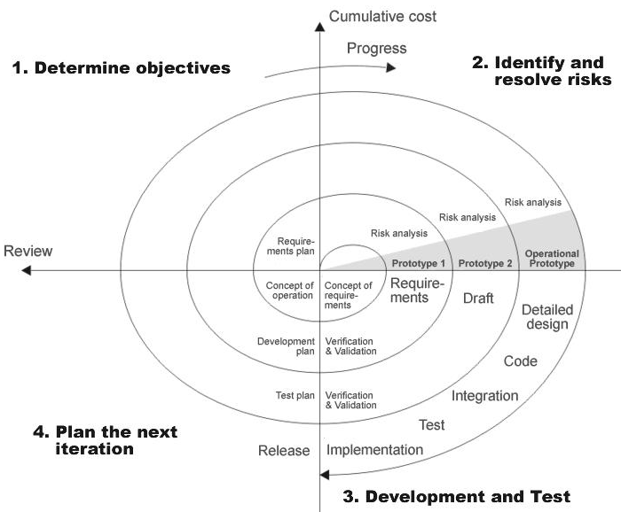

Fig 1.0-Spiral Model

2.3 STUDY OF THE SYSTEM
In the flexibility of the uses the interface has been developed a graphics concept in mind, associated through a browser interface. The GUI’S at the top level have been categorized as
- Administrative user interface
- The operational or generic user interface
The administrative user interface concentrates on the consistent information that is practically, part of the organizational activities and which needs proper authentication for the data collection. The interfaces help the administrations with all the transactional states like Data insertion, Data deletion and Data updating along with the extensive data search capabilities.
The operational or generic user interface helps the users upon the system in transactions through the existing data and required services. The operational user interface also helps the ordinary users in managing their own information helps the ordinary users in managing their own information in a customized manner as per the assisted flexibilities
NUMBER OF MODULES
The system after careful analysis has been identified to be presented with the following modules:
- ADMIN PAGE who have contacts with blood banks,
- Donors will download application and REGISTER with ID, DOB, phone no., blood group etc.
- Admin will send NOTIFICATION to the application users.
- Admin can locate people who are nearby.
- Admin can sort-out people who can come in emergency and send notification to everyone if he gets a donor.
- Provide NAVIGATION to the hospitals that require blood to reach as soon as possible.
- RECORD of donor’s information along with their details

2.4 System Requirement Specifications
Hardware Requirements:
- Android mobile with a minimum version 2.2.
- Processor is not less than 500MHZ.
- RAM is not less than 170MB.
- SD card with minimum of 512MB.
- Resolution is not less than 480*800pixs.
- Bluetooth enabled Android device
Software Requirements:
- Mobile Operating System: Android 2.2 or Later
- Server Operating System: Windows XP or Later
- Tools (IDE): Eclipse or Android Studio
- User Interface: XML
- Code Behind: JAVA and XML
- Telephony Service: Yes
- Internet: No
2.5 PROPOSED SYSTEM
To debug the existing system, remove procedures those cause data redundancy, make navigational sequence proper. To provide information about users on different level and also to reflect the current work status depending on organization. To build strong password mechanism.
NEED FOR COMPUTERIZATION
We all know the importance of computerization. The world is moving ahead at lightning speed and everyone is running short of time. One always wants to get the information and perform a task he/she/they desire(s) within a short period of time and too with amount of efficiency and accuracy.
The application areas for the computerization have been selected on the basis of following factors:
- Minimizing the manual records kept at different locations.
- There will be more data integrity.
- Facilitating desired information display, very quickly, by retrieving information from users.
- Facilitating various statistical information which helps in decision-making?
- To reduce manual efforts in activities that involved repetitive work.
- Updating and deletion of such a huge amount of data will become easier.
FUNCTIONAL FEATURES OF THE MODEL
As far as the project is developed the functionality is simple, the objective of the proposal is to strengthen the functioning of Audit Status Monitoring and make them effective and better. The entire scope has been classified into five streams knows as Coordinator Level, management Level, Auditor Level, User Level and State Web Coordinator Level. The proposed software will cover the information needs with respect to each request of the user group viz. accepting the request, providing vulnerability document report and the current status of the audit.
2.6 PROCESS MODEL USED WITH JUSTIFICATION
ACCESS CONTROL FOR DATA WHICH REQUIRE USER AUTHENTICAION
The following commands specify access control identifiers and they are typically used to authorize and authenticate the user (command codes are shown in parentheses).
USER NAME (USER)
The user identification is that which is required by the server for access to its file system. This command will normally be the first command transmitted by the user after the control connections are made (some servers may require this).

PASSWORD (PASS)
This command must be immediately preceded by the user name command, and, for some sites, completes the user's identification for access control. Since password information is quite sensitive, it is desirable in general to "mask" it or suppress type out.

FEASIBILTTY REPORT
Preliminary investigation examines project feasibility, the likelihood the system will be useful to the organization. The main objective of the feasibility study is to test the Technical, Operational and Economical feasibility for adding new modules and debugging old running system. All system is feasible if they are unlimited resources and infinite time. There are aspects in the feasibility study portion of the preliminary investigation:
- Technical Feasibility
- Operational Feasibility
- Economic Feasibility
3.1. TECHNICAL FEASIBILITY
The technical issue usually raised during the feasibility stage of the investigation includes the following:
- Does the necessary technology exist to do what is suggested?
- Do the proposed equipment's have the technical capacity to hold the data required to use the new system?
- Will the proposed system provide adequate response to inquiries, regardless of the number or location of users?
- Can the system be upgraded if developed?
- Are there technical guarantees of accuracy, reliability, ease of access and data security?
Earlier no system existed to cater to the needs of ‘Secure Infrastructure Implementation System’. The current system developed is technically feasible. It is a web-based user interface for audit work-flow at NIC-CSD.
Thus, it provides an easy access to the users. The database’s purpose is to create, establish and maintain a work-flow among various entities in order to facilitate all concerned users in their various capacities or roles. Permission to the users would be granted based on the roles specified. Therefore, it provides the technical guarantee of accuracy, reliability and security. The software and hard requirements for the development of this project are not many and are already available in-house at NIC or are available as free as open source. The work for the project is done with the current equipment and existing software technology. Necessary bandwidth exists for providing a fast feedback to the users irrespective of the number of users using the system.

3.2. OPERATIONAL FEASIBILITY
Proposed projects are beneficial only if they can be turned out into information system. That will meet the organization’s operating requirements. Operational feasibility aspects of the project are to be taken as an important part of the project implementation. Some of the important issues raised are to test the operational feasibility of a project includes the following:
- Is there sufficient support for the management from the users?
- Will the system be used and work properly if it is being developed and implemented?
This system is targeted to be in accordance with the above-mentioned issues. Beforehand, the management issues and user requirements have been taken into consideration. So, there is no question of resistance from the users that can undermine the possible application benefits.
The well-planned design would ensure the optimal utilization of the computer resources and would help in the improvement of performance status
.3.3. ECONOMICAL FEASIBILITY
A system can be developed technically and that will be used if installed must still be a good investment for the organization. In the economic feasibility, the development cost in creating the system is evaluated against the ultimate benefit derived from the new systems. Financial benefits must equal or exceed the costs.
The system is economically feasible. It does not require any addition hardware or software. Since the interface for this system is developed using the existing resources and technologies available at NIC, there is nominal expenditure and economic feasibility for certain.

SOFTWARE REQUIREMENT SPECIFICATION
The software, Site Explorer is designed for management of web sites from a remote location.
INTRODUCTION
Purpose: The main purpose for preparing this document is to give a general insight into the analysis and requirements of the existing system or situation and for determining the operating characteristics of the system.
Scope: This Document plays a vital role in the development life cycle (SDLC) and it describes the complete requirement of the system. It is meant for use by the developers and will be the basic during testing phase. Any changes made to the requirements in the future will have to go through formal change approval process.
DEVELOPERS RESPONSIBILITIES OVERVIEW
The developer is responsible for:
- Developing the system, which meets the SRS and solving all the requirements of the system?
- Demonstrating the system and installing the system at client's location after the acceptance testing is successful.
- Submitting the required user manual describing the system interfaces to work on it and also the documents of the system.
- Conducting any user training that might be needed for using the system.
- Maintaining the system for a period of one year after installation.

4.1 FUNCTIONAL REQUIREMENTS
OUTPUT DESIGN
Outputs from computer systems are required primarily to communicate the results of processing to users. They are also used to provide a permanent copy of the results for later consultation. The various types of outputs in general are:
- External Outputs, whose destination is outside the organization,
- Internal Outputs whose destination is within organization and they are the
- User’s main interface with the computer.
- Operational outputs whose use is purely within the computer department.
- Interface outputs, which involve the user in communicating directly.

OUTPUT DEFINITION
The outputs should be defined in terms of the following points:
    - Type of the output
    - Content of the output
    - Format of the output
    - Location of the output
    - Frequency of the output
    - Volume of the output
    - Sequence of the output
It is not always desirable to print or display data as it is held on a computer. It should be decided as which form of the output is the most suitable.
For Example:
Output Media:
In the next stage it is to be decided that which medium is the most appropriate for the output. The main considerations when deciding about the output media are:
- The suitability for the device to the particular application.
- The need for a hard copy.
- The response time required.
- The location of the users
- The software and hardware available.
Keeping in view the above description the project is to have outputs mainly coming under the category of internal outputs. The main outputs desired according to the requirement specification are:
The outputs were needed to be generated as a hot copy and as well as queries to be viewed on the screen. Keeping in view these outputs, the format for the output is taken from the outputs, which are currently being obtained after manual processing. The standard printer is to be used as output media for hard copies.
INPUT DESIGN
Input design is a part of overall system design. The main objective during the input design is as given below:
- To produce a cost-effective method of input.
- To achieve the highest possible level of accuracy.
- To ensure that the input is acceptable and understood by the user.
INPUT STAGES:
The main input stages can be listed as below:
- Data recording
- Data transcription
- Data conversion
- Data verification
- Data control
- Data transmission
- Data validation
- Data correction
INPUT TYPES:
It is necessary to determine the various types of inputs. Inputs can be categorized as follows:
- External inputs, which are prime inputs for the system.
- Internal inputs, which are user communications with the system.
- Operational, which are computer department’s communications to the system?
- Interactive, which are inputs entered during a dialogue.
INPUT MEDIA:
At this stage choice has to be made about the input media. To conclude about the input media consideration has to be given to;
- Type of input
- Flexibility of format
- Speed
- Accuracy
- Verification methods
- Rejection rates
- Ease of correction
- Storage and handling requirements
- Security
- Easy to use
- Portability
Keeping in view the above description of the input types and input media, it can be said that most of the inputs are of the form of internal and interactive. As
Input data is to be the directly keyed in by the user, the keyboard can be considered to be the most suitable input device.
ERROR AVOIDANCE
At this stage care is to be taken to ensure that input data remains accurate form the stage at which it is recorded up to the stage in which the data is accepted by the system. This can be achieved only by means of careful control each time the data is handled.
ERROR DETECTION
Even though every effort is made to avoid the occurrence of errors, still a small proportion of errors is always likely to occur, these types of errors can be discovered by using validations to check the input data.
DATA VALIDATION
Procedures are designed to detect errors in data at a lower level of detail. Data validations have been included in the system in almost every area where there is a possibility for the user to commit errors. The system will not accept invalid data. Whenever an invalid data is keyed in, the system immediately prompts the user and the user has to again key in the data and the system will accept the data only if the data is correct. Validations have been included where necessary.
The system is designed to be a user friendly one. In other words, the system has been designed to communicate effectively with the user. The system has been designed with pop-up menus.
USER INTERFACE DESIGN
It is essential to consult the system users and discuss their needs while designing the user interface:
USER INTERFACE SYSTEMS CAN BE BROADLY CLASIFIED AS:
- User initiated interface the user is in charge, controlling the progress of the user/computer dialogue. In the computer-initiated interface, the computer selects the next stage in the interaction.
- Computer initiated interfaces
- In the computer-initiated interfaces the computer guides the progress of the user/computer dialogue. Information is displayed and the user response of the computer takes action or displays further information.
USER_INITIATED INTERFACES
User initiated interfaces fall into two approximate classes:
- Command driven interfaces: In this type of interface the user inputs commands or queries which are interpreted by the computer.
- Forms oriented interface: The user calls up an image of the form to his/her screen and fills in the form. The forms-oriented interface is chosen because it is the best choice.

COMPUTER-INITIATED INTERFACES
The following computer – initiated interfaces were used:
- The menu system for the user is presented with a list of alternatives and the user chooses one of alternatives.
- Questions – answer type dialog system where the computer asks question and takes action based on the basis of the users reply.
Right from the start the system is going to be menu driven, the opening menu displays the available options. Choosing one option gives another popup menu with more options. In this way every option leads the users to data entry form where the user can key in the data.
ERROR MESSAGE DESIGN:
The design of error messages is an important part of the user interface design. As user is bound to commit some errors or other while designing a system the system should be designed to be helpful by providing the user with information regarding the error he/she has committed.
This application must be able to produce output at different modules for different inputs.
4.2. PERFORMANCE REQUIREMENTS
Performance is measured in terms of the output provided by the application.
Requirement specification plays an important part in the analysis of a system. Only when the requirement specifications are properly given, it is possible to design a system, which will fit into required environment. It rests largely in the part of the users of the existing system to give the requirement specifications because they are the people who finally use the system.
This is because the requirements have to be known during the initial stages so that the system can be designed according to those requirements. It is very difficult to change the system once it has been designed and on the other hand designing a system, which does not cater to the requirements of the user, is of no use.
The requirement specification for any system can be broadly stated as given below:
- The system should be able to interface with the existing system
- The system should be accurate
- The system should be better than the existing system
The existing system is completely dependent on the user to perform all the duties.

SELECTED SOFTWARE
5.1 WHAT IS ANDROID?
Android is a mobile operating system (OS) based on the Linux kernel and currently developed by Google. With a user interface based on direct manipulation, Android is designed primarily for touch screen mobile devices such as smart phones and tablet computers, with specialized user interfaces for televisions (Android TV), cars and wrist watches. The OS uses touch inputs that loosely correspond to real-world actions, like swiping, tapping, pinching, and reverse pinching to manipulate on-screen objects, and a virtual keyboard. Despite being primarily designed for touch screen input, it also has been used in game consoles, digital cameras, regular PCs (e.g. the HP Slate 21) and other electronics.
Android is the most widely used mobile OS and, as of 2013, the highest selling OS overall. Android devices sell more than Microsoft Windows, iOS, and Mac OS X devices combined, with sales in 2012, 2013 and 2014close to the installed base of all PCs, As of July 2013 the Google Play store has had over one million Android applications published, and over 50 billion applications downloaded. A developer survey conducted in April–May 2013 found that 7196 of mobile developers develop for Android. At Google I/O 2014, the company revealed that there were over one billion active monthly Android users, up from 538 million in June 2013.
Android's source code is released by Google under open source licenses, although most Android devices ultimately ship with a combination of open source and proprietary software, including proprietary software developed and licensed by Google. Initially developed by Android, Inc., which Google backed financially and later bought in 2005, Android was unveiled in 2007 along with the founding of the Open Handset Alliancea consortium of hardware, software, and telecommunication companies devoted to advancing open standards for mobile devices.
Android is popular with technology companies which require a ready-made, low-cost and customize operating system for high-tech devices. Android's open nature has encouraged a large community of developers and enthusiasts to use the open-source code as a foundation for community-driven projects, which add new features for advanced users or bring Android to devices which were officially, released running other operating systems. The operating system's success has made it a target for patent litigation as part of the so-called "smart phone wars" between technology companies.
Android, Inc. was founded in Palo Alto, California in October 2003 by Andy Rubin (co-founder of Danger), Rich Miner(co-founder of Wildfire Communications, Inc.), Nick Sears (once VP at T-Mobile), and Chris White (headed design and interface development at WebTV) to develop, in Rubin's words, "smarter mobile devices that are more aware of its owner's location and preferences". The early intentions of the company were to develop an advanced operating system for digital cameras.
Though, when it was realized that the market for the devices was not large enough, the company diverted its efforts toward producing a smart phone operating system that would rival Symbian and Microsoft Windows Mobile. Despite the past accomplishments of the founders and early employees, Android Inc. operated secretly, revealing only that it was working on software for mobile phones. That same year, Rubin ran out of money. Steve Perlman, a close friend of Rubin, brought him $10,000 in cash in an envelope and refused a stake in the company.
Google acquired Android Inc. on August 17, 2005; key employees of Android Inc., including Rubin, Miner, and White, stayed at the company after the acquisition. Not much was known about Android Inc. at the time, but many assumed that Google was planning to enter the mobile phone market with this move. At Google, the team led by Rubin developed a mobile device platform powered by the Linux kernel. Google marketed the platform to handset makers and carriers on the promise of providing a flexible, up-gradable system. Google had lined up a series of hardware component and software partners and signalled to carriers that it was open to various degrees of cooperation on their part.
Speculation about Google's intention to enter the mobile communications market continued to build through December 2006.^{[35]} An earlier prototype code-named “Sooner" had a closer resemblance to a BlackBerry phone, with no touch screen, and a physical, QWERTY keyboard, but was later re-engineered to support a touch screen, to compete with other announced devices such as the 2006 LG Prada and 2007 Apple iPhone. In September 2007, Information Week covered an Evalue serve study reporting that Google had filed several patent applications in the area of mobile telephony.
Eric Schmidt, Andy Rubin, and Hugo Barra at a press conference for the Google's Nexus 7 tablet on November 5, 2007, the Open Handset Alliance, a consortium of technology companies including Google, device manufacturers such as HTC, Sony and Samsung, wireless carriers such as Sprint Nextel and T-Mobile, and chip set makers such as Qualcomm and Texas Instruments, unveiled itself, with a goal to develop open standards for mobile devices. That day, Android was unveiled as its first product, a mobile device platform built on the Linux kernel version 2.6.25. The first commercially available Smart-phone running Android was the HTC Dream, released on October 22, 2008.
In 2010, Google launched its Nexus series of devices – a line of Smartphone’s and tablets running the Android operating system, and built by manufacturing partners. HTC collaborated with Google to release the first Nexus Smart-phone, the Nexus One. Google has since updated the series with newer devices, such as the Nexus 5 phone (made by LG) and the Nexus 7 tablet (made by Asus). Google releases the Nexus phones and tablets to act as their flagship Android devices, demonstrating Android's latest software and hardware features. On March 13, 2013 Larry Page announced in a blog post that Andy Rubin had moved from the Android division to take on new projects at Google. He was replaced by Sundar Pichai, who also continues his role as the head of Google's Chrome division, which develops Chrome OS.
Since 2008, Android has seen numerous updates which have incrementally improved the operating system, adding new features and fixing bugs in previous releases. Each major release is named in alphabetical order after a dessert or sugary treat; for example, version 1.5 Cupcake was followed by 1.6 Donut. Version 4.4.4 KitKat appeared as a security-only update; it was released on June 19, 2014, shortly after 4.4.3 was released. As of November 2014, the newest version of the Android operating system, Android 5.0 "Lollipop", is available for selected devices.
From 2010 to 2013, Hugo Barra served as product spokesperson for the Android team, representing Android at both press conferences and Google I/O, Google’s annual developer-focused conference. Barra’s product involvement included the entire Android ecosystem of software and hardware, including Honeycomb, Ice Cream Sandwich, Jelly Bean and KitKat operating system launches, the Nexus 4 and Nexus 5 Smartphone’s, the Nexus 7 and Nexus 10 tablets, and other related products such as Google Now and Google Voice Search, Google’s speech recognition product comparable to Apple’s Siri. In 2013, Barra left the Android team for Chinese Smartphone maker Xiaomi.
5.2 FEATURES
Interface
Notifications are accessed by sliding from the top of the display; individual notifications can be dismissed by sliding them away, and may contain additional functions (such as on the "missed call" notification seen here).
Android's default user interface is based on direct manipulation, using touch inputs, that loosely correspond to real-world actions, like swiping, tapping, pinching, and reverse pinching to manipulate on-screen objects, and a virtual keyboard. The response to user input is designed to be immediate and provides a fluid touch interface, often using the vibration capabilities of the device to provide hepatic feedback to the user. Internal hardware such as accelerometer s, gyroscopes and proximity are used by some applications to respond to additional user actions, for example adjusting the screen from portrait to landscape depending on how the device is oriented, or allowing the user to steer a vehicle in a racing game by rotating the device, simulating control of a steering wheel.
Android devices boot to the home screen, the primary navigation and information point on the device, which is similar to the desktop found on PCs. Android home screens are typically made up of app icons and widgets; app icons launch the associated app, whereas widgets display live, auto-updating content such as the weather forecast, the user's email inbox, or a news ticker directly on the home screen. Third-party apps available on Google Play and other app stores can extensively re-theme the home screen, and even mimic the look of other operating systems, such as Windows Phone. Most manufacturers, and some wireless carriers, customize the look and feel of their Android devices to differentiate themselves from their competitors.
Present along the top of the screen is a status bar, showing information about the device and its connectivity. This status bar can be "pulled" down to reveal a notification screen where apps display important information or updates, such as a newly received email or SMS text, in a way that does not immediately interrupt or inconvenience the user. Notifications are persistent until read (by tapping, which opens the relevant app) or dismissed by sliding it off the screen. Beginning on Android 4.1, "expanded notifications" can display expanded details or additional functionality; for instance, a music player can display playback controls, and a "missed call" notification provides buttons for calling back or sending the caller an SMS message.
Android provides the ability to run applications which change the default launcher and hence the appearance and externally visible behaviour of Android. These appearance changes include a multi-page dock or no dock, and many more changes to fundamental features of the user interface.
Applications
See also: Android software development and Google Play
Applications, that extend the functionality of devices, are written primarily in the Java programming language (without the usual "write once, run anywhere" claim of the Java platform) using the Android software development kit (SDK). The SDK includes a comprehensive set of development tools, including a debugger, software libraries, a handset emulator based on QEMU, documentation, sample code, and tutorials. The officially supported integrated development environment (IDE) is Eclipse using the Android Development Tools (ADT) plug-in. Other development tools are available, including a Native Development Kit for applications or extensions in C or C++, Google App Inventor, a visual environment for novice programmers, and various cross platform mobile web applications frameworks. In January 2014, Google unveiled an Apache Cordova–based framework for porting Chrome HTML 5 applications to Android, wrapped in a native application shell.
Android has a growing selection of third-party applications, which can be acquired by users by downloading and installing the application's APK file, or by downloading them using an application store program that allows users to install, update, and remove applications from their devices. Google Play Store is the primary application store installed on Android devices that comply with Google's compatibility requirements and license the Google Mobile Services software. Google Play Store allows users to browse, download and update applications published by Google and third-party developers; As of July 2013, there are more than one million applications available for Android in Play Store. As of May 2013, 48 billion applications have been installed from Google Play Store and in July 2013, 50 billion applications were installed. Some carriers offer direct carrier billing for Google Play application purchases, where the cost of the application is added to the user's monthly bill.
Due to the open nature of Android, a number of third-party application marketplace also exist for Android, either to provide a substitute for devices that are not allowed to ship with Google Play Store, provide applications that cannot be offered on Google Play Store due to policy violations, or for other reasons. Examples of these third-party stores have included the Amazon, Get Jar, and Slide Me. F-Droid, another alternative marketplace, seeks to only provide applications that are distributed under free and open source licenses.
Memory management
Since Android devices are usually battery-powered, Android is designed to manage memory (RAM) to keep power consumption at a minimum, in contrast to desktop operating systems which generally assume they are connected to unlimited mains electricity. When an Android application is no longer in use, the system will automatically suspend it in memory; while the application is still technically "open", suspended applications consume no resources (for example, battery power or processing power) and sit idly in the background until needed again. This brings a dual benefit by increasing the general responsiveness of Android devices, since applications do not need to be closed and reopened from scratch each time, and by ensuring that background applications do not consume power needlessly.
Android manages the applications stored in memory automatically: when memory is low, the system will begin killing applications and processes that have been inactive for a while, in reverse order since they were last used (oldest first). This process is designed to be invisible to the user, so that users do not need to manage memory or the killing of applications themselves. As of 2011, third-party task killers were reported by Life hacker as doing more harm than good.
5.3Development
Android is developed in private by Google until the latest changes and updates are ready to be released, at which point the source code is made available publicly. This source code will only run without modification on select devices, usually the Nexus series of devices. The source code is, in turn, adapted by OEMs to run on their hardware. Android's source code does not contain the often-proprietary devices that are needed for certain hardware components.
The green Android logo was designed for Google in 2007 by graphic designer Irina Blok. The design team was tasked with a project to create a universally identifiable icon with the specific inclusion of a robot in the final design. After numerous design developments based on science-fiction and space movies, the team eventually sought inspiration from the human symbol on restroom doors and modified the figure into a robot shape. As Android is open-sourced, it was agreed that the logo should be likewise, and since its launch the green logo has been reinterpreted into countless variations on the original design.
Update schedule
Google provides major incremental upgrades to Android every six to nine months, with confectionary-themed names, which most devices are capable of receiving over the air. The latest major release is Android 5.0 "Lollipop".
Compared to its chief rival mobile operating system, namely iOS, Android updates are typically slow to reach actual devices. For devices not under the Nexus brand, updates often arrive months from the time the given version is officially released. This is partly due to the extensive variation in hardware of Android devices, to which each upgrade must be specifically tailored, as the official Google source code only runs on their flagship Nexus devices. Porting Android to specific hardware is a time- and resource-consuming process for device manufacturers, who prioritize their newest devices and often leave older ones behind. Hence, older Smartphone’s are frequently not updated if the manufacturer decides it is not worth their time, regardless of whether the phone is capable of running the update. This problem is compounded when manufacturers customize Android with their own interface and apps, which must be reapplied to each new release. Additional delays can be introduced by wireless carriers who, after receiving updates from manufacturers, further customize and brand Android to their needs and conduct extensive testing on their networks before sending the upgrade out to users.
The lack of after-sale support from manufacturers and carriers has been widely criticized by consumer groups and the technology media. Some commentators have noted that the industry has a financial incentive not to upgrade their devices, as the lack of updates for existing devices fuels the purchase of newer ones, an attitude described as "insulting". The Guardian has complained that the method of distribution for updates is complicated only because manufacturers and carriers have designed it that way. In 2011, Google partnered with a number of industry players to announce an "Android Update Alliance", pledging to deliver timely updates for every device for 18 months after its release however; there has not been another official word about that alliance.
In 2012, Google began decoupling certain aspects of the operating system (particularly core applications) so they could be updated through Google Play Store, independently of Android itself. One of these components, Google Play Services, is a closed-source system-level process providing APIs for Google services, installed automatically on nearly all devices running Android version 2.2 and higher. With these changes, Google can add new operating system functionality through Play Services and application updates without having to distribute an upgrade to the operating system itself. As a result, Android 4.2 and 4.3 contained relatively fewer user-facing changes, focusing more on minor changes and platform improvements.
Linux kernel
Android's kernel is based on one of the Linux kernel's long-term support (LTS) branches. Since April 2014, Android devices mainly use versions 3.4 or 3.10 of the Linux kernel. The specific kernel version depends on the actual Android device and its hardware platform Android has used various kernel versions since the version 2.6.25 that was used in Android 1.0.
Android's variant of the Linux kernel has further architectural changes that are implemented by Google outside the typical Linux kernel development cycle, such as the inclusion of components like Binder, ashmem, pmem, logger, wake locks, and different out-of-memory (OOM) handling. Certain features that Google contributed back to the Linux kernel, notably a power management feature called "wake locks", were rejected by mainline kernel developers partly because they felt that Google did not show any intent to maintain its own code. Google announced in April 2010 that they would hire two employees to work with the Linux kernel community, but Greg Kroah-Hartman, the current Linux kernel maintainer for the stable branch, said in December 2010 that he was concerned that Google was no longer trying to get their code changes included in mainstream Linux. Some Google Android developers hinted that "the Android team was getting fed up with the process," because they were a small team and had more urgent work to do on Android.
In August 2011, Linus Torvalds said that "eventually Android and Linux would come back to a common kernel, but it will probably not be for four to five years". In December 2011, Greg Kroah-Hartman announced the start of Android Mainlining Project, which aims to put some Android drivers, patches and features back into the Linux kernel, starting in Linux 3.3. Linux included the auto sleep and wake locks capabilities in the 3.5 kernel, after many previous attempts at merger. The interfaces are the same but the upstream Linux implementation allows for two different suspend modes: to memory (the traditional suspend that Android uses), and to disk (hibernate, as it is known on the desktop). Google maintains a public code repository that contains their experimental work to re-base Android off the latest stable Linux versions.
The flash storage on Android devices is split into several partitions, such as system for the operating system itself, and data for user data and application installations. In contrast to desktop Linux distributions, Android device owners are not given root access to the operating system and sensitive partitions such as systems are read-only.
Android is a Linux distribution according to the Linux Foundation, Google's open-source chief Chris DiBona, and several journalists. Others, such as Google engineer Patrick Brady, say that Android is not Linux in the traditional Unix Linux distribution sense; Android does not include the GNU C Library and some of other components typically found in Linux distributions.
Software stack
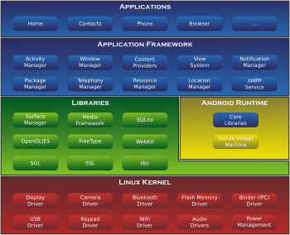
Fig: Android’s architecture diagram
On top of the Linux kernel, there are the middleware, libraries and APIs written in C, and application software running on an application which includes Java-compatible libraries based on Apache Harmony. Development of the Linux kernel continues independently of other Android's source code bases.
Until version 5.0, Android used Dalvik as a process virtual machine with just-in-time (JIT) compilation to run Dalvik "dex-code" (Dalvik Executable), which is usually translated from the Java. Following the JIT principle, Dalvik performs the compilation each time an application is launched. Android 4.4 introduced Android Runtime (ART) as a new runtime environment, which uses ahead-of-time (AOT) compilation to compile the byte code upon the installation of an application.
In Android 4.4, ART was an experimental feature and not enabled by default; it became the only runtime option in the next major version of Android, 5.0.
Android's standard C library, Bionic, was developed by Google specifically for Android, as a derivation of the BSD's standard C library code. Bionic itself has been designed with several major features specific to the Linux kernel. The main benefits of using Bionic instead of the GNU C Library (glib) or uClibc are its smaller runtime footprint, and optimization for low-frequency CPUs. At the same time, Bionic is licensed under the terms of BSD licence, which Google finds more suitable for the Android's overall licensing model.
Aiming for a different licensing model, toward the end of 2012 Google switched the Bluetooth stack in Android from the GPL-licensed BlueZ to the Apache-licensed Blue Droid.
Android does not have a native X Window System by default, nor does it support the full set of standard GNU libraries. This made it difficult to port existing Linux applications or libraries to Android, until version r5 of the Android Native Development Kit brought support for applications written completely in C or C++. Libraries written in C may also be used in applications by injection of a small shim and usage of the JNI.
Open-source community
Android has an active community of developers and enthusiasts who use the Android Open Source Project (AOSP) source code to develop and distribute their own modified versions of the operating system. These community-developed releases often bring new features and updates to devices faster than through the official manufacturer/carrier channels, albeit without as extensive testing or quality assurance; provide continued support for older devices that no longer receive official updates; or bring Android to devices that were officially released running other operating systems, such as the HP Touchpad. Community releases often come pre-rooted and contain modifications unsuitable for non-technical users, such as the ability to over clock or over/under volt the device's processor. Cyanogen Mod is the most widely used community firmware, and acts as a foundation for numerous others.
Historically, device manufacturers and mobile carriers have typically been unsupportive of third-party firmware development. Manufacturers express concern about improper functioning of devices running unofficial software and the support costs resulting from this. Moreover, modified firmware such as cyanogen Mod sometimes offers features, such as tethering, for which carriers would otherwise charge a premium. As a result, technical obstacles including locked boot loaders and restricted access to root permissions are common in many devices. However, as community-developed software has grown more popular, and following a statement by the Librarian of Congress in the United States that permits the "jail breaking" of mobile devices, manufacturers and carriers have softened their position regarding third party development, with some, including HTC, Samsung, Sony, Motorola providing support and encouragement development.
As a result of this, over time the need to circumvent hardware restrictions to install unofficial firmware has lessened as an increasing number of devices are shipped with unlocked or unlock able boot loaders, similar to Nexus series of phones, although usually requiring that users waive their devices' warranties to do so. However, despite manufacturer acceptance, some carriers in the US still require that phones are locked down, frustrating developers and customers.

SYSTEM DESIGN
6.1. INTRODUCTION
Software design sits at the technical kernel of the software engineering process and is applied regardless of the development paradigm and area of application. Design is the first step in the development phase for any engineered product or system. The designer’s goal is to produce a model or representation of an entity that will later be built. Beginning, once system requirement has been specified and analysed, system design is the first of the three technical activities -design, code and test that is required to build and verify software.
The importance can be stated with a single word “Quality”. Design is the place where quality is fostered in software development. Design provides us with representations of software that can assess for quality. Design is the only way that we can accurately translate a customer’s view into a finished software product or system. Software design serves as a foundation for all the software engineering steps that follow. Without a strong design we risk building an unstable system – one that will be difficult to test, one whose quality cannot be assessed until the last stage.
During design, progressive refinement of data structure, program structure, and procedural details are developed reviewed and documented. System design can be viewed from either technical or project management perspective. From the technical point of view, design is comprised of four activities – architectural design, data structure design, interface design and procedural design.
6.2 NORMALIZATION
It is a process of converting a relation to a standard form. The process is used to handle the problems that can arise due to data redundancy i.e. repetition of data in the database, maintain data integrity as well as handling problems that can arise due to insertion, updating, deletion anomalies.
Decomposing is the process of splitting relations into multiple relations to eliminate anomalies and maintain anomalies and maintain data integrity. To do this we use normal forms or rules for structuring relation.
Insertion anomaly: Inability to add data to the database due to absence of other data.
Deletion anomaly: Unintended loss of data due to deletion of other data.
Update anomaly: Data inconsistency resulting from data redundancy and partial update
Normal Forms: These are the rules for structuring relations that eliminate anomalies.
FIRST NORMAL FORM:
A relation is said to be in first normal form if the values in the relation are atomic for every attribute in the relation. By this we mean simply that no attribute value can be a set of values or, as it is sometimes expressed, a repeating group.
SECOND NORMAL FORM:
A relation is said to be in second Normal form is it is in first normal form and it should satisfy any one of the following rules.
- Primary key is a not a composite primary key
- No non key attributes are present
- Every non key attribute is fully functionally dependent on full set of primary keys.
THIRD NORMAL FORM:
A relation is said to be in third normal form if their exits no transitive dependencies.
Transitive Dependency: If two non-key attributes depend on each other as well as on the primary key then they are said to be transitively dependent. The above normalization principles were applied to decompose the data in multiple tables thereby making the data to be maintained in a consistent state.
6.3 DATA FLOW DIAGRAMS
A data flow diagram is graphical tool used to describe and analyse movement of data through a system. These are the central tool and the basis from which the other components are developed. The transformation of data from input to output, through processed, may be described logically and independently of physical components associated with the system. These are known as the logical data flow diagrams. The physical data flow diagrams show the actual implements and movement of data between people, departments and workstations. A full description of a system actually consists of a set of data flow diagrams. Using two familiar notations Yourdon, Gane and Sarson notation develops the data flow diagrams. Each component in a DFD is labelled with a descriptive name. Process is further identified with a number that will be used for identification purpose. The development of DFD’S is done in several levels. Each process in lower level diagrams can be broken down into a more detailed DFD in the next level. The lop-level diagram is often called context diagram. It consists a single process bit, which plays vital role in studying the current system. The process in the context level diagram is exploded into other process at the first level DFD.
The idea behind the explosion of a process into more process is that understanding at one level of detail is exploded into greater detail at the next level. This is done until further explosion is necessary and an adequate amount of detail is described for analyst to understand the process.
A DFD is also known as a “bubble Chart” has the purpose of clarifying system requirements and identifying major transformations that will become programs in system design. So, it is the starting point of the design to the lowest level of detail. A DFD consists of a series of bubbles joined by data flows in the system.
DFD SYMBOLS:
In the DFD, there are four symbols
- A square defines a source(originator) or destination of system data
- An arrow identifies data flow. It is the pipeline through which the information flows
- A circle or a bubble represents a process that transforms incoming data flow into outgoing data flows.
- An open rectangle is a data store, data at rest or a temporary repository of data.

Process that transforms data flow.

Source or Destination of data

Data flow

Data Store

CONSTRUCTING A DFD:
Several rules of thumb are used in drawing DFD’S:
- Process should be named and numbered for an easy reference. Each name should be representative of the process.
- The direction of flow is from top to bottom and from left to right. Data traditionally flow from source to the destination although they may flow back to the source. One way to indicate this is to draw long flow line back to a source.
- An alternative way is to repeat the source symbol as a destination. Since it is used more than once in the DFD it is marked with a short diagonal.
- When a process is exploded into lower level details, they are numbered.
- The names of data stores and destinations are written in capital letters. Process and dataflow names have the first letter of each work capitalized.
A DFD typically shows the minimum contents of data store. Each data store should contain all the data elements that flow in and out.
Questionnaires should contain all the data elements that flow in and out. Missing interfaces redundancies and like is then accounted for often through interviews.
SAILENT FEATURES OF DFD’S
- The DFD shows flow of data, not of control loops and decision are controlled considerations do not appear on a DFD.
- The DFD does not indicate the time factor involved in any process whether the dataflow take place daily, weekly, monthly or yearly.
- The sequence of events is not brought out on the DFD.

TYPES OF DATA FLOW DIAGRAMS
- Current Physical
- Current Logical
- New Logical
- New Physical

CURRENT PHYSICAL:
In Current Physical DFD process label include the name of people or their positions or the names of computer systems that might provide some of the overall system-processing label includes an identification of the technology used to process the data. Similarly, data flows and data stores are often labelling with the names of the actual physical media on which data are stored such as file folders, computer files, business forms or computer tapes.
CURRENT LOGICAL:
The physical aspects at the system are removed as much as possible so that the current system is reduced to its essence to the data and the processors that transforms them regardless of actual physical form.
NEW LOGICAL:
This is exactly like a current logical model if the user were completely happy with the user were completely happy with the functionality of the current system but had problems with how it was implemented typically through the new logical model will differ from current logical model while having additional functions, absolute function removal and inefficient flows recognized.
NEW PHYSICAL:
The new physical represents only the physical implementation of the new system.

RULES GOVERNING THE DFD’S

PROCESS
- No process can have only outputs.
- No process can have only inputs. If an object has only inputs than it must be a sink.
- A process has a verb phrase label.
DATA STORE
- Data cannot move directly from one data store to another data store, a process must move data.
- Data cannot move directly from an outside source to a data store, a process, which receives, must move data from the source and place the data into data store
- A data store has a noun phrase label.

SOURCE OR SINK
The origin and /or destination of data.
- Data cannot move direly from a source to sink it must be moved by a process
- A source and /or sink has a noun phrase land
DATA FLOW
- A Data Flow has only one direction of flow between symbols. It may flow in both directions between a process and a data store to show a read before an update. The later is usually indicated however by two separate arrows since these happen at different type.
- A join in DFD means that exactly the same data comes from any of two or more different processes data store or sink to a common location.
- A data flow cannot go directly back to the same process it leads. There must be at least one other process that handles the data flow produce some other data flow returns the original data into the beginning process.
- A Data flow to a data store means update (delete or change).
- A data Flow from a data store means retrieve or use.

Context Level Diagram:
Order Management
Donor Management
User Management
Login Management
Group Management
Blood Management
Blood Bank
Management
System

6.4 UML DIAGRAMS
Activity Diagram: -

User
Login
Home
Login fail
Can donate
Can request for blood
Can save and update detail
Can see donor list
User can see lifesaver list

Class diagram:-
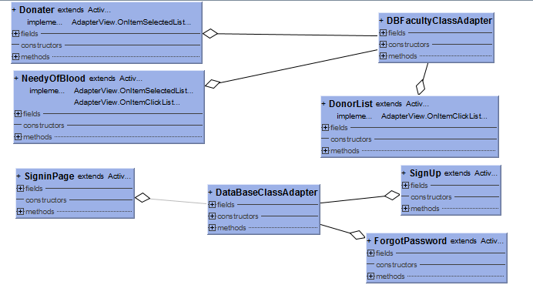

Component Diagram:-
Blood group
Donator
Needy of Blood
Blood Bank Management
Database

Persistance

Blood Bank management
system

Sequence diagram:-
User
Login
Homepage
Donator can save and update detail
Admin home page
Admin
Users Requester
1 : login()
2 : login()
3 : can request for blood()
4 : login fail()
5 : can save and update deati()
6 : login fail()
7 : can see donor list()

State chart diagram admin: -State chart diagram user:-

User
User homepage
Login
Can select donor/requester
As a donor can save data
As a requester can see donor
User can see life saver list
User
User homepage
Login
Can select donor/requester
As a donor can save data
As a requester can see donor
User can see life saver list

Use case diagram:-

System
User
Sign in
Sign up
User Home
select option
can donate or request for blood
as a donor can save and update detail
as a acceptor search donor
user can see the life saver details

CHAPTER-7
OUTPUT SCREENS

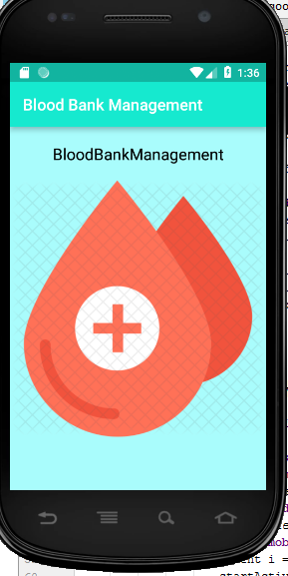

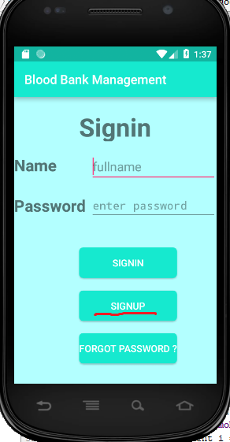

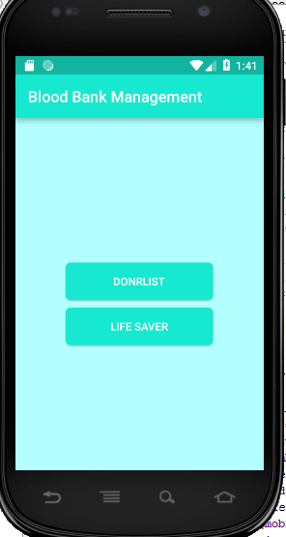

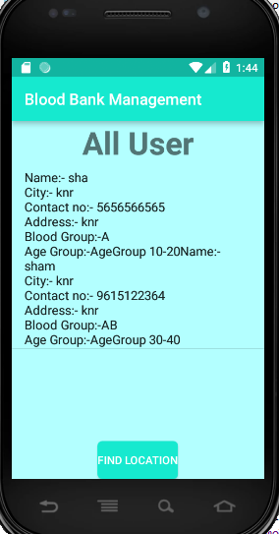

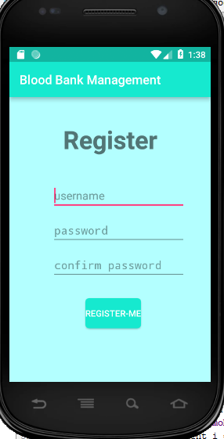
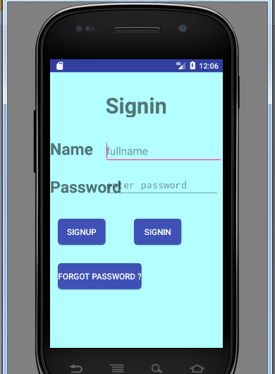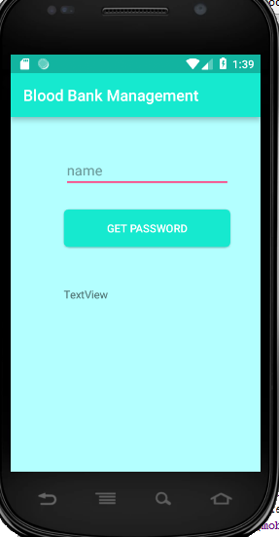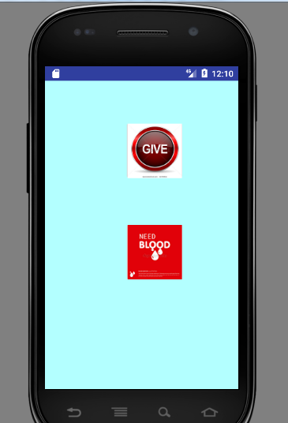
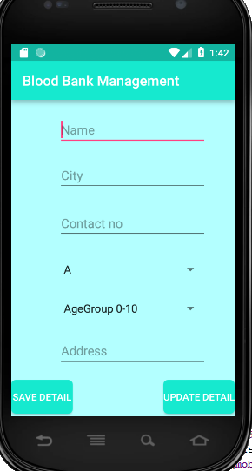
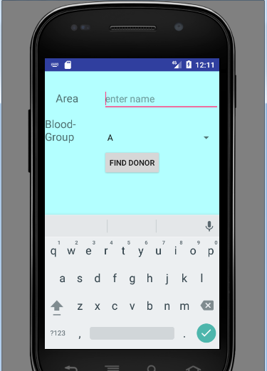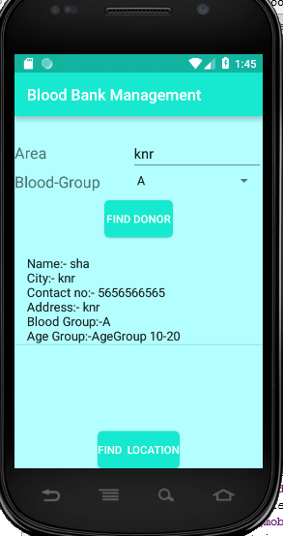

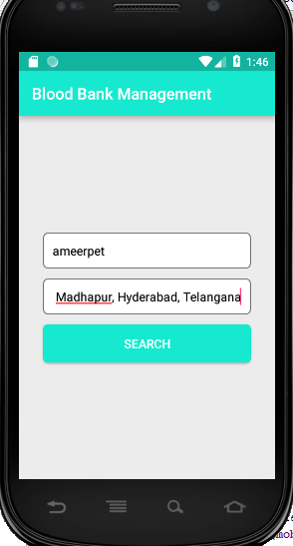

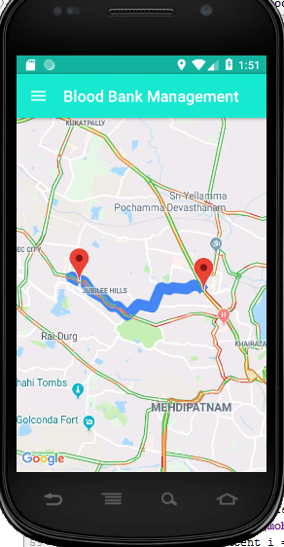

CHAPTER-8
SYSTEM TESTING AND IMPLEMENTATION
  - INTRODUCTION
Software testing is a critical element of software quality assurance and represents the ultimate review of specification, design and coding. In fact, testing is the one step in the software engineering process that could be viewed as destructive rather than constructive.
A strategy for software testing integrates software test case design methods into a well-planned series of steps that result in the successful construction of software. Testing is the set of activities that can be planned in advance and conducted systematically. The underlying motivation of program testing is to affirm software quality with methods that can economically and effectively apply to both strategic to both large and small-scale systems.
8.2. STRATEGIC APPROACH TO SOFTWARE TESTING
The software engineering process can be viewed as a spiral. Initially system engineering defines the role of software and leads to software requirement analysis where the information domain, functions, behaviour, performance, constraints and validation criteria for software are established. Moving inward along the spiral, we come to design and finally to coding. To develop computer software, we spiral in along streamlines that decrease the level of abstraction on each turn.
A strategy for software testing may also be viewed in the context of the spiral. Unit testing begins at the vertex of the spiral and concentrates on each unit of the software as implemented in source code. Testing progress by moving outward along the spiral to integration testing, where the focus is on the design and the construction of the software architecture. Talking another turn on outward on the spiral we encounter validation testing where requirements established as part of software requirements analysis are validated against the software that has been constructed. Finally, we arrive at system testing, where the software and other system elements are tested as a whole
.

8.3. UNIT TESTING
Unit testing focuses verification effort on the smallest unit of software design, the module. The unit testing, we have is white box oriented and some modules the steps are conducted in parallel.
1. WHITE BOX TESTING
This type of testing ensures that
- All independent paths have been exercised at least once
- All logical decisions have been exercised on their true and false sides
- All loops are executed at their boundaries and within their operational bounds
- All internal data structures have been exercised to assure their validity.
To follow the concept of white box testing we have tested each form. we have created independently to verify that Data flow is correct, all conditions are exercised to check their validity, all loops are executed on their boundaries.
2. BASIC PATH TESTING
Established technique of flow graph with Cyclomatic complexity was used to derive test cases for all the functions. The main steps in deriving test cases were:
Use the design of the code and draw correspondent flow graph.
Determine the Cyclomatic complexity of resultant flow graph, using formula:
V (G) =E-N+2 or
V (G) =P+1 or
V (G) =Number of Regions
Where V (G) is Cyclamate complexity,
E is the number of edges,
N is the number of flow graph nodes,
P is the number of predicate nodes.
Determine the basis of set of linearly independent paths.

3. CONDITIONAL TESTING
In this part of the testing each of the conditions were tested to both true and false aspects. And all the resulting paths were tested. So that each path that may be generate on particular condition is traced to uncover any possible errors.
4. DATA FLOW TESTING
This type of testing selects the path of the program according to the location of definition and use of variables. This kind of testing was used only when some local variable were declared. The definition-use chain method was used in this type of testing. These were particularly useful in nested statements.
5. LOOP TESTING
- In this type of testing all the loops are tested to all the limits possible. The following exercise was adopted for all loops:
- All the loops were tested at their limits, just above them and just below them.
- All the loops were skipped at least once.
- For nested loops test the inner most loop first and then work outwards.
- For concatenated loops the values of dependent loops were set with the help of connected loop.
- Unstructured loops were resolved into nested loops or concatenated loops and tested as above.
- Each unit has been separately tested by the development team itself and all the input have been validated.

CHAPTER-9
SYSTEM SECURITY

9.1 INTRODUCTION
The protection of computer-based resources that includes hardware, software, data, procedures and people against unauthorized use or natural
Disaster is known as System Security.
System Security can be divided into four related issues:
- Security
- Integrity
- Privacy
- Confidentiality
SYSTEM SECURITY refers to the technical innovations and procedures applied to the hardware and operation systems to protect against deliberate or accidental damage from a defined threat.
DATA SECURITY is the protection of data from loss, disclosure, modification and destruction.
SYSTEM INTEGRITY refers to the power functioning of hardware and programs, appropriate physical security and safety against external threats such as eavesdropping and wiretapping
PRIVACY defines the rights of the user or organizations to determine what information they are willing to share with or accept from others and how the organization can be protected against unwelcome, unfair or excessive dissemination of information about it.
CONFIDENTIALITY is a special status given to sensitive information in a database to minimize the possible invasion of privacy. It is an attribute of information that characterizes its need for protection.
9.2 SECURITY SOFTWARE
System security refers to various validations on data in form of checks and controls to avoid the system from failing. It is always important to ensure that only valid data is entered and only valid operations are performed on the system. The system employees two types of checks and controls:
CLIENT-SIDE VALIDATION
Various client-side validations are used to ensure on the client side that only valid data is entered. Client-side validation saves server time and load to handle invalid data. Some checks imposed are:
- VBScript in used to ensure those required fields are filled with suitable data only. Maximum lengths of the fields of the forms are appropriately defined.
- Forms cannot be submitted without filling up the mandatory data so that manual mistakes of submitting empty fields that are mandatory can be sorted out at the client side to save the server time and load.
- Tab-indexes are set according to the need and taking into account the ease of user while working with the system.
SERVER-SIDE VALIDATION
on several restricted operations are imposed. Some checks cannot be applied at client side. Server-side checks are necessary to save the system from failing and intimating the user that some invalid operation has been performed or the performed operation is restricted. Some of the server-side checks imposed is:
- Server-side constraint has been imposed to check for the validity of primary key and foreign key. A primary key value cannot be duplicated. Any attempt to duplicate the primary value results into a message intimating the user about those values through the forms using foreign key can be updated only of the existing foreign key values.
- User is intimating through appropriate messages about the successful operations or exceptions occurring at server side.
- Various Access Control Mechanisms have been built so that one user may not agitate upon another. Access permissions to various types of users are controlled according to the organizational structure. Only permitted users can log on to the system and can have access according to their category. User- name, passwords and permissions are controlled o the server side.
- Using server-side validation, constraints

10.CONCLUSION
It has been a great pleasure for me to work on this exciting and challenging project. This project proved good for me as it provided practical knowledge of not only programming in Java, but also about all handling procedure related with “Blood Bank Management System”. It also provides knowledge about the latest technology used in developing web enabled application and client server technology that will be great demand in future. This will provide better opportunities and guidance in future in developing projects independently.
- By using Blood bank application having the information about the currently blood available blood banks. It contains the information about the blood donor's according to the blood group wise, by using this system to view all the donor details and select the right donor. With this application the user will be able make quick decision in selecting a donor.

11.FUTURE IMPROVEMENT
- This System being web-based and an undertaking of Cyber Security Division, needs to be thoroughly tested to find out any security gaps.

- A console for the data centre may be made available to allow the personnel to monitor on the sites which were cleared for hosting during a particular period.

- Moreover, it is just a beginning; further the system may be utilized in various other types of auditing operation viz. Network auditing or similar process/workflow-based applications.

LIFE SAVING CONTACTS
If at all the people in search of a donor doesn’t get any match from their area and group then they will be provided service i.e. he will be given a Contact Person details for their nearby cities who have the details of many other donors with him. The people in search can call him and can get the details of the donors and can be provided services in this manner. But this life saving contact persons can be available only for a limited number of cities not for all. These contact persons are the authorized persons of many blood banks.

LOCATION
The location of the donors can be sent to the acceptors.

12. BIBLIOGRAPHY
- Android Developer Guide: http://developer.android.com/guide/index.html.
- Android API: http://developer.android.com/reference/packages.html
- Java 6 API: http://download-llnw.oracle.com/javase/6/docs/api/
- Google Maps API: http://code.google.com/android/add-ons/google-apis/reference/com/google/android/maps/package-summary.html
- Android Fundamentals: http://developer.android.com/guide/topics/fundamentals.html
- The Java Tutorials: http://download-llnw.oracle.com/javase/tutorial/index.html
- Android Native Development Kit: http://developer.android.com/sdk/ndk/index.html
- Android User Interfaces: http://developer.android.com/guide/topics/ui/index.html
- Declaring Layout: http://developer.android.com/guide/topics/ui/declaring-layout.html
- Common Tasks: http://developer.android.com/guide/appendix/faq/commontasks.html
- Maps External Library:
http://code.google.com/android/add-ons/google-apis/maps-overview.html
- Maps API Key: http://code.google.com/android/add-ons/google-apis/mapkey.html
- Icons: http://developer.android.com/guide/practices/ui_guidelines/icon_design.html
- Sample Source Code: http://developer.android.com/resources/samples/get.html
- List of Sample Apps: http://developer.android.com/resources/samples/index.html.
- Apps-for-android Sample Apps: http://code.google.com/p/apps-for-android/.
- Android Developer's Blog: http://android-developers.blogspot.com/
- Developer FAQ: http://developer.android.com/resources/faq/
- Developer Forums: http://developer.android.com/resources/community-groups.html
- Android Developer's Group: http://groups.google.com/group/android-developers?lnk=
- XDA-Developers Forums: http://forum.xda-developers.com/
22. A book by O’reilly called “android application development”.

General Android Information and/or Forums
- Android Power: http://blogs.computerworld.com/raphael
- The Droid Guy: http://thedroidguy.com/
- Seeing through Windows: http://blogs.computerworld.com/gralla
- Phandroid: http://phandroid.com/
- Android Guys: http://www.androidguys.com/
- CW: http://www.computerworld.com/s/article/9178688/Android_news_reviews_more
- Wireless & Mobile News: http://www.wirelessandmobilenews.com/tag/android
- http://www.android.com/
- http://developer.android.com/sdk/index.html

http://developer.android.com/guide/basics/what-is-android.html
*******Your Name*********

