2023-05-06 - Handout – Stacks 2

# Q1. Build an Array With Stack Operations

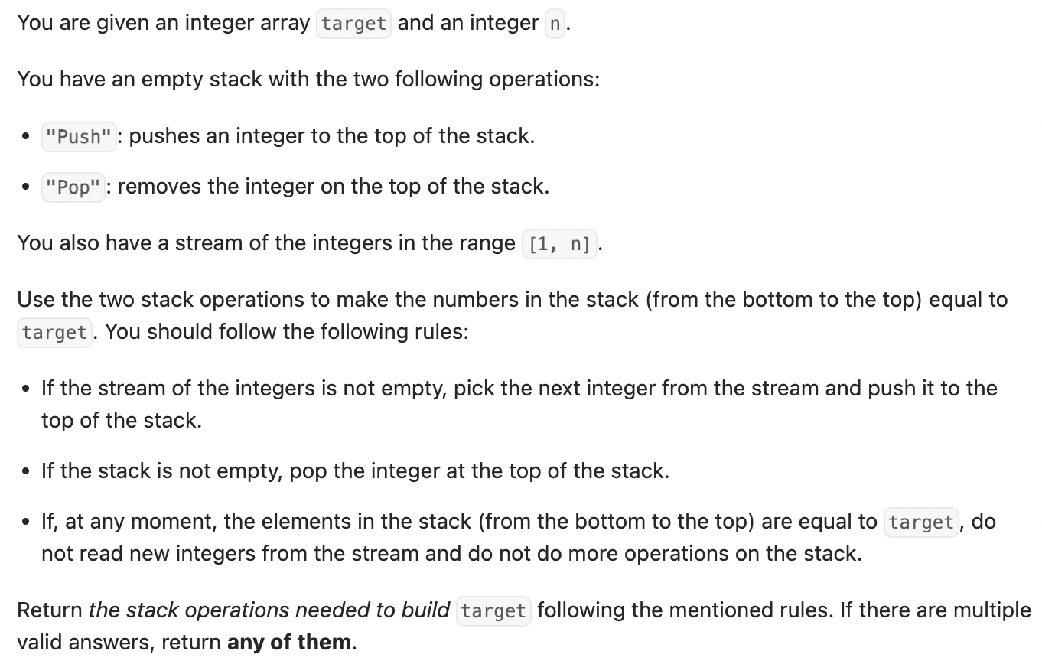Link: <https://leetcode.com/problems/build-an-array-with-stack-operations/description/>

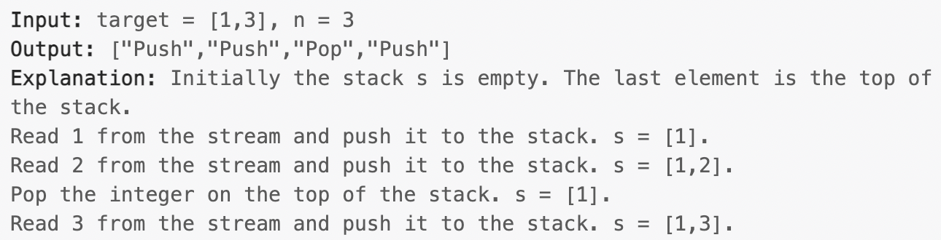Constraints: 1 <= target[i] <= n, target is strictly increasing

# Q2. Daily Temperature

Link: <https://leetcode.com/problems/daily-temperatures/>

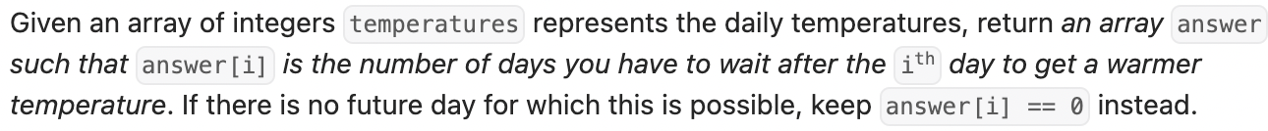

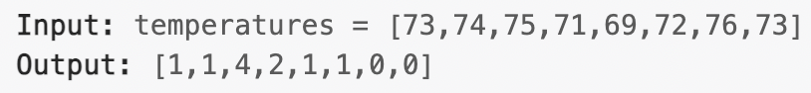

# Q3. Basic Calculator

Link: <https://leetcode.com/problems/basic-calculator/>

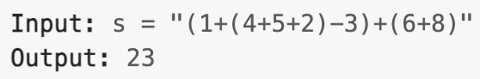

# Q4. Trapping Rain Water

Link: <https://leetcode.com/problems/trapping-rain-water/description/>



**Example 2:**

