ASSIGNMENT 1
PRACTICAL BASED ON CS-2118

QUES) Create your own profile page using HTML tags. You must use maximum basic tags such as text formatting tags, table tag, list tag and explore at least 5 tags which are specific to HTML 5 version. Submit the assignment as a single PDF with webpage snapshot and html code.
SOLN)
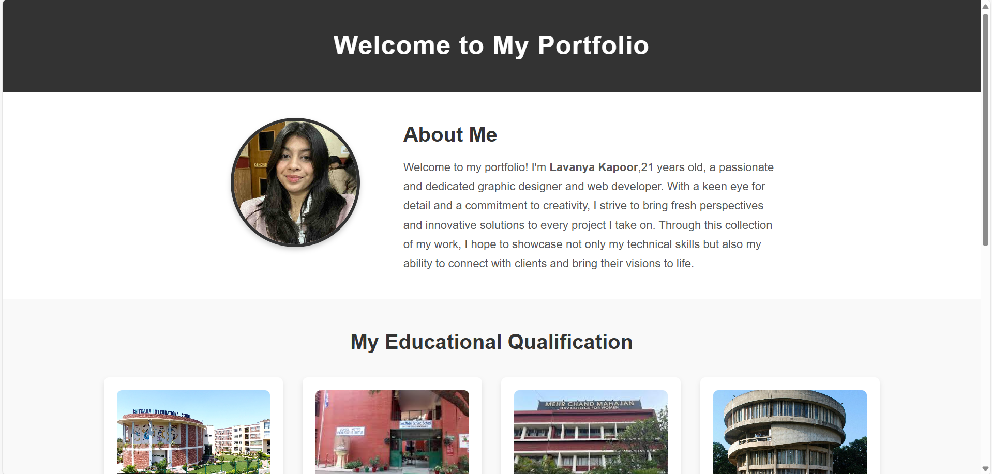

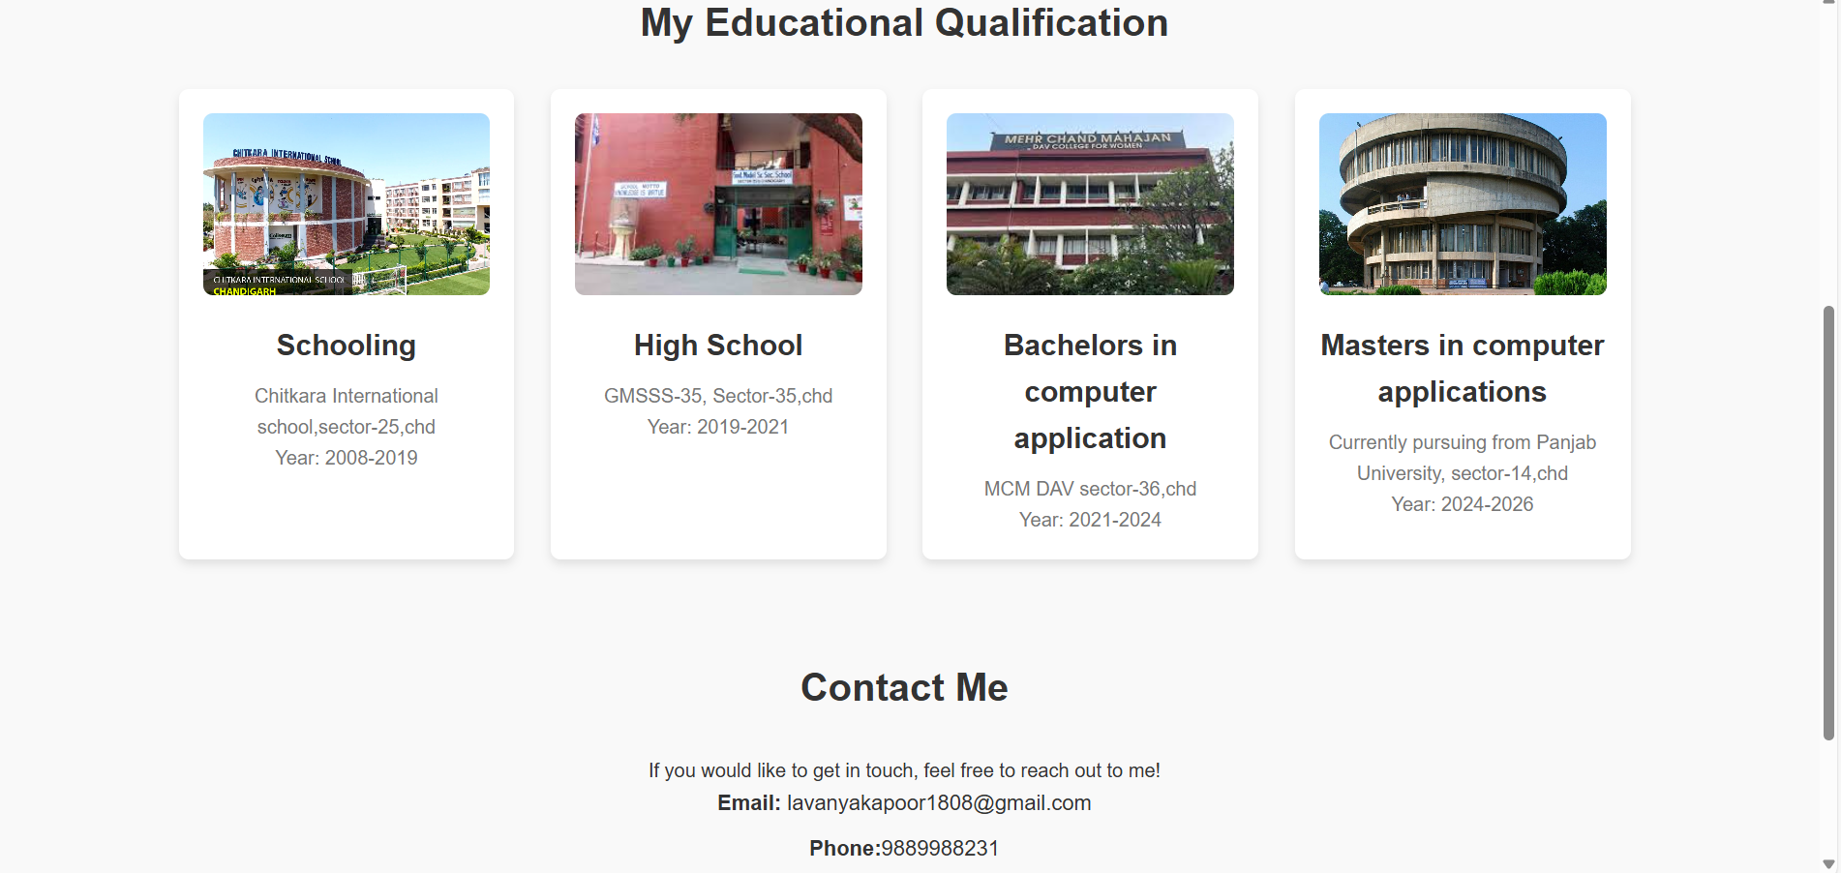

HTML CODE:
Saved as portf.html

<!DOCTYPE html>
<html lang="en">
<head>
<meta charset="UTF-8">
<meta name="viewport" content="width=device-width, initial-scale=1.0">
<meta name="description" content="John Doe's Portfolio">
<title>John Doe - Portfolio</title>
<link rel="stylesheet" href="styles.css"> <!-- Link to the external CSS file -->
</head>
<body>

<!-- Header Section -->
<header>
<h1>Welcome to My Portfolio</h1>
</header>

<!-- About Me Section -->
<section id="about">
<div class="about-content">
<div class="about-img-container">
<img src="PHO.jpg" alt="LAVANYA KAPOOR" class="about-img">
</div>
<div class="about-text">
<h2>About Me</h2>
<p>Welcome to my portfolio! I'm <b>Lavanya Kapoor</b>,21 years old, a passionate and dedicated graphic designer and web developer.
With a keen eye for detail and a commitment to creativity, I strive to bring fresh perspectives and innovative solutions to every project I take on.
Through this collection of my work, I hope to showcase not only my technical skills but also my ability to connect with clients and bring their visions to life.</p>
</div>
</section>

<!-- Education Section -->
<section id="education">
<h2>My Educational Qualification</h2>
<div class="education-content">
<div class="education-item">
<img src="sch1.jpg" alt="school" class="education-img">
<h3>Schooling</h3>
<p>Chitkara International school,sector-25,chd<br>Year: 2008-2019</p>
</div>
<div class="education-item">
<img src="sch2.jpg" alt="highschool" class="education-img">
<h3>High School</h3>
<p>GMSSS-35, Sector-35,chd<br>Year: 2019-2021</p>
</div>
<div class="education-item">
<img src="sch3.jpg" alt="bca" class="education-img">
<h3>Bachelors in computer application</h3>
<p>MCM DAV sector-36,chd<br>Year: 2021-2024</p>
</div>
<div class="education-item">
<img src="sch4.jpg" alt="mca" class="education-img">
<h3>Masters in computer applications</h3>
<p>Currently pursuing from Panjab University, sector-14,chd<br>Year: 2024-2026</p>
</div>
</div>
</section>

<!-- Contact Me Section -->
<section id="contact">
<h2>Contact Me</h2>
<p>If you would like to get in touch, feel free to reach out to me!</p>
<ul>
<li><strong>Email:</strong> <a href="mailto:lavanyakapoor1808@gmail.com">lavanyakapoor1808@gmail.com</a></li>
<li><strong>Phone:</strong>9889988231</li>
<li><strong>LinkedIn:</strong> <a href="https://www.linkedin.com/in/lavanya" target="_blank">linkedin.com/in/lavanya</a></li>
</ul>
</section>

<!-- Footer Section -->
<footer>
<p>&copy; 2025 lavanya kapoor. All Rights Reserved.</p>
</footer>

</body>
</html>

CSS CODE:
Styles.css

* {
margin: 0;
padding: 0;
box-sizing: border-box;
}

/* Body */
body {
font-family: 'Arial', sans-serif;
background-color: #fafafa;
color: #333;
line-height: 1.6;
}

/* Header */
header {
background-color: #333;
color: #fff;
text-align: center;
padding: 40px 0;
}

header h1 {
font-size: 2.5rem;
letter-spacing: 1px;
}

/* About Me Section */
#about {
display: flex;
justify-content: center;
align-items: center;
padding: 40px;
background-color: #fff;
}

.about-content {
display: flex;
justify-content: space-between;
max-width: 900px;
width: 100%;
}

.about-img-container {
flex: 1;
display: flex;
justify-content: center;
}

.about-img {
width: 200px;
height: 200px;
border-radius: 50%;
object-fit: cover;
border: 5px solid #333;
box-shadow: 0 4px 8px rgba(0, 0, 0, 0.2);
}

.about-text {
flex: 2;
margin-left: 20px;
}

.about-text h2 {
font-size: 2rem;
margin-bottom: 10px;
}

.about-text p {
font-size: 1.1rem;
line-height: 1.7;
color: #555;
}

/* Education Section */
#education {
padding: 40px;
background-color: #f9f9f9;
text-align: center;
}

#education h2 {
font-size: 2rem;
margin-bottom: 30px;
}

.education-content {
display: grid;
grid-template-columns: repeat(4, 1fr); /* 4 columns */
gap: 30px; /* Space between the columns */
max-width: 1200px;
margin: 0 auto;
}

.education-item {
background-color: #fff;
padding: 20px;
border-radius: 8px;
box-shadow: 0 4px 8px rgba(0, 0, 0, 0.1);
text-align: center;
}

.education-item img {
width: 100%;
height: 150px;
object-fit: cover;
border-radius: 8px;
margin-bottom: 15px;
}

.education-item h3 {
font-size: 1.5rem;
color: #333;
margin-bottom: 10px;
}

.education-item p {
font-size: 1rem;
color: #777;
}

/* Contact Section */
#contact {
padding: 40px;
background-color: #f9f9f9;
text-align: center;
}

#contact h2 {
font-size: 2rem;
margin-bottom: 30px;
}
#contact ul {
list-style-type: none;
padding: 0;
}
#contact li {
font-size: 1.1rem;
margin-bottom: 10px;
}
#contact a {
color: #333;
text-decoration: none;
}
#contact a:hover {
color: #ff5733;
}
/* Footer Section */
footer {
background-color: #333;
color: #fff;
text-align: center;
padding: 20px;
margin-top: 40px;
}
footer p {
font-size: 1rem;
}

