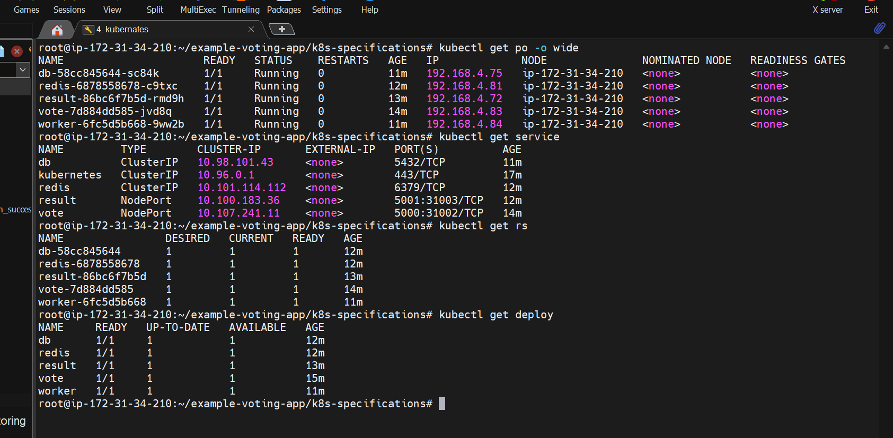

Voter application:

Result application:

Delete the vote pod:

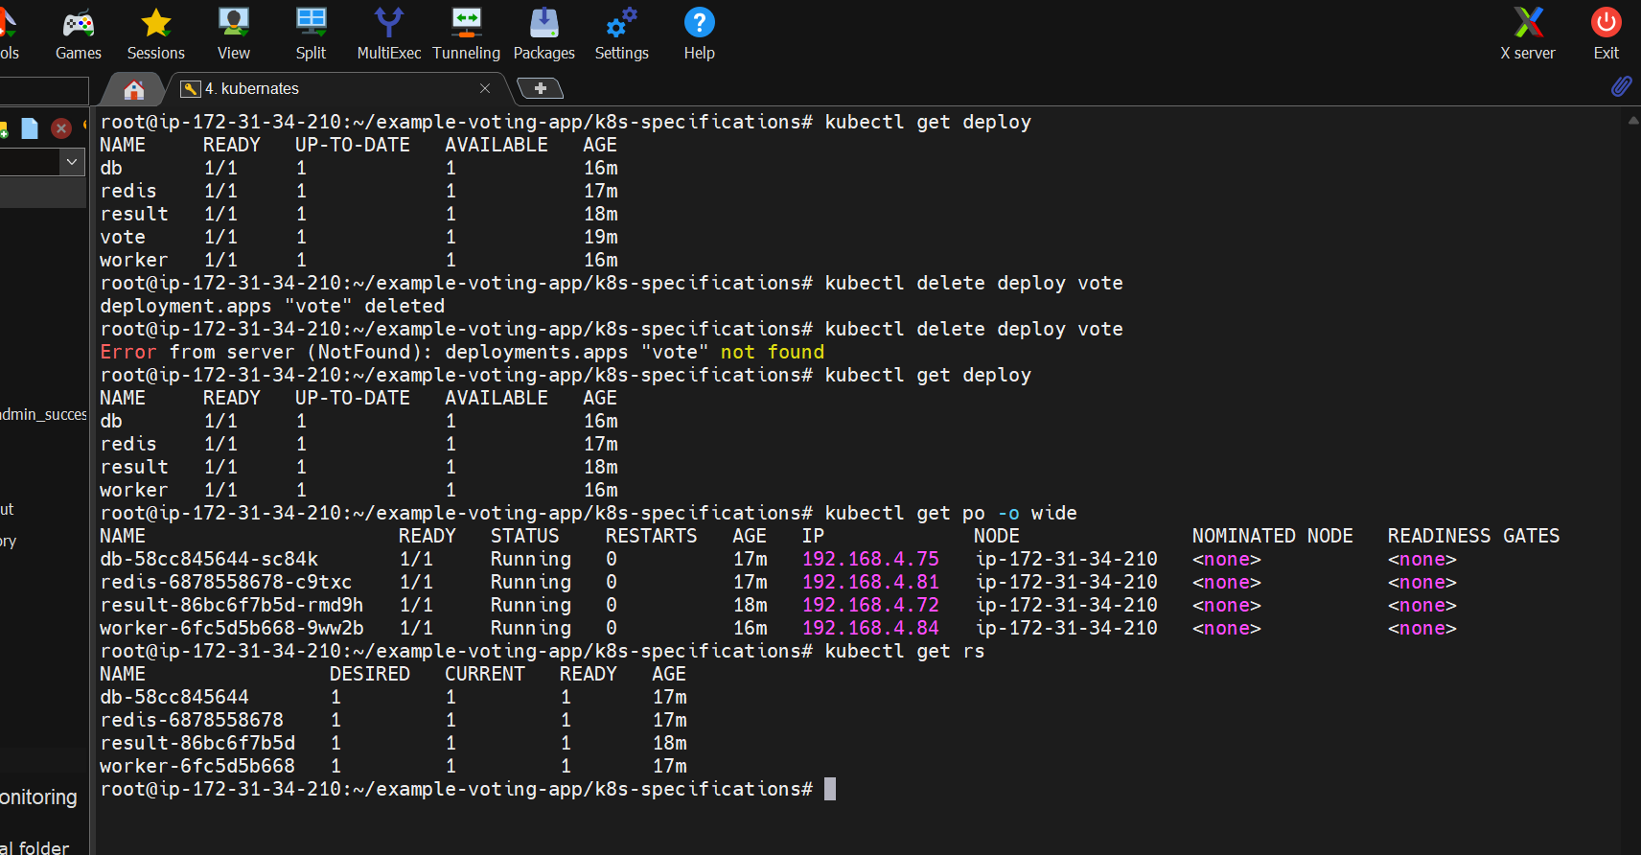

After deleting the vote pod: The application is not responding

Delete worker pod:

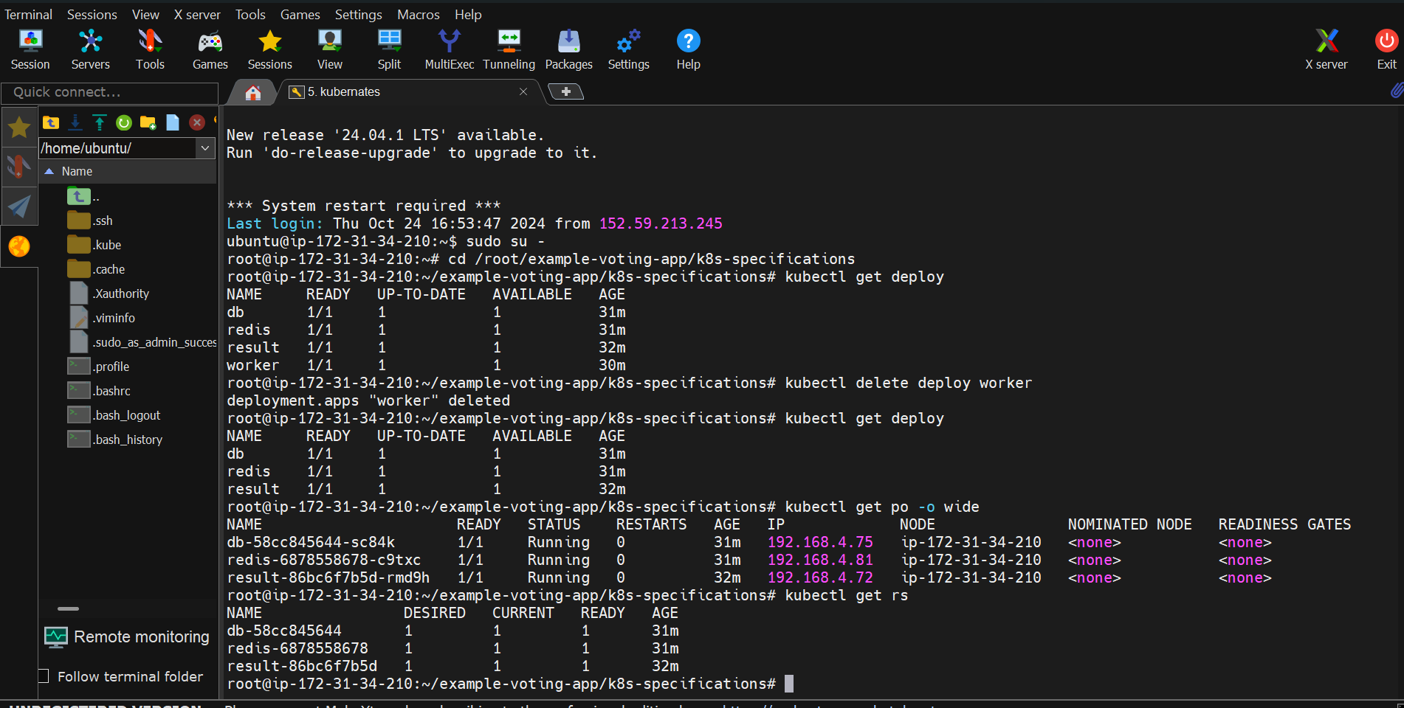

Delete DB POD:

