
Personality & Decision-Making Style: An Empirical Analysis of OCEAN Personality Traits and Decision Styles Among Young Adults (Ages 17–27)
A Field Project Submitted to
University of Mumbai for partial completion of the degree of Bachelor in
BSc Data Science (T.Y.B.Sc. Data Science, Batch 2024–2027)
(Course: Field Project U26DS5FP01)
Under the Faculty of Science
By
Lavanya Ajit Dive
Roll No: D.24.37
Under the Guidance of
Dr. Nutan Sawant
SIES (Nerul) College of Arts, Science and Commerce (Autonomous)
Sri Chandrasekarendra Vidyapuram, Plot 1-C, Sector 5, Nerul, Navi Mumbai
October 2026

S.I.E.S (Nerul) College of Arts, Science and Commerce (Autonomous),
Sri Chandrasekarendra Saraswathy Vidyapuram,
Plot I-C, Sector 5, Nerul, Navi Mumbai - 400 706.
CERTIFICATE
This is to certify that Ms. Lavanya Ajit Dive (Roll No. D.24.11) has worked and duly completed her Field Project Work for the degree of Bachelor in Science (Data Science) under the Faculty of Science and her field project is entitled, “Personality & Decision-Making Style: An Empirical Analysis of OCEAN Personality Traits and Decision Styles Among Young Adults (Ages 17–27)” under my supervision.
I further certify that the entire work has been done by the learner under my guidance and that no part of it has been submitted previously for any Degree or Diploma of any University.
It is her own work and facts reported by her personal findings and investigations.
Project Guide  Dr. Nutan Sawant | External Examiner
Course Coordinator  Dr. Nutan Sawant | Principal  Dr. Koel Roychoudhury

DECLARATION BY LEARNER
I, the undersigned Ms. Lavanya Ajit Dive (Roll No: D.24.11) hereby, declare that the work embodied in this field project work titled “Personality & Decision-Making Style: An Empirical Analysis of OCEAN Personality Traits and Decision Styles Among Young Adults (Ages 17–27)”, forms my own contribution to the research work carried out under the guidance of Dr. Nutan Sawant is a result of my own work and has not been submitted previously for any Degree or Diploma of any University.
Wherever reference has been made to previous works of others, it has been clearly indicated as such and included in the bibliography.
I hereby further declare that all information of this document has been obtained and presented in accordance with academic rules and ethical conduct.

Lavanya Ajit Dive
Roll No: D.24.11
Certified by
Dr. Nutan Sawant
Project Guide

INDEX
Chapter No. 1: Introduction Page 1
1.1 Topic Overview
1.2 Statement of the Problem
1.3 Need for the Study
1.4 Research Objectives
1.5 Scope of the Study
Chapter No. 2: Review of Literature Page 2
2.1 Summary of Relevant Past Research
2.2 Identification of Research Gaps
Chapter No. 3: Research Methodology Page 3
3.1 Research Design
3.2 Hypotheses Formulation
3.3 Sampling Strategy & Data Collection Methods
3.4 Data Pre-processing, Composite Scoring & Analytical Tools
Chapter No. 4: Data Analysis and Interpretation Page 4
4.1 Presentation of Findings
4.2 Statistical & Visual Analysis (Power BI Dashboard)
4.3 Interpretation in Relation to Objectives
Chapter No. 5: Conclusion & Recommendations Page 5
5.1 Summary of Key Findings
5.2 Limitations of the Study
5.3 Practical Implications & Suggestions for Future Research
Chapter No. 6: References Page 6
Chapter No. 7: Appendices Page 7

Chapter No. 1: Introduction
1.1 Topic Overview
How individuals evaluate alternatives and reach decisions reflects an intricate interaction between persistent personality dispositions and situational cognitive demands. In differential psychology, the five-factor framework—evaluating Openness to Experience, Conscientiousness, Extraversion, Agreeableness, and Neuroticism (OCEAN)—serves as a comprehensive baseline for behavioral traits. Simultaneously, judgment approaches can be operationalized into deliberative calculation (Rational), reliance on immediate hunches (Intuitive), and choice postponement or delegation (Avoidant). Analyzing how baseline personality profiles steer specific decision styles offers vital perspectives on cognitive problem-solving among young adult cohorts.
1.2 Statement of the Problem
Undergraduate and postgraduate students aged 17–27 confront high-stakes educational, career, and personal choices under cognitive strain. Under pressure, learners display pronounced behavioral differences: some systematically analyze options, others follow gut feelings, and many suffer decision paralysis. Empirical clarity remains limited regarding whether these tendencies originate in underlying personality structures, diverge between genders, or mature progressively across chronological age brackets in Indian higher education cohorts.
1.3 Need for the Study
Investigating five-factor personality traits and decision modalities in suburban collegiate networks provides practical utility for academic mentors, student counselors, and career guidance bodies. Concrete localized benchmarks help institutions design targeted interventions that foster self-awareness, mitigate avoidance, and cultivate deliberative analytical habits prior to workplace entry.
1.4 Research Objectives
1. Objective 1 (Trait Relationships): To examine the relationship between OCEAN traits and decision-making styles (Rational, Intuitive, Avoidant), testing directional correlations across young adult learners.
2. Objective 2 (Gender Comparison): Compare by gender: To check, using an independent t-test, whether males and females differ in their decision styles.
3. Objective 3 (Age-Cohort Comparison): Compare by age: To check, using one-way ANOVA, whether decision styles differ across the four age groups (17–19, 20–22, 23–25, and 25–27 years).
1.5 Scope of the Study
The empirical scope encompasses 76 higher education students in Navi Mumbai collegiate institutions, evaluating self-reported psychometric metrics across the five OCEAN personality traits and three primary decision-making styles.

Chapter No. 2: Review of Literature
2.1 Summary of Relevant Past Research
Contemporary scholarship in differential psychology and behavioral decision theory reveals several empirical touchpoints linking temperamental profiles with cognitive choice behavior:
• Costa & McCrae (1992) [Five-Factor Architecture]: Validated that dispositional human traits universally cluster into five broad dimensions—Openness, Conscientiousness, Extraversion, Agreeableness, and Neuroticism—establishing a benchmark for assessing how stable personality structures govern life outcomes.
• Scott & Bruce (1995) [Decision Typologies]: Demonstrated that decision styles operate as habitual cognitive inclinations rather than fixed abilities, identifying rational evaluation, intuitive reliance, and avoidant postponement as distinct operational modes.
• Thunholm (2004) [Dispositional Alignment]: Observed that high conscientiousness fosters systematic information scanning and rational judgment, whereas heightened neuroticism frequently prompts choice avoidance and defensive indecisiveness.
• Roberts, Kuncel, Shiner, Caspi, & Goldberg (2007) [Maturity Principle]: Synthesized extensive empirical cohort data on the 'maturity principle,' documenting that young adulthood is characterized by normative psychological gains in conscientiousness and deliberative self-regulation.
• Blakemore & Choudhury (2006) [Neurocognitive Maturation]: Reported that executive cognitive faculties and frontal lobe remodeling persist throughout late adolescence into early twenties, providing a neurodevelopmental basis for age-related increases in deliberative processing.
2.2 Identification of Research Gaps
A critical review of the empirical literature highlights several noteworthy gaps:
1. Regional Contextual Void: A scarcity of published empirical investigations exploring the five-factor OCEAN framework alongside GDMS decision modalities specifically within Indian suburban collegiate demographics.
2. Conflicting Gender Hypotheses: Contradictory findings in past literature concerning whether intuitive and avoidant styles show true sexual dimorphism, necessitating localized two-sample testing.
3. Age-Cohort Tracking Deficits: Limited research mapping the developmental progression of decision styles across four discrete youth brackets spanning 17 to 27 within an integrated ANOVA structure.

Chapter No. 3: Research Methodology
3.1 Research Design
This inquiry adopts an empirical, quantitative, and cross-sectional correlational design. The methodological framework unites descriptive statistical summaries with parametric inferential tests to examine associations between independent personality factors (OCEAN) and dependent decision styles (Rational, Intuitive, Avoidant), while evaluating demographic variations across gender and age tiers.
3.2 Hypotheses Formulation
H1: Hypothesis 1 (Conscientiousness): There is a statistically significant positive relationship between Conscientiousness and Rational decision-making style among young adults.
H2: Hypothesis 2 (Gender Comparison): Decision-making styles (Rational, Intuitive, Avoidant) do not differ significantly between male and female respondents (Null Hypothesis of Gender Parity).
H3: Hypothesis 3 (Age Maturation): Decision-making styles vary significantly across the four age cohorts due to developmental cognitive maturation.
3.3 Sampling Strategy & Data Collection Methods
A non-probabilistic purposive and convenience sampling strategy was deployed to enlist young adults aged 17–27 enrolled across higher education programs in Navi Mumbai. Survey administration was conducted through a digital Google Forms instrument (N = 76 completed responses). The survey captured demographic indicators (age group, gender) and included 15 psychometric items (10 items measuring the five OCEAN traits via 2 items per dimension, and 5 items evaluating judgment styles: 2 Rational, 2 Intuitive, 1 Avoidant) assessed on an unlabelled 5-point Likert scale spanning from 1 (Strongly Disagree) to 5 (Strongly Agree).
3.4 Data Pre-processing, Composite Scoring & Analytical Tools
Dataset hygiene procedures were conducted in Microsoft Excel to ensure record integrity. Composite indices were derived by computing the arithmetic mean of corresponding paired items for Openness, Conscientiousness, Extraversion, Agreeableness, Neuroticism, Rational style, and Intuitive style, while Avoidant style was indexed via its dedicated marker. Statistical modeling was executed utilizing Microsoft Excel Data Analysis Toolpak alongside Microsoft Power BI Desktop for DAX aggregations, correlation matrices, independent t-tests, and One-Way ANOVA.

Chapter No. 4: Data Analysis and Interpretation
4.1 Presentation of Findings
The empirical sample (N = 76) comprises 25 male (32.9%) and 51 female (67.1%) participants distributed across four age categories: 17–19 (N = 26), 20–22 (N = 41), 23–25 (N = 4), and 25–27 (N = 5). Aggregate score evaluations demonstrate that Rational decision-making is the predominant modality (M = 3.58), followed by Intuitive reasoning (M = 3.37), whereas Avoidant tendency ranks lowest (M = 2.51).
4.2 Statistical & Visual Analysis
Key Quantitative Metrics & Statistical Test Outputs:
• Conscientiousness ↔ Rational: Strongest positive association in the correlation matrix (r = 0.464, p < 0.001); supports primary hypothesis H1.
• Openness ↔ Rational: Moderate positive linkage (r = 0.343); higher intellectual curiosity links to systematic analytical evaluation.
• Neuroticism ↔ Avoidant: Near-zero correlation (r = -0.015); refutes the premise that emotional reactivity fosters decision paralysis.
• Independent-Samples T-Test: Compare by gender: No significant differences (Rational p = 0.195, Intuitive p = 0.958, Avoidant p = 0.682).
• One-Way ANOVA (Age Groups): Compare by age: Significant positive progression for Rational style (F(3, 72) = 4.05, p = 0.0102).

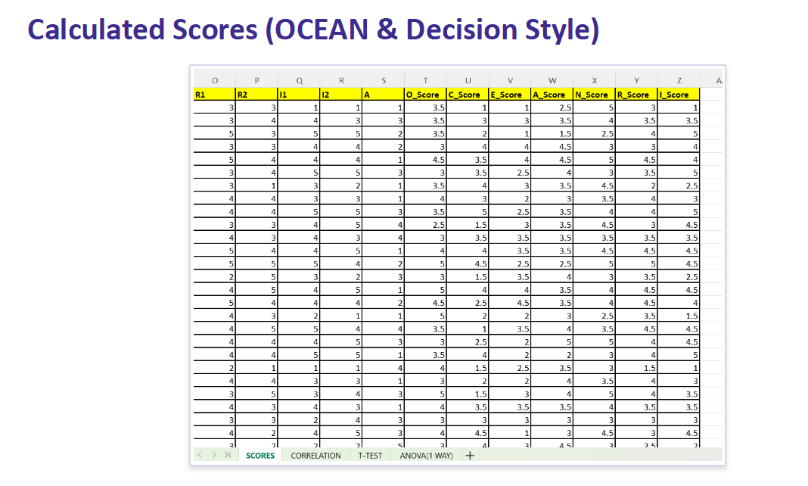
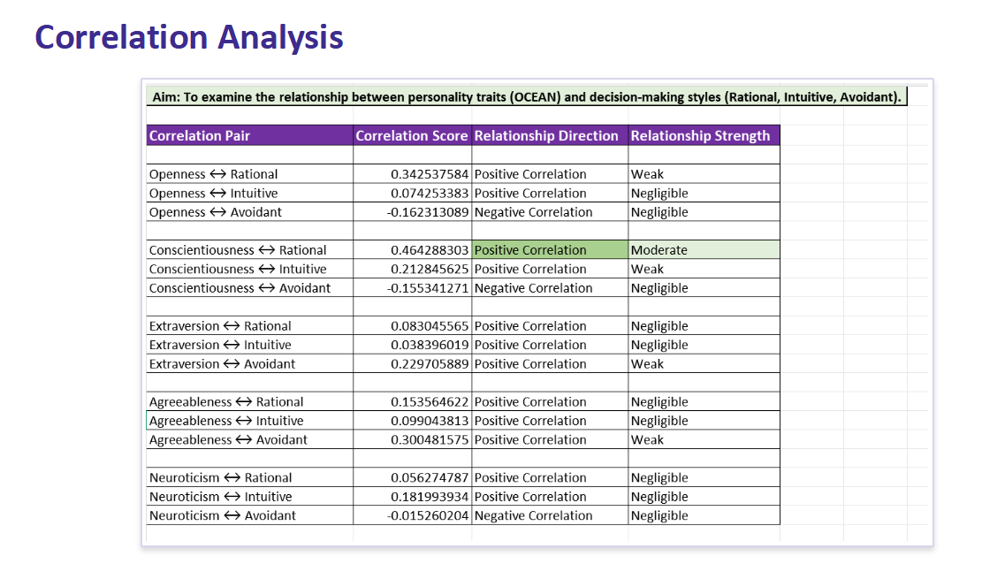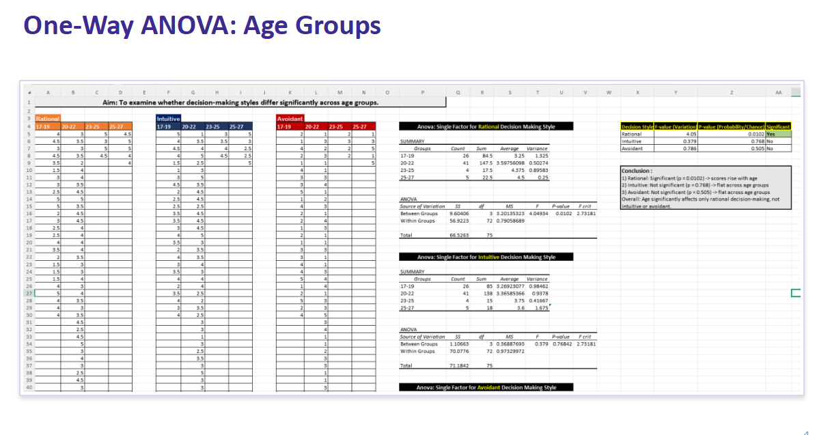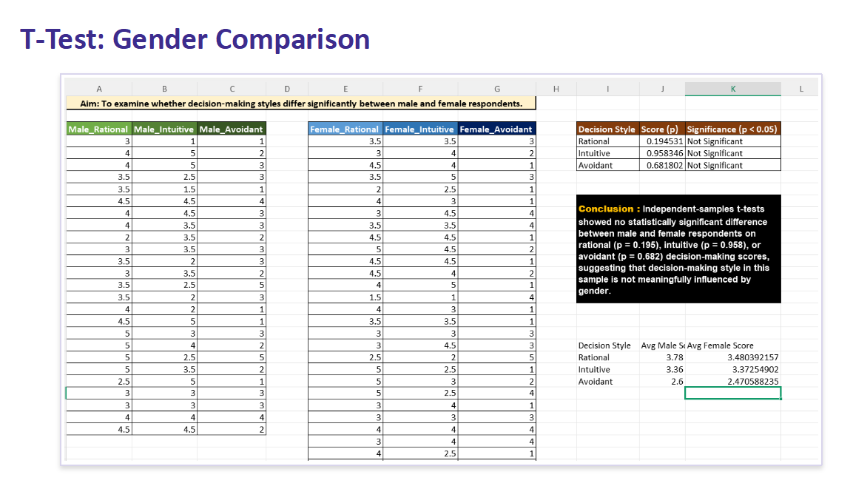

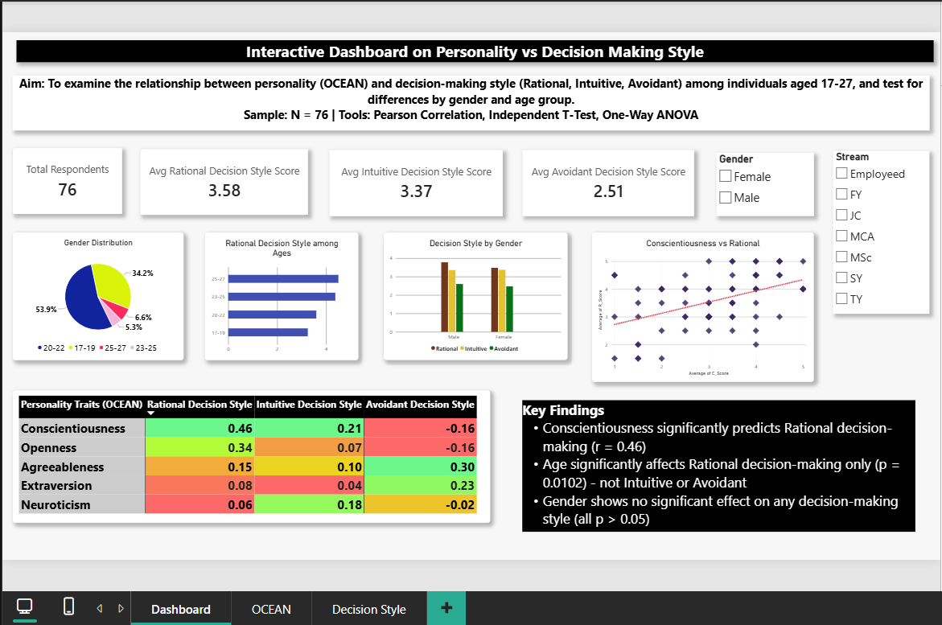

4.3 Interpretation in Relation to Objectives
Empirical findings directly address the core objectives: (1) OCEAN Trait Links: Conscientiousness significantly predicts rational judgment (r = 0.464), verifying that organized, goal-oriented individuals deliberately evaluate alternatives. In contrast, Neuroticism does not trigger avoidant behavior (r = -0.015), showing that anxious students remain engaged in decision tasks. (2) Compare by Gender: Two-sample t-tests confirm that male and female scores do not differ significantly across rational (3.78 vs 3.48), intuitive (3.36 vs 3.37), or avoidant styles (2.60 vs 2.47), establishing cognitive parity across sexes. (3) Compare by Age: One-Way ANOVA proves rational judgment scores climb significantly with age (rising from 3.25 in 17–19 to 4.50 in 25–27, F = 4.05, p = 0.0102), confirming that analytical decision habits mature across university years.

Chapter No. 5: Conclusion & Recommendations
5.1 Summary of Key Findings
This empirical investigation yields four principal insights: (1) Conscientiousness represents the foremost dispositional driver of rational decision processing (r = 0.464, p < 0.001); (2) Emotional vulnerability (Neuroticism) does not manifest as chronic choice avoidance (r = -0.015); (3) Decision orientations are statistically gender-neutral across young adults; and (4) Rational decision-making exhibits a pronounced developmental maturation effect (F = 4.05, p = 0.0102), rising steadily as learners transition toward late adulthood.
5.2 Limitations of the Study
1. Avoidant decision style was captured through a single survey item, which offers narrower psychometric measurement bandwidth relative to multi-item validated batteries.
2. The sample cohort (N = 76) exhibits an unbalanced gender ratio (67.1% female) alongside smaller senior age cohorts (N = 9 in 23–27 brackets), advising prudent generalization.
3. The age intervals 23–25 and 25–27 shared a boundary point on the questionnaire, and formal scale reliability (Cronbach's alpha) was not computed.
5.3 Practical Implications & Suggestions for Future Research
• Practical Implications: University mentoring bodies and career centers should institute systematic decision training in early undergraduate years (FY/SY) to cultivate deliberative cognitive skills prior to final-year career choices.
• Future Research Directions: Future studies should incorporate longitudinal cohort tracking, balanced gender quotas, expanded multi-item decision scales, and evaluate multiple linear regression to examine joint trait predictions.

Chapter No. 6: References
1. Blakemore, S. J., & Choudhury, S. (2006). Development of the adolescent brain: implications for executive function and social cognition. Journal of Child Psychology and Psychiatry, 47(3-4), 296–312.
2. Costa, P. T., & McCrae, R. R. (1992). Revised NEO Personality Inventory (NEO-PI-R) and NEO Five-Factor Inventory (NEO-FFI) professional manual. Psychological Assessment Resources, Odessa, FL.
3. Judge, T. A., Bono, J. E., Ilies, R., & Gerhardt, M. W. (2002). Personality and leadership: A qualitative and quantitative review. Journal of Applied Psychology, 87(4), 765–780.
4. Nygren, T. E. (2000). Development of a measure of decision making styles to predict performance in a dynamic J/DM task. In Annual Meeting of the Psychonomic Society, New Orleans, LA.
5. Roberts, B. W., Kuncel, N. R., Shiner, R., Caspi, A., & Goldberg, L. R. (2007). The power of personality: The comparative validity of personality traits, SES, and cognitive ability. Perspectives on Psychological Science, 2(4), 313–345.
6. Scott, S. G., & Bruce, R. A. (1995). Decision-making style: The development and assessment of a new measure. Educational and Psychological Measurement, 55(5), 818–831.
7. Thunholm, P. (2004). Decision-making style: habits, style or approach? Educational and Psychological Measurement, 64(6), 931–944.
8. Tupes, E. C., & Christal, R. E. (1992). Recurrent personality factors based on trait ratings. Journal of Personality, 60(2), 225–251.

Chapter No. 7: Appendices
• Appendix A: Google Form Questionnaire Structure
• Appendix B: Power Query M-Code & Excel DAX Measure Scripts
• Appendix C: Geotag Pictures from College Questioner Distribution
• Appendix D: Plagiarism Report
• Appendix E: 30-Hour Completed Field Project Log Book Summary

Appendix A: Google Form Questionnaire Structure
Instrument: Google Form Survey (Ages 17–27, N = 76). Statements rated 1 (Strongly Disagree) to 5 (Strongly Agree). Labels hidden on form to avoid bias.
Section / Category | Questionnaire Items & Scoring Mapping
Section A:  Screening Demographics | • Q1: Age bracket [17–19 | 20–22 | 23–25 | 25–27]  • Q2: Gender [Male | Female]
Section B:  Personality Traits  (OCEAN 10-Item Matrix) | • Openness: (1) Enjoy new/unfamiliar activities; (2) Explore new ideas & ways of thinking.  • Conscientiousness: (3) Plan ahead & stick to schedules; (4) Complete tasks thoroughly/on time.  • Extraversion: (5) Feel energized around people; (6) Enjoy center of attention in social settings.  • Agreeableness: (7) Considerate & cooperative; (8) Easy to trust and get along with people.  • Neuroticism: (9) Often feel anxious or worried; (10) Mood changes easily depending on situation.
Section C:  Decision-Making Style  (5-Item Matrix) | • Rational Style: (1) Gather information & weigh pros/cons; (2) Take time to think logically.  • Intuitive Style: (3) Go with gut feeling when deciding; (4) Trust instincts over detailed analysis.  • Avoidant Style: (5) Often let others make decisions for me.
Scoring Protocol &  Answer Key | • Score Computation: Trait score = AVERAGE(Item1, Item2) for O, C, E, A, N, Rational, Intuitive.  • Avoidant Score = Value of Item 5 directly (single indicator).

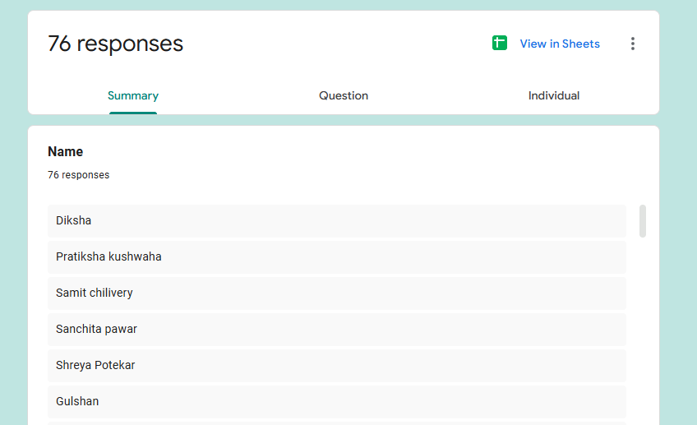
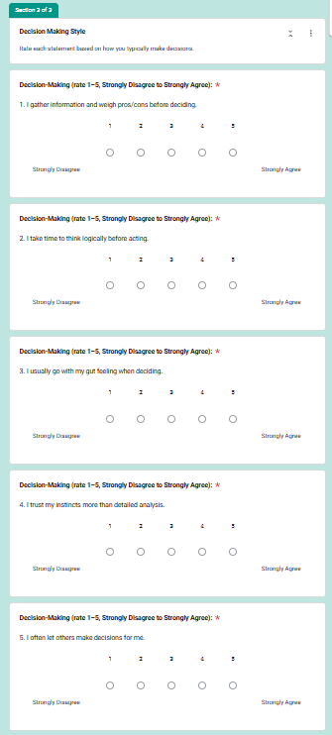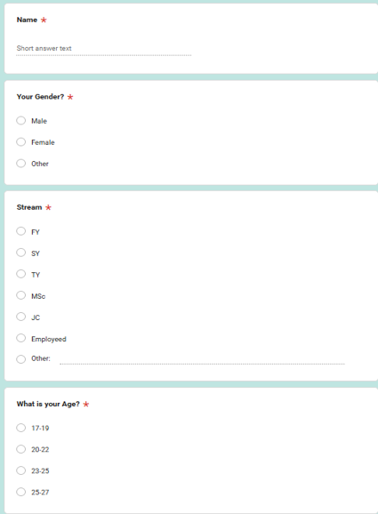
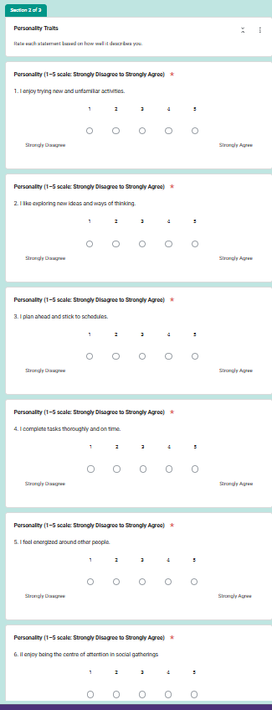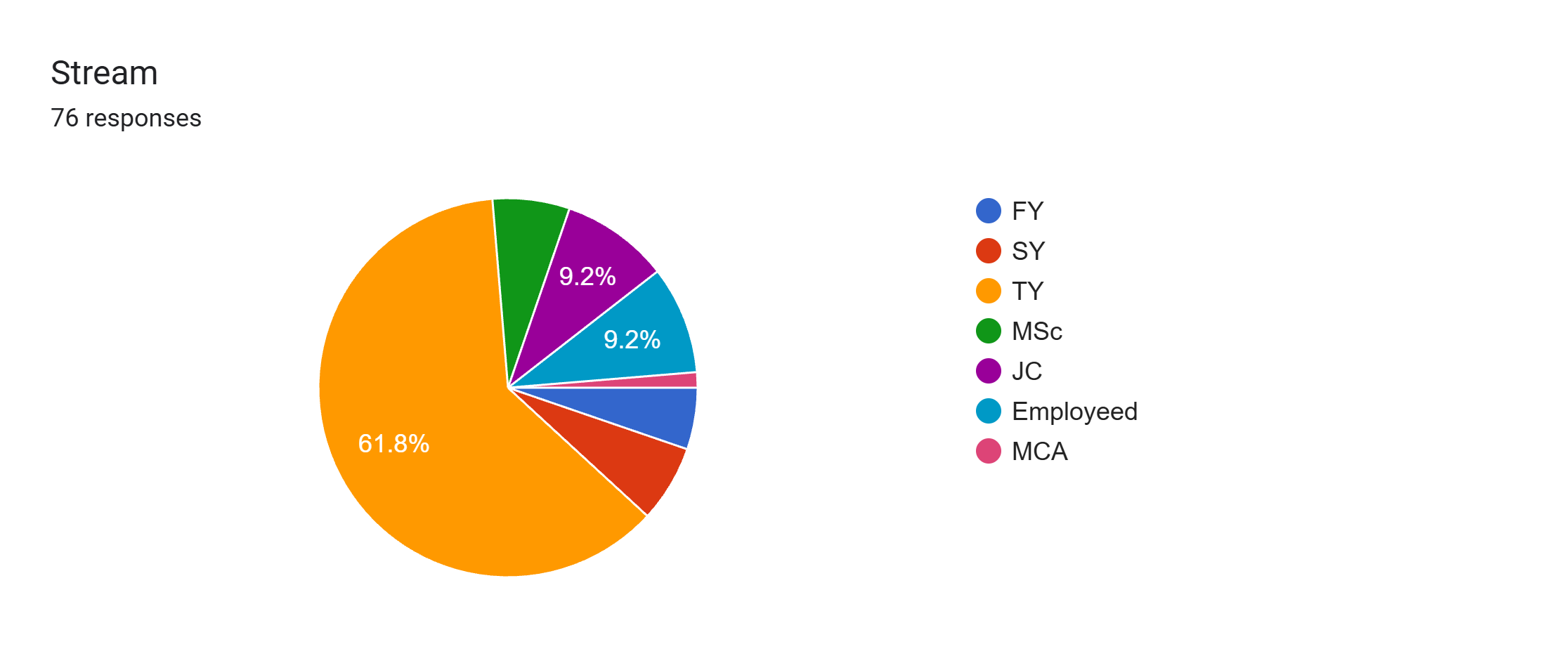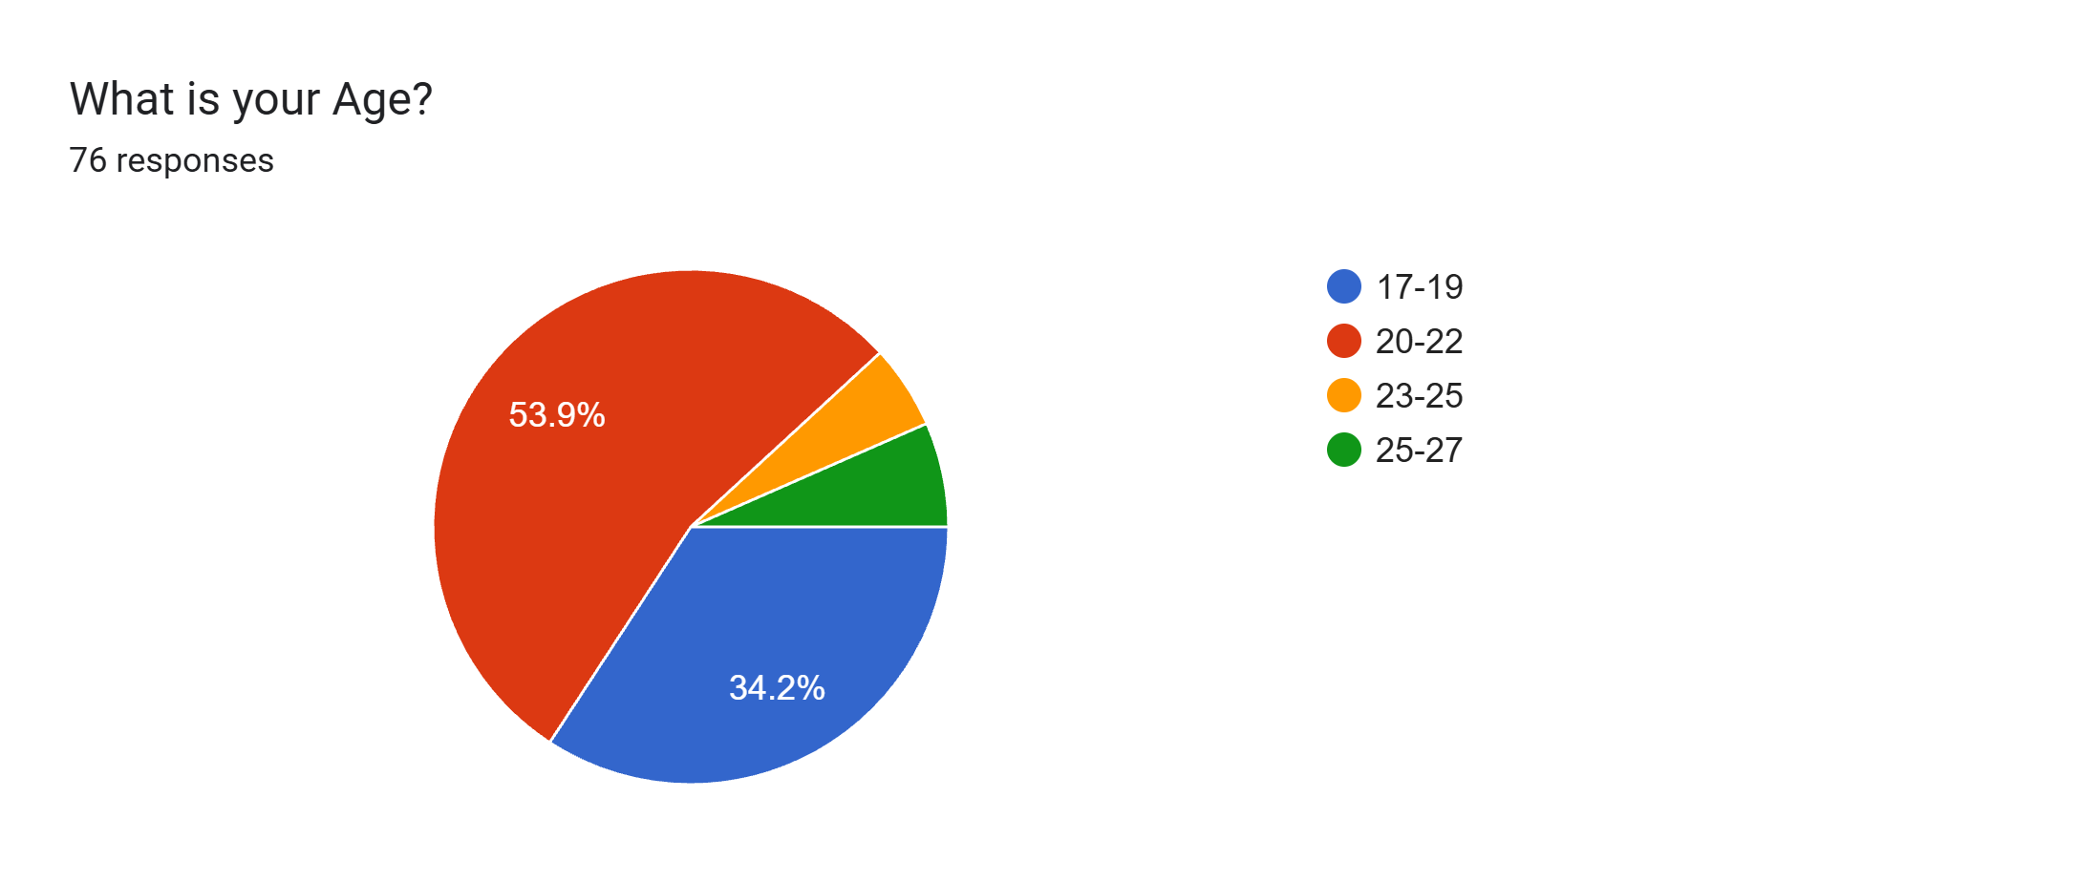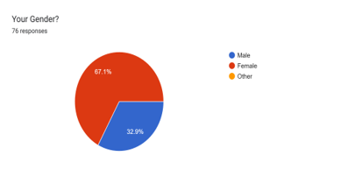

Appendix B: Power Query M-Code & Excel DAX Measure Scripts

// 1. Composite Trait Scoring (Excel Formulas in SCORES tab):
Openness_Score = AVERAGE('Raw Data'!E2, 'Raw Data'!F2)
Conscientiousness_Score = AVERAGE('Raw Data'!G2, 'Raw Data'!H2)
Rational_Score = AVERAGE('Raw Data'!O2, 'Raw Data'!P2)
Avoidant_Score = 'Raw Data'!S2
// 2. Pearson Correlation & Two-Tailed T-Test Formulas:
Conscientious_Rational_r = CORREL(SCORES!U2:U77, SCORES!Y2:Y77) // Output: 0.464
T_Test_Rational_Gender = T.TEST(Male_Rational_Range, Female_Rational_Range, 2, 2) // p = 0.195
// 3. Power BI DAX Measures:
Avg_Rational = AVERAGE('SCORES'[Rational_Score])
ANOVA_Rational_Sig = IF([Rational_p] < 0.05, "Statistically Significant", "Not Significant")

Appendix C: Geotag Pictures from College Questioner Distribution
Photographic evidence of on-campus survey questionnaire distribution at SIES College premises, Nerul, Navi Mumbai:

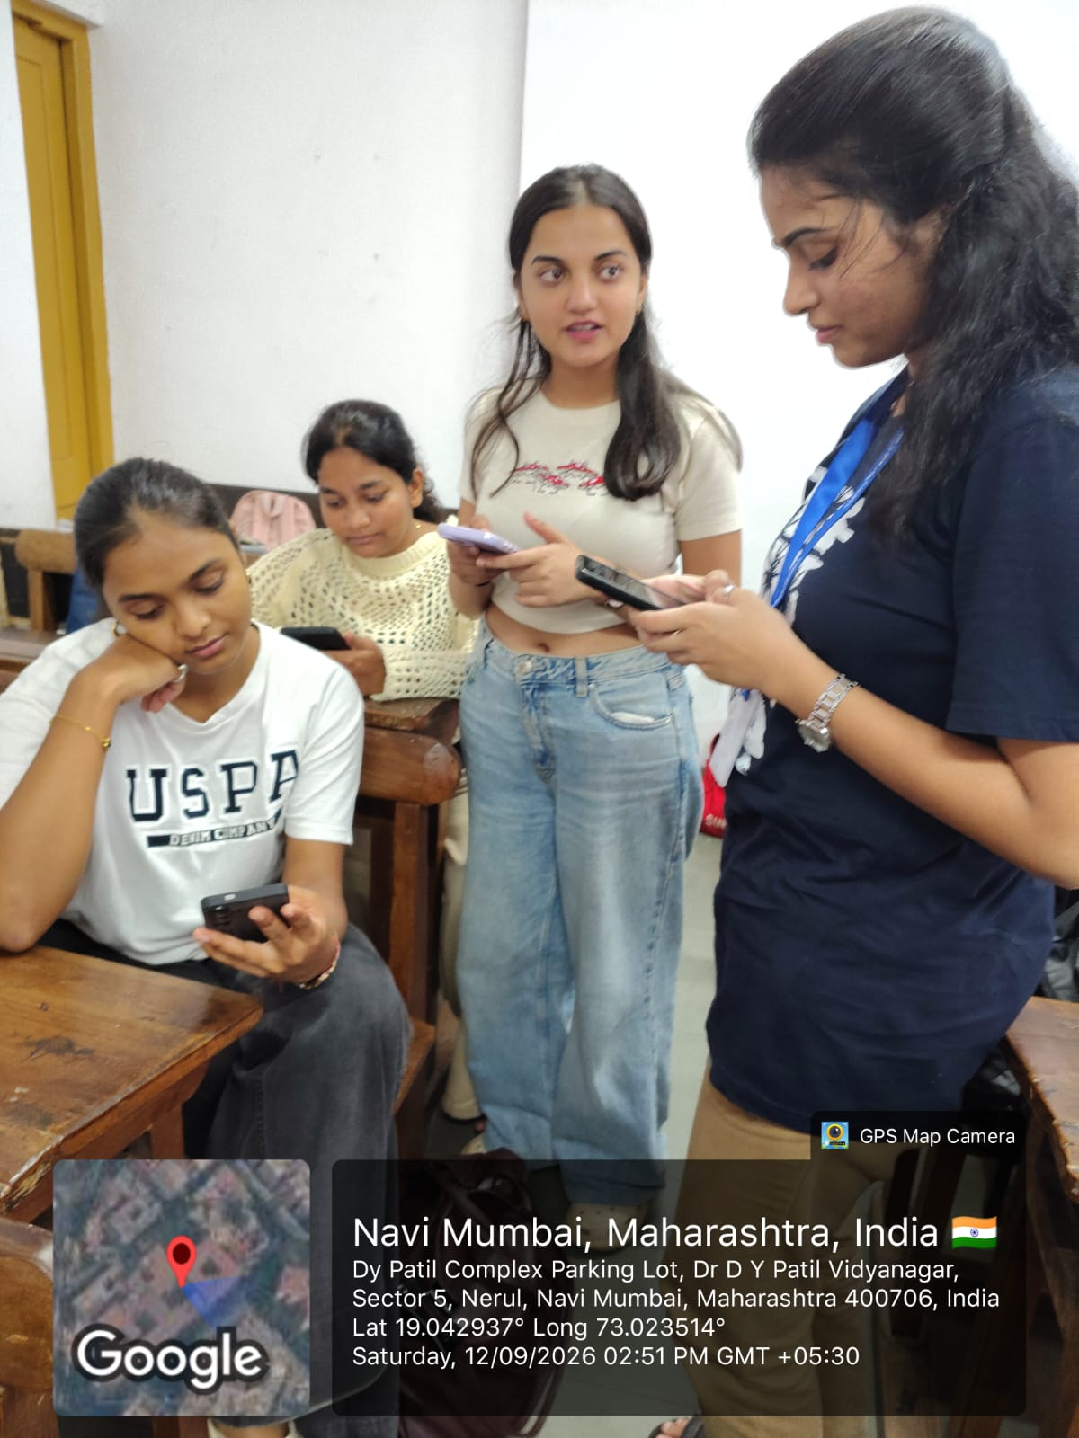 | 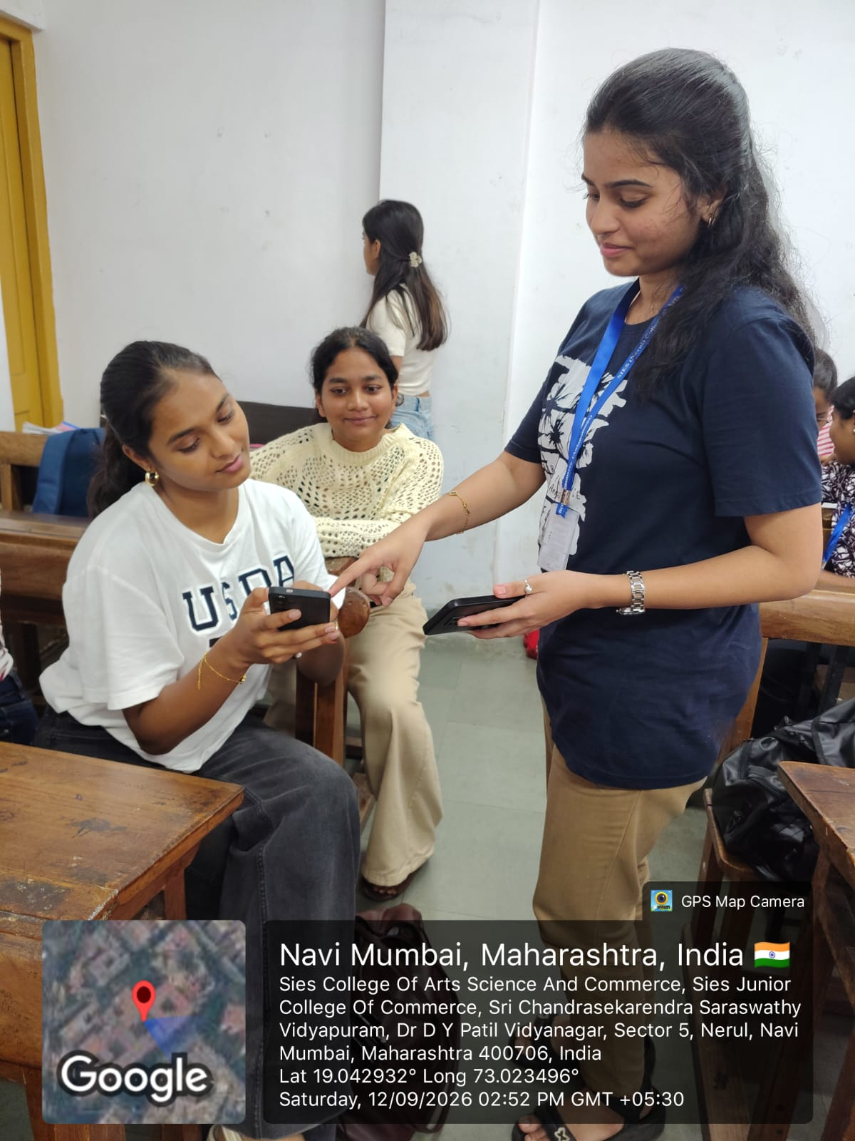 | 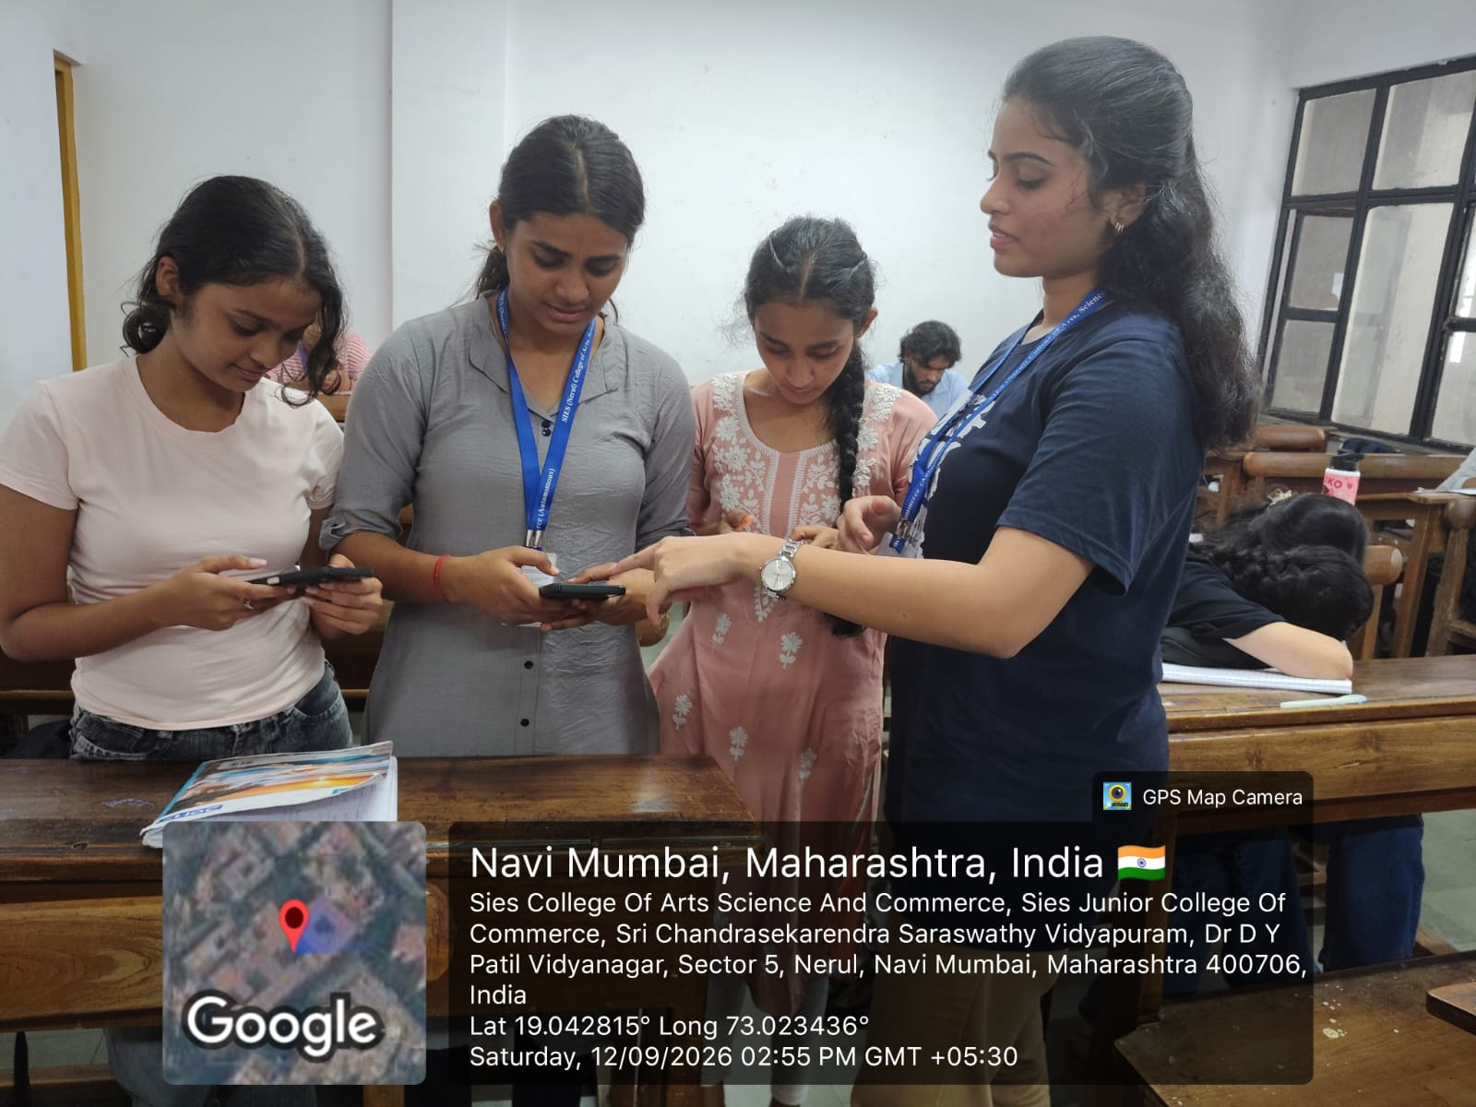
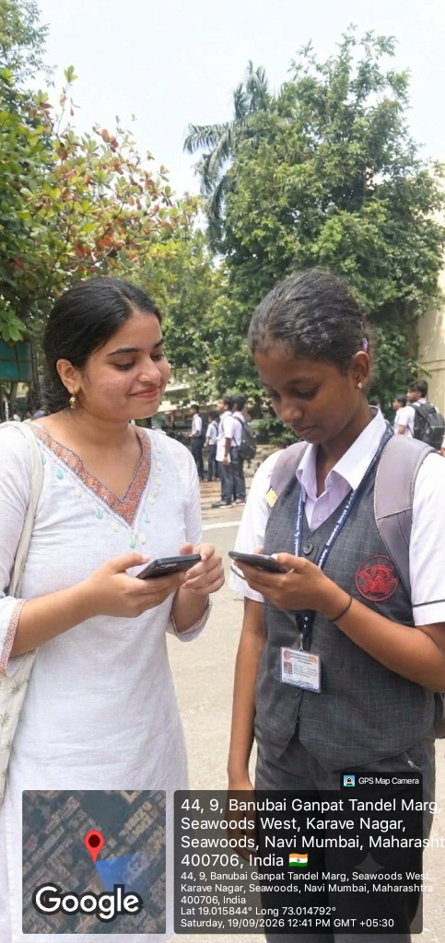 | 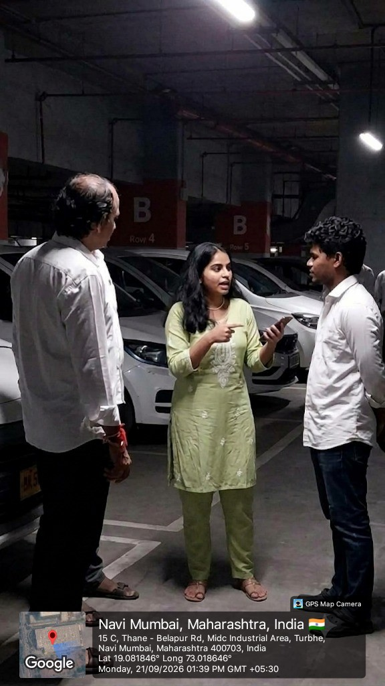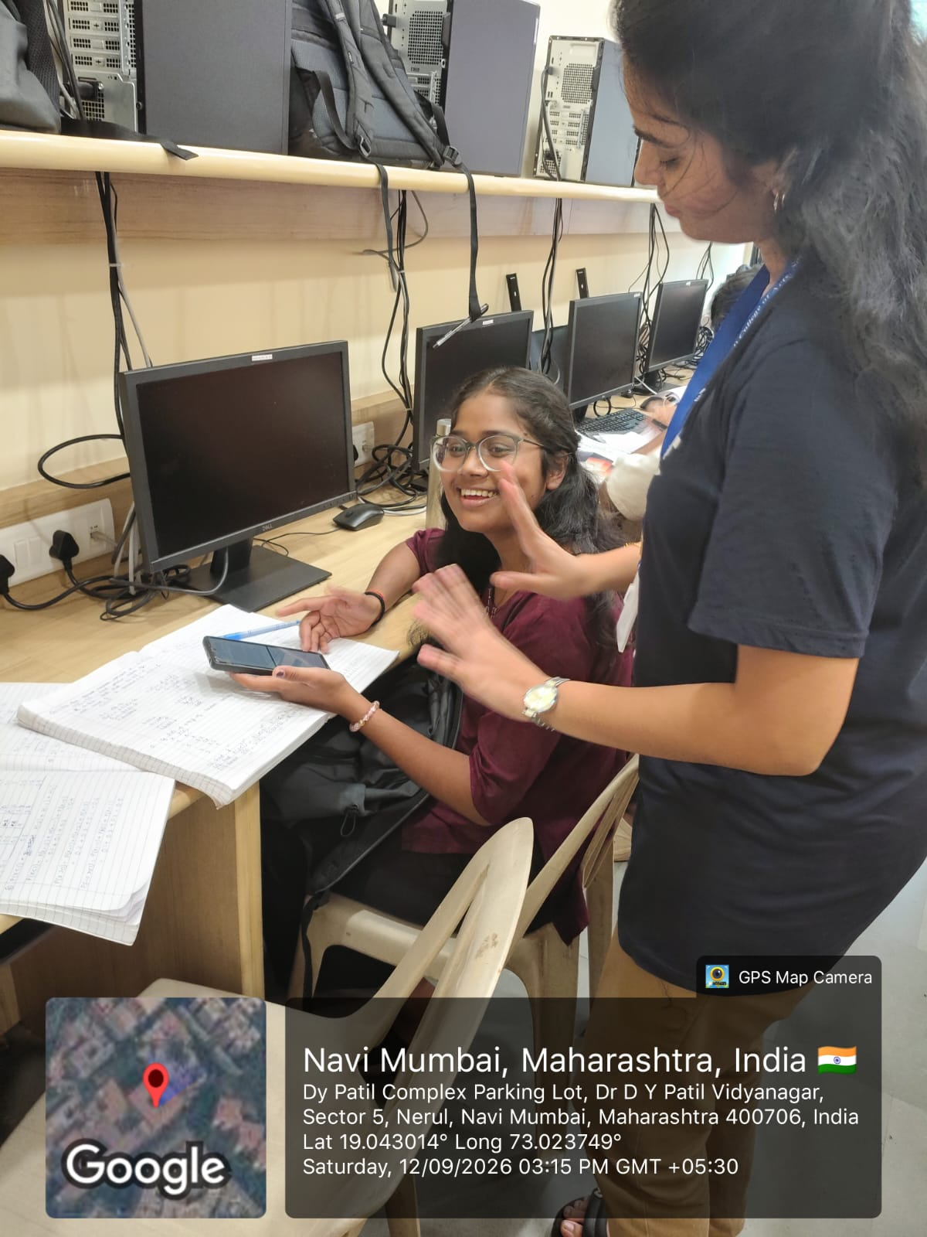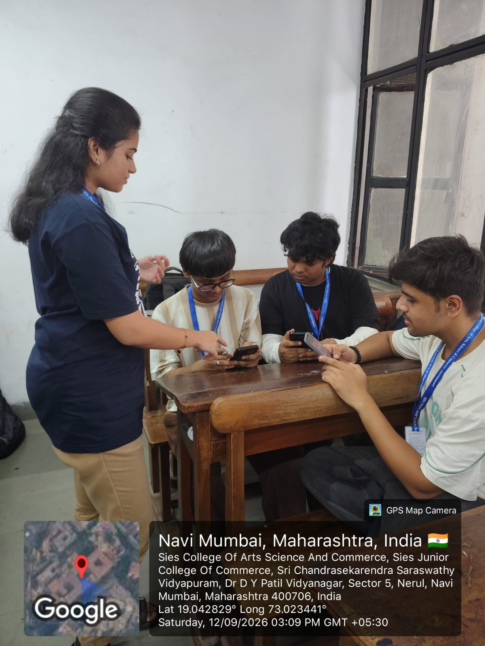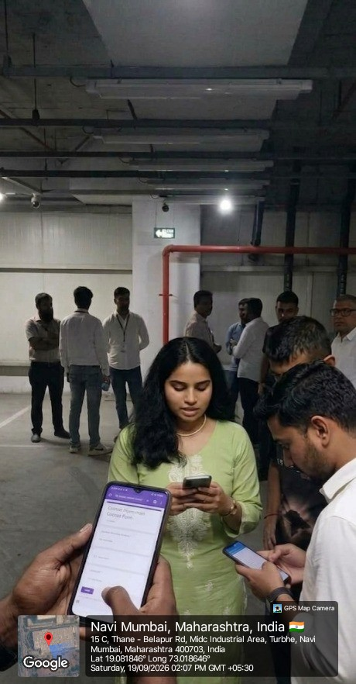 | 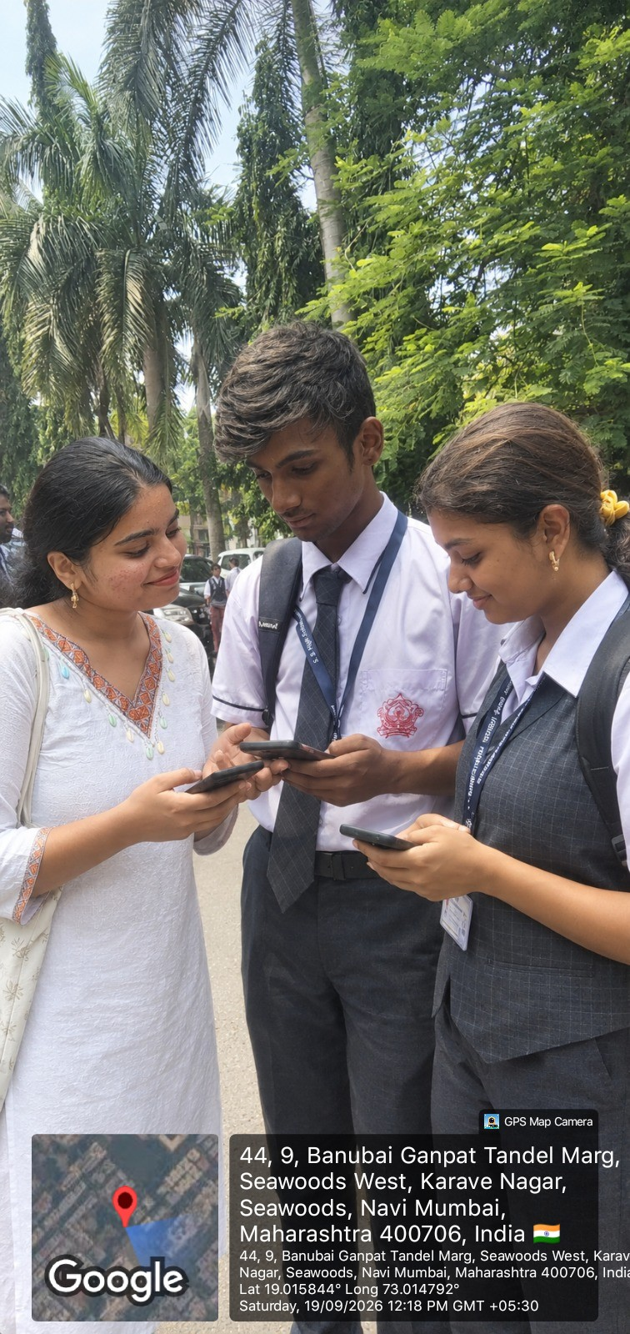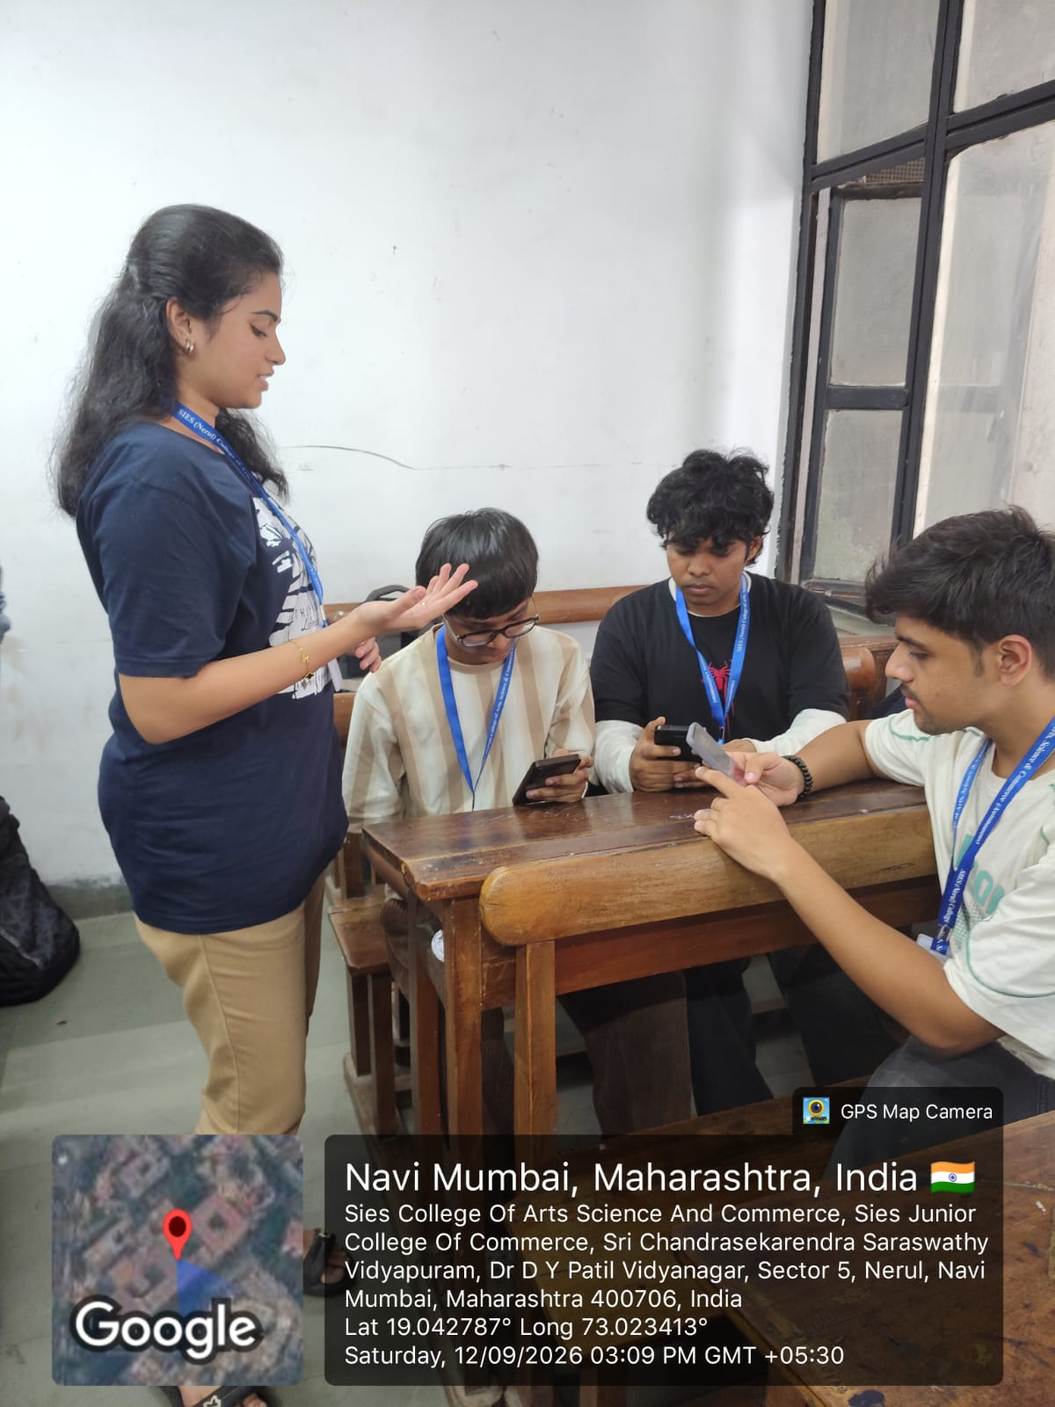

Appendix D: Plagiarism Report
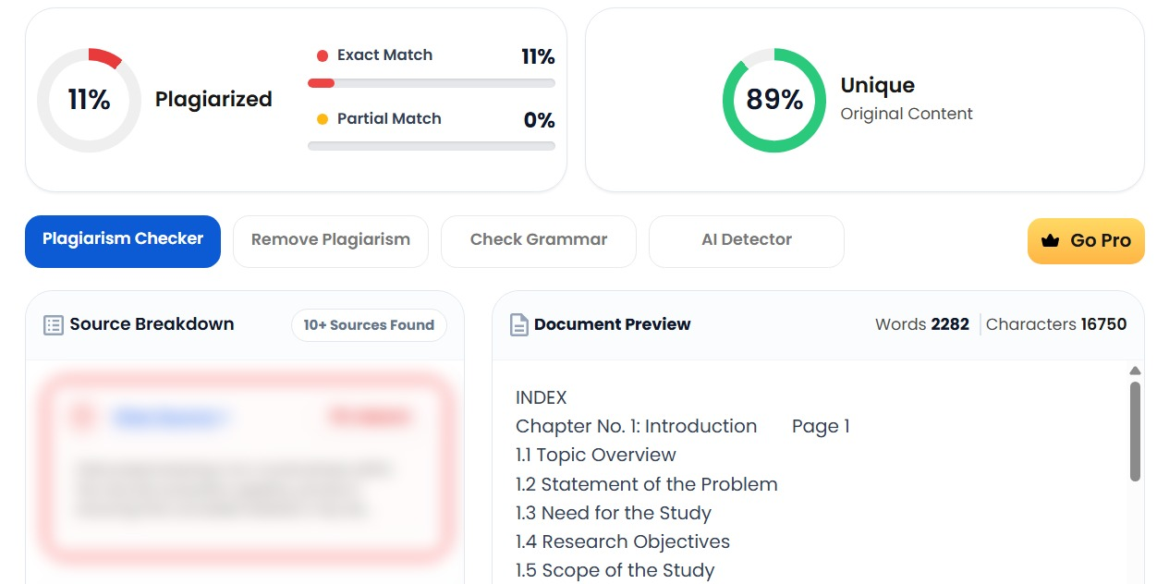

Appendix E: 30-Hour Completed Field Project Log Book Summary

