**1.Create a P-T-S VPN and attach a VM to it**

Create a virtual network

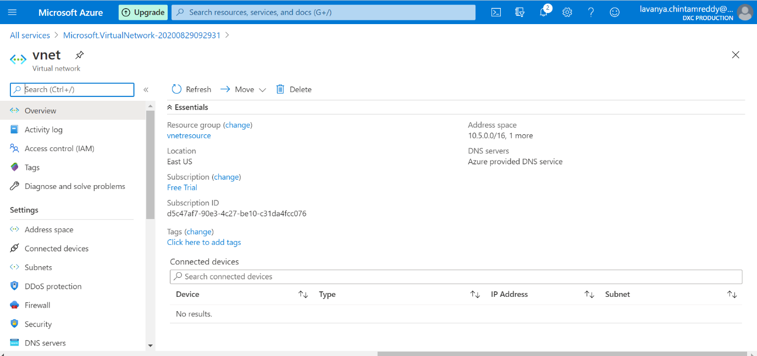

Create gateway subnet to vnet

Create virtual network gateway

Configure the point to site to vpn

Attaching the vm to vpn

**2.create a two web application in west us and central Us then attach to the traffic manager with Priority routing method**

Create a web application in west us

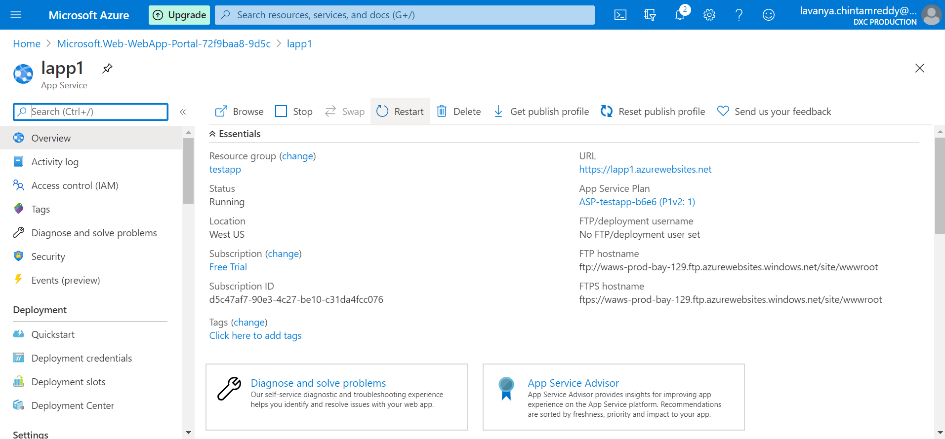

Create a web application in central us

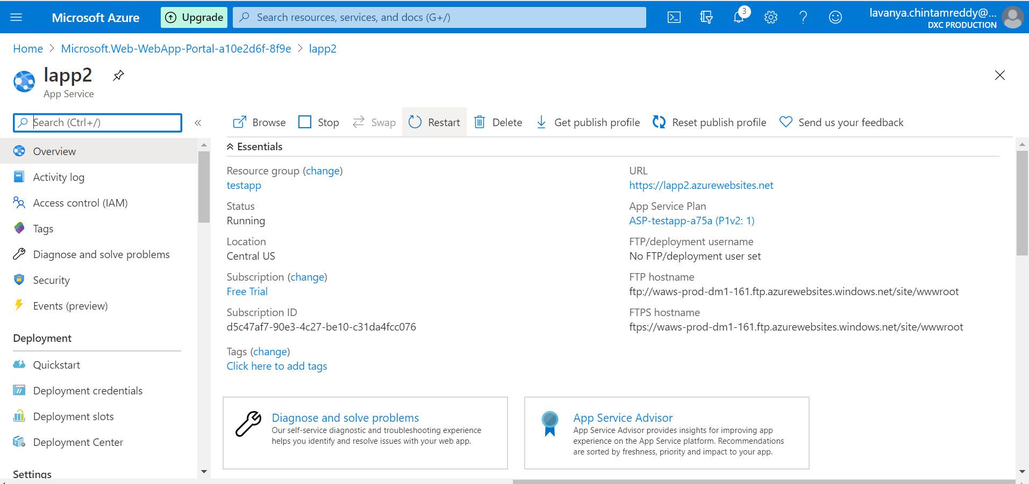

Attach the first web app to the traffic manager

Attach the second web app to the traffic manager

Attach both web apps to tha traffic manager with priority routing method

**3.create a windows server with AD installed and integrate with Azure AD**

Create window server with ad installed

Server is integrated with azure AD

**4.configure a backup to the VM you installed AD**

Add the vm to the backup

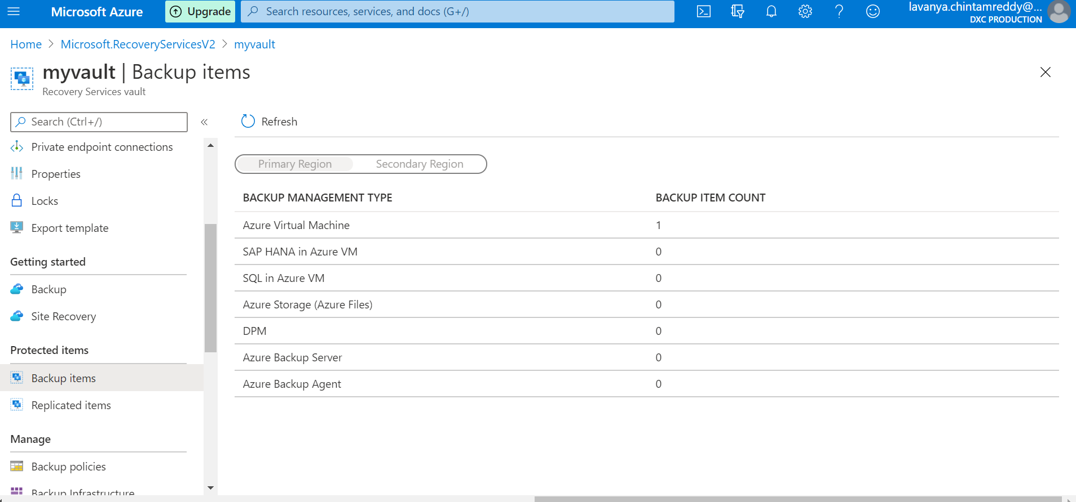

**5.configure alerts for the VM**

Create a alert rule to the vm

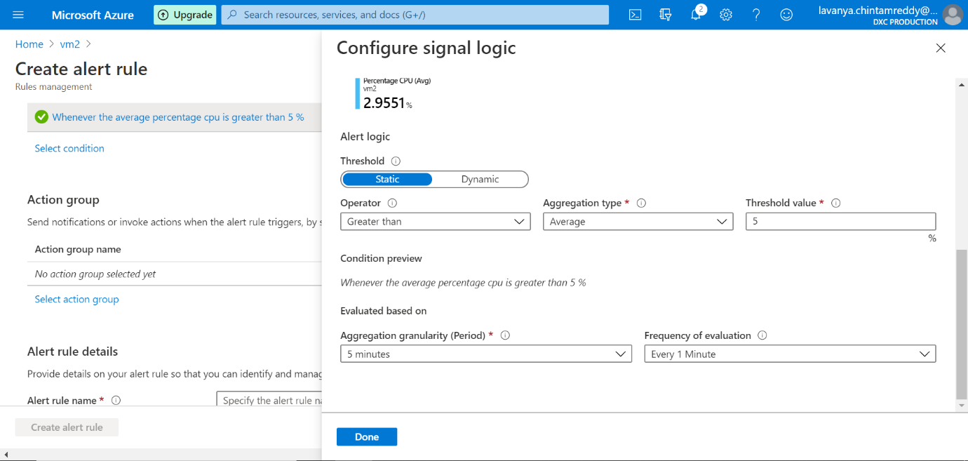

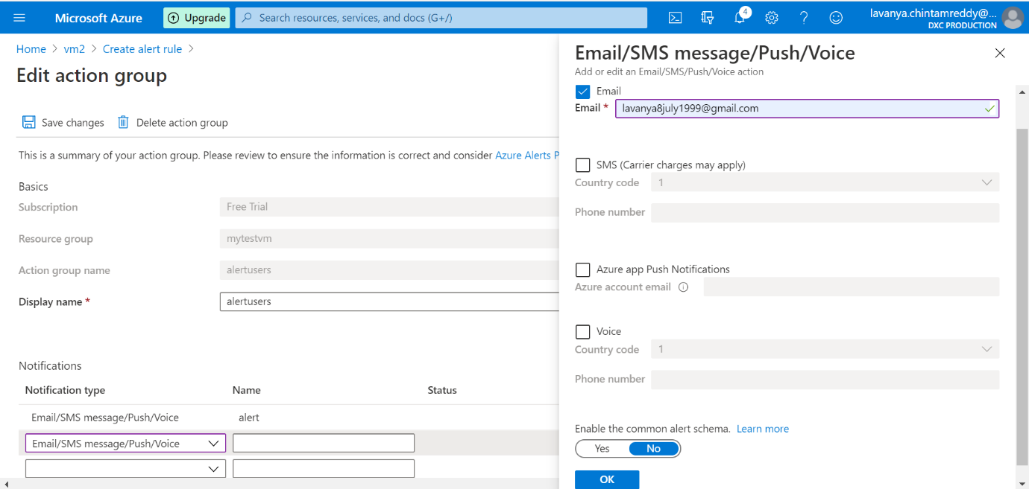

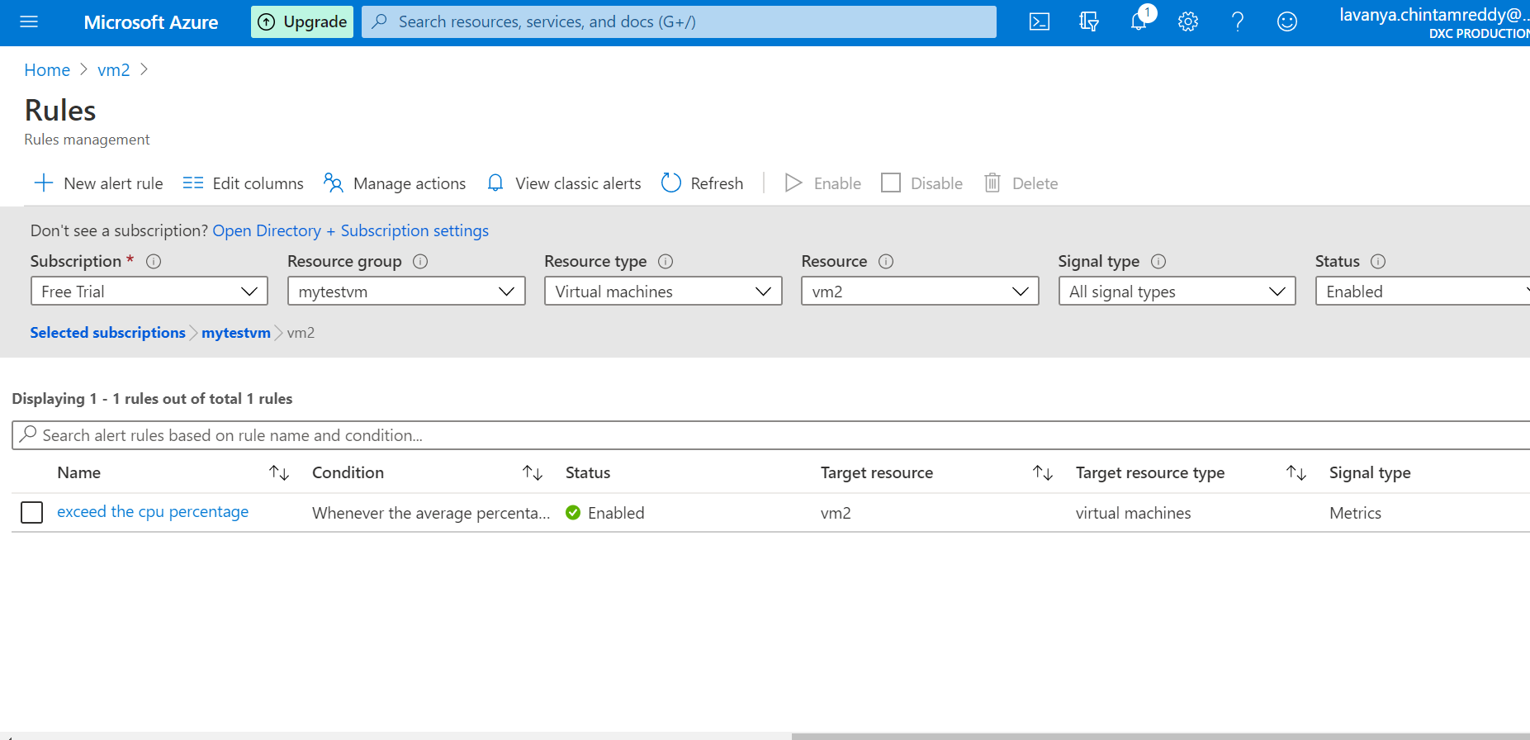

**6.Apply any security policy to the subscription**

**7.create a SQL server with database installed in the elastic pool**

