ASSIGNMENTS

1)create a windows 2019 VM with Ds1-V2 standard

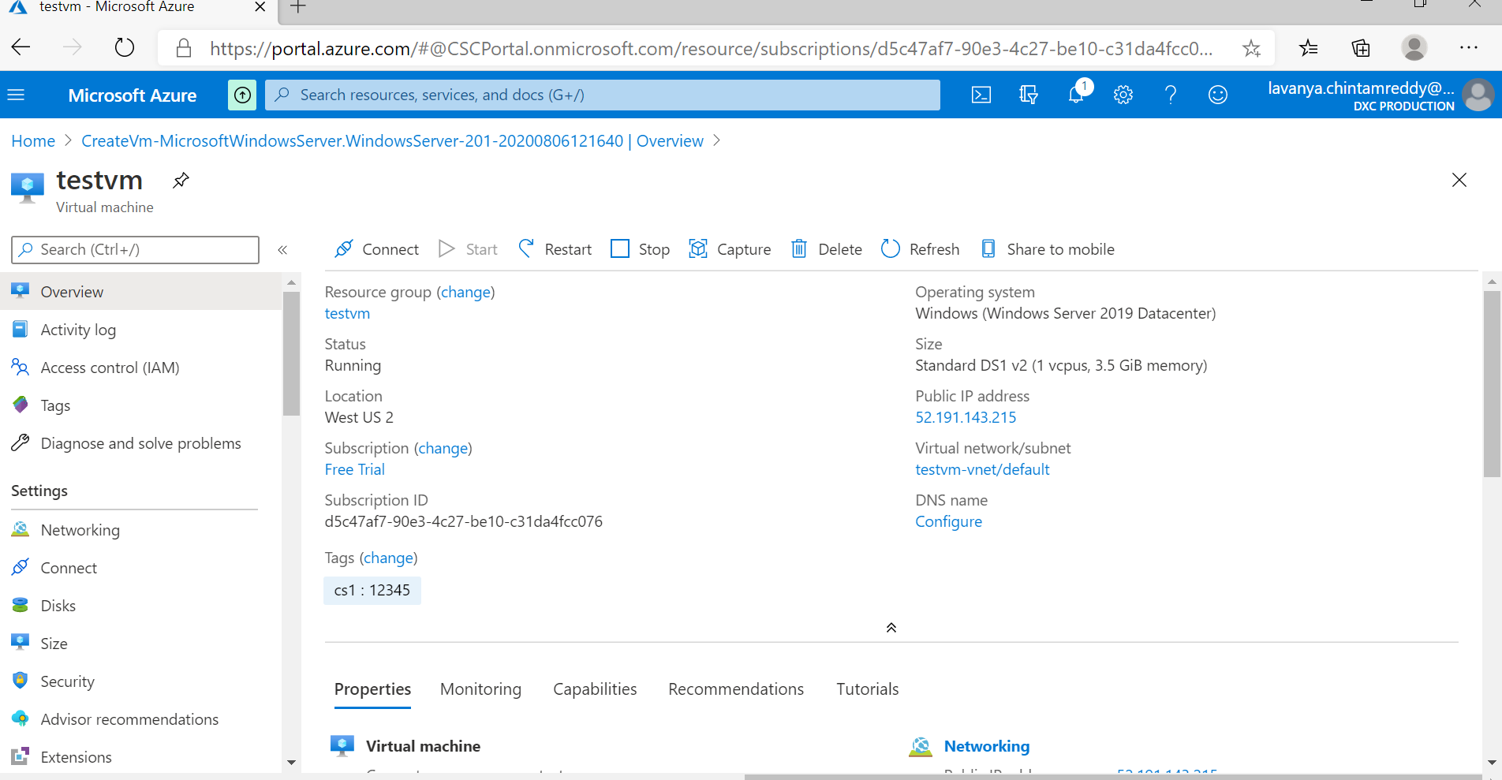

2)attach one data disk of size 50GB and split into 3 inside the Vm

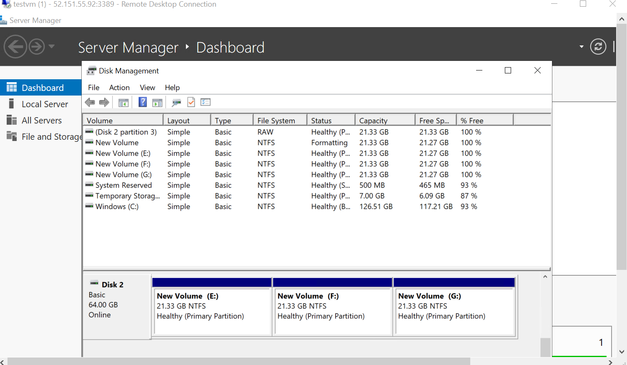

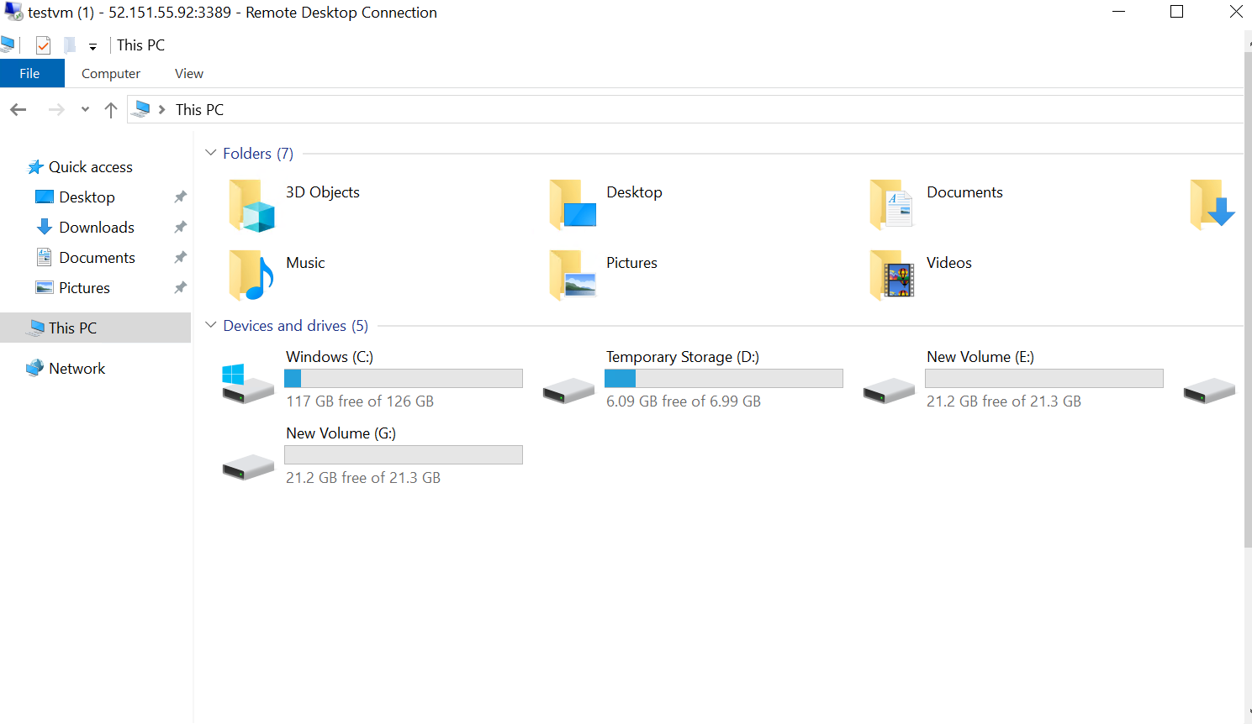

3)it should have enabled auto shutdown by 5.00PM IST before that it has to trigger a notification to the mail id

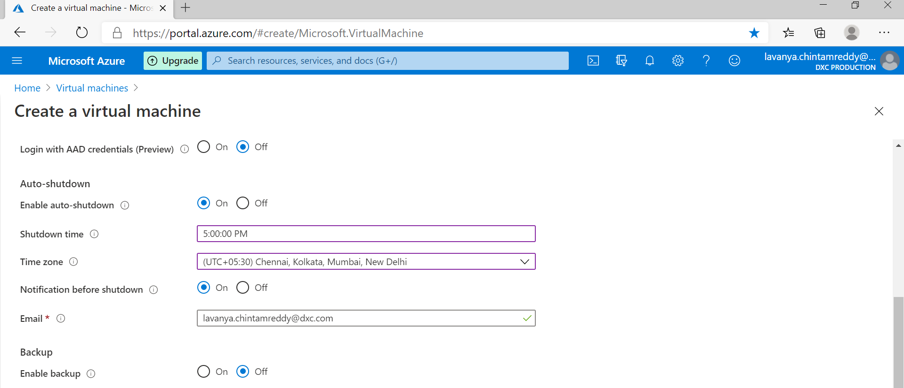

4)you should be able to login to the servers with two usernames

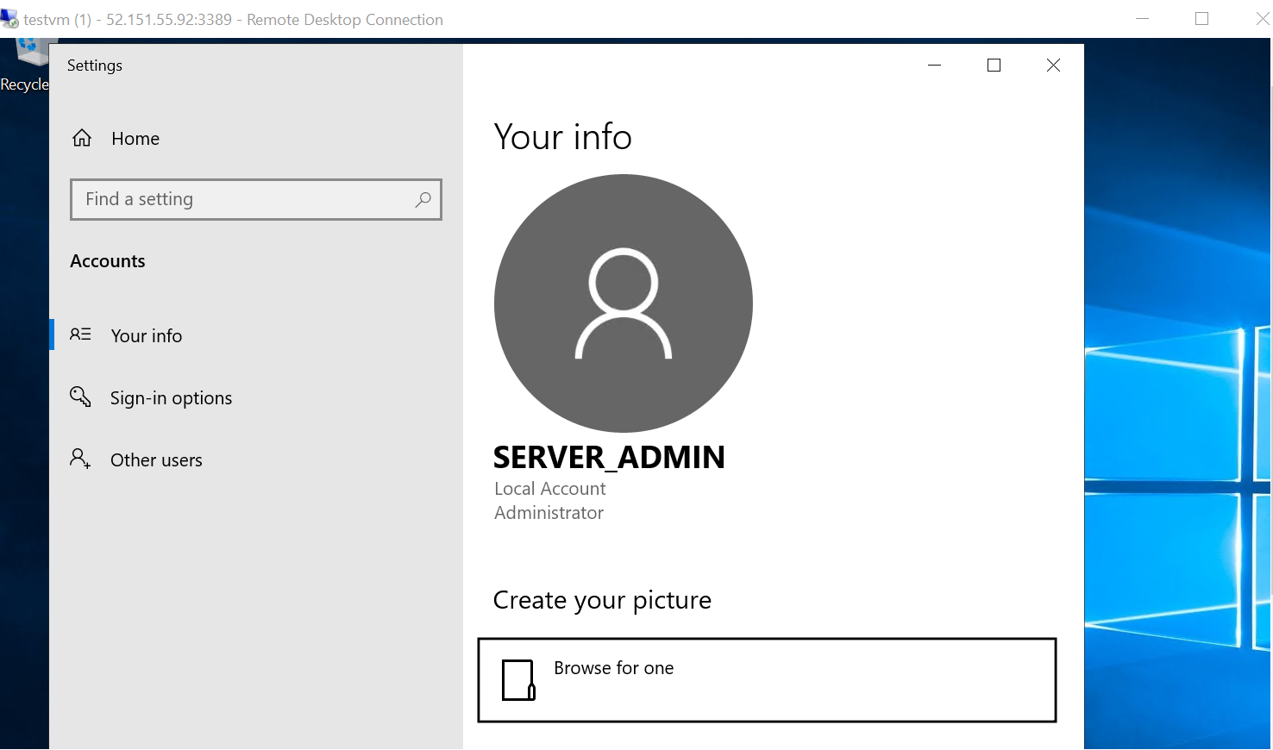

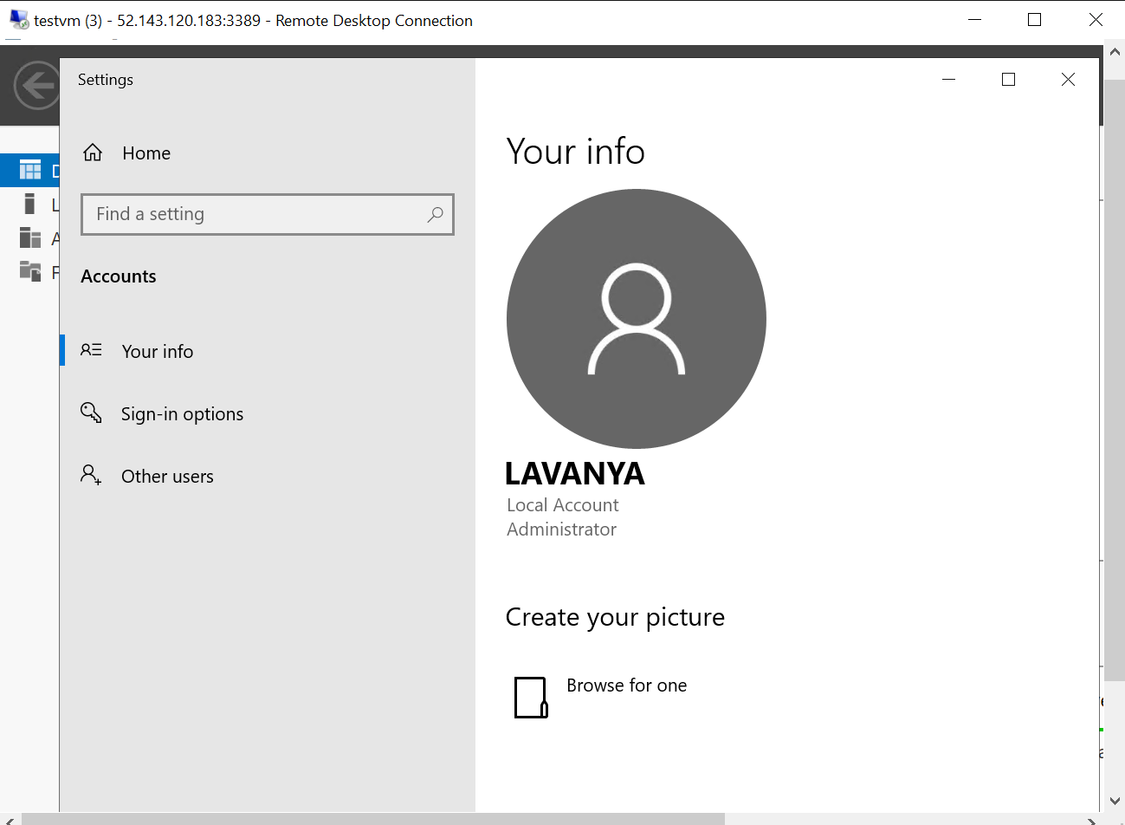

5)install Microsoft antimalware extensions in the VM

