**Create a scale set with windows OS**

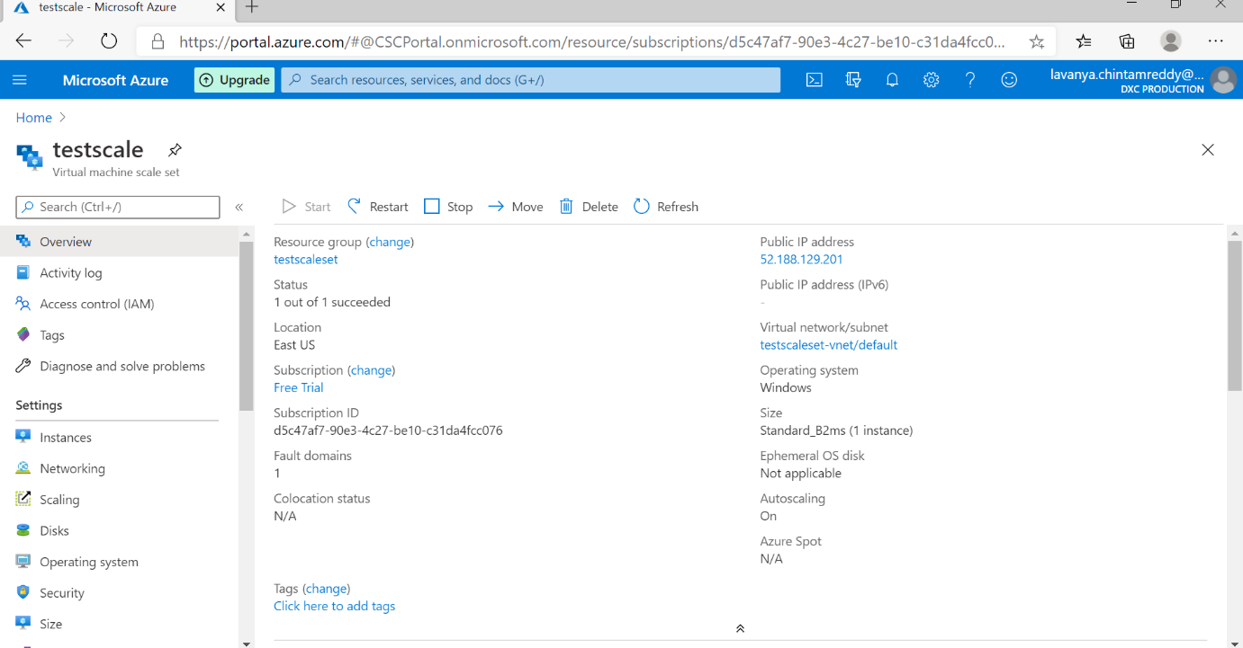

**Write a scale out rule using CPU perecentage of 70% threshold and scale in rule using CPU percentage of 40% threshold**

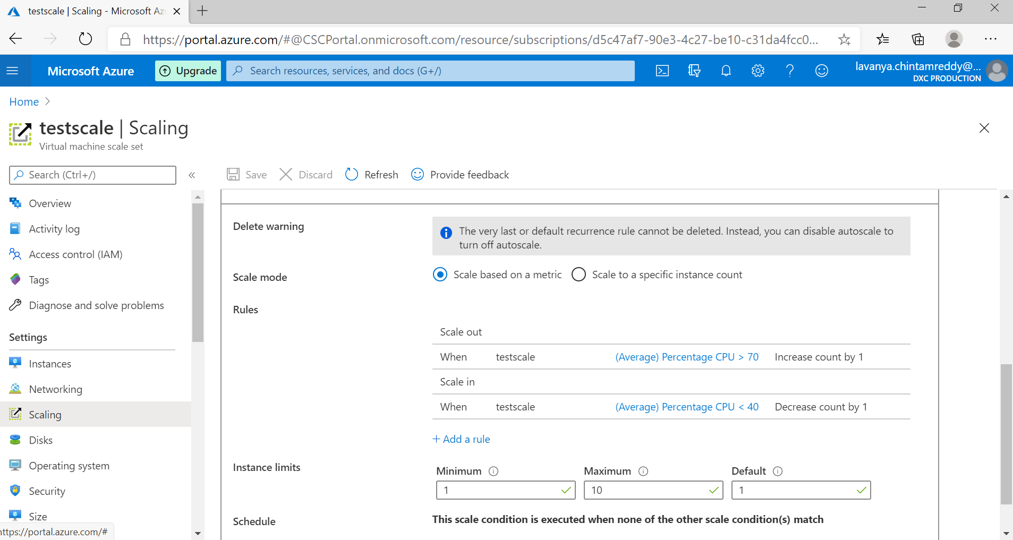

**Create an storage account and containers with anonyms access ,create a static website in the storage account**

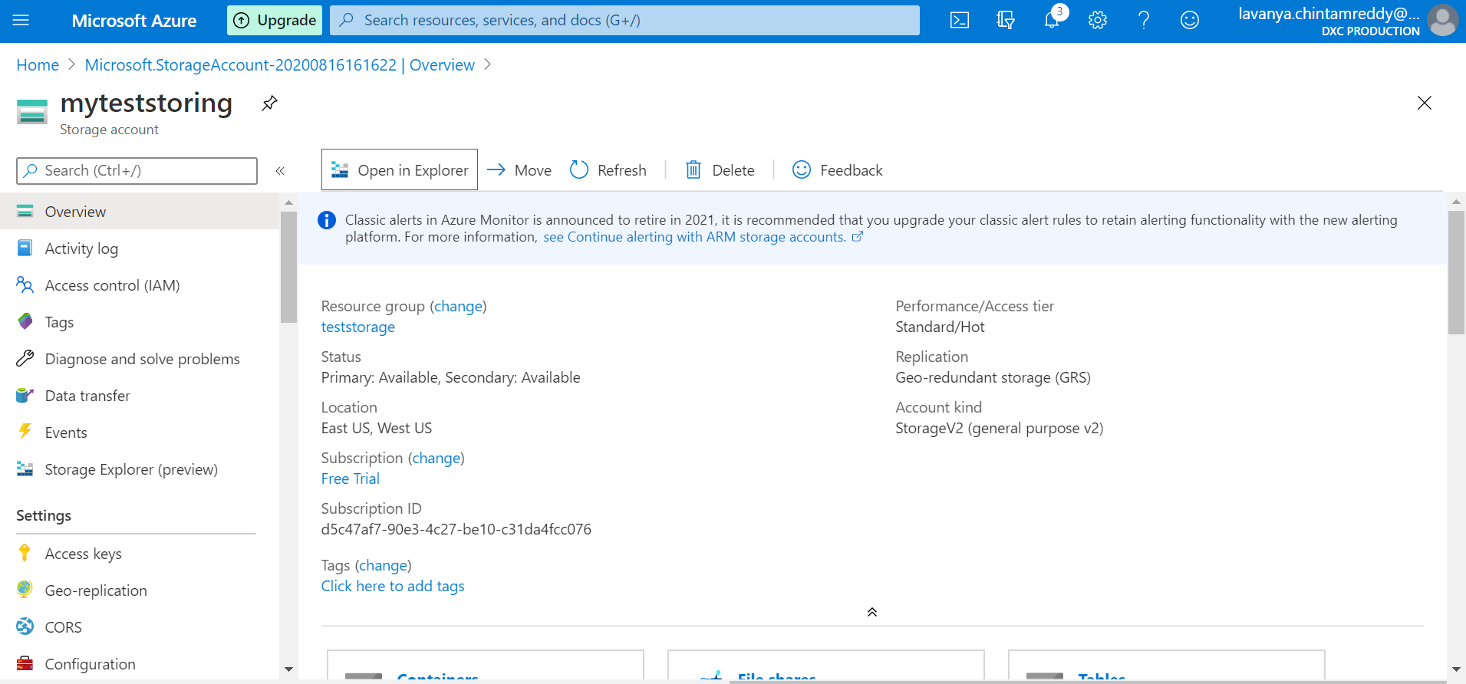

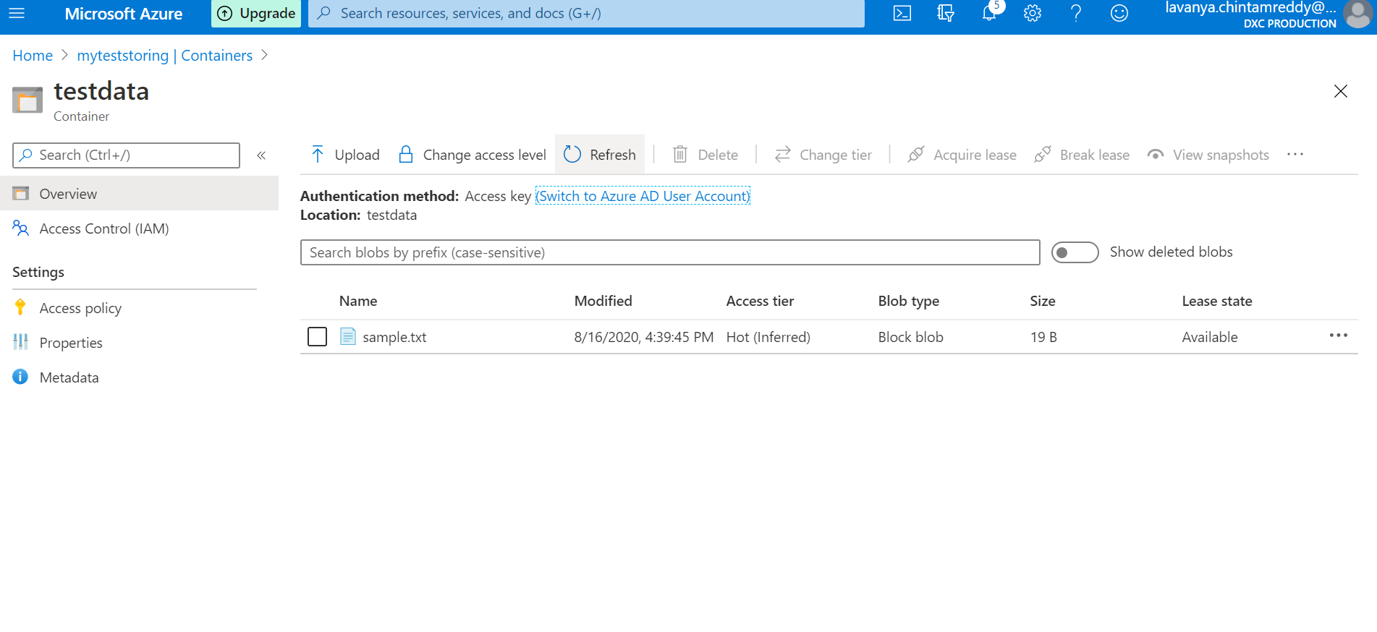

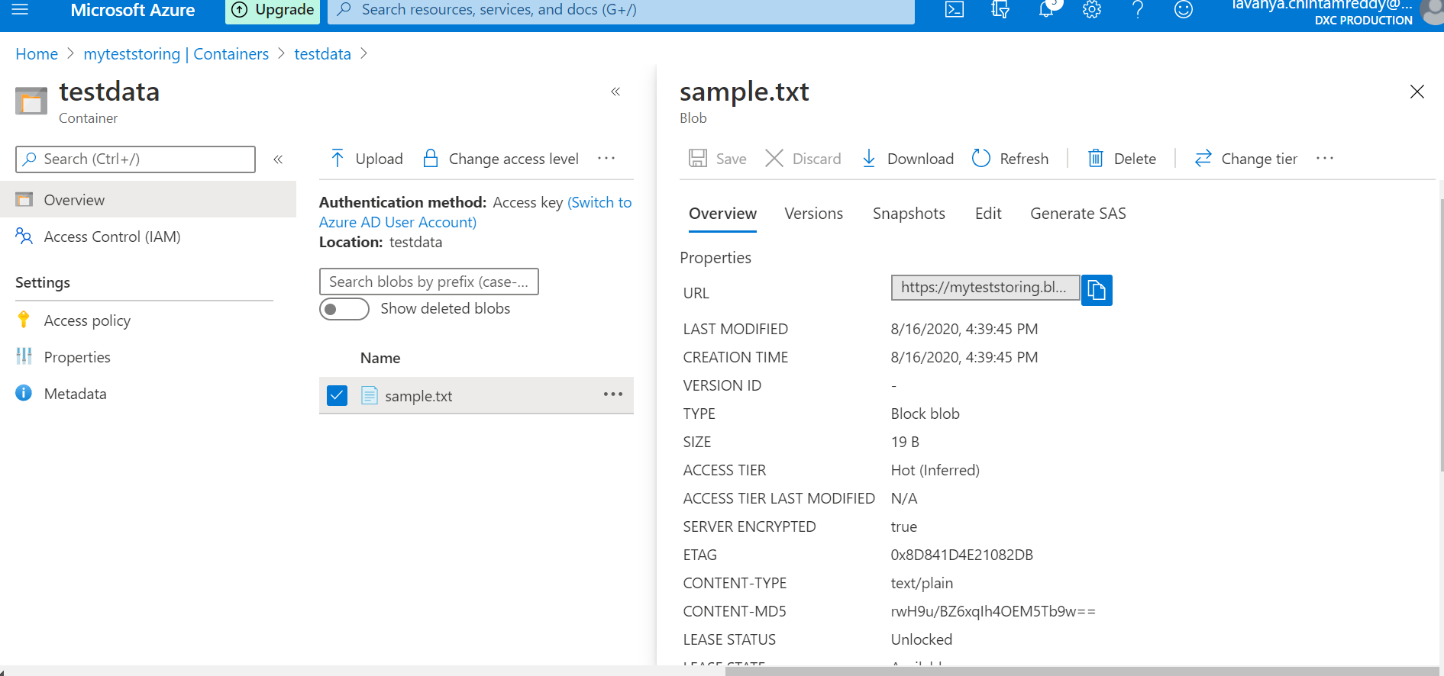

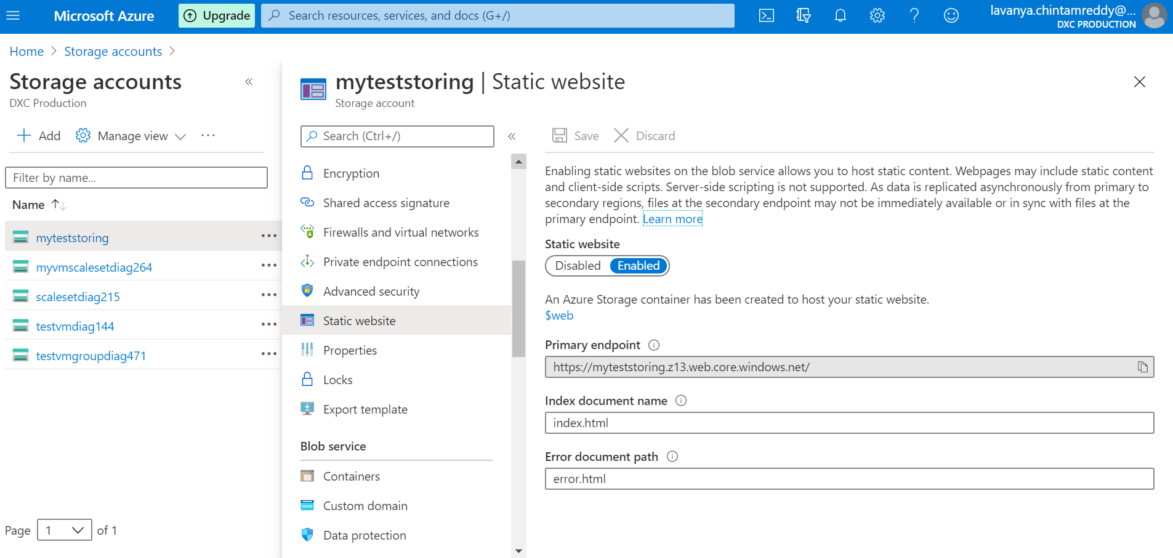

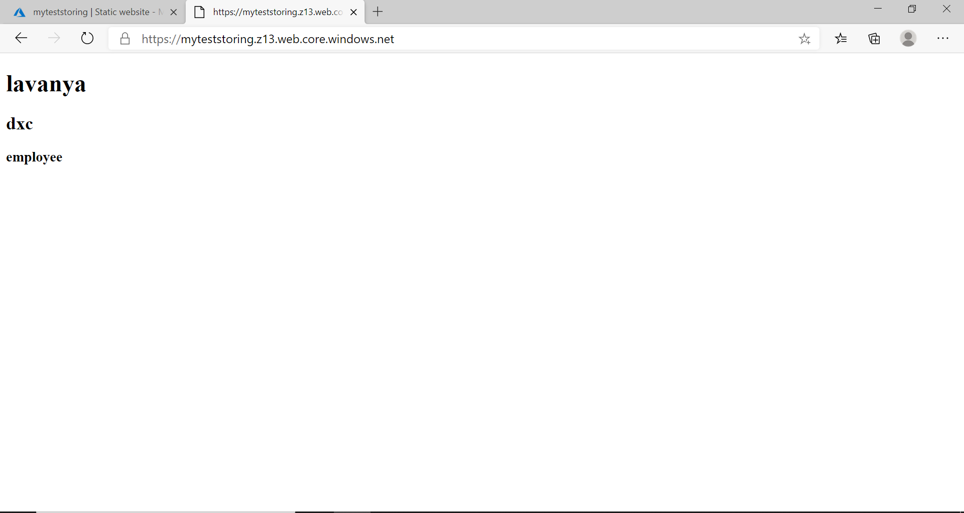

**Create an two virtual machines with no public ip’s**

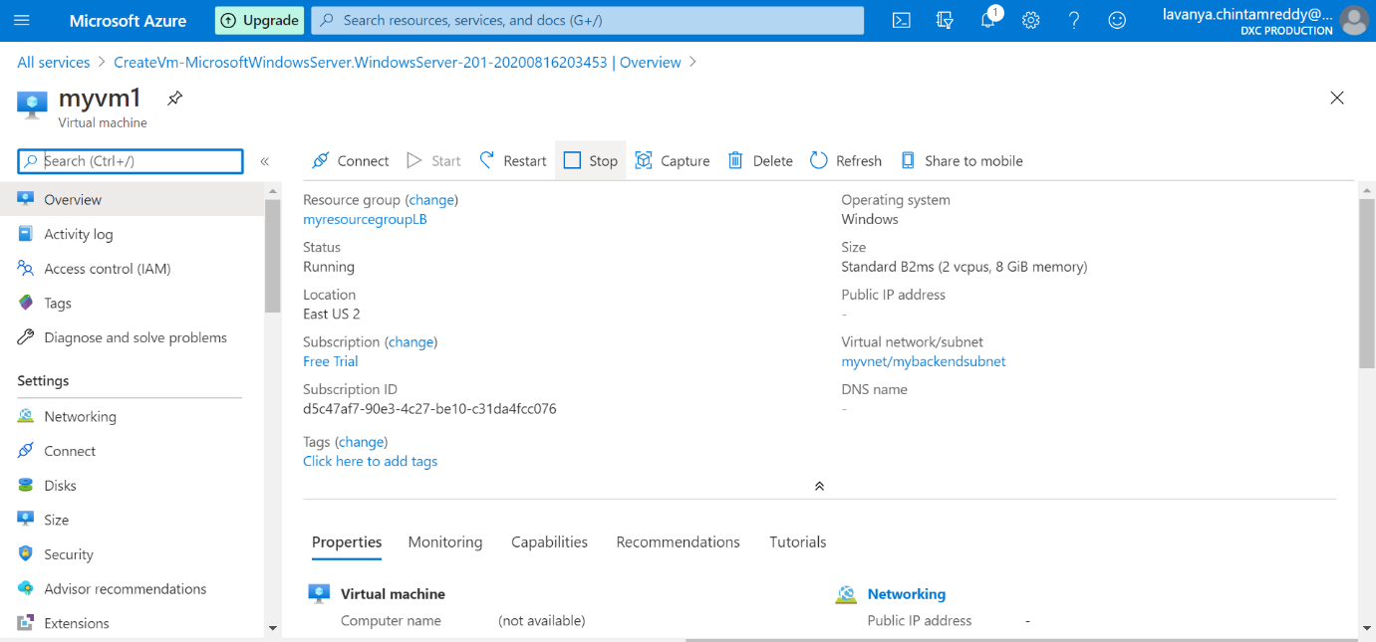

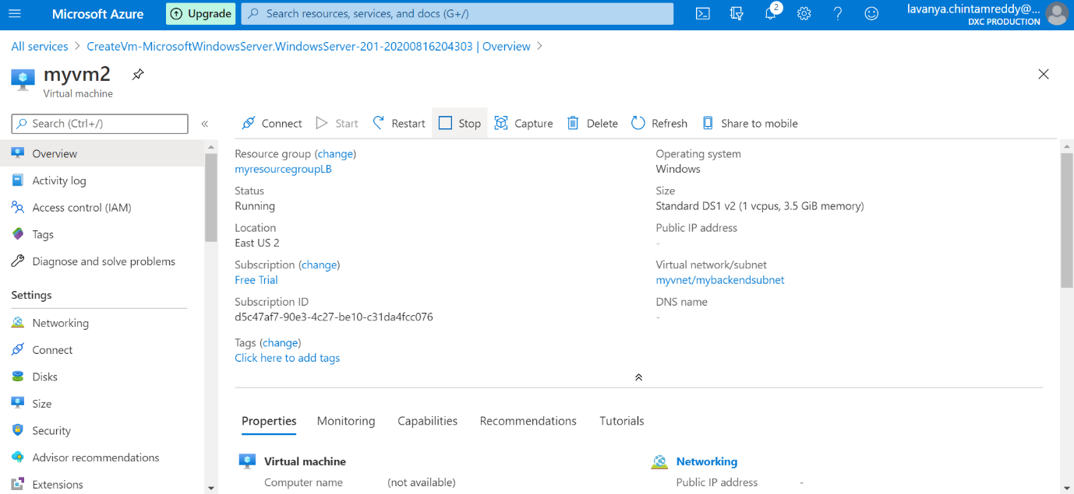

**Attach the machines to the load balancer and block the 3389 port use 50010**

