**Assignment1:**

**Starting all ssh servers:**

---------------------------------------------------

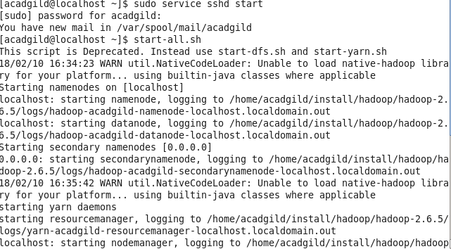

**Checking the started daemons using jps command:**

-------------------------------------------------------------------

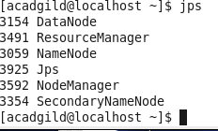

**Using pwd and ls command:**

--------------------------------------------------------------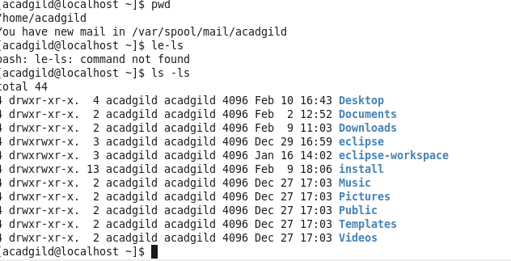

**Starting HDFS website. Overview Window:**

**----------------------------------------------------------**

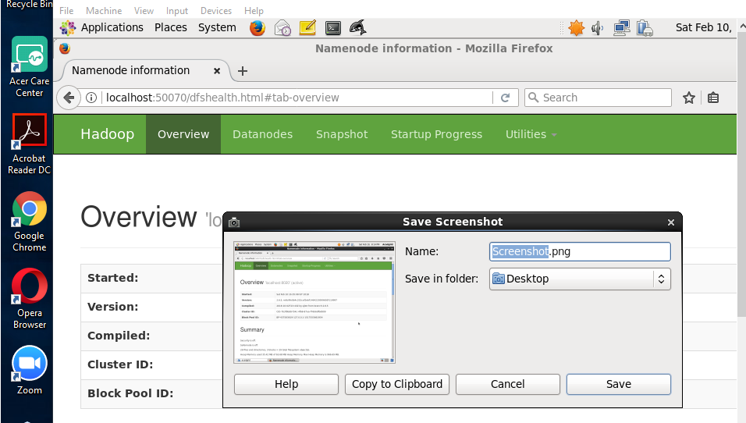

**Data Node Information:**

-----------------------------------------------------

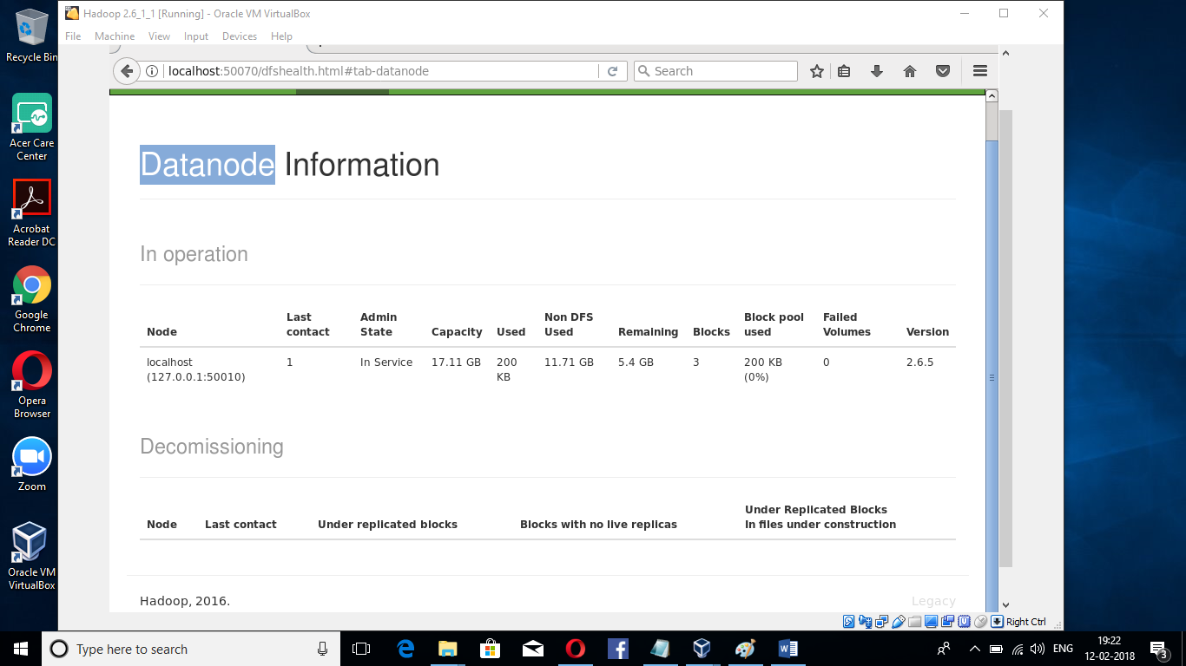

**Start Up Progress Page:**

**-------------------------------**

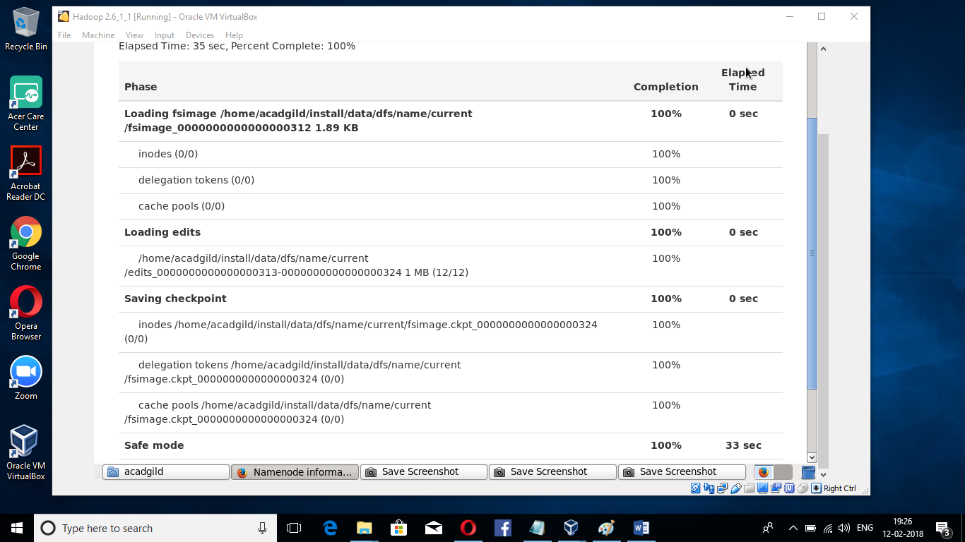

**Utilities->Browsing files**

**--------------------------------**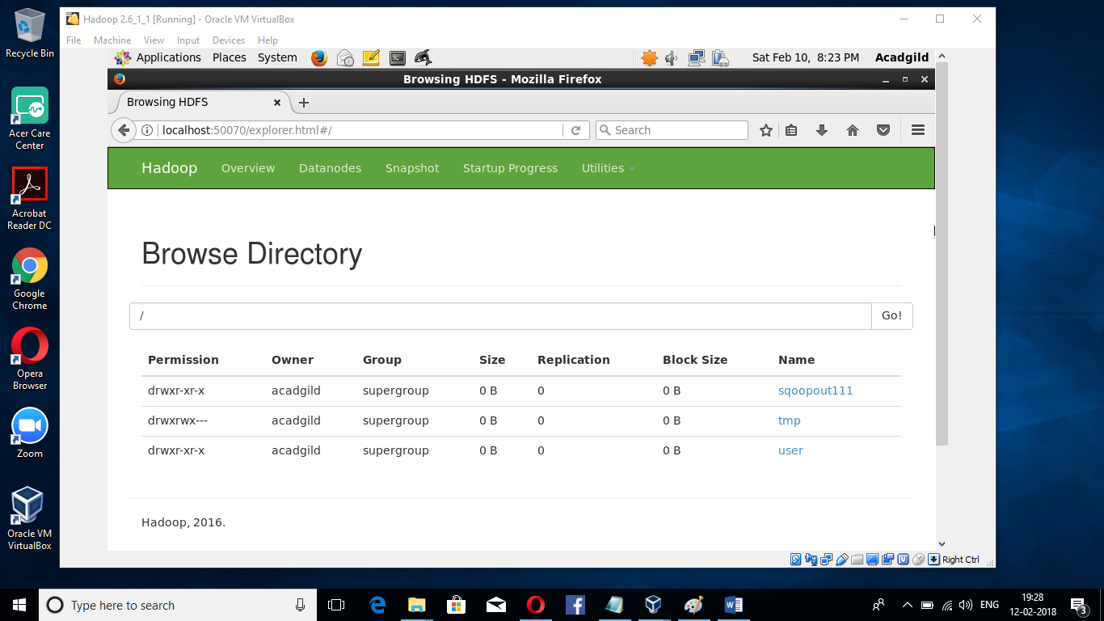

**Creating a file using nano Editor and viewing using cat**

**-------------------------------------------------------------------------**

