**ASSIGNMENT 9.1 Advance Hive**

**---------------------------------------------**

**Problem Statement:**

**---------------------------**

Given Olympic data set, write a hive program for the below tasks.

**Created table and loaded the data using below commands:**

**1.create table Olympic_data(name String, age Int, country String, year String, Cdate String, sport String, GMedal int, SMedal int, BMedal int, Totmedals int ) row format delimited fields terminated by '\t';**

**2. LOAD DATA LOCAL INPATH '/home/acadgild/olympix_data.csv' into table Olympic_data;**

**Task 1:**

**--------**

1. Write a Hive program to find the number of medals won by each country in swimming.

Query for the above task:

--------------------------------

**select country , sum(totmedals) from olympic_data where sport = "Swimming" group by country;**

**output:**

**----------**

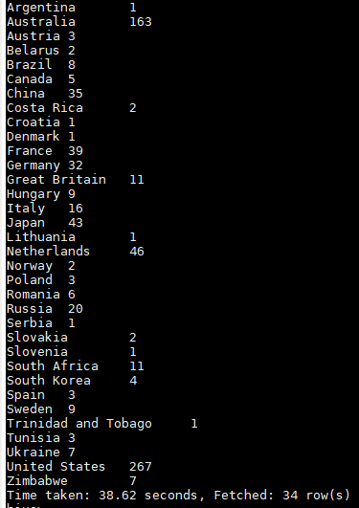

2. Write a Hive program to find the number of medals that India won year wise.

Query for the above task:

**select year , sum(totmedals) from olympic_data where country = "India" group by year;**

**output:**

----------



3. Write a Hive Program to find the total number of medals each country won.

**select country , sum(totmedals) from olympic_data group by country;**

**Output:**

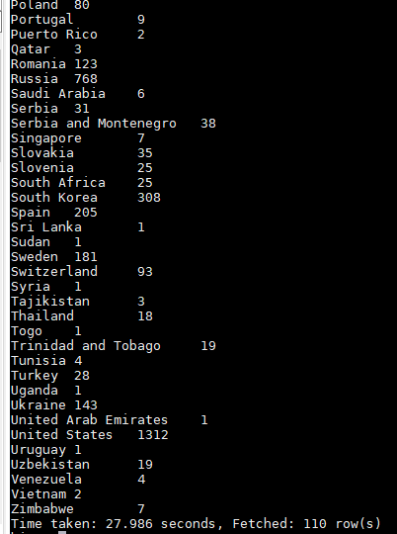

4. Write a Hive program to find the number of gold medals each country won.

**select country , sum(GMedals) from olympic_data group by country;**

**Output:**

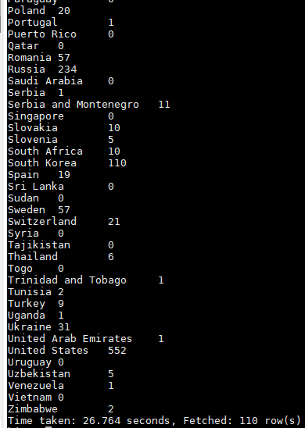

**Task 2:**

**----------**

Write a hive UDF that implements functionality of string concat_ws(string SEP, array<string>).

This UDF will accept two arguments, one string and one array of string.

It will return a single string where all the elements of the array are separated by the SEP.

Steps to create a udf in Hive:

2. For Adding the import org.apache.hadoop.hive.ql.exec.UDF without error add the below external jar files as below:

install/hive/bin/hive-exec-2.3.2

3. Once after fixing all the code issues create a jar file(concat_ws1.jar) using eclipse IDE. Source code is attached as separate file explaining the code.

4. Move the concat_ws1.jar file to the VM local file system.

5. Add the jar file and create temporary function as below:

**ADD JAR /home/acadgild/concat_ws1.jar;**

**CREATE TEMPORARY FUNCTION concat1 AS 'concat_ws.concat_ws';**

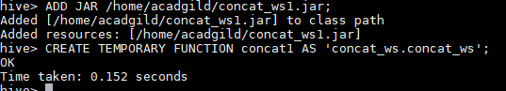

7. Now use the created temporary file to concat1 to create the below output.

**select concat1('-', zip,temp) from temperature_data;**

**Output:**

**----------**

