**Assignment 3.1**

**Task 1:**

**---------**

**Execute WordMedian​ , WordMean​ , WordStandardDeviation ​programs using**

**hadoop-mapreduce-examples-2.9.0.jar file present in your AcadGild VM.**

**Task to execute wordmedian:**

**-----------------------------------------**

**Commands used for executing wordmedian:**

**------------------------------------------------------------**

1. **cd $HADOOP_HOME, cd share, cd Hadoop, cd mapreduce.**
2. **Hadoop jar Hadoop-mapreduce-examples-2.6.0.jar wordmedian /file.txt /output/FileWM**

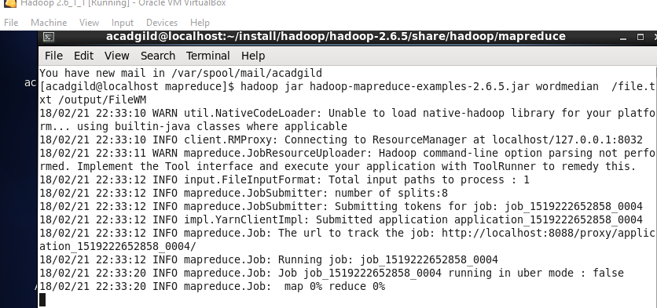

**Output To find the Word Median:**

**---------------------------------------------**

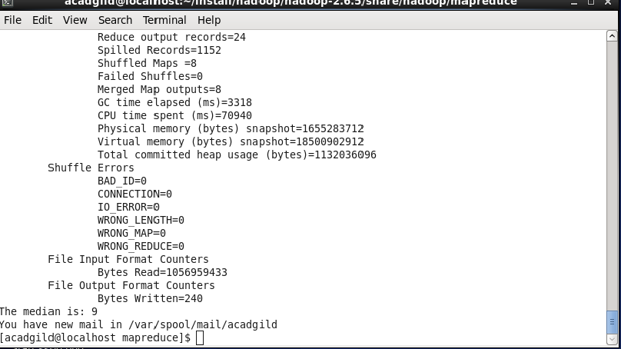

**Output 2: to view the FileWM that is created on running wordmedian**

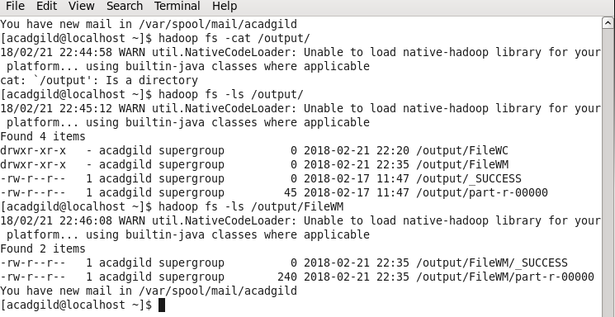

**Task to execute Word Mean:**

**---------------------------------------**

**Commands used for executing wordmean:**

**------------------------------------------------------------**

1. **cd $HADOOP_HOME, cd share, cd Hadoop, cd mapreduce**
2. **Hadoop jar Hadoop-mapreduce-examples-2.6.0.jar wordmean /file.txt /output/FileWMean**

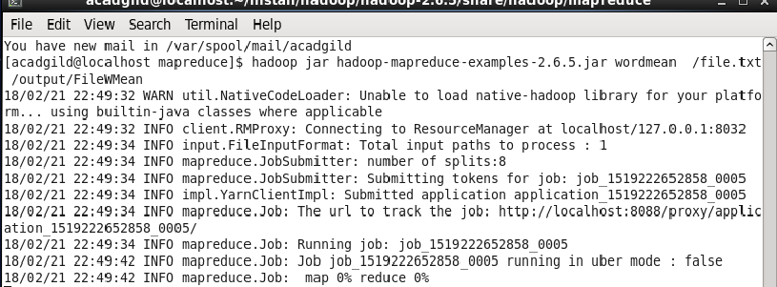

**Output:**

**-----------**

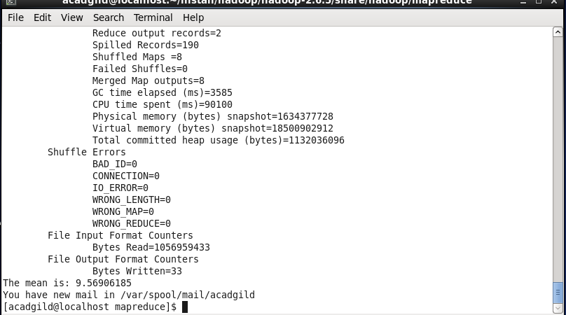

**Output 2: to view the FileWMean that is created on running wordmean:**

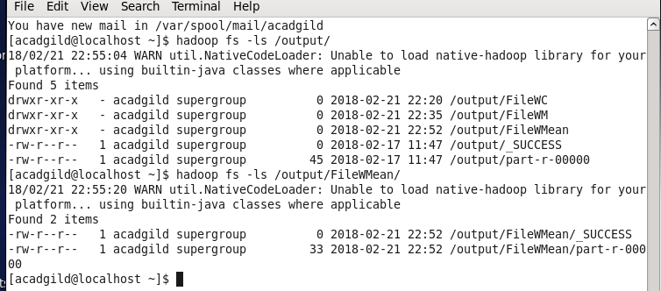

**Task to execute Word Standard Deviation:**

**---------------------------------------------------------**

**Commands used for executing Word Standard Deviation:**

**-----------------------------------------------------------------------------**

1. **cd $HADOOP_HOME, cd share, cd Hadoop, cd mapreduce**
2. **Hadoop jar Hadoop-mapreduce-examples-2.6.0.jar wordstandarddeviation /file.txt /output/FileWSD**

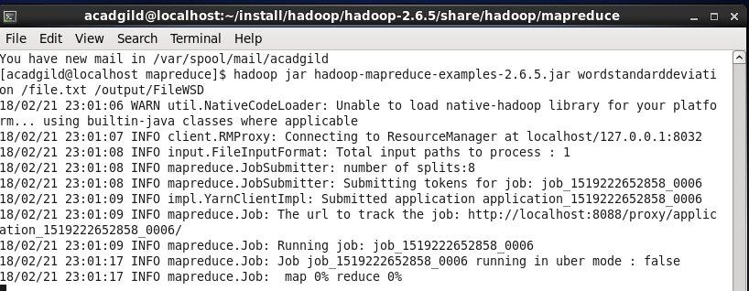

**Output:**

**-----------**

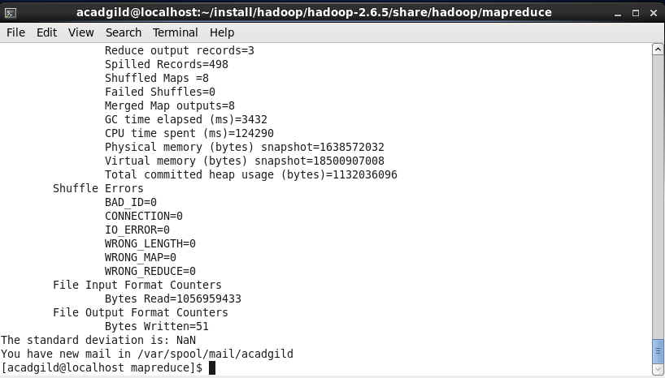

**Output 2: to view the FileWSD that is created on running wordstandarddeviation:**

