**Assignment 2.1 Introduction to HDFS:**

**----------------------------------------------------**

**Task 1:**

**----------**

**To check if user/acadgild folder exits in the hdfs and to create another folder hadoop:**

**Used the below command:**

**---------------------------**

**Hadoop fs -ls /user/acadgild/Hadoop to view if the folders are available**

**Output 1:**

**-----------**

**In the terminal window.**

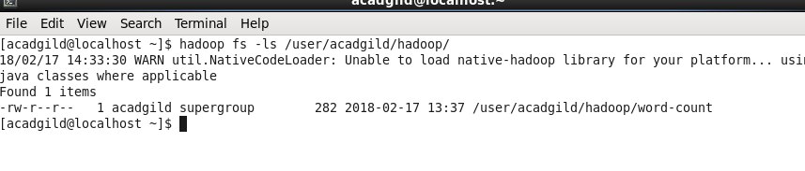

**Output 2:**

**-------------**

**In the local host website:**

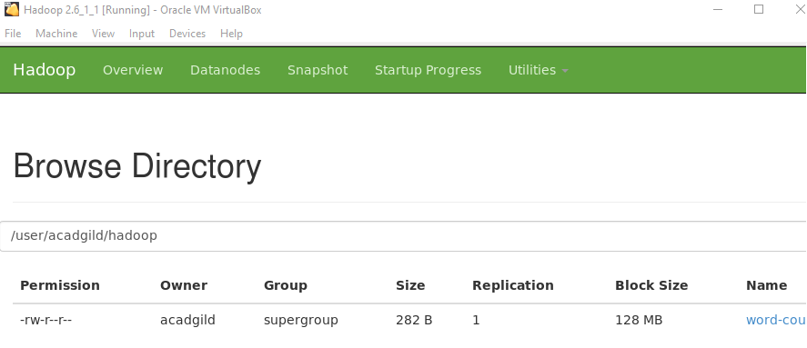

**Used the below command to create the Hadoop folder:**

**Hadoop fs -mkdir /user/acadgild/Hadoop1 created hadoop1 as Hadoop was created already.**

**Output:**

**-----------**

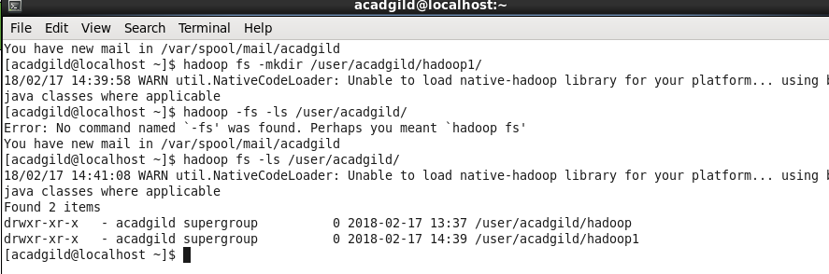

**Task2:**

**--------**

1. **Create a file in HDFS under directory /user/acadgild/hadoop, with name word-count.txt.**
2. **Created word-count.txt file in local fs using nano command and typed few lines and viewed the same using cat command.**

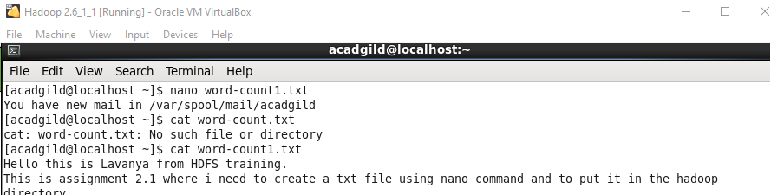

**Using put command moved the word count file to hdfs folder.**

**Output 1: terminal window.**

**-------------------------------------**

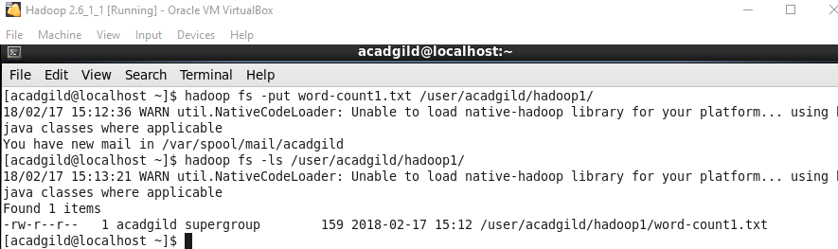

**Output 2 : In local host website:**

**--------------------------------------------**

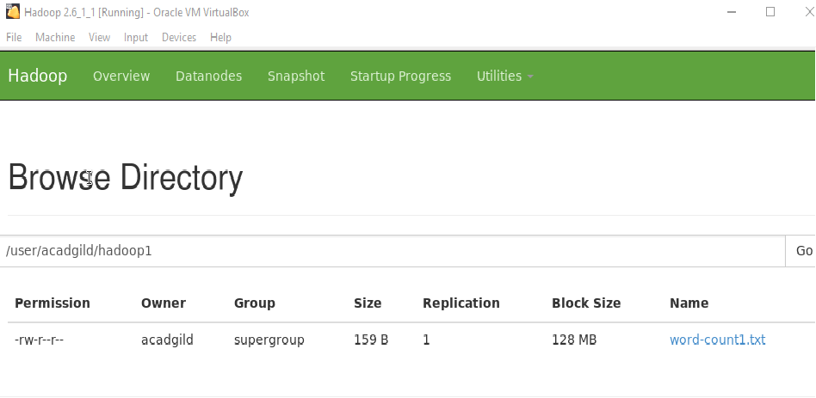

**Task 3:**

**---------**

**Create a file max-temp.txt in local FS.**

**Put some 10-15 records of date and temperature example:**

**dd-mm-yyyy,temperature**

**Created file max-temp.txt and added contents and viewed the same.**

**Commands used:**

**-----------------------**

1. **Nano max-temp.txt to create a file**
2. **Entered 10 different dates and temperature and saved the file using ctrl+x and giving y.**
3. **Cat max-temp.txt to view the file.**

**Output:**

**-----------**

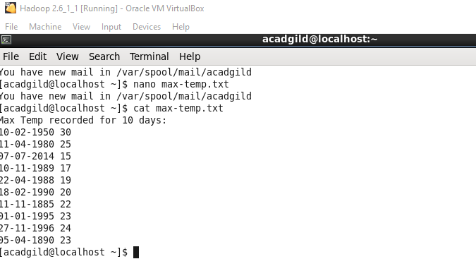

**Moved the max-temp.txt file from local fs to HDFS:**

**Commands used:**

**Hadoop fs -put max-temp.txt /user/acadgild/hadoop1/ to put the local file into HDFS.**

**Hadoop fs -ls /user/acadgild/hadoop1/ to view the moved file.**

**Output:**

**-----------**

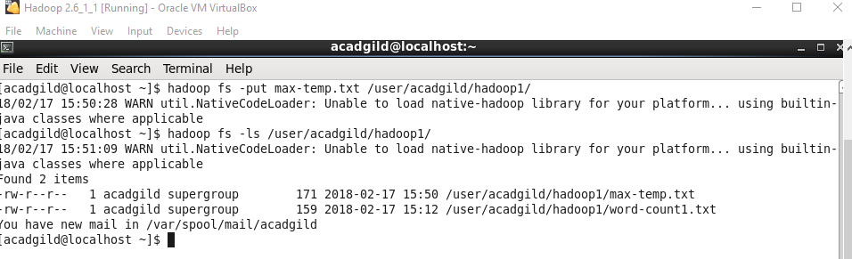

**Task 4:**

**Change the permission of the file /user/acadgild/hadoop/max-temp.txt, such that only the owner and**

**the group members have full control over the file.**

**Others do not have any control over it.**

**Initial permission for the files are as below:**

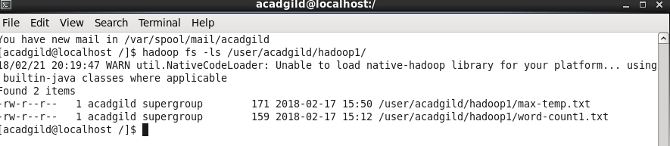

**Changed the file permission using the below command:**

**Hadoop fs -chmod 770 /user/acadgild/hadoop1/max-temp.txt.**

**Output:**

