Credit Lending ETL Framework

Architecture:
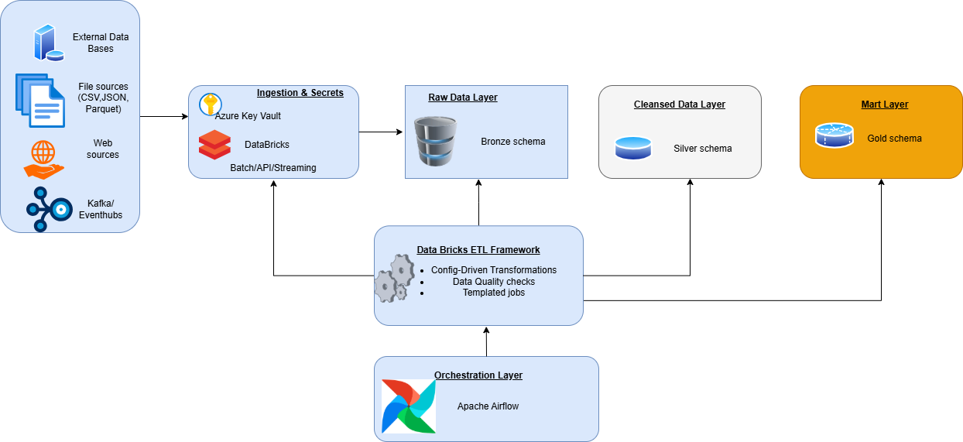

Sample Outputs:
- Framework execution screenshot
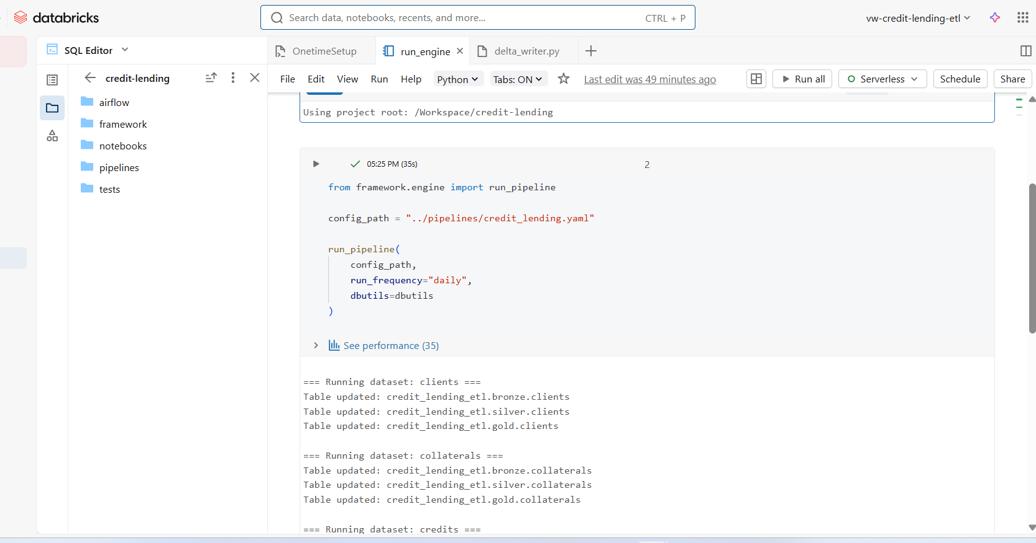

- Bronze layer sample output
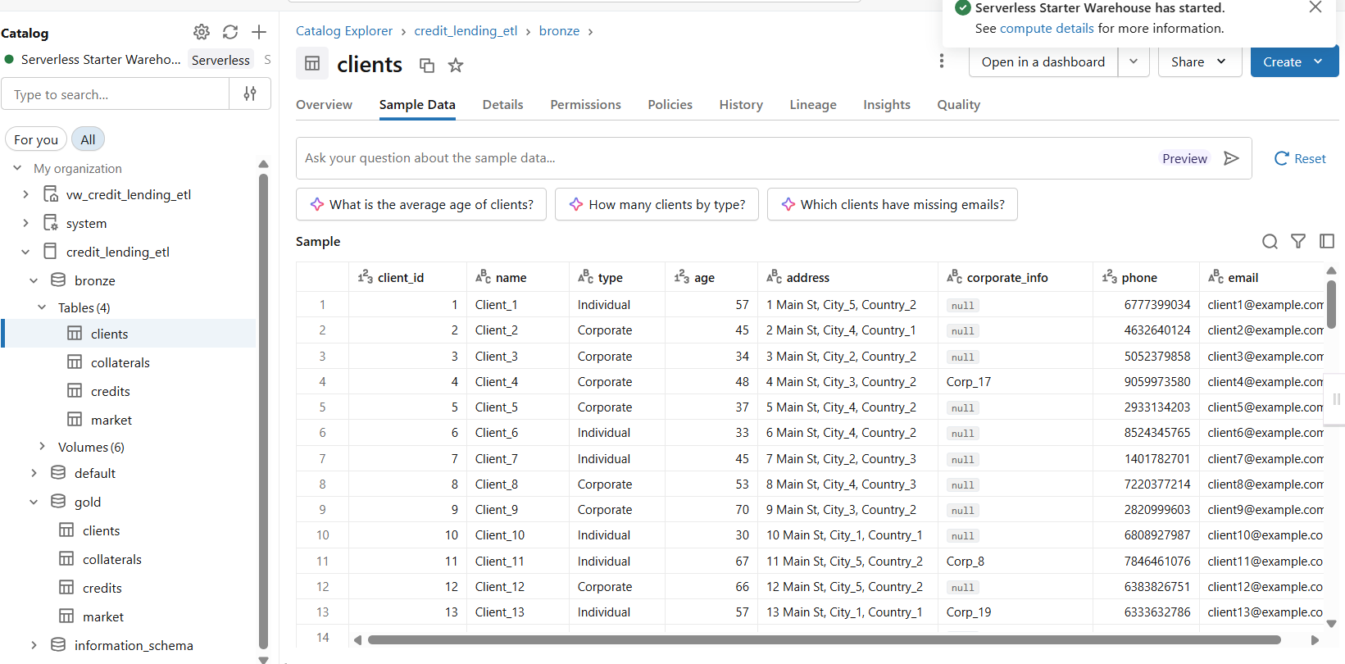
- Silver layer sample output
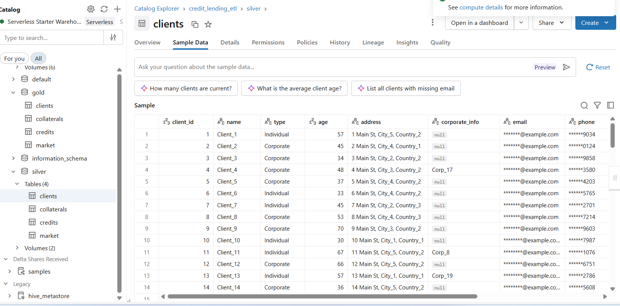

- Gold layer sample output
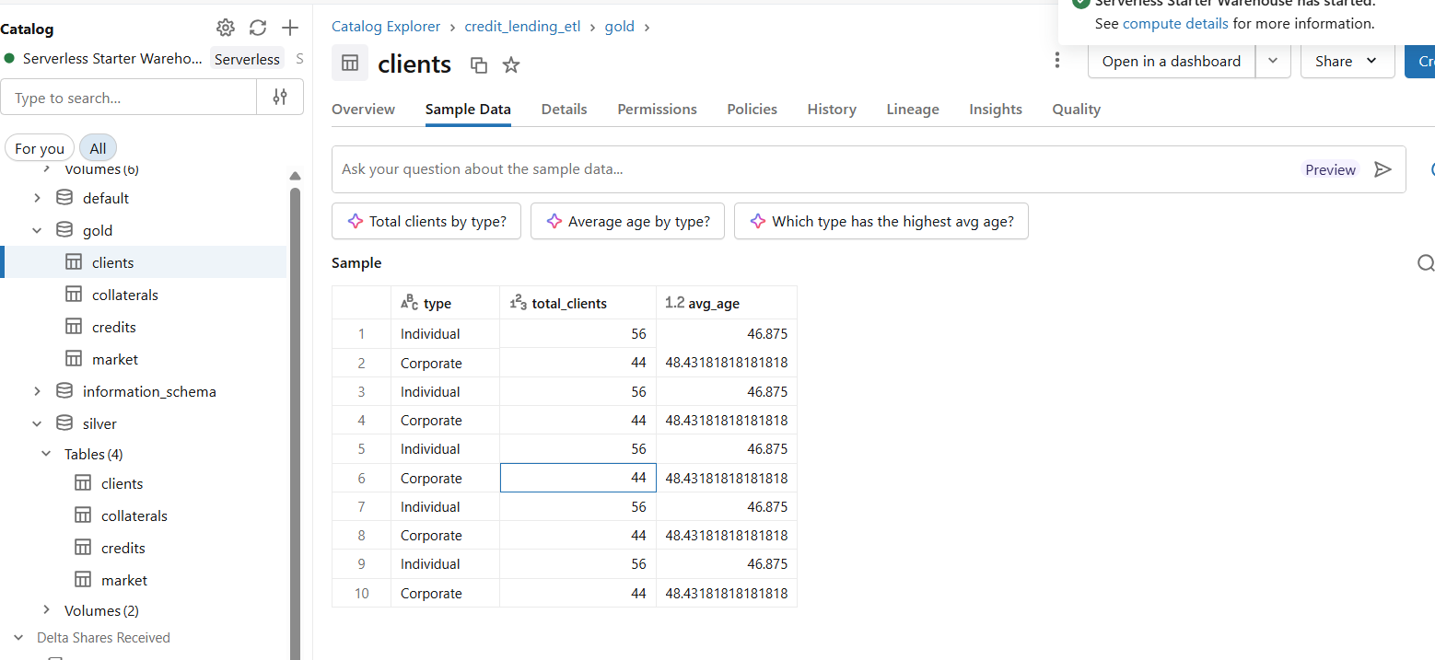
- Audit – etl_audit_log table output
