**Introduction**

* Navigating complex aerospace regulations is a challenging yet critical task for safety and compliance.
* Manual verification of regulatory documents is time-consuming and prone to errors.
* Leveraging BERT, an advanced NLP model, enables automated analysis of regulatory texts for compliance verification.
* This approach enhances accuracy, reduces manual effort, and streamlines the compliance process in the aerospace industry.

**Problem statement**

Manual compliance verification in the aerospace industry faces challenges like time inefficiency, human error, and regulatory complexity. An automated NLP-based system can streamline interpretation and verification, ensuring faster and more accurate compliance at scale. Leveraging BERT enhances precision by analyzing complex regulatory texts efficiently.

**Objectives**

* Develop a system to automate the verification of aerospace compliance against regulations issued by the FAA, EASA, and ICAO.​
* Improve accuracy in identifying potential non-compliance issues across complex regulatory texts.​
* Ensure the system can handle updates to regulations dynamically and remain adaptable to changes.​
* Minimize the risk of non-compliance penalties by ensuring thorough and consistent checks.

**Methodology**

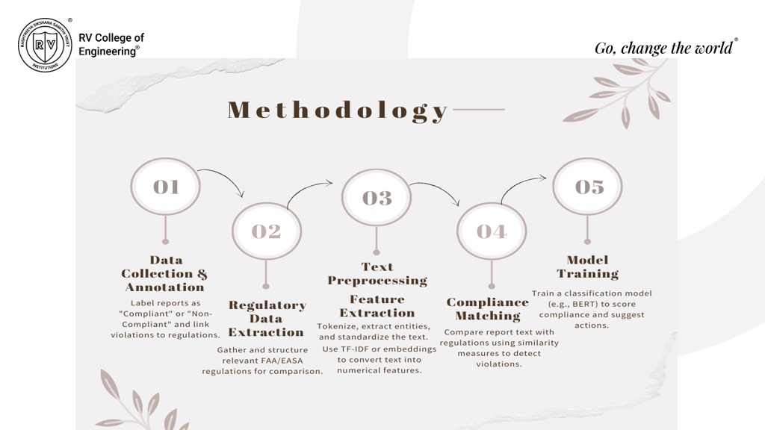

Tools and techniques used

Frontend Stack:

1. HTML5/CSS3: Provided semantic structure and responsive styling for the compliance detection interface.
2. JavaScript (ES6+): Handled asynchronous file uploads and API interactions using modern JavaScript features.
3. CSS: Implemented utility-first CSS framework for rapid UI development and consistent styling.

Backend & ML Stack:

1. Django Framework: Served as the backend framework handling file uploads, user authentication, and API endpoints.
2. BERT (bert-base-uncased):BERT classifier is a deep learning model that analyzes text from both directions simultaneously to accurately categorize aerospace maintenance reports as compliant or non-compliant based on contextual understanding.
3. PyTorch: Served as the deep learning framework for model training and inference with GPU acceleration.
4. Transformers Library: Handled tokenization and model architecture for processing maintenance report text.
5. Focal Loss: Addressed class imbalance between compliant and non-compliant cases while improving model performance through dynamic loss weighting.

**Results and discussions**

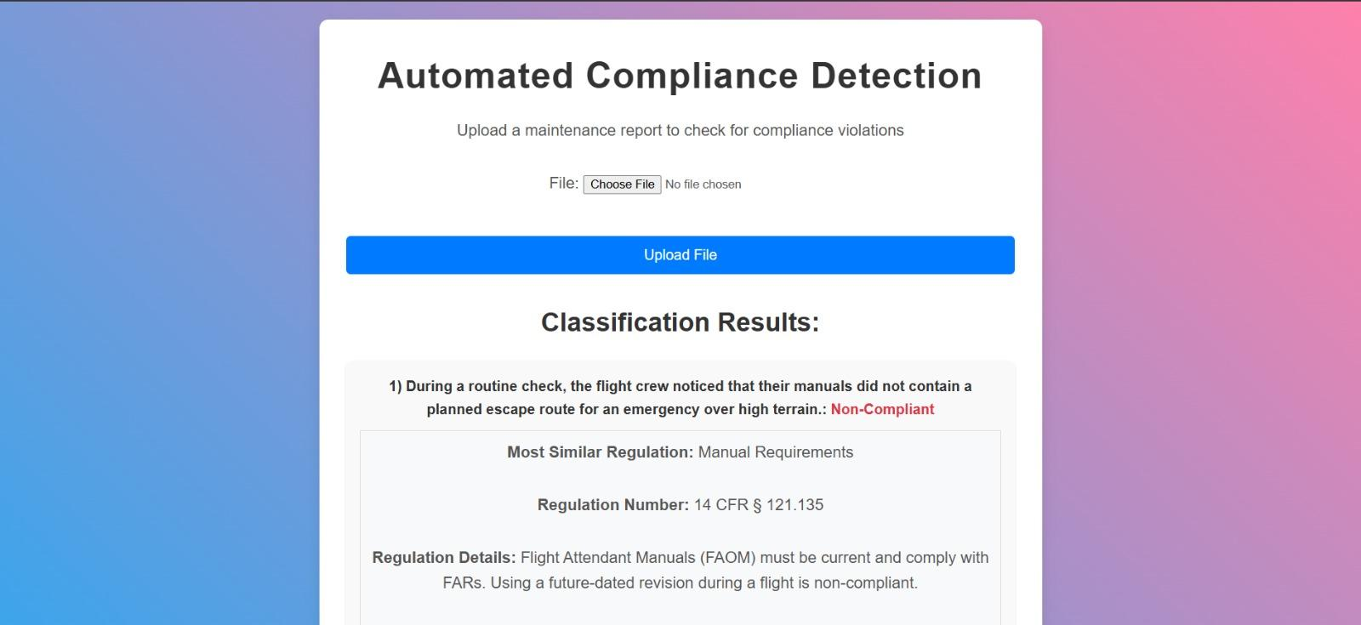

The system accepts maintenance report files and processes them through our BERT-based classifier to automatically detect compliance violations according to aerospace regulations.

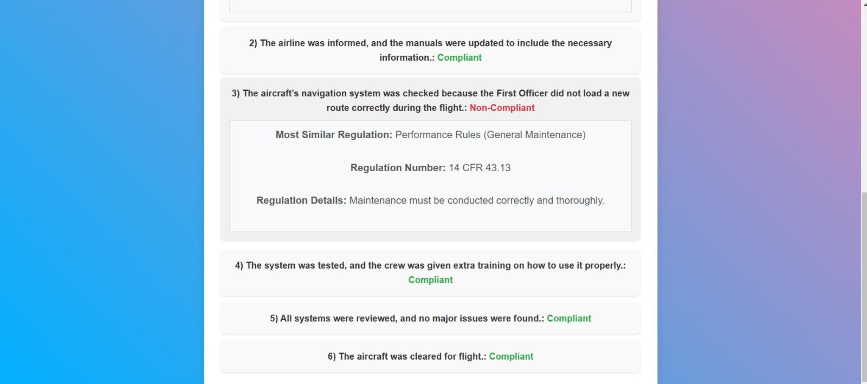

The system automatically classifies maintenance report entries as compliant or non-compliant, matches them with relevant regulations (like 14 CFR § 121.135), and provides specific regulation details for any detected violations, streamlining the compliance verification process with 87.98% accuracy.

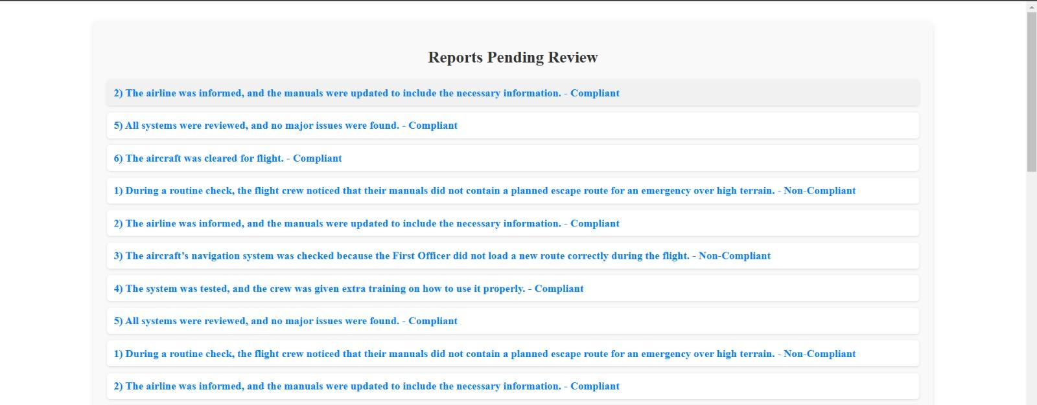

Expert reviewers can validate or override AI classifications and add explanatory notes for each maintenance report. The reviewed reports automatically become part of the training dataset, creating a continuous learning loop that improves model accuracy over time. This hybrid system combines fast AI classification with human expertise to ensure high compliance standards while significantly reducing review time.

Conclusion and future scope

The Automated Compliance Detection system successfully combines BERT-based classification with human expertise, achieving 87.98% accuracy in aerospace maintenance report analysis. The system significantly reduces manual review time while maintaining high regulatory standards through its human-in-the-loop validation feature. This hybrid approach creates a scalable solution that continuously improves through expert feedback, enhancing aviation compliance verification efficiency.

**future scope**

* Integration with live maintenance systems for real-time compliance verification and instant alerts for critical violations.
* Enhancement of AI capabilities with multi-language support and advanced anomaly detection to identify unusual maintenance patterns.
* Development of mobile applications and APIs for broader accessibility and third-party system integration.
* Extension of the system to other aviation domains and highly regulated industries while maintaining high accuracy and efficiency.