PROJECT REPORT

1. Project Title
Kitchen Vision – AI-Powered Kitchen Inventory and Smart Recipe Recommendation System
Team ID : SWTID-2026-4770
Team Size : 4
Team Leader : LAVANYA P R
Team member : NANDHINI P
Team member : SIVALI S
Team member : ROSHINI M

2. Project Description
Kitchen Vision is an intelligent kitchen assistant that uses Artificial Intelligence and computer vision to analyze ingredients from a kitchen or pantry image and generate suitable recipes.
The system allows users to upload an image of available kitchen ingredients. The uploaded image is processed using image preprocessing techniques such as resizing and enhancement. After processing, an AI vision module detects the ingredients present in the image.
The system then categorizes these ingredients into storage types such as Dry Storage, Cold Storage, Frozen, and Fresh Produce. Based on the detected ingredients, the application generates simple recipes that users can prepare with the available items.
If certain ingredients required for the recipe are missing, the system identifies them and may suggest substitutes or create a grocery list. This helps users cook efficiently while reducing food waste.
The project demonstrates how Artificial Intelligence can be applied to everyday cooking tasks, making meal planning easier and smarter.

3. Application Scenario / Use Cases

Use Case 1: Pantry Image Analysis
Users upload a photo of their kitchen pantry. The AI system analyzes the image and detects available food ingredients.

Use Case 2: Ingredient Categorization
Detected ingredients are categorized into storage types such as:
- Dry Storage
- Cold Storage
- Frozen
- Fresh Produce

Use Case 3: Recipe Recommendation
Based on detected ingredients, the system generates simple recipes that can be prepared using those items.

Use Case 4: Kitchen Inventory Assistance
The system helps users understand what ingredients are available and how they can be used in recipes.

Use Case 5: Reducing Food Waste
By suggesting recipes based on available ingredients, the system helps reduce unused food items.

4. Technical Architecture Overview
The Kitchen Vision system follows a modular architecture where different components handle specific tasks.

Main Components
Frontend Layer
- Built using Streamlit
- Allows users to upload images and view results
Image Processing Module
- Uses Pillow (PIL)
- Handles image resizing and enhancement
AI Vision Module
- Uses OpenAI Vision API
- Detects ingredients from the uploaded image
Recipe Generation Module
- Generates recipes based on detected ingredients
Configuration Module
- Manages API keys and environment variables using dotenv

Workflow
- User uploads pantry image
- Image preprocessing is performed
- AI model detects ingredients
- Ingredients are categorized
- Recipe suggestions are generated
- Results are displayed in the Streamlit interface

5. Prerequisites

Software Requirements
- Python 3.8 or higher
- Visual Studio Code
- Streamlit Framework
- OpenAI API Access
- Internet Connection

Libraries / Frameworks / Dependencies
- Streamlit – Web interface framework
- Pillow (PIL) – Image processing
- Requests – API communication
- Python-dotenv – Environment variable management
- Typing Extensions – Type support
- OpenAI API – Ingredient detection and recipe generation

Hardware Requirements
- Minimum 4GB RAM
- Processor: Intel i3 or higher
- Storage: Minimum 5GB free space
- Webcam or smartphone (optional for capturing pantry images)

6. Prior Knowledge Required
To understand and implement this project, the following knowledge is helpful:
- Basic Python programming
- Understanding of Artificial Intelligence concepts
- Basics of API integration
- Knowledge of Streamlit framework
- Basic image processing concepts

7. Project Objectives
The main objectives of Kitchen Vision are:
- To develop an AI-powered system that identifies kitchen ingredients from images
- To generate recipes using available ingredients
- To assist users in kitchen inventory management
- To reduce food waste by utilizing existing ingredients
- To simplify meal planning using AI technology

8. System Overview
The system works as an AI-powered cooking assistant.

Input
- Image of kitchen ingredients or pantry

Processing
- Image preprocessing
- Ingredient detection using AI
- Ingredient categorization
- Recipe generation

Output
- Detected ingredient list
- Categorized storage items
- Suggested recipes
- Cooking instructions

9. Milestone 1: Requirement Analysis and System Design

Problem Definition
Many people face difficulty deciding what to cook using the ingredients available in their kitchen. This leads to confusion, inefficient kitchen management, and food wastage.
Kitchen Vision aims to solve this problem by using Artificial Intelligence to automatically detect ingredients and recommend recipes.

Functional Requirements
The system should:
- Allow users to upload kitchen images
- Detect ingredients from images
- Categorize ingredients
- Generate recipes based on ingredients
- Display results through a user-friendly interface

Non-Functional Requirements
- Fast response time
- Easy-to-use interface
- Secure API key management
- Reliable AI output
- Scalable architecture

System Design Decisions
- Use Streamlit for fast UI development
- Use OpenAI Vision API for ingredient detection
- Use Pillow for image preprocessing
- Use modular architecture for maintainability

Technology Stack Selection Justification
Technology | Reason
Python | Easy AI and API integration
Streamlit | Quick web interface development
OpenAI API | Powerful AI vision capabilities
Pillow | Efficient image processing

Architecture Diagram

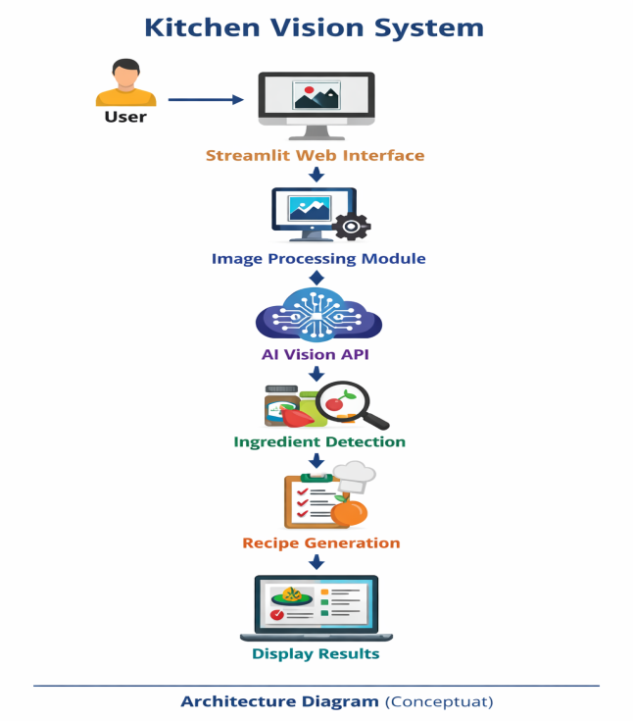

ER Diagram

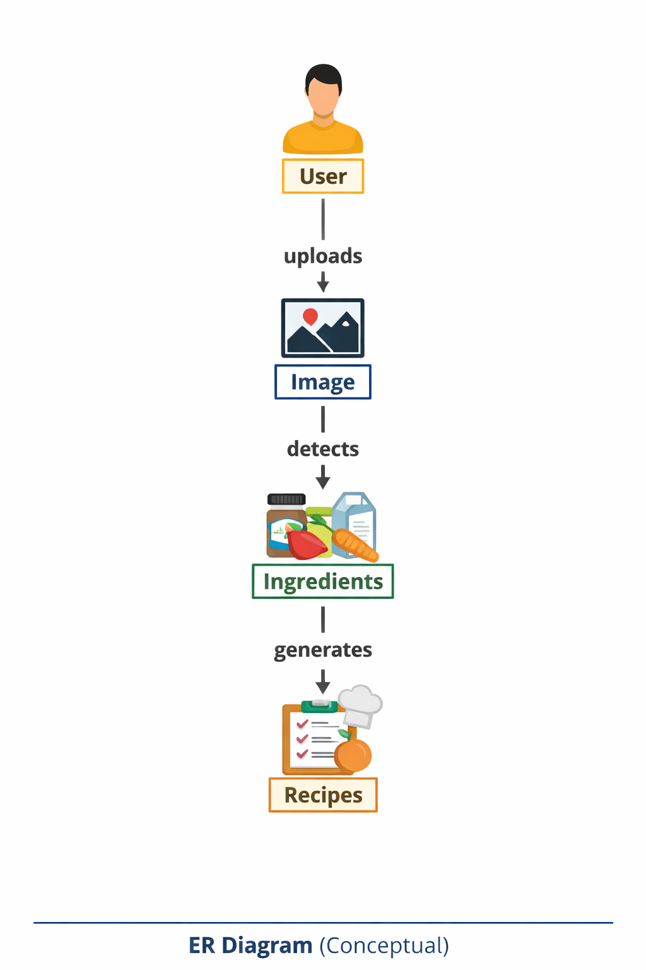

API Structure
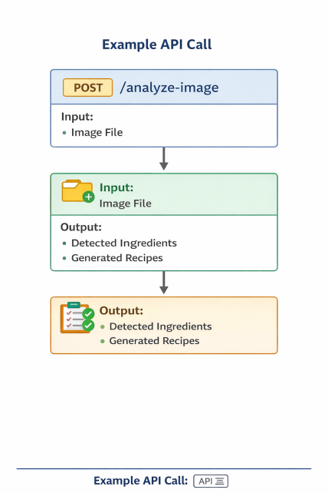

10. Milestone 2: Environment Setup and Initial Configuration

Development Environment Setup
- Install Python
- Install Visual Studio Code
- Create project folder

Dependency Installation
pip install streamlit
pip install pillow
pip install requests
pip install python-dotenv
Project Structure Creation

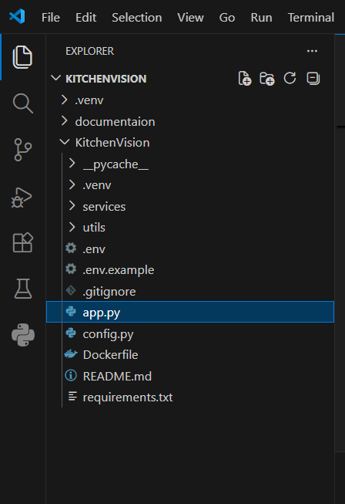

Step 1: Set Up Ai Provider Access

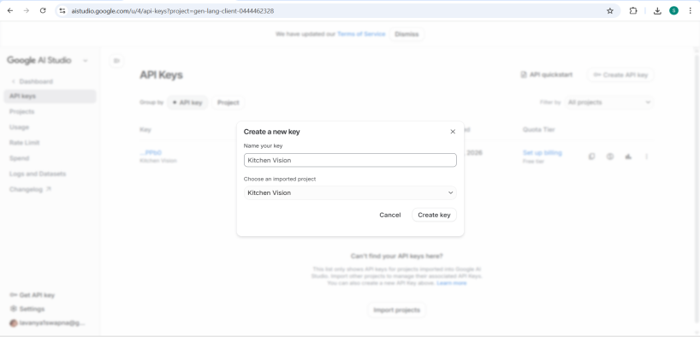

Step 2: Configure Api Keys And Environment

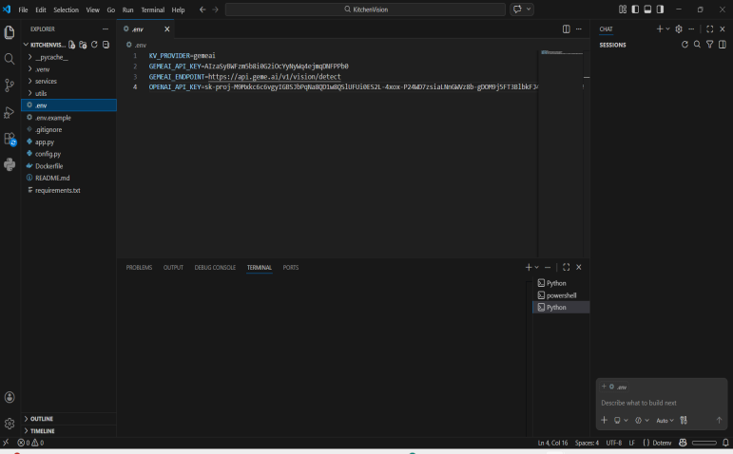

Step 3: Required Python Libraries

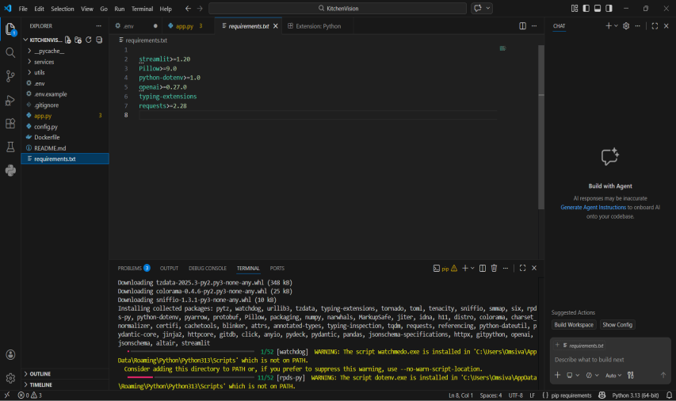

Step 4: Software Setup For Kitchenvision

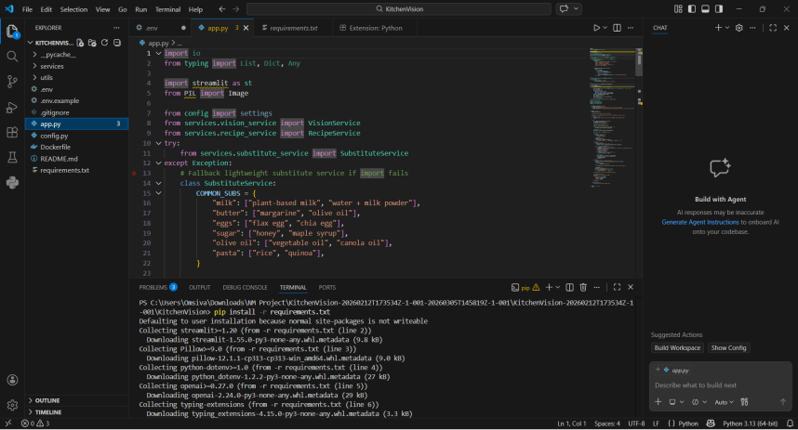

Step 5: Running The Application Using Streamlit

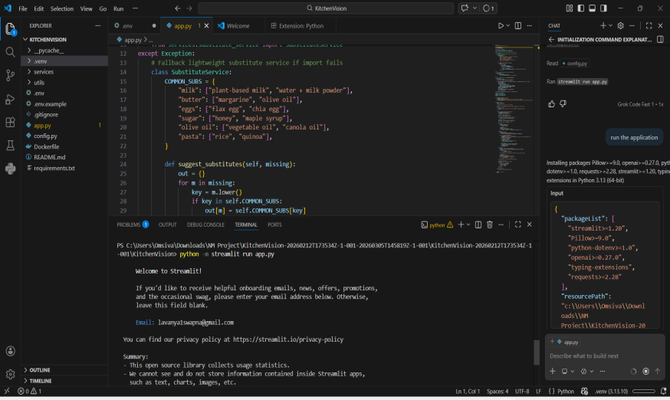

Step 6: Application Link Generated By Streamlit

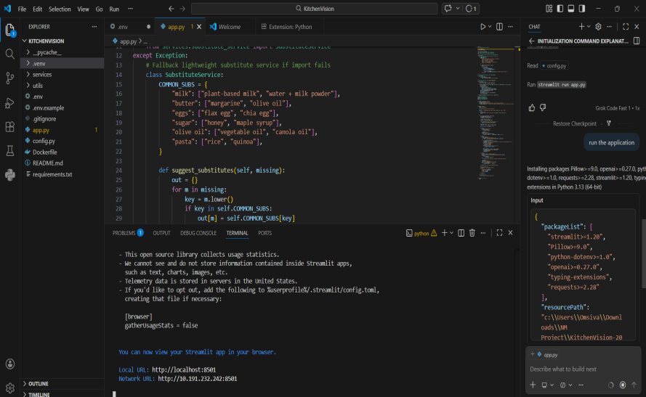

11. Milestone 3: Core System Development

Feature 1: Pantry Image Upload

Description
Users upload a pantry image using the Streamlit interface.

Code Explanation
Streamlit file uploader is used to capture image input.

Output
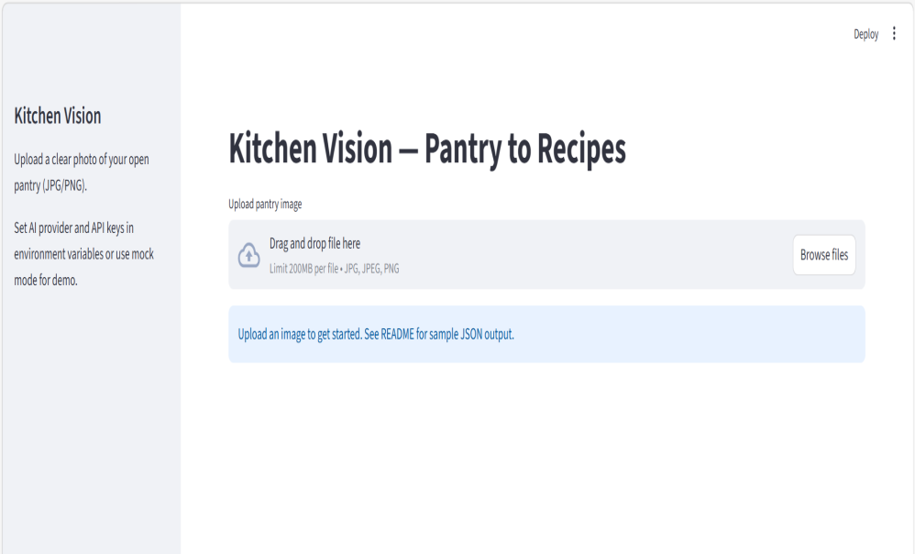

Feature 2: Ingredient Detection

Implementation
AI model analyzes the uploaded image and identifies ingredients.

Input
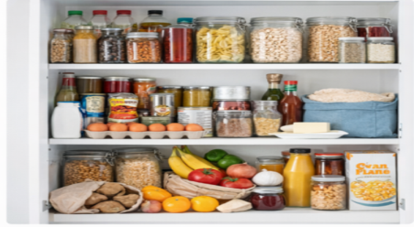

Feature 3: Recipe Generation

Implementation
Detected ingredients are used to generate suitable recipes.

Business Logic
- Match ingredients
- Create recipe instructions
- Display cooking steps

Output

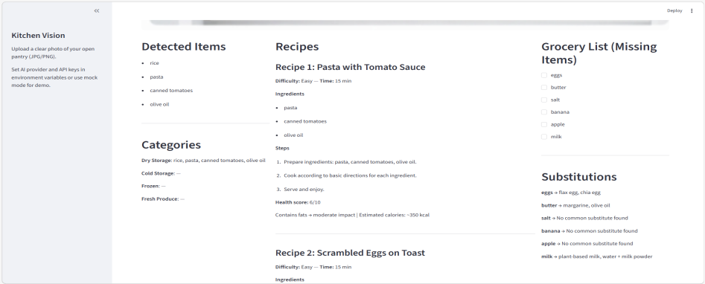

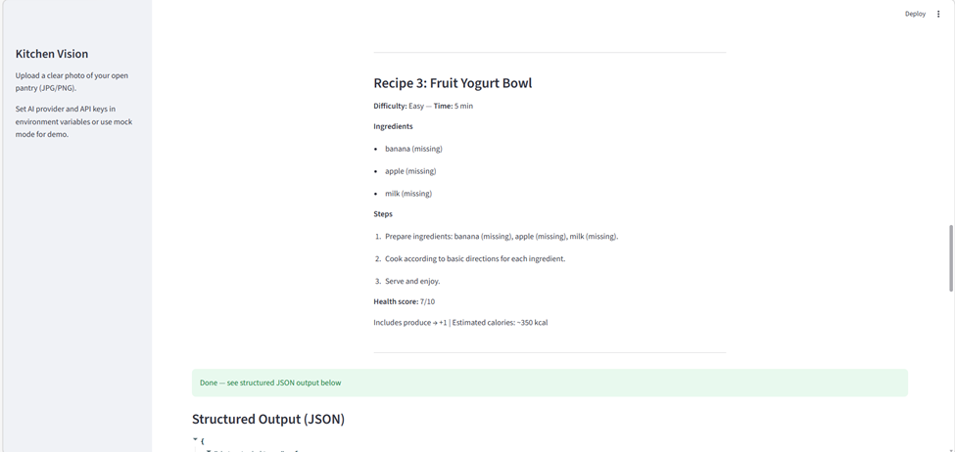

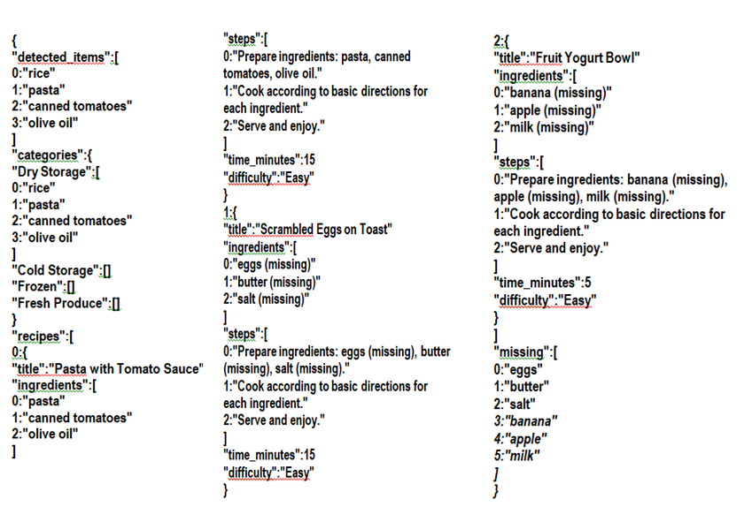

12. Milestone 4: Integration & Optimization

Component Integration
Connect image processing, AI detection, and recipe generation modules.

Performance Optimization
- Image resizing
- Efficient API calls

Security Enhancements
- Use .env file for API keys

Error Handling
- Handle invalid images
- Handle API failures

13. Milestone 5: Testing & Validation

Test Cases
Test Case ID | Input | Expected Output | Status
TC1 | Pantry Image | Ingredient Detection | Pass
TC2 | Ingredient List | Recipe Generation | Pass
TC3 | Invalid Image | Error Message | Pass
Unit Testing
Test individual modules like image processing and API communication.

Integration Testing
Test full system workflow.

User Acceptance Testing

Ensure system is easy to use.

Performance Metrics
- Response Time
- Accuracy of ingredient detection
- Recipe relevance

14. Deployment

Deployment Architecture
The application is deployed as a Streamlit web application.

Hosting Platform
- Localhost
- Streamlit Cloud (optional)

Deployment Steps
- Install dependencies
- Configure API keys
- Run Streamlit application
15. Project Structure
KitchenVision/
│
├── app.py
├── services/
├── config/
├── utils/
├── static/
├── tests/
├── requirements.txt
└── .env

Folder Explanation
- app.py – Main application file
- services/ – AI and recipe logic
- config/ – API configuration
- utils/ – Helper functions
- tests/ – Testing scripts

16. Results

System Output
- Detected ingredients from images
- Generated recipes
- Cooking instructions

Performance Evaluation
The system successfully identifies ingredients and generates useful recipes.

17. Advantages & Limitations

Advantages
- Reduces food waste
- Helps users decide recipes quickly
- Easy-to-use interface
- AI-powered automation

Limitations
- Detection accuracy depends on image quality
- Requires internet connection for API access

18. Future Enhancements
- Smart refrigerator integration
- Mobile application
- Voice-based cooking assistant
- Automatic grocery list generation
- Online grocery delivery integration

19. Conclusion
Kitchen Vision demonstrates how Artificial Intelligence can assist in everyday cooking decisions. The system successfully detects ingredients from kitchen images, categorizes them, and generates recipes. This project shows the potential of AI in simplifying kitchen management and improving cooking efficiency.

20. Appendix
- Source Code
- Configuration Files
- API Documentation
- GitHub Repository Link
- Demo Application Link

