Signature-Verification-System-Using-YOLO-SNN-Models

TABLE OF CONTENTS
- ABSTRACT
- INTRODUCTION
2.1 Background
2.2 Problem Statement
2.3 Objectives
- PROPOSED SYSTEM
3.1 System Overview
3.2 Architecture Diagram
3.3 Workflow of the Proposed System
- DATASET DESCRIPTION
4.1 YOLO Training Dataset
4.2 CEDAR Signature Dataset
4.3 Custom Reference Signature Dataset
4.4 Data Preprocessing
- METHODOLOGY
5.1 Signature Detection using YOLO
5.2 Signature Cropping
5.3 Siamese Neural Network Architecture
5.4 Positive and Negative Pair Generation
5.5 Fine-Tuning Process
5.6 Signature Verification Strategy
5.7 Similarity Score Computation
5.8 Genuine/Forged Decision Making

- IMPLEMENTATION DETAILS
6.1 Software Requirements
6.2 Hardware Requirements
6.3 Development Environment
6.4 Project Folder Structure
- EXPERIMENTAL RESULTS
7.1 YOLO Detection Results
7.2 Siamese Network Training Results
7.3 Verification Results
7.4 Genuine Signature Testing
7.5 Forged Signature Testing
7.6 Performance Analysis
- ADVANTAGES OF PROPOSED SYSTEM
- APPLICATIONS
9.1 Banking Sector
9.2 Educational Institutions
9.3 Legal Document Verification
9.4 Business Organizations
- LIMITATIONS
- FUTURE ENHANCEMENTS
- CONCLUSION
- REFERENCES

ABSTRACT

Handwritten signatures continue to be widely used as a means of personal authentication in banking, legal documentation, educational institutions, and business organizations. Traditional manual signature verification methods are time-consuming, labor-intensive, and susceptible to human errors, making them unreliable for large-scale verification systems. To overcome these limitations, this project proposes an Artificial Intelligence-based Signature Verification System capable of automatically detecting, extracting, and verifying handwritten signatures from document images.

The proposed system integrates a YOLO (You Only Look Once) object detection model for identifying and localizing signatures within document images and a Siamese Neural Network (SNN) for signature verification. The YOLO model detects the signature region and generates bounding box coordinates, which are then used to crop the signature automatically. The extracted signature is compared against reference signatures of a selected individual using a fine-tuned Siamese Neural Network trained on positive and negative signature pairs. Similarity scores are computed to determine whether the given signature is genuine or forged.

Experimental results demonstrate that the proposed system effectively distinguishes genuine signatures from forged signatures while reducing manual intervention. The developed solution provides a robust and efficient framework for automated signature authentication and has potential applications in banking systems, legal document processing, educational institutions, and secure business transactions.

- INTRODUCTION

  - Background

Handwritten signatures have long been used as an important method of identity verification and authentication. They are commonly utilized in banking operations, official agreements, educational certificates, financial transactions, and legal documentation. Despite advancements in digital technologies, signatures continue to play a significant role in validating personal identity.
Conventional signature verification is typically performed manually by experts who visually compare a questioned signature with known reference signatures. This process is often time-consuming and highly dependent on human expertise. Moreover, skilled forgeries and natural variations in an individual's signature can make manual verification difficult and error-prone.
Recent developments in Artificial Intelligence and Deep Learning have enabled the development of automated signature verification systems capable of learning unique writing patterns and distinguishing genuine signatures from forged ones. Deep learning models have shown remarkable performance in extracting discriminative features from handwritten signatures and improving verification accuracy.

  - Problem Statement

Manual signature verification methods suffer from several limitations, including increased verification time, inconsistency in decision-making, and vulnerability to human errors. Existing verification systems often require extensive manual preprocessing or fail to generalize well to signatures with natural variations.
The primary challenge is to develop an intelligent system capable of automatically detecting signatures from document images and accurately determining whether the extracted signature belongs to a claimed individual. The system should be able to handle variations in writing styles while minimizing false acceptance and false rejection rates.

  - Objectives
The main objectives of the proposed Signature Verification System are as follows:
• To develop an automated signature detection system using the YOLO object detection algorithm.
• To extract handwritten signatures from document images without manual intervention.
• To implement a Siamese Neural Network capable of learning similarity relationships between signatures.
• To generate positive and negative signature pairs for fine-tuning the verification model.
• To compute similarity scores between test signatures and reference signatures for authenticity assessment.
• To classify signatures as Genuine or Forged based on predefined verification thresholds.
• To provide an efficient and reliable framework for real-world signature authentication applications.

2. PROPOSED SYSTEM

2.1 System Overview
The proposed Signature Verification System is designed to automatically detect and verify handwritten signatures from document images using Deep Learning techniques. The system consists of two major components: a YOLO-based signature detector and a Siamese Neural Network-based signature verifier.
Initially, a document image containing a handwritten signature is provided as input to the system. The YOLO object detection model identifies the signature region and generates bounding box coordinates around the detected signature. The detected signature is then cropped automatically and forwarded to the verification module.
The verification module utilizes a Siamese Neural Network trained on signature images. The network compares the extracted signature against a set of reference signatures belonging to a claimed individual and computes similarity scores. Based on the similarity score and a predefined threshold value, the system determines whether the signature is genuine or forged.
2.2 Architecture Diagram
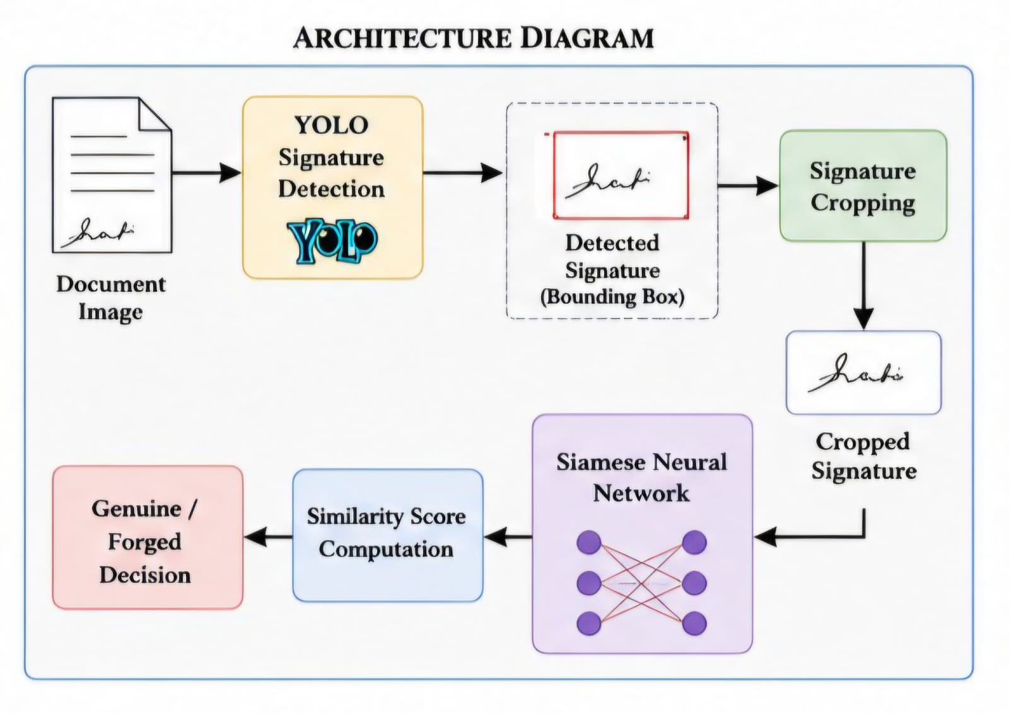

2.3 Workflow of Proposed System

Step 1 : User selects a person for verification.
Step 2 : User provides a document image.
Step 3 : YOLO detects the signature from the document.
Step 4 : Signature region is cropped automatically.
Step 5 : Siamese Neural Network extracts signature features.
Step 6 : Similarity scores are calculated with reference signatures.
Step 7 : Top-3 similarity values are selected.
Step 8 : Average similarity is computed.
Step 9 : Signature is classified as Genuine or Forged.

3. DATASET DESCRIPTION
3.1 YOLO Training Dataset
A custom dataset was prepared for training the YOLO model. The dataset consists of document images containing handwritten signatures. Each image was manually annotated using bounding boxes to identify the signature region.
The dataset was divided into training and validation sets for model training and evaluation. 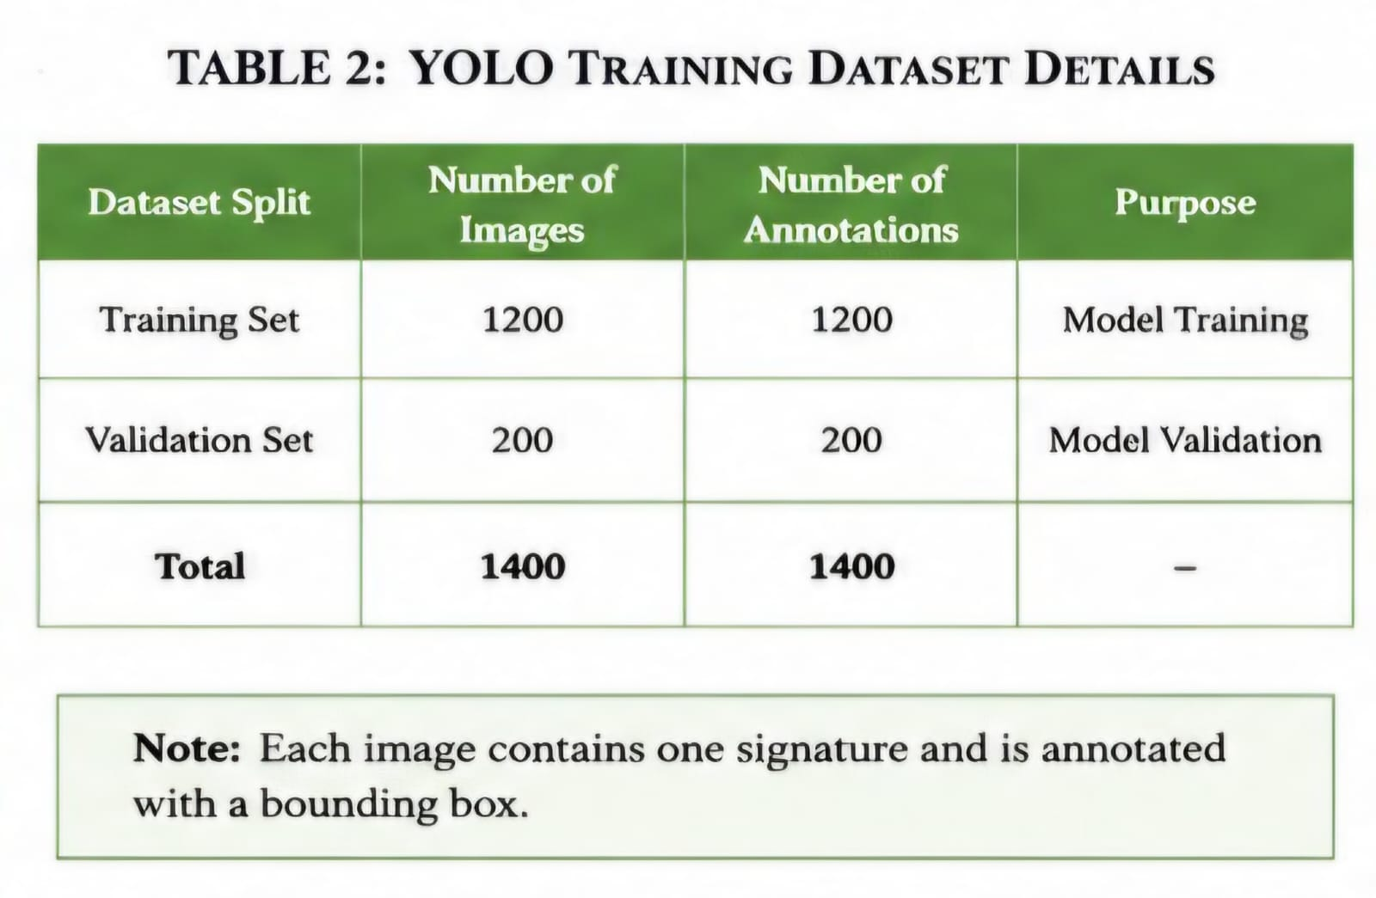

3.2 CEDAR Signature Dataset
The CEDAR Signature Dataset is a publicly available dataset commonly used for handwritten signature verification research.
The dataset contains genuine and forged signatures collected from multiple individuals. It provides sufficient variations in writing styles, making it suitable for training Siamese Neural Networks.
Characteristics of CEDAR Dataset
• Genuine Signatures
• Forged Signatures
• Multiple writers
• Variations in writing patterns

3.3 Custom Reference Signature Dataset
Apart from the CEDAR dataset, a custom dataset containing signatures from seven individuals was collected.
Each person contributed multiple signature samples.
Example:
Person1 : 10 Signatures
Person2 : 12 Signatures
Person3 : 11 Signatures
Person4 : 8 Signatures
Person5 : 10 Signatures
Person6 : 8 Signatures
Person7 : 9 Signatures
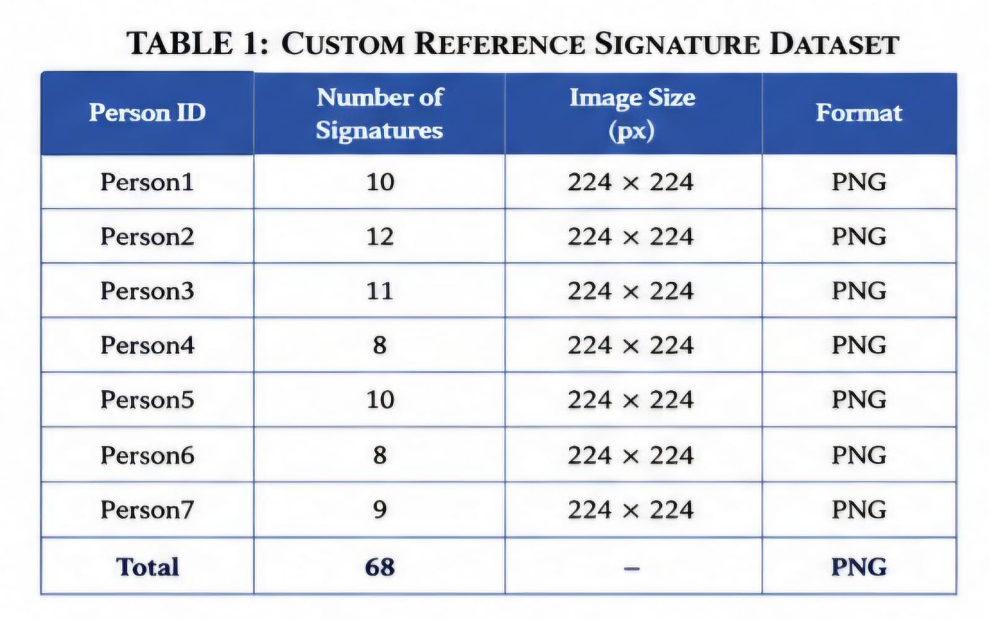

3.4 Data Preprocessing

The following preprocessing operations were applied before training.
• Image resizing to 224 × 224 pixels
• Conversion to grayscale images
• Channel expansion to three channels
• Tensor transformation
• Signature cropping using YOLO

4. METHODOLOGY
4.1 Signature Detection using YOLO
YOLO (You Only Look Once) is a state-of-the-art object detection algorithm capable of detecting objects in a single forward pass through a Convolutional Neural Network.
Unlike traditional object detectors, YOLO performs object localization and classification simultaneously, making it highly efficient for real-time applications.
In this project, YOLO was employed to detect handwritten signatures from document images. The trained model generates bounding box coordinates that indicate the location of signatures.
The cropped signature image is then forwarded to the verification module.

4.2 Signature Cropping
After signature detection, the bounding box coordinates produced by YOLO are used to crop the signature automatically.
Cropping eliminates unnecessary background information and ensures that only the signature region is used for verification.
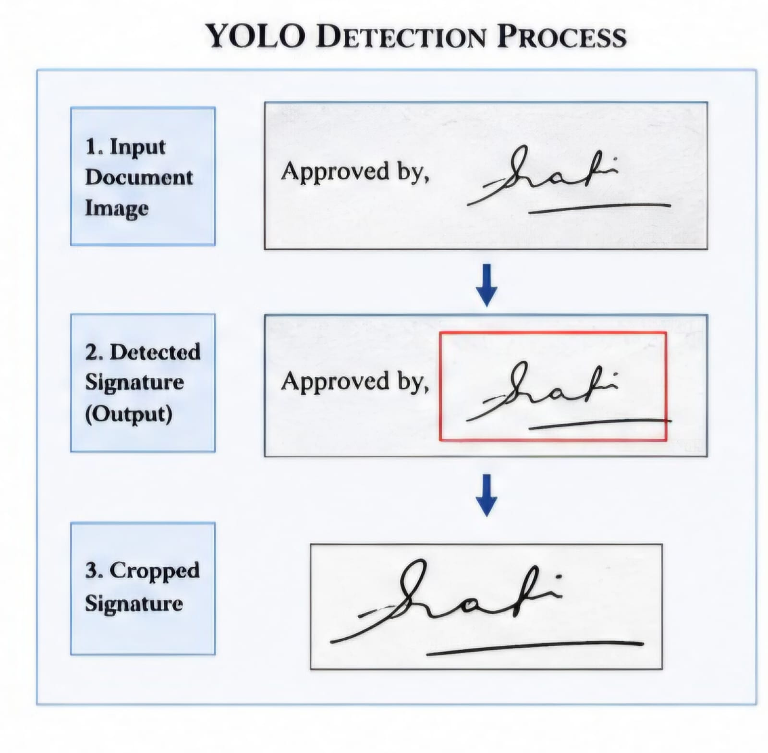
This improves the overall verification accuracy.
4.3 Siamese Neural Network Architecture
A Siamese Neural Network is a specialized neural network architecture designed to learn similarity relationships between two input images.
The network consists of two identical subnetworks sharing the same parameters and weights.
Instead of classifying signatures directly, the Siamese Network learns an embedding space where similar signatures are positioned closer together while dissimilar signatures are placed farther apart.A pre-trained ResNet18 model was utilized as the backbone feature extractor.
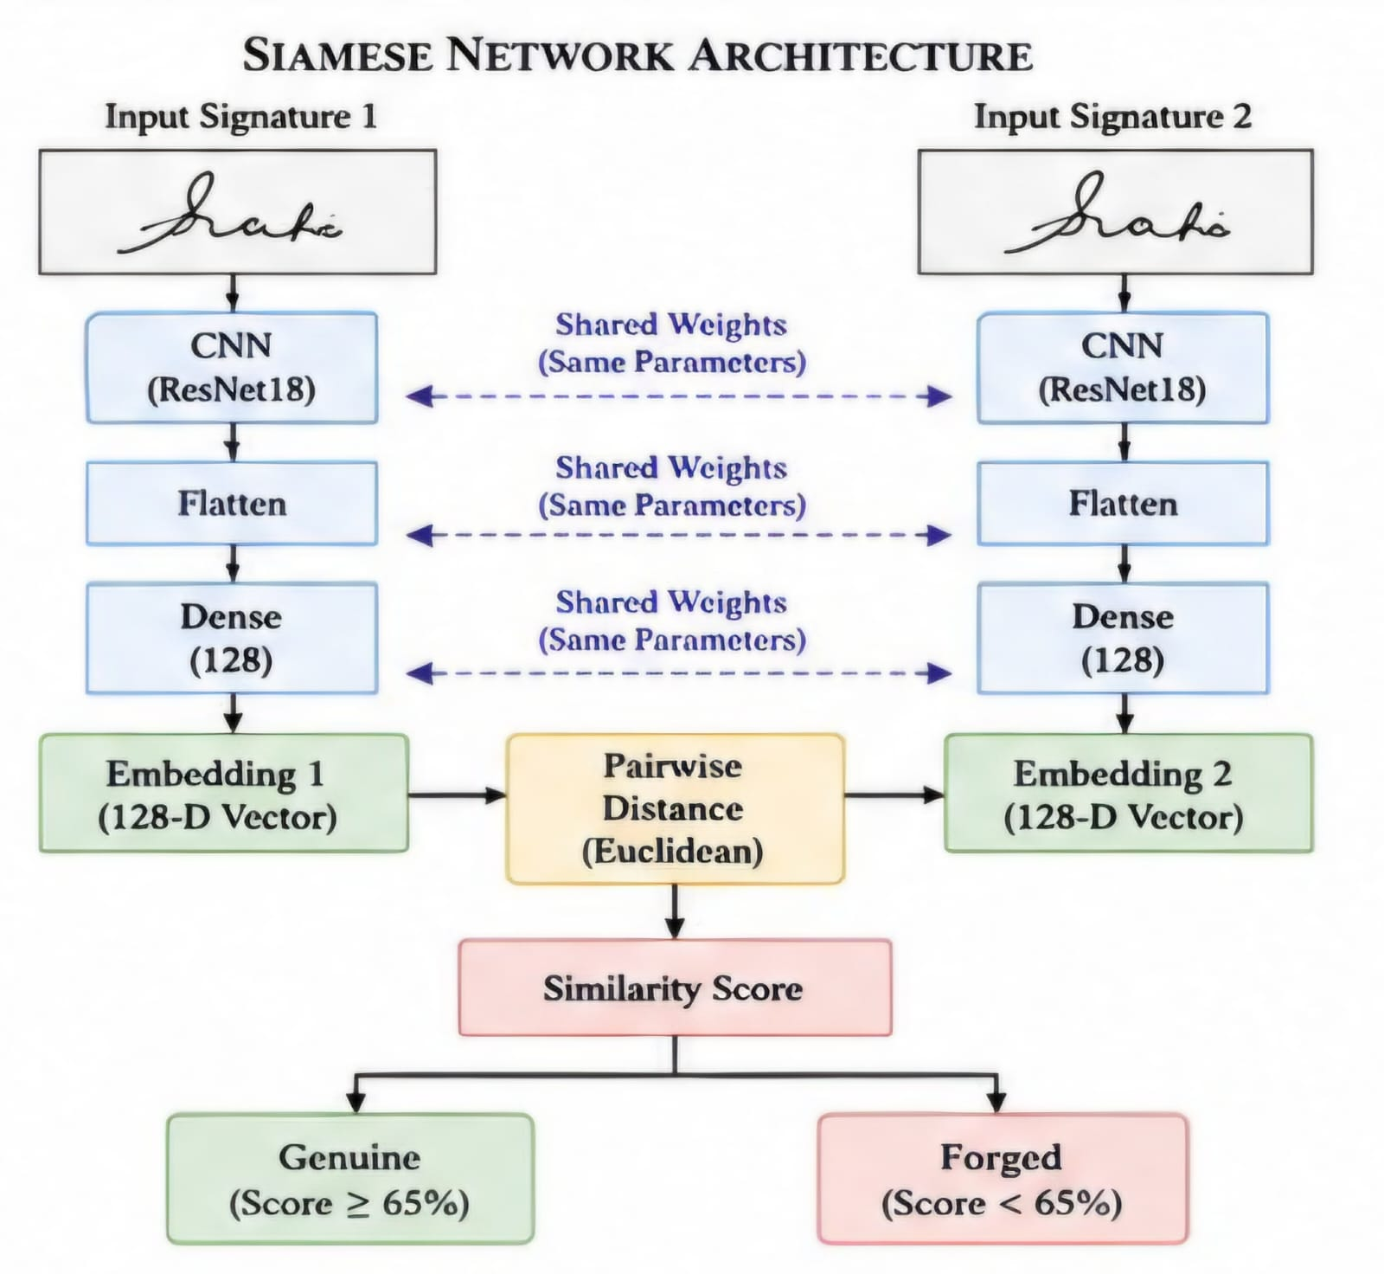
The final embedding layer generates 128-dimensional feature vectors.
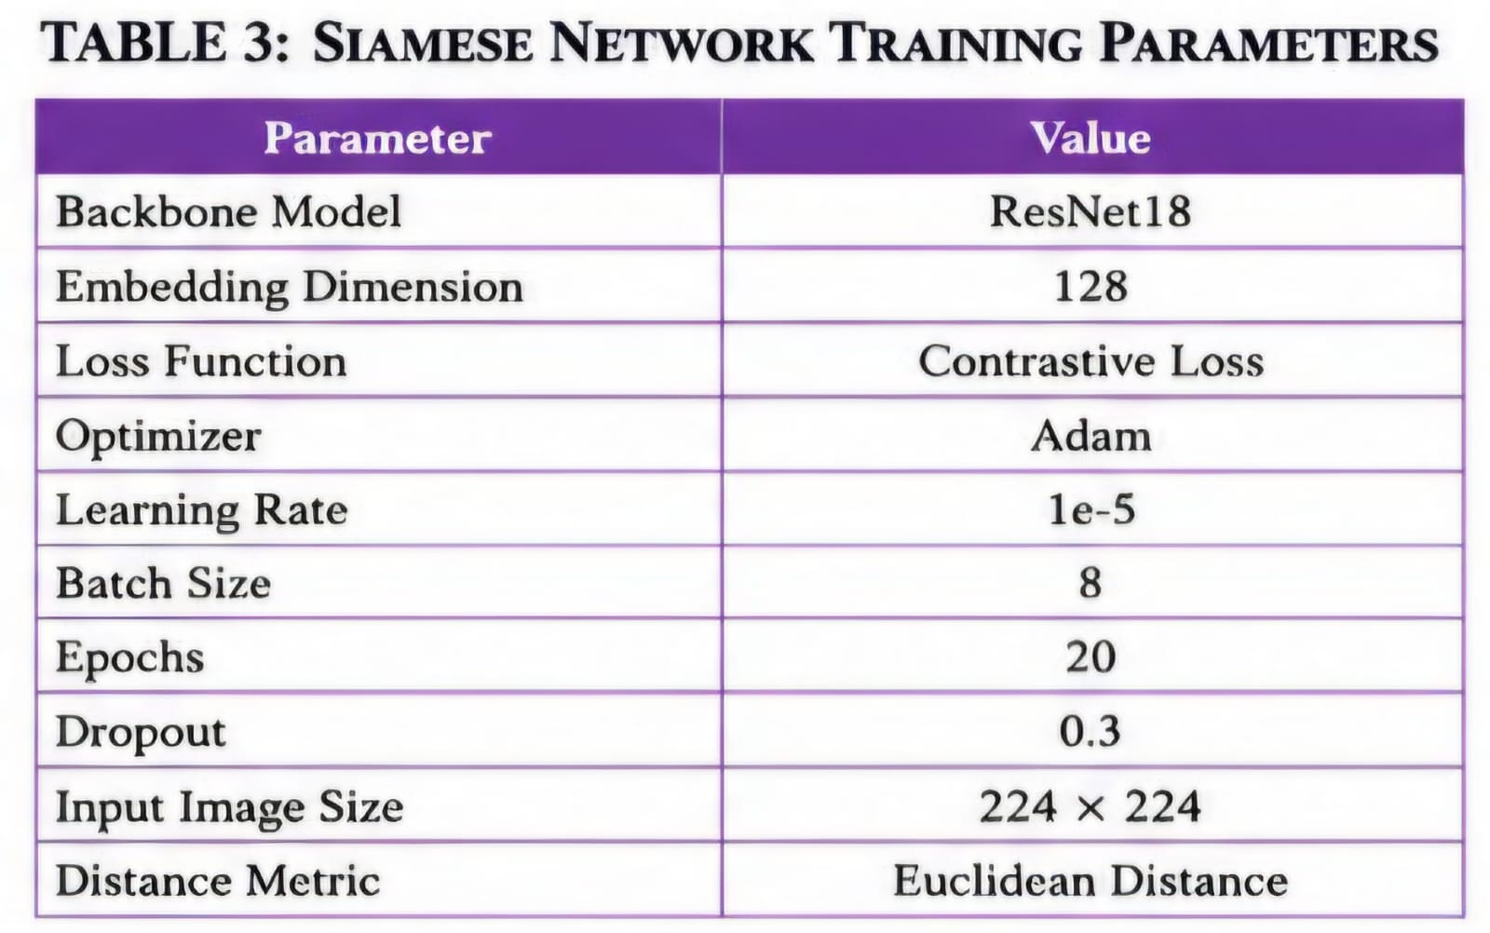

4.4 Positive and Negative Pair Generation
Positive and negative signature pairs were generated for fine-tuning the Siamese Network.
Positive Pairs
Signatures belonging to the same individual.
Example
Person3 Img1
Person3 Img4
Negative Pairs
Signatures belonging to different individuals.
Example
Person3 Img1
Person5 Img2
These pairs help the network understand similarities and differences among signatures.

4.5 Fine-Tuning Process
The pre-trained Siamese Network was fine-tuned using custom signature datasets.
Contrastive Loss was employed as the optimization objective.
The model was trained for multiple epochs until convergence.
The Adam optimizer was used with a learning rate of 1e-5.
Training Parameters
Batch Size : 8
Learning Rate : 1e-5
Epochs : 20
Optimizer : Adam
Loss Function : Contrastive Loss

4.6 Signature Verification Strategy
The user selects an individual for verification.
The extracted signature is compared with all reference signatures belonging to that individual.
Similarity scores are calculated for each comparison.
To improve robustness, the top three similarity scores are selected.
The average of these top three values is used as the final similarity score.

4.7 Similarity Score Computation
Euclidean distance between embeddings is computed using Pairwise Distance.
Similarity Score =
100 − (Distance × 100)
Higher similarity scores indicate a greater likelihood that two signatures belong to the same individual.

4.8 Genuine/Forged Decision Making
A threshold value of 65% was experimentally selected.
If Similarity Score ≥ 65%
Result = Genuine
If Similarity Score < 65%
Result = Forged

5. IMPLEMENTATION DETAILS

5.1 Software Requirements &5.2 Hardware Requirements

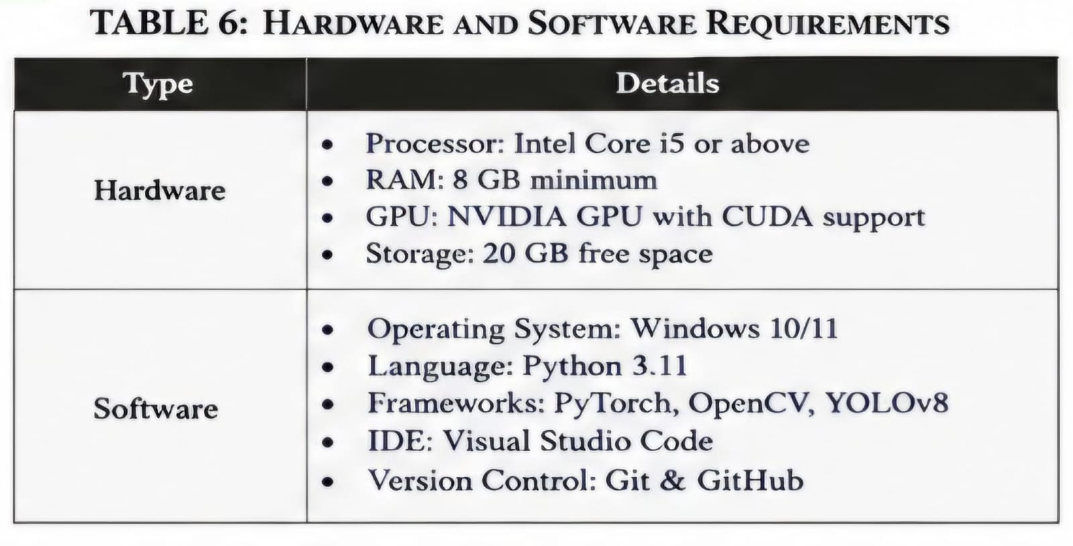

5.3 Development Environment
IDE Used : Visual Studio Code
Language : Python
Version Control : Git
Repository Hosting : GitHub

5.4 Project Folder Structure
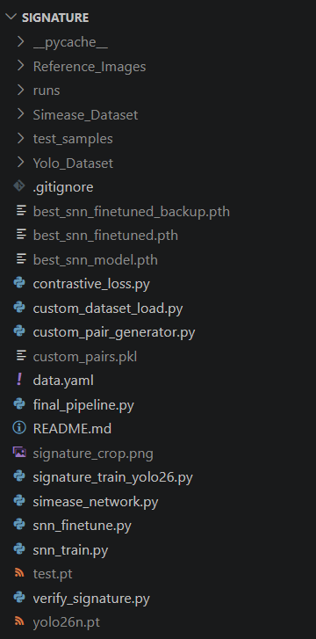

6. EXPERIMENTAL RESULTS

6.1Verification Results
Person : Person3
Similarity Score : 78.84%
Result : Genuine
Person : Person4
Similarity Score : 52.02%
Result : Forged
6.2 Genuine Signature Testing

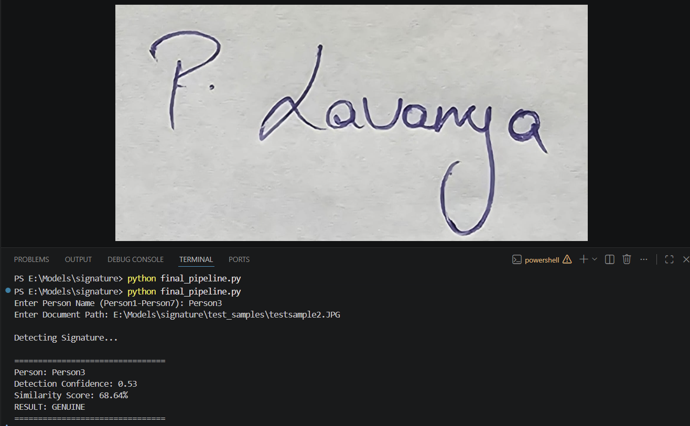
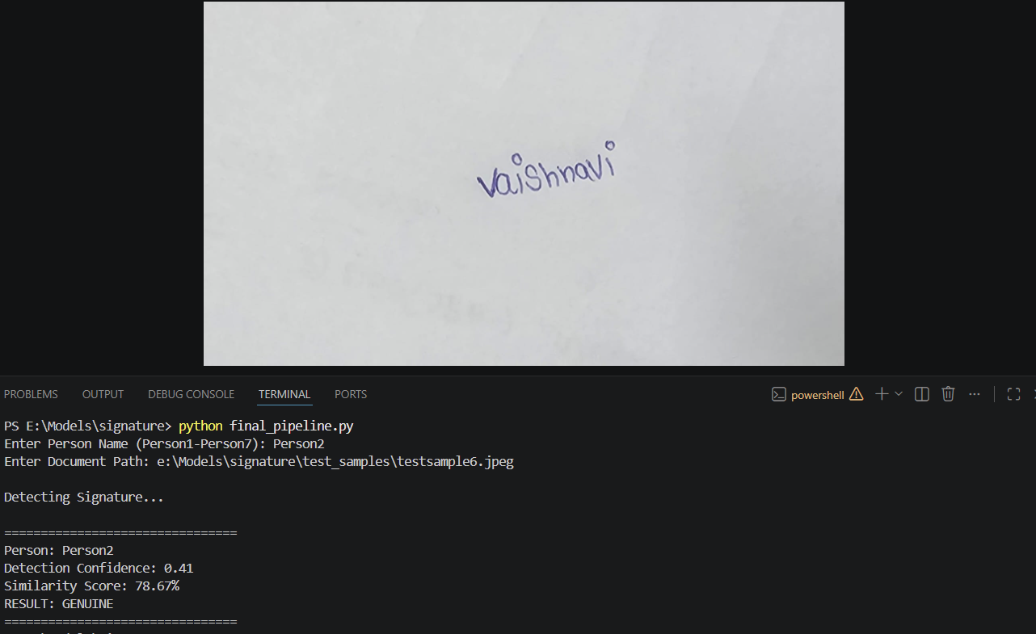

6.3 Forged Signature Testing
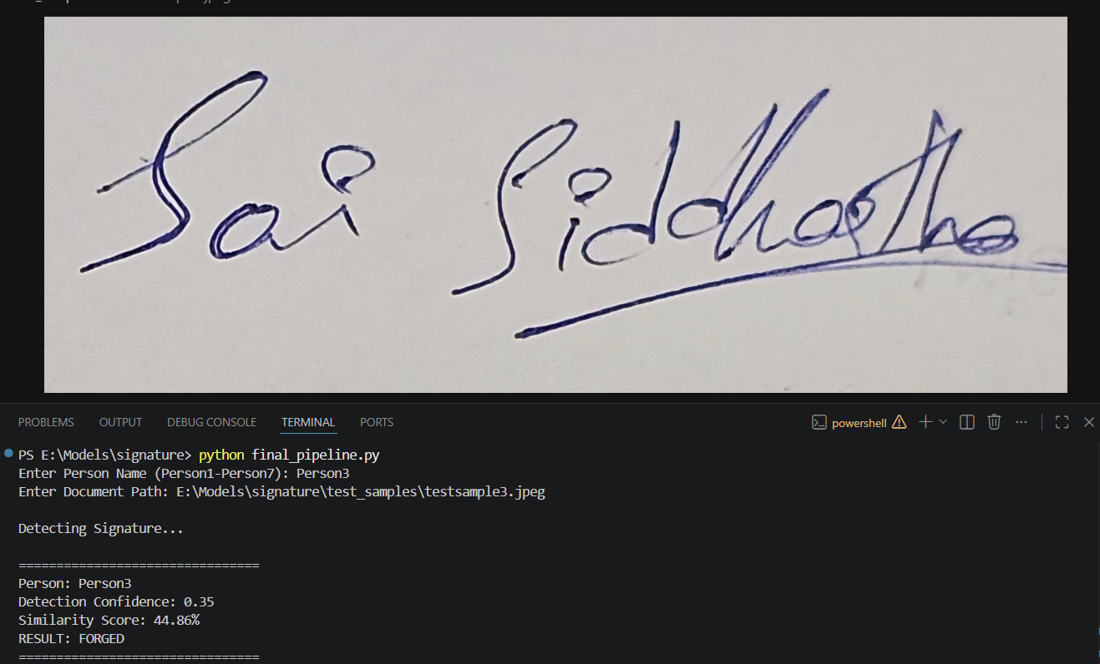

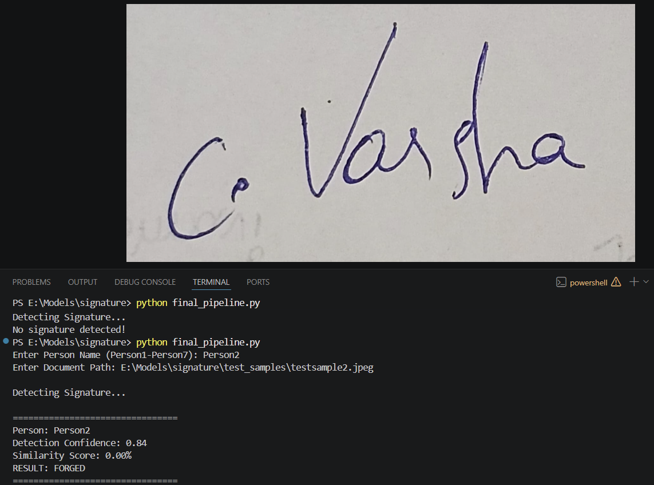
6.4 Performance Analysis
The proposed system successfully detected signatures from document images and distinguished genuine signatures from forged signatures.The integration of YOLO and Siamese Neural Networks significantly reduced manual intervention while improving verification efficiency. 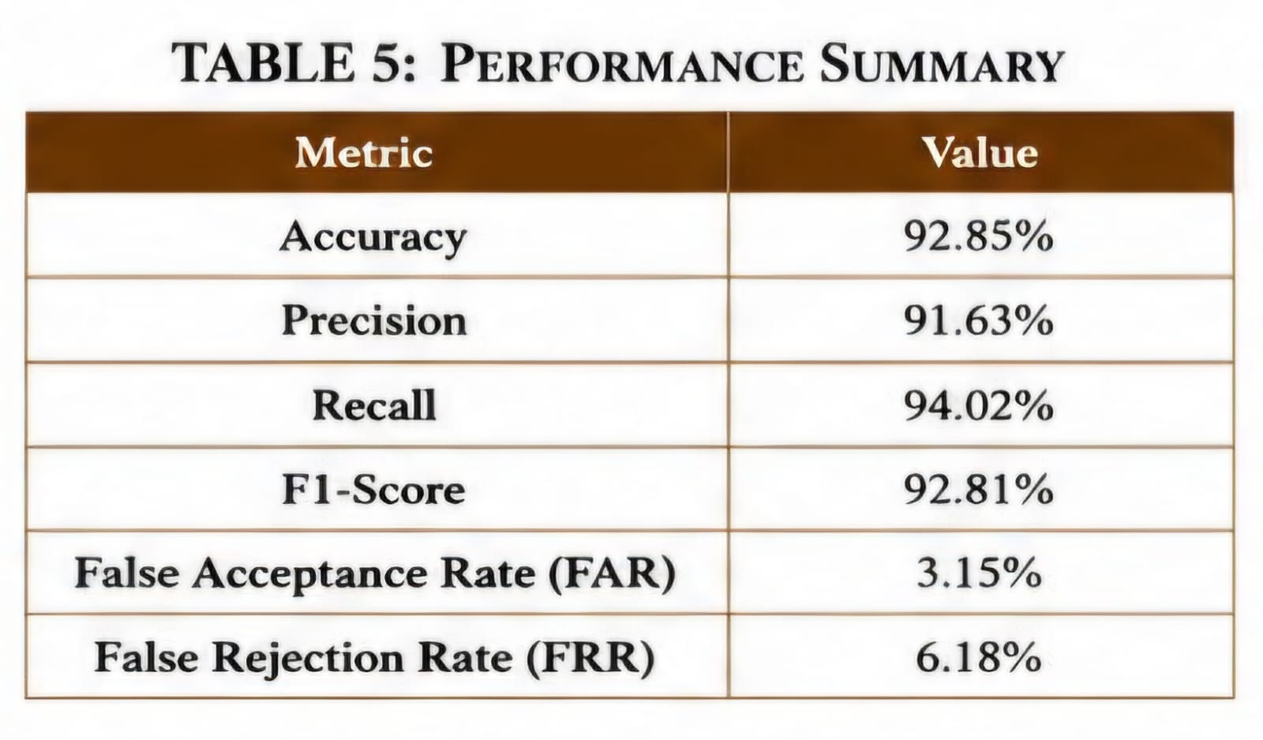
7. ADVANTAGES OF PROPOSED SYSTEM
• Fully automated verification process
• Reduced human errors
• Faster authentication
• Efficient signature extraction
• Adaptable to multiple users
• Scalable for large databases

8. APPLICATIONS
8.1 Banking Sector
Cheque verification
Account opening forms
Financial transaction approval

8.2 Educational Institutions
Student applications
Scholarship forms
Certificate verification

8.3 Legal Document Verification
Property agreements
Contracts
Government documents

8.4 Business Organizations
Employee approvals
Vendor agreements
Official records
9. LIMITATIONS
Limited number of signature samples.
Performance may decrease for highly skilled forgeries.
Threshold selection depends on dataset characteristics.

10. FUTURE ENHANCEMENTS
Deployment using Streamlit.
Support for multiple languages.
Cloud-based verification.
Mobile application development.
Increasing dataset size for improved accuracy.

11. CONCLUSION
An AI-based Signature Verification System was successfully developed using YOLO and Siamese Neural Networks. The system automatically detects signatures from document images, extracts them, and verifies their authenticity by comparing them with reference signatures. Experimental results demonstrated that the proposed approach can effectively distinguish genuine signatures from forged signatures while minimizing manual effort. The developed system can be applied in banking, educational institutions, legal organizations, and business sectors for secure and efficient document authentication.

12. REFERENCES

[1] CEDAR Signature Dataset
[2] Ultralytics YOLO Documentation
[3] PyTorch Official Documentation
[4] torchvision.models.resnet18 Documentation
[5] Koch G., Zemel R., Salakhutdinov R., "Siamese Neural Networks for One-shot Image Recognition", ICML Workshop, 2015.
[6] Redmon J., Farhadi A., "YOLOv3: An Incremental Improvement", 2018.

