How to read stock prices in Zerodha (VERY IMPORTANT)
When you open a stock (like Tata Steel), you’ll see numbers like:
📊 Important fields:
1. LTP (Last Traded Price)
👉 Current price
Example: ₹100
2. Bid Price (Buyers)
👉 Highest price someone is ready to BUY
Example:
- ₹99.80
3. Ask Price (Sellers)
👉 Lowest price someone is ready to SELL
Example:
- ₹100.20
👉 This difference = spread
🔥 Key Understanding:
You choose | What happens
Market Order | Buy instantly at available price
Limit Order | Buy only at your price

Example:
- You place Market Buy → you may buy at ₹100.20
- You place Limit Buy ₹100 → waits until price comes
🔹 What is Delivery (CNC)?
In Zerodha:
👉 CNC = Cash and Carry (Delivery)
Meaning:
- You buy shares
- They go into your demat account
- You can hold as long as you want (days, months, years)
- 🔹 Key Difference
Type | Holding
Intraday (MIS) | Same day only
Delivery (CNC) | No time limit

🔹 How to BUY using CNC (Step-by-Step)
Let’s take
Tata Steel as example
🟢 Step 1: Open stock
Search “Tata Steel”
🟢 Step 2: Click BUY
🟢 Step 3: Fill details
✔ Product Type
👉 Select CNC ✅ (very important)

✔ Quantity
Let’s assume:
- Price = ₹100
You have ₹10,000
👉 You can buy:
- 100 shares (₹100 × 100 = ₹10,000)
- ✔ Order Type
- Beginner → Use:
- 👉 Market Order (simple)

- 🟢 Step 4: Confirm
- Click BUY ✔

- 🔹 What happens after buying?
- 👉 Shares go into your demat account (within T+1 day)
- You can see in:
👉 “Holdings”
- 🔹 How long should you hold?
- This depends on your goal 👇
🟢 Option 1: Short-term (Days–Weeks)
- Buy at ₹100
- Sell at ₹110
👉 Profit = ₹10 per share
🟢 Option 2: Medium-term (Weeks–Months)
- Hold until good price movement

🟢 Option 3: Long-term (Best for beginners)
- Hold for months/years
- Benefit from growth
🔹 FULL EXAMPLE (₹10,000)

🟢 Step 1: Buy
- Stock: Tata Steel
- Price: ₹100
- Quantity: 100
👉 Investment = ₹10,000

🟢 Step 2: Wait
After some days:
Scenario A (Profit)
- Price becomes ₹120

🟢 Step 3: Sell
- Sell 100 shares at ₹120
👉 You get ₹12,000

💰 Profit:
👉 ₹12,000 – ₹10,000 = ₹2,000 profit
🔻 Scenario B (Loss)
- Price drops to ₹90
If you sell:
👉 ₹9,000
👉 Loss = ₹1,000
🔹 Golden Rules (VERY IMPORTANT)
✅ Start with CNC (delivery)
✅ Invest small amounts
✅ Don’t expect quick profit
✅ Observe price movement
🔥 Final Understanding
- CNC = You own real shares
- You can hold anytime
- Profit comes when price increases
- Loss only if you sell at lower price

Guidance of which stocks should I buy
🔹 1. Which stocks should beginners choose? (Safe picks)
Start with large, stable companies (called blue-chip stocks):
Examples:
- Tata Steel
- Infosys
- Reliance Industries
- HDFC Bank
👉 Why these?
- Less sudden crashes
- More stable movement
- Easy to learn patterns
- 🔹 2. What is a Chart?
- A chart shows:
👉 How price moved over time

- 🔹 3. Types of Charts (Use THIS)
- 👉 Use: Candlestick chart (most important)
🔹 4. What is a Candle? (CORE CONCEPT 🔥)
Each candle shows:
- Open price
- Close price
- High
- Low
🟢 Green Candle (Bullish)
👉 Price went UP
Example:
- Open = ₹100
- Close = ₹105
🔴 Red Candle (Bearish)
👉 Price went DOWN
Example:
- Open = ₹105
- Close = ₹100
🔹 5. How to read a chart (Simple way)
Imagine this for
Tata Steel

Example Chart Movement
Time | Price
9:30 | ₹100
10:30 | ₹103
11:30 | ₹107
1:00 | ₹105
3:00 | ₹110
👉 Chart will show:
- Mostly green candles
- Upward movement
👉 Meaning:
✅ Buyers are strong
👉 Good sign

🔹 6. When to BUY (Simple beginner signal)
✅ Rule 1: Buy in Uptrend
👉 If chart is:
- Making higher highs
- Going upward steadily
Example:
- ₹100 → ₹105 → ₹110
👉 This is uptrend
👉 You can consider buying
🔹 7. When NOT to buy
❌ If chart is falling
Example:
- ₹110 → ₹105 → ₹100
👉 Downtrend
👉 Avoid buying
🔹 8. Support & Resistance (VERY IMPORTANT)
🟢 Support
👉 Price where stock stops falling
Example:
- Price falls to ₹100 again and again
👉 ₹100 = support
🔴 Resistance
👉 Price where stock stops rising
Example:
- Price struggles at ₹110
👉 ₹110 = resistance

🔹 9. Simple Strategy (Beginner)
✔ Buy near support
Example:
- Support = ₹100
👉 Buy around ₹100
✔ Sell near resistance
Example:
- Resistance = ₹110
👉 Sell near ₹110

- 🔹 10. Full Real Example (₹10,000)

Step 1: Observe stock

Infosys

You see:
- Support = ₹1400
- Resistance = ₹1500

Step 2: Buy
- Buy at ₹1400
- Quantity = 7 shares (~₹9800)

- Step 3: Wait
- Price moves to ₹1500
Step 4: Sell
- Sell at ₹1500
- 💰 Profit
- ₹100 × 7 = ₹700 profit
🔹 11. How to avoid loss (VERY IMPORTANT)
✔ Always use Stop-Loss
Example:
- Buy at ₹100
- Stop-loss = ₹95
👉 If price falls → auto sell
✔ Don’t invest full money in one stock
Instead:
- ₹5000 → Tata Steel
- ₹5000 → Infosys
🔹 12. How to read chart in Zerodha
In Zerodha:
- Open stock
- Click Chart
- Select:
  - Candlestick
  - Timeframe:
    - 5 min (intraday)
    - 1 day (delivery)
🔥 Final Understanding
- Chart = story of buyers vs sellers
- Green candles = buyers winning
- Red candles = sellers winning
- Buy when buyers are strong
NEXT LEVEL
👉 “Exact 1 simple strategy (entry + exit clearly)”
👉 “How to read candles like pro (patterns)”
👉 “Live example with explanation”
I’ll teach you:
- ✅ One simple strategy (entry + exit)
- ✅ Candlestick patterns (pro basics)
- ✅ A real-style example
- 🔹 1. SIMPLE STRATEGY (Beginner Friendly)
- 👉 This is called: “Support Bounce Strategy”
🟢 Step 1: Find Support Level
Take
Tata Steel
You observe chart and see:
- Price falls to ₹100 again and again
👉 ₹100 = Support
🟢 Step 2: Wait for price to come near support
Example:
- Price = ₹102 → ₹101 → ₹100
👉 Now price is near support
🟢 Step 3: Look for GREEN candle
👉 When price touches ₹100:
- If next candle turns green
👉 Buyers are coming
- 🟢 Step 4: ENTRY (Buy)
- 👉 Buy at ₹101

🟢 Step 5: Set Stop-Loss
👉 Always protect yourself
- Buy = ₹101
- Stop-loss = ₹97
🟢 Step 6: TARGET
👉 Next resistance level
Example:
- Resistance = ₹110
💰 Outcome
- Buy = ₹101
- Sell = ₹110
👉 Profit = ₹9 per share
🔹 2. Candlestick Patterns (Pro Basics)
You don’t need 50 patterns — just learn these 3 👇
🟢 1. Bullish Candle (Strong Buy Signal)
- Big green candle
- Close near top
👉 Meaning:
Strong buyers entered
🔴 2. Bearish Candle (Danger)
- Big red candle
👉 Meaning:
Strong selling pressure
⭐ 3. Doji (Confusion Candle)
- Small body
- Equal open & close
👉 Meaning:
Market unsure
🔹 3. Powerful Pattern (VERY USEFUL)
🟢 Bullish Reversal Pattern
At support:
- Red candle
- Then green candle
👉 This means:
Trend may reverse upward
👉 Good place to BUY
Let’s say you watch
Infosys

You observe:
- Price falling: ₹1500 → ₹1450 → ₹1400
- Stops falling at ₹1400
👉 ₹1400 = Support

Then you see:
- Red candle
- Next candle GREEN
👉 Signal: Buyers entered

You act:
- Buy at ₹1410
- Stop-loss = ₹1380

Later:
- Price goes to ₹1480
👉 You sell

💰 Profit:
₹70 × quantity
🔹 5. Entry & Exit Rules (Golden Rules)
✅ Entry ONLY when:
- Price near support
- Green candle appears
✅ Exit when:
- Near resistance
- OR small profit achieved
❌ Don’t:
- Buy in middle randomly
- Chase rising price
🔹 6. Common Beginner Mistake (Important)
❌ Buying like this:
- Price already ₹100 → ₹110 → ₹120
👉 You buy at ₹120
👉 Then price falls
👉 Always:
✅ Buy near support, not at top

LIVE TRADING STEP BY STEP WITH EXPLANATION
SCENARIO: Live Trade Simulation
We’ll simulate using Tata Steel on Zerodha
Step 1: Market Opens (Observation Phase)
Time: 9:30 AM
You see:
- Price = ₹100
- Chart shows slight downward movement
👉 Action:
❌ Do NOTHING
👉 Just observe
🔹 Step 2: Identify Support
After some time, you notice:
- Price falls → ₹100 → ₹99.5 → ₹100 → ₹99.8
👉 Price is not going below ₹99.5
👉 This means:
✅ Support ≈ ₹100
🔹 Step 3: Wait for Confirmation
Now you watch candles:
- Red candle (price falling) 🔴
- Then a GREEN candle appears 🟢
👉 This is your signal:
Buyers are entering
🔹 Step 4: ENTRY (You Buy)
👉 You decide:
- Buy price = ₹101
- Quantity = 50 shares
👉 Investment = ₹5050
🔹 Step 5: Set Stop-Loss (VERY IMPORTANT)
👉 Immediately set:
- Stop-loss = ₹97
👉 Why?
If price goes wrong → loss controlled
🔹 Step 6: Price Movement (Now watch calmly)
Scenario playing out:
- ₹101 → ₹103 → ₹105
👉 You are in profit now
🔹 Step 7: Identify Resistance
You observe:
- Price struggling near ₹108–₹110
👉 Resistance ≈ ₹110
🔹 Step 8: EXIT (You Sell)
👉 You sell at ₹108
💰 Final Result
- Buy = ₹101
- Sell = ₹108
- Profit = ₹7 × 50 = ₹350
🔹 What if trade goes WRONG? (Important)
Let’s say:
- You buy at ₹101
- Price falls to ₹97
👉 Stop-loss hits
👉 Loss = ₹4 × 50 = ₹200

REAL TIME CHART EXPLANATION WITH SCREENSHOT
🔹 Imagine This Chart (Tata Steel Example)
Take
Tata Steel
When you open chart → you’ll see something like this:
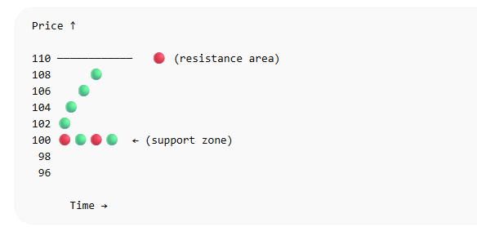
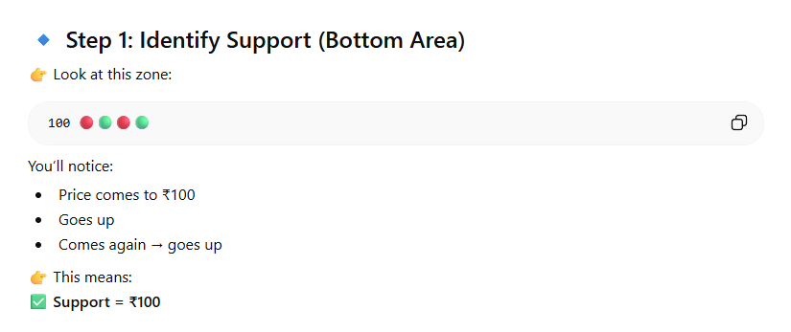

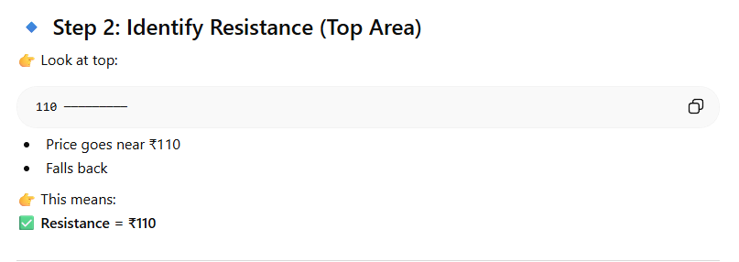
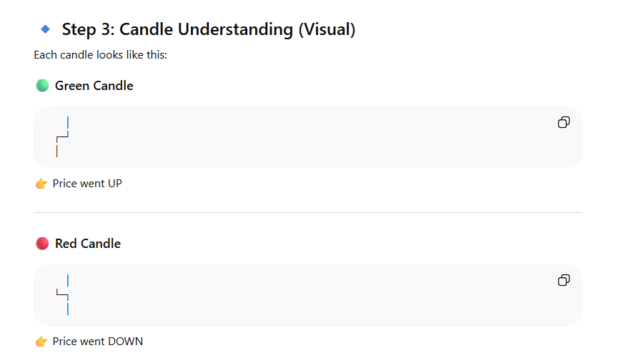
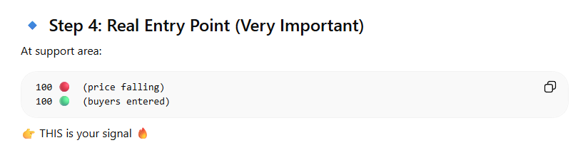
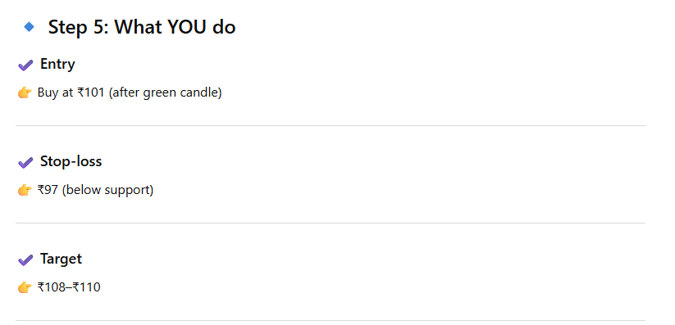
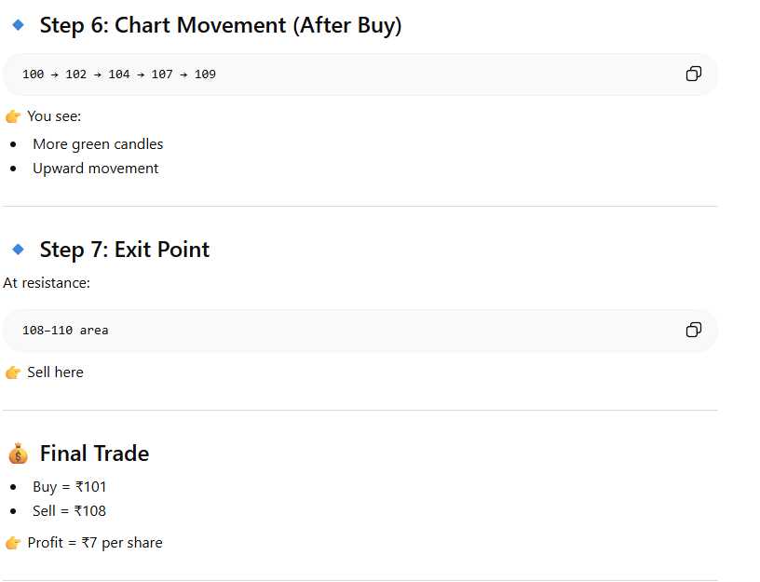

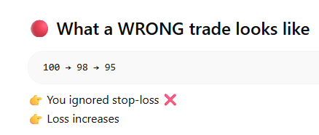

🔹 PART 1: Candlestick Patterns (Easy + Powerful)
We’ll use examples with
Tata Steel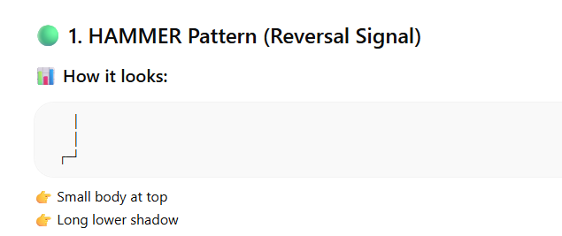
🧠 Meaning:
- Price went DOWN strongly
- Buyers pushed it back UP
👉 Sellers failed, buyers entered
✅ When to use:
- At support level

💡 Example:
- Price falls: ₹105 → ₹100
- Hammer forms at ₹100
👉 Signal:
🟢 Possible reversal → BUY
🔴 2. BEARISH HAMMER (Ignore for now)
👉 Opposite case — not needed yet
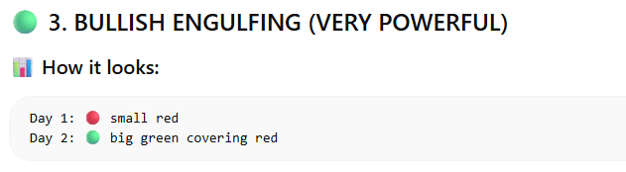
🧠 Meaning:
- Sellers were in control
- Suddenly buyers took over strongly
👉 Trend reversal signal
💡 Example:
- ₹105 → ₹100 (red candle)
- Next candle → ₹100 → ₹108 (big green)
👉 Signal:
🟢 Strong BUY

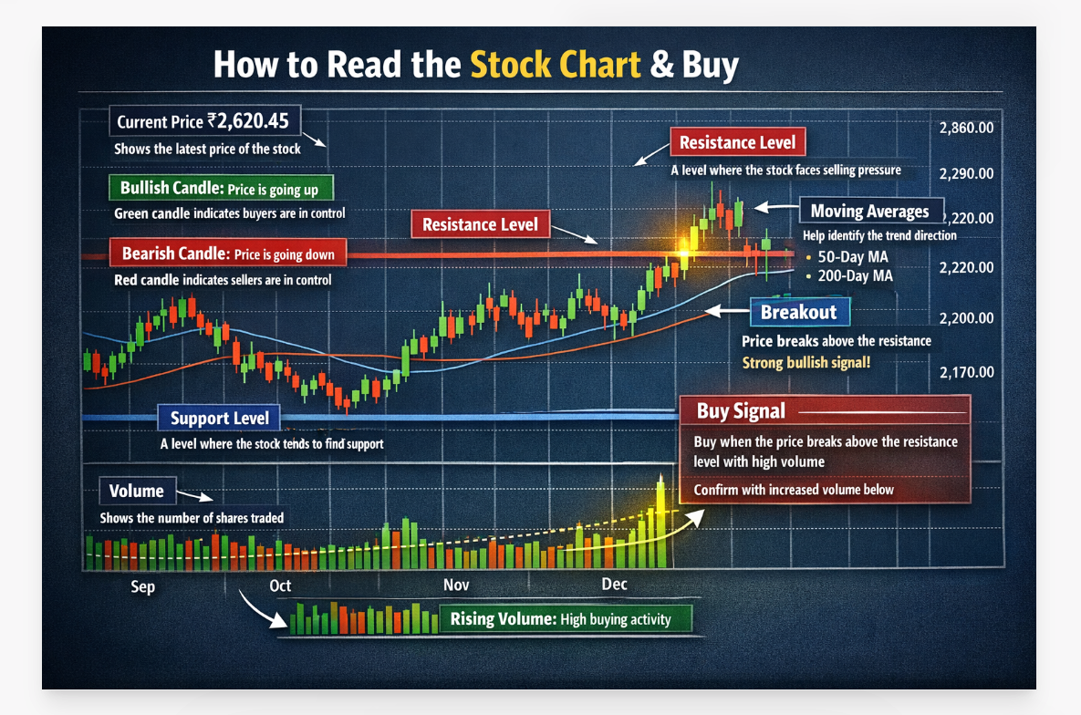

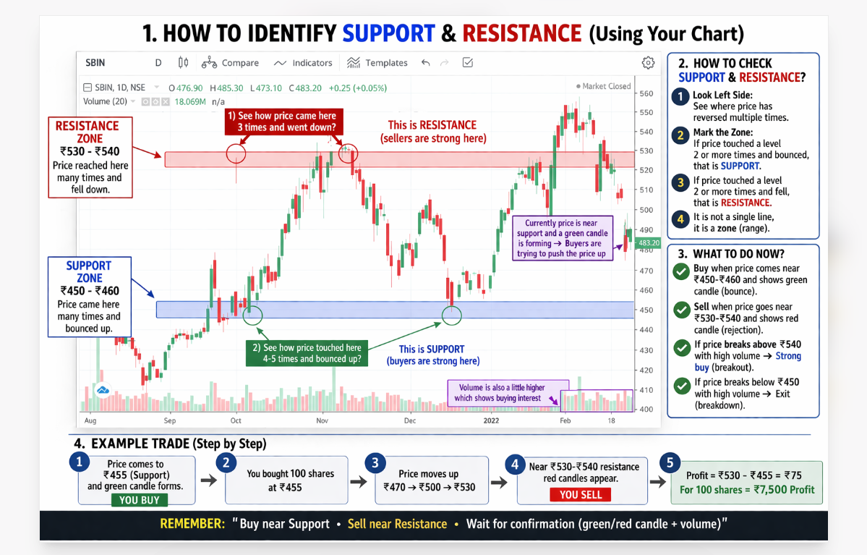
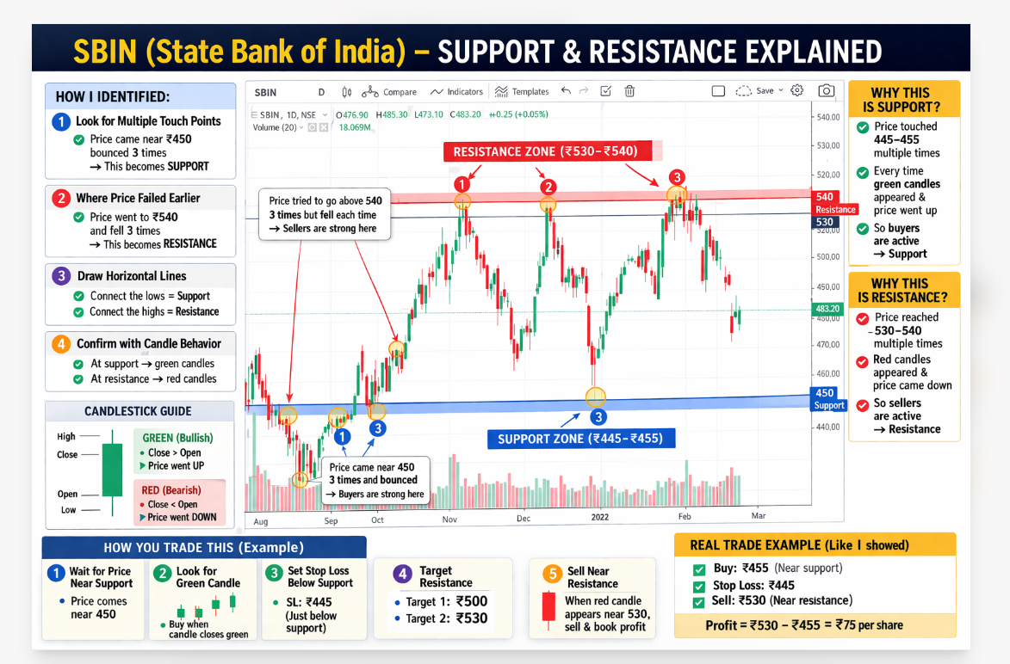
✅ Correct Way (Very Simple Rule)
👉 You should NOT buy just because of red candle
👉 You should NOT sell just because of green candle

🧠 REAL LOGIC (Easy Version)
✔️ BUY when:
- Price comes to a LOW area (support)
- AND you see first green candle

✔️ SELL when:
- Price goes to a HIGH area (resistance)
- AND you see red candle

🎯 Simple Example
Let’s say stock price:
👉 ₹400 → ₹390 → ₹380 → ₹370 (falling 🔴🔴🔴)
You DO NOT buy yet

Now:
👉 ₹370 → ₹375 (first green candle 🟢)
👉 THIS is where you BUY

Then:
👉 ₹375 → ₹390 → ₹410 → ₹430 (going up 🟢🟢🟢)

Near top:
👉 ₹430 → ₹425 (red candle 🔴)
👉 THIS is where you SELL
The correct approach:
- Buy when red candles touch the support level and you see a reversal signal (like a small green candle forming after multiple reds)
- Sell when green candles touch the resistance level and momentum slows
- Stop loss always below support to protect yourself
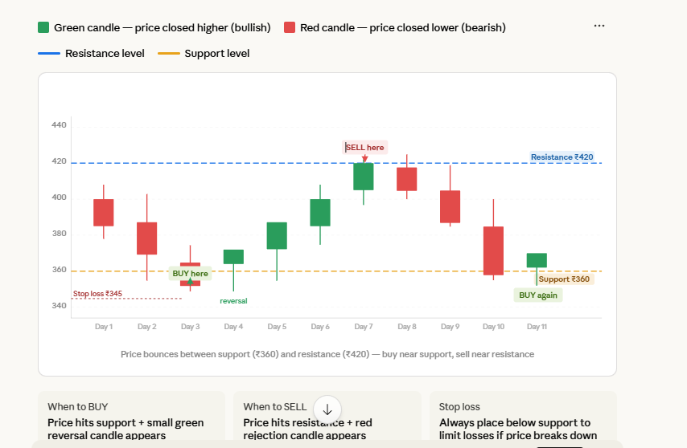
Reading the chart — the 3-step rule:
Step 1 — Identify support and resistance first. Look at the chart history. Where does price keep bouncing up from? That's support. Where does it keep getting rejected from the top? That's resistance.
Step 2 — Don't buy every red candle. Wait for price to touch the support level AND then see a small green reversal candle forming. That confirms buyers are stepping in.
Step 3 — Sell near resistance, not randomly. When price approaches resistance and you see a red rejection candle (green candle followed by a red one at the top), that's your exit signal.
One critical thing you got wrong — buying at ₹400 and selling when green comes is risky because the green candle could appear at ₹402, giving you only ₹2 profit but risking large loss if the price falls. The support/resistance method gives you a clear target — buy near ₹360, sell near ₹420, giving you a ₹60 potential gain per share.
E. GTT (Good Till Triggered)
- One-time trigger order valid for 1 year
- Use: Set target/stop-loss and forget (no need to monitor)
Example: Bought at ₹100
GTT SELL Target: ₹120 (take profit)
GTT SELL Stop-loss: ₹95 (limit loss)
5. KEY TERMS ON ZERODHA KITE
On Order Screen
- Bid Price: Highest price buyers willing to pay (Green)
- Ask Price: Lowest price sellers willing to accept (Red)
- LTP (Last Traded Price): Most recent transaction price
- Volume: Number of shares traded
- OI (Open Interest): For F&O - total open contracts
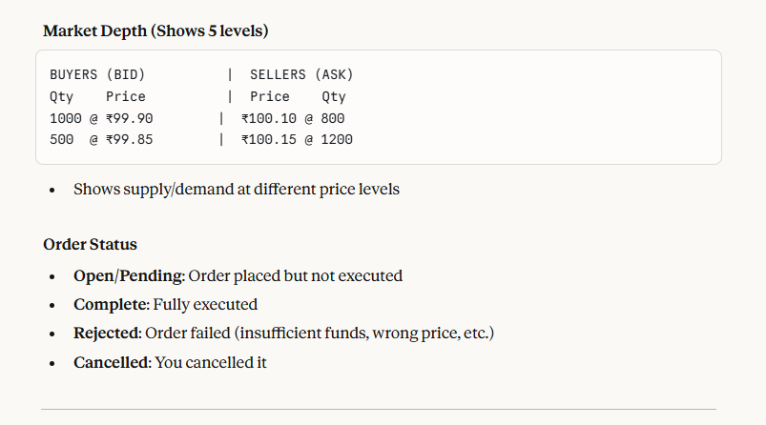
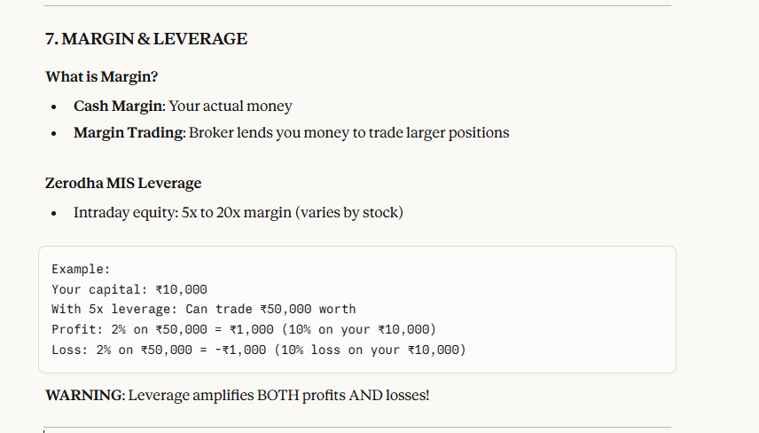
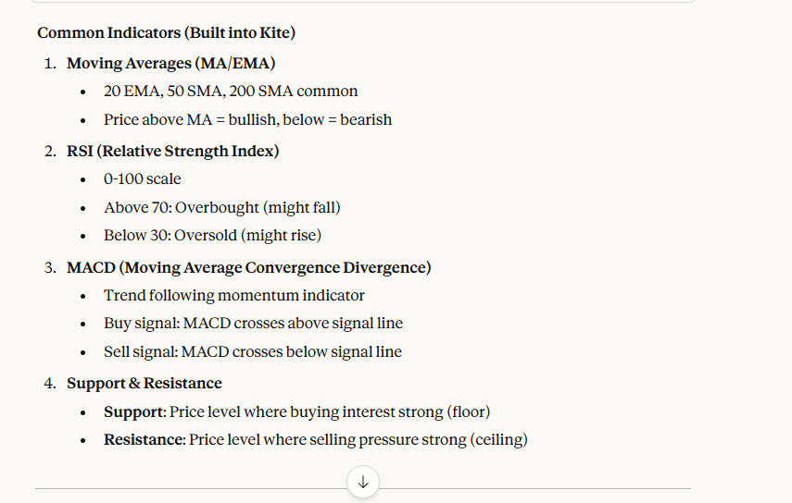
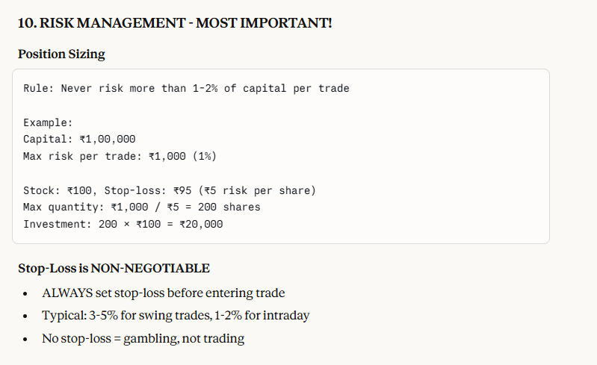
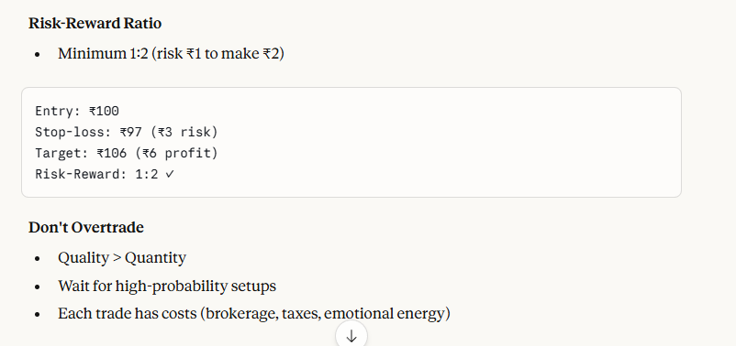
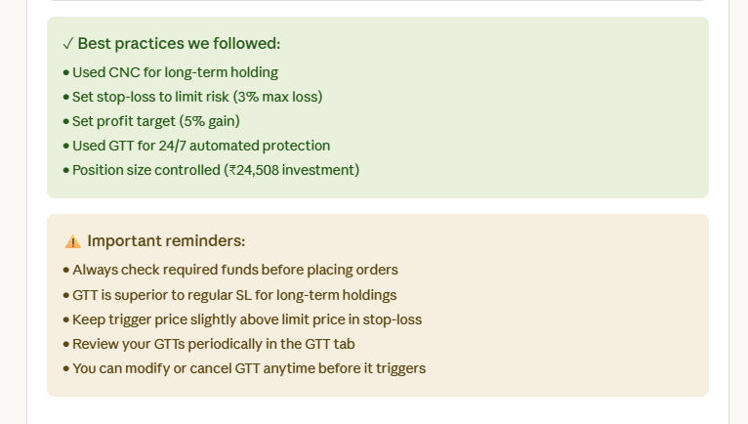
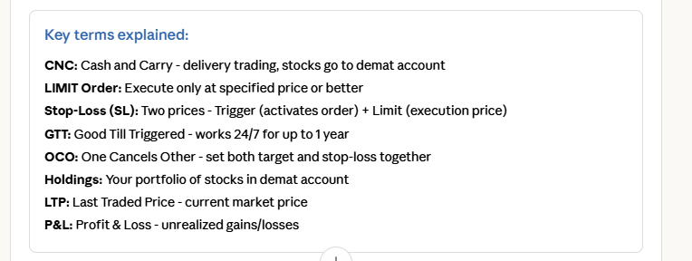
Key Terms:
- NAV (Net Asset Value): Price of 1 mutual fund unit (like stock price)
- SIP (Systematic Investment Plan): Auto-invest fixed amount monthly
- Lumpsum: One-time big investment
- AUM (Assets Under Management): Total money in the fund
- Expense Ratio: Annual fee charged by fund (e.g., 0.5% = ₹50 fee per ₹10,000 invested)
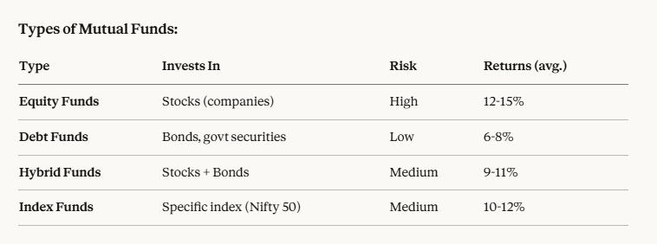
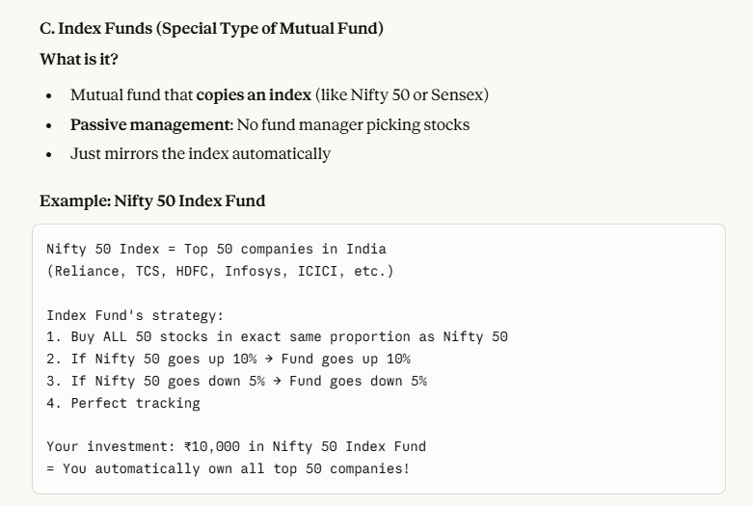
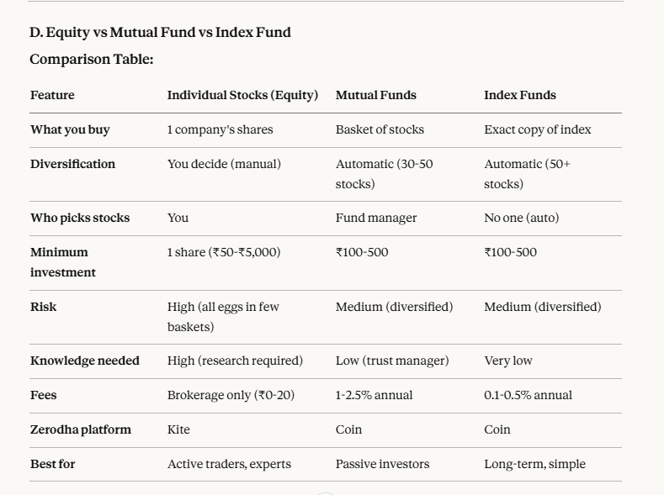
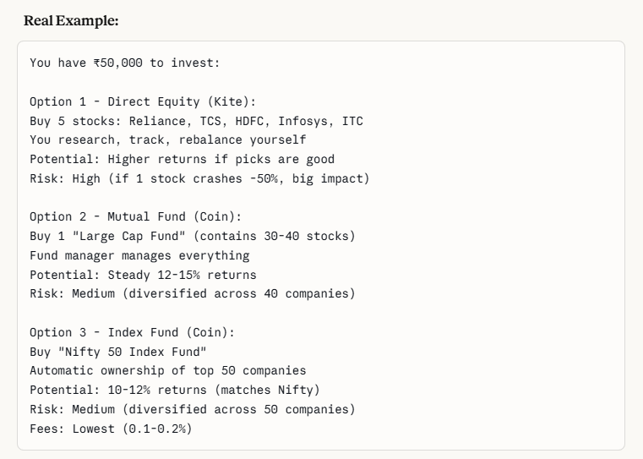
5. IPO (Initial Public Offering) EXPLAINED
What is an IPO?
Simple Definition:
- When a private company becomes public by selling shares on stock exchange for the first time
- Before IPO: Only founders, VCs, employees own shares (not available to public)
- After IPO: Anyone can buy shares on NSE/BSE
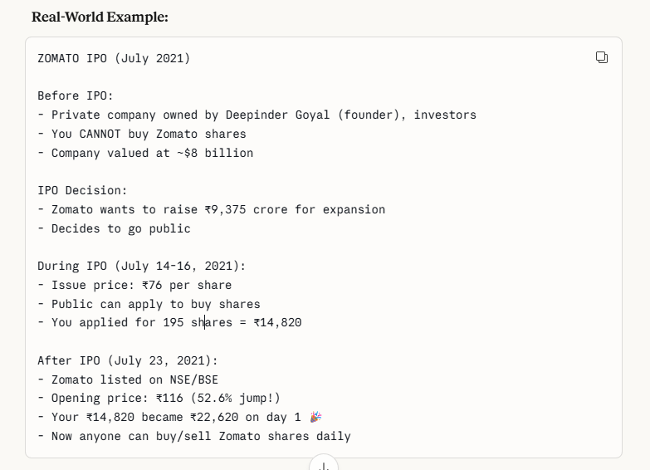
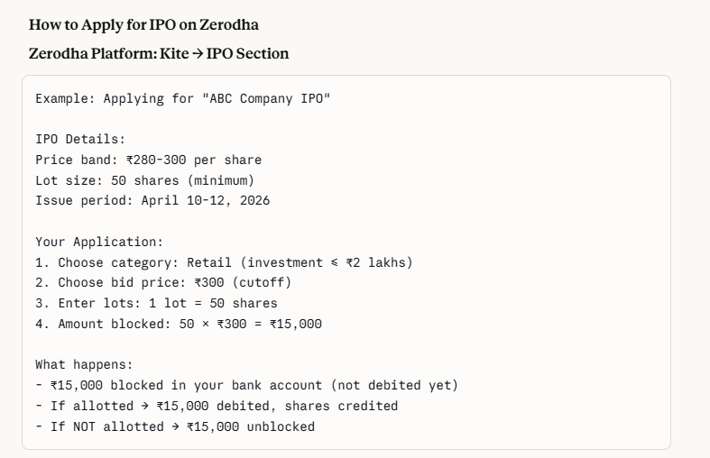

PART 1: UNDERSTANDING CHART TIMEFRAMES
What Those Buttons Mean (1D, 5M, 6M, 1Y)
When you click on HDFC Bank in Zerodha Kite, you see a chart with timeframe options at the bottom:
TIME FRAMES EXPLAINED:
5M = 5 Minutes → Each candle = 5 minutes of trading
15M = 15 Minutes → Each candle = 15 minutes
1H = 1 Hour → Each candle = 1 hour
1D = 1 Day → Each candle = 1 full trading day
1W = 1 Week → Each candle = 1 week
1M = 1 Month → Each candle = 1 month
VIEWS (How far back you see):
1D = Today's chart only
5D = Last 5 days
1M = Last 1 month
6M = Last 6 months
1Y = Last 1 year
5Y = Last 5 years
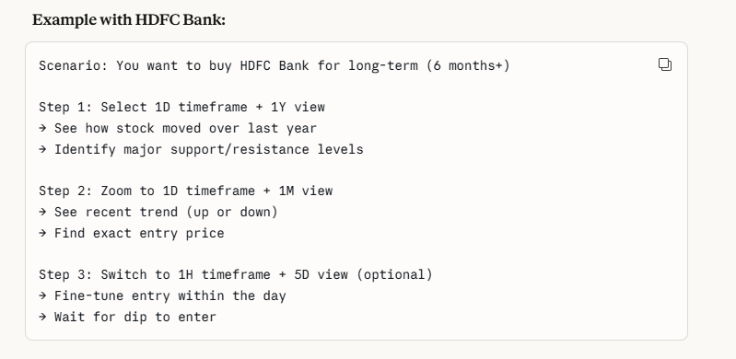
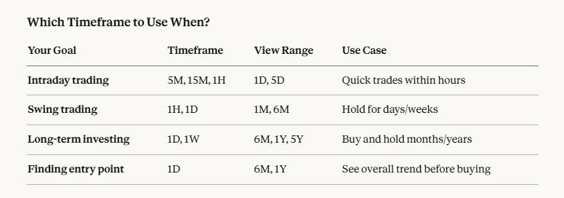
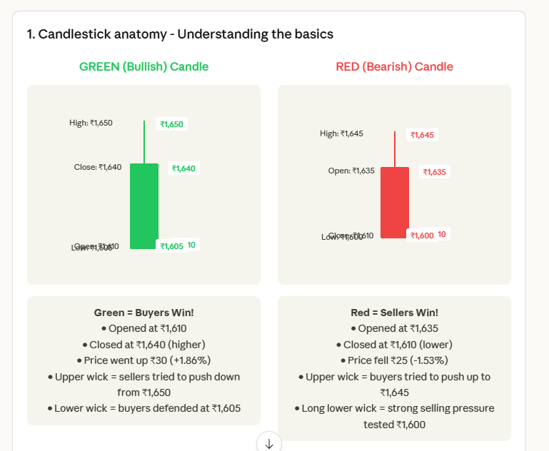
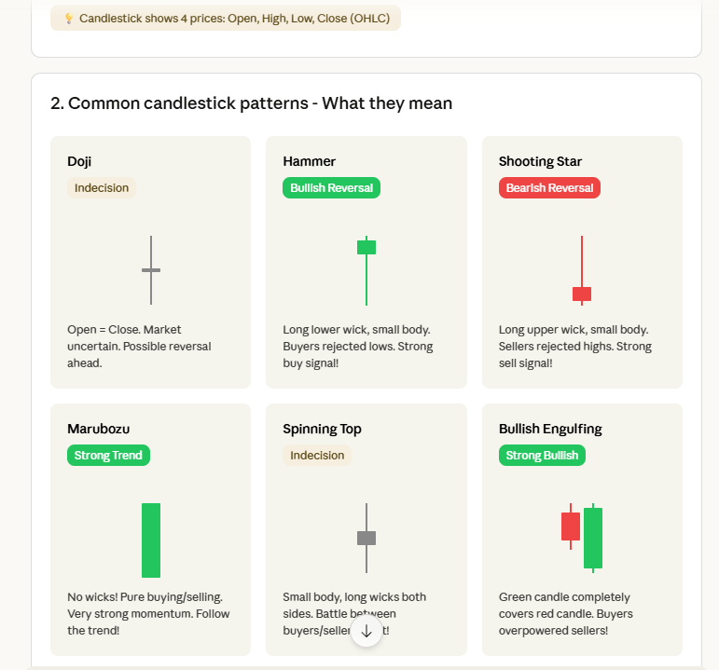
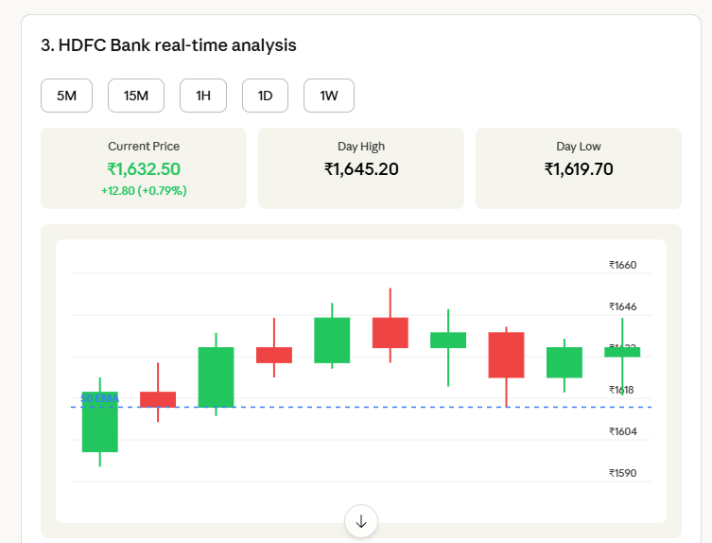
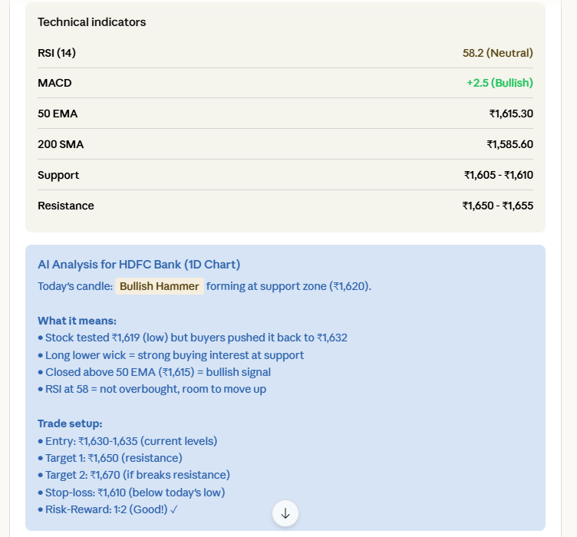
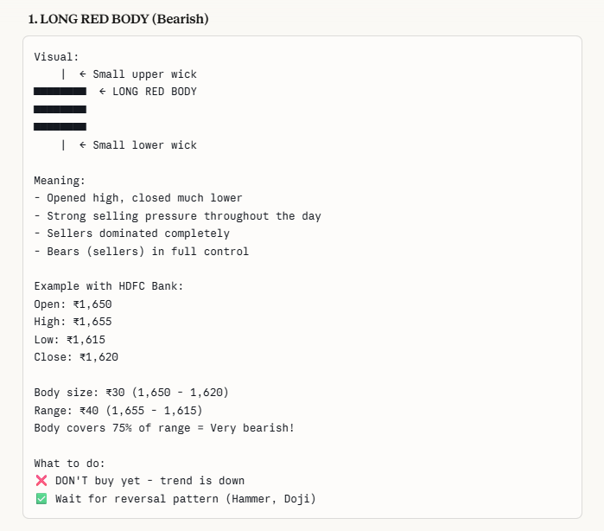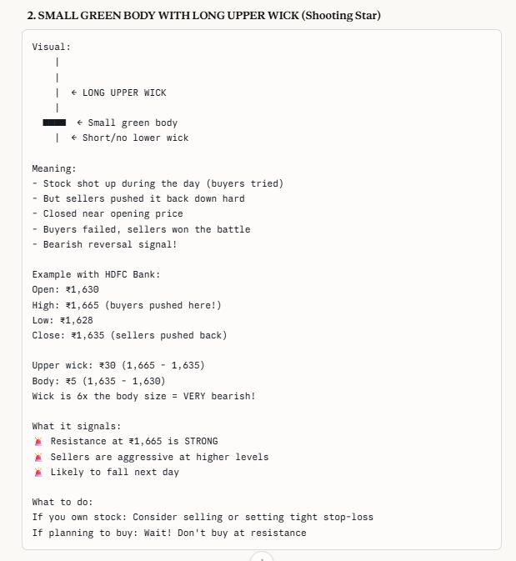
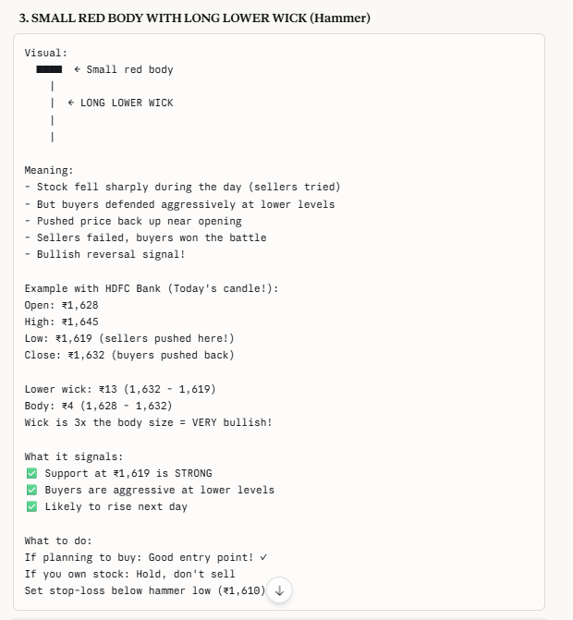
PART 6: TECHNICAL INDICATORS EXPLAINED
What You See in Zerodha Kite Chart:
When you click "Studies" button on chart, you can add these indicators:
1. RSI (Relative Strength Index)
What it is:
- Measures if stock is overbought or oversold
- Scale: 0 to 100
- Formula compares average gains vs average losses over 14 days

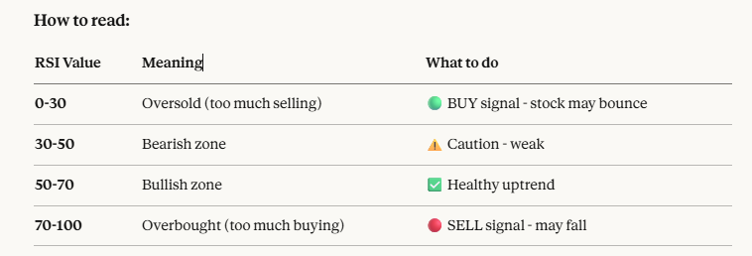
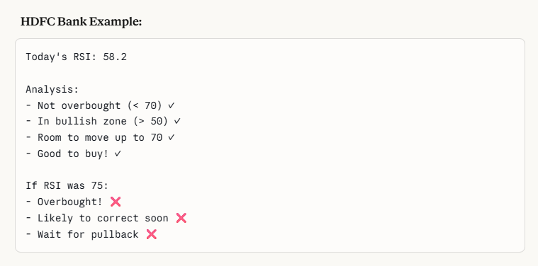
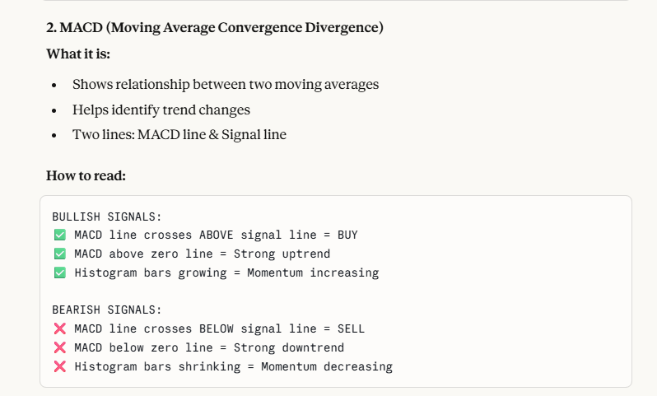
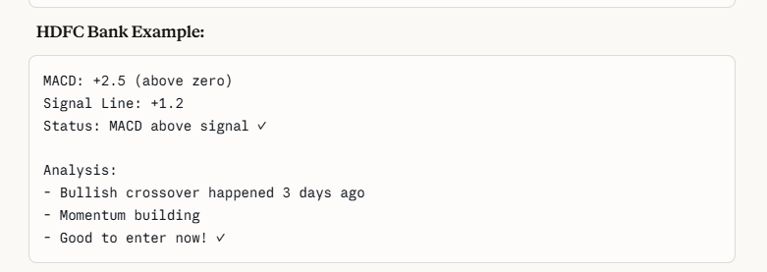
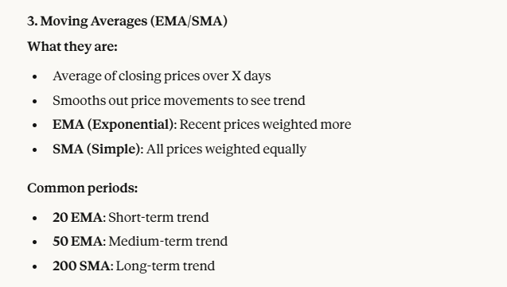
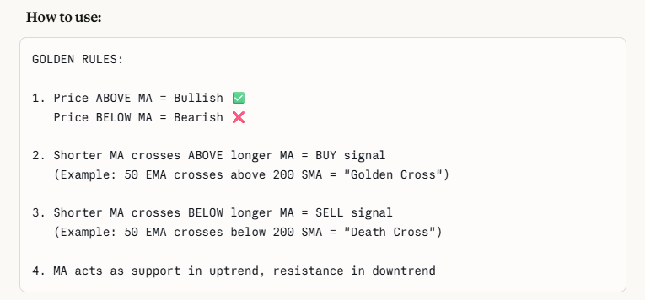
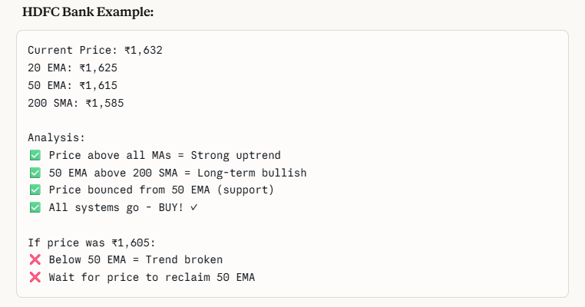
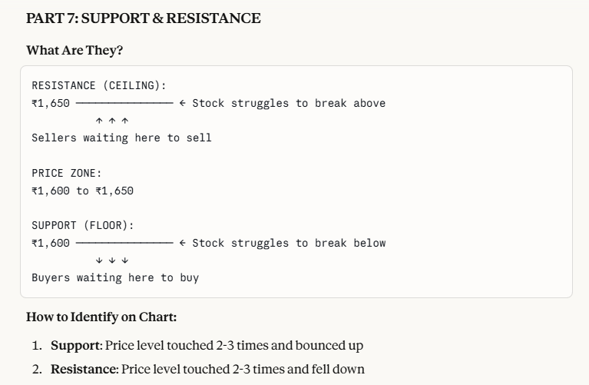
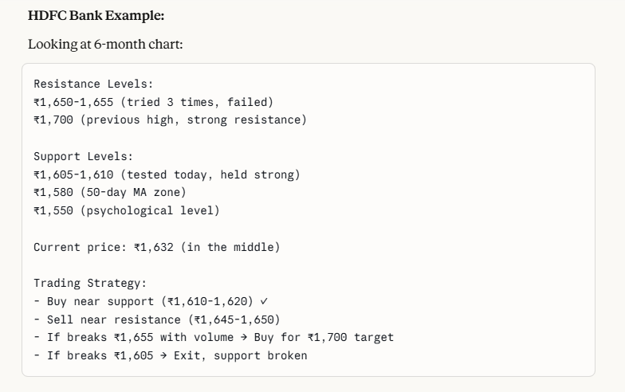
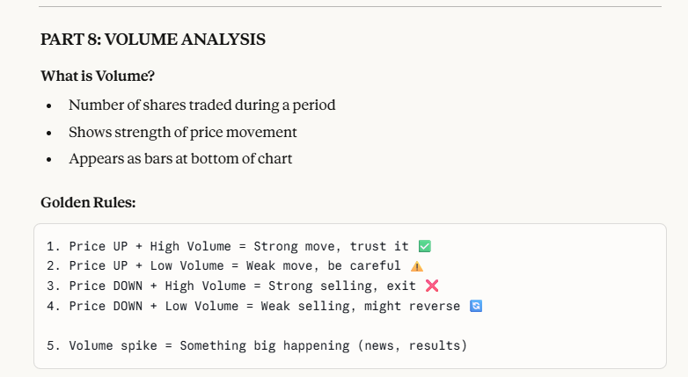
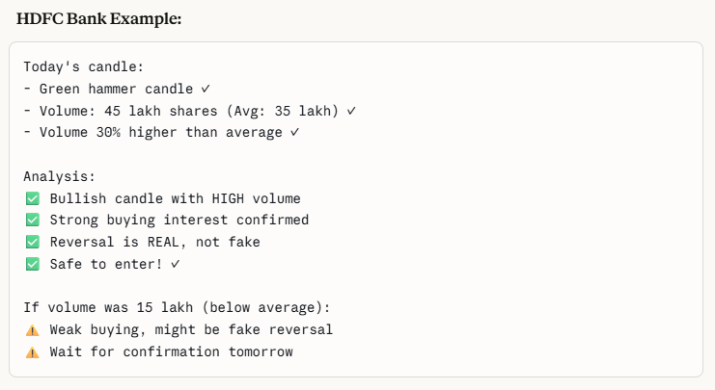
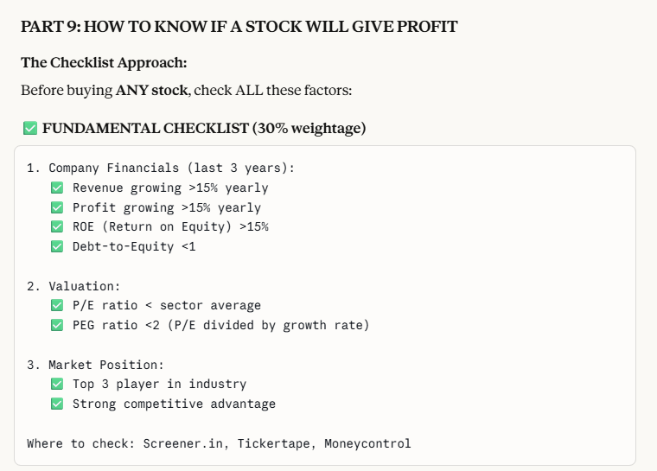
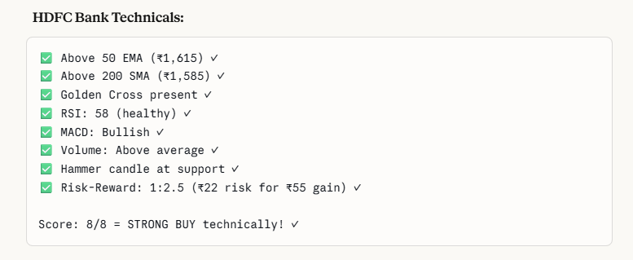
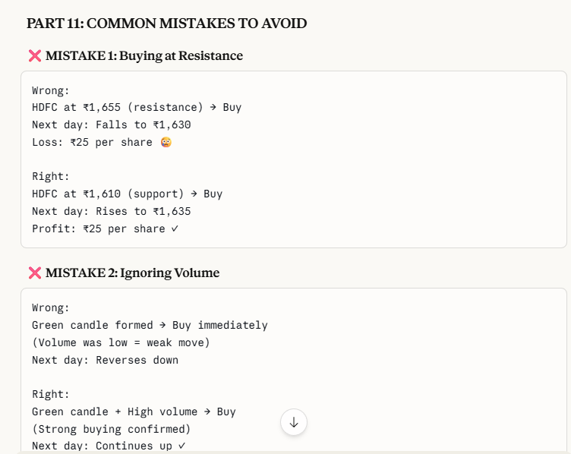

TickerTape
Screener --- company analysis to get knowledge about whether it is small cap or mid cap
ROE andROCE must be above 15%, which means it is a good stock

