DOCKER – CONTENARISATION
Docker is a tool that simplifies the process of developing, packaging, and deploying applications. It solves the “works on my machine” problem by ensuring code runs identically across environments.
- Docker allows you to build, package, and run applications inside containers
- Containers are lightweight piece of software that contains all the code, libraries, and dependencies that the application needs to run.
- Containers share the host operating system’s kernel but keep applications and their dependencies isolated. This makes containers faster to start, less resource-hungry, and portable across environments.

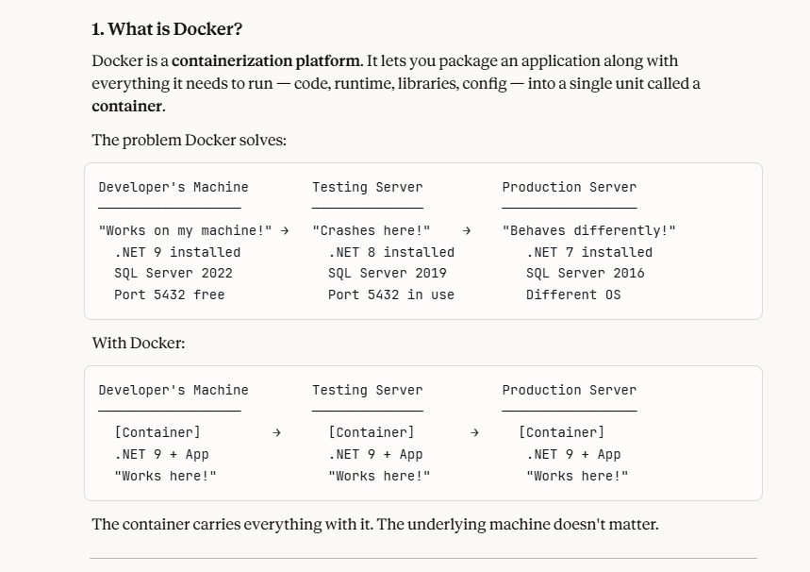

2. Core Concepts — The Building Blocks
1. IMAGE : A read-only blueprint/template for creating containers. Like a class in C#.
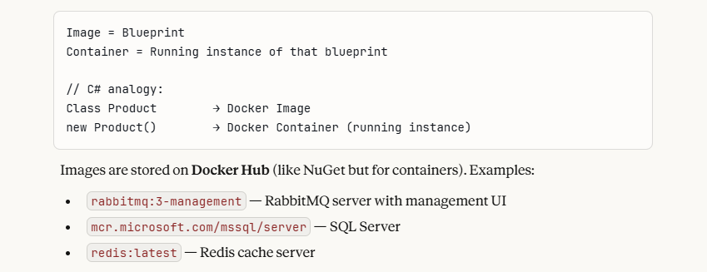

2. CONTAINER : A running instance of an image. Isolated, lightweight, has its own filesystem and network. You can run multiple containers from the same image.
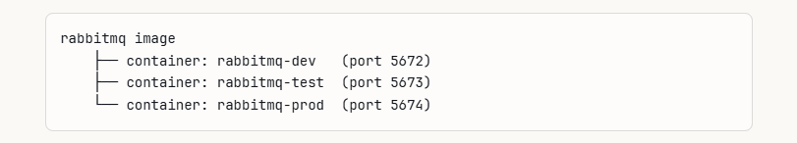

3. DOCKERFILE : A text file with instructions to build your own custom image. You write this for your own apps.

# Start from official .NET 9 image
FROM mcr.microsoft.com/dotnet/aspnet:9.0

# Set working directory inside container
WORKDIR /app

# Copy published files into container
COPY . .

# Tell container which port your app listens on
EXPOSE 8080

# Command to run when container starts
ENTRYPOINT ["dotnet", "OrderAPI_Phase2.dll"]
```

### Docker Hub
A public **registry** (cloud storage) for Docker images. When you run `docker run rabbitmq`, Docker automatically downloads the image from Docker Hub if it's not already on your machine.
```
Your Machine
│
│ docker run rabbitmq (image not found locally)
▼
Docker Hub (hub.docker.com)
│
│ downloads rabbitmq image
▼
Your Machine (image cached locally)
│
│ starts container from image
▼
Running RabbitMQ Container
```

### Volume
**Persistent storage** for containers. By default, when a container is deleted, all its data is lost. Volumes solve this.
```
Without Volume:
Container deleted → SQL Server data GONE ❌

With Volume:
Container deleted → SQL Server data SAFE on your disk ✅
New container → mounts same volume → data still there ✅
```

### Network
Docker containers are **isolated by default** — they can't talk to each other. Docker networks connect them.
```
Without network:
Order.API container ──✗──▶ RabbitMQ container (can't reach)

With network (same Docker network):
Order.API container ──✅──▶ RabbitMQ container (can reach by container name)

DOCKER COMMANDS

- Image Commands

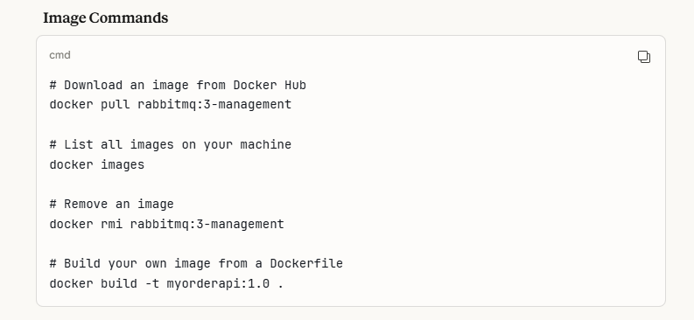

- Container commands

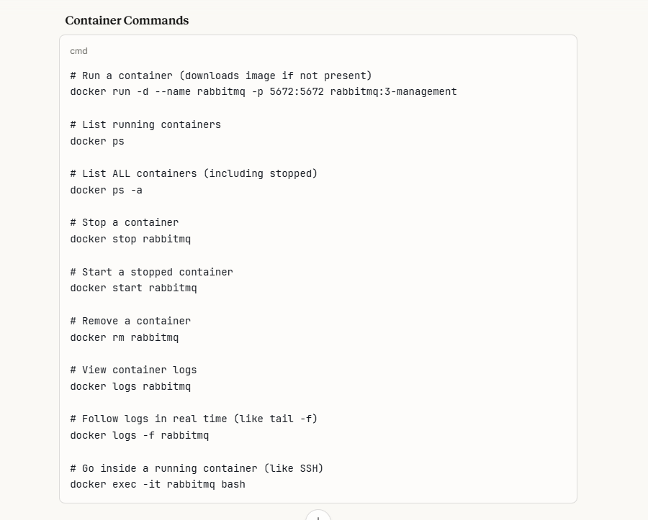

- Volume Commands

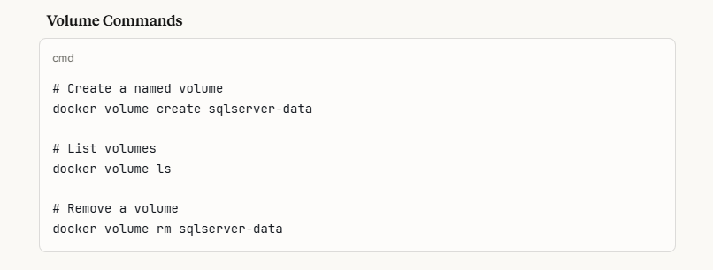

- Network Commands

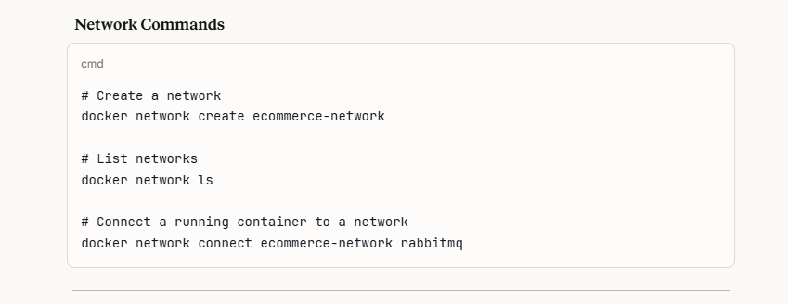
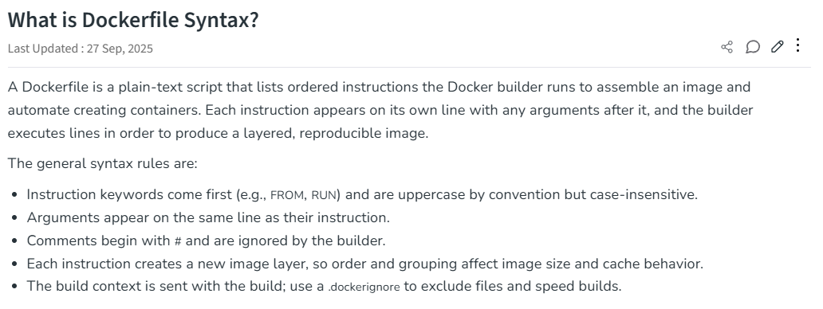
Docker File Fields Format
- FROM – a stmt defines which image to download from
- 1st command in the docker file
- Dcokerfile can have multiple FROM stmts ,which means the docker file produces more than one image
- From java : 8

- MAINTAINER – it is a kind of documentation
- Defines the author who is creating the dockerfile, or who should you contact if it has bugs
- MAINTAINER Firstname Lastname <example@geeksforgeeks.com>
- RUN – running a command through shell, waiting for it to finish
-saves the result
- it tells what process will be running inside the container at the run time

-RUN unzip install.zip /opt/install
RUN echo hello

- ADD – if we want to add some files, ADD stmt is used
- It gives instructions to copy new files,directories or remote files urls
- It then adds them to the filesystem of the image.
- Local Files: ADD run.sh /run.sh
Tar Archives: ADD project.tar.gz /install/
URLs: ADD https://project.example-gfg.com/downloads/1.0/testingproject.rpm/test

- ENV – it sets the environment variables both during the build and when running the result.
- Can be used in the dockerfile and any scripts it calls.

ENV URL_POST=production.example-gfg.com

- ENTRY POINT - it specifies the starting of the expression to use when starting your container
- It specifies the start of the command to run
- If the container acts like a command-line program, you can use ENTRYPOINT
- ENTRYPOINT ["/start.sh"]

- CMD – it specifies the whole command to run
- It is the default argument passed into the entrypoint.
- Its main purpose is to launch the software required in a container.
- CMD ["program-foreground"]
CMD ["executable", "program1", "program2"]

- EXPOSE – this stmt maps a port into the container
- The ports can be TCP or UDP but by default, it is TCP
- EXPOSE 3030
Port : a port is a logical communication endpoint in a computer
Think of it like this:
- 🏠 Your IP address = your house address
- 🚪 Port number = the room inside your house
When data comes to your computer:
- The IP address tells which computer
- The port number tells which application inside that computer
Real Example
When you open:
- A browser → it uses a specific port
- WhatsApp → different port
- Email app → different port
All are running on the same computer, but ports help the system know where to send the data.

Aport is represented by a number between 0 – 65535
192.168.1.10:443
- 192.168.1.10 → IP address – it is like a house
- 443 → Port number – it is a room in the house where the application runs

What is TCP Port?
TCP stands for Transmission Control Protocol.
A TCP port is a port that uses the TCP protocol for communication.
TCP Characteristics:
- Connection-oriented
- Reliable
- Guarantees delivery
- Data arrives in correct order
📌 Common TCP Ports:
Port | Service
80 | HTTP
443 | HTTPS
21 | FTP
25 | SMTP

What is UDP Port?
UDP stands for User Datagram Protocol.
A UDP port is a port that uses the UDP protocol.
✅ UDP Characteristics:
- Connectionless
- Faster
- No guarantee of delivery
- No ordering guarantee
📌 Common UDP Ports:
Port | Service
53 | DNS
67 | DHCP
123 | NTP

- VOLUME – it defines shared volumes or ephemeral volumes depending upon whether you have one or two arguments.
1. If you have two arguments, it maps a host path into a container path.
VOLUME ["/host/path" "/container/path/"]
2. If you have one arguments, it creates a volume that can be inherited by the later containers.
VOLUME ["/shared-data"]

- WORKDIR – it sets the directory that the container start in.
- It s main purpose is to set the working directory for all the future dockerfile commands
- WORKDIR /directory-name
- USER – it sets which user’s container will run as.
- This can be useful if you have shared network directories involved that assume a fixed username or a fixed user number
- USER geeksforgeeks
USER 4000
- ARG – a variable that can be provided at build time is defined by an ARG instruction.
- Once it has been specified in the Dockerfile, you can specify it using the --build-arg switch when creating the image.
- The Dockerfile supports multiple ARG instructions
- The only instruction in the Dockerfile that can come before the FROM instruction is ARG.
- After the image is created, ARG values are not accessible. An ARG variable value won't be accessible to a running container.
- ARG image_name=latest
FROM centos:$image_name
docker build -t <image-name>:<tag> --build-arg image_name=centos8 .

Best practices for writing Dockerfiles
- As a base image, use official images. And whenever it is possible, use Alpine images as a base image.
- Don't copy unnecessary files and folders or install/use unnecessary packages of software.
- Running a container process as root is not recommended. As a non-root user, launch the application container process.
- Reduce the number of image layers as much as you can.
- Wherever possible, try to use multi-stage Docker files to reduce the size of the image.
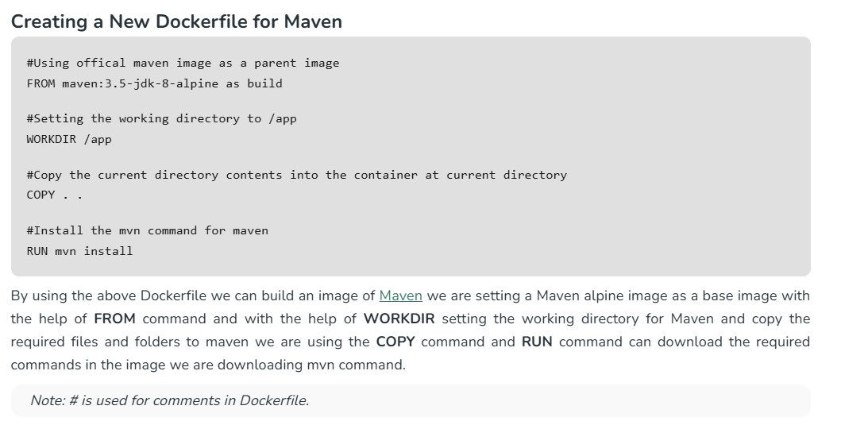
DOCKER COMPOSE – USED TO RUN MULTIPLE DOCKER CONTAINERS
Docker Compose is a tool that lets you run and manage multiple Docker containers together as a single application., define everything in one file and run
First, Let's Understand the Problem It Solves
Imagine you're building a typical web application. It has 3 parts:
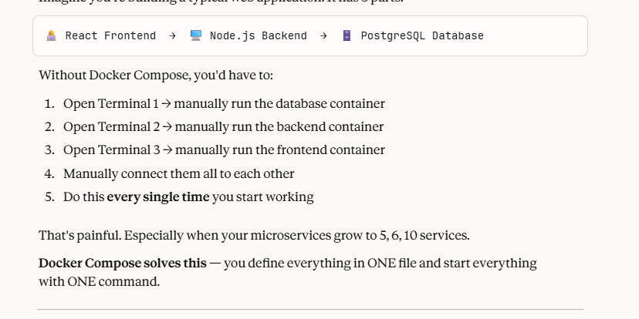

What is Docker Compose?
Think of it like a remote control for all your containers together.
- Docker = manages one container at a time
- Docker Compose = manages multiple containers as a group

The docker-compose.yml File
Everything is written in a file called docker-compose.yml. YAML is just a simple, readable format using indentation (like Python).

Let's build it step by step with a real example.

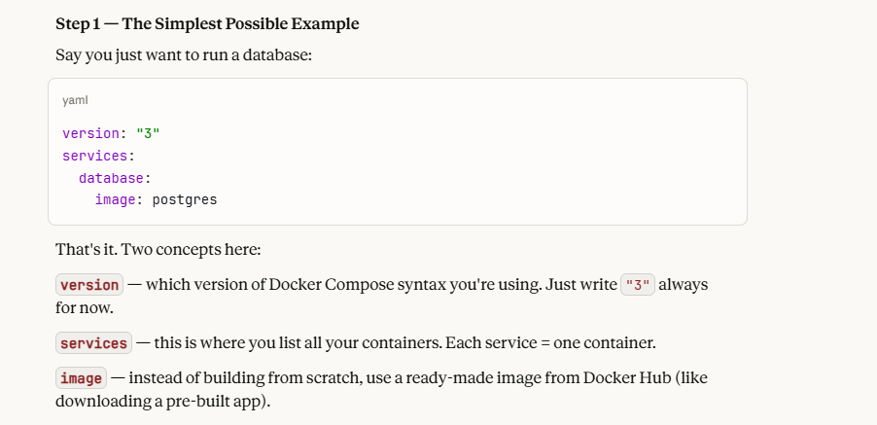

Step 2 — Adding Your Own App (with build)
Now let's say you also have a Node.js backend you wrote yourself:

**`build`** — instead of pulling a ready image, build one from YOUR code using the Dockerfile in that folder.

**`ports`** — by default, containers are isolated. They don't expose anything to your laptop. Ports punch a hole so you can access it.

``` Your Browser → localhost:5000 → Container's port 5000
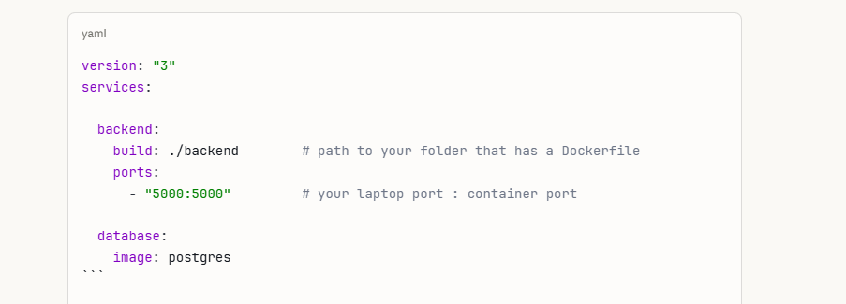

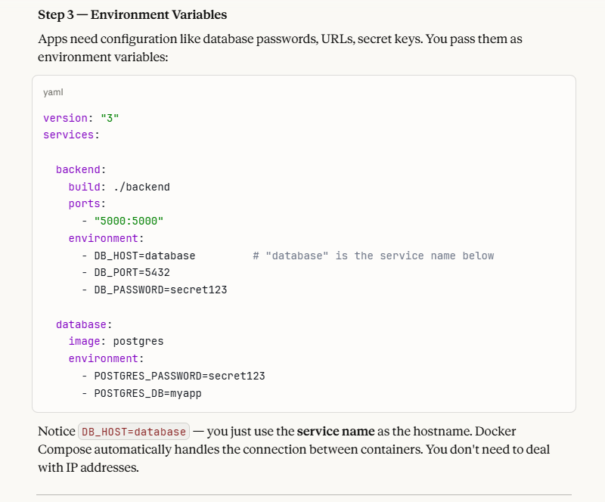

Step 4 — Full Example with Frontend + Backend + Database

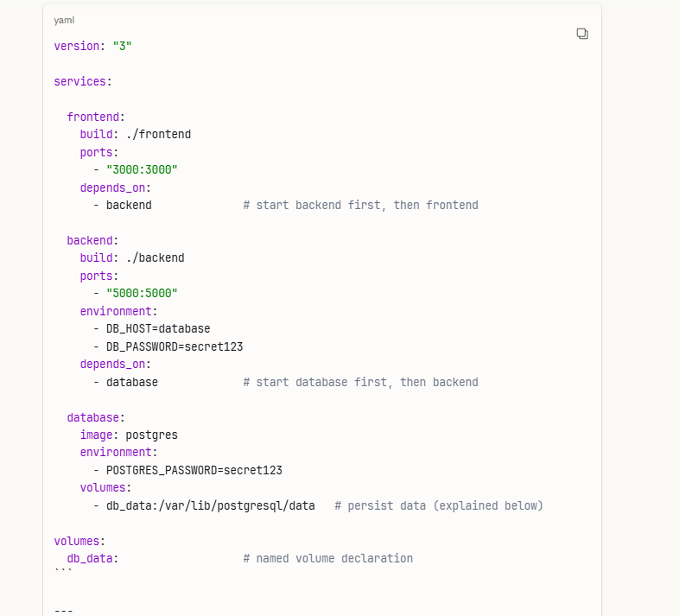

Key Concepts Explained

**`depends_on`** Controls startup order. Database should start before backend. Backend before frontend. Without this, your backend might crash trying to connect to a DB that isn't ready yet.
**`volumes`** Containers are temporary. If your database container stops, all data is gone. Volumes save data to your actual laptop/server so it survives restarts.

Example if you have images folder uploads folder, when the container restarts everything goes off ,so to persist the data we use volumes

``` Container (temporary) ←→ Volume (permanent storage on your machine)

**How services find each other** All services in a docker-compose file are automatically on the same internal network. They can talk to each other just using the service name. ```

``` backend container calls → "database:5432" Docker resolves this → routes to the database container automatically

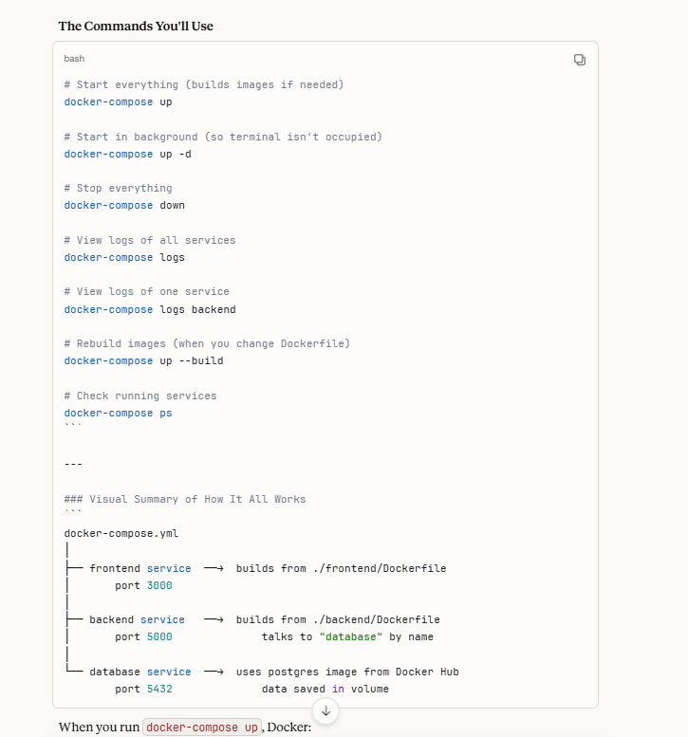

When you run docker-compose up, Docker:
- Reads the yml file
- Builds or pulls all images
- Creates all containers
- Connects them on a shared network
- Starts them in the right order

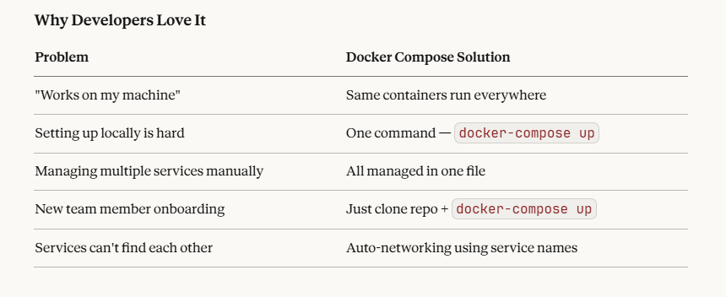
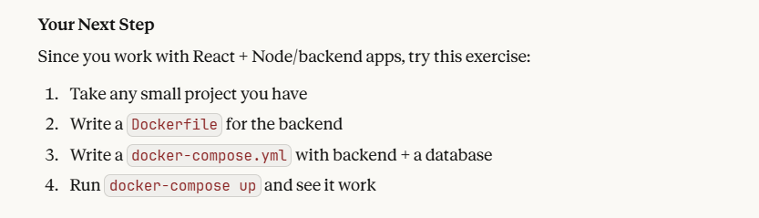

Very important concept from above docker compose file

What is "Pulling an Image" ?
Think of Docker Hub like a Google Play Store / App Store, but for software packages.

When you write
“image: postgres"
Docker says - I don't have postgres (it is a software) on this machine, let me go download it from Docker Hub
That **downloading** is called **Pulling**.

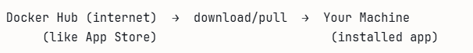

When you installed RabbitMQ in Docker Desktop, what actually happened behind the scenes was Docker pulled the RabbitMQ image from Docker Hub to your machine.

After pulling once, it stays on your machine. Next time it won't download again — it uses the cached version.

You can also manually pull

docker pull postgres //you can mention and pull the specific software
docker pull rabbitmq

You don't install postgres on your laptop directly. Docker pulls the postgres image and runs it inside a container. Your laptop stays clean.

Why image: postgres for Database but build for Backend?

This is the most important concept to understand.

image — means "this software already exists on Docker Hub, just download and run it"
build — means "this is MY code, build a container from my Dockerfile"

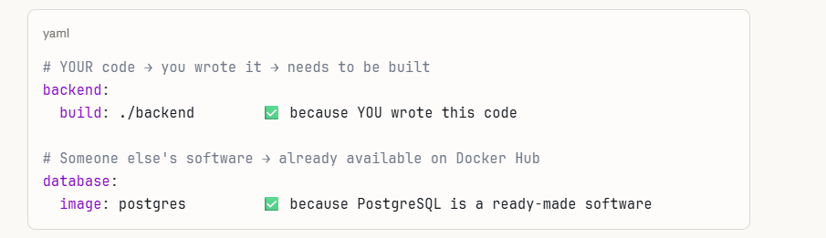
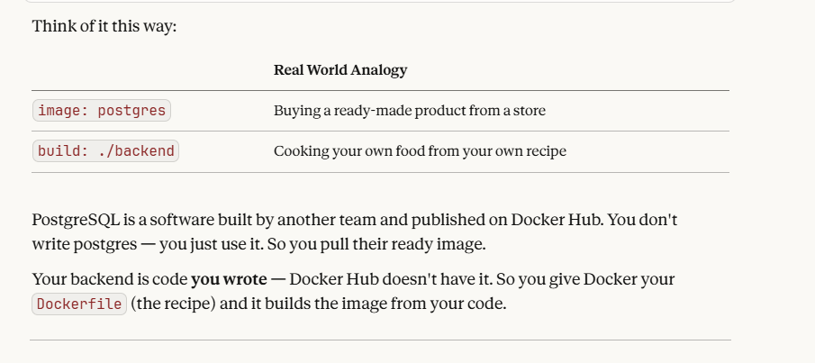
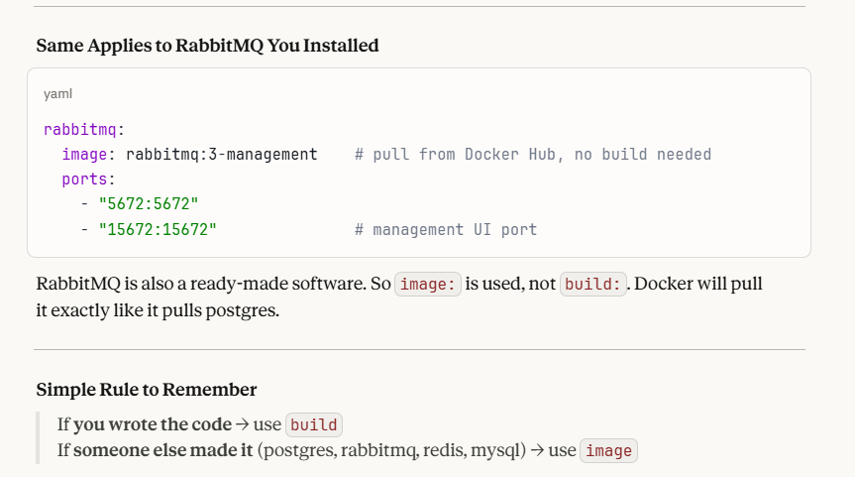

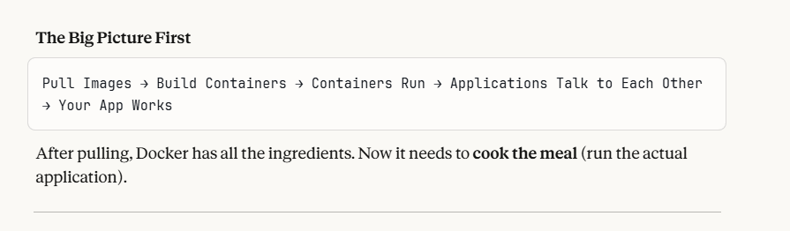

WHAT HAPPENS AFTER PULLING ?

Step 1 — Images are Ready on Your Machine

Think of an Image like a CD / Installation File. Just having the CD doesn't mean the software is running. You need to install and launch it.
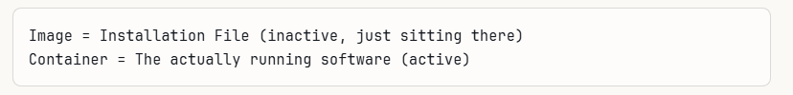

Step 2 — Docker Creates Containers from Images

When you run docker-compose up, Docker takes each image and creates a container from it — a live, running instance.

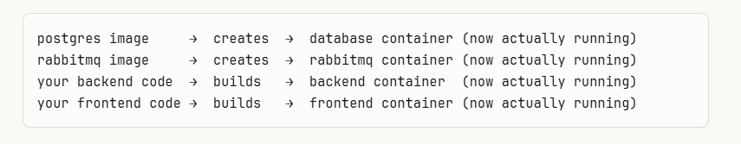

Step 3 — Each Container is Now a Running Application

Each container is basically a mini isolated computer running one job:

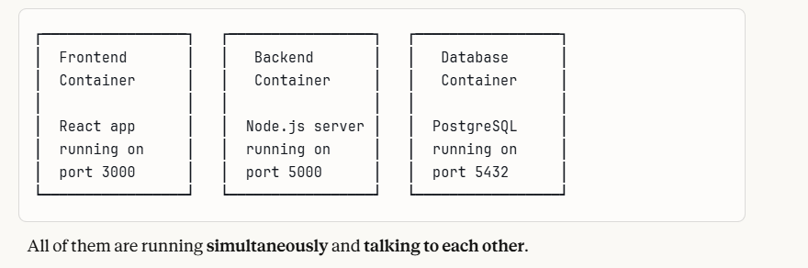
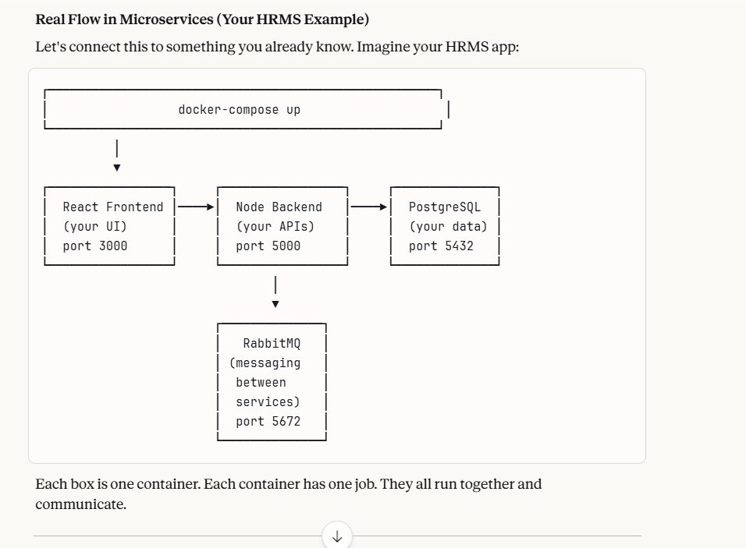
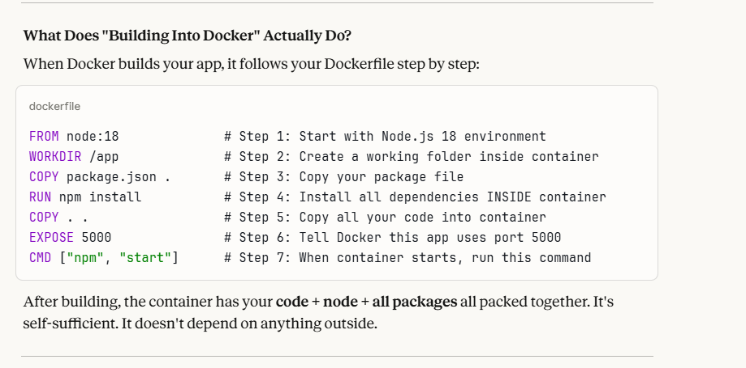

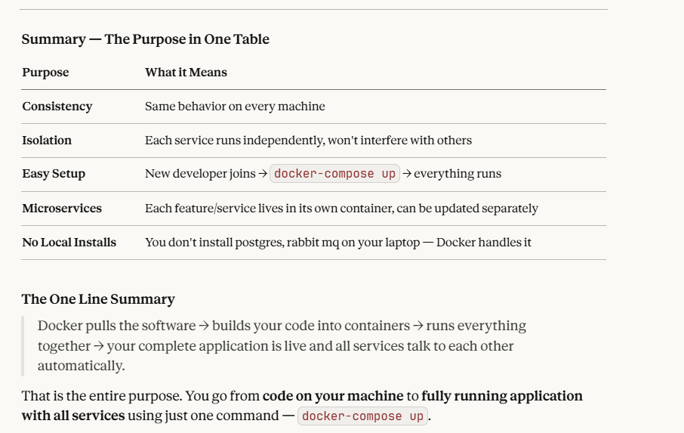

DOCKER NETWORKING (BASICS ONLY)

What is it?

When multiple containers are running, they need to talk to each other. Docker Networking is how that communication happens.

But Docker Compose automatically handles networking for you, we need not manually set it

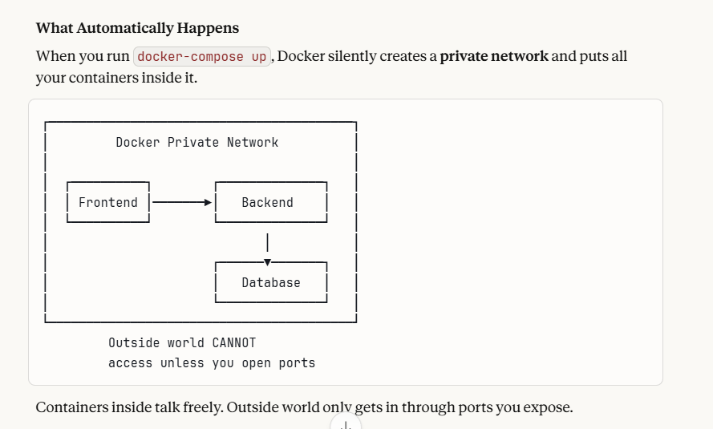

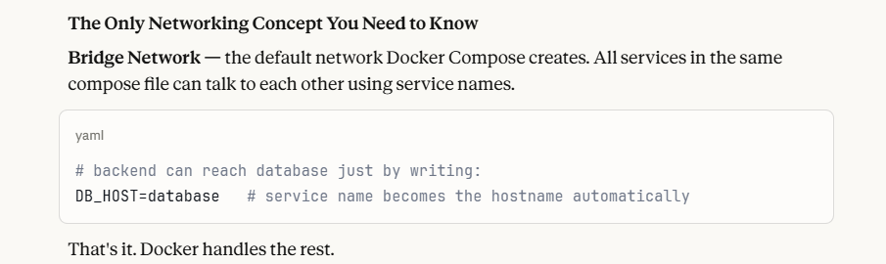

DOCKER SWARM (BASIC)

Docker Swarm is a tool to run containers across **multiple machines/servers** and manage them together.

Without Swarm: All containers → run on YOUR one machine

With Swarm: Containers spread across → Machine 1 + Machine 2 + Machine 3 (managed as one cluster)

In production (real live applications), one machine is not enough. You need:
- High availability (if one server dies, others keep running)
- Load balancing (spread traffic across servers)
- Scaling (run 5 copies of backend during heavy traffic) Docker Swarm handles all of this.
Also — in the real industry right now: ``` Docker Swarm → mostly replaced by → Kubernetes (K8s)

