
SRI MITTAPALLI INSTITUTE OF TECHNOLOGY FOR WOMEN
Tummlapalem-512133, Guntur (Dt), Andhra Pradesh
DEPARTMENT OF COMPUTER SCIENCE & ENGINEERING



DEPARTMENT OF COMPUTER SCIENCE & ENGINEERING

SRI MITTAPALLI INSTITUTE OF TECHNOLOGY FOR WOMEN
(Affiliated to JNTU KAKINADA, Approved by AICTE)
Thummalapalem-522233, Guntur (Dt.), Andhra Pradesh
(2022-2026)

PROGRAM BOOK FOR
SHORT - TERM INTERNSHIP
Name of the student: PUCHAKAYALA LAVANYA

Name of the college: SRI MITTAPALLI INSTITUTE OF TECHNOLOGY FOR WOMEN

Registration Number :22MK1A0587

Period of Internship: From:5/05/2024 To: 5/07/2024

Name & Address of the Intern Organization
Data Valley,Vijayawada

2024 YEAR

Student’s Declaration

I PUCHAKAYALA LAVANYA, a student of Internship Program, Reg. No.22MK1A0587 of the Department of Computer Science and Engineering College do hereby declare that I have completed the mandatory community service from 5/5/2024 to 5/7/2024 in Data Valley
under the Faculty Guideship of M.ANANTHA LAKSHMI, Department of Computer Science and Engineering in SRI MITTAPALLI INSTITUTE OF TECHNOLOGY FOR WOMEN.
(Signature and Date)

Endorsements

Faculty Guide
N.RAJESH

Head of the Department
K.SUDHAKAR BABU

INTERNSHIP TITLE

DATA SCIENCE SHORT TERM INTERNSHIP ON BIGMART SALES PREDICTION USING ENSEMBLE LEARNING



SUBMITTED BY
Name 1 P.Lavanya
Name 2 Swathi Ratna.M
Name 3 T.Sri Lakshmi
Name 4 M.Lavanya
Name 5 V.Krishnaveni

Guidance and Internship Location
Address Vijayawada
Link of the company
https://datavalley.ai/

CERTIFICATION

This is to certify that, this is a Bonafide record of the project work on
“DATA SCIENCE”

SUBMITTED BY
Name 1 P.Lavanya
Name 2 Swathi Ratna.M
Name 3 T.Sri Lakshmi
Name 4 M.Lavanya
Name 5 V.Krishnaveni

Of final “Computer Science and Engineering, Sri Mittapalli Institute of Technology”, “Thummalapalem”
Signature of the in-charge Signature Of HOD

SUB: INTENSHIP COMPLETION LETTER
This is to certify that Miss 1) P.Lavanya (22MK1A0587) 2)Swathi Ratna.M (22MK1A05A2) 3) T.Sri Lakshmi (22MK1A05A8) 4) M.Lavanya(22MK1A0572) 5) V.Krishnaveni (22MK1A05B7) undergoing from Sri Mittapalli College of Engineering we successfully completed internship at Data Valley as per his curriculum requirement from 5/52024 to 5/7/2024. we have been found sincerely and hardworking to the best of our knowledge and satisfaction during our tenure over here.

During the internship we are exposed to the various activities in the field of website creation. we are very much interested to learn the concepts of our course division and willing to put our efforts and get into the depth of the subject to understand it better. Their association with us very fruitful and we wish his all the best for their future and endeavours.

FOR DATA VALLEY
Authorized signatory

INTERNSHIP WORK SUMMARY
In my Data Science internship program, we focused on acquiring and applying data science techniques and tools across multiple modules. This internship provided an opportunity to delve into various aspects of data science, including Python programming, data manipulation, SQL, mathematics for data science, machine learning, and an introduction to deep learning with neural networks. The hands-on experience culminated in a project titled "Big Mart Sales Prediction Using Ensemble Learning."

Modules Covered
- Python Programming
- Python Libraries for Data Science
- SQL for Data Science
- Mathematics for Data Science
- Machine Learning
- Introduction to Deep Learning - Neural Networks
Project: Big Mart Sales Prediction Using Ensemble Learning
For the project, we applied ensemble learning techniques to predict the sales of products at Big Mart outlets. The project involved data cleaning, feature engineering, and model building using algorithms such as Random Forest, Gradient Boosting, and XGBoost. The final model aimed to improve the accuracy of sales predictions, providing valuable insights for inventory management and sales strategies.
Overall, this internship experience was beneficial in developing my skills in data science, including programming, data analysis, and machine learning. It also provided an opportunity to gain experience working on a real-world project, collaborating with a team to develop a complex predictive model.

Authorized signatory
Company name
DATA VALLEY

Self-Assessment
In this Data Science internship, we embarked on a comprehensive learning journey through various data science modules and culminated our experience with the project titled "Big Mart Sales Prediction Using Ensemble Learning."
For the project, we applied ensemble learning techniques to predict sales for Big Mart outlets. We utilized Python programming and various data science libraries to clean, manipulate, and analyze the data. The project involved feature engineering, model training, and evaluation using ensemble methods such as Random Forest, Gradient Boosting, and XGBoost.
Throughout this internship, we gained hands-on experience with key data science tools and techniques, enhancing our skills in data analysis, statistical modeling, and machine learning. The practical application of theoretical knowledge in a real-world project was immensely valuable.
We are very satisfied with the work we have done, as it has provided us with extensive knowledge and practical experience. This internship was highly beneficial, allowing us to enrich our skills in data science and preparing us for future professional endeavors. We are confident that the knowledge and skills acquired during this internship will be of great use in our personal and professional growth.

Company name Student Signature
Data Valley P.Lavanya

Acknowledgement
I express my sincere thanks to Dr C.RAVIKANTH, Principal of SRI MITTAPALLI INSTITUTE OF TECHNOLOGY FOR WOMEN for helping me in many ways throughout the period of my project with his timely suggestions.

I sincerely owe my respect and gratitude to Mr.K.SUDHAKAR BABU Head of the Department of CSE for his/her continuous and patient encouragement during all times of my project and helped, me in completing this study successfully.

I express my sincere and heartful thanks to my internal guide Mrs.M.ANANTHA LAKSHMI lecturer for her encouragement and valuable support in bringing the present shape of my work.

I express my special thanks to my organization guide Mr. N.RAJESH who extended their kind support in completing my project.

I also greatly thank all the trainers without whose training and feedback in this project would stand nothing. In addition, I am grateful to all those who helped directly or indirectly for completing this project work successfully.

 | CONTENT | PAGE NO
1 | INTRODUCTION TO DATA SCIENCE | 2 | PYTHON FOR DATA SCIENE | 11 -26
2 | PYTHON FOR DATA SCIENE | 3 | SQL FOR DATA SCIENCE | 27-30
3 | SQL FOR DATA SCIENCE | 4 | MATHEMATICS FOR DATA SCIENCE | 30-34
4 | MATHEMATICS FOR DATA SCIENCE | 5 | MACHINE LEARNING | 35-53
5 | MACHINE LEARNING | 6 | INTRODUCTION TO DEEP LEARNING – NEURAL NETWORKS | 54-59
6 | INTRODUCTION TO DEEP LEARNING – NEURAL NETWORKS | 54-59
7 | PROJECT & FINAL OUTPUT | 60 - 63
8 | WEEKLY LOG
TABLE OF CONTENTS

THEORETICAL BACKGROUND OF THE STUDY

INTRODUCTION TO DATA SCIENCE

OVERVIEW OF DATA SCIENCE
Data Science is an interdisciplinary field that leverages scientific methods, algorithms, and systems to extract knowledge and insights from structured and unstructured data. It integrates various domains including mathematics, statistics, computer science, and domain expertise to analyze data and make data-driven decisions.
WHAT IS DATA SCIENCE?
Data Science involves the study of data through statistical and computational techniques to uncover patterns, make predictions, and gain valuable insights. It encompasses data cleansing, data preparation, analysis, and visualization, aiming to solve complex problems and inform business strategies.
APPLICATIONS OF DATA SCIENCE
- HEALTHCARE: In healthcare, Data Science is applied for predictive analytics to forecast patient outcomes, personalized medicine to tailor treatments based on individual patient data, and health monitoring systems using wearable devices and sensors.
- FINANCE: Data Science plays a crucial role in finance for fraud detection, where algorithms analyze transaction patterns to identify suspicious activities, risk management to assess and mitigate financial risks, algorithmic trading to automate trading decisions based on market data, and customer segmentation for targeted marketing campaigns based on spending behaviors.
- RETAIL: In retail, Data Science is used for demand forecasting to predict consumer demand for products, recommendation systems that suggest products to customers based on their browsing and purchasing history, and sentiment analysis to understand customer feedback and sentiment towards products and brands.
- TECHNOLOGY: Data Science applications in technology include natural language processing (NLP) for understanding and generating human language, image recognition and computer vision for analyzing and interpreting visual data such as images and videos, autonomous vehicles for making decisions based on real-time data from sensors, and personalized user experiences in applications and websites based on user behavior and preferences.

DIFFERENCE BETWEEN AI AND DATA SCIENCE
- AI (ARTIFICIAL INTELLIGENCE): AI refers to the ability of machines to perform tasks that typically require human intelligence, such as understanding natural language, recognizing patterns in data, and making decisions. It encompasses a broader scope of technologies and techniques aimed at simulating human intelligence.
- DATA SCIENCE: Data Science focuses on extracting insights and knowledge from data through statistical and computational methods. It involves cleaning, organizing, analyzing, and visualizing data to uncover patterns and trends, often utilizing AI techniques such as machine learning and deep learning to build predictive models and make data-driven decisions.
DATA SCIENCE TRENDS
Data Science is evolving rapidly with advancements in technology and increasing volumes of data generated daily. Key trends include the rise of deep learning techniques for complex data analysis, automation of machine learning workflows to accelerate model development and deployment, and growing concerns around ethical considerations such as bias in AI models and data privacy regulations.

MODULE 2 : PYTHON FOR DATA SCIENCE

1. INTRODUCTION TO PYTHON
Python is a high-level, interpreted programming language known for its simplicity, readability, and versatility. Created by Guido van Rossum and first released in 1991, Python has grown into one of the most popular languages worldwide. Its design philosophy emphasizes readability and simplicity, making it accessible for beginners and powerful for advanced users. Python supports multiple programming paradigms including procedural, object-oriented, and functional programming.
Python's key features include:
- Interpreted Language: Code is executed line-by-line by an interpreter, facilitating rapid development and debugging.
- Extensive Standard Library: Provides numerous modules and functions for diverse tasks without needing external libraries.
- Versatility: Widely used across various domains such as web development, data science, AI/ML, automation, and scripting.
- Syntax Simplicity: Uses significant whitespace (indentation) to delimit code blocks, enhancing readability.
- Interactive Mode (REPL): Supports quick experimentation and prototyping directly in the interpreter.
Example: 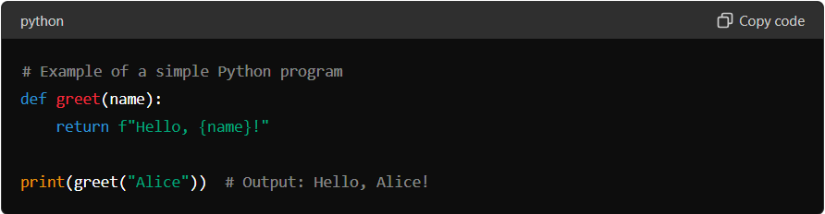

DOMAIN USAGE
Python finds application in numerous domains:
- Web Development: Django and Flask are popular frameworks for building web applications.
- Data Science: NumPy, Pandas, Matplotlib facilitate data manipulation, analysis, and visualization.
- AI/ML: TensorFlow, PyTorch, scikit-learn are used for developing AI models and machine learning algorithms.
- Automation and Scripting: Python's simplicity and extensive libraries make it ideal for automating tasks and writing scripts.

2. BASIC SYNTAX AND VARIABLES
Python's syntax is designed to be clean and easy to learn, using indentation to define code structure. Variables in Python are dynamically typed, meaning their type is inferred from the value assigned. This makes Python flexible and reduces the amount of code needed for simple tasks.

Detailed Explanation:
Python's syntax:
- Uses indentation (whitespace) to define code blocks, unlike languages that use curly braces {}.
- Encourages clean and readable code by enforcing consistent indentation practices.
Variables in Python:
- Dynamically typed: You don't need to declare the type of a variable explicitly.
- Types include integers, floats, strings, lists, tuples, sets, dictionaries, etc.
Example: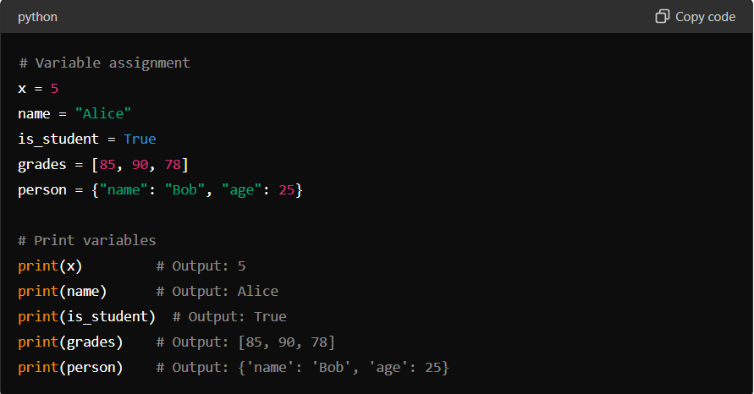

3. CONTROL FLOW STATEMENTS
Control flow statements in Python determine the order in which statements are executed based on conditions or loops. Python provides several control flow constructs:

Detailed Explanation:
- Conditional Statements (if, elif, else):
  - Used for decision-making based on conditions.
  - Executes a block of code if a condition is true, otherwise executes another block.
Example:
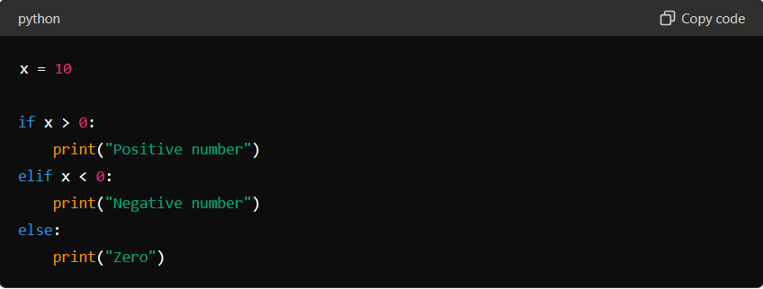

Output:
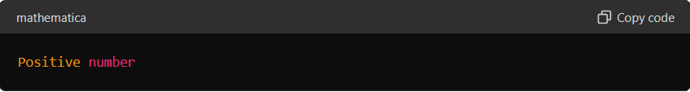

- Loops (for and while):
- for loop: Iterates over a sequence (e.g., list, tuple) or an iterable object.
- while loop: Executes a block of code as long as a condition is true.
Example: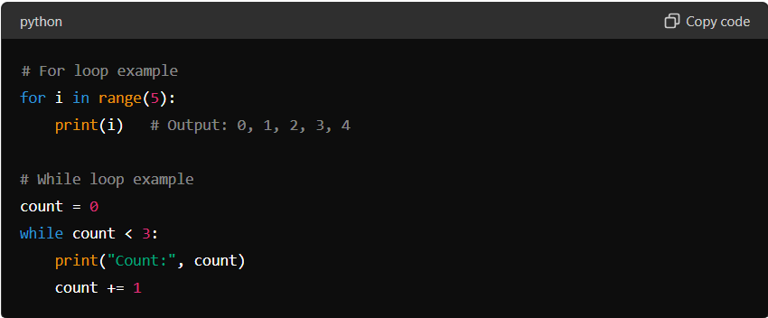
Output: 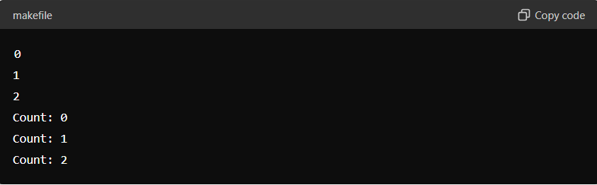
Example Explanation:
- Conditional Statements: In Python, if statements allow you to execute a block of code only if a specified condition is true. The elif and else clauses provide additional conditions to check if the preceding conditions are false.
- Loops: Python's for loop iterates over a sequence (e.g., a range of numbers) or an iterable object (like a list). The while loop repeats a block of code as long as a specified condition is true.
4. FUNCTIONS
Functions in Python are blocks of reusable code that perform a specific task. They help in organizing code into manageable parts, promoting code reusability and modularity.

Detailed Explanation:
- Function Definition (def keyword):
  - Functions in Python are defined using the def keyword followed by the function name and parentheses containing optional parameters.
  - The body of the function is indented.
Example: 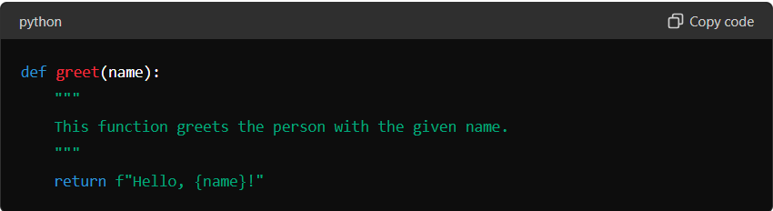
- Function Call:
- Functions are called or invoked by using the function name followed by parentheses containing arguments (if any).
Example: 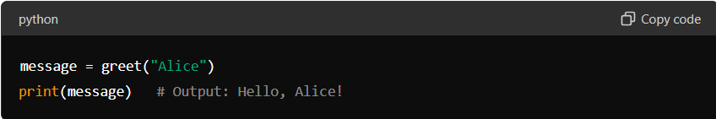
- Parameters and Arguments:
- Functions can accept parameters (inputs) that are specified when the function is called.
- Parameters can have default values, making them optional.
Example: 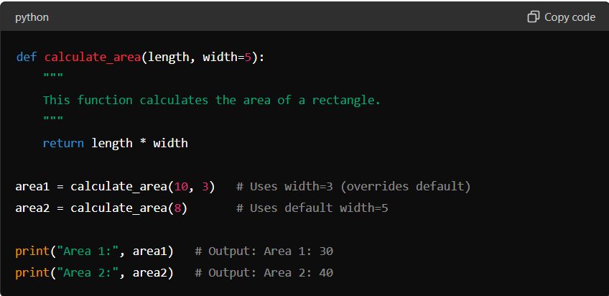

Example Explanation:
- Function Definition: Functions are defined using def followed by the function name and parameters in parentheses. The docstring (optional) provides a description of what the function does.
- Function Call: Functions are called by their name followed by parentheses containing arguments (if any) that are passed to the function.
- Parameters and Arguments: Functions can have parameters with default values, allowing flexibility in function calls. Parameters are variables that hold the arguments passed to the function.

5. DATA STRUCTURES
Python provides several built-in data structures that allow you to store and organize data efficiently. These include lists, tuples, sets, and dictionaries.

Detailed Explanation:
1. Lists:
- Ordered collection of items.
- Mutable (can be modified after creation).
- Accessed using index.
Example: 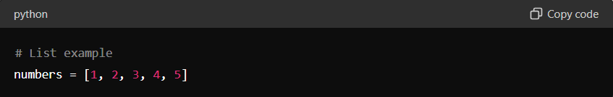
2. Tuples:
- Ordered collection of items.
- Immutable (cannot be modified after creation).
- Accessed using index.
Example: 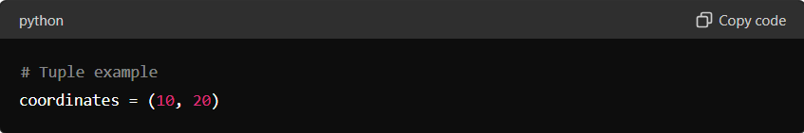
3. Sets:
- Unordered collection of unique items.
- Mutable (can be modified after creation).
- Cannot be accessed using index.

Example:
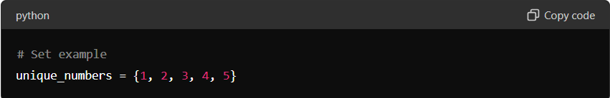
4. Dictionaries:
- Unordered collection of key-value pairs.
- Mutable (keys are unique and values can be modified).
- Accessed using keys.
Example: 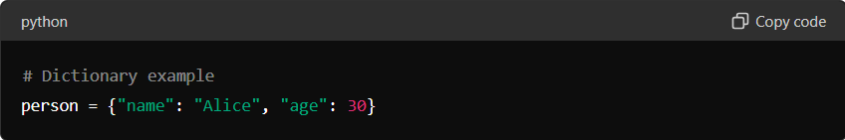

Example Explanation:
- Lists: Used for storing ordered collections of items that can be changed or updated.
- Tuples: Similar to lists but immutable, used when data should not change.
- Sets: Used for storing unique items where order is not important.
- Dictionaries: Used for storing key-value pairs, allowing efficient lookup and modification based on keys.
6. FILE HANDLING IN PYTHON:
File handling in Python allows you to perform various operations on files, such as reading from and writing to files. This is essential for tasks involving data storage and manipulation.

Detailed Explanation:
1. Opening and Closing Files:
- Files are opened using the open() function, which returns a file object.
- Use the close() method to close the file once operations are done.
Example: 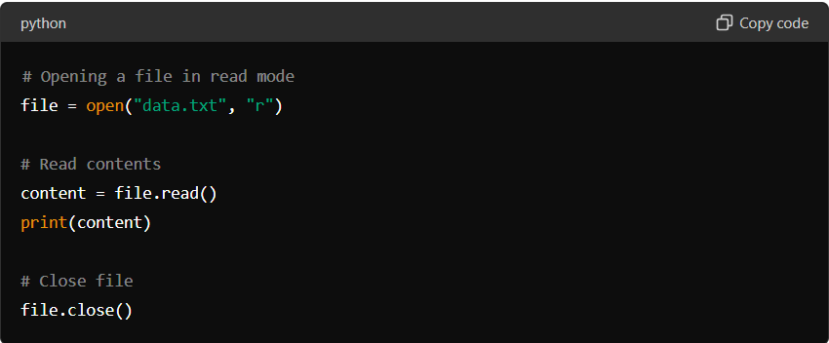
2. Reading from Files:
- Use methods like read(), readline(), or readlines() to read content from files.
- Handle file paths and exceptions using appropriate error handling.
Example: 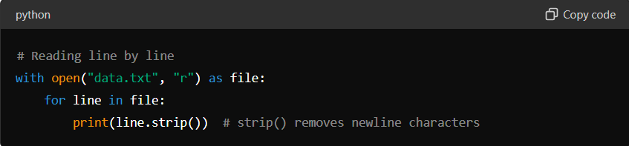
3. Writing to Files:
- Open a file in write or append mode ("w" or "a").
- Use write() or writelines() methods to write content to the file.
Example: 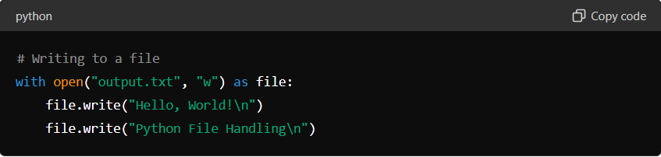

Example Explanation:
- Opening and Closing Files: Files are opened using open() and closed using close() to release resources.
- Reading from Files: Methods like read(), readline(), and readlines() allow reading content from files, handling file operations efficiently.
- Writing to Files: Use write() or writelines() to write data into files, managing file contents as needed.

7. ERRORS AND EXCEPTION HANDLING
Errors and exceptions are a natural part of programming. Python provides mechanisms to handle errors gracefully, preventing abrupt termination of programs.

Detailed Explanation:
- Types of Errors:
  - Syntax Errors: Occur when the code violates the syntax rules of Python. These are detected during compilation.
  - Exceptions: Occur during the execution of a program and can be handled using exception handling.
- Exception Handling:
- Use try, except, else, and finally blocks to handle exceptions.
- try block: Contains code that might raise an exception.
- except block: Handles specific exceptions raised in the try block.
- else block: Executes if no exceptions are raised in the try block.
- finally block: Executes cleanup code, regardless of whether an exception occurred or not.
Example: 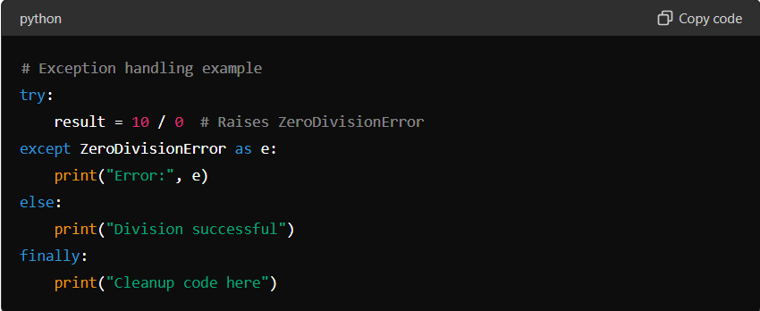
3. Raising Exceptions:
- Use raise statement to deliberately raise exceptions based on specific conditions or errors.
Example: 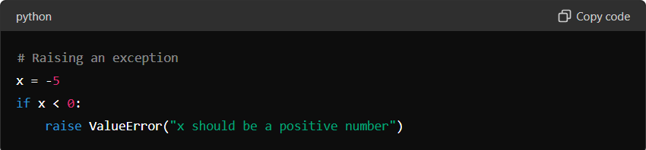

Example Explanation:
- Types of Errors: Syntax errors are caught during compilation, while exceptions occur during runtime.
- Exception Handling: try block attempts to execute code that may raise exceptions, except block catches specific exceptions, else block executes if no exceptions occur, and finally block ensures cleanup code runs regardless of exceptions.
- Raising Exceptions: Use raise to trigger exceptions programmatically based on specific conditions.

8. OBJECT-ORIENTED PROGRAMMING (OOP) USING PYTHON

Object-Oriented Programming (OOP) is a paradigm that allows you to structure your software in terms of objects that interact with each other. Python supports OOP principles such as encapsulation, inheritance, and polymorphism.

Detailed Explanation:
1. Classes and Objects:
- Class: Blueprint for creating objects. Defines attributes (data) and methods (functions) that belong to the class.
- Object: Instance of a class. Represents a specific entity based on the class blueprint.
Example: 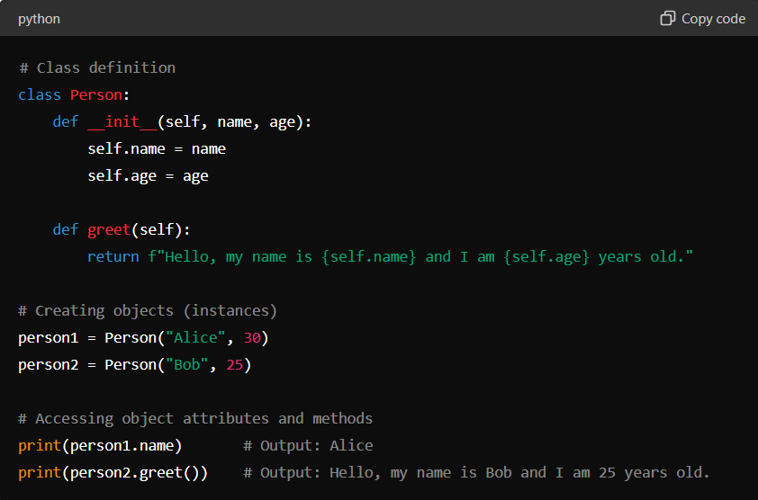
2. Encapsulation:
- Bundling of data (attributes) and methods that operate on the data into a single unit (class).
- Access to data is restricted to methods of the class, promoting data security and integrity.
3. Inheritance:
- Ability to create a new class (derived class or subclass) from an existing class (base class or superclass).
- Inherited class (subclass) inherits attributes and methods of the base class and can override or extend them.
Example: 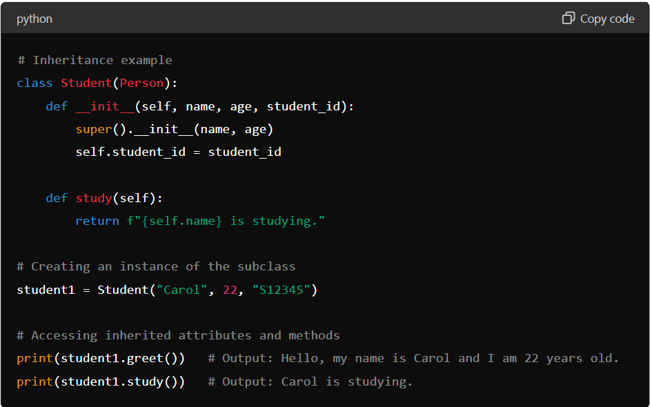
4. Polymorphism:
- Ability of objects to take on multiple forms. In Python, polymorphism is achieved through method overriding and method overloading.
- Same method name but different implementations in different classes.
Example: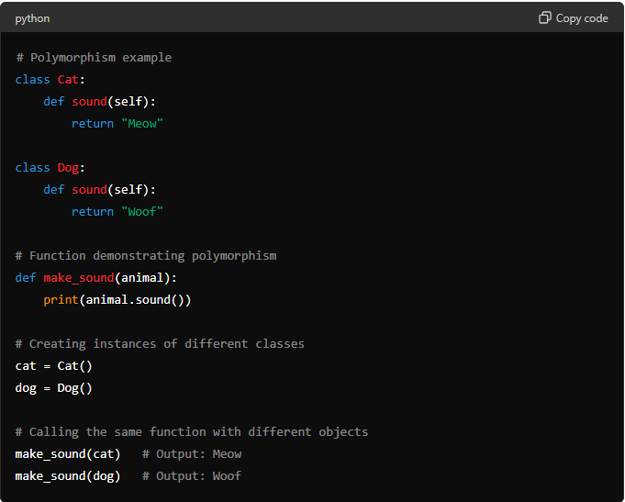

Example Explanation:
- Classes and Objects: Classes define the structure and behavior of objects, while objects are instances of classes with specific attributes and methods.
- Encapsulation: Keeps the internal state of an object private, controlling access through methods.
- Inheritance: Allows a new class to inherit attributes and methods from an existing class, facilitating code reuse and extension.
- Polymorphism: Enables flexibility by using the same interface (method name) for different data types or classes, allowing for method overriding and overloading.
PYTHON LIBRARIES FOR DATA SCIENCE

1. NUMPY
NumPy (Numerical Python) is a fundamental package for scientific computing in Python. It provides support for large, multi-dimensional arrays and matrices, along with a collection of mathematical functions to operate on these arrays efficiently.

Detailed Explanation:
- Arrays in NumPy:
  - NumPy's main object is the homogeneous multidimensional array (ndarray), which is a table of elements (usually numbers), all of the same type, indexed by a tuple of non-negative integers.
  - Arrays are created using np.array() and can be manipulated for various mathematical operations.
Example: 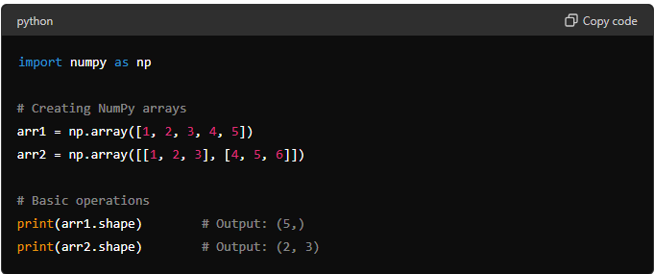
- NumPy Operations:
  - NumPy provides a wide range of mathematical functions such as np.sum(), np.mean(), np.max(), np.min(), etc., which operate element-wise on arrays or perform aggregations across axes.

Example: 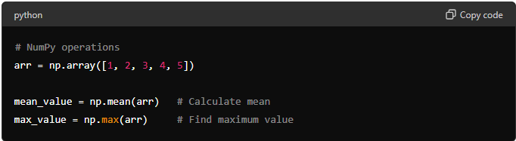
- Broadcasting:
  - Broadcasting is a powerful mechanism that allows NumPy to work with arrays of different shapes when performing arithmetic operations.
Example: 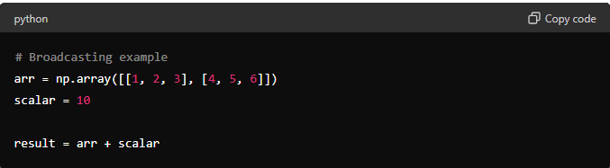

Example Explanation:
- Arrays in NumPy: NumPy arrays are homogeneous, multidimensional data structures that facilitate mathematical operations on large datasets efficiently.
- NumPy Operations: Use built-in functions and methods (np.sum(), np.mean(), etc.) to perform mathematical computations and aggregations on arrays.
- Broadcasting: Automatically extends smaller arrays to perform arithmetic operations with larger arrays, enhancing computational efficiency.
2. PANDAS
Pandas is a powerful library for data manipulation and analysis in Python. It provides data structures and operations for manipulating numerical tables and time series data.

Detailed Explanation:
- DataFrame and Series:
  - DataFrame: Represents a tabular data structure with labeled axes (rows and columns). It is similar to a spreadsheet or SQL table.
  - Series: Represents a one-dimensional labeled array capable of holding data of any type (integer, float, string, etc.).

Example: 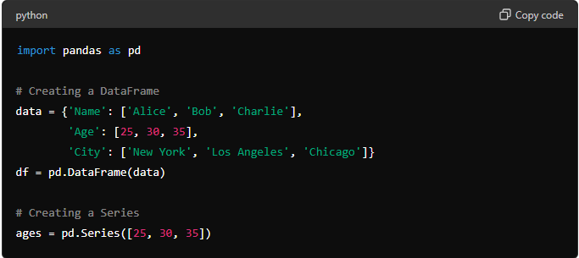
- Basic Operations:
  - Indexing and Selection: Use loc[] and iloc[] for label-based and integer-based indexing respectively.
  - Filtering: Use boolean indexing to filter rows based on conditions.
  - Operations: Apply operations and functions across rows or columns.
Example: 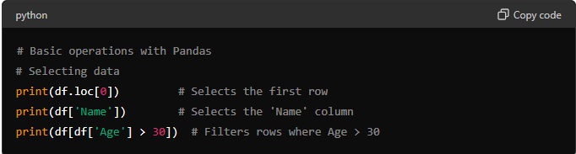
- Data Manipulation:
  - Adding and Removing Columns: Use assignment (df['New_Column'] = ...) or drop() method.
  - Handling Missing Data: Use dropna() to drop NaN values or fillna() to fill NaN values with specified values.
Example: 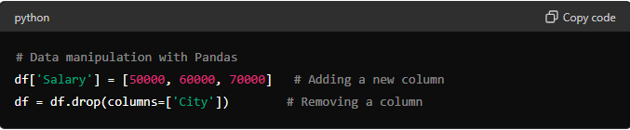
Example Explanation:
- DataFrame and Series: Pandas DataFrame is used for tabular data, while Series is used for one-dimensional labeled data.
  - Basic Operations: Perform indexing, selection, filtering, and operations on Pandas objects to manipulate and analyze data.
- Data Manipulation: Add or remove columns, handle missing data, and perform transformations using built-in Pandas methods.
3. MATPLOTLIB AND SEABORN
Matplotlib is a comprehensive library for creating static, animated, and interactive visualizations in Python. Seaborn is built on top of Matplotlib and provides a higher-level interface for drawing attractive and informative statistical graphics.

Detailed Explanation:
- Matplotlib:
  - Basic Plotting: Create line plots, scatter plots, bar plots, histograms, etc., using plt.plot(), plt.scatter(), plt.bar(), plt.hist(), etc.
  - Customization: Customize plots with labels, titles, legends, colors, markers, and other aesthetic elements.
  - Subplots: Create multiple plots within the same figure using plt.subplots().
Example: 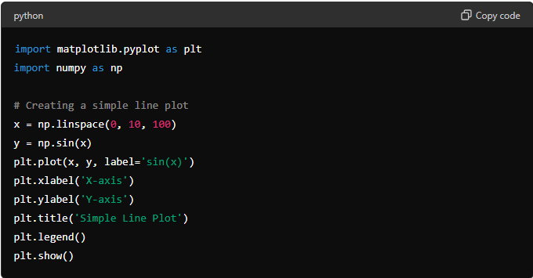
2. Seaborn:
- Statistical Plots: Easily create complex statistical visualizations like violin plots, box plots, pair plots, etc., with minimal code.
- Aesthetic Enhancements: Seaborn enhances Matplotlib plots with better aesthetics and default color palettes.
- Integration with Pandas: Seaborn integrates seamlessly with Pandas DataFrames for quick and intuitive data visualization.
Example: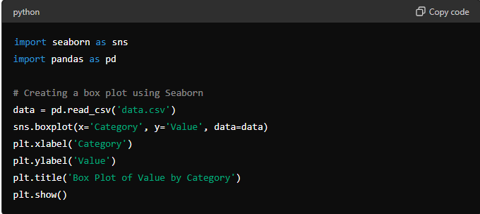

Example Explanation:
- Matplotlib: Create various types of plots and customize them using Matplotlib's extensive API for visualization.
- Seaborn: Build complex statistical plots quickly and easily, leveraging Seaborn's high-level interface and aesthetic improvements.

MODULE 3 – SQL FOR DATA SCIENCE

1. INTRODUCTION TO SQL
SQL (Structured Query Language) is a standard language for managing and manipulating relational databases. It is essential for data scientists to retrieve, manipulate, and analyze data stored in databases.

Detailed Explanation:
2. Basic SQL Commands:
- SELECT: Retrieves data from a database.
Example:
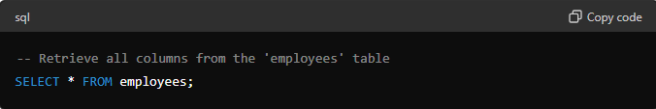*
- INSERT: Adds new rows of data into a database table.
Example: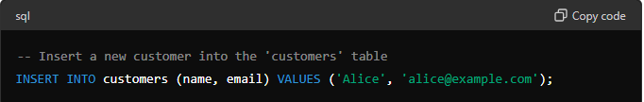
- UPDATE: Modifies existing data in a database table.
Example: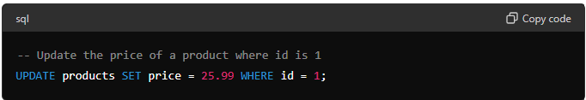
- DELETE: Removes rows from a database table.
Example: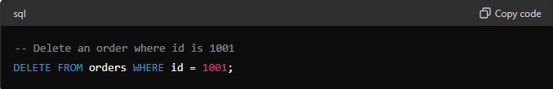
3. Querying Data:
- Use SELECT statements with conditions (WHERE), sorting (ORDER BY), grouping (GROUP BY), and aggregating functions (COUNT, SUM, AVG) to retrieve specific data subsets.
Example: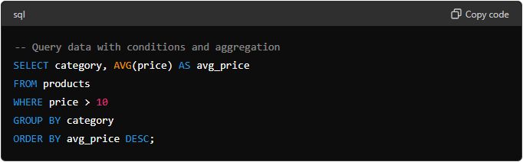
4. TYPES OF SQL JOINS
SQL joins are used to combine rows from two or more tables based on a related column between them. There are different types of joins:
- INNER JOIN:
  - Returns rows when there is a match in both tables based on the join condition.
Example: 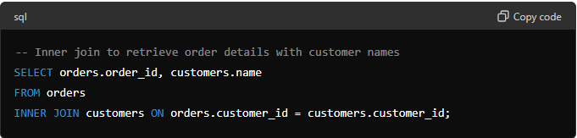
- LEFT JOIN (or LEFT OUTER JOIN):
  - Returns all rows from the left table (orders), and the matched rows from the right table (customers). If there is no match, NULL values are returned from the right side.
Example: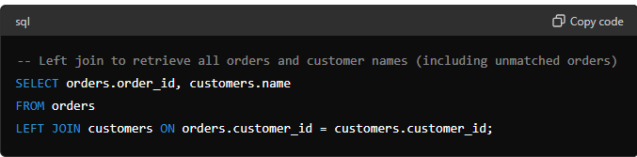
- RIGHT JOIN (or RIGHT OUTER JOIN):
  - Returns all rows from the right table (customers), and the matched rows from the left table (orders). If there is no match, NULL values are returned from the left side.
Example: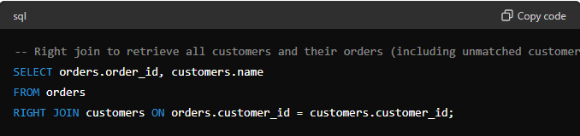
- FULL OUTER JOIN:
  - Returns all rows when there is a match in either left table (orders) or right table (customers). If there is no match, NULL values are returned from the opposite side.
Example: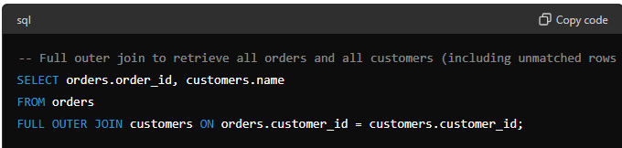

Example Explanation:
- INNER JOIN: Returns rows where there is a match in both tables based on the join condition (customer_id).
- LEFT JOIN: Returns all rows from the left table (orders) and the matched rows from the right table (customers). Returns NULL if there is no match.
- RIGHT JOIN: Returns all rows from the right table (customers) and the matched rows from the left table (orders). Returns NULL if there is no match.
- FULL OUTER JOIN: Returns all rows when there is a match in either table (orders or customers). Returns NULL if there is no match.

MODULE 4 -- MATHEMATICS FOR DATA SCIENCE

1. MATHEMATICAL FOUNDATIONS
Mathematics forms the backbone of data science, providing essential tools and concepts for understanding and analyzing data.

Detailed Explanation:
1. Linear Algebra:
  - Vectors and Matrices: Basic elements for representing and manipulating data.
  - Matrix Operations: Addition, subtraction, multiplication, transpose, and inversion of matrices.
  - Dot Product: Calculation of dot product between vectors and matrices.
Example: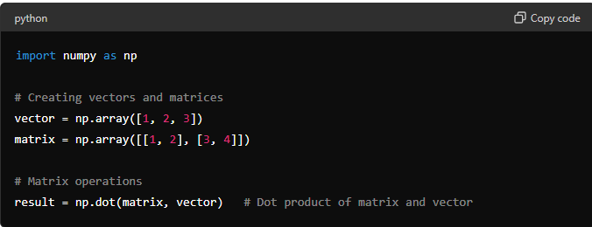
2. Calculus:
- Differentiation: Finding derivatives to analyze the rate of change of functions.
- Integration: Calculating areas under curves to analyze cumulative effects.
Example: 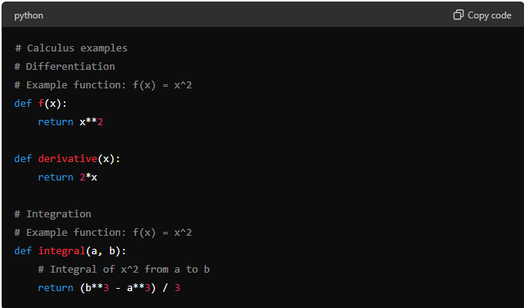

Example Explanation:
- Linear Algebra: Essential for handling large datasets with operations on vectors and matrices.
- Calculus: Provides tools for analyzing and modeling continuous changes and cumulative effects in data.

2. PROBABILITY AND STATISTICS FOR DATA SCIENCE
Probability and statistics are fundamental in data science for analyzing and interpreting data, making predictions, and drawing conclusions.

Detailed Explanation:
1. Probability Basics:
- Probability Concepts: Probability measures the likelihood of an event occurring. It ranges from 0 (impossible) to 1 (certain).
- Probability Rules: Includes addition rule (for mutually exclusive events) and multiplication rule (for independent events).
Example: 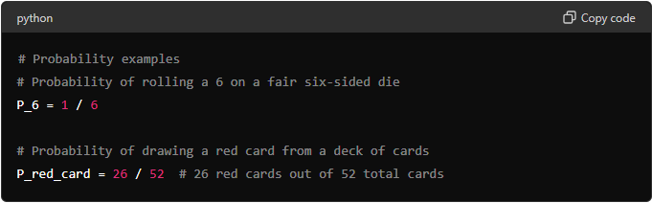
2. Descriptive Statistics:
Descriptive statistics are used to summarize and describe the basic features of data. They provide insights into the central tendency, dispersion, and shape of a dataset.

Detailed Explanation:
1.Measures of Central Tendency:
  - Mean: Also known as average, it is the sum of all values divided by the number of values.
  - Median: The middle value in a sorted, ascending or descending, list of numbers.
  - Mode: The value that appears most frequently in a dataset.
Example: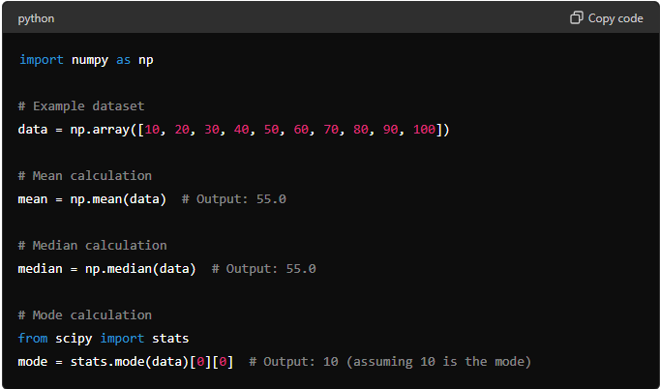
2. Measures of Dispersion:
- Variance: Measures how far each number in the dataset is from the mean.
- Standard Deviation: Square root of the variance; it indicates the amount of variation or dispersion of a set of values.
- Range: The difference between the maximum and minimum values in the dataset.
Example: 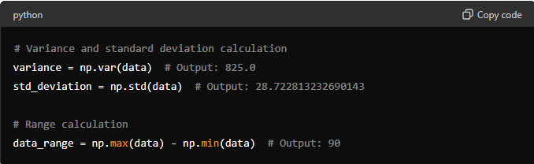
3. Skewness and Kurtosis:
- Skewness: Measures the asymmetry of the distribution of data around its mean.
- Kurtosis: Measures the "tailedness" of the data's distribution (how sharply or flatly peaked it is compared to a normal distribution).
Example: 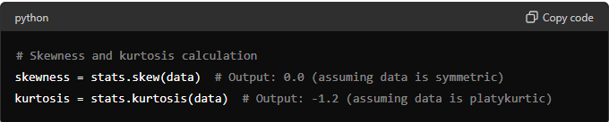

Example Explanation:
- Measures of Central Tendency: Provide insights into the typical value of the dataset (mean, median) and the most frequently occurring value (mode).
- Measures of Dispersion: Indicate the spread or variability of the dataset (variance, standard deviation, range).
- Skewness and Kurtosis: Describe the shape of the dataset distribution, whether it is symmetric or skewed, and its tail characteristics.

3. PROBABILITY DISTRIBUTIONS
Probability distributions are mathematical functions that describe the likelihood of different outcomes in an experiment. They play a crucial role in data science for modeling and analyzing data.

Detailed Explanation:
1.Normal Distribution:
- Definition: Also known as the Gaussian distribution, it is characterized by its bell-shaped curve where the data cluster around the mean.
- Parameters: Defined by mean (μ) and standard deviation (σ).
Example: 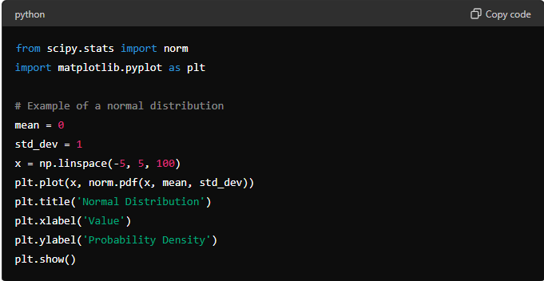
2. Binomial Distribution:
- Definition: Models the number of successes (or failures) in a fixed number of independent Bernoulli trials (experiments with two outcomes).
- Parameters: Number of trials (n) and probability of success in each trial (p).
Example: 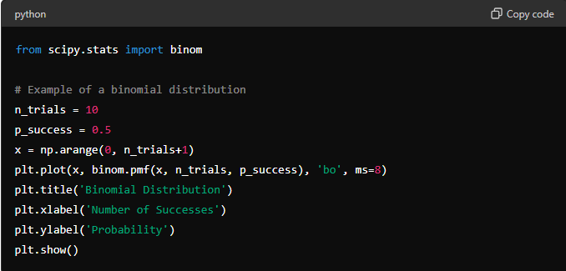
3.Poisson Distribution:
- Definition: Models the number of events occurring in a fixed interval of time or space when events happen independently at a constant average rate.
- Parameter: Average rate of events occurring (λ).
Example: 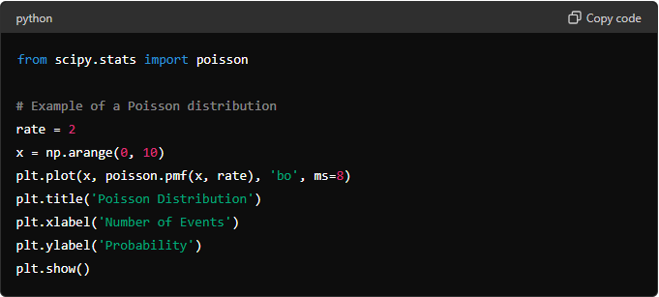

Example Explanation:
- Normal Distribution: Commonly used to model phenomena such as heights, weights, and measurement errors due to its symmetrical and well-understood properties.
- Binomial Distribution: Applicable when dealing with discrete outcomes (success/failure) in a fixed number of trials, like coin flips or medical trials.
- Poisson Distribution: Useful for modeling rare events or occurrences over a fixed interval of time or space, such as the number of emails received per day or number of calls to a customer service center.
MODULE 5 – MACHINE LEARNING

INTRODUCTION TO MACHINE LEARNING
Machine Learning (ML) is a branch of artificial intelligence (AI) that empowers computers to learn from data and improve their performance over time without explicit programming. It focuses on developing algorithms that can analyze and interpret patterns in data to make predictions or decisions.

Detailed Explanation:
- Types of Machine Learning
  - Supervised Learning: Learns from labeled data, making predictions or decisions based on input-output pairs.
  - Unsupervised Learning: Extracts patterns from unlabeled data, identifying hidden structures or relationships.
  - Reinforcement Learning: Trains models to make sequences of decisions, learning through trial and error with rewards or penalties.
  - Semi-Supervised Learning: Uses a combination of labeled and unlabeled data for training.
  - Transfer Learning: Applies knowledge learned from one task to a different but related task
- Applications of Machine Learning
  - Natural Language Processing (NLP): Speech recognition, language translation, sentiment analysis.
  - Computer Vision: Object detection, image classification, facial recognition.
  - Healthcare: Disease diagnosis, personalized treatment plans, medical image analysis.
  - Finance: Fraud detection, stock market analysis, credit scoring.
  - Recommendation Systems: Product recommendations, content filtering, personalized marketing.
- Machine Learning vs. Data Science
  - Machine Learning: Focuses on algorithms and models to make predictions or decisions based on data.
  - Data Science: Broader field encompassing data collection, cleaning, analysis, visualization, and interpretation to derive insights and make informed decisions.
- Machine Learning vs. Deep Learning
  - Machine Learning: Relies on algorithms and statistical models to perform tasks; requires feature engineering and domain expertise.
  - Deep Learning: Subset of ML using artificial neural networks with multiple layers to learn representations of data; excels in handling large volumes of data and complex tasks like image and speech recognition.
SUPERVISED MACHINE LEARNING
Supervised learning involves training a model on labeled data, where each data point is paired with a corresponding target variable (label). The goal is to learn a mapping from input variables (features) to the output variable (target) based on the input-output pairs provided during training.
Classification
Definition: Classification is a type of supervised learning where the goal is to predict discrete class labels for new instances based on past observations with known class labels.
Algorithms:
- Logistic Regression: Estimates probabilities using a logistic function.
- Decision Trees: Hierarchical tree structures where nodes represent decisions based on feature values.
- Random Forest: Ensemble of decision trees to improve accuracy and reduce overfitting.
- Support Vector Machines (SVM): Finds the optimal hyperplane that best separates classes in high-dimensional space.
- k-Nearest Neighbors (k-NN): Classifies new instances based on similarity to known examples
1. Logistic Regression
- Definition: Despite its name, logistic regression is a linear model for binary classification that uses a logistic function to estimate probabilities.
- Key Concepts:
  - Logistic Function: Sigmoid function that maps input values to probabilities between 0 and 1.
  - Decision Boundary: Threshold that separates the classes based on predicted probabilities.
: 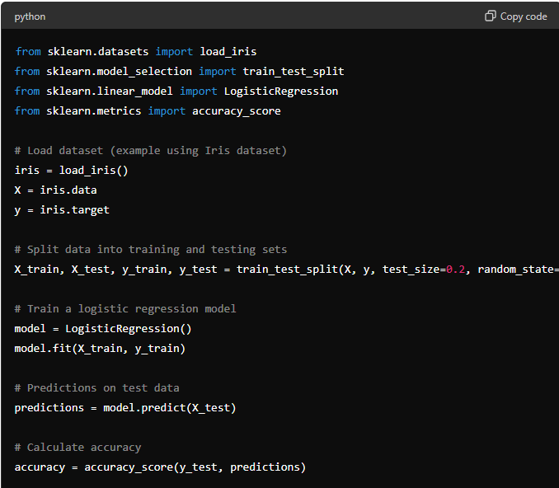
2. Decision Trees
- Definition: Non-linear model that uses a tree structure to make decisions by splitting the data into nodes based on feature values.
- Key Concepts:
  - Nodes and Branches: Represent conditions and possible outcomes in the decision-making process.
  - Entropy and Information Gain: Measures used to determine the best split at each node.
Example:
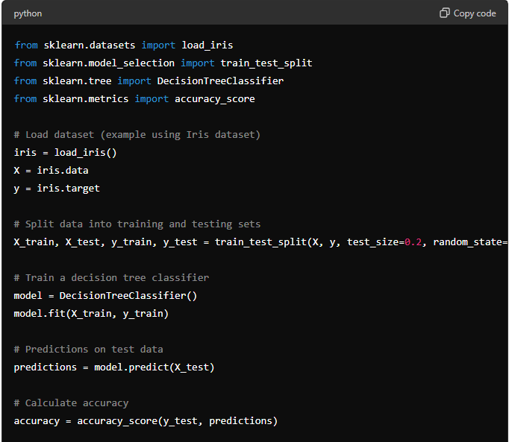
3. Random Forest
- Definition: Ensemble learning method that constructs multiple decision trees during training and outputs the mode of the classes (classification) or mean prediction (regression) of the individual trees.
- Key Concepts:
  - Bagging: Technique that combines multiple models to improve performance and reduce overfitting.
  - Feature Importance: Measures the contribution of each feature to the model's predictions.
Example: 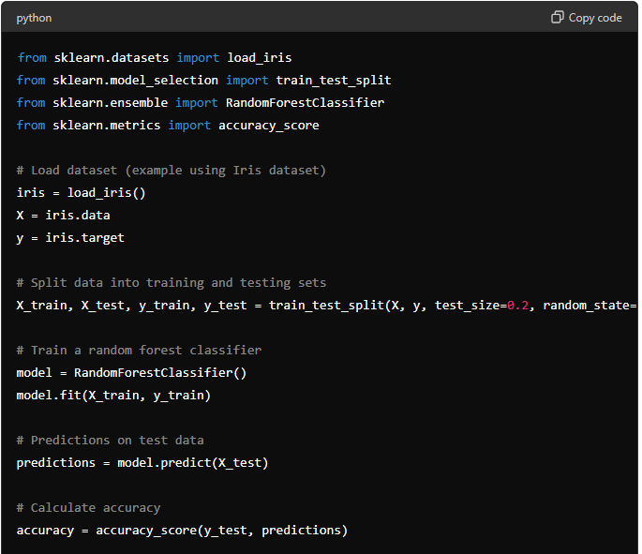

4. Support Vector Machines (Svm)
Support Vector Machines (SVM) are robust supervised learning models used for classification and regression tasks. They excel in scenarios where the data is not linearly separable by transforming the input space into a higher dimension.

Detailed Explanation:
- Basic Concepts of SVM
  - Hyperplane: SVMs find the optimal hyperplane that best separates classes in a high-dimensional space.
  - Support Vectors: Data points closest to the hyperplane that influence its position and orientation.
  - Kernel Trick: Technique to transform non-linearly separable data into linearly separable data using kernel functions (e.g., polynomial, radial basis function (RBF)).

- Types of SVM
  - C-Support Vector Classification (SVC): SVM for classification tasks, maximizing the margin between classes.
  - Nu-Support Vector Classification (NuSVC): Similar to SVC but allows control over the number of support vectors and training errors.
  - Support Vector Regression (SVR): SVM for regression tasks, fitting a hyperplane within a margin of tolerance.
Example (SVM for Classification): 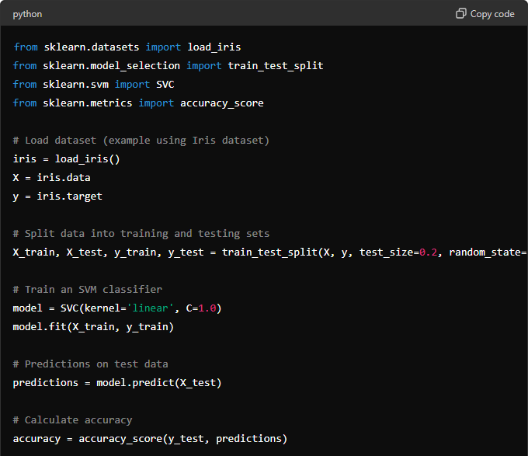
3. Advantages of SVM
- Effective in High-Dimensional Spaces: Handles datasets with many features (dimensions).
- Versatile Kernel Functions: Can model non-linear decision boundaries using different kernel functions.
- Regularization Parameter (C): Controls the trade-off between maximizing the margin and minimizing classification errors.
4. Applications of SVM
- Text and Hypertext Categorization: Document classification, spam email detection.
- Image Recognition: Handwritten digit recognition, facial expression classification.
- Bioinformatics: Protein classification, gene expression analysis.
Hyperplane and Support Vectors: SVMs find the optimal hyperplane that maximizes the margin between classes, with support vectors influencing its position.
Kernel Trick: Transforms data into higher dimensions to handle non-linear separability, improving classification accuracy.
Applications: SVMs are applied in diverse fields for classification tasks requiring robust performance and flexibility in handling complex data patterns.

5. Decision Trees
Decision Trees are versatile supervised learning models used for both classification and regression tasks. They create a tree-like structure where each internal node represents a "decision" based on a feature, leading to leaf nodes that represent the predicted outcome.

Detailed Explanation:
- Basic Concepts of Decision Trees
  - Nodes and Branches: Nodes represent features or decisions, and branches represent possible outcomes or decisions.
  - Splitting Criteria: Algorithms choose the best feature to split the data at each node based on metrics like Gini impurity or information gain.
  - Tree Pruning: Technique to reduce the size of the tree to avoid overfitting.
- Types of Decision Trees
  - Classification Trees: Predicts discrete class labels for new data points.
  - Regression Trees: Predicts continuous numeric values for new data points.
Example (Decision Tree for Classification):
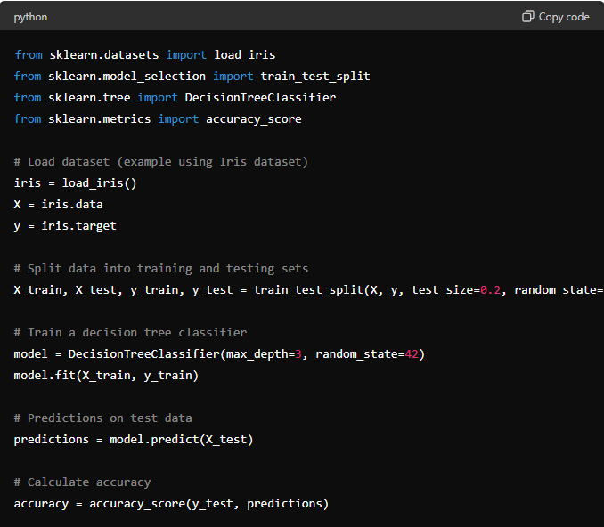
3. Advantages of Decision Trees
- Interpretability: Easy to interpret and visualize, making it useful for exploratory data analysis.
- Handles Non-linearity: Can capture non-linear relationships between features and target variables.
- Feature Importance: Automatically selects the most important features for prediction.
4. Applications of Decision Trees
- Finance: Credit scoring, loan default prediction.
- Healthcare: Disease diagnosis based on symptoms.
- Marketing: Customer segmentation, response prediction to marketing campaigns.
Regression Analysis

1. Linear Regression
Linear Regression is a fundamental supervised learning algorithm used for predicting continuous numeric values based on input features. It assumes a linear relationship between the input variables (features) and the target variable.

Detailed Explanation:
1. Basic Concepts of Linear Regression
- Linear Model: Represents the relationship between the input features XXX and the target variable yyy using a linear equation.
- Coefficients: Slope coefficients β\betaβ that represent the impact of each feature on the target variable.
- Intercept: Constant term β0\beta_0β0​ that shifts the regression line.
2. Types of Linear Regression
- Simple Linear Regression: Predicts a target variable using a single input feature.
- Multiple Linear Regression: Predicts a target variable using multiple input features.
3. Assumptions of Linear Regression
- Linearity: Assumes a linear relationship between predictors and the target variable.
- Independence of Errors: Residuals (errors) should be independent of each other.
- Homoscedasticity: Residuals should have constant variance across all levels of predictors.

Example (Simple Linear Regression): 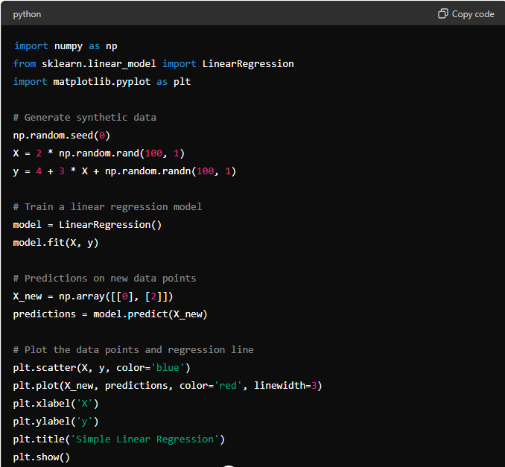
4. Advantages of Linear Regression
- Interpretability: Easy to interpret coefficients and understand the impact of predictors.
- Computational Efficiency: Training and prediction times are generally fast.
- Feature Importance: Identifies which features are most influential in predicting the target variable.
5. Applications of Linear Regression
- Economics: Predicting GDP growth based on economic indicators.
- Marketing: Predicting sales based on advertising spend.
- Healthcare: Predicting patient outcomes based on medical data.

2. Naive Bayes
Naive Bayes is a probabilistic supervised learning algorithm based on Bayes' theorem, with an assumption of independence between features. It is commonly used for classification tasks and is known for its simplicity and efficiency, especially with high-dimensional data.

Detailed Explanation:
- Basic Concepts of Naive Bayes
  - Bayes' Theorem: Probabilistic formula that calculates the probability of a hypothesis based on prior knowledge.
  - Independence Assumption: Assumes that the features are conditionally independent given the class label.
  - Posterior Probability: Probability of a class label given the features.
- Types of Naive Bayes
  - Gaussian Naive Bayes: Assumes that continuous features follow a Gaussian distribution.
  - Multinomial Naive Bayes: Suitable for discrete features (e.g., word counts in text classification).
  - Bernoulli Naive Bayes: Assumes binary or boolean features (e.g., presence or absence of a feature).
Example (Gaussian Naive Bayes): 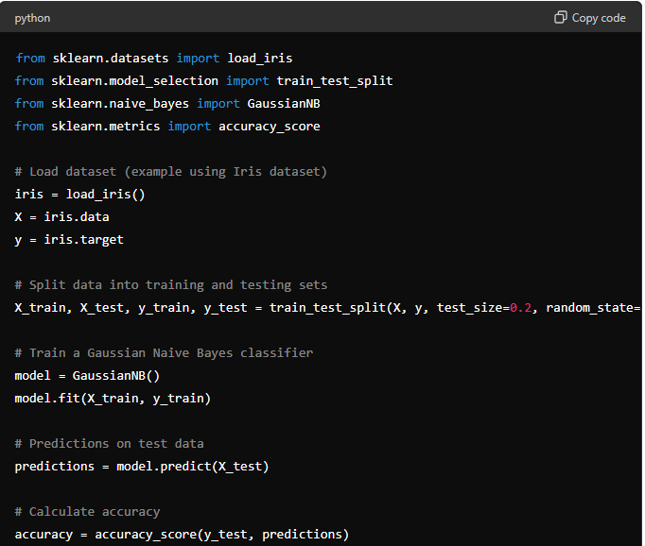
3. Advantages of Naive Bayes
- Efficiency: Fast training and prediction times, especially with large datasets.
- Simplicity: Easy to implement and interpret, making it suitable for baseline classification tasks.
- Scalability: Handles high-dimensional data well, such as text classification.
4. Applications of Naive Bayes
- Text Classification: Spam detection, sentiment analysis.
- Medical Diagnosis: Disease prediction based on symptoms.
- Recommendation Systems: User preferences prediction.

3. Support Vector Machines (Svm) For Regression
Support Vector Machines (SVM) are versatile supervised learning models that can be used for both classification and regression tasks. In regression, SVM aims to find a hyperplane that best fits the data, while maximizing the margin from the closest points (support vectors).

Detailed Explanation:
- Basic Concepts of SVM for Regression
  - Kernel Trick: SVM can use different kernel functions (linear, polynomial, radial basis function) to transform the input space into a higher-dimensional space where a linear hyperplane can separate the data.
  - Loss Function: SVM minimizes the error between predicted values and actual values, while also maximizing the margin around the hyperplane.
- Mathematical Formulation
  - SVM for regression predicts the target variable yyy for an instance X using a linear function
Example (Support Vector Machines for Regression):
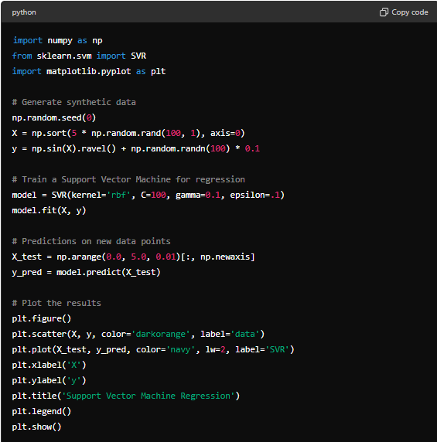
3. Advantages of SVM for Regression
  - Effective in High-Dimensional Spaces: SVM can handle data with many features (high-dimensional spaces).
  - Robust to Overfitting: SVM uses a regularization parameter CCC to control overfitting.
  - Versatility: Can use different kernel functions to model non-linear relationships in data.
4.Applications of SVM for Regression
  - Stock Market Prediction: Predicting stock prices based on historical data.
  - Economics: Forecasting economic indicators like GDP growth.
  - Engineering: Predicting equipment failure based on sensor data.

Example Explanation:
• Kernel Trick: SVM uses kernel functions to transform the input space into a higher-dimensional space where data points can be linearly separated.
• Loss Function: SVM minimizes the error between predicted and actual values while maximizing the margin around the hyperplane.
• Applications: SVM is widely used in regression tasks where complex relationships between variables need to be modeled effectively.

4. Random Forest For Regression
Random Forest is an ensemble learning method that constructs multiple decision trees during training and outputs the average prediction of the individual trees for regression tasks.

Detailed Explanation:
- Basic Concepts of Random Forest
  - Ensemble Learning: Combines multiple decision trees to improve generalization and robustness over a single tree.
  - Bagging: Random Forest uses bootstrap aggregating (bagging) to train each tree on a random subset of the data.
  - Decision Trees: Each tree in the forest is trained on a different subset of the data and makes predictions independently.
- Random Forest Algorithm
  - Tree Construction: Random Forest builds multiple decision trees, where each tree is trained on a random subset of features and data points.
  - Prediction: For regression, Random Forest averages the predictions of all trees to obtain the final output.
Example (Random Forest for Regression): 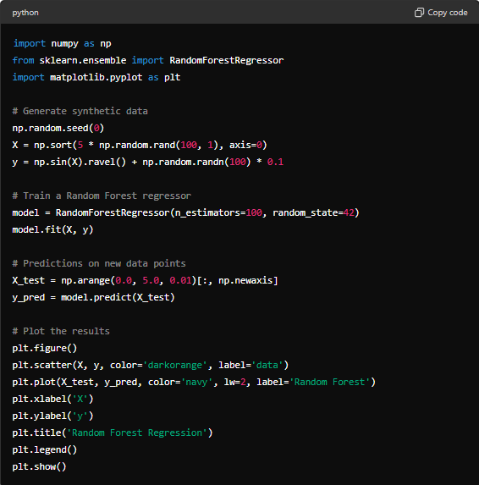
3. Advantages of Random Forest for Regression
- High Accuracy: Combines multiple decision trees to reduce overfitting and improve prediction accuracy.
- Feature Importance: Provides a measure of feature importance based on how much each feature contributes to reducing impurity across all trees.
- Robustness: Less sensitive to outliers and noise in the data compared to individual decision trees.
4. Applications of Random Forest for Regression
- Predictive Modeling: Sales forecasting based on historical data.
- Climate Prediction: Forecasting temperature trends based on meteorological data.
- Financial Analysis: Predicting stock prices based on market indicators.

Example Explanation:
- Ensemble Learning: Random Forest combines multiple decision trees to obtain a more accurate and stable prediction.
- Feature Importance: Random Forest calculates feature importance scores, allowing analysts to understand which variables are most influential in making predictions.
- Applications: Random Forest is widely used in various domains for regression tasks where accuracy and robustness are crucial.

5. Gradient Boosting For Regression
Gradient Boosting is an ensemble learning technique that combines multiple weak learners (typically decision trees) sequentially to make predictions for regression tasks.

Detailed Explanation:
- Basic Concepts of Gradient Boosting
  - Boosting Technique: Sequentially improves the performance of weak learners by emphasizing the mistakes of previous models.
  - Gradient Descent: Minimizes the loss function by gradient descent, adjusting subsequent models to reduce the residual errors.
  - Trees as Weak Learners: Typically, decision trees are used as weak learners, known as Gradient Boosted Trees.
- Gradient Boosting Algorithm
  - Sequential Training: Trains each new model (tree) to predict the residuals (errors) of the ensemble of previous models.
  - Gradient Descent: Updates the ensemble by adding a new model that minimizes the loss function gradient with respect to the predictions.
Example (Gradient Boosting for Regression):
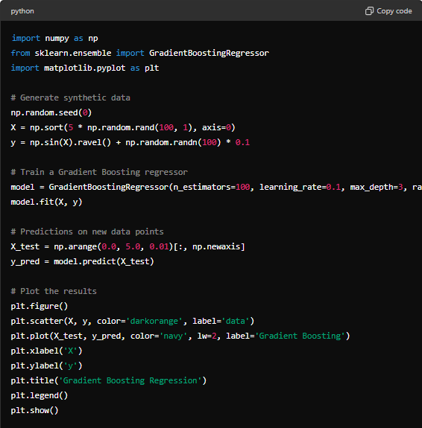
3. Advantages of Gradient Boosting for Regression
  - High Predictive Power: Combines the strengths of multiple weak learners to produce a strong predictive model.
  - Handles Complex Relationships: Can capture non-linear relationships between features and target variable.
  - Regularization: Built-in regularization through shrinkage (learning rate) and tree constraints (max depth).
4. Applications of Gradient Boosting for Regression
  - Click-Through Rate Prediction: Predicting user clicks on online advertisements.
  - Customer Lifetime Value: Estimating the future value of customers based on past interactions.
  - Energy Consumption Forecasting: Predicting energy usage based on historical data.

Example Explanation:
- Boosting Technique: Gradient Boosting sequentially improves the model's performance by focusing on the residuals (errors) of previous models.
- Gradient Descent: Updates the model by minimizing the loss function gradient, making successive models more accurate.
- Applications: Gradient Boosting is widely used in domains requiring high predictive accuracy and handling complex data relationships.

UNSUPERVISED MACHINE LEARNING

INTRODUCTION TO UNSUPERVISED LEARNING
Unsupervised learning algorithms are used when we only have input data (X) and no corresponding output variables. The algorithms learn to find the inherent structure in the data, such as grouping or clustering similar data points together.

Detailed Explanation:
- Basic Concepts of Unsupervised Learning
  - No Target Variable: Unlike supervised learning, unsupervised learning does not require labeled data.
  - Exploratory Analysis: Unsupervised learning helps in exploring data to understand its characteristics and patterns.
  - Types of Tasks: Common tasks include clustering similar data points together or reducing the dimensionality of the data.
- Types of Unsupervised Learning Tasks
  - Clustering: Grouping similar data points together based on their features or similarities.
  - Dimensionality Reduction: Reducing the number of variables under consideration by obtaining a set of principal variables.
- Algorithms in Unsupervised Learning
  - Clustering Algorithms: Such as K-Means, Hierarchical Clustering, DBSCAN.
  - Dimensionality Reduction Techniques: Like Principal Component Analysis (PCA), t-Distributed Stochastic Neighbor Embedding (t-SNE).
- Applications of Unsupervised Learning
  - Customer Segmentation: Grouping customers based on their purchasing behaviors.
  - Anomaly Detection: Identifying unusual patterns in data that do not conform to expected behavior.
  - Recommendation Systems: Suggesting items based on user preferences and similarities.
Dimensionality Reduction Techniques

Principal Component Analysis (Pca)
Principal Component Analysis (PCA) is a dimensionality reduction technique used to transform high-dimensional data into a lower-dimensional space while preserving the most important aspects of the original data.

Detailed Explanation:
- Basic Concepts of PCA
  - Dimensionality Reduction: Reduces the number of features (dimensions) in the data while retaining as much variance as possible.
  - Eigenvalues and Eigenvectors: PCA identifies the principal components (eigenvectors) that capture the directions of maximum variance in the data.
  - Variance Explanation: Each principal component explains a certain percentage of the variance in the data.
- PCA Algorithm
  - Step-by-Step Process:
    - Standardize the data (mean centering and scaling).
    - Compute the covariance matrix of the standardized data.
    - Calculate the eigenvectors and eigenvalues of the covariance matrix.
    - Select the top kkk eigenvectors (principal components) that explain the most variance.
    - Project the original data onto the selected principal components to obtain the reduced-dimensional representation.
Example (PCA): 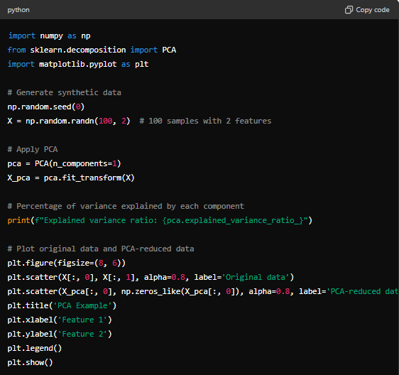
3. Advantages of PCA
- Dimensionality Reduction: Reduces the computational complexity and storage space needed for processing data.
- Feature Interpretability: PCA transforms data into a new space where features are uncorrelated (orthogonal).
- Noise Reduction: Focuses on capturing the largest sources of variance, effectively filtering out noise.
4.Applications of PCA
- Image Compression: Reduce the dimensionality of image data while retaining important features.
- Bioinformatics: Analyze gene expression data to identify patterns and reduce complexity.
- Market Research: Analyze customer purchase behavior across multiple product categories.
Clustering techniques

K-Means Clustering
K-Means clustering is a popular unsupervised learning algorithm used for partitioning a dataset into K distinct, non-overlapping clusters.

Detailed Explanation:
- Basic Concepts of K-Means Clustering
  - Objective: Minimize the variance within each cluster and maximize the variance between clusters.
  - Centroid-Based: Each cluster is represented by its centroid, which is the mean of the data points assigned to the cluster.
  - Distance Measure: Typically uses Euclidean distance to assign data points to clusters.
- K-Means Algorithm
  - Initialization: Randomly initialize K centroids.
  - Assignment: Assign each data point to the nearest centroid based on distance (typically Euclidean distance).
  - Update Centroids: Recalculate the centroids as the mean of all data points assigned to each centroid.
  - Iterate: Repeat the assignment and update steps until convergence (when centroids no longer change significantly or after a specified number of iterations).
Example (K-Means Clustering):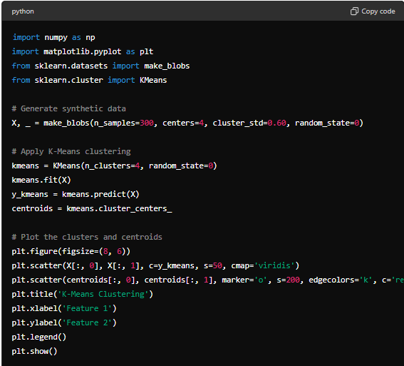
3.Advantages of K-Means Clustering
- Simple and Efficient: Easy to implement and computationally efficient for large datasets.
- Scalable: Scales well with the number of data points and clusters.
- Interpretability: Provides interpretable results by assigning each data point to a cluster.
4. Applications of K-Means Clustering
- Customer Segmentation: Grouping customers based on purchasing behavior for targeted marketing.
- Image Segmentation: Partitioning an image into regions based on color similarity.
- Anomaly Detection: Identifying outliers or unusual patterns in data.

Hierarchical Clustering
Hierarchical Clustering is an unsupervised learning algorithm that groups similar objects into clusters based on their distances or similarities.

Detailed Explanation:
- Basic Concepts of Hierarchical Clustering
  - Agglomerative vs. Divisive:
    - Agglomerative: Starts with each data point as a singleton cluster and iteratively merges the closest pairs of clusters until only one cluster remains.
    - Divisive: Starts with all data points in one cluster and recursively splits them into smaller clusters until each cluster contains only one data point.
  - Distance Measures: Uses measures like Euclidean distance or correlation to determine the similarity between data points.
- Hierarchical Clustering Algorithm
  - Distance Matrix: Compute a distance matrix that measures the distance between each pair of data points.
  - Merge or Split: Iteratively merge or split clusters based on their distances until the desired number of clusters is achieved or a termination criterion is met.
  - Dendrogram: Visual representation of the clustering process, showing the order and distances of merges or splits.
Example (Hierarchical Clustering):
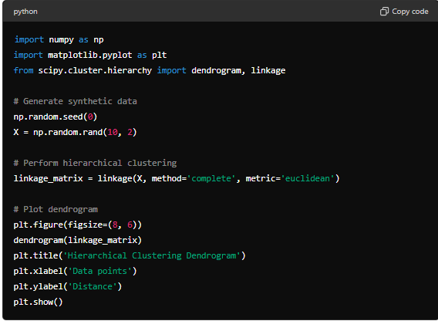
3. Advantages of Hierarchical Clustering
- No Need to Specify Number of Clusters: Hierarchical clustering does not require the number of clusters to be specified beforehand.
- Visual Representation: Dendrogram provides an intuitive visual representation of the clustering hierarchy.
- Cluster Interpretation: Helps in understanding the relationships and structures within the data.
4. Applications of Hierarchical Clustering
- Biology: Grouping genes based on expression levels for studying genetic relationships.
- Document Clustering: Organizing documents based on similarity of content.
- Market Segmentation: Segmenting customers based on purchasing behavior for targeted marketing strategies.

MODULE 6 – INTRODUCTION TO DEEP LEARNING

INTRODUCTION TO DEEP LEARNING
Deep Learning is a subset of machine learning that involves neural networks with many layers (deep architectures) to learn from data. It has revolutionized various fields like computer vision, natural language processing, and robotics.
Detailed Explanation:
- Basic Concepts of Deep Learning
  - Neural Networks: Deep Learning models are based on artificial neural networks inspired by the human brain's structure.
  - Layers: Deep networks consist of multiple layers (input layer, hidden layers, output layer), each performing specific transformations.
  - Feature Learning: Automatically learn hierarchical representations of data, extracting features at different levels of abstraction.
- Components of Deep Learning
  - Artificial Neural Networks (ANN): Basic building blocks of deep learning models, consisting of interconnected layers of neurons.
  - Activation Functions: Non-linear functions applied to neurons to introduce non-linearity and enable complex mappings.
  - Backpropagation: Training algorithm used to adjust model weights based on the difference between predicted and actual outputs.
- Applications of Deep Learning
  - Image Recognition: Classifying objects in images (e.g., detecting faces, identifying handwritten digits).
  - Natural Language Processing (NLP): Processing and understanding human language (e.g., sentiment analysis, machine translation).
  - Autonomous Driving: Training models to perceive and navigate the environment in autonomous vehicles.

Example Explanation:
- Neural Networks: Deep Learning models use interconnected layers of neurons to process and learn from data.
- Feature Learning: Automatically learn hierarchical representations of data, reducing the need for manual feature engineering.
- Applications: Deep Learning has transformed industries by achieving state-of-the-art performance in complex tasks like image and speech recognition.

Basic Terminology For Deep Learning - Neural Networks
• Neuron:
- A fundamental unit of a neural network that receives inputs, applies weights, and computes an output using an activation function.
• Activation Function:
- Non-linear function applied to the output of a neuron, allowing neural networks to learn complex patterns. Examples include ReLU (Rectified Linear Unit), sigmoid, and tanh.
• Layer:
- A collection of neurons that process input data. Common layers include input, hidden (where computations occur), and output (producing the network's predictions).
• Feedforward Neural Network:
- A type of neural network where connections between neurons do not form cycles, and data flows in one direction from input to output.
• Backpropagation:
- Learning algorithm used to train neural networks by adjusting weights in response to the network's error. It involves computing gradients of the loss function with respect to each weight.
• Loss Function:
- Measures the difference between predicted and actual values. It guides the optimization process during training by quantifying the network's performance.
• Gradient Descent:
- Optimization technique used to minimize the loss function by iteratively adjusting weights in the direction of the negative gradient.
• Batch Size:
- Number of training examples used in one iteration of gradient descent. Larger batch sizes can speed up training but require more memory.
• Epoch:
- One complete pass through the entire training dataset during the training of a neural network.
• Learning Rate:
- Parameter that controls the size of steps taken during gradient descent. It affects how quickly the model learns and converges to optimal weights.
• Overfitting:
- Condition where a model learns to memorize the training data rather than generalize to new, unseen data. Regularization techniques help mitigate overfitting.
• Underfitting:
- Condition where a model is too simple to capture the underlying patterns in the training data, resulting in poor performance on both training and test datasets.
• Dropout:
- Regularization technique where randomly selected neurons are ignored during training to prevent co-adaptation of neurons and improve model generalization.
• Convolutional Neural Network (CNN):
- Deep learning architecture particularly effective for processing grid-like data, such as images. CNNs use convolutional layers to automatically learn hierarchical features.
• Recurrent Neural Network (RNN):
- Neural network architecture designed for sequential data processing, where connections between neurons can form cycles. RNNs are suitable for tasks like time series prediction and natural language processing.

Neural Network Architecture And Its Working
Neural networks are computational models inspired by the human brain's structure and function. They consist of interconnected neurons organized into layers, each performing specific operations on input data to produce desired outputs. Here's an overview of neural network architecture and its working:

Neural Network Architecture
- Neurons and Layers:
  - Neuron: The basic unit that receives inputs, applies weights, and computes an output using an activation function.
  - Layers: Neurons are organized into layers:
    - Input Layer: Receives input data and passes it to the next layer.
    - Hidden Layers: Intermediate layers between the input and output layers. They perform computations and learn representations of the data.
    - Output Layer: Produces the final output based on the computations of the hidden layers.
- Connections and Weights:
  - Connections: Neurons in adjacent layers are connected by weights, which represent the strength of influence between neurons.
  - Weights: Adjusted during training to minimize the difference between predicted and actual outputs, using techniques like backpropagation and gradient descent.
- Activation Functions:
  - Purpose: Applied to the output of each neuron to introduce non-linearity, enabling neural networks to learn complex patterns.

Working of Neural Networks
- Feedforward Process:
  - Input Propagation: Input data is fed into the input layer of the neural network.
  - Forward Pass: Data flows through the network layer by layer. Each neuron in a layer receives inputs from the previous layer, computes a weighted sum, applies an activation function, and passes the result to the next layer.
  - Output Generation: The final layer (output layer) produces predictions or classifications based on the learned representations from the hidden layers.
- Training Process:
  - Loss Calculation: Compares the network's output with the true labels to compute a loss (error) value using a loss function (e.g., Mean Squared Error for regression, Cross-Entropy Loss for classification).
  - Backpropagation: Algorithm used to minimize the loss by adjusting weights backward through the network. It computes gradients of the loss function with respect to each weight using the chain rule of calculus.
  - Gradient Descent: Optimization technique that updates weights in the direction of the negative gradient to reduce the loss, making the network more accurate over time.
  - Epochs and Batch Training: Training involves multiple passes (epochs) through the entire dataset, with updates applied in batches to improve training efficiency and generalization.
- Model Evaluation and Deployment:
  - Validation: After training, the model's performance is evaluated on a separate validation dataset to assess its generalization ability.
  - Deployment: Once validated, the trained model can be deployed to make predictions or classifications on new, unseen data in real-world applications.

Types Of Neural Networks and Their Importance

1. Feedforward Neural Networks (FNN)
- Description: Feedforward Neural Networks are the simplest form of neural networks where information travels in one direction: from input nodes through hidden layers (if any) to output nodes.
- Importance: They form the foundation of more complex neural networks and are widely used for tasks like classification and regression.
- Applications:
  - Classification: Image classification, sentiment analysis.
  - Regression: Predicting continuous values like house prices.

2. Convolutional Neural Networks (CNN)
- Description: CNNs are specialized for processing grid-like data, such as images or audio spectrograms. They use convolutional layers to automatically learn hierarchical patterns.
- Importance: CNNs have revolutionized computer vision tasks by achieving state-of-the-art performance in image recognition and analysis.
- Applications:
  - Image Recognition: Object detection, facial recognition.
  - Medical Imaging: Analyzing medical scans for diagnostics.

3. Recurrent Neural Networks (RNN)
- Description: RNNs are designed to process sequential data by maintaining an internal state or memory. They have connections that form cycles, allowing information to persist.
- Importance: Ideal for tasks where the sequence or temporal dependencies of data matter, such as time series prediction and natural language processing.
- Applications:
  - Natural Language Processing (NLP): Language translation, sentiment analysis.
  - Time Series Prediction: Stock market forecasting, weather prediction.

4. Long Short-Term Memory Networks (LSTM)
- Description: A type of RNN that mitigates the vanishing gradient problem. LSTMs have more complex memory units and can learn long-term dependencies.
- Importance: LSTMs excel in capturing and remembering patterns in sequential data over extended time periods.
- Applications:
  - Speech Recognition: Transcribing spoken language into text.
  - Predictive Text: Autocomplete suggestions in messaging apps.

5. Generative Adversarial Networks (GAN)
- Description: GANs consist of two neural networks: a generator and a discriminator. They compete against each other in a game-like framework to generate new data samples that resemble the training data.
- Importance: GANs are used for generating synthetic data, image-to-image translation, and creative applications like art generation.
- Applications:
  - Image Generation: Creating realistic images from textual descriptions.
  - Data Augmentation: Generating additional training examples for improving model robustness.

Importance and Usage
- Versatility: Each type of neural network is tailored to different data structures and tasks, offering versatility in solving complex problems across various domains.
- State-of-the-Art Performance: Neural networks have achieved remarkable results in areas such as image recognition, natural language understanding, and predictive analytics.
- Automation and Efficiency: They automate feature extraction and data representation learning, reducing the need for manual feature engineering.

PROJECT WORK
TITLE: BIGMART SALES PREDICTION USING ENSEMBLE LEARNING
PROJECT OVERVIEW
Introduction: Sales forecasting is a pivotal practice for businesses aiming to allocate resources strategically for future growth while ensuring efficient cash flow management. Accurate sales forecasting helps businesses estimate their expenditures and revenue, providing a clearer picture of their short- and long-term success. In the retail sector, sales forecasting is instrumental in understanding consumer purchasing trends, leading to better customer satisfaction and optimal utilization of inventory and shelf space.
Project Description: The BigMart Sales Forecasting project is designed to simulate a professional environment for students, enhancing their understanding of project development within a corporate setting. The project involves data extraction and processing from an Amazon Redshift database, followed by the application of various machine learning models to predict sales.
Data Description: The dataset for this project includes annual sales records for 2013, encompassing 1559 products across ten different stores located in various cities. The dataset is rich in attributes, offering valuable insights into customer preferences and product performance.
Key Objectives
- Develop robust predictive models to forecast sales for individual products at specific store locations.
- Identify and analyze key factors influencing sales performance, including product attributes, store characteristics, and external variables.
- Implement and compare various machine learning algorithms to determine the most effective approach for sales prediction.
- Provide actionable insights to optimize inventory management, resource allocation, and marketing strategies.
Learning Objectives:
- Data Processing Techniques: Students will learn to extract, process, and clean large datasets efficiently.
- Exploratory Data Analysis (EDA): Students will conduct EDA to uncover patterns and insights within the data.
- Statistical and Categorical Analysis:
  - Chi-squared Test
  - Cramer’s V Test
  - Analysis of Variance (ANOVA)
- Machine Learning Models:
  - Basic Models: Linear Regression
  - Advanced Models: Gradient Boosting, Generalized Additive Models (GAMs), Splines, and Multivariate Adaptive Regression Splines (MARS)
- Ensemble Techniques:
  - Model Stacking
  - Model Blending
- Model Evaluation: Assessing the performance of various models to identify the best predictive model for sales forecasting.
Methodology
1. Data Extraction and Processing:
- Utilize Amazon Redshift for efficient data storage and retrieval.
- Implement data cleaning and preprocessing techniques to ensure data quality.
2. Exploratory Data Analysis (EDA):
- Conduct in-depth analysis of sales patterns, trends, and correlations.
- Apply statistical tests such as Chi-squared, Cramer's V, and ANOVA to understand categorical relationships.
3. Feature Engineering:
- Create relevant features to enhance model performance.
- Utilize domain knowledge to develop meaningful predictors.
Model Development:
- Implement a range of models, including:
a. Traditional statistical models (e.g., Linear Regression)
b. Advanced machine learning algorithms (e.g., Gradient Boosting)
c. Generalized Additive Models (GAMs)
d. Spline-based models, including Multivariate Adaptive Regression Splines (MARS)
- Ensemble Techniques:
  - Explore model stacking and blending to improve prediction accuracy.
  - Model Evaluation and Selection:
  - Assess model performance using appropriate metrics.
  - Select the most effective model or ensemble for deployment.
Expected Outcomes
- A robust sales prediction system capable of forecasting product-level sales across different store locations.
- Insights into key drivers of sales performance, enabling targeted improvements in product offerings and store management.
- Optimized inventory management and resource allocation strategies based on accurate sales forecasts.
- Enhanced understanding of customer preferences and purchasing patterns.
- Improved overall business performance through data-driven decision-making.

Results and Findings
Summarized Model Performance and Key Findings:
- Model Performance Evaluation:
  - Linear Regression: This basic model provided a foundational understanding of the relationship between features and sales. However, its performance was limited due to its inability to capture non-linear patterns in the data.
  - Gradient Boosting: This advanced model significantly improved prediction accuracy by iteratively correcting errors from previous models. It captured complex interactions between features but required careful tuning to avoid overfitting.
  - Generalized Additive Models (GAMs): GAMs offered a balance between interpretability and flexibility, performing well by modeling non-linear relationships without sacrificing too much simplicity.
  - Multivariate Adaptive Regression Splines (MARS): MARS excelled in handling interactions between features and provided robust performance by fitting piecewise linear regressions.
  - Ensemble Techniques (Model Stacking and Model Blending): By combining predictions from multiple models, ensemble techniques delivered the best performance. Model stacking, in particular, improved accuracy by leveraging the strengths of individual models.
- Key Findings:
  - Feature Importance: Through various models, features such as item weight, item fat content, and store location were consistently identified as significant predictors of sales.
  - Customer Preferences: Analysis revealed that products with lower fat content had higher sales in urban stores, indicating a health-conscious consumer base in these areas.
  - Store Performance: Certain stores consistently outperformed others, suggesting potential areas for targeted marketing and inventory strategies.
3. Best-Performing Model:
- The ensemble technique, specifically model stacking, emerged as the best-performing model. It combined the strengths of individual models (Linear Regression, Gradient Boosting, GAMs, and MARS) to deliver the highest prediction accuracy and robustness.

Conclusion and Recommendations
Conclusion: The BigMart Sales Forecasting project successfully demonstrated the application of various data processing, statistical analysis, and machine learning techniques to predict retail sales. The use of advanced models and ensemble techniques resulted in highly accurate sales forecasts, providing valuable insights into product and store performance. The project showcased the importance of comprehensive data analysis and the effectiveness of combining multiple predictive models.
Recommendations:
- Inventory Management:
  - Utilize the insights from the sales forecasts to optimize inventory levels, ensuring high-demand products are adequately stocked to meet customer needs while reducing excess inventory for low-demand items.
- Targeted Marketing:
  - Implement targeted marketing strategies based on customer preferences identified in the analysis. For example, promote low-fat products more aggressively in urban stores where they are more popular.
- Store Performance Optimization:
  - Investigate the factors contributing to the success of high-performing stores and apply these strategies to underperforming locations. This could involve adjusting product assortments, store layouts, or local marketing efforts.
- Continuous Model Improvement:
  - Regularly update and retrain the predictive models with new sales data to maintain accuracy and adapt to changing market trends. Incorporate additional data sources, such as economic indicators or customer feedback, for more comprehensive forecasting.
- Employee Training:
  - Train store managers and staff on the use of sales forecasts and data-driven decision-making. Empowering employees with these insights can lead to better in-store execution and customer service.

ACTIVITY LOG FOR FIRST WEEK
Date | Day | Brief description of daily activity | Learning outcome | Person in-charge signature
20 May 2024 | Day 1 | Concepts covered:  Program Overview and details  Introduction to Data Science | Understand the program flow and Introduction to Data ScienceDefinition
21 May 2024 | Day 2 | Applications and Use cases | Understand the applications and practical usage
22 May 2024 | Day 3 | Delve deeper into Introductory module covering Basic definitions and differences | Basic terminology and differences. Able to differentiate the concepts
23 May 2024 | Day 4 | Introduction to Different modules of the course – Python, SQL, Data Analytics | Understand what exactly Data Science is, and all the components
24 May 2024 | Day 5 | Introduction to Different modules of the course – Statistics, ML, DL | Understand the basics of Machine Learning and Deep Learning

WEEKLY REPORT
WEEK - 1 (From Dt 20 May 2024to Dt 24 May 2024)
Objective of the Activity Done: The first week aimed to introduce the students to the fundamentals of Data Science, covering program structure, key concepts, applications, and an overview of various modules such as Python, SQL, Data Analytics, Statistics, Machine Learning, and Deep Learning.
Detailed Report: During the first week, the training sessions provided a comprehensive introduction to the Data Science internship program. On the first day, students were oriented on the program flow, schedule, and objectives. They learned about the definition and significance of Data Science in today's data-driven world.
The following day, students explored various applications and real-world use cases of Data Science across different industries, helping them understand its practical implications and benefits. Mid-week, the focus was on basic definitions and differences between key terms like Data Science, Data Analytics, and Business Intelligence, ensuring a solid foundational understanding.
Towards the end of the week, students were introduced to the different modules of the course, including Python, SQL, Data Analytics, Statistics, Machine Learning, and Deep Learning. These sessions provided an overview of each module's importance and how they contribute to the broader field of Data Science.
By the end of the week, students had a clear understanding of the training program's structure, fundamental concepts of Data Science, and the various applications and use cases across different industries. They were also familiar with the key modules to be studied in the coming weeks, laying a strong foundation for more advanced learning.

ACTIVITY LOG FOR SECOND WEEK

Date | Day | Brief description of daily activity | Learning outcome | Person in-charge signature
27 May 2024 | Day - 1 | Introduction to Python | Understanding the applications of Python
28 May 2024 | Day - 2 | Python Basics – Installation, Jupyter Notebook, Variables, Datatypes, operators, Input/Output | Installation&Setup, Defining variables, understanding datatypes, Input/output
29 May 2024 | Day - 3 | Control Structures, Looping statements, Basic Data Structures | Defining the data flow, Defining the data structures, Storing and accessing
30 May 2024 | Day - 4 | Functions, methods and modules | Function definition, Calling and Recursion, User-defined and built-In functions
31 May 2024 | Day - 5 | Errors and Exception Handling | User-defined Errors and exceptions, Built-in Exceptions

WEEKLY REPORT
WEEK - 2 (From Dt 27 May 2024 to Dt31 May 2024)
Objective of the Activity Done: To provide students with a comprehensive introduction to Python programming, covering the basics necessary for data manipulation and analysis in Data Science.
Detailed Report: Throughout the week, students were introduced to Python, starting with its installation and setup. They learned about variables, data types, operators, and input/output operations. The sessions covered control structures and looping statements to define data flow and basic data structures like lists, tuples, dictionaries, and sets for data storage and access. Functions, methods, and modules were also discussed, emphasizing user-defined and built-in functions, as well as the importance of modular programming. The week concluded with lessons on errors and exception handling, teaching students how to manage and handle different types of exceptions in their code.
Learning Outcomes:
- Gained an understanding of Python's role in Data Science.
- Learned how to install and set up Python and Jupyter Notebook.
- Understood and applied basic programming concepts such as variables, data types, operators, and control structures.
- Developed skills in using basic data structures and writing functions.
- Acquired knowledge in handling errors and exceptions in Python programs.

ACTIVITY LOG FOR THIRD WEEK

Date | Day | Brief description of daily activity | Learning outcome | Person in-charge signature
3 June 2024 | Day - 1 | Object Oriented Programming in Python | OOPS concepts, Practical implementation
4 June 2024 | Day - 2 | Python Libraries for Data Science - Numpy | Numerical operations, Multi-dimensional Storage structures
5 June 2024 | Day - 3 | Data Analysis using Pandas | Dataframes definition, Data loading and analysis
6 June 2024 | Day - 4 | SQL Basics – Relational Databases Introduction, SQL Vs NoSQL, SQL Databases | Introduction to Databases, Understanding of Various databases and features
7 June 2024 | Day - 5 | Types of SQL – DDL, DCL, DML, TCL commands | Understanding of Basic SQL Commands, Creating Databases, Tables and Loading the data

WEEKLY REPORT
WEEK - 3 (From Dt 03 June 2024 to Dt07 June 2024 )
Objective of the Activity Done: The fourth week aimed to introduce students to Object-Oriented Programming (OOP) concepts in Python, Python libraries essential for Data Science (NumPy and Pandas), and foundational SQL concepts. Students learned practical implementation of OOP principles, numerical operations using NumPy, data manipulation with Pandas dataframes, and basic SQL commands for database management.
Detailed Report:
- Object Oriented Programming in Python:
  - Students were introduced to OOP concepts such as classes, objects, inheritance, polymorphism, and encapsulation in Python. They implemented these concepts in practical coding exercises.
- Python Libraries for Data Science - Numpy:
  - Focus was on NumPy, a fundamental library for numerical operations in Python. Students learned about multi-dimensional arrays, array manipulation techniques, and mathematical operations using NumPy.
- Data Analysis using Pandas:
  - Introduction to Pandas, a powerful library for data manipulation and analysis in Python. Students learned about dataframes, loading data from various sources, and performing data analysis tasks such as filtering, sorting, and aggregation.
- SQL Basics – Relational Databases Introduction:
  - Overview of relational databases, including SQL vs NoSQL databases. Students gained an understanding of the features and use cases of SQL databases in data management.
- Types of SQL – DDL, DCL, DML, TCL commands:
  - Introduction to SQL commands categorized into Data Definition Language (DDL), Data Control Language (DCL), Data Manipulation Language (DML), and Transaction Control Language (TCL). Students learned to create databases, define tables, and manipulate data using basic SQL commands.
Learning Outcomes:
- Acquired proficiency in OOP concepts and their practical implementation in Python.
- Developed skills in numerical operations and multi-dimensional array handling using NumPy.
- Mastered data manipulation techniques using Pandas dataframes for efficient data analysis.
- Gained foundational knowledge of SQL databases, including SQL vs NoSQL distinctions and basic SQL commands.
- Learned to create databases, define tables, and perform data operations using SQL commands.

ACTIVITY LOG FOR FOURTH WEEK

Date | Day | Brief description of daily activity | Learning outcome | Person in-charge signature
10 June 2024 | Day - 1 | SQL Joins and Advanced SQL Queries | Joining data from tables in a Database, executing advanced commands
11 June 2024 | Day - 2 | SQL Hands-On – Sample Project on Ecommerce Data | Data Analysis on Ecommerce Data, Executing all commands on Ecommerce Database
12 June 2024 | Day - 3 | Mathematics for Data Science – Statistics, Types of Statistics – Descriptive Statistics | Understanding statistics used for Machine Learning
13 June 2024 | Day - 4 | Inferential Statistics, Hypothesis Testing, Different tests | Making conclusions from data using tests
14 June 2024 | Day - 5 | Probability Measures and Distributions | Understanding data distributions, Skewness and Bias

WEEKLY REPORT
WEEK - 4 (From Dt 10 June 2024 to Dt14 June 2024)
Objective of the Activity Done: The focus of the third week was to delve into SQL, advanced SQL queries, and database operations for data analysis. Additionally, the week covered fundamental mathematics for Data Science, including descriptive statistics, inferential statistics, hypothesis testing, probability measures, and distributions essential for data analysis and decision-making.
Detailed Report:
- SQL Joins and Advanced SQL Queries:
  - Students learned how to join data from multiple tables using SQL joins. They executed advanced SQL commands to perform complex data manipulations and queries.
- SQL Hands-On – Sample Project on Ecommerce Data:
  - Students applied their SQL skills to analyze ecommerce data. They executed SQL commands on an ecommerce database, gaining practical experience in data retrieval, filtering, and aggregation.
- Mathematics for Data Science – Statistics:
  - Introduction to statistics for Data Science, focusing on descriptive statistics. Students learned about measures like mean, median, mode, variance, and standard deviation used for data summarization.
- Inferential Statistics, Hypothesis Testing, Different Tests:
  - Delved into inferential statistics, where students learned to make conclusions and predictions from data using hypothesis testing and various statistical tests such as t-tests, chi-square tests, and ANOVA.
- Probability Measures and Distributions:
  - Students studied probability concepts, including measures of central tendency and variability, as well as different probability distributions such as normal distribution, binomial distribution, and Poisson distribution. They understood the implications of skewness and bias in data distributions.
Learning Outcomes:
- Acquired proficiency in SQL joins and advanced SQL queries for effective data retrieval and manipulation.
- Applied SQL skills in a practical project scenario involving ecommerce data analysis.
- Developed a solid foundation in descriptive statistics and its application in summarizing data.
- Gained expertise in inferential statistics and hypothesis testing to draw conclusions from data.
- Learned about probability measures and distributions, understanding their characteristics and applications in Data Science.

ACTIVITY LOG FOR FIFTH WEEK

Date | Day | Brief description of daily activity | Learning outcome | Person in-charge signature
17 June 2024 | Day - 1 | Machine Learning Basics  Introduction, ML Vs DL,  Types of Machine Learning | Understanding of various types of Machine Learning
18 June 2024 | Day - 2 | Supervised Learning – Introduction, Tabular Data and Various Algorithms | Understanding Tabular Data, features and Supervised learning mechanisms
19 June 2024 | Day - 3 | Supervised Learning – Decision Trees, Random Forest, SVM | Understanding algorithms that can be applied for both classification and regression,
20 June 2024 | Day - 4 | Unsupervised Learning – Introduction, Clustering and Dimensionality Reduction | Understanding feature importance, High dimensionality elimination
21 June 2024 | Day - 5 | Model evaluation, Metrics and Hyper Parameter Tuning | Hyper Parameter Tuning and improving Model Performance techniques

WEEKLY REPORT
WEEK - 5 (From Dt 17 June 2024 to Dt 21 June 2024)
Objective of the Activity Done: The fifth week focused on Machine Learning fundamentals, covering supervised and unsupervised learning techniques, model evaluation metrics, and hyperparameter tuning. Students gained a comprehensive understanding of different types of Machine Learning, algorithms used for both classification and regression, and techniques for feature importance and dimensionality reduction.
Detailed Report:
- Machine Learning Basics:
  - Introduction to Machine Learning (ML) and comparison with Deep Learning (DL).
  - Overview of supervised and unsupervised learning approaches.
- Supervised Learning – Tabular Data and Various Algorithms:
  - Introduction to tabular data and features.
  - Explanation of supervised learning mechanisms and algorithms suitable for tabular data.
- Supervised Learning – Decision Trees, Random Forest, SVM:
  - Detailed study of decision trees, random forests, and support vector machines (SVM).
  - Understanding their applications in both classification and regression tasks.
- Unsupervised Learning – Clustering and Dimensionality Reduction:
  - Introduction to unsupervised learning.
  - Focus on clustering techniques for grouping data and dimensionality reduction methods to reduce the number of features.
- Model Evaluation, Metrics, and Hyperparameter Tuning:
  - Techniques for evaluating machine learning models, including metrics like accuracy, precision, recall, and F1-score.
  - Importance of hyperparameter tuning in optimizing model performance and techniques for achieving better results.
Learning Outcomes:
- Developed a comprehensive understanding of Machine Learning fundamentals, including supervised and unsupervised learning techniques.
- Acquired knowledge of popular algorithms such as decision trees, random forests, and SVM for both classification and regression tasks.
- Learned methods for feature importance assessment and dimensionality reduction in unsupervised learning.
- Gained proficiency in evaluating model performance using metrics and techniques for hyperparameter tuning to improve model accuracy and effectiveness.

ACTIVITY LOG FOR SIXTH WEEK

Date | Day | Brief description of daily activity | Learning outcome | Person in-charge signature
24 June 2024 | Day - 1 | Machine Learning Project – Project Lifecycle and Description | Understanding various phases of ML project development
25 June 2024 | Day - 2 | Data Preparation, EDA and Splitting the data | Understanding Data Cleansing, Analysis and Training & Testing data
26 June 2024 | Day - 3 | Model Development and Evaluation | How to use various models to for ensemble model – Bagging, Boosting and Stacking
27 June 2024 | Day - 4 | Introduction to Deep Learning and Neural Networks | Understanding the applications of Deep learning and Why to use Deep Learning
28 June 2024 | Day - 5 | Basic Terminology and Types of Neural Networks | Understanding Various neural networks, Architecture and Processing output.

WEEKLY REPORT
WEEK - 6 (From Dt 24 June 2024 toDt 28 June 2024)
Objective of the Activity Done: The sixth week focused on practical aspects of Machine Learning (ML) and introduction to Deep Learning (DL). Topics included the ML project lifecycle, data preparation, exploratory data analysis (EDA), model development and evaluation, ensemble methods (bagging, boosting, stacking), introduction to DL and neural networks.
Detailed Report:
- Machine Learning Project – Project Lifecycle and Description:
  - Students gained an understanding of the phases involved in an ML project, from problem definition and data collection to model deployment and maintenance.
- Data Preparation, EDA and Splitting the Data:
  - Focus on data preprocessing tasks such as data cleansing, handling missing values, and feature engineering. Students learned about EDA techniques to gain insights from data and splitting data into training and testing sets.
- Model Development and Evaluation:
  - Introduction to various machine learning models and techniques for model evaluation. Students explored ensemble methods such as bagging (e.g., Random Forest), boosting (e.g., Gradient Boosting Machines), and stacking for improving model performance.
- Introduction to Deep Learning and Neural Networks:
  - Overview of Deep Learning, its applications, and advantages over traditional Machine Learning methods.
- Basic Terminology and Types of Neural Networks:
  - Students learned about fundamental concepts in neural networks, including architecture, layers, and types such as feedforward neural networks, convolutional neural networks (CNNs), and recurrent neural networks (RNNs).
Learning Outcomes:
- Acquired practical knowledge of the ML project lifecycle and essential data preparation techniques.
- Developed skills in exploratory data analysis (EDA) and data splitting for model training and evaluation.
- Learned about ensemble methods (bagging, boosting, stacking) and their application in combining multiple models for improved predictive performance.
- Gained an introduction to Deep Learning, understanding its applications and advantages.
- Explored basic terminology and types of neural networks, laying the foundation for deeper study in Deep Learning.

