home dir: file:///home/lavanya/Documents/Sem6/CC/CCProject-fin/Acts2/

Step 1:

Terminal 1:

SET UP ASSIGNMENT ON LOCALHOST

file:///home/lavanya/Documents/Sem6/CC/CCProject-fin/Acts2/

>>sudo docker-compose up

Step 2:

Terminal 2:

IMPORT SCHEMA INTO MONGO CONTAINER

optional: file:///home/lavanya/Documents/Sem6/CC/CCProject-fin/Acts2/mong

>> sudo docker ps
>> docker exec -i -t <container_id from ps> /bin/bash
>> ls
>> bash importData.sh
>> mongo
>> db.getMongo().getDBNames()
>> use cc_assignment
>> db.getCollectionNames()

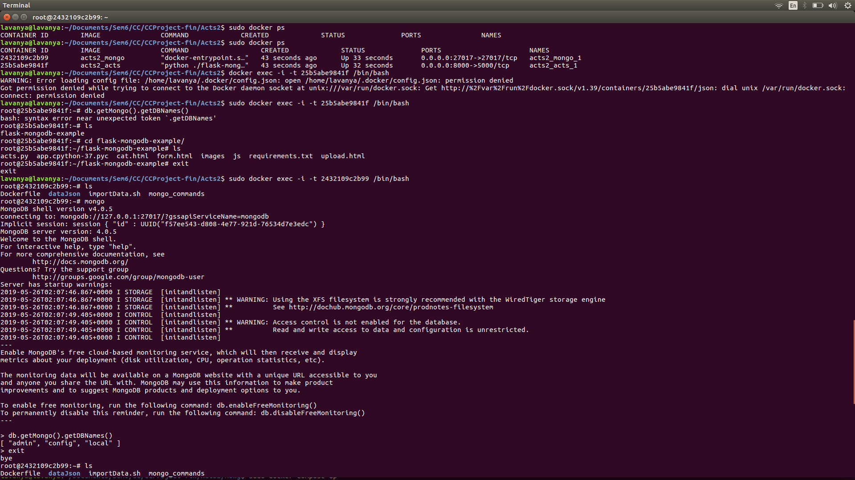
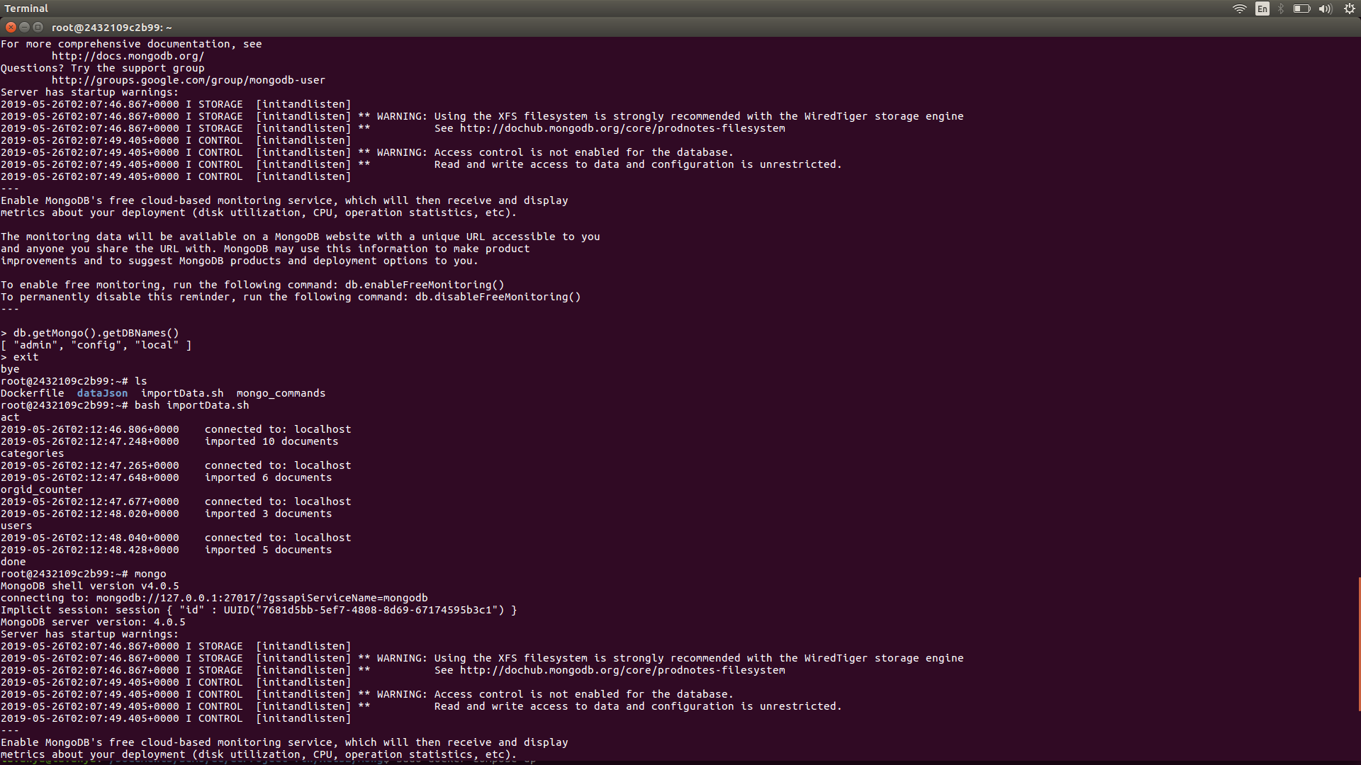
Step 3:

TESTING USING POSTMAN

- import file:///home/lavanya/Documents/Sem6/CC/CCProjectfin/Acts2/CC_assignment_APP_Test.postman_collection.json into postman and try using all the apis.

- OPEN MONGO COMPASS: localhost:27017
- Open cc_assignment database and verify the changes being reflected.

PROJECT PART:

Step 4:

Terminal 3:

START THE LOAD BALANCER (from home dir)

>> sudo python3 loadbalancer.py

Step 5:

TESTING USING POSTMAN

- send http://127.0.0.1:5000/api/v1/categories using GET in postman and make sure it works.

Step 6:

SCALE UP and DOWN

>>sudo bash run.sh

