 

Test Summary Report

# Total Test Cases : 2 Passed : 2 Failed : 0

|  |  |  |  |  |
| --- | --- | --- | --- | --- |
| **Test Scenario Sr No** | **Test Case/Step Desc** | **Test Case/Step Status** | **StartTime** | **EndTime** |

|  |  |  |  |  |
| --- | --- | --- | --- | --- |
| **TC-001 Account Creation** | **Account Creation** | **Passed** | **2022/05/02 12:28:35** | **2022/05/02 12:28:39** |

|  |  |  |  |  |
| --- | --- | --- | --- | --- |
| **Test Step No** | **Step Desc** | **Expected Result** | **Actual Result** | **Step Status** |

|  |  |  |  |  |
| --- | --- | --- | --- | --- |
| 1 | Entering text 'madhukar.lakkam@globe.com.ph' in 'UserName' text field | Should able to enter data'madhukar.lakkam@globe.com.ph' into 'UserName' text field | Entered data'madhukar.lakkam@globe.com.ph' into 'UserName' text field successfully | Passed |

|  |  |  |  |  |
| --- | --- | --- | --- | --- |
| 2 | Entering text 'Lavi@1234' in 'Password' text field | Should able to enter data'Lavi@1234' into 'Password' text field | Entered data'Lavi@1234' into 'Password' text field successfully | Passed |

|  |  |  |  |  |
| --- | --- | --- | --- | --- |
| 3 | Click on 'LoginButton' | Able to click on 'LoginButton' button. | Clicked on 'LoginButton' button. | Passed |

|  |  |  |  |  |
| --- | --- | --- | --- | --- |
| 4 | Check visibility of locator 'WelcomeButton' in Page 'QRHooksHomePage' | 'WelcomeButton' should be visible on the Application | 'WelcomeButton' is visbile on the page 'QRHooksHomePage' | Passed |

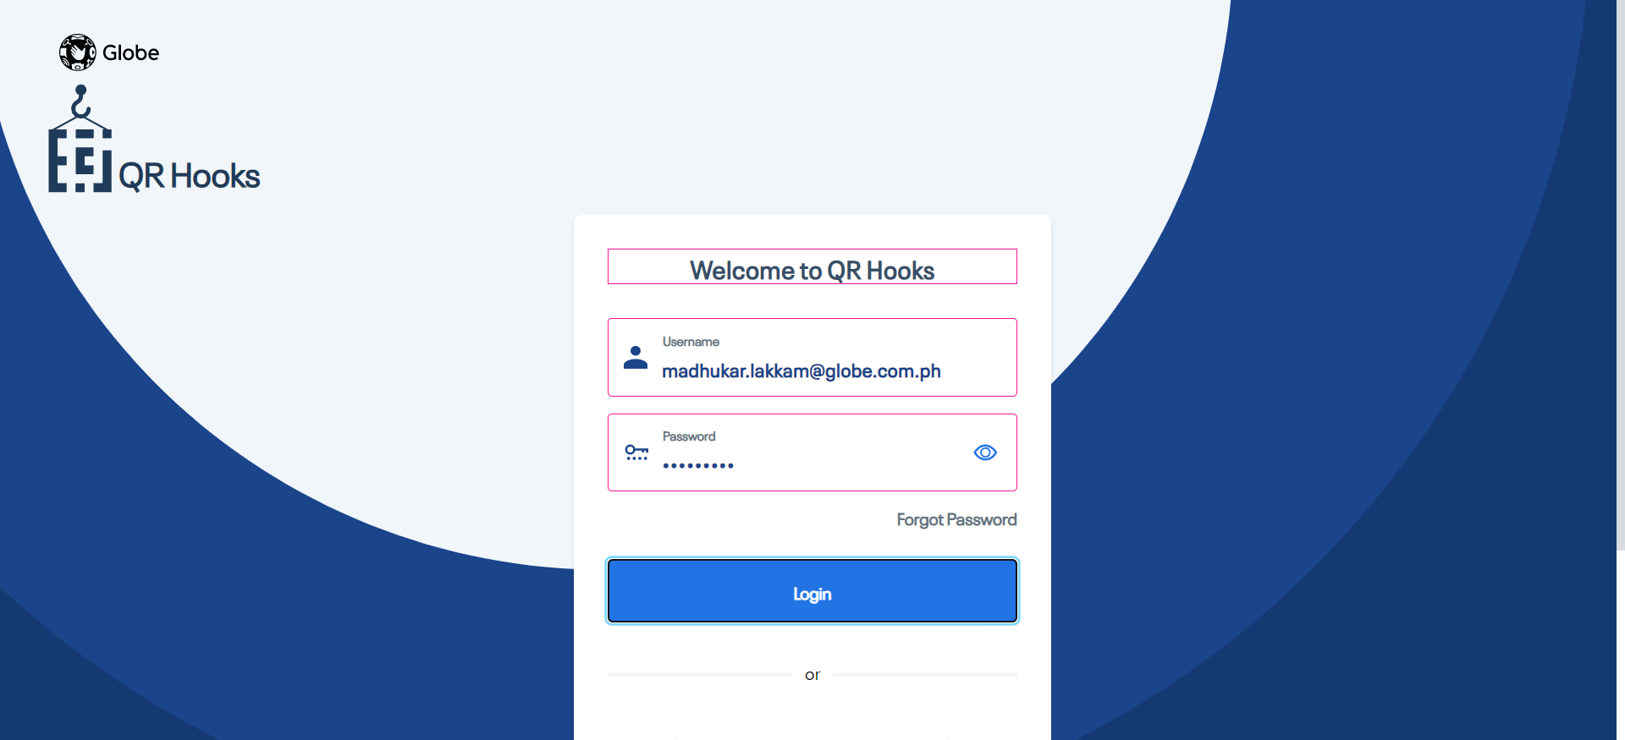

|  |  |  |  |  |
| --- | --- | --- | --- | --- |
| **Test Scenario Sr No** | **Test Case/Step Desc** | **Test Case/Step Status** | **StartTime** | **EndTime** |

|  |  |  |  |  |
| --- | --- | --- | --- | --- |
| **TC-009 create group** | **user able to create the group** | **Passed** | **2022/05/02 12:28:39** | **2022/05/02 12:28:48** |

|  |  |  |  |  |
| --- | --- | --- | --- | --- |
| **Test Step No** | **Step Desc** | **Expected Result** | **Actual Result** | **Step Status** |

|  |  |  |  |  |
| --- | --- | --- | --- | --- |
| 1 | Check visibility of locator 'GroupText' in Page 'QRHooksHomePage' | 'GroupText' should be visible on the Application | 'GroupText' is visbile on the page 'QRHooksHomePage' | Passed |

|  |  |  |  |  |
| --- | --- | --- | --- | --- |
| 2 | Click on 'CreateNewGroupButton' | Able to click on 'CreateNewGroupButton' button. | Clicked on 'CreateNewGroupButton' button. | Passed |

|  |  |  |  |  |
| --- | --- | --- | --- | --- |
| 3 | Click on 'SaveButton' | Able to click on 'SaveButton' button. | Clicked on 'SaveButton' button. | Passed |

|  |  |  |  |  |
| --- | --- | --- | --- | --- |
| 4 | Check visibility of locator 'GrooupNameRequired' in Page 'CreateNewGroupPopUpWindow' | 'GrooupNameRequired' should be visible on the Application | 'GrooupNameRequired' is visbile on the page 'CreateNewGroupPopUpWindow' | Passed |

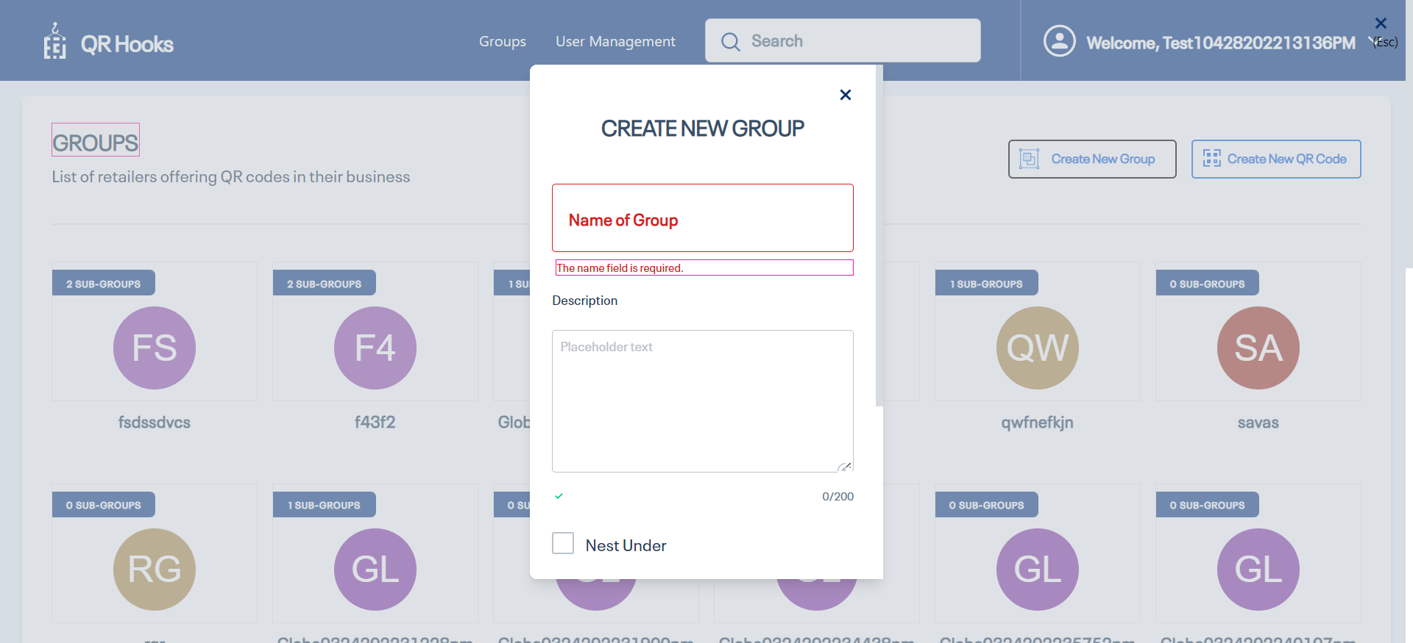

|  |  |  |  |  |
| --- | --- | --- | --- | --- |
| 5 | Click on 'CancelButton' | Able to click on 'CancelButton' button. | Clicked on 'CancelButton' button. | Passed |

|  |  |  |  |  |
| --- | --- | --- | --- | --- |
| 6 | Click on 'CreateNewGroupButton' | Able to click on 'CreateNewGroupButton' button. | Clicked on 'CreateNewGroupButton' button. | Passed |

|  |  |  |  |  |
| --- | --- | --- | --- | --- |
| 7 | Click on 'groupnameTextfield' | Able to click on 'groupnameTextfield' button. | Clicked on 'groupnameTextfield' button. | Passed |

|  |  |  |  |  |
| --- | --- | --- | --- | --- |
| 8 | Entering text 'Globe05022022122835pm' in 'groupnameTextfield' text field | Should able to enter data'Globe05022022122835pm' into 'groupnameTextfield' text field | Entered data'Globe05022022122835pm' into 'groupnameTextfield' text field successfully | Passed |

|  |  |  |  |  |
| --- | --- | --- | --- | --- |
| 9 | Check visibility of locator 'Desciption' in Page 'CreateNewGroupPopUpWindow' | 'Desciption' should be visible on the Application | 'Desciption' is visbile on the page 'CreateNewGroupPopUpWindow' | Passed |

|  |  |  |  |  |
| --- | --- | --- | --- | --- |
| 10 | Entering text 'User going to create the new group' in 'groupDescriptionField' text field | Should able to enter data'User going to create the new group' into 'groupDescriptionField' text field | Entered data'User going to create the new group' into 'groupDescriptionField' text field successfully | Passed |

|  |  |  |  |  |
| --- | --- | --- | --- | --- |
| 11 | Check visibility of locator 'Nest Under' in Page 'CreateNewGroupPopUpWindow' | 'Nest Under' should be visible on the Application | 'Nest Under' is visbile on the page 'CreateNewGroupPopUpWindow' | Passed |

|  |  |  |  |  |
| --- | --- | --- | --- | --- |
| 12 | Check visibility of locator 'DescriptionLegnth' in Page 'CreateNewGroupPopUpWindow' | 'DescriptionLegnth' should be visible on the Application | 'DescriptionLegnth' is visbile on the page 'CreateNewGroupPopUpWindow' | Passed |

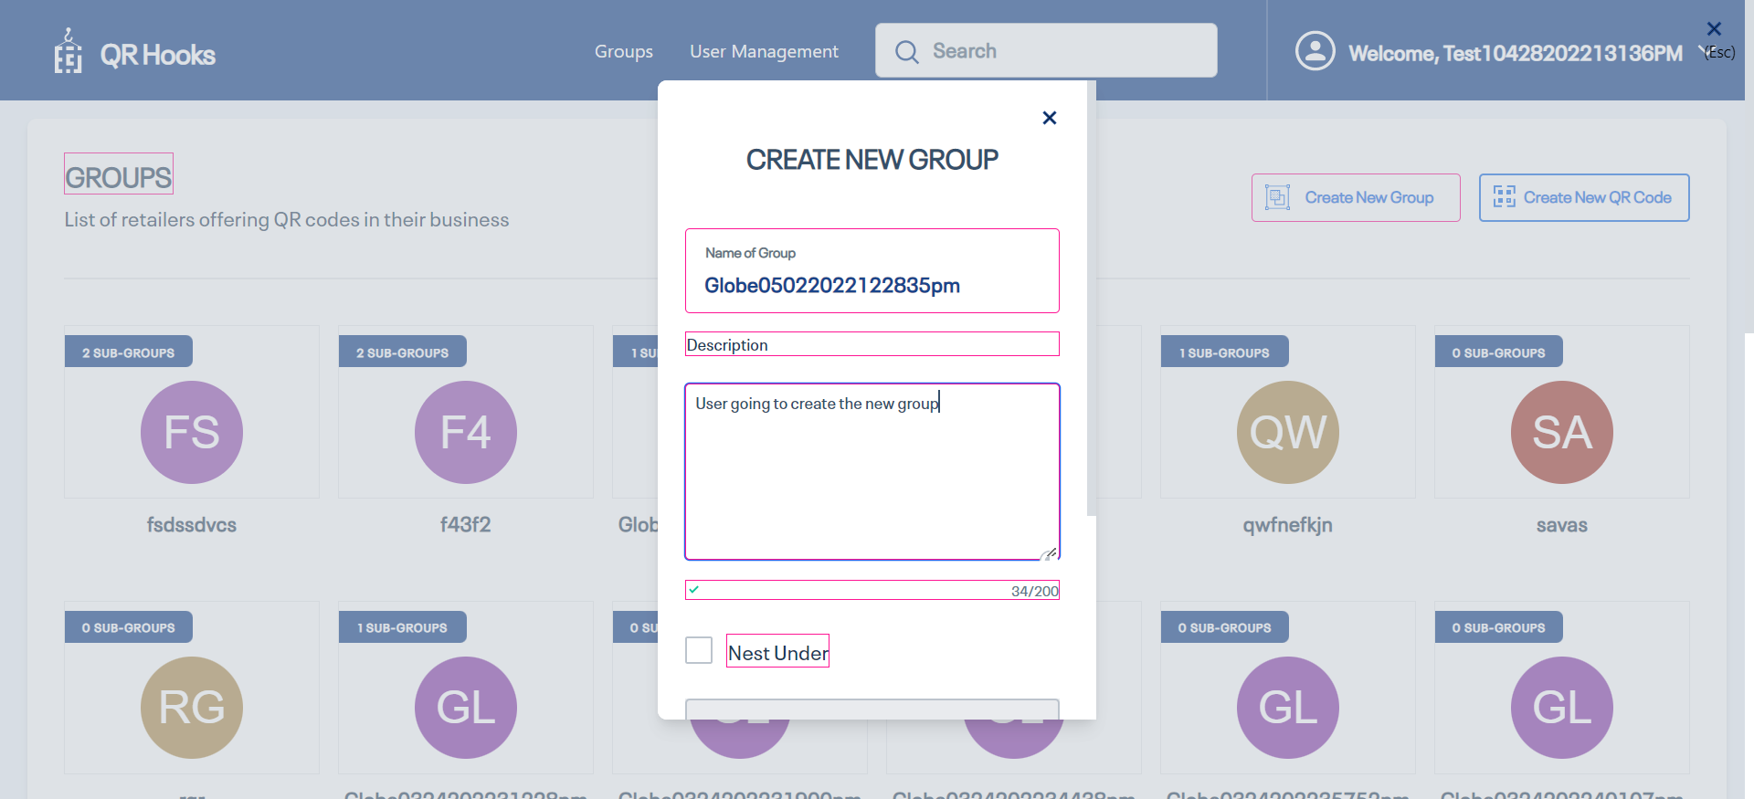

|  |  |  |  |  |
| --- | --- | --- | --- | --- |
| 13 | Check visibility of locator 'SaveButton' in Page 'CreateNewGroupPopUpWindow' | 'SaveButton' should be visible on the Application | 'SaveButton' is visbile on the page 'CreateNewGroupPopUpWindow' | Passed |

|  |  |  |  |  |
| --- | --- | --- | --- | --- |
| 14 | Click on 'SaveButton' | Able to click on 'SaveButton' button. | Clicked on 'SaveButton' button. | Passed |

|  |  |  |  |  |
| --- | --- | --- | --- | --- |
| 15 | Check visibility of locator 'GroupcreatedSuccessMessage' in Page 'QRHooksHomePage' | 'GroupcreatedSuccessMessage' should be visible on the Application | 'GroupcreatedSuccessMessage' is visbile on the page 'QRHooksHomePage' | Passed |

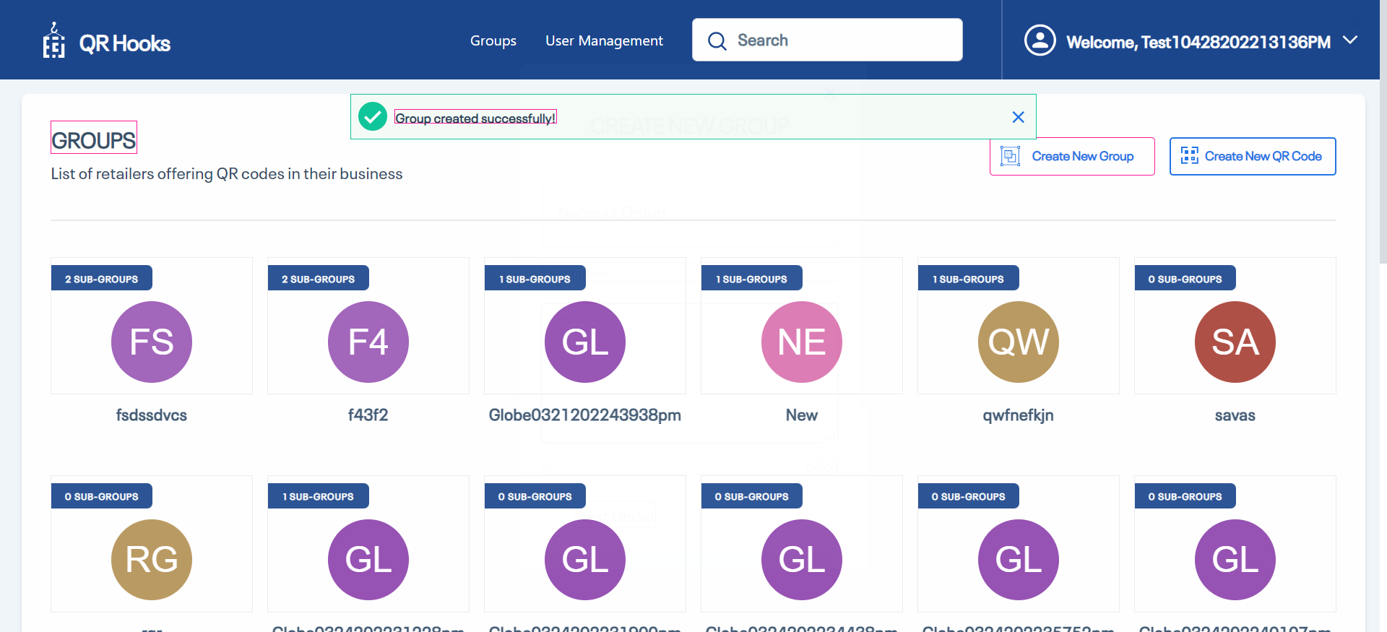

|  |  |  |  |  |
| --- | --- | --- | --- | --- |
| 16 | Entering text 'Globe05022022122835pm' in 'SearchBar' text field | Should able to enter data'Globe05022022122835pm' into 'SearchBar' text field | Entered data'Globe05022022122835pm' into 'SearchBar' text field successfully | Passed |

|  |  |  |  |  |
| --- | --- | --- | --- | --- |
| 17 | Check visibility of locator 'Globe05022022122835pm' in Page 'Edit Profile' | 'Globe05022022122835pm' should be visible on the Application | 'Globe05022022122835pm' is visbile on the page 'Edit Profile' | Passed |

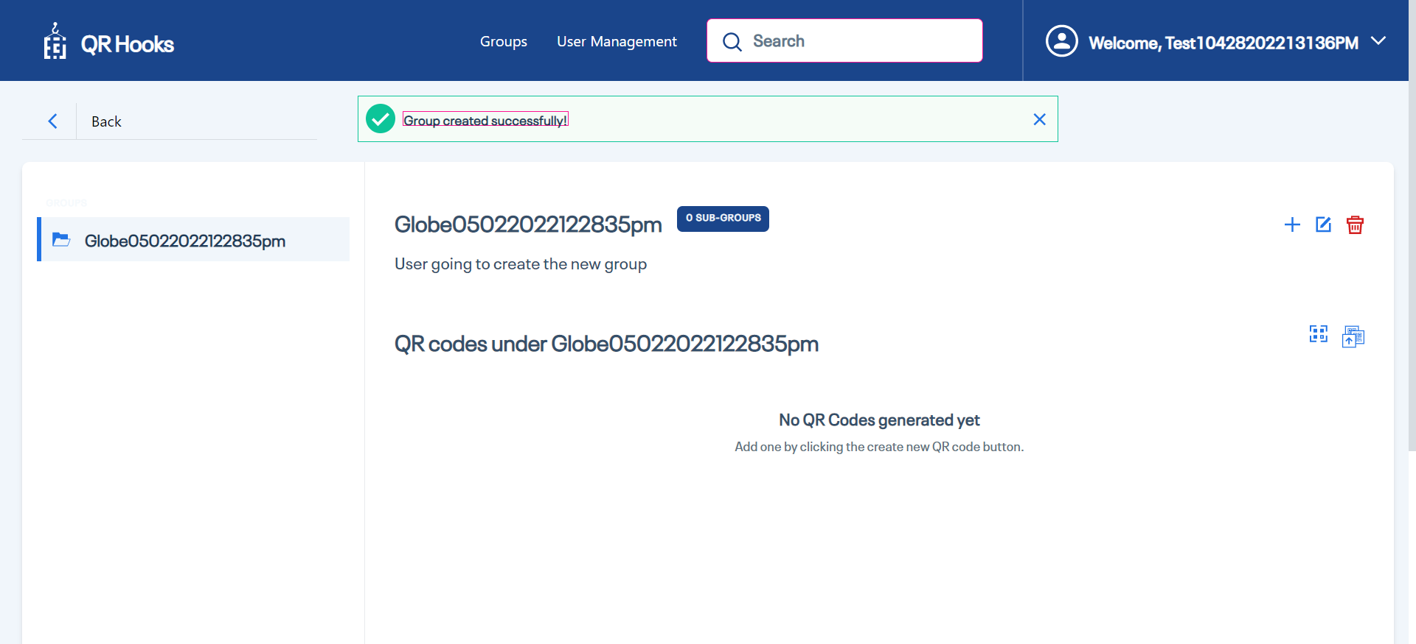

|  |  |  |  |  |
| --- | --- | --- | --- | --- |
|  |  |  |  |  |

|  |  |  |  |  |
| --- | --- | --- | --- | --- |
| 18 | Click on 'Batch ADD QR Code' | Able to click on 'Batch ADD QR Code' button. | Clicked on 'Batch ADD QR Code' button. | Passed |

|  |  |  |  |  |
| --- | --- | --- | --- | --- |
| 19 | Check visibility of locator 'BatchCreationText' in Page 'CreateBatchFilePage' | 'BatchCreationText' should be visible on the Application | 'BatchCreationText' is visbile on the page 'CreateBatchFilePage' | Passed |

|  |  |  |  |  |
| --- | --- | --- | --- | --- |
| 20 | Check visibility of locator 'DowloadTemplateText' in Page 'CreateBatchFilePage' | 'DowloadTemplateText' should be visible on the Application | 'DowloadTemplateText' is visbile on the page 'CreateBatchFilePage' | Passed |

|  |  |  |  |  |
| --- | --- | --- | --- | --- |
| 21 | Click on 'DowloadQRCodeTemplateText' | Able to click on 'DowloadQRCodeTemplateText' button. | Clicked on 'DowloadQRCodeTemplateText' button. | Passed |

|  |  |  |  |  |
| --- | --- | --- | --- | --- |
| 22 | Check visibility of locator 'UploadFileText' in Page 'CreateBatchFilePage' | 'UploadFileText' should be visible on the Application | 'UploadFileText' is visbile on the page 'CreateBatchFilePage' | Passed |

|  |  |  |  |  |
| --- | --- | --- | --- | --- |
| 23 | Dowload the QR hooks batch template | user should be able to dowload the QR hooks batch template | User is able to dowload the QR hooks batch template | Passed |

|  |  |  |  |  |
| --- | --- | --- | --- | --- |
| 24 | Click on 'UploadQRText' | Able to click on 'UploadQRText' button. | Clicked on 'UploadQRText' button. | Passed |

|  |  |  |  |  |
| --- | --- | --- | --- | --- |
| 25 | Click on 'GenerateQRCodeButton' | Able to click on 'GenerateQRCodeButton' button. | Clicked on 'GenerateQRCodeButton' button. | Passed |

|  |  |  |  |  |
| --- | --- | --- | --- | --- |
| 26 | Check visibility of locator 'BatchQRCodeSuccessMessage' in Page 'CreateQRCodepageBatch' | 'BatchQRCodeSuccessMessage' should be visible on the Application | 'BatchQRCodeSuccessMessage' is visbile on the page 'CreateQRCodepageBatch' | Passed |

|  |  |  |  |  |
| --- | --- | --- | --- | --- |
| 27 | Click on 'GoToHomeButton' | Able to click on 'GoToHomeButton' button. | Clicked on 'GoToHomeButton' button. | Passed |

|  |  |  |  |  |
| --- | --- | --- | --- | --- |
| 28 | Check visibility of locator 'GroupText' in Page 'QRHooksHomePage' | 'GroupText' should be visible on the Application | 'GroupText' is visbile on the page 'QRHooksHomePage' | Passed |

|  |  |  |  |  |
| --- | --- | --- | --- | --- |
| 29 | Entering text 'Globe05022022122835pm' in 'SearchBar' text field | Should able to enter data'Globe05022022122835pm' into 'SearchBar' text field | Entered data'Globe05022022122835pm' into 'SearchBar' text field successfully | Passed |

|  |  |  |  |  |
| --- | --- | --- | --- | --- |
| 30 | Check visibility of locator 'Globe05022022122835pm' in Page 'Edit Profile' | 'Globe05022022122835pm' should be visible on the Application | 'Globe05022022122835pm' is visbile on the page 'Edit Profile' | Passed |

|  |  |  |  |  |
| --- | --- | --- | --- | --- |
| 31 | Generating multiple QR codes using batch file | user should be able to see the QR Codes in group page | user is able to see the Qr codes in group page | Passed |

